02/12/2020

Benisty Georges, Vanhaelen Luke

InsTITUT POLYTECHNIQUE DES SCIENCES AVANCÉES

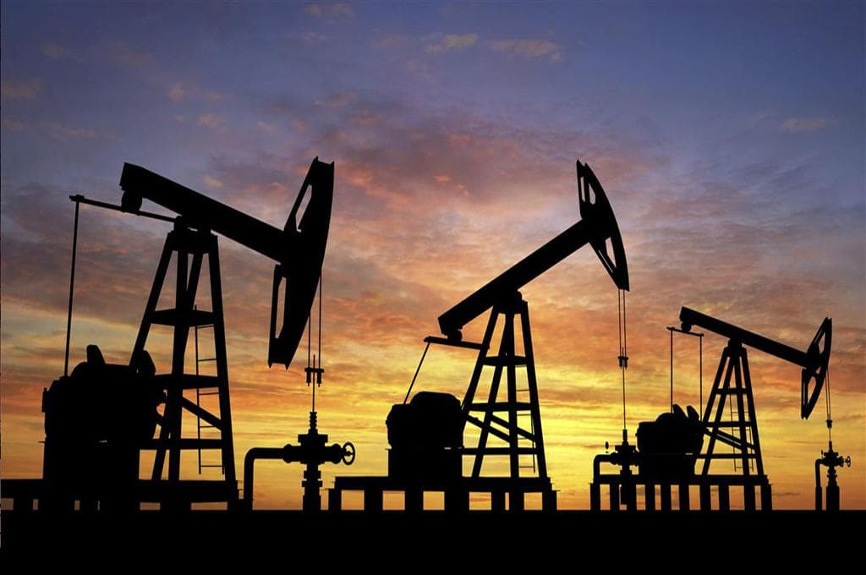

Numerical techniques for resolving PDEs

*Petroleum Recovery*

Table of content

[Glossary & Notations 2](#_Toc60241678)

[1 Introduction 3](#_Toc60241679)

[2 Modeling 5](#_Toc60241680)

[2.1 Use of a parcel 5](#_Toc60241681)

[2.2 Without gravity 7](#_Toc60241682)

[2.3 Adding gravity 8](#_Toc60241683)

[3 Discretization 9](#_Toc60241684)

[3.1 Without gravity 9](#_Toc60241685)

[3.2 With Gravity 12](#_Toc60241686)

[4 Implementation 14](#_Toc60241687)

[4.1 Implementation without the effects of gravity 14](#_Toc60241688)

[4.2 Implementation with the effects of gravity 17](#_Toc60241689)

[5 Study case 20](#_Toc60241690)

[5.1 Presence of oil in India 20](#_Toc60241691)

[5.2 Shale and sandstone 22](#_Toc60241692)

[5.2.1 Problem definition 22](#_Toc60241693)

[5.2.2 Without gravity 23](#_Toc60241694)

[5.2.3 Presence of gravity 26](#_Toc60241695)

[5.3 Conclusion of the study case 29](#_Toc60241696)

[6 Conclusion 30](#_Toc60241697)

[7 Bibliography and webography 31](#_Toc60241698)

**All necessary Python files to elaborate this report can be found on GitHub at the following address :**

<https://github.com/GeorgesBenisty/Petroleum_Reservoir_IPSA_2020>

# Glossary & Notations

In this section, we provide a list of frequent occurrences of mathematical terms, also an glossary of frequent terms with their definitions

Petroleum reservoir: a porous medium that contains hydrocarbons.

Darcy law : law that gives us the set of equations to solve to obtain the saturation in function of time and space. In the equation of mass conservation (*q* is the “source term”), the Darcy law express *u* as the superficial Darcy velocity 

saturation of the phase *α*. In our study, . We denote oil as *o* and water as *w* so that the saturation satisfies *so + sw = 1*.

*K* : permeability tensor of a porous medium such that  If *k11 = k22 = k33* and *K = k(x)I3*, the porous medium is considered as isotropic, otherwise it is called anisotropic.

*φ* : porosity of the porous medium. We have 

*ρ* : density of the fluid per unit volume

*P* : pressure of the fluid

*Ω* : mathematical representation of the porous medium.

respectively space and time step

*N* : number of points to discretize *Ω*

*M* : number of points to discretize time such that *tM = 1* (time mesh)

*g :* constant of gravity, *g = 9.81 m.s-2*

# Introduction

Since the mid 1950’s, oil became one of the most precious resource available on Earth. The products obtainable from processing oil, underpin our modern days society. Oil is used in many sectors and in various forms, its primary role is to provide energy to the industries, supply fuel for transport vehicles and heat up homes across many countries. To get an idea of its importance, the usage of oil in transport represent around 75% of its total usage while a quarter is used in chemical feedstocks and other applications. The usage of oil has largely increased over the past years and it’s now a fundamental ingredient in the conception of various objects from our daily lives. For instance, computer hardware, binding agents for creams, coatings for pills, contact lenses, insulating material and roofing tiles are all made of processed oil and play, in some ways, a vital role in our lives. Without oil, our society would have to evolve in order to survive. An oil crisis or shortage would lead to devastating economical and political instability that would endanger the global economy. In our history, only twice did such event ever occur, they had an impact on millions of people throughout the world and on the economy itself which took some time to recover from the whole ordeal.

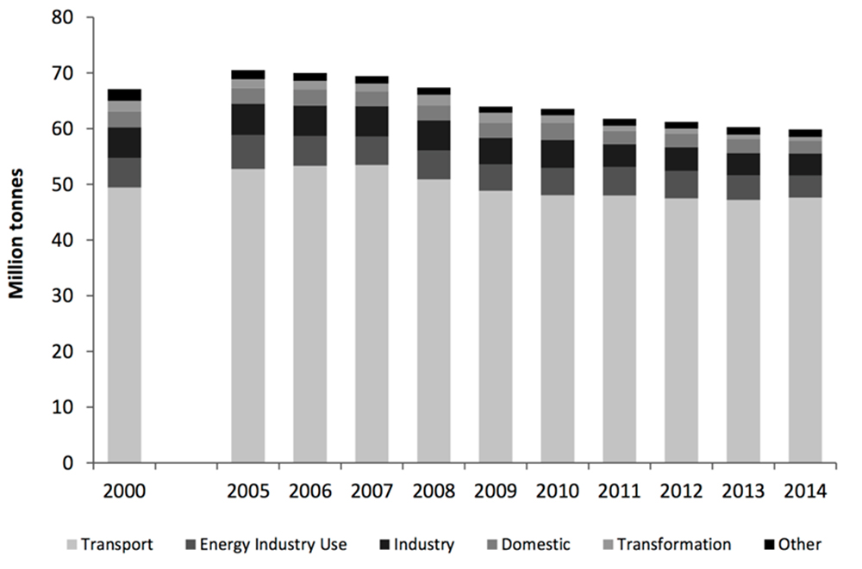

Although we aren’t facing any major oil crisis as of today, we could well be facing one in just a few decades. Unsurprisingly, with the preponderant role of oil in our society and our urge to exploit every single drop we can find, its exploitation is getting harder and more challenging over time despite the fact that oil reserves are being found all across the world. Indeed, most countries can rely on their own oil resources, however, they don’t all have the same amount of oil at their disposal, nor do they have the sale needs for it. Saudi Arabia is the biggest producer of oil barrel with approximately 266.2 billion of barrels produced each year, however, their needs for oil is lower than most developed countries like France, the United-States of America or even China.

The scarcity of this resource is beginning to be felt worldwide. According to the scientific community, the Planet Earth is left with approximately enough oil reserves to last for around 50 years. This means that by the 2050s, the planet’s oil reserves will be completely depleted, and humanity will be facing the worst oil crisis ever. Despite our best effort, we won’t be able to prevent such event from happening, however, we can find ways to delay it in order to buy some time in order to find a way to replace oil with something more ecofriendly and efficient.

Even if there are numerous petroleum reservoir around the Earth, it doesn’t mean that all of them are exploitable. Some reservoirs might still be forming and not totally ready to be exploited. The exploitation of reservoirs not fully “formed” yet could result in the loss of considerable amounts of oil which would be terrible regarding the scarcity of the latter. Therefore, it is useful to know where these petroleum reservoirs are located and how much oil we could potentially extract from them. To achieve this goal, we need to have an idea of the oil saturation evolution in a certain amount of time.

The aim of this practical work is to learn how to extract oil from petroleum reservoirs by injecting water into the latter. The injection of water is intended to build up the pressure into the reservoir which would then push the oil up towards the surface where it could then be collected. However, we cannot afford to dig everywhere and anywhere. Some reservoirs might be more exploitable than others, to avoid wasting time and resources on useless reservoirs, the method of reservoir simulation is applied. The primary objective of reservoir simulation is to predict future performance of a reservoir and find ways or means of optimizing it to the maximum of our abilities the recovery of the hydrocarbons. Since the equations governing a mathematical model of a reservoir cannot be solved by analytical methods the use of numerical models is required. These models are used to understand, predict, and optimize the complex physical fluid flow processes in petroleum reservoirs.

Therefore, we first need to modelized the governing equations inside a petroleum reservoir. We have to call the Darcy law which gives us a link between the velocity and the gradient of pressure. Combined with the mass conservation, we have governing equations for each phase. We will eliminate the velocity profile, so we obtain equations for saturation that depends on time only. To be used on a computer, such equations will be discretized. Many methods exist but, in our case, we will focus on the finite volume methods only. 3 main schemes will be explored: Upwind scheme, Lax-Friederichs and Godunov scheme. We will run our program with those 3 schemes and comment our results.

# Modeling

## Use of a parcel

To have a physic approach, we will first study the governing laws for a single phase in a porous medium. Because of the continuity and the homogeneity, we will express laws for two phase immiscible flow.

Let us consider a parcel of fluid, no matter the fluid that wet it. Inside this parcel, we will use the cartesian coordinates. We will modelized this parcel of fluid as a rectangular cube. The face is parallel to the cartesian system. For each direction *i (i = 1,2,3)*, *xi* represents the coordinate of the center of the cube and *Δxi* the length of the rectangular cube. The mass flux of the *xi*-component is given by *ρui*.

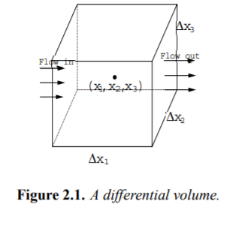

Because we took the center of the cube, we are exactly at the middle of *Δxi*. Hence, we look at the mass inflow across the surface at per unit time : following the definition of mass flux, the mass inflow is . When the flow gets out of the cube, we have .

We apply the same procedure for the directions *x2* and *x3* :



Because of the character of the porous medium, it is more interesting from a physical to integrate the compressibility of the fluid. This leads to a mass accumulation on pores. Mathematically, we can write this mass accumulation per unit volume per unit time as . Also, one phase (fluid) will wet the porous medium. It means that one fluid is introduced (or removed inside). This input can be modelized as a source with a certain strength *q*. Considering the volume where the source acts, there will be a decrement (resp.) accumulation which is *-qΔx1Δx2Δx3*. If it is a source, *q* is positive whereas for the sink, *q* is negative.

All elements are now set up to express the mass conservation principle with the presence of a source *q* :



If we want to have a high fidelity of modeling, we have to take several other cubes where their *Δxi* is becoming smaller and smaller. It is mathematically represented by *Δxi → 0*. It gives us . Finally, we express the fluid velocity in the form of Darcy’s law. It is determinate experimentally as . Substituting in the mass conservation equation leads to . The only inconvenient of our method is that Darcy’s law is only valid for Newtonian fluid. For non-Newtonian fluid, the Darcy law is corrected as 

The problem should be completed by stating initial and boundary conditions. If we call *Γ* a border of the porous medium, if the pressure is a known function of position and time, then *P = P1* in *Γ*. The same theory apply for the total mass flux : by taking the outward normal *n*, ρu.*n* = *G* *in Γ*. The initial conditions is stated in term of pressure as *P(0,x) = P0(x)* for any *x* inside *Ω*.

Now that we have fixed the theory for single phase, we can generalize for two immiscible phases : the immiscible hypothesis is set to simplify our work. Otherwise, we should have taken into account that the two phases would form an homogeneous medium, resulting in some chemical equilibrium equations, which are outside of the scope of this report. Also, in term of mass, this hypothesis implies that there is no mass transfer between two phases. Thus, the mass is conserved at each phase.

For two fluids, in our petroleum reservoir, one phase (for example, water) wets the porous medium where there is already a nonwetting phase (concretely, oil in our case). This leads to introduce the saturation which is defined as a ratio between the void volume of a porous medium filled by this phase. When two fluids join the fluids, we can write that *so + sw = 1* where *so* and *sw* denotes the saturation of each phase (respectively, oil and water).

In addition of the saturation, we also introduce the notion of capillary pressure. Concretely, it is the pressure between two immiscible fluids. It appears due to the presence of pores in the porous medium.

We perform mass conservation principle using the same expressions as above, but we apply them for each fluid which respect to their saturation. We also state the mass accumulation in a differential volume for each phase which is . It results for each phase in . The Darcy law for single phase is written for each phase . Thus, we have the problem :



Boundary conditions and initial conditions apply as seen above but for each phase. For the purpose of our first modeling, we suppose that *μα = 1*.

## Without gravity

Let us consider a one-dimensional and homogeneous porous medium. We suppose that For each phase *o* and *w* (respectively oil and water), this leads to solve :



For each velocity phase, we recall that is the expression of the momentum conservation under the form of Darcy law. *fα* are given functions which are determined experimentally.

In a first approach, we assume that *g = 0* means there is no gravity. We also suppose that *Pc = Po - Pw = 0 → Po = Pw = P* means there is no capillary pressure. Thus, the velocity phase becomes



The functions *fα* will be given functions in the scope of this report.

We eliminate *vw* and *vo* using the fact that *φ* and *K* are constant. Hence, we get



We substitute *(4)* in *(1)* and *(2)*. When summing *(5)* and *(6)*,



The function *fw(s)* and *fo(s)* are determined experimentally. They represent the evolution of the saturation in our porous medium. For our report, we suppose that :

* *fw + fo* is continuous and strictly positive on the space interval *[0,1]*
* Each of these functions are Lipschitz
* The initial conditions give us *fw(0) = 0* and *fw(1) = 0*

We can see that the quantity depends only on time. So,



In the scope of this report, we suppose *q(t) = α > 0*. Physically, we assume that either our strength or our sink is having a given constant flow throughout the time. In our results, we will put this assumption in practice with some values of *α*. Therefore, we will discretize:



We have the so-call Buckley Leverett governing equation inside a petroleum reservoir. This is anon liner scalar conservation law of the form . To have a complete problem, we have to prescribe initial and boundary conditions:

* We suppose that the porous medium is fully saturated in oil so *s(0,x) = 0*. This is our initial condition.
* We also need to prescribe that that is *P(0,x) = P0(x)* which is our boundary conditions. The quantity *αφ* represents the rate of flow.

## Adding gravity

Now let us add gravity. We still assume that there is no capillary pressure. Therefore, we have to consider the density *ρα* of each phase :



With velocity profile 

Thus, we eliminate the pressure :



As  does not depend on time, we denote her value *α* as we did before. Therefore, the gradient of pressure can be expressed as :



Let us have a look at *(15)*. In the *x* derivative term, we found back the first term that we had when we set the no gravity case. Taking into account the gravity has leads to one supplementary term which considers the gravity by the *β* coefficient (difference between two density).

Factorizing by *fw(s)* at the numerator leads to 

We found again a nonlinear scalar conservation law. This time .

The initial condition remains unchanged as the porous medium is fully saturated in oil : *s(0,x) = 0*. Also, the flux at *x = 0* is only composed of oil so 

We also prescribe a boundary condition on the pressure 

# Discretization

## Without gravity

When discretizing, we cannot eliminate the pressure. In fact, our equation should be discretized whatever the dimension considered. In most cases, we will consider a pressure gradient on the 3 axes of the cartesian coordinates, which explains why we cannot simplify the equation . Thus, it justified our approximation done before, so we consider

To discretize this equation, we need to have a space step . The time step definition is not evident: his formal definition is . In fact, the time step is linked to the space step with the so-call CFL condition. To ensure that we adhere to CFL condition, we will take here . Hence, we can define . This helps us to give ourselves a space and time mesh so we can discretize *(9)*.

The discrete condition is translated as . In order to have the values of saturation at the time *n+1* in terms of the saturation at time *n*, we will use a finite volume scheme explicit in time for the saturation. This explains why this scheme belongs to the so-call “IMPES” scheme category. “IMPES” stands “Implicit Pressure Explicit Saturation”. It indicates that computation of the saturation at the next time step can be done directly while the computation of the pressure cannot be done directly and requires to solve a linear system.

The idea behind the finite volume element method is to split space and time zone into small domain control “control volume”. After this splitting, we integrate *(5)* on all control volumes. This method of finite volume is robust. However, in some complex cases, the accuracy of the solution tends to decrease. Other methods exist, such as the finite element method, which is outside the scope of this report.

Hence,



The value of depends on the sign of . So we have to find the sign of . Summing the two equations leads to :





The previous quantities do not depend on *i* : in fact, on the left-hand side of the equation all variables are taken at the space mesh and on the right it is for the space mesh . The use of boundary conditions gives 

For our need, we will suppose that *α > 0* so the sign of our desired quantity is negative :  .

As *s(t,0) = 1* (boundary conditions), this can be translated as 

Thus,



Hence, we arrive to the following numerical scheme:



This is the upwind scheme (the scheme is requiring the values from the one-time loop before).

We will also use two other schemes:

* Lax Friederichs: 
* Godunov: 

Those 3 schemes are built with the same basis of discretization of nonlinear conservation laws : integrating into volume control leads to 

If we denote that  we end up with the following scheme :. The upwind chose consists to take or for our practical work 

While the upwind scheme is a basic approximation as it only takes the two terms before, it is also intuitive from a mathematical point of view. It has been demonstrated in the scope of our course that this scheme does not violates the maximum principle.

This principle states that the solution of a partial differential equation always stays between the maximum and the minimum of our initial conditions. We recall that *s(0,x) = 1* and that the function *fw* and *fo* are strictly positive. So, the initial saturation cannot be less than 0 (otherwise it has no physical interpretation). Let us demonstrate here that the upwind scheme satisfies to the maximum principle : if we come back to our general case, we have

The sum of the two coefficients is . As *uin+1* appears as a convex combination of *uin* and *ui-1n*, it is necessarily between 0 and 1 and thus respects the maximum principle.

The Lax-Friederichs adds the “average” of the two terms before and their evaluation with the saturation function. Also, it respects the discrete maximum principle and it also more intuitive for a physician.

Ultimately, the Godunov scheme define an auxiliary quantity which change throughout the loops and makes this scheme the most precise scheme to plot the saturation of the fluid.

## With gravity

When adding the gravity (that is the density of the phase), we have to conduct a new sign study. The principle remains the same if we use the same notations :



The choice for depends on the sign of . If we sum the two previous equation, we have 

Both quantities on the left and right side does not depends on *i* (they are taken at the same *i+1/2*). We assumed in paragraph 2 that  does not depend on time. Hence, we can write . We can now obtain the value of 

Due to the sign of the previous quantity, we will choose . The case *i = 0* and *i = N* corresponds to the boundary conditions. Because of the gravity, we have to do the same work for the oil phase : however, appears to be of the same sign of . As the sign of  varies through space and time, we will make a choice depending on the sign :



Thus,



Since we started to study the sign of previous quantities, the precedent formula is not valid for the case *i = 0* and *i = N*. Those cases correspond to the boundary conditions. At *i = 0*, it corresponds to the case *x = 0* where the porous medium is fully in oil. Thus, . The flux at *x = 0* is only composed of water, so when injecting oil . Those two cases correspond to the exterior fluxes. The term “exterior” has to be understood as we look outside the porous medium, so when we inject oil. The general cases correspond to the interior cases, mean when we look inside the porous medium.

Finally, we get the discretized scheme that we will implement on Python :



The same work can be performed by taking variants of this scheme : Lax Friederichs and Godunov. For Godunov, instead of having a function depending on one saturation, the function *G* depends on two saturations.

# Implementation

In the scope of this report, we will implement those mathematical equations with the Python language. The *numpy* library is necessary : as the equations are discretized, they will be treated by modifying a list according to a numerical scheme. We will also import the *matplotlib.pyplot* library to plot the results on a graph.

## Implementation without the effects of gravity

In order to obtain the numerical approximation of the one-dimensional model, without taking gravity into account, we need to get the model itself. Before getting this model, we will need to initialize a few variables. These variables are the followings:

* The limits of the space model
* Initial conditions of our model
* Number of points for the representation of our model
* The time span
* Initial saturation vector for Upwind, Godunov, and Lax-Friederich
* Boundary Conditions for each vector

We set the variables for our model without gravity as following: we will modify them in the study case.

The saturation is defined as a matrix of *T* columns and *N+1* line.

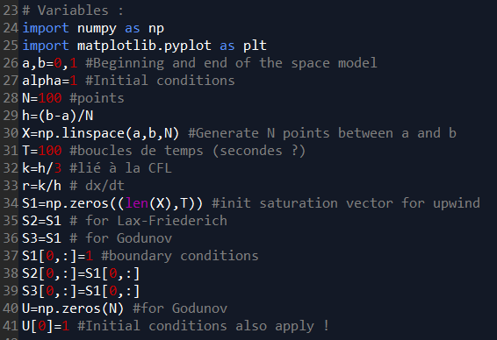

Now that we have defined our variables, we can proceed to the next step. We can start creating our functions. We will need three functions for the elaboration of our numerical model, we will need a function for water, one for oil and one that will take both into account.

* For the function of water, which we named **fwater** (latter named **fw**), we have:
* Regarding the function of oil, which we named **foil** (as before we latter changed its name to **foil** for simplicity), we have:
* As for the final function named **f** we have:

In python, these functions will look slightly different but will remain the same. Therefore, we get the following functions:

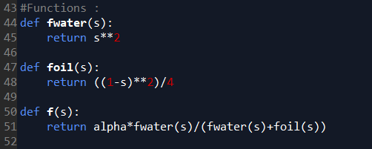

Since we now have established the variables and created the functions required for our numerical model without the effects of gravity, we can proceed to write the relations behind each one of the three schemes.

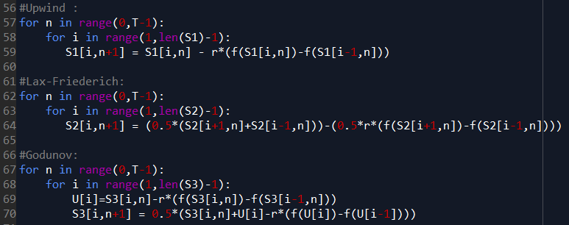The schemes relations are the following: Upwind scheme, Godunov scheme, and Lax-Friederich scheme. The loop trough the time is performed by the variable *i*. We begin at 1 as we fill out the saturation with a boundary condition.

Once we have set up the variables for our model without gravity, created the required functions and schemes, we can finally proceed to the simulation and obtain a plot representing the comparison of the previous three numerical scheme for petroleum recovery while neglecting the effects of gravity.

According to the graph, all three schemes seems to be merging together when the effects of gravity are neglected. Since all three schemes are merged together, it is hard to point out which one of them is the most efficient for this task.

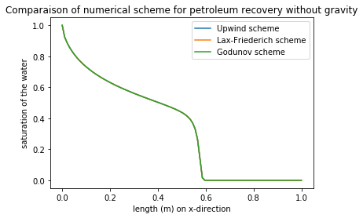

## Implementation with the effects of gravity

Now that we have obtained the numerical approximation of the one-dimensional model, without taking gravity into account, we can repeat the whole process but this time we will not neglect the effects of gravity on our model.

Similarly, to the first model, we will need to initialize almost the same variables as before but since gravity comes into play, we will have to add some more. These variables are once again the followings:

* The limits of the space model
* Initial conditions of our model
* Number of points for the representation of our model
* The time spans
* Initial saturation vector for Upwind, Godunov, and Lax-Friederich
* Boundary Conditions for each vector
* Permeability
* Gravitational acceleration
* Density
* A correction factor due to gravity

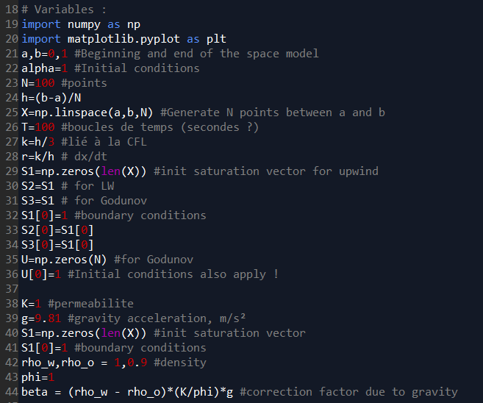We set the variables for our model with gravity as following:

Now that we have defined our new variables, we can proceed to the next step. Just like for the numerical model without gravity, we start by creating our functions. We will once again need three functions for the elaboration of our numerical model, we will need a function for water, one for oil and this time a third function a little more complex. The first two functions do not differ from the ones in the first case.

* For the function of water, which we named **fwater** (latter named **fw**), we have:
* Regarding the function of oil, which we named **foil** (as before we latter changed its name to **foil** for simplicity), we have:

As for the final function named **G(a,b)**, we have:

* if
* otherwise

Unsurprisingly, in python, these functions will look different but will remain the same. Therefore, we get the following functions:

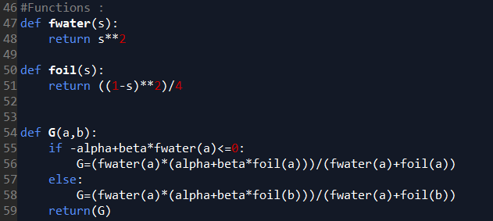

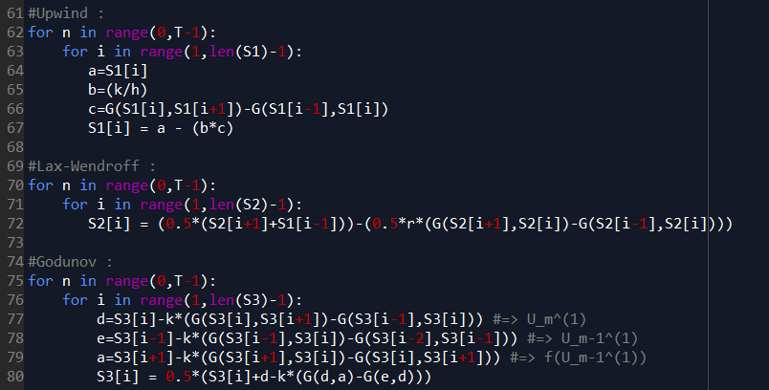Having now established the variables and created the functions required for our numerical model with the effects of gravity, we can proceed to write the relations behind each one of the three schemes.

Once we have set up the variables for our model without gravity, created the required functions and schemes, we can finally proceed to the simulation and obtain a plot representing the comparison of the previous three numerical scheme for petroleum recovery while neglecting the effects of gravity.

According to the graph, even when taking the effects of gravity into consideration, the three schemes seems to be almost totally merging together. However, we can see that around a length of 0.95m and a water saturation of around 0.5, the Godunov scheme makes a better job (judging by the curvature) while the Upwind and Lax-Friederich schemes are still merged together. By this, we can easily see that the Godunov Scheme is the most efficient of the three.

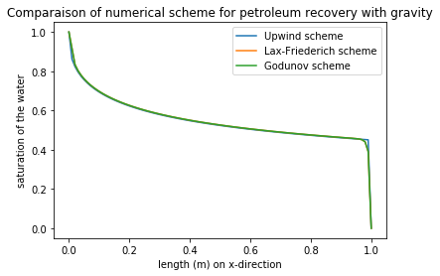

# Study case

In the implementation part, we focus on how to implement and have mathematically correct graph. However, the values of porosity, permeability and density in the precedent part does not have a physical sense. For instance, a fluid with a permeability of 1 would mean that the fluid is capable to let enter the wetting phase complete. In real life, such a fluid in porous medium does not exist. Also, the value of *α* is unrealistic : a value of 1 mean physically that we are constantly injecting fluid, which is simply unrealistic (the fluid is a finite volume). Thus, we will focus on a real petroleum reservoir. We will change :

* Density *ρ*
* Permeability *K*
* Porosity *φ*
* *α*

It is also worth mentioning that some data may not be as accurate as they are in real life. Some of our values needed might be confidential.

## Presence of oil in India

In the oil industry, the first step to ensure oil extraction is to probe underground in order to determine the geology. Therefore, depending on the location, the oil company can decide whether or not to install an oil recovery system on this petroleum reservoir. The fluid to extract is rarely located on the firs layer :

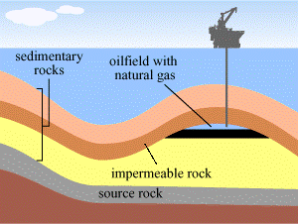

A region in the world which have enough oil reserves is, with the Arabic Golf, India. The country holds around 27 basins of petrol :

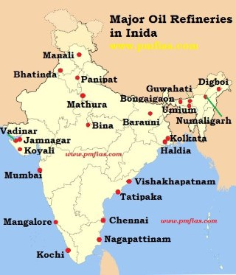

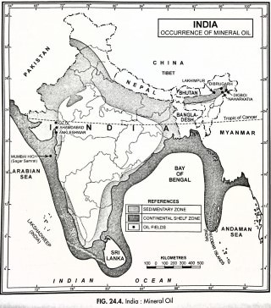

In the scope of this report, we will assume that there is only 2 layers : the oilfield and the impermeable rock. In fact, our Python code is designed to manage only 2 phases.

## Shale and sandstone

### Problem definition

The literature and our course mainly focus on two types of fluids commonly used : oil and water. However, the figure above suggests that the model of petroleum recovery is not only valid for these two types of fluids. They can be used for any type of fluids. Therefore, we will setup ourselves the following problem :

* The wetting phase (the fluid which is injected) will be the Sandstone. Thus, it corresponds to the “water” phase
* Consequently, the phase which is wet is the shale. It corresponds to the oil “phase”

The problem remains in one dimension, as we have developed the theory for the one-dimension case. All other assumptions are the same, that is :

* No capillary pressure means that the pressure is a continuous data.
* No source terms.

All values needed for our problem are listed in the table below :

|  |  |  |
| --- | --- | --- |
| Name of the variable in Python | Value | Remark, explanation |
|  | *0, 2000* | Represent the depth of our reservoir. Value extrapolated from an oil reservoir in the Erath field, Louisiana, USA. |
| *α* | 0.1472 | Provided by Suez |
| *N* | 200 | Deduced as a compromise between realism (the saturation should go slowly in the depth) and time computation |
| *T* | 30 | Will be increased in the next part to visualize the progression of the saturation. Expressed in seconds |
| h |  |  |
| *k* |  | Adhere to the CFL condition, will be modified later. |
| *r* |  |  |
| *φ* | 0,4 | Several types of porosity exist, but the main idea consists to operate the ratio between void volume and volume occupied by the rock. Therefore, it is given as a percentage. |
| *K* | 0,1 | Defined with the Darcy unity such that 1 Darcy = 1 µm². However, it is obsolete but gives an understanding of the measurement |
| *g* | 9.81 | m/s² : constant of gravity |

### Without gravity

Without the presence of gravity, *K* and *φ* are not needed as seen before. Starting with the linear choice of permeability, *i.e.* *fo(s) = s* and *fw(s) = 1-s* :

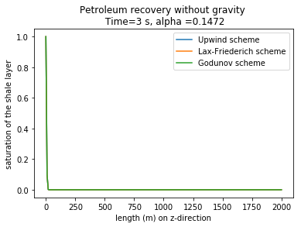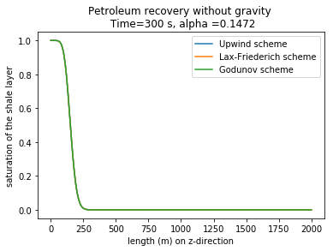



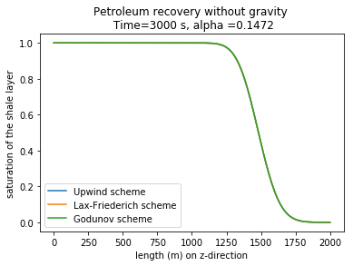



Remember that the saturation is defined as the ratio between the fluid wetting and the fluid which is wet. Therefore, as we set the initial saturation to 1 at time 0, the maximum principle states the saturation should remain between 0 and 1 (to have a physical interpretation), which is the case here. Thus, our numerical scheme respects the maximum principle. What has to be noticed is the phenomenon of “transportation” that can be seen throughout time loop. It is therefore accurate with what we stated in the modeling part.

When we obtain a saturation is equal to one, it means that the fluid we want to extract is extracted at the position *x*. For the prescribed value of alpha, around 8 hours and 20 minutes (3000 seconds) are necessary to sort out the shale. Increasing the value of alpha leads to a faster extraction process :

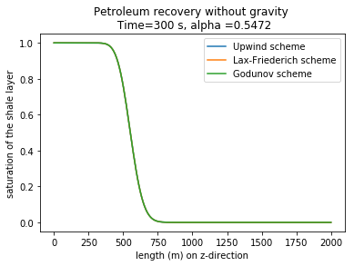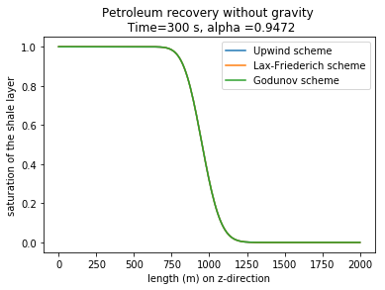

What can be noticed is that no matter the scheme used; the 3 curves are perfectly confused. It is due to our settings. In fact, the Godunov scheme is stated as the “best” one especially for extreme case where Lax-Friederichs and the upwind scheme might diverge. We will see this in the next part with the addition.

At a certain moment, the saturation suddenly increases with a strong slope from 0 to 1. This way of representing is not rigorous as the analytical solution shows that there is a discontinuity for any time :

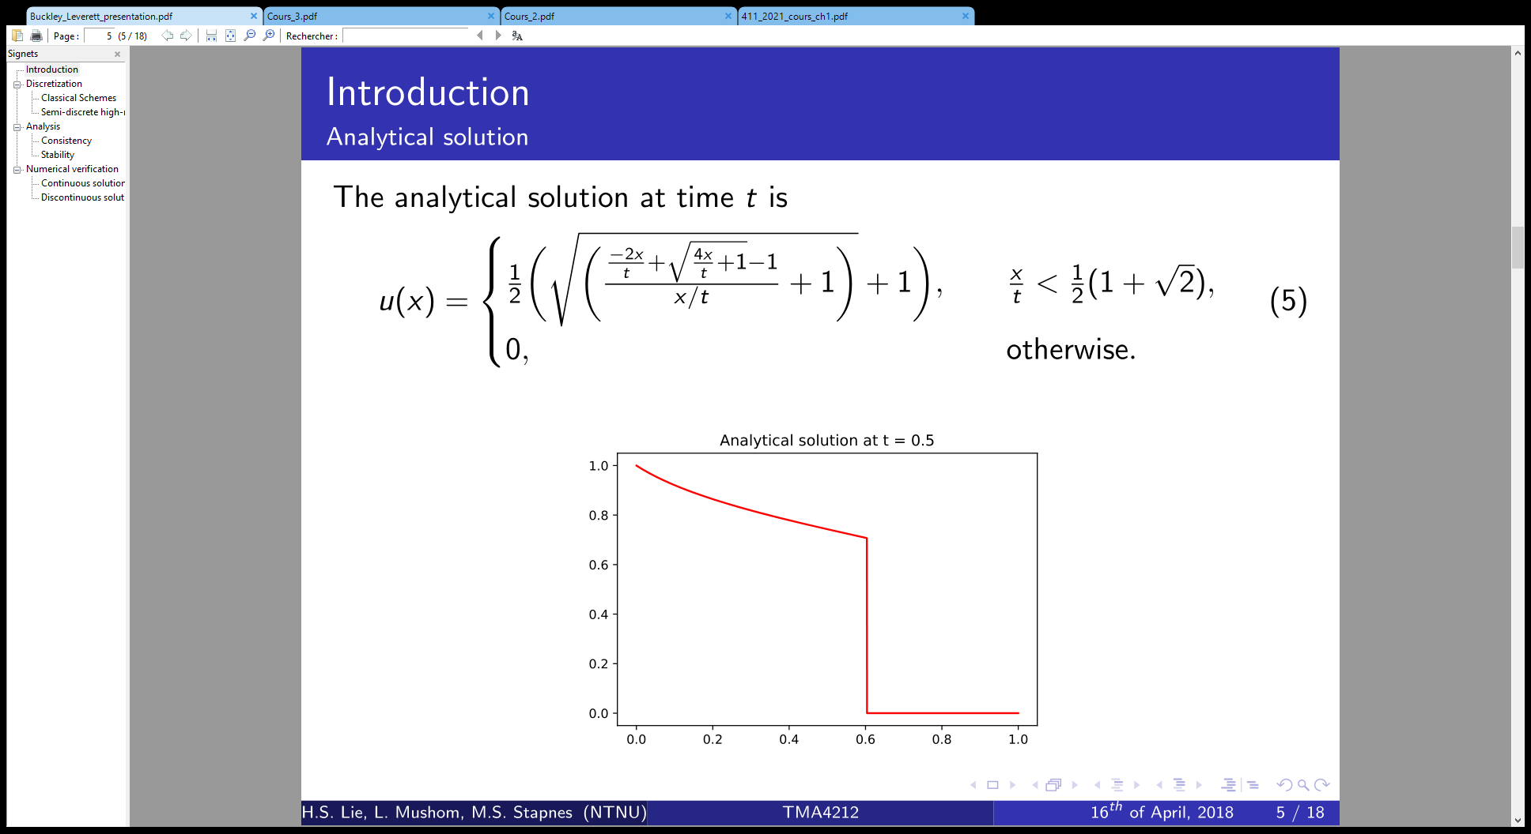

This is due to our choice of the experimental function. For a better accuracy, we switch to the quadratic choice, that is to say . We obtain a better accuracy 30s after the sand start to do his way to the wetted phase :

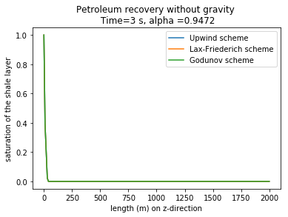 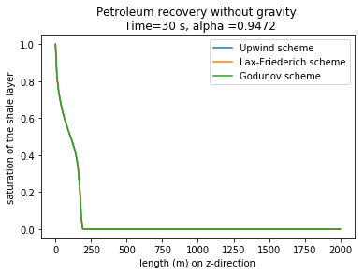

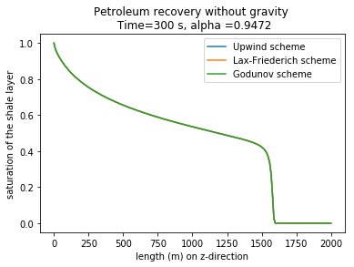

At time T = 3s, the variation of the saturation is so low that both linear and quadratic choice gives the same result. However, due to the strong value of the alpha, the saturation quickly increases through the depth in a very short time : already 40% of the fluid we want is already extracted at the half-deep after 3 minutes.

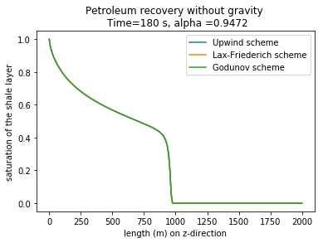

We observe the same effect in we revert back to the original value of alpha :

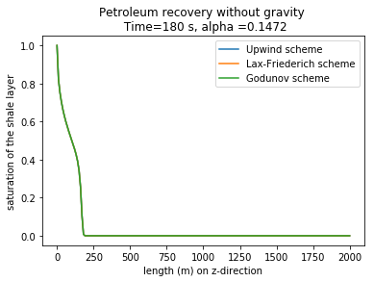

### Presence of gravity

In presence of gravity, we recall that the following terms are added :

* Porosity
* Permeability
* Density

In the scope of this report, we take 

We follow the same methodology as above : we first proceed with the linear choice of saturation. The precision of the solution is bad compared to the previous case. The Godunov scheme tends to be the most precise and accurate one to the analytical solution :

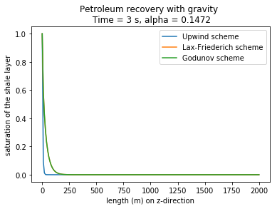 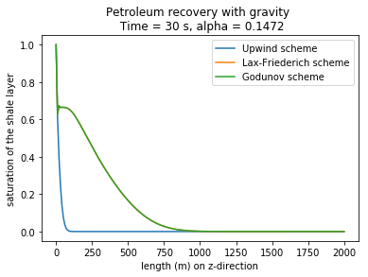

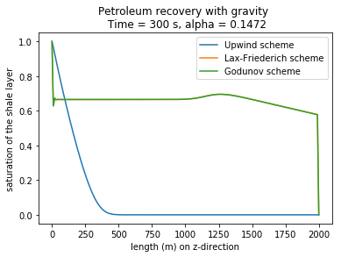

We can confirm that the choice of linear saturation is therefore not appropriated. To see the effect of alpha, we stop our study at time T = 30 s :

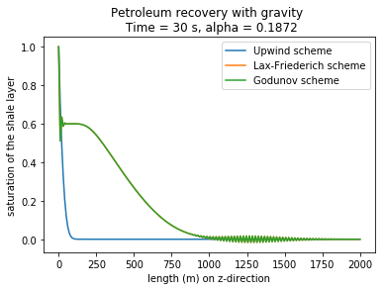

If we tend to increase just by a little the value of alpha, the Godunov is losing his accuracy, especially at the last meters where noise appends. Let us now revert to the original value of alpha and take the quadratic case :

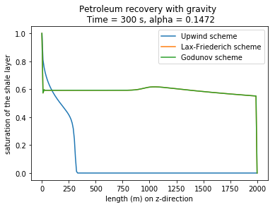

Without modifying the CFL condition, we arrive in an absurd situation where the upwind scheme is better than Godunov ! In order to correct this, we have to modify the *k* value. One must pay attention that the *k* variable is linked such that we obey to the CFL condition ! In order to still respect the maximum principle, we will take . Through this modification, we mathematically refine the space mesh in order to avoid the little “trap” observed with Godunov. It has been proved in the previous year that the upwind scheme remains unconditionally stable.

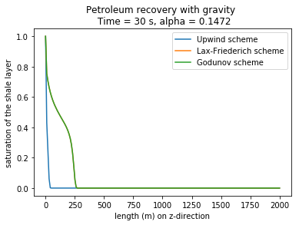

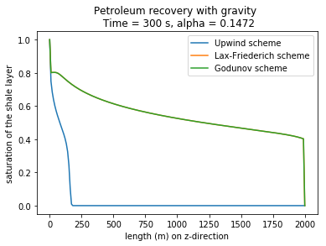

For time T = 3s, linear and quadratic choice still gives close results. It tends to confirm our observation that the saturation varies slowly only a few seconds after the wetting phase is making his way in depth :

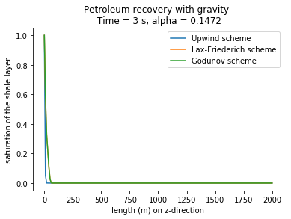

## Conclusion of the study case

Throughout this study, we have been able to see the effect of different data taken from the real world. The linear choice of saturation is shown to be only a “school” case to understand the influence of variables on the saturation. However, when we switch to quadratic case (rated as the most accurate one), we should correct some of our variables in order to have a coherent model ! Petroleum reservoir are not only present in India : the Arabic Golf is also largely coveted for his large reserve of oil :

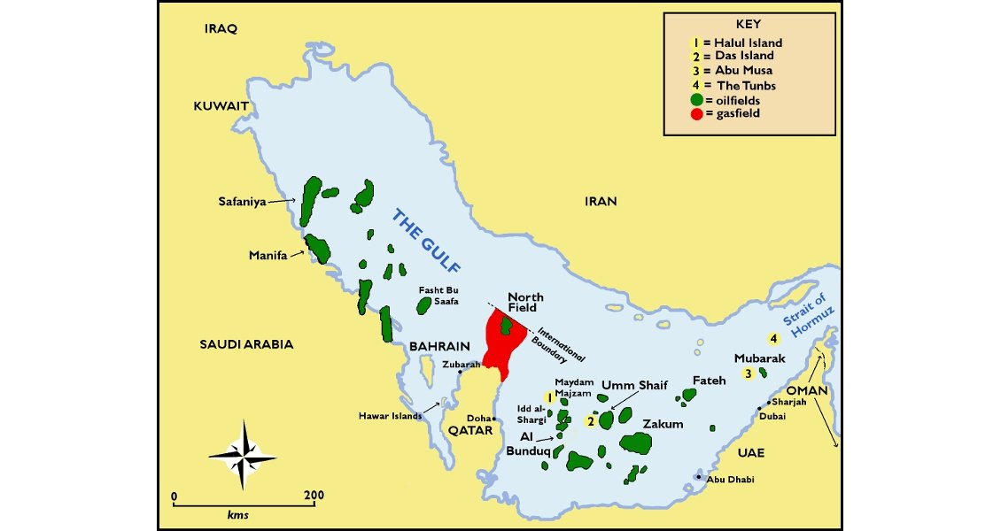

# Conclusion

The oil recovery process is known since the early age. One key question is to know the saturation of a wetting phase denoted “water” and reciprocally the saturation of the wetted phase denoted as “oil”. The goal is therefore to extract as much oil as we can using today technologies.

To know the saturation, we have to use a differential method based on parcel of fluids. We first assume that there is no source term, no capillary pressure, and no gravity. After using the mass conservation, we call the Darcy law (1856) which allow us to express the velocity of the fluid in function of the gradient of pression. We end up by obtaining a differential equation that satisfies the Buckley-Leverett scheme when we take smaller and smaller parcel. Such a differential equation cannot be solved analytically and requires the use of finite method, which implies to discretize equations. Adding gravity leads to consider porosity, permeability, and density.

In this field, we use the finite volume method. After meshing space into “control volume”, we integrate the Buckley-Leverett equation on each of those control volumes. Space and time step and make possible to express the saturation of each location (that is to say each control volume) at the next time in terms of the precedent saturations. It implies to introduce experimental given functions for the oil and water phase. However, we did not go through the finite element method as it is another theory which requires multiple partial differential equations, which is outside the scope of this report. In the end, we obtain a first numerical scheme which is called “Upwind”. Two other schemes are also coded : Lax-Friederichs and Godunov. The last one is reputed to be the most precise and robust algorithm.

For the purpose of discretization, we used “pedagogical” values. However, they do not represent the reality or have no physical meaning. Thus, we propose ourselves to perform a study case. The example of a petroleum reservoir in India shows the robustness and accuracy of Godunov scheme. We can also confirm that the quadratic choice of experimental function for oil and water is providing better accuracy to the analytical solutions than the linear case where . However, taking other values result sometimes in absurd case where Godunov tend to provide the “worst” solution while the upwind scheme remains unstable. We have to modify our variables to still adhere to the so-call CFL condition !

In the light of those “pedagogical” results, it comes that extraction of oil in a process that take time. Patience is necessary as could take hours and sometimes days to extract considerable amount of oil, as we saw in our simulation. The robustness and accuracy of numerical play then a major component for big compagnies like Total.

What has not been explored in this report is listed below :

* The variation of the depth of the petroleum reservoir : one could logically think that the lower the reservoir is, the fastest and the biggest the oil extracted will be.
* Lax-Wendorff : we implement Upwind, Lax-Friederichs and Godunov scheme. There is another scheme, as accurate as Lax-Friederichs, which allow us to plot the saturation in the same way as our implementation part. It could have been used to confirm his robustness
* Other experimental functions : only linear and quadratic choice of experimental has been explored in this report. Other choices could have been done, such as a hyperbolic choice. For example, 

# Bibliography and webography

Presence of petroleum reservoir in India : <https://www.pmfias.com/formation-petroleum-mineral-oil-distribution-india-on-shore-off-shore-oil-production-india/>

Different type of reservoir : <https://wiki.aapg.org/Petroleum_reservoir_fluid_properties>

A basic understanding of the theory of the petroleum reservoir simulation : <https://www.spe-aberdeen.org/wp-content/uploads/2018/06/Devex-2018-Introduction-to-Reservoir-Simulation.pdf>

Petroleum reservoir: <https://www.sciencedirect.com/topics/earth-and-planetary-sciences/petroleum-reservoir>

Oil resources: <https://www.nrcan.gc.ca/energy/energy-sources-distribution/crude-oil/oil-resources/18085>

Oil and petroleum products explained: <https://www.eia.gov/energyexplained/oil-and-petroleum-products/use-of-oil.php>

Fueling oil scarcity: <https://jia.sipa.columbia.edu/fueling-oil-scarcity-produced-scarcity-sociopolitical-fate-renewable-energy>

Importance of oil: [https://www.ukogplc.com/page.php?pID=74#:~:text=Oil%3A%20lifeblood%20of%20the%20industrialised,people%20all%20over%20the%20world](https://www.ukogplc.com/page.php?pID=74" \l ":~:text=Oil%3A%20lifeblood%20of%20the%20industrialised,people%20all%20over%20the%20world).

US oil reserves: <https://oilprice.com/Energy/Energy-General/US-Has-Worlds-Largest-Oil-Reserves.html>

Range of porosity : <https://www.sciencedirect.com/science/article/pii/B9780128182642000026>

Mineralogy of sandstones : <https://www.geological-digressions.com/mineralogy-of-sandstones-porosity-and-permeability/>

Density for our study case : <https://chem.libretexts.org/Bookshelves/Ancillary_Materials/Exemplars_and_Case_Studies/Exemplars/Geology/Density_of_Rocks_and_Soils>

P.A. Allen and J.R. Allen, *[Basin Analysis: Principles and Applications](https://www.wiley.com/en-us/Basin+Analysis%3A+Principles+and+Application+to+Petroleum+Play+Assessment%2C+3rd+Edition-p-9780470673768" \t "_blank)*. Blackwell 2005

Well Productivity Handbook, Boyun Guo, Kai Sun and Ali Ghalambor, 2008.