Corey Stewart Mentions Analysis

Georges Colbert

07/15/2018

# Period of July 08 to July 14

Our goal is to cover the conversations being had about the candidates across multiple platforms, interpret it and visualize the information in a way that can help drive decision making. The Graphs shown and metrics calculated are best estimation of what can be most useful to the candidate. Through a process of constant feedback between us and the campaign, the most relevant information will be identified and facilitate the creation of a personalized dashboard that the campaign can access 24/7. For now, multiple visualizations of the same information could be provided as we try to identify the best way for the campaign to retain the information and identify the KPIs amongst the myriad of metrics available.

In the case of Twitter, it is really fortunate that twitter provides an API on which developers can request an acquire a substantial amount of tweets from the previous ten days before the API call.

For more information on the twitter API the link is:

<https://developer.twitter.com/en/docs/tweets/search/api-reference/get-search-tweets.html>

To facilitate the process of Data mining the tweets, here’s a list of packages used:

* [TwitteR Package](https://cran.r-project.org/web/packages/twitteR/twitteR.pdf)
* [TM package](https://cran.r-project.org/web/packages/tm/index.html)
* [ggplot2 package](https://cran.r-project.org/web/packages/ggplot2/index.html)
* [wordcloud package](https://cran.r-project.org/web/packages/wordcloud/wordcloud.pdf)
* [SnowballC package](https://cran.r-project.org/web/packages/SnowballC/SnowballC.pdf)
* [SentimentR package](https://cran.r-project.org/web/packages/sentimentr/sentimentr.pdf)

For this analysis, a request was made to the API for up to 30,000 tweets that mentioned either "Corey Stewart" or "@CoreyStewartVA" covering the period of July 08-July 14. All the tweets returned by the API are in the zip folder.

**OVERVIEW**

# Total Number of tweets

## [1] 4495

# Time-Series of Tweets Per Day

##   
## Attaching package: 'scales'

## The following object is masked from 'package:readr':  
##   
## col_factor

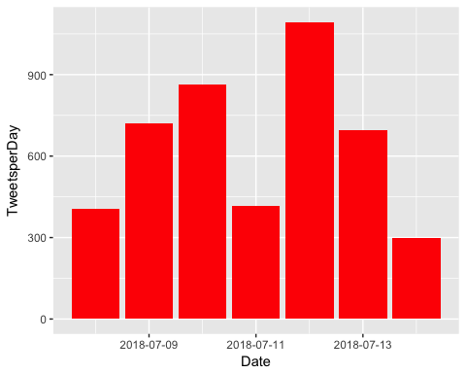

# How many are retweets?

##### How many are retweets?  
   
 table(VA.tweetdf$isRetweet)

##   
## FALSE TRUE   
## 1480 3015

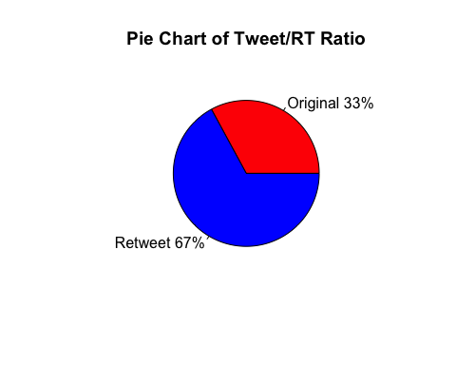**ENGAGEMENT**

Engagement is a measurement of how people on the platform are interacting with the candidate's profile. Tracking engagement allows the campaign to assess how intensively are potential voters discussing or following the candidate, and identify which topics/tweets are "riling the base" by comparing popular tweets to ones that are less so. As a Measure of direct engagement, here is a time series graph created with the ggplot2 package that shows, per day, how often people tweeted direct replies to one of the Candidates tweets.

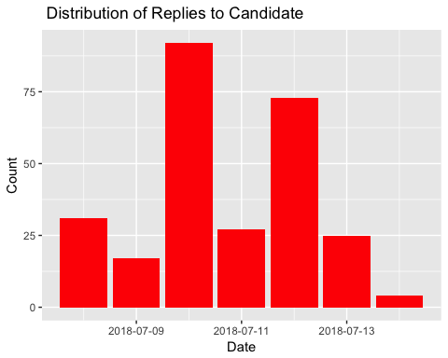

As another form of engagement, here is a breakdown of how many Favorable engagements(RT and Favs) did the candidate accumulate per day for every day that he/she tweeted.

# Fav/RT per Day

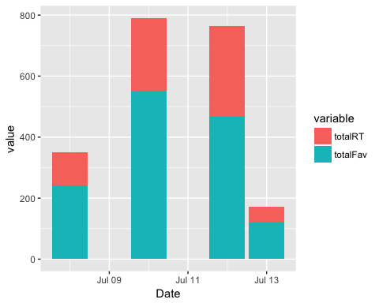

It helps to track which tweets are the most popular, both from the candidate's account and from third party accounts, as a way to understand which points/topics people are engaging the most favorably with. When printed, the tweets may be truncated. To see the full tweet, follow the ([https://](NULL)...) link at the end of the tweet.

Note: It might be helpful to look up these third-party accounts that sent out such popular tweets, as a way to identify potential allies that motivate other voters or share links for fundraising, or as a way to monitor detractors that may be spreading false/malicious points about the candidate.

### list of top 6 favorite tweets by the candidate

## text  
## 1 Check out our new ad: Kaine attended an "Abolish ICE" rally on June 30 and has done nothing in D.C. but raise taxes… https://t.co/lrN6xz7oWM  
## 2 Tonight, President Trump took another bold step toward restoring constitutional govt by selecting Brett Kavanaugh f… https://t.co/a7aMt6ZnWk  
## 3 .@realDonaldTrump has brought America's economy back. \n\n&gt;Econ Growth is at 4%. \n&gt;Unemployment is at its lowest in 1… https://t.co/k5R0FN1yyp  
## 4 The #ViolentLeft throws a tantrum at the slightest perceived offense. \n\nIt is not good for our Commonwealth or our… https://t.co/ZkVIE63JO9  
## 5 #FakeNews media used to love the "pay their fair share" line.\n\nNow @realdonaldTrump pushes the EU to help pay for N… https://t.co/6nwiHLWnYU  
## 6 Americans want SCOTUS to defend our Constitutional Rights, not advance @timkaine's radical, out-of-touch leftwing a… https://t.co/UQMP50GxRJ  
## favoriteCount created screenName  
## 1 466 2018-07-12 02:52:09 CoreyStewartVA  
## 2 262 2018-07-10 01:40:39 CoreyStewartVA  
## 3 241 2018-07-08 16:37:45 CoreyStewartVA  
## 4 172 2018-07-10 15:05:48 CoreyStewartVA  
## 5 121 2018-07-13 15:40:13 CoreyStewartVA  
## 6 117 2018-07-10 19:02:31 CoreyStewartVA

## other than from candidate's account, most favorited

## text  
## 1 .@kasie - If you're trying to ensure I never tune in again, opening your show with Alan Dershowitz after having Cor… https://t.co/jVe0SJ3srP  
## 2 The Virginia GOP is in free fall. My report on the slow decline of the Republican party in my home state over the l… https://t.co/XywQ6VSXbC  
## 3 HOW DARE @ADL_National accuse @CoreyStewartVA of being a white supremacist &amp; Anti-Semite! \n\nCorey &amp; his wife are be… https://t.co/iumPBqXyh5  
## 4 NC - Russell Walker, white supremacist\n\nILL- Arthur Jones, American Nazi Party Member\n\nVA -Corey Stewart, white sup… https://t.co/HfKlDhnPbD  
## 5 The ADL is a fake Jewish organization and they don’t care about Jewish people.\n\nThey are completely in bed with the… https://t.co/ov6GEu4P9L  
## 6 "At some point, it stops being ‘Never Trump,’ and it stops being ‘Never Corey,’ and it starts being ‘Never Republic… https://t.co/ap8fdMCir6  
## favoriteCount created screenName  
## 1 1617 2018-07-09 00:14:15 HoarseWisperer  
## 2 413 2018-07-12 17:36:46 xan_desanctis  
## 3 366 2018-07-13 23:14:27 LauraLoomer  
## 4 351 2018-07-09 16:56:55 MaggieJordanACN  
## 5 247 2018-07-14 00:07:47 LauraLoomer  
## 6 243 2018-07-13 14:05:27 MichaelRWarren

# top 6 retweeted tweets

## text  
## 1 RT @realDonaldTrump: Thank you to all of my great supporters, really big progress being made. Other countries wanting to fix crazy trade de…  
## 2 RT @realDonaldTrump: Thank you to all of my great supporters, really big progress being made. Other countries wanting to fix crazy trade de…  
## 3 Check out our new ad: Kaine attended an "Abolish ICE" rally on June 30 and has done nothing in D.C. but raise taxes… https://t.co/lrN6xz7oWM  
## 4 .@realDonaldTrump has brought America's economy back. \n\n&gt;Econ Growth is at 4%. \n&gt;Unemployment is at its lowest in 1… https://t.co/k5R0FN1yyp  
## 5 Tonight, President Trump took another bold step toward restoring constitutional govt by selecting Brett Kavanaugh f… https://t.co/a7aMt6ZnWk  
## 6 The #ViolentLeft throws a tantrum at the slightest perceived offense. \n\nIt is not good for our Commonwealth or our… https://t.co/ZkVIE63JO9  
## retweetCount created screenName  
## 1 25600 2018-07-10 18:52:35 CoreyStewartVA  
## 2 25597 2018-07-10 18:52:35 CoreyStewartVA  
## 3 297 2018-07-12 02:52:09 CoreyStewartVA  
## 4 108 2018-07-08 16:37:45 CoreyStewartVA  
## 5 105 2018-07-10 01:40:39 CoreyStewartVA  
## 6 74 2018-07-10 15:05:48 CoreyStewartVA

# top 6 retweeted tweet Not including candidate

## text  
## 1 NC - Russell Walker, white supremacist\n\nILL- Arthur Jones, American Nazi Party Member\n\nVA -Corey Stewart, white sup… https://t.co/HfKlDhnPbD  
## 2 .@kasie - If you're trying to ensure I never tune in again, opening your show with Alan Dershowitz after having Cor… https://t.co/jVe0SJ3srP  
## 3 The Virginia GOP is in free fall. My report on the slow decline of the Republican party in my home state over the l… https://t.co/XywQ6VSXbC  
## 4 HOW DARE @ADL_National accuse @CoreyStewartVA of being a white supremacist &amp; Anti-Semite! \n\nCorey &amp; his wife are be… https://t.co/iumPBqXyh5  
## 5 It is Shabbat, &amp; even during Shabbat, Hamas terrorists in Gaza are firing rockets into Southern Israel. An IDF sold… https://t.co/FUoJuWjiE6  
## 6 The ADL is a fake Jewish organization and they don’t care about Jewish people.\n\nThey are completely in bed with the… https://t.co/ov6GEu4P9L  
## retweetCount created screenName  
## 1 440 2018-07-09 16:56:55 MaggieJordanACN  
## 2 253 2018-07-09 00:14:15 HoarseWisperer  
## 3 199 2018-07-12 17:36:46 xan_desanctis  
## 4 177 2018-07-13 23:14:27 LauraLoomer  
## 5 113 2018-07-13 23:58:22 LauraLoomer  
## 6 94 2018-07-14 00:07:47 LauraLoomer

### Top ten retweets overall

In this case, there were tweets that were creeated before the designated period that were still being shared on Twitter and accumulating retweets.

## text  
## 1 RT @realDonaldTrump: Thank you to all of my great supporters, really big progress being made. Other countries wanting to fix crazy trade de…  
## 2 RT @realDonaldTrump: Congratulations to Corey Stewart for his great victory for Senator from Virginia. Now he runs against a total stiff, T…  
## 3 RT @ikebarinholtz: Just so we're clear Donald Trump is supporting Corey Stewart who is a Neo-Confederate white supremacist which means you…  
## 4 RT @BillKristol: Corey Stewart wins in Virginia.\nSteve King retweets a neo-Nazi.\nPaul Ryan undercuts a DACA solution.\nMitch McConnell won't…  
## 5 RT @brianschatz: If you are not for Corey Stewart you should say so. If you are not for separating kids from their families you should join…  
## 6 RT @DisavowTrump20: BREAKING: Far-right Trump supporter and champion of the confederate flag Corey Stewart has won the GOP nomination for t…  
## 7 RT @bIazingxmexican: List of white supremacists running for office:\nArthur Jones in Illinois.\nJoe Arpaio in Arizona. \nCorey Stewart in Virg…  
## 8 RT @DisavowTrump20: Chris Cuomo just completely destroyed racist bigot and Virginia GOP Senate candidate Corey Stewart and would not let hi…  
## 9 RT @TheLeadCNN: Corey Stewart, the man who built his image on championing Confederate symbols and made joint appearances with the white nat…  
## 10 RT @funder: BREAKING: Senator Tim Kaine’s opponent Corey Stewart is now under investigation @TheDemCoalition. Help fund our research team b…  
## retweetCount created screenName isRetweet  
## 1 25600 2018-07-10 18:52:35 CoreyStewartVA TRUE  
## 2 16303 2018-07-13 03:23:28 iaalrogmom TRUE  
## 3 5763 2018-07-13 14:58:31 KimBrowning2 TRUE  
## 4 4502 2018-07-10 16:12:18 bithead2001 TRUE  
## 5 4209 2018-07-11 19:10:18 JohnKato1956 TRUE  
## 6 3812 2018-07-14 05:18:13 AntibanterKraky TRUE  
## 7 3407 2018-07-12 03:26:28 bearfootncrazy TRUE  
## 8 2157 2018-07-08 23:12:09 arturo_stein TRUE  
## 9 1814 2018-07-08 03:31:02 mybellmichell TRUE  
## 10 1299 2018-07-10 01:35:53 JimmyV08070562 TRUE

## accounts that have the most total Retweets

## screenName x  
## 158 CoreyStewartVA 696  
## 467 MaggieJordanACN 440  
## 440 LauraLoomer 384  
## 306 HoarseWisperer 253  
## 844 xan_desanctis 200  
## 811 vademocrats 139

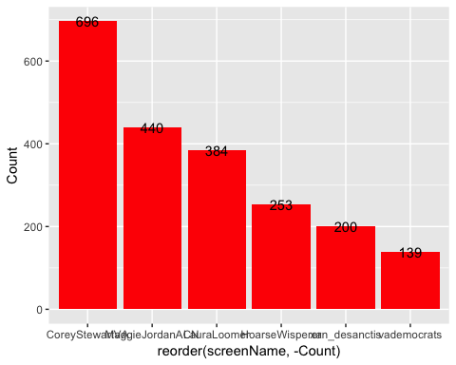

## Most Active Accounts (including Retweets)

## Var1 Freq  
## 2401 QueenBoo 38  
## 1415 jim_beau_mtb 32  
## 73 AdamJeromeGrump 19  
## 134 amayalindsey 19  
## 1266 IlIlIlIlIl7 18  
## 3281 youcnbmywingman 18

## Most Active Accounts

## Var1 Freq  
## 636 QueenBoo 28  
## 370 jim_beau_mtb 25  
## 21 AdamJeromeGrump 19  
## 324 IlIlIlIlIl7 18  
## 612 pinkpassion2 16  
## 36 amayalindsey 14

**TEXT MINING**

What are people saying? The goal is to capture what words are being used to describe the candidate. We expect this section to be the one of the most interesting, as the team's NLP capabilities get better we expect this section to expand.

# WORDCLOUD of most common used words (Top 300)

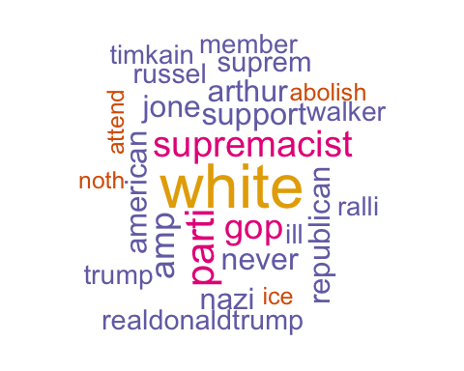

# List of The Top 15 Frequently used Words

## word freq  
## white white 1064  
## parti parti 643  
## supremacist supremacist 575  
## gop gop 540  
## amp amp 526  
## support support 468  
## never never 458  
## arthur arthur 453  
## jone jone 453  
## american american 442  
## republican republican 440  
## nazi nazi 439  
## suprem suprem 408  
## realdonaldtrump realdonaldtrump 398  
## russel russel 392

# Plot of Words that Appear at least 400 times

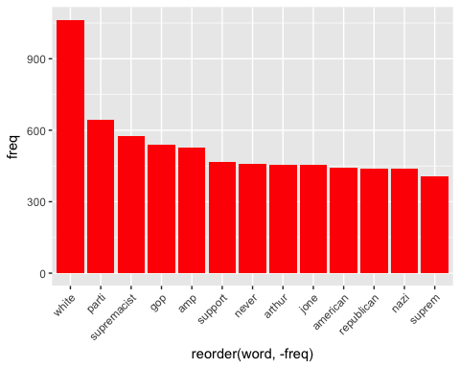

## Words Association

To find out what words are associated with the candidates, I use a function called FindAssocs() on the dataset. For any given word, findAssocs() calculates its correlation with every other word in the dataset. Scores range from 0 to 1. A score of 1 means that two words always appear together, while a score of 0 means that they never appear together.

# which words are associated with "tim", "kaine", or "timkaine", "corey","stewart" or "coreystewartva"

## $tim  
## bash bigleaguepol kain politifact race   
## 0.53 0.47 0.46 0.34 0.32   
## rid patrol wvjoe abolish ice   
## 0.27 0.26 0.23 0.22 0.22   
## kai chrismo maganinajo parscal scottpresl   
## 0.21 0.21 0.21 0.21 0.21   
## pant border via csaever antif   
## 0.21 0.20 0.19 0.19 0.19   
## zenonichol rate knowledg doe madasednam   
## 0.19 0.18 0.18 0.17 0.17   
## transplant countycounti map matt antitrumpmvmt   
## 0.17 0.17 0.17 0.17 0.17   
## chanc smart reelect senat attend   
## 0.16 0.16 0.16 0.15 0.15   
## claim idiot integr unapologet retir   
## 0.15 0.15 0.15 0.15 0.15   
## water updat unequivoc chaznuttycomb ralli   
## 0.15 0.15 0.15 0.15 0.13   
## promis stewart win said deplorablemo   
## 0.13 0.12 0.12 0.12 0.12   
## joke swamp flip iwillredpillu trumpback   
## 0.12 0.12 0.12 0.12 0.12   
## alecmacgilli brianefallon excit fallon jmartnyt   
## 0.12 0.12 0.12 0.12 0.12   
## agress primari someon poll final   
## 0.12 0.11 0.11 0.11 0.10

## $kain  
## abolish ice attend check june   
## 0.81 0.81 0.79 0.74 0.74   
## new done rais ralli tax   
## 0.73 0.73 0.73 0.72 0.71   
## noth tim bash tom bigleaguepol   
## 0.68 0.46 0.27 0.24 0.24   
## coreystewartva ellaaacruzzz front biker hillari   
## 0.23 0.23 0.23 0.21 0.19   
## politifact protest hen red race   
## 0.17 0.15 0.14 0.14 0.14   
## patrol wvjoe chrismo maganinajo parscal   
## 0.13 0.12 0.11 0.11 0.11   
## scottpresl pant   
## 0.11 0.11

## $timkain  
## radic defend advanc agend   
## 0.39 0.38 0.37 0.37   
## leftw touch constitut scotus   
## 0.37 0.37 0.36 0.36   
## coreystewartva want right brerva   
## 0.35 0.26 0.26 0.21   
## johnreason robertcd fightingveteran esquir   
## 0.19 0.19 0.18 0.18   
## markwarn face islam karenshavoc   
## 0.17 0.16 0.16 0.16   
## realdonaldtrump dis clinton joshuarosen   
## 0.15 0.15 0.14 0.14   
## jdjc democrathitjob toler jail   
## 0.14 0.14 0.14 0.14   
## vote senat senschum tie   
## 0.13 0.13 0.13 0.13   
## has justinhendrix realjameswood boadkinsbvva   
## 0.13 0.13 0.13 0.12   
## economi inherit obama indivis   
## 0.12 0.12 0.11 0.11   
## vabeachdem terrymcauliff aca econom   
## 0.11 0.11 0.11 0.11   
## lesliecockburn elaineluriava truecinzia caramastrey   
## 0.10 0.10 0.10 0.10   
## cap text ginatrump inna   
## 0.10 0.10 0.10 0.10   
## yea pack   
## 0.10 0.10

## $corey  
## stewart supremacist white russel   
## 0.76 0.45 0.41 0.39   
## walker member maggiejordanacn ill   
## 0.38 0.37 0.37 0.36   
## arthur jone suprem american   
## 0.35 0.35 0.33 0.31   
## nazi ensur alan dershowitz   
## 0.31 0.29 0.29 0.29   
## hoarsewisper kasi tune tri   
## 0.29 0.29 0.29 0.28   
## never show open trump   
## 0.27 0.26 0.26 0.24   
## accus dare wife antisemit   
## 0.23 0.23 0.23 0.22   
## beauti result crackdown how   
## 0.22 0.20 0.20 0.19   
## candid child parti adlnat   
## 0.19 0.19 0.18 0.17   
## separ amp washingtonpost after   
## 0.17 0.15 0.15 0.15   
## michaelrwarren talbertswan confeder embrac   
## 0.15 0.15 0.14 0.14   
## legaci start histori cjane   
## 0.14 0.13 0.13 0.13   
## stop celebr alongsid alleg   
## 0.12 0.12 0.12 0.12   
## virginia hillari endors unit   
## 0.11 0.11 0.11 0.11   
## nomine reject lean proconfeder   
## 0.11 0.11 0.11 0.11   
## texantruth bash whit bigleaguepol   
## 0.11 0.11 0.10 0.10

## $stewart  
## corey russel walker member   
## 0.76 0.49 0.49 0.48   
## maggiejordanacn ill arthur jone   
## 0.48 0.47 0.46 0.46   
## suprem white american nazi   
## 0.44 0.42 0.41 0.41   
## supremacist parti candid crackdown   
## 0.37 0.29 0.27 0.26   
## child result separ trump   
## 0.25 0.25 0.23 0.22   
## washingtonpost after talbertswan confeder   
## 0.20 0.20 0.19 0.18   
## embrac legaci histori celebr   
## 0.18 0.18 0.17 0.16   
## cjane virginia alongsid nomine   
## 0.16 0.15 0.15 0.15   
## bash alleg hillari endors   
## 0.15 0.15 0.14 0.14   
## race lean proconfeder texantruth   
## 0.14 0.14 0.14 0.14   
## support unit paul reject   
## 0.13 0.13 0.13 0.13   
## whit bigleaguepol headlin say   
## 0.13 0.13 0.13 0.12   
## altright red tim protest   
## 0.12 0.12 0.12 0.12   
## ellaaacruzzz front dunk jerrydunleavi   
## 0.12 0.12 0.12 0.12   
## time hen tom biker   
## 0.11 0.11 0.11 0.11   
## nehlen king comment donald   
## 0.11 0.11 0.11 0.11   
## neoconfeder raci dineshdsouza nehlan   
## 0.10 0.10 0.10 0.10   
## lead ikebarinholtz   
## 0.10 0.10

## $coreystewartva  
## timkain check done june   
## 0.35 0.33 0.33 0.33   
## rais ralli tax new   
## 0.33 0.33 0.33 0.31   
## noth attend realdonaldtrump adlnat   
## 0.30 0.29 0.28 0.27   
## abolish ice accus beauti   
## 0.27 0.27 0.24 0.24   
## dare wife antisemit kain   
## 0.24 0.24 0.23 0.23   
## how amp constitut defend   
## 0.22 0.16 0.16 0.16   
## advanc agend leftw radic   
## 0.15 0.15 0.15 0.15   
## touch scotus justinhendrix violent   
## 0.15 0.14 0.14 0.12   
## lauraloom right denverva vabeachdem   
## 0.11 0.11 0.10 0.10   
## charlottesvil   
## 0.10

**Sentiment Analysis**

Using the (SentimentR) package, every tweet is scored to assess whether they are negative, positive or neutral. The algorithm estimates how negative or positive a tweet is based on the words and punctuation.

# WorldCloud of words used in top 1000 most negative and top 1000 most positive tweets

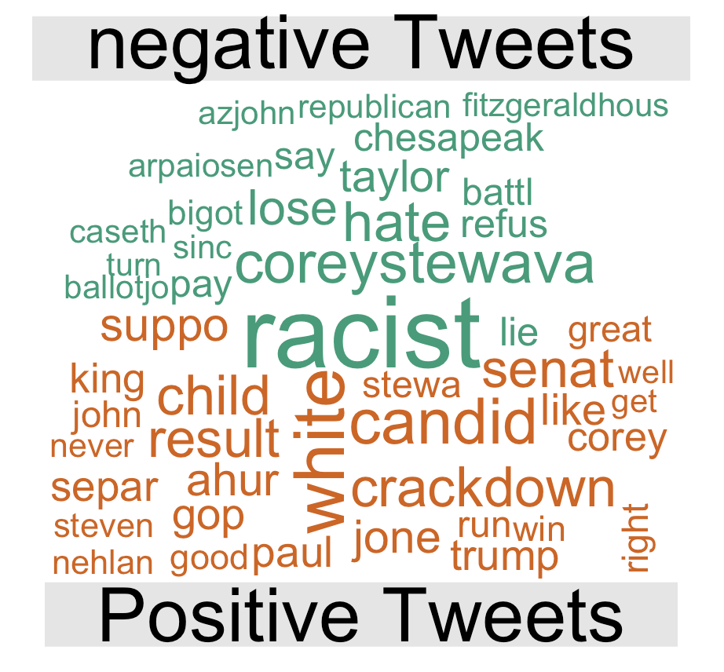

**Note: The WordCloud indicates which words were most common amongst the positive and negative tweets, it’s not stating if these words themselves are positive or negative.**

