## Loading required package: RColorBrewer

## Loading required package: NLP

##   
## Attaching package: 'dplyr'

## The following objects are masked from 'package:twitteR':  
##   
## id, location

## The following objects are masked from 'package:stats':  
##   
## filter, lag

## The following objects are masked from 'package:base':  
##   
## intersect, setdiff, setequal, union

##   
## Attaching package: 'ggplot2'

## The following object is masked from 'package:NLP':  
##   
## annotate

##   
## Attaching package: 'rtweet'

## The following object is masked from 'package:twitteR':  
##   
## lookup_statuses

## Warning: Missing column names filled in: 'X1' [1]

## Parsed with column specification:  
## cols(  
## X1 = col_integer(),  
## text = col_character(),  
## favorited = col_logical(),  
## favoriteCount = col_integer(),  
## replyToSN = col_character(),  
## created = col_datetime(format = ""),  
## truncated = col_logical(),  
## replyToSID = col_double(),  
## id = col_double(),  
## replyToUID = col_double(),  
## statusSource = col_character(),  
## screenName = col_character(),  
## retweetCount = col_integer(),  
## isRetweet = col_logical(),  
## retweeted = col_logical(),  
## longitude = col_character(),  
## latitude = col_character()  
## )

Our goal is to cover the conversations being had about the candidates across multiple platforms, interpret it and visualize the information in a way that can help drive decision making. The Graphs shown and metrics calculated are best estimation of what can be most useful to the candidate. Through a process of constant feedback between us and the campaign, the most relevant information will be identified and facilitate the creation of a personalized dashboard that the campaign can access 24/7. For now, multiple visualizations of the same information could be provided as we try to identify the best way for the campaign to retain the information and identify the KPIs amongst the myriad of metrics available.

In the case of Twitter, it is really fortunate that twitter provides an api on which developers can request an acquire a substantial amount of tweets from the previous ten days before the API call.  
For more information on the twitter API the link is: <https://developer.twitter.com/en/docs/tweets/search/api-reference/get-search-tweets.html> To facilitate the process of Data mining the tweets, here's a list of packages used: - TwitteR Package - TM package - ggplot2 package - wordcloud package - SnowballC package - SentimentR package

For this analysis, a request was made to the API for up to 30,000 tweets that mentioned either "Corey Stewart" or "@CoreyStewartVA" covering the period of July 16-July 22. All the tweets returned by the API are in the zip folder. OVERVIEW

# Total Number of tweets

## [1] 23301

# Time-Series of Tweets Per Day

##   
## Attaching package: 'scales'

## The following object is masked from 'package:readr':  
##   
## col_factor

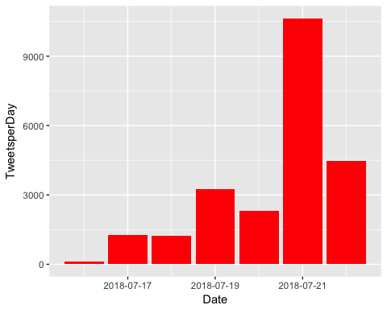

# How many are retweets?

##### How many are retweets?  
   
 table(VA.tweetdf$isRetweet)

##   
## FALSE TRUE   
## 4993 18308

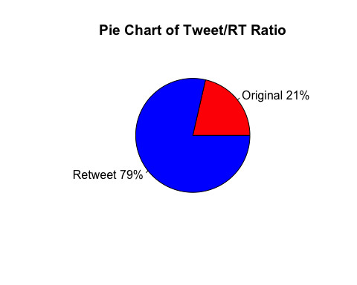 ENGAGEMENT

Engagement is a measurement of how people on the platform are interacting with the candidate's profile. Tracking engagement allows the campaign to assess how intensively are potential voters discussing or following the candidate, and identify which topics/tweets are "riling the base" by comparing popular tweets to ones that are less so. As a Measure of direct engagement, here is a time series graph created with the ggplot2 package that shows, per day, how often people tweeted direct replies to one of the Candidates tweets.

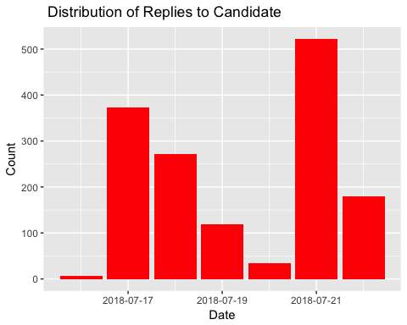

As another form of engagement, here is a breakdown of how many Favorable engagements(RT and Favs) did the candidate accumulate per day for every day that he/she tweeted.

# Fav/RT per Day

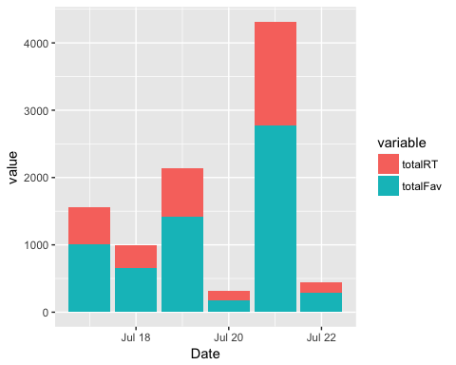

It helps to track which tweets are the most popular, both from the candidate's account and from third party accounts, as a way to understand which points/topics people are engaging the most favorably with. When printed, the tweets may be truncated. To see the full tweet, follow the ([https://](NULL)...) link at the end of the tweet.

Note: It might be helpful to look up these third-party accounts that sent out such popular tweets, as a way to identify potential allies that motivate other voters or share links for fundraising, or as a way to monitor detractors that may be spreading false/malicious points about the candidate.

### list of top 6 favorite tweets by the candidate

## text  
## 1 Leftists during Bush: "Intel Community Lied to take the U.S. into Iraq!"\n\nLeftists now: "How could anyone ever doub… https://t.co/loxsv32KEZ  
## 2 If the U.S. can't even trust Putin enough to have a talk with him, why did Barack's and Hillary's regime sell Putin… https://t.co/EDoE0Gnf28  
## 3 Check out our discussion of the issues at the #VBADebate today for #VASen. \n\nTim Kaine is weak, Liberal, and he's g… https://t.co/JQlWq8DQMS  
## 4 .@timkaine was first Governor in Virginia's modern history to leave office with a budget that had less revenue than… https://t.co/Krtl1wb3oK  
## 5 .@timkaine and his liberal pals used to claim to want peace with fellow nations of the world. \n\nNow it seems they w… https://t.co/0N8CH4sS82  
## 6 .@timkaine is too weak, too liberal, and has done too little for Virginia. \n\nWe need less crime, to crackdown on il… https://t.co/muiT5VzZRN  
## favoriteCount created screenName  
## 1 1411 2018-07-19 02:13:09 CoreyStewartVA  
## 2 1006 2018-07-17 13:28:23 CoreyStewartVA  
## 3 336 2018-07-21 18:30:57 CoreyStewartVA  
## 4 295 2018-07-22 18:02:44 CoreyStewartVA  
## 5 292 2018-07-21 16:29:48 CoreyStewartVA  
## 6 236 2018-07-21 15:13:59 CoreyStewartVA

## other than from candidate's account, most favorited

## text  
## 1 Debate Audience Erupts in Laughter After Republican Corey Stewart Says Trump “is standing up to the Russians.”\n\nhttps://t.co/vSuqxZtsiH  
## 2 Corey Stewart, who campaigned for Senate candidate Roy Moore in AL, won't renounce him, defends him on the underage… https://t.co/iErDDTuMcf  
## 3 Neo-confederate Republican Corey Stewart gets laughed at by Tim Kaine and the entire audience at the #VASen debate… https://t.co/BmR6V9Vn50  
## 4 Tim Kaine in Senate debate with Corey Stewart: "I live by my church's teachings. But I don't think my job as an ele… https://t.co/O30rCLbidv  
## 5 Kaine challenger prompts laughter by saying Trump is 'standing up' to Russia https://t.co/xkWC5luG5z  
## 6 JUST IN: Police and a Prince William County magistrate have opened an investigation into New York Times reporter St… https://t.co/ef9hW3Xal2  
## favoriteCount created screenName  
## 1 3288 2018-07-22 05:54:19 politvidchannel  
## 2 2129 2018-07-21 16:05:22 LarrySabato  
## 3 1992 2018-07-21 17:51:25 adamcbest  
## 4 1750 2018-07-21 15:40:27 sagewarner_  
## 5 1724 2018-07-21 18:50:58 Bencjacobs  
## 6 772 2018-07-19 01:28:59 BreakingNLive

# top 6 retweeted tweets

## text  
## 1 RT @Jim_Jordan: A year and a half with President Trump:\n\n-Lower taxes\n-Reduced regs\n-Unemployment down\n-Economy growing\n-Gorsuch on the Cou…  
## 2 RT @realDonaldTrump: 3.4 million jobs created since our great Election Victory - far greater than ever anticipated, and only getting better…  
## 3 RT @realDonaldTrump: Received many calls from leaders of NATO countries thanking me for helping to bring them together and to get them focu…  
## 4 RT @jasoninthehouse: The face of the Democratic Party https://t.co/5gY4mz4EsR  
## 5 Leftists during Bush: "Intel Community Lied to take the U.S. into Iraq!"\n\nLeftists now: "How could anyone ever doub… https://t.co/loxsv32KEZ  
## 6 If the U.S. can't even trust Putin enough to have a talk with him, why did Barack's and Hillary's regime sell Putin… https://t.co/EDoE0Gnf28  
## retweetCount created screenName  
## 1 24844 2018-07-18 14:58:13 CoreyStewartVA  
## 2 22948 2018-07-18 14:58:56 CoreyStewartVA  
## 3 21862 2018-07-16 14:51:31 CoreyStewartVA  
## 4 1505 2018-07-16 15:43:39 CoreyStewartVA  
## 5 728 2018-07-19 02:13:09 CoreyStewartVA  
## 6 551 2018-07-17 13:28:23 CoreyStewartVA

# top 6 retweeted tweet Not including candidate

## text  
## 1 Debate Audience Erupts in Laughter After Republican Corey Stewart Says Trump “is standing up to the Russians.”\n\nhttps://t.co/vSuqxZtsiH  
## 2 Neo-confederate Republican Corey Stewart gets laughed at by Tim Kaine and the entire audience at the #VASen debate… https://t.co/BmR6V9Vn50  
## 3 Corey Stewart, who campaigned for Senate candidate Roy Moore in AL, won't renounce him, defends him on the underage… https://t.co/iErDDTuMcf  
## 4 Kaine challenger prompts laughter by saying Trump is 'standing up' to Russia https://t.co/xkWC5luG5z  
## 5 JUST IN: Police and a Prince William County magistrate have opened an investigation into New York Times reporter St… https://t.co/ef9hW3Xal2  
## 6 Tim Kaine in Senate debate with Corey Stewart: "I live by my church's teachings. But I don't think my job as an ele… https://t.co/O30rCLbidv  
## retweetCount created screenName  
## 1 1705 2018-07-22 05:54:19 politvidchannel  
## 2 1102 2018-07-21 17:51:25 adamcbest  
## 3 660 2018-07-21 16:05:22 LarrySabato  
## 4 572 2018-07-21 18:50:58 Bencjacobs  
## 5 474 2018-07-19 01:28:59 BreakingNLive  
## 6 414 2018-07-21 15:40:27 sagewarner_

### Top ten retweets overall

In this case, there were tweets that were creeated before the designated period that were still being shared on Twitter and accumulating retweets.

## text  
## 1 RT @Jim_Jordan: A year and a half with President Trump:\n\n-Lower taxes\n-Reduced regs\n-Unemployment down\n-Economy growing\n-Gorsuch on the Cou…  
## 2 RT @realDonaldTrump: 3.4 million jobs created since our great Election Victory - far greater than ever anticipated, and only getting better…  
## 3 RT @realDonaldTrump: Received many calls from leaders of NATO countries thanking me for helping to bring them together and to get them focu…  
## 4 RT @realDonaldTrump: Congratulations to Corey Stewart for his great victory for Senator from Virginia. Now he runs against a total stiff, T…  
## 5 RT @CoreyStewartVA: I am running for U.S. Senate to defeat @timkaine - Join the movement. https://t.co/HXPdTRFsHM #DefeatKaine  
## 6 RT @DisavowTrump20: BREAKING: Far-right Trump supporter and champion of the confederate flag Corey Stewart has won the GOP nomination for t…  
## 7 RT @RVAwonk: A reminder: Former Trump campaign manager Corey Lewandowski approved of Carter Page’s trip to Moscow in July 2016 — i.e., smac…  
## 8 RT @politvidchannel: Debate Audience Erupts in Laughter After Republican Corey Stewart Says Trump “is standing up to the Russians.”\n\nhttps…  
## 9 Debate Audience Erupts in Laughter After Republican Corey Stewart Says Trump “is standing up to the Russians.”\n\nhttps://t.co/vSuqxZtsiH  
## 10 RT @jasoninthehouse: The face of the Democratic Party https://t.co/5gY4mz4EsR  
## retweetCount created screenName isRetweet  
## 1 24844 2018-07-18 14:58:13 CoreyStewartVA TRUE  
## 2 22948 2018-07-18 14:58:56 CoreyStewartVA TRUE  
## 3 21862 2018-07-16 14:51:31 CoreyStewartVA TRUE  
## 4 16224 2018-07-21 00:59:27 Laus_Deo4ever TRUE  
## 5 6322 2018-07-22 21:25:52 Maggiestoneham TRUE  
## 6 3813 2018-07-21 17:29:02 pdeeeps TRUE  
## 7 1985 2018-07-22 12:11:18 stewart_shannon TRUE  
## 8 1705 2018-07-22 23:59:52 garykellum TRUE  
## 9 1705 2018-07-22 05:54:19 politvidchannel FALSE  
## 10 1505 2018-07-16 15:43:39 CoreyStewartVA TRUE

## accounts that have the most total Retweets

## screenName x  
## 528 CoreyStewartVA 3475  
## 1909 politvidchannel 1705  
## 76 adamcbest 1102  
## 2531 vademocrats 898  
## 235 Bencjacobs 833  
## 1364 LarrySabato 808

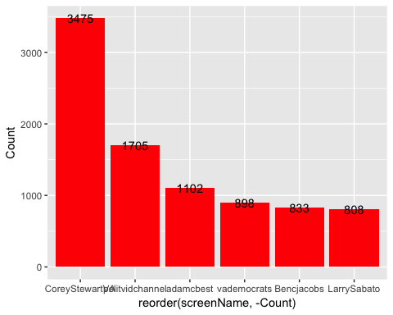

## Most Active Accounts (including Retweets)

## Var1 Freq  
## 10862 rpb3c 67  
## 13294 VirginiaMAGAKAG 66  
## 5367 IanSams 61  
## 8585 MJA_DC_FFX 59  
## 10180 QueenBoo 58  
## 13194 VAPolitical 54

## Most Active Accounts

## Var1 Freq  
## 2092 rpb3c 67  
## 1950 QueenBoo 41  
## 77 AdamJeromeGrump 36  
## 528 CoreyStewartVA 35  
## 1018 IanSams 31  
## 2081 ronirelandmusic 31

TEXT MINING What are people saying? The goal is to capture what words are being used to describe the candidate. We expect this section to be the one of the most interesting, as the team's NLP capabilities get better we expect this section to expand.

# WORDCLOUD of most common used words (Top 300)

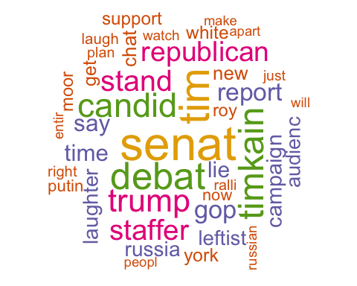

# List of The Top 15 Frequently used Words

## word freq  
## senat senat 4831  
## tim tim 4241  
## debat debat 3711  
## timkain timkain 3432  
## candid candid 3240  
## trump trump 3040  
## stand stand 2718  
## staffer staffer 2640  
## republican republican 2542  
## gop gop 2282  
## report report 2219  
## say say 2035  
## time time 2009  
## lie lie 1894  
## campaign campaign 1809

# Plot of Words that Appear at least 400 times

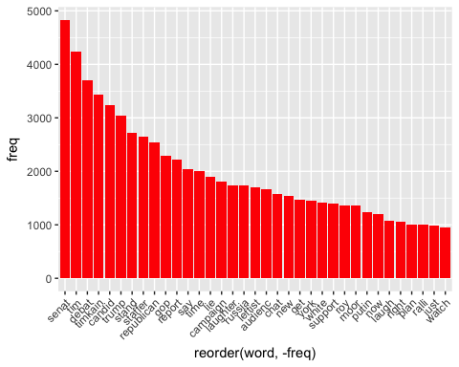

## Words Association

To find out what words are associated with the candidates, I use a function called FindAssocs() on the dataset. For any given word, findAssocs() calculates its correlation with every other word in the dataset. Scores range from 0 to 1. A score of 1 means that two words always appear together, while a score of 0 means that they never appear together.

# which words are associated with "tim", "kaine", or "timkaine", "corey","stewart" or "coreystewartva"

## $tim  
## kain debat adamcbest laugh   
## 0.85 0.44 0.39 0.39   
## neoconfeder entir stewart corey   
## 0.39 0.38 0.35 0.31   
## militari theapeopl fight servic   
## 0.31 0.31 0.30 0.30   
## get improv arm aca   
## 0.29 0.29 0.29 0.28   
## drug sabotag congressman bring   
## 0.28 0.28 0.27 0.26   
## compani vicious nanci senhorraposa   
## 0.26 0.26 0.26 0.26   
## church sagewarn teach portray   
## 0.25 0.25 0.25 0.25   
## lol control pelosi audienc   
## 0.25 0.25 0.25 0.24   
## cost live mikezollo but   
## 0.24 0.24 0.24 0.22   
## job wage healthcar attack   
## 0.22 0.22 0.21 0.20   
## first must demolish win   
## 0.20 0.20 0.20 0.19   
## never elect vademocrat republican   
## 0.19 0.18 0.17 0.16   
## nasti bigleaguepol think make   
## 0.16 0.16 0.16 0.15   
## robertowinssh watch gott media   
## 0.15 0.14 0.14 0.14   
## carterelliottiv consist discuss stronger   
## 0.13 0.13 0.13 0.13   
## opio solut shellshock indivisiblenet   
## 0.13 0.13 0.12 0.11   
## sen stage today check   
## 0.11 0.11 0.11 0.11   
## person the press   
## 0.10 0.10 0.10

## $kain  
## tim debat adamcbest laugh   
## 0.85 0.37 0.33 0.33   
## neoconfeder entir challeng prompt   
## 0.33 0.32 0.30 0.29   
## get militari theapeopl arm   
## 0.27 0.27 0.27 0.26   
## servic stewart fight improv   
## 0.26 0.25 0.25 0.24   
## wage congressman aca drug   
## 0.24 0.24 0.23 0.23   
## sabotag nanci senhorraposa bring   
## 0.23 0.23 0.23 0.22   
## compani vicious lol control   
## 0.22 0.22 0.22 0.22   
## pelosi corey church sagewarn   
## 0.22 0.21 0.21 0.21   
## teach portray bencjacob cost   
## 0.21 0.21 0.20 0.20   
## first live mikezollo audienc   
## 0.20 0.20 0.20 0.19   
## say but job healthcar   
## 0.19 0.19 0.19 0.17   
## must demolish never attack   
## 0.17 0.17 0.17 0.16   
## win gteconomi gthigher sen   
## 0.16 0.16 0.16 0.15   
## elect vademocrat bac gtunemploy   
## 0.15 0.15 0.15 0.15   
## low nasti bigleaguepol denounc   
## 0.15 0.14 0.14 0.14   
## grow make think roll   
## 0.14 0.13 0.13 0.13   
## robertowinssh gott republican carterelliottiv   
## 0.12 0.12 0.11 0.11   
## consist watch increas check   
## 0.11 0.11 0.11 0.11   
## discuss media stronger opio   
## 0.11 0.11 0.11 0.11   
## solut laughter russia today   
## 0.11 0.10 0.10 0.10   
## guardian shellshock   
## 0.10 0.10

## $timkain  
## coreystewartva want liber less governor   
## 0.46 0.24 0.22 0.22 0.21   
## weak fail rtdschapiro keithellison offic   
## 0.20 0.18 0.18 0.18 0.17   
## elimin proof offshoredril hillaryclinton schumer   
## 0.17 0.17 0.17 0.16 0.16   
## crime world peac crackdown illega   
## 0.16 0.16 0.16 0.16 0.16   
## abort offshor hes pal ice   
## 0.16 0.16 0.15 0.15 0.15   
## correct fellow whe budget revenu   
## 0.15 0.15 0.15 0.15 0.15   
## virginian nation democrat defeat celebr   
## 0.14 0.14 0.14 0.14 0.14   
## chair drjanerubi modern stanc deputi   
## 0.14 0.14 0.14 0.14 0.14   
## run elaineluriava forward littl back   
## 0.13 0.13 0.13 0.13 0.13   
## name wall vba american done   
## 0.13 0.13 0.13 0.13 0.13   
## govern duck join card repeal   
## 0.13 0.13 0.13 0.13 0.13   
## richmond movement enforc accomplish tenur   
## 0.13 0.13 0.13 0.13 0.13   
## ruleoflaw abolishic defeatkain boon far   
## 0.13 0.13 0.13 0.13 0.12   
## histori show everyth build need   
## 0.12 0.12 0.12 0.12 0.12   
## zero antisemit left play view   
## 0.12 0.12 0.12 0.12 0.12   
## amer wipe higher suffer drill   
## 0.12 0.12 0.12 0.12 0.12   
## tpp choic conserv oppos unfair   
## 0.12 0.11 0.11 0.11 0.11   
## best face polit late cut   
## 0.11 0.11 0.11 0.11 0.11   
## allow day alabama rather forc   
## 0.11 0.11 0.11 0.11 0.11   
## moral illegalalien shut wome look   
## 0.11 0.11 0.11 0.11 0.10   
## trade hour glad drive term   
## 0.10 0.10 0.10 0.10 0.10   
## iamdarylleon   
## 0.10

## $corey  
## stewart tim debat staffer   
## 0.87 0.31 0.26 0.25   
## audienc kain campaign version   
## 0.24 0.21 0.21 0.21   
## dumber republican candid tonyposnanski   
## 0.21 0.20 0.20 0.20   
## entir adamcbest laugh neoconfeder   
## 0.19 0.18 0.18 0.18   
## made larrysabato donald altright   
## 0.18 0.17 0.17 0.16   
## ralli unit possibl renounc   
## 0.16 0.16 0.16 0.15   
## underag think get defend   
## 0.15 0.15 0.14 0.14   
## thedailybeast erupt politvidchannel moor   
## 0.14 0.13 0.13 0.13   
## roy aca bring drug   
## 0.13 0.13 0.13 0.13   
## improv sabotag plan organ   
## 0.13 0.13 0.13 0.13   
## didnt russian right compani   
## 0.13 0.12 0.12 0.12   
## watch charlottesvill cop kazweida   
## 0.12 0.12 0.12 0.12   
## girl church sagewarn teach   
## 0.12 0.12 0.12 0.12   
## portray vicious liter was   
## 0.12 0.12 0.12 0.12   
## attack nazi shareblu healthcar   
## 0.11 0.11 0.11 0.11   
## natemcdermott num phone sent   
## 0.11 0.11 0.11 0.11   
## apart broke mikezollo saturday   
## 0.11 0.11 0.11 0.10   
## cost pretti screw websit   
## 0.10 0.10 0.10 0.10   
## bigleaguepol cha willsomm   
## 0.10 0.10 0.10

## $stewart  
## corey tim portray mikezollo   
## 0.87 0.35 0.33 0.31   
## vicious wage attack must   
## 0.31 0.29 0.27 0.26   
## kain win staffer audienc   
## 0.25 0.24 0.23 0.21   
## debat media version tonyposnanski   
## 0.20 0.20 0.19 0.19   
## dumber campaign chat larrysabato   
## 0.19 0.18 0.17 0.17   
## adamcbest entir laugh neoconfeder   
## 0.16 0.16 0.16 0.16   
## made donald get altright   
## 0.16 0.15 0.14 0.14   
## ralli unit possibl candid   
## 0.14 0.14 0.14 0.13   
## the defend renounc underag   
## 0.13 0.13 0.13 0.13   
## think politvidchannel republican improv   
## 0.13 0.12 0.12 0.12   
## tie organ thedailybeast moor   
## 0.12 0.12 0.12 0.11   
## roy aca bring drug   
## 0.11 0.11 0.11 0.11   
## sabotag plan nationalist landrum   
## 0.11 0.11 0.11 0.11   
## liter stay didnt notic   
## 0.11 0.11 0.11 0.11   
## white right compani charlottesvill   
## 0.10 0.10 0.10 0.10   
## cop kazweida church sagewarn   
## 0.10 0.10 0.10 0.10   
## teach reason was   
## 0.10 0.10 0.10

## $coreystewartva  
## timkain anyon communiti ever   
## 0.46 0.23 0.23 0.23   
## intel bush iraq how   
## 0.23 0.23 0.23 0.22   
## take talk doubt trust   
## 0.22 0.22 0.22 0.21   
## putin sell liber weak   
## 0.21 0.21 0.20 0.20   
## enough barack regim leftist   
## 0.20 0.20 0.20 0.19   
## even iansam now hillari   
## 0.19 0.19 0.19 0.19   
## lie vbadeb rtdschapiro disavow   
## 0.15 0.14 0.14 0.14   
## realdonaldtrump want governor less   
## 0.13 0.12 0.12 0.12   
## issu offic tax attend   
## 0.11 0.11 0.11 0.11   
## this check unlaw back   
## 0.10 0.10 0.10 0.10   
## done keithellison   
## 0.10 0.10

Sentiment Analysis

Using the (SentimentR) package, every tweet is scored to assess whether they are negative, positive or neutral. The algorithm estimates how negative or positive a tweet is based on the words and punctuation.

## Warning: Missing column names filled in: 'X1' [1]

## Parsed with column specification:  
## cols(  
## X1 = col_integer(),  
## text = col_character(),  
## favorited = col_logical(),  
## favoriteCount = col_integer(),  
## replyToSN = col_character(),  
## created = col_datetime(format = ""),  
## truncated = col_logical(),  
## replyToSID = col_double(),  
## id = col_double(),  
## replyToUID = col_double(),  
## statusSource = col_character(),  
## screenName = col_character(),  
## retweetCount = col_integer(),  
## isRetweet = col_logical(),  
## retweeted = col_logical(),  
## longitude = col_character(),  
## latitude = col_character()  
## )

# Top 10 Negative Tweets

## text  
## 1 @CoreyStewartVA Liar liar pants on fire  
## 2 @CoreyStewartVA LIES  
## 3 WATERGATE 2.0: Failing \u2066@nytimes\u2069 \u2066scumbag reporter \u2066\u2066@stefsaul\u2069 Stephanie Saul breaking &amp; entering Virginia home… https://t.co/RyHMp0Mc86  
## 4 GOOD\n\nAnd they should prosecute her ass to the fullest extent of the law\n\nWe are getting sick and tired of these… https://t.co/awLjLG4puE  
## 5 Tim Kaine vs Corey Stewart, Debate #1, beginning now. A sense of dread? A fear of vicious attacks? You bet. It's to… https://t.co/ig5mNE7M1v  
## 6 @CoreyStewartVA That didn't happen. Nice try comrade.  
## 7 @CoreyStewartVA This is a lie. This is a lie. This is a lie. This is a lie. This is a lie. This is a lie. This is a… https://t.co/rhkyKeZgiE  
## 8 .@CoreyStewartVA calls out @timkaine for failing to disavow anti-semites like @LeslieCockburn , racists, &amp; #antifa… https://t.co/3GBmlzKco8  
## 9 If @Denver4VA and racist @CoreyStewartVA stay silent when Trump sells us out to Putin, you can be damn sure they wo… https://t.co/vynDJNtTKY  
## 10 @CoreyStewartVA This is absolutely false. Proven false everywhere. Stop lying.  
## retweetCount favoriteCount created screenName  
## 1 0 74 2018-07-17 16:26:53 kingwala1  
## 2 0 31 2018-07-17 16:32:57 pdixon911  
## 3 29 23 2018-07-19 02:57:40 DrJaneRuby  
## 4 22 45 2018-07-19 16:01:18 DrJaneRuby  
## 5 55 314 2018-07-21 15:03:23 LarrySabato  
## 6 0 21 2018-07-17 16:27:05 DarthZapata  
## 7 1 122 2018-07-17 16:26:57 KajagoogooDuvet  
## 8 24 23 2018-07-21 16:01:16 DrJaneRuby  
## 9 4 30 2018-07-18 12:01:52 indivisibleVA05  
## 10 1 42 2018-07-17 16:27:33 BiscuitForShort  
## sentiment  
## 1 -0.9185587  
## 2 -0.7071068  
## 3 -0.6280639  
## 4 -0.6000992  
## 5 -0.5863020  
## 6 -0.5669467  
## 7 -0.5570860  
## 8 -0.5293077  
## 9 -0.5223418  
## 10 -0.5059644

# Top 10 Positive Tweets

## text  
## 1 #vbadebate @coreystewartva can't think of a modern Virginian he admires but praises Confederate monuments #vasen  
## 2 .@timkaine wants ‘comprehensive immigration reform’ but @CoreyStewartVA says Democrat favors amnesty for illegal immigrants. #VAsen  
## 3 @IanSams @CoreyStewartVA @thedailybeast But good ole Donald Trump endorsed this guy. Wow.  
## 4 @CoreyStewartVA @timkaine Everyone’s laughing at you. Tim Kaine’s *much* brighter and far more believable. Womp womp. \n\n#NoMoreIdiots  
## 5 @CoreyStewartVA Don't be ignorant Corey, but keep defending comrade trump.  
## 6 @CoreyStewartVA Money money money \U0001f4b0!  
## 7 @AK_INJUSTICE @CoreyStewartVA But obviously you cuddle up to Nazi's  
## 8 @ravencottage1 @Politicalprozac @CoreyStewartVA I really don’t care who you believe...I’ll believe the truth  
## 9 @johnniezigzag @CoreyStewartVA Ummm... very mature? Well, with regard to you, and please dont take offense... I was… https://t.co/YSMaJ40Mp2  
## 10 @JordanUhl Yes. .@CoreyStewartVA is well known racist-nazi lover who is all about defending and protecting sexual… https://t.co/B8PiUqneQX  
## 11 @winkbarry @CoreyStewartVA Wow thank you for the compliment *Squints* winkbarry. Really upping Stewart’s chances of winning keep it up.  
## 12 @CoreyStewartVA Good luck Corey  
## 13 @ArmenAndrew @Ferric242 @ForecasterEnten But Trump endorsing a candidate like Corey Stewart makes himself look raci… https://t.co/EkBmSTiFQU  
## 14 @CoreyStewartVA Congrats in putting it to Comrade Kaine (Cain) in the debate. Glad I supported you with $. Hope the… https://t.co/E9g0nulvgy  
## 15 Please provide JUST ONE time @keithellison promoted violence? You won’t be believed until you provide evidence of… https://t.co/9x3I3yTI3c  
## retweetCount favoriteCount created screenName  
## 1 0 0 2018-07-21 16:31:59 Rick_Sincere  
## 2 1 1 2018-07-21 16:05:15 RTDSchapiro  
## 3 0 0 2018-07-20 08:28:06 True4Colors  
## 4 0 4 2018-07-21 19:37:31 Trout8Trout  
## 5 0 0 2018-07-17 16:51:35 thornhillwes  
## 6 0 0 2018-07-17 18:30:03 JerJenkins4  
## 7 0 0 2018-07-17 14:02:44 LylajoyRose  
## 8 0 0 2018-07-19 12:00:02 johnniezigzag  
## 9 0 0 2018-07-17 15:01:43 ColusaPorDios  
## 10 1 0 2018-07-21 20:43:24 LauraMcAfee1  
## 11 0 1 2018-07-21 19:46:27 brothdaydreamer  
## 12 0 1 2018-07-18 01:24:42 kevinsolie  
## 13 0 0 2018-07-20 02:03:43 galizerigfanda  
## 14 0 0 2018-07-22 23:43:07 Roundhead50  
## 15 0 0 2018-07-18 17:14:07 HankSilverberg  
## sentiment  
## 1 1.2538138  
## 2 1.1200668  
## 3 0.9676391  
## 4 0.9119340  
## 5 0.9018816  
## 6 0.9000000  
## 7 0.8266667  
## 8 0.8082904  
## 9 0.7754604  
## 10 0.7639872  
## 11 0.7570719  
## 12 0.7500000  
## 13 0.7363832  
## 14 0.7267221  
## 15 0.6835366

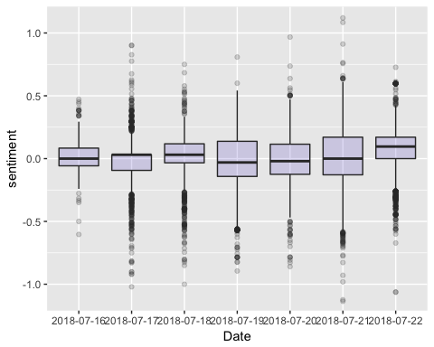

# WorldCloud of words used in top 1000 most negative and top 1000 most positive tweets

## Length Class Mode  
## negative.txt 2 PlainTextDocument list  
## positive.txt 2 PlainTextDocument list

## Warning in brewer.pal(ncol(tc2_matrix), "Dark2"): minimal value for n is 3, returning requested palette with 3 different levels

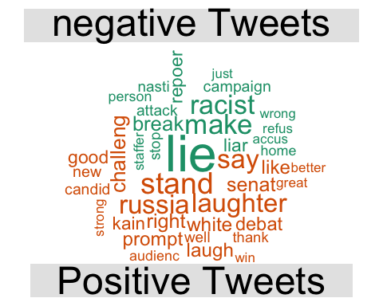

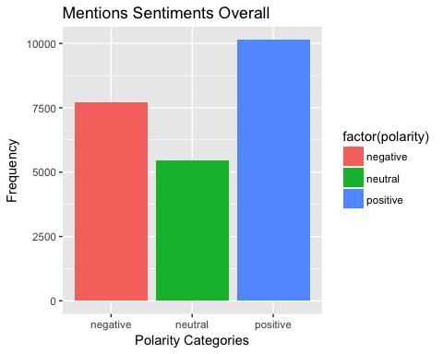

b <- B %>% group_by(Date) %>% count(polarity)  
   
#df_melt = melt(b, id.vars = 'Date')  
  
ggplot(b, aes(fill=polarity, y=n, x=Date)) +   
 geom_bar( stat="identity")+ ggtitle("Mentions Sentiment by Date ")+ylab("Count")

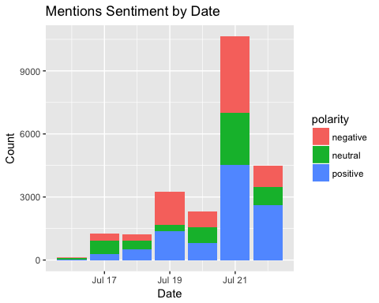

#ggplot(B,aes(x=Date, y=sentiment, fill=polarity)) + geom_bar(stat="identity",position = "stack")  
  
  
ggplot(b, aes(fill=polarity, y=n, x=Date)) +   
 geom_bar( stat="identity",position = "fill")+ ggtitle("Mentions Sentiment by Date (%)")+ylab("Percentage")

