Corey Stewart Mentions Analysis

Georges Colbert

07/10/2018

# Period of June 30 to July 07

Our goal is to cover the conversations being had about the candidates across multiple platforms, interpret it and visualize the information in a way that can help drive decision making. The Graphs shown and metrics calculated are best estimation of what can be most useful to the candidate. Through a process of constant feedback between us and the campaign, the most relevant information will be identified and facilitate the creation of a personalized dashboard that the campaign can access 24/7. For now, multiple visualizations of the same information could be provided as we try to identify the best way for the campaign to retain the information and identify the KPI’s amongst the myriad of metrics available.

In the case of Twitter, it is really fortunate that twitter provides an api on which developers can request an acquire a substantial amount of tweets from the previous ten days before the api call.

For more information on the twitter api the link is:

<https://developer.twitter.com/en/docs/tweets/search/api-reference/get-search-tweets.html>

To facilitate the process of Data mining the tweets, here’s a list of packages used:

* [TwitteR Package](https://cran.r-project.org/web/packages/twitteR/twitteR.pdf)
* [TM package](https://cran.r-project.org/web/packages/tm/index.html)
* [ggplot2 package](https://cran.r-project.org/web/packages/ggplot2/index.html)
* [wordcloud package](https://cran.r-project.org/web/packages/wordcloud/wordcloud.pdf)
* [SnowballC package](https://cran.r-project.org/web/packages/SnowballC/SnowballC.pdf)
* [SentimentR package](https://cran.r-project.org/web/packages/sentimentr/sentimentr.pdf)

For this analysis, a request was made to the API for up to 30,000 tweets that mentioned either “Corey Stewart” or “CoreyStewartVA” covering the period of June 30-July 07. All the tweets returned by the API are in the zip folder.

# Total Number of tweets

**12627**

# Total Mentions/Tweets per Day

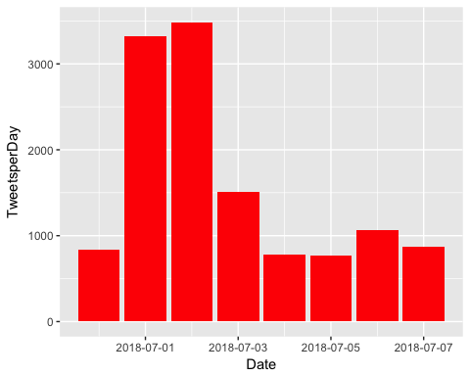

# How many are retweets?

##### How many are retweets?  
   
 table(VA.tweetdf$isRetweet)

##   
## FALSE TRUE   
## 3328 9299

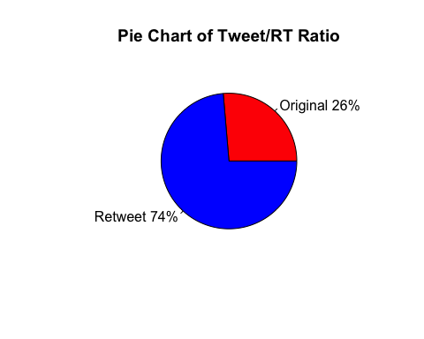

**Engagement**

To Measure Engagement, here is a time series graph created with the ggplot2 package that shows, per day, how often people tweeted direct replies at the Candidate.

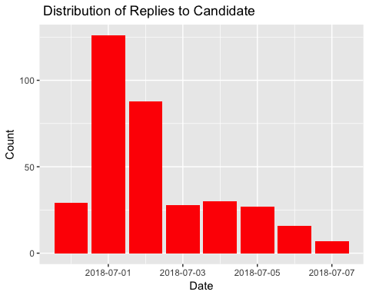

Another form of engagement, here is a breakdown of many Favorable engagements(RT and Favs) did the candidate accumulate per day for every day that he/she tweeted.

**FAV/RT Per Day**

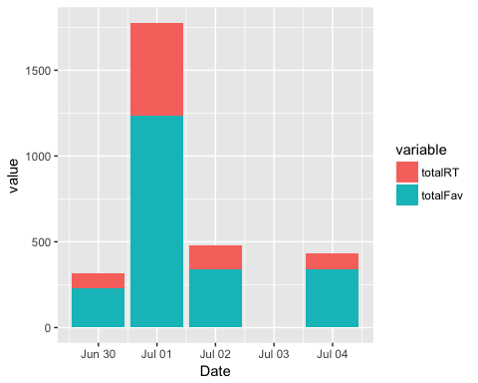

### list of top 6 favorite tweets by the candidate

## text  
## 1 Heard @realDonaldTrump on Fox this morning talking about our rally outside the Red Hen yesterday with the Bikers fo… https://t.co/hI6dvM5Vef  
## 2 There are more jobs than people out of work, something the American economy has never experienced before!\n\nThank yo… https://t.co/g7TxIjSoTu  
## 3 How many Americans would have to immigrate to Mexico to vote out their new communist President? \n\nDo you think he'd… https://t.co/Krt03imB8f  
## 4 Yesterday, we rallied outside of the Red Hen with @realDonaldTrump supporters and @trump_bikers in Lexington!\n\nWatc… https://t.co/Ev76XZxhT6  
## 5 At the Dale City Parade celebrating Independence Day\n\n #VaSen #MAGA #Virginia #July4th https://t.co/pxnJVQ1XlG  
## 6 When selecting the new @VA_GOP Chairman, party leadership should choose a strong leader who will fight for Presiden… https://t.co/7mLsr81TG2  
## favoriteCount created screenName  
## 1 750 2018-07-01 15:05:57 CoreyStewartVA  
## 2 292 2018-07-01 18:04:44 CoreyStewartVA  
## 3 240 2018-07-02 14:03:44 CoreyStewartVA  
## 4 194 2018-07-01 14:34:32 CoreyStewartVA  
## 5 192 2018-07-04 15:10:54 CoreyStewartVA  
## 6 161 2018-06-30 18:04:57 CoreyStewartVA

## other than from candidate's account, most favorited

## text  
## 1 #Breaking Huge crowd of patriots arrives in Lexington with @CoreyStewartVA to protest Red Hen! https://t.co/ld064iIKFm  
## 2 And for those who need receipts—here are links affirming the above GOP ticket Nazis\n•WA Nazi… https://t.co/QEqBpKAkvI  
## 3 Rather than support racist, Trump-loving pro-Confederate candidate Corey Stewart, who promises to run a 'vicious ca… https://t.co/u2TWIeoSpI  
## 4 \xed\xa0\xbd\xed\xb1\x8f\xed\xa0\xbd\xed\xb1\x8fPro-Trump Senate Candidate for Virginia, Corey Stewart Holds Rally at Red Hen Restaurant. \xed\xa0\xbd\xed\xb1\x8a\xed\xa0\xbd\xed\xb1\x8a\n\nCorey Stewart is ru… https://t.co/k14zb1G8qK  
## 5 Virginia GOP chair John Whitbeck abruptly resigns in wake of Corey Stewart's Senate nomination. More bad news: The… https://t.co/N7bxuGV4Ee  
## 6 Listen up everyone in Virginia! It's not too early to show support for Corey Stewart for senator of your great stat… https://t.co/VazB2rp3Ml  
## favoriteCount created screenName  
## 1 1870 2018-07-01 19:25:09 JackPosobiec  
## 2 1266 2018-07-01 23:57:20 MuslimIQ  
## 3 877 2018-06-30 23:38:59 activist360  
## 4 717 2018-07-02 00:50:06 cs0058sc  
## 5 680 2018-07-01 00:51:46 LarrySabato  
## 6 612 2018-07-02 04:14:54 Redhead4645

# top 6 retweeted tweets

## text  
## 1 RT @realDonaldTrump: To the great and brave men and women of ICE, do not worry or lose your spirit. You are doing a fantastic job of keepin…  
## 2 RT @realDonaldTrump: The Democrats are making a strong push to abolish ICE, one of the smartest, toughest and most spirited law enforcement…  
## 3 RT @JackPosobiec: #Breaking Huge crowd of patriots arrives in Lexington with @CoreyStewartVA to protest Red Hen! https://t.co/ld064iIKFm  
## 4 RT @JackPosobiec: #Breaking Huge crowd of patriots arrives in Lexington with @CoreyStewartVA to protest Red Hen! https://t.co/ld064iIKFm  
## 5 Heard @realDonaldTrump on Fox this morning talking about our rally outside the Red Hen yesterday with the Bikers fo… https://t.co/hI6dvM5Vef  
## 6 There are more jobs than people out of work, something the American economy has never experienced before!\n\nThank yo… https://t.co/g7TxIjSoTu  
## retweetCount created screenName  
## 1 38613 2018-07-02 21:43:28 CoreyStewartVA  
## 2 27362 2018-07-02 21:43:37 CoreyStewartVA  
## 3 936 2018-07-02 15:47:19 CoreyStewartVA  
## 4 936 2018-07-02 15:47:19 CoreyStewartVA  
## 5 304 2018-07-01 15:05:57 CoreyStewartVA  
## 6 163 2018-07-01 18:04:44 CoreyStewartVA

# top 6 retweeted tweet Not including candidate

## text  
## 1 #Breaking Huge crowd of patriots arrives in Lexington with @CoreyStewartVA to protest Red Hen! https://t.co/ld064iIKFm  
## 2 And for those who need receipts—here are links affirming the above GOP ticket Nazis\n•WA Nazi… https://t.co/QEqBpKAkvI  
## 3 Listen up everyone in Virginia! It's not too early to show support for Corey Stewart for senator of your great stat… https://t.co/VazB2rp3Ml  
## 4 Rather than support racist, Trump-loving pro-Confederate candidate Corey Stewart, who promises to run a 'vicious ca… https://t.co/u2TWIeoSpI  
## 5 \xed\xa0\xbd\xed\xb1\x8f\xed\xa0\xbd\xed\xb1\x8fPro-Trump Senate Candidate for Virginia, Corey Stewart Holds Rally at Red Hen Restaurant. \xed\xa0\xbd\xed\xb1\x8a\xed\xa0\xbd\xed\xb1\x8a\n\nCorey Stewart is ru… https://t.co/k14zb1G8qK  
## 6 Corey Stewart, VA GOP nominee for Senate celebrating Virginia’s confederate legacy: “It’s time that we embrace our… https://t.co/JBTfkDlbmd  
## retweetCount created screenName  
## 1 936 2018-07-01 19:25:09 JackPosobiec  
## 2 588 2018-07-01 23:57:20 MuslimIQ  
## 3 568 2018-07-02 04:14:54 Redhead4645  
## 4 548 2018-06-30 23:38:59 activist360  
## 5 517 2018-07-02 00:50:06 cs0058sc  
## 6 402 2018-07-06 16:51:53 TalbertSwan

### Top ten retweets overall

In this case, there were tweets that were created possibly before the designated period, or simply popular retweets from another account, that were still being shared on Twitter and accumulating retweets.

## text  
## 1 RT @realDonaldTrump: To the great and brave men and women of ICE, do not worry or lose your spirit. You are doing a fantastic job of keepin…  
## 2 RT @realDonaldTrump: The Democrats are making a strong push to abolish ICE, one of the smartest, toughest and most spirited law enforcement…  
## 3 RT @realDonaldTrump: Congratulations to Corey Stewart for his great victory for Senator from Virginia. Now he runs against a total stiff, T…  
## 4 RT @CoreyStewartVA: I am running for U.S. Senate to defeat @timkaine - Join the movement. https://t.co/HXPdTRFsHM #DefeatKaine  
## 5 RT @ikebarinholtz: Just so we're clear Donald Trump is supporting Corey Stewart who is a Neo-Confederate white supremacist which means you…  
## 6 RT @DisavowTrump20: BREAKING: Far-right Trump supporter and champion of the confederate flag Corey Stewart has won the GOP nomination for t…  
## 7 RT @CoreyStewartVA: Local officials who ignore Federal Immigration law and push for sanctuary cities should be in jail. Retweet if you agre…  
## 8 RT @letsgomathias: Steve King is from Iowa. Corey Stewart is from Minnesota. https://t.co/qtps7IeFgS  
## 9 RT @TheLeadCNN: Corey Stewart, the man who built his image on championing Confederate symbols and made joint appearances with the white nat…  
## 10 RT @CuomoPrimeTime: “I take support from whoever wants to give it me. That doesn’t mean I support their views”\n\nGOP Senate candidate Corey…  
## retweetCount created screenName isRetweet  
## 1 38613 2018-07-02 21:43:28 CoreyStewartVA TRUE  
## 2 27362 2018-07-02 21:43:37 CoreyStewartVA TRUE  
## 3 16332 2018-07-06 21:56:55 tloerjtoker57 TRUE  
## 4 6185 2018-07-07 00:04:05 MotherVoorhees TRUE  
## 5 5750 2018-07-02 23:59:57 NikkiBluejeans TRUE  
## 6 3811 2018-07-07 18:25:35 traceychristin1 TRUE  
## 7 2483 2018-06-30 17:25:54 CajkaSr TRUE  
## 8 2357 2018-07-05 14:11:38 christineNYT TRUE  
## 9 1814 2018-06-30 00:13:40 ScopingItOut TRUE  
## 10 1806 2018-07-03 18:56:11 smp0312 TRUE

## accounts that have the most total Retweets

## screenName x  
## 805 JackPosobiec 936  
## 367 CoreyStewartVA 863  
## 387 cs0058sc 711  
## 1480 Redhead4645 602  
## 1247 MuslimIQ 588  
## 45 activist360 548

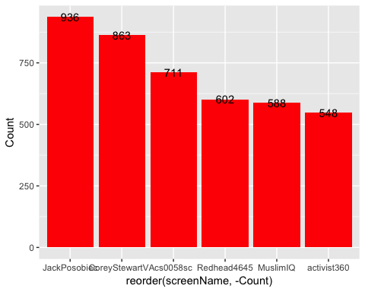

## Most Active Accounts (including Retweets)

## Var1 Freq  
## 8383 VAPolitical 68  
## 8558 WhatsYo70344542 50  
## 1291 CarlosV64910815 45  
## 5942 OpTheResistance 45  
## 3380 IlIlIlIlIl7 34  
## 3769 jim_beau_mtb 30

## Most Active Accounts

## Var1 Freq  
## 1319 OpTheResistance 40  
## 779 IlIlIlIlIl7 34  
## 1890 VAPolitical 30  
## 322 ChefChip 27  
## 884 John_R_Eason 24  
## 1453 ravencottage1 23

# WORDCLOUD of most common used words (Top 500)

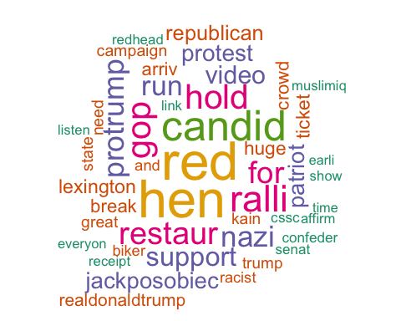

# List of The Top 15 Frequently used Words

## word freq  
## red red 3499  
## hen hen 3448  
## candid candid 2670  
## ralli ralli 2280  
## gop gop 2091  
## hold hold 2065  
## restaur restaur 1885  
## for for 1789  
## protrump protrump 1727  
## nazi nazi 1698  
## run run 1612  
## support support 1536  
## video video 1406  
## protest protest 1258  
## jackposobiec jackposobiec 1223

# Plot of Words that Appear at least 1000 times

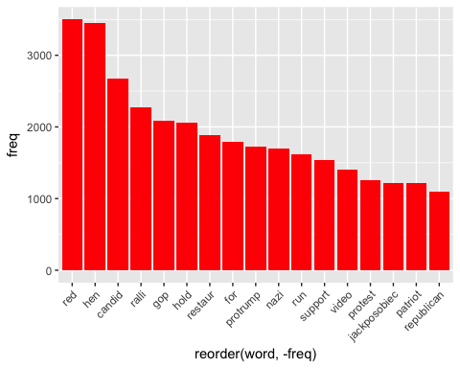

## Words Association

To find out what words are associated with the candidates, I use a function called FindAssocs() on the dataset. For any given word, findAssocs() calculates its correlation with every other word in the dataset. Scores range from 0 to 1. A score of 1 means that two words always appear together, while a score of 0 means that they never appear together.

# which words are associated with "tim", "kaine", or "timkaine", "corey","stewart" or "coreystewartva"

## $tim  
## border politifact kain want ice   
## 0.76 0.75 0.71 0.65 0.63   
## sen rid pant patrol abolish   
## 0.62 0.58 0.58 0.50 0.48   
## claim said doe rate dure   
## 0.45 0.45 0.44 0.44 0.35   
## broadcast pat facebook republican get   
## 0.35 0.35 0.34 0.33 0.31   
## fire live despit oppon stew   
## 0.31 0.29 0.29 0.28 0.26   
## away euthanasia cathol sheepdog carrnut   
## 0.21 0.19 0.18 0.18 0.18   
## abort that pick fals radic   
## 0.17 0.16 0.15 0.15 0.14   
## former domest repstevensmith mincemeat craigrozniecki   
## 0.14 0.14 0.14 0.14 0.14   
## updat corey fellow predict chaznuttycomb   
## 0.13 0.11 0.11 0.11 0.11   
## matt politicaldoggi son   
## 0.11 0.11 0.10

## $kain  
## tim tom front ellaaacruzzz border   
## 0.71 0.60 0.59 0.59 0.58   
## politifact hillari rep want ice   
## 0.56 0.55 0.49 0.49 0.47   
## sen rid pant patrol biker   
## 0.46 0.44 0.43 0.38 0.37   
## abolish trump claim said doe   
## 0.36 0.35 0.34 0.34 0.33   
## rate broadcast facebook dure pat   
## 0.33 0.27 0.26 0.26 0.26   
## get protest republican fire live   
## 0.24 0.23 0.23 0.23 0.22   
## despit oppon run stew corey   
## 0.22 0.21 0.20 0.19 0.16   
## away cathol sheepdog euthanasia abort   
## 0.16 0.14 0.14 0.14 0.13   
## stewart predict that domest repstevensmith   
## 0.12 0.12 0.11 0.11 0.11   
## fals candid mincemeat craigrozniecki   
## 0.11 0.10 0.10 0.10

## $timkain  
## movement defeatkain join dreamashrev   
## 0.40 0.39 0.38 0.30   
## defeat dis fightingveteran islam   
## 0.29 0.29 0.29 0.29   
## pquamm dianegor triciaedward face   
## 0.29 0.28 0.27 0.26   
## has clinton merrycan posterchild   
## 0.25 0.25 0.24 0.24   
## termlimit coreystewartva tie artemi   
## 0.22 0.20 0.20 0.20   
## pwcdanica jenniferforva jenniferwexton now   
## 0.18 0.16 0.15 0.14   
## jeremymcpik bere hartlac lap   
## 0.14 0.14 0.14 0.14   
## dramamama recognit robertcd brandonmwear   
## 0.14 0.14 0.13 0.13   
## satan melismaticdiva katebolduan judgejeanin   
## 0.13 0.13 0.13 0.13   
## meanwhil abcrichard ovalhead whatsyo   
## 0.12 0.12 0.12 0.12   
## cdonatac heck allhearingear ifthund   
## 0.12 0.12 0.12 0.12   
## lesliecockburn billytwi terrymcauliff ivotedforfunk   
## 0.11 0.11 0.11 0.11   
## kegan droneal harrisonburg winchest   
## 0.11 0.11 0.11 0.11   
## not solut mpennylegion johnpdca   
## 0.10 0.10 0.10 0.10

## $corey  
## stewart candid for cssc protrump   
## 0.94 0.53 0.47 0.45 0.44   
## restaur run hold ralli hen   
## 0.42 0.37 0.32 0.31 0.19   
## red video redhead earli senat   
## 0.19 0.19 0.18 0.18 0.18   
## listen everyon show promis activist   
## 0.17 0.17 0.17 0.17 0.17   
## kain vicious campaign histori proconfeder   
## 0.16 0.16 0.16 0.16 0.16   
## trumplov support talbertswan rather legaci   
## 0.16 0.15 0.15 0.15 0.15   
## hillari virginia embrac abrupt wake   
## 0.14 0.14 0.14 0.14 0.13   
## more chair larrysabato front tom   
## 0.13 0.13 0.13 0.13 0.13   
## ellaaacruzzz bad nomine racist nomin   
## 0.13 0.12 0.12 0.12 0.12   
## news atop ice celebr tim   
## 0.12 0.12 0.11 0.11 0.11   
## state john defund resign with   
## 0.11 0.11 0.11 0.11 0.11   
## mincemeat turmoil politifact deplorablemk border   
## 0.11 0.11 0.11 0.11 0.10   
## great sen obam prolif repeal   
## 0.10 0.10 0.10 0.10 0.10   
## sanctuari sonofliberti   
## 0.10 0.10

## $stewart  
## corey candid for cssc protrump   
## 0.94 0.54 0.47 0.46 0.45   
## restaur run hold ralli hen   
## 0.43 0.37 0.33 0.32 0.20   
## red video redhead listen everyon   
## 0.20 0.20 0.19 0.18 0.18   
## earli senat show promis activist   
## 0.18 0.18 0.17 0.17 0.17   
## proconfeder trumplov vicious campaign histori   
## 0.17 0.17 0.16 0.16 0.16   
## rather talbertswan embrac legaci support   
## 0.16 0.15 0.15 0.15 0.14   
## hillari virginia abrupt bad wake   
## 0.14 0.14 0.14 0.13 0.13   
## chair larrysabato front tom ellaaacruzzz   
## 0.13 0.13 0.13 0.13 0.13   
## kain nomine racist news more   
## 0.12 0.12 0.12 0.12 0.12   
## atop celebr great state john   
## 0.12 0.11 0.11 0.11 0.11   
## defund obam prolif repeal resign   
## 0.11 0.11 0.11 0.11 0.11   
## with turmoil deplorablemk repres sanctuari   
## 0.11 0.11 0.11 0.10 0.10   
## sonofliberti   
## 0.10

## $coreystewartva  
## jackposobiec lexington arriv huge   
## 0.46 0.38 0.37 0.37   
## crowd break realdonaldtrump protest   
## 0.36 0.36 0.31 0.27   
## patriot yesterday outsid thetrumpladi   
## 0.27 0.22 0.22 0.21   
## timkain heard fox morn   
## 0.20 0.20 0.20 0.20   
## talk vagop glad american   
## 0.19 0.19 0.19 0.19   
## part vote event vademocrat   
## 0.18 0.16 0.16 0.15   
## day work someth experienc   
## 0.15 0.15 0.15 0.15   
## thank job there economi   
## 0.14 0.14 0.14 0.14   
## iansam mani way gave   
## 0.13 0.13 0.13 0.13   
## new year think keep   
## 0.13 0.12 0.12 0.12   
## today mexico men biker   
## 0.12 0.12 0.12 0.12   
## trumpbik ago brave home   
## 0.12 0.12 0.12 0.12   
## young you presid immigr   
## 0.12 0.11 0.11 0.11   
## parad join communist big   
## 0.11 0.11 0.11 0.11   
## barbaracomstock peopl defeatkain movement   
## 0.10 0.10 0.10 0.10

# 

# Sentiment Analysis

Using the SentimentR package, all the tweets were scored and given a value of below 0 if negative and above 0 if positive. The wordcloud and ggplot2 packages were used to then create the vizualizations.

# WorldCloud of words used in top 1000 most negative and top 1000 most positive tweets

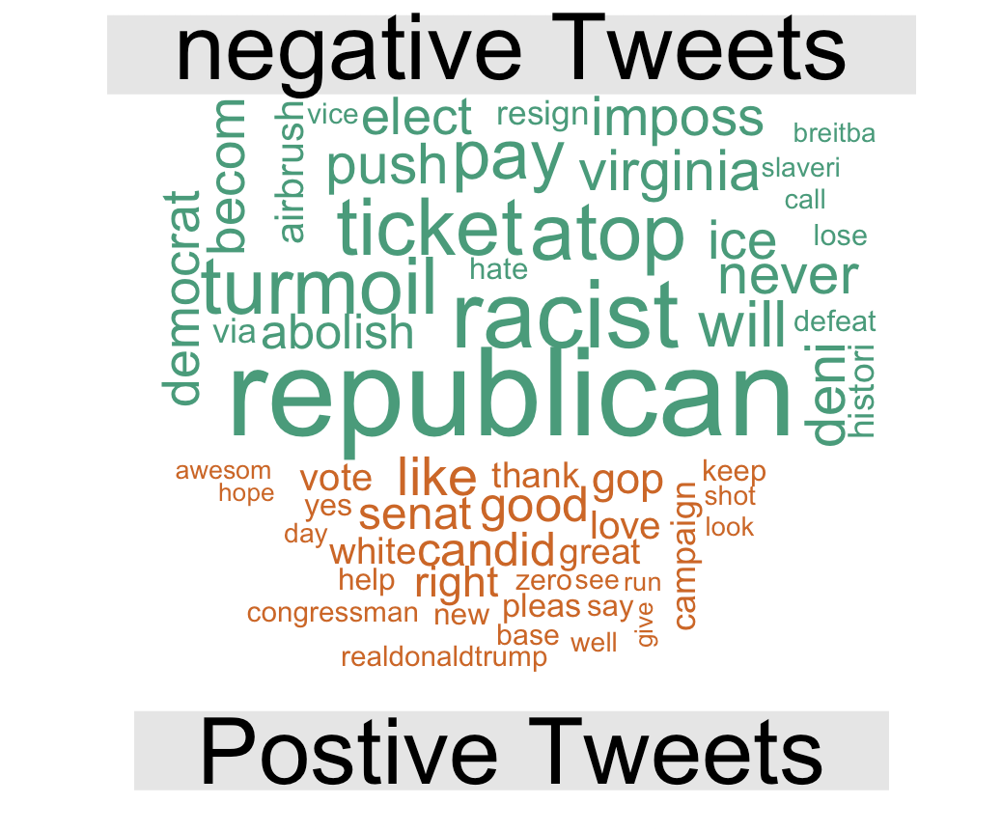

**Note: The WordCloud indicates which words were most common amongst the positive and negative tweets, it’s not stating if these words themselves are positive or negative.**

