## Loading required package: RColorBrewer

## Loading required package: NLP

##   
## Attaching package: 'dplyr'

## The following objects are masked from 'package:twitteR':  
##   
## id, location

## The following objects are masked from 'package:stats':  
##   
## filter, lag

## The following objects are masked from 'package:base':  
##   
## intersect, setdiff, setequal, union

## Warning: Missing column names filled in: 'X1' [1]

## Parsed with column specification:  
## cols(  
## X1 = col_integer(),  
## text = col_character(),  
## favorited = col_logical(),  
## favoriteCount = col_integer(),  
## replyToSN = col_character(),  
## created = col_datetime(format = ""),  
## truncated = col_logical(),  
## replyToSID = col_double(),  
## id = col_double(),  
## replyToUID = col_double(),  
## statusSource = col_character(),  
## screenName = col_character(),  
## retweetCount = col_integer(),  
## isRetweet = col_logical(),  
## retweeted = col_logical(),  
## longitude = col_character(),  
## latitude = col_character()  
## )

# Total Number of tweets

nrow(VA.tweetdf)

## [1] 29969

# How many are retweets?

##### How many are retweets?  
   
 table(VA.tweetdf$isRetweet)

##   
## FALSE TRUE   
## 5059 24910

### list of top 6 favorite tweets by the candidate

## text  
## 1 The real Trump Hotel. https://t.co/PP6nIbzNQR  
## 2 My week: Trump tweets that I am a “total stiff.” But he called Kim Jong Un a “very talented man.” I’ll take it! \xed\xa0\xbe\xed\xb4\xb7‍♂️  
## 3 The Old Testament instructs the faithful: “When a foreigner resides among you in your land, do not mistreat them...… https://t.co/aQvwcxscMV  
## 4 The Old Testament instructs the faithful: “When a foreigner resides among you in your land, do not mistreat them...… https://t.co/aQvwcxscMV  
## 5 Well, I have an opponent.\n\nHe has stoked the fires of bigotry in Virginia.\nHe's underfunded public schools and heal… https://t.co/0QjTynWuz2  
## 6 For those wanting to know about my Senate opponent, take a look at his latest bit of wisdom. \n\nAn empty bucket ratt… https://t.co/KikRhsNmLv  
## favoriteCount created screenName  
## 1 78055 2018-06-18 18:29:32 timkaine  
## 2 17010 2018-06-16 00:45:21 timkaine  
## 3 12633 2018-06-20 13:15:50 timkaine  
## 4 12614 2018-06-20 13:15:50 timkaine  
## 5 12194 2018-06-13 02:09:55 timkaine  
## 6 8612 2018-06-14 17:49:14 timkaine

## other than from candidate's account, most favorited

## text  
## 1 .@TimKaine and I are demanding answers about the Trump Administration’s #FamilySeparation policy. We’ve signed on t… https://t.co/yiGf4oTwiy  
## 2 We need a new president https://t.co/B1EqUblKB9  
## 3 Virginia's just-nominated Republican candidate for U.S. senate, @CoreyStewartVA, is now sharing hoax photoshops of… https://t.co/MGTl9VQjOX  
## 4 BREAKING: Senator Tim Kaine’s GOP opponent Corey Stewart is now under investigation by @TheDemCoalition. Help fund… https://t.co/m5FCESlNDl  
## 5 BREAKING: Senator Tim Kaine’s opponent Corey Stewart is now under investigation @TheDemCoalition. Help fund our res… https://t.co/Nys86z1bBZ  
## 6 'We Will Have a Red Tide': VA GOP Sen Candidate Corey Stewart Rips Tim Kaine, Praises Trump 'Successes' https://t.co/esll8oOohT  
## favoriteCount created screenName  
## 1 2345 2018-06-20 13:13:37 MarkWarner  
## 2 1593 2018-06-20 03:06:36 SOMEXlCAN  
## 3 1557 2018-06-14 05:05:46 Yair_Rosenberg  
## 4 1540 2018-06-14 19:39:10 joncoopertweets  
## 5 1462 2018-06-14 19:21:29 funder  
## 6 947 2018-06-15 00:20:37 FoxNews

# top 6 retweeted tweets

## text  
## 1 RT @SenJohnMcCain: The administration’s current family separation policy is an affront to the decency of the American people, and contrary…  
## 2 The real Trump Hotel. https://t.co/PP6nIbzNQR  
## 3 The Old Testament instructs the faithful: “When a foreigner resides among you in your land, do not mistreat them...… https://t.co/aQvwcxscMV  
## 4 The Old Testament instructs the faithful: “When a foreigner resides among you in your land, do not mistreat them...… https://t.co/aQvwcxscMV  
## 5 Well, I have an opponent.\n\nHe has stoked the fires of bigotry in Virginia.\nHe's underfunded public schools and heal… https://t.co/0QjTynWuz2  
## 6 My week: Trump tweets that I am a “total stiff.” But he called Kim Jong Un a “very talented man.” I’ll take it! \xed\xa0\xbe\xed\xb4\xb7‍♂️  
## retweetCount created screenName  
## 1 65553 2018-06-19 13:06:17 timkaine  
## 2 40622 2018-06-18 18:29:32 timkaine  
## 3 4436 2018-06-20 13:15:50 timkaine  
## 4 4434 2018-06-20 13:15:50 timkaine  
## 5 3510 2018-06-13 02:09:55 timkaine  
## 6 2558 2018-06-16 00:45:21 timkaine

# top 6 retweeted tweet Not including candidate

## text  
## 1 BREAKING: Senator Tim Kaine’s GOP opponent Corey Stewart is now under investigation by @TheDemCoalition. Help fund… https://t.co/m5FCESlNDl  
## 2 BREAKING: Senator Tim Kaine’s opponent Corey Stewart is now under investigation @TheDemCoalition. Help fund our res… https://t.co/Nys86z1bBZ  
## 3 Virginia's just-nominated Republican candidate for U.S. senate, @CoreyStewartVA, is now sharing hoax photoshops of… https://t.co/MGTl9VQjOX  
## 4 We need a new president https://t.co/B1EqUblKB9  
## 5 .@TimKaine and I are demanding answers about the Trump Administration’s #FamilySeparation policy. We’ve signed on t… https://t.co/yiGf4oTwiy  
## 6 Tim Kaine shares photos of child immigrant detention center: This is "the real Trump Hotel" https://t.co/68MZf4r2gB https://t.co/jsgbdX5LTW  
## retweetCount created screenName  
## 1 1314 2018-06-14 19:39:10 joncoopertweets  
## 2 1300 2018-06-14 19:21:29 funder  
## 3 997 2018-06-14 05:05:46 Yair_Rosenberg  
## 4 817 2018-06-20 03:06:36 SOMEXlCAN  
## 5 668 2018-06-20 13:13:37 MarkWarner  
## 6 314 2018-06-19 11:06:42 thehill

### Top ten retweets overall

In this case, there were tweets that were creeated before the designated period that were still being shared on Twitter and accumulating retweets.

I <- VA.tweetdf[order(VA.tweetdf$retweetCount, decreasing=TRUE),]  
  
  
 I <- I[!duplicated(I$text),]  
  
  
I <- head(select(I,text,retweetCount,created,screenName,isRetweet),10)  
   
 as.data.frame(I)

## text  
## 1 RT @SenJohnMcCain: The administration’s current family separation policy is an affront to the decency of the American people, and contrary…  
## 2 The real Trump Hotel. https://t.co/PP6nIbzNQR  
## 3 RT @timkaine: The real Trump Hotel. https://t.co/PP6nIbzNQR  
## 4 RT @realDonaldTrump: Congratulations to Corey Stewart for his great victory for Senator from Virginia. Now he runs against a total stiff, T…  
## 5 RT @Camila_Cabello: i am at a loss for words ...... https://t.co/ginoXLsEqS  
## 6 RT @CoreyStewartVA: I am running for U.S. Senate to defeat @timkaine - Join the movement. https://t.co/HXPdTRFsHM #DefeatKaine  
## 7 The Old Testament instructs the faithful: “When a foreigner resides among you in your land, do not mistreat them...… https://t.co/aQvwcxscMV  
## 8 RT @nowthisnews: Liviu Librescu survived the Holocaust as a young boy. \n\nDecades later, he lost his life to senseless gun violence as a pro…  
## 9 RT @DisavowTrump20: BREAKING: Far-right Trump supporter and champion of the confederate flag Corey Stewart has won the GOP nomination for t…  
## 10 Well, I have an opponent.\n\nHe has stoked the fires of bigotry in Virginia.\nHe's underfunded public schools and heal… https://t.co/0QjTynWuz2  
## retweetCount created screenName isRetweet  
## 1 65553 2018-06-19 13:06:17 timkaine TRUE  
## 2 40622 2018-06-18 18:29:32 timkaine FALSE  
## 3 40613 2018-06-20 23:56:56 AlexeeeP TRUE  
## 4 16371 2018-06-20 22:03:46 Here4TrumpSpice TRUE  
## 5 7931 2018-06-20 23:53:05 dadaycamren TRUE  
## 6 6046 2018-06-20 03:19:39 DoringHaak TRUE  
## 7 4436 2018-06-20 13:15:50 timkaine FALSE  
## 8 4004 2018-06-19 04:53:10 jammopo2014 TRUE  
## 9 3806 2018-06-20 13:17:46 Rose07123078 TRUE  
## 10 3510 2018-06-13 02:09:55 timkaine FALSE

## accounts that have the most total Retweets

## screenName x  
## 3242 timkaine 61359  
## 1621 joncoopertweets 1314  
## 1147 funder 1300  
## 3186 thehill 1296  
## 3565 Yair_Rosenberg 997  
## 2980 SOMEXlCAN 817

## Most Active Accounts (including Retweets)

## Var1 Freq  
## 18385 openletterbot 45  
## 3771 BT_58 34  
## 14223 lesstaxingcpa 33  
## 15263 Mad_Max2020 29  
## 25404 welllookythere 29  
## 1449 amelia_reads 28

## Most Active Accounts

## Var1 Freq  
## 2439 openletterbot 45  
## 475 BT_58 34  
## 2042 Mad_Max2020 29  
## 3493 welllookythere 29  
## 163 amelia_reads 28  
## 3114 tastipes 26

# WORDCLOUD of most common used words (Top 1000)

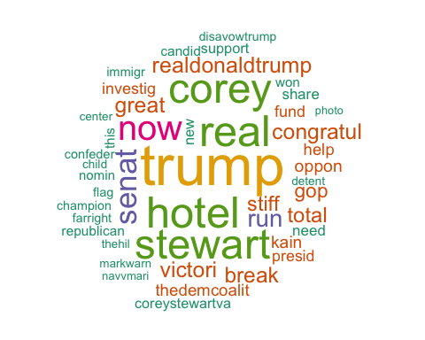

# List of The Top 15 Frequently used Words

## word freq  
## trump trump 11827  
## hotel hotel 8643  
## real real 8596  
## corey corey 8401  
## stewart stewart 8331  
## now now 6793  
## senat senat 5719  
## run run 4176  
## realdonaldtrump realdonaldtrump 3590  
## great great 3559  
## victori victori 3553  
## congratul congratul 3531  
## break break 3490  
## total total 3351  
## stiff stiff 3260

# Plot of Words that Appear at least 1700 times

##   
## Attaching package: 'ggplot2'

## The following object is masked from 'package:NLP':  
##   
## annotate

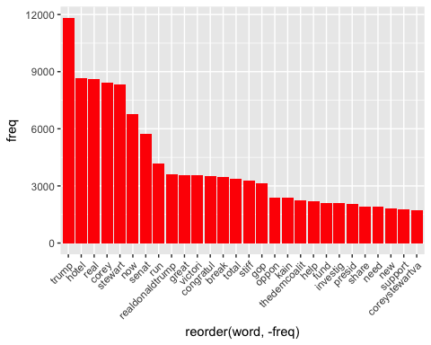

## Words Association

To find out what words are associated with the candidates, I use a function called FindAssocs() on the dataset. For any given word, findAssocs() calculates its correlation with every other word in the dataset. Scores range from 0 to 1. A score of 1 means that two words always appear together, while a score of 0 means that they never appear together.

# which words are associated with "tim", "kaine", or "timkaine", "corey",

## $tim  
## kain investig fund help thedemcoalit   
## 0.98 0.45 0.45 0.44 0.44   
## oppon immigr thehil center detent   
## 0.42 0.33 0.33 0.32 0.32   
## child joncoopertweet photo funder team   
## 0.32 0.31 0.30 0.30 0.30   
## research this break sen stewart   
## 0.29 0.28 0.28 0.20 0.20   
## will lose corey secofst feel   
## 0.19 0.19 0.19 0.19 0.18   
## gop reelect success have elect   
## 0.18 0.17 0.17 0.16 0.16   
## know rip weak tide vote   
## 0.16 0.16 0.16 0.16 0.15   
## senat racism prais share red   
## 0.15 0.15 0.15 0.15 0.14   
## foxnew more armyoftrump busylizzi mag   
## 0.14 0.14 0.14 0.14 0.14   
## ohnoshetwitnt like for wake resear   
## 0.14 0.13 0.13 0.13 0.12   
## can now son hillari neoconfeder   
## 0.11 0.11 0.11 0.10 0.10

## $kain  
## tim investig fund help thedemcoalit   
## 0.98 0.45 0.45 0.43 0.43   
## oppon immigr center detent thehil   
## 0.42 0.33 0.32 0.32 0.32   
## child photo team joncoopertweet research   
## 0.31 0.30 0.30 0.30 0.29   
## funder this break sen stewart   
## 0.29 0.28 0.28 0.21 0.20   
## will lose corey secofst feel   
## 0.19 0.19 0.19 0.19 0.18   
## gop reelect success know rip   
## 0.18 0.17 0.17 0.16 0.16   
## weak have vote elect senat   
## 0.16 0.15 0.15 0.15 0.15   
## prais share tide red for   
## 0.15 0.15 0.15 0.14 0.14   
## foxnew racism armyoftrump busylizzi ohnoshetwitnt   
## 0.14 0.14 0.14 0.14 0.14   
## son like wake more mag   
## 0.13 0.13 0.13 0.13 0.13   
## resear can now neoconfeder   
## 0.12 0.11 0.11 0.10

## $timkain  
## the hotel real trump   
## 0.72 0.64 0.64 0.54   
## markwarn legisl demand familysepar   
## 0.26 0.19 0.18 0.18   
## sign weve administr answer   
## 0.18 0.18 0.17 0.17   
## polici danielturnerptf   
## 0.17 0.10

## $corey  
## stewart senat now break   
## 0.97 0.72 0.62 0.57   
## total stiff congratul victori   
## 0.56 0.55 0.53 0.53   
## realdonaldtrump great gop run   
## 0.52 0.51 0.48 0.45   
## investig fund help thedemcoalit   
## 0.43 0.43 0.42 0.42   
## oppon flag champion nomin   
## 0.40 0.35 0.34 0.34   
## won confeder disavowtrump farright   
## 0.34 0.34 0.34 0.34   
## support research funder joncoopertweet   
## 0.30 0.29 0.29 0.29   
## team kain tim will   
## 0.28 0.19 0.19 0.14   
## rip success have foxnew   
## 0.14 0.14 0.13 0.13   
## prais armyoftrump mag tide   
## 0.13 0.13 0.13 0.13   
## red wake more resear   
## 0.12 0.12 0.12 0.12   
## busylizzi for   
## 0.12 0.10

## $Coreystewartva  
## numeric(0)

# Number of Tweets per Day

##   
## Attaching package: 'scales'

## The following object is masked from 'package:readr':  
##   
## col_factor

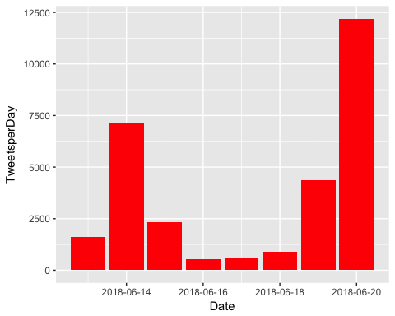

## Warning: Missing column names filled in: 'X1' [1]

## Parsed with column specification:  
## cols(  
## X1 = col_integer(),  
## text = col_character(),  
## favorited = col_logical(),  
## favoriteCount = col_integer(),  
## replyToSN = col_character(),  
## created = col_datetime(format = ""),  
## truncated = col_logical(),  
## replyToSID = col_double(),  
## id = col_double(),  
## replyToUID = col_double(),  
## statusSource = col_character(),  
## screenName = col_character(),  
## retweetCount = col_integer(),  
## isRetweet = col_logical(),  
## retweeted = col_logical(),  
## longitude = col_character(),  
## latitude = col_character()  
## )

# Top 10 Negative Tweets

## text  
## 1 fuck trump fuck hillary fuck the government fuck politics //tco/tf6x2sigeg  
## 2 timkaine but you murder the unborn  
## 3 them stupid libtards try to use the bible but they really are the antichrist because for their disgusting inmoral //tco/osxrkonsyj  
## 4 timkaine pls impeach this dangerous evil potus before he wreaks more havoc in the world and space and on inn //tco/6eehw4dbzp  
## 5 this is fucking disgusting i cant even put into words how much of a fucking asshole realdonaldtrump is youre a //tco/2mfk898gld  
## 6 kasiedc kasie coreystewava that was bad but it got worse when he staed talking about tim kaine shameful  
## 7 this is disgusting inhumane atrocious heabreaking repulsive //tco/uqjiwwpmo0  
## 8 timkaine trueas opposed to the islamic waywho invade destroy rape and kill  
## 9 so fucking sad and inhumane //tco/cnhp77trkn  
## 10 especially dont forget that tim kaine really fucking sucks //tco/aoz1f2sgdi  
## retweetCount favoriteCount created screenName  
## 1 1 4 2018-06-20 12:19:06 ICY_E0  
## 2 0 0 2018-06-20 14:44:26 roger_brenz  
## 3 0 0 2018-06-20 21:54:35 calientehombre1  
## 4 0 0 2018-06-20 12:40:43 OldManOfHoy  
## 5 0 1 2018-06-20 09:34:43 yo_titaa  
## 6 0 0 2018-06-18 00:58:17 laurelk229  
## 7 1 0 2018-06-19 22:11:04 AlyssaLegnetti  
## 8 0 0 2018-06-20 16:11:39 HowardJ86363096  
## 9 0 0 2018-06-20 15:27:15 morganwallacew  
## 10 0 0 2018-06-14 00:46:09 balvertos

# Top 10 Positive Tweets

## text  
## 1 donating some money to gefosteryouth in honor of supremely nice dad timkaine and his excellent paner in life //tco/e8uwx3ra3l  
## 2 lisamoraitis1 timkaine they are safe and being taken care of they're actually better taken care of than hundreds //tco/ykg5ee88zt  
## 3 mrdane1982 i love tim kaine but you're right castro would have been a better pick maybe 2020 is his year  
## 4 markwarner timkaine thank you but i still wish you hadn't voted to confirm kristen nielsen  
## 5 well said and well chosen quote timkaine //tco/lgjxg7m1bj  
## 6 kasiedc please continue to try to interrupt and provide truth rather than playing the debate game your talk wit //tco/saaacmpix9  
## 7 madmax2020 timkaine i appreciate your respectful reply i wish you the best i agree we're all struggling to do right  
## 8 virginia might well celebrate the beginnings of effective amp exemplary waime emancipation may 24 1861 at fo //tco/ka4ygcfxfm  
## 9 excellent point her choice of tim kaine was perfect as evidenced by her winning //tco/bebjjfykqd  
## 10 congratulations trump i hope youre happy now i hope youre real damn happy //tco/1gqwmw8sbu  
## retweetCount favoriteCount created screenName  
## 1 1 14 2018-06-17 20:56:58 SaraJBenincasa  
## 2 1 7 2018-06-20 14:26:19 pcgallagher17  
## 3 0 0 2018-06-17 14:47:24 js_edit  
## 4 1 15 2018-06-20 13:41:24 jojozaff  
## 5 0 0 2018-06-20 19:08:32 Rdekadt  
## 6 0 0 2018-06-18 11:30:17 ronifrey16  
## 7 0 1 2018-06-20 14:28:57 jadegustin  
## 8 0 0 2018-06-19 23:33:48 amberpages_g  
## 9 1 16 2018-06-15 21:35:35 CONNORisSWEET  
## 10 0 10 2018-06-20 03:44:39 56_kait

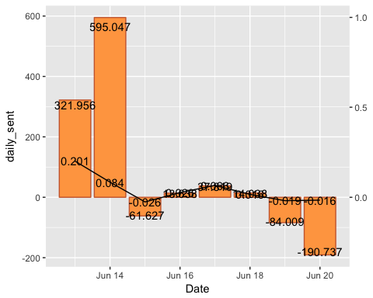

# WorldCloud of words used in top 1000 most negateive and most positive tweets

## Length Class Mode  
## negative.txt 2 PlainTextDocument list  
## positive.txt 2 PlainTextDocument list

## Warning in brewer.pal(ncol(term.matrix), "Dark2"): minimal value for n is 3, returning requested palette with 3 different levels

## Warning in comparison.cloud(tc2_matrix, max.words = 50, random.order =  
## FALSE): pleas could not be fit on page. It will not be plotted.

## Warning in comparison.cloud(tc2_matrix, max.words = 50, random.order =  
## FALSE): coreystewava could not be fit on page. It will not be plotted.

## Warning in comparison.cloud(tc2_matrix, max.words = 50, random.order =  
## FALSE): markwarn could not be fit on page. It will not be plotted.

## Warning in comparison.cloud(tc2_matrix, max.words = 50, random.order =  
## FALSE): america could not be fit on page. It will not be plotted.

## Warning in comparison.cloud(tc2_matrix, max.words = 50, random.order =  
## FALSE): good could not be fit on page. It will not be plotted.

## Warning in comparison.cloud(tc2_matrix, max.words = 50, random.order =  
## FALSE): gop could not be fit on page. It will not be plotted.

## Warning in comparison.cloud(tc2_matrix, max.words = 50, random.order =  
## FALSE): better could not be fit on page. It will not be plotted.

## Warning in comparison.cloud(tc2_matrix, max.words = 50, random.order =  
## FALSE): donald could not be fit on page. It will not be plotted.

## Warning in comparison.cloud(tc2_matrix, max.words = 50, random.order =  
## FALSE): proud could not be fit on page. It will not be plotted.

## Warning in comparison.cloud(tc2_matrix, max.words = 50, random.order =  
## FALSE): republican could not be fit on page. It will not be plotted.

## Warning in comparison.cloud(tc2_matrix, max.words = 50, random.order =  
## FALSE): moral could not be fit on page. It will not be plotted.

## Warning in comparison.cloud(tc2_matrix, max.words = 50, random.order =  
## FALSE): want could not be fit on page. It will not be plotted.

## Warning in comparison.cloud(tc2_matrix, max.words = 50, random.order =  
## FALSE): obama could not be fit on page. It will not be plotted.

