Tim Kaine Mentions Analysis

Georges Colbert

6/12/2018

**Period of June 03 to June 11**

# Total Number of tweets

nrow(VA.tweetdf)

## [1] 21044

# How many are retweets?

##### How many are retweets?  
   
 table(VA.tweetdf$isRetweet)

##   
## FALSE TRUE   
## 4990 16054

### list of top 6 favorite tweets

## text  
## 1 RT @NRDC_AF: Sen. Tim Kaine is an environmental champion who fights for healthy families &amp; a safe environment. He is a tireless advocate fo…  
## 2 RT @alicelintong: I am so proud to work for @timkaine, a leader who believes deeply in treating every person equally and embracing the stre…  
## favoriteCount created screenName  
## 1 0 2018-06-07 14:59:39 timkaine  
## 2 0 2018-06-07 18:03:49 timkaine

## other than from candidate's account, most favorited

## text  
## 1 Or picking Tim Kaine as your running mate https://t.co/pLLN5gSV6J  
## 2 Tim Kaine, when asked about Trump's belief he can pardon himself, noted that he once lived in Honduras: "I know dic… https://t.co/AnGFXNe2LY  
## 3 Only one day left until the primary and we must defeat @TimKaine in November!\n\nMake sure to vote tomorrow!… https://t.co/PbxT3Hwqt8  
## 4 Green Beret Combat Veteran and member of the Virginia House of Delegates @NickForVA will crush @timkaine this Novem… https://t.co/ctjDHqsGSs  
## 5 Tim Kaine just told me this when asked about Trump pardon talk.\n“I lived in a military dictatorship in the Honduras… https://t.co/J9ALd2AEnQ  
## 6 Peak Tim “dad joke” Kaine here https://t.co/AX7lRXa1j1  
## favoriteCount created screenName  
## 1 4381 2018-06-08 22:13:01 historyinflicks  
## 2 1248 2018-06-05 22:00:17 kylegriffin1  
## 3 919 2018-06-11 13:12:26 NickForVA  
## 4 815 2018-06-10 16:12:14 Stump_for_Trump  
## 5 585 2018-06-05 14:39:23 mkraju  
## 6 577 2018-06-05 02:28:29 seungminkim

# top 6 retweeted tweets

## text  
## 1 RT @alicelintong: I am so proud to work for @timkaine, a leader who believes deeply in treating every person equally and embracing the stre…  
## 2 RT @NRDC_AF: Sen. Tim Kaine is an environmental champion who fights for healthy families &amp; a safe environment. He is a tireless advocate fo…  
## retweetCount created screenName  
## 1 53 2018-06-07 18:03:49 timkaine  
## 2 32 2018-06-07 14:59:39 timkaine

# top 6 retweeted tweet Not including candidate

## text  
## 1 Tim Kaine, when asked about Trump's belief he can pardon himself, noted that he once lived in Honduras: "I know dic… https://t.co/AnGFXNe2LY  
## 2 Green Beret Combat Veteran and member of the Virginia House of Delegates @NickForVA will crush @timkaine this Novem… https://t.co/ctjDHqsGSs  
## 3 Or picking Tim Kaine as your running mate https://t.co/pLLN5gSV6J  
## 4 Only one day left until the primary and we must defeat @TimKaine in November!\n\nMake sure to vote tomorrow!… https://t.co/PbxT3Hwqt8  
## 5 Tim Kaine just told me this when asked about Trump pardon talk.\n“I lived in a military dictatorship in the Honduras… https://t.co/J9ALd2AEnQ  
## 6 \xed\xa0\xbd\xed\xb4\xb4\u26aa️\xed\xa0\xbd\xed\xb4\xb5\xed\xa0\xbd\xed\xb4\xb4\u26aa️\xed\xa0\xbd\xed\xb4\xb5\xed\xa0\xbd\xed\xb4\xb4\u26aa️\xed\xa0\xbd\xed\xb4\xb5\xed\xa0\xbd\xed\xb4\xb4\nWAKE UP VIRGINIA ‼️\u23f0\n\nPRIMARY JUNE 12th\n\nNO MORE TIM KAINE\u274c\u274c\n\nVOTE NICK FREITAS\nFOR US SENATE ‼️… https://t.co/9k1P0OH2Vx  
## retweetCount created screenName  
## 1 608 2018-06-05 22:00:17 kylegriffin1  
## 2 575 2018-06-10 16:12:14 Stump_for_Trump  
## 3 521 2018-06-08 22:13:01 historyinflicks  
## 4 454 2018-06-11 13:12:26 NickForVA  
## 5 277 2018-06-05 14:39:23 mkraju  
## 6 272 2018-06-07 10:32:37 busylizzie48

### Top ten retweets overall

In this case, there were tweets that were creeated before the designated period that were still being shared on Twitter and accumulating retweets.

I <- VA.tweetdf[order(VA.tweetdf$retweetCount, decreasing=TRUE),]  
  
  
 I <- I[!duplicated(I$text),]  
  
  
I <- head(select(I,text,retweetCount,created,screenName,isRetweet),10)  
   
 as.data.frame(I)

## text  
## 1 RT @timkaine: RT if you support #DACA and #DREAMers who make our nation stronger #DefendDACA  
## 2 RT @timkaine: People often forget that we *already had* an assault weapons ban. For a decade! So don't let the gun lobby cry "unconstitutio…  
## 3 RT @timkaine: Too real. https://t.co/A8fjFNJ2Oh  
## 4 RT @CoreyStewartVA: I am running for U.S. Senate to defeat @timkaine - Join the movement. https://t.co/HXPdTRFsHM #DefeatKaine  
## 5 RT @timkaine: Given the NRA's ubiquitous presence in U.S. elections, it should alarm every American that the bipartisan Senate Intelligence…  
## 6 RT @timkaine: This might surprise some people but I think this is the most polite White House in history. They’re always saying “pardon me.”  
## 7 RT @nowthisnews: Liviu Librescu survived the Holocaust as a young boy. \n\nDecades later, he lost his life to senseless gun violence as a pro…  
## 8 RT @timkaine: Of course citizen Trump said President Obama couldn’t strike Syria without congressional approval—but now President Trump doe…  
## 9 RT @NickForVA: Thank you for your support! Let’s continue to put the pressure on Tim Kaine and win in November - vote June 12th and let’s #…  
## 10 RT @charliekirk11: Nick is a total stud and Tim Kaine might be one of the most repulsive US Senators out there\n\nNick can win and unseat Tim…  
## retweetCount created screenName isRetweet  
## 1 34521 2018-06-06 02:52:51 janievan16 TRUE  
## 2 19543 2018-06-05 23:09:32 Vetivera24 TRUE  
## 3 14569 2018-06-08 20:58:21 bokiko_ TRUE  
## 4 5924 2018-06-11 23:55:55 360BullCreek TRUE  
## 5 5486 2018-06-11 17:24:32 NefertitiCobaka TRUE  
## 6 5240 2018-06-11 23:57:45 garnet_noblet TRUE  
## 7 4010 2018-06-11 00:06:14 bougienickel TRUE  
## 8 3339 2018-06-11 05:13:39 1Nastygal TRUE  
## 9 3145 2018-06-10 03:27:55 KitDeplore TRUE  
## 10 3031 2018-06-08 11:31:06 FWSBill TRUE

## accounts that have the most total Retweets

## screenName x  
## 2071 NickForVA 1349  
## 425 busylizzie48 649  
## 1584 kylegriffin1 608  
## 2700 Stump_for_Trump 575  
## 1167 historyinflicks 522  
## 384 BrennanCenter 426

## Most Active Accounts (including Retweets)

## Var1 Freq  
## 9724 MikeWebbNow 677  
## 10068 MrGQ37 41  
## 4247 DrWifeQuotes 32  
## 9590 michael__1776 30  
## 2274 CarlosV64910815 24  
## 494 AkhavanKayvan 23

## Most Active Accounts

The Reason MikeWebbNow has 677 tweets is because he continued a conversation thread by tweeting 677 in row, essentially to himself Link -> <https://t.co/6dI4BJcpih>

## Var1 Freq  
## 1914 MikeWebbNow 677  
## 1991 MrGQ37 41  
## 859 DrWifeQuotes 32  
## 1034 GarrettShorr 23  
## 1160 HillaryisGod 22  
## 2424 Rogue_VHA 22

# WORDCLOUD of most common used words

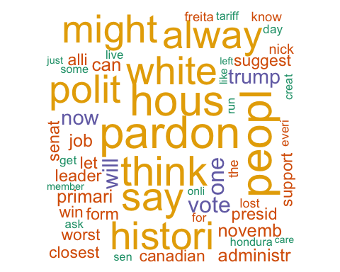

# List of The Top 15 Frequently used Words

## word freq  
## pardon pardon 4868  
## peopl peopl 4735  
## hous hous 4661  
## think think 4389  
## say say 4233  
## white white 4128  
## polit polit 4120  
## alway alway 4106  
## histori histori 4104  
## might might 4102  
## surpris surpris 4091  
## theyr theyr 4090  
## nickforva nickforva 2882  
## one one 2153  
## vote vote 2101

# Plot of Words that Appear at least 1250 times

##   
## Attaching package: 'ggplot2'

## The following object is masked from 'package:NLP':  
##   
## annotate

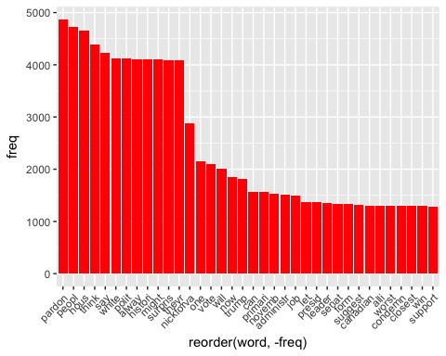

## Words Association

To find out what words are associated with the candidates, I use a function called FindAssocs() on the dataset. For any given word, findAssocs() calculates its correlation with every other word in the dataset. Scores range from 0 to 1. A score of 1 means that two words always appear together, while a score of 0 means that they never appear together.

# which words are associated with "tim", "kaine", or "timkaine"

## $timkain  
## hous this peopl histori alway   
## 0.38 0.37 0.36 0.35 0.35   
## surpris polit white might theyr   
## 0.35 0.35 0.35 0.35 0.35   
## say think pardon one administr   
## 0.34 0.32 0.22 0.20 0.20   
## now condemn canadian closest leader   
## 0.20 0.18 0.18 0.18 0.18   
## suggest worst alli form will   
## 0.18 0.18 0.18 0.17 0.15   
## lost job creat everi some   
## 0.14 0.14 0.13 0.13 0.13   
## tariff loss stumpfortrump enough crush   
## 0.13 0.13 0.12 0.11 0.11   
## veteran combat member markwarn   
## 0.11 0.11 0.10 0.10

## $tim  
## kain june hondura live ask   
## 0.96 0.37 0.35 0.34 0.33   
## vote wake note belief dictat   
## 0.30 0.28 0.28 0.28 0.28   
## kylegriffin more nickfrei historyinflick pick   
## 0.28 0.27 0.27 0.27 0.26   
## mate pressur put continu let   
## 0.26 0.26 0.25 0.23 0.23   
## busylizzi for freita nick primari   
## 0.22 0.21 0.20 0.20 0.20   
## dictatorship run mkraju told support   
## 0.20 0.19 0.19 0.19 0.18   
## thank elect know talk militari   
## 0.18 0.18 0.18 0.17 0.17   
## senat fine involv pretend three   
## 0.16 0.16 0.16 0.16 0.16   
## trump vasenamp winblu yeswecan gop   
## 0.14 0.14 0.14 0.14 0.14   
## just winner seri thomaswictor demsworkusa   
## 0.14 0.14 0.14 0.14 0.13   
## with all bob corker agenda   
## 0.13 0.13 0.13 0.13 0.12   
## weak week keepit sumoh push   
## 0.12 0.11 0.11 0.11 0.11   
## offic afford bring democrati   
## 0.11 0.11 0.11 0.11

## $kain  
## tim june live hondura ask   
## 0.96 0.36 0.34 0.34 0.33   
## vote wake kylegriffin nickfrei note   
## 0.29 0.28 0.28 0.27 0.27   
## belief dictat more pick mate   
## 0.27 0.27 0.26 0.26 0.26   
## historyinflick pressur put continu busylizzi   
## 0.26 0.26 0.25 0.23 0.22   
## let for freita nick primari   
## 0.22 0.21 0.20 0.20 0.20   
## elect thank run dictatorship mkraju   
## 0.20 0.19 0.19 0.19 0.19   
## told support senat know corker   
## 0.19 0.18 0.18 0.17 0.17   
## talk militari fine involv pretend   
## 0.16 0.16 0.16 0.16 0.16   
## three trump vasenamp winblu yeswecan   
## 0.16 0.14 0.14 0.14 0.14   
## just winner seri leftwardsw thomaswictor   
## 0.14 0.14 0.14 0.14 0.14   
## demsworkusa gop with all was   
## 0.13 0.13 0.13 0.13 0.13   
## bob antifa son agenda pusha   
## 0.13 0.12 0.12 0.12 0.12   
## tdrake keepit sumoh push afford   
## 0.12 0.11 0.11 0.11 0.11   
## bring democrati god touch weak   
## 0.11 0.11 0.11 0.11 0.11   
## feud joeperticon declin stanc week   
## 0.11 0.11 0.11 0.11 0.10   
## ralli offic idiot   
## 0.10 0.10 0.10

## $trump  
## creat some job hondura tariff   
## 0.60 0.60 0.60 0.60 0.60   
## loss ask live enough everi   
## 0.60 0.59 0.58 0.57 0.56   
## lost note belief dictat kylegriffin   
## 0.54 0.49 0.49 0.49 0.49   
## presid dictatorship mkraju told know   
## 0.45 0.35 0.34 0.34 0.33   
## will talk militari just can   
## 0.32 0.29 0.29 0.21 0.20   
## kain tim foreign whether pardon   
## 0.14 0.14 0.13 0.12 0.12   
## decid   
## 0.11

# Number of Tweets per Day

##   
## Attaching package: 'scales'

## The following object is masked from 'package:readr':  
##   
## col_factor

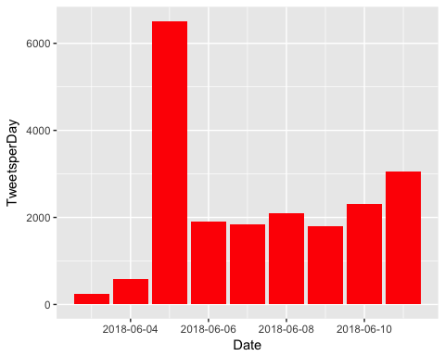

# Top 6 Negative Tweets

## text  
## 1 pattymurray timkaine children separated from their parents are much more likely to suffer abuse this is a despicable policy  
## 2 timkaine jail or stop using why is it that everyone wants to see a shoplifterdealer etc in jail but an addict deserves a pass  
## 3 creep creep creep same creep energy as tim kaine bad //tco/kgejyzvwt2  
## 4 we will eviscerate high tax high crime timkaine in november //tco/xgzczqdis6  
## 5 timkaine very sick america is falling  
## 6 columbiabugle more bizarre than tim kaine's crazy eyebrows  
## retweetCount created screenName  
## 1 0 2018-06-07 00:53:18 MrLes  
## 2 0 2018-06-06 04:38:45 latinajames2256  
## 3 0 2018-06-08 09:45:46 AmyEAdams77  
## 4 46 2018-06-06 14:22:44 CoreyStewartVA  
## 5 0 2018-06-10 23:58:50 roddddk  
## 6 0 2018-06-10 12:19:00 Texas_Fire

# Top 6 Positive Tweets

## text  
## 1 honestlyless timkaine be quite what quite intelligent quite astute quite dapper what should he be quite  
## 2 cnn i thought tim kaine's eyebrow was funny but this is hilarious   
## 3 timkaine clever timmy very clever   
## 4 timkaine my husband likes the dad joke however i laughed because what you said was funny  
## 5 timkaine a good sense of humor is essential in these times thankful for your good character decency humility c //tco/wiabekkurd  
## 6 timkaine timely joke dude there's nothing young folks love more than a good gallagher reference  
## retweetCount created screenName  
## 1 0 2018-06-07 01:40:27 itslikebrandy  
## 2 0 2018-06-11 13:24:41 AtLrg61  
## 3 0 2018-06-05 00:59:08 kathymnh  
## 4 0 2018-06-05 22:19:08 heartfan90  
## 5 0 2018-06-09 17:54:05 rogeratsum  
## 6 0 2018-06-08 19:16:35 micknygard

