## Loading required package: RColorBrewer

## Loading required package: NLP

## Warning: Missing column names filled in: 'X1' [1]

## Parsed with column specification:  
## cols(  
## X1 = col_integer(),  
## text = col_character(),  
## favorited = col_logical(),  
## favoriteCount = col_integer(),  
## replyToSN = col_character(),  
## created = col_datetime(format = ""),  
## truncated = col_logical(),  
## replyToSID = col_double(),  
## id = col_double(),  
## replyToUID = col_double(),  
## statusSource = col_character(),  
## screenName = col_character(),  
## retweetCount = col_integer(),  
## isRetweet = col_logical(),  
## retweeted = col_logical(),  
## longitude = col_character(),  
## latitude = col_character()  
## )

## Warning: Missing column names filled in: 'X1' [1]

## Parsed with column specification:  
## cols(  
## X1 = col_integer(),  
## text = col_character(),  
## favorited = col_logical(),  
## favoriteCount = col_integer(),  
## replyToSN = col_character(),  
## created = col_datetime(format = ""),  
## truncated = col_logical(),  
## replyToSID = col_double(),  
## id = col_double(),  
## replyToUID = col_double(),  
## statusSource = col_character(),  
## screenName = col_character(),  
## retweetCount = col_integer(),  
## isRetweet = col_logical(),  
## retweeted = col_logical(),  
## longitude = col_character(),  
## latitude = col_character()  
## )

Starting of this report by looking as the use of #VASen on twitter, between May 07 and May 23. Twitter returned 963 total tweets between these dates that used this hashtag.

##### How many are retweets?  
   
 table(VA.tweetdf$isRetweet)

##   
## FALSE TRUE   
## 129 834

It appears that 834 out the 963 tweets, or 86.6%, were retweets. this is normal since most of the produced on Twitter are ussually retweets.

WORDCLOUD of Most Frequently used words in tweets, minimum frequency 30

## Warning in wordcloud(names(freq), freq, min.freq = 50, rot.per = 0.2,  
## colors = dark2, : coreystewartva could not be fit on page. It will not be  
## plotted.

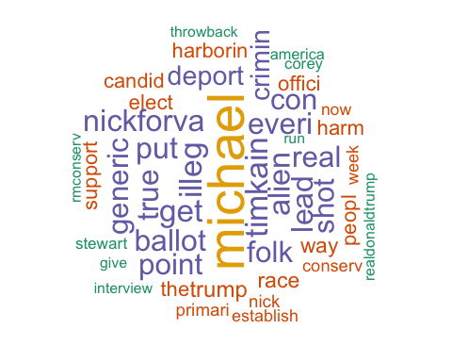

Corey Stewarts handle is the most common used word amongst all the tweets, suggesting that either tweets about Corey Stewart are more likely to use that hashtag than tweets about Nick Freitas.

The second most frequent word is michael. let's find out who michael is.

##   
## Attaching package: 'dplyr'

## The following objects are masked from 'package:twitteR':  
##   
## id, location

## The following objects are masked from 'package:stats':  
##   
## filter, lag

## The following objects are masked from 'package:base':  
##   
## intersect, setdiff, setequal, union

## # A tibble: 7 x 1  
## text  
## <chr>  
## 1 RT @michael__1776: Throwback to @RMConservative's interview with @NickForVA  
## 2 RT @michael__1776: Folks, @timkaine is only leading by 3 points in the gene  
## 3 RT @michael__1776: Proud to have made another donation to @NickForVA, our b  
## 4 RT @michael__1776: 2 weeks ago, conservatives dodged a bullet by rejecting   
## 5 "RT @michael__1776: NEW Arlington and Alexandria #VASen Straw Poll!\n\n@Nic  
## 6 RT @michael__1776: Every Virginian should check out this inspirational vide  
## 7 RT @michael__1776: This is not how we win. All @CoreyStewartVA will do is m

## # A tibble: 7 x 3  
## screenName retweetCount created  
## <chr> <int> <dttm>  
## 1 sandrajdayton 62 2018-05-14 22:35:57  
## 2 luvUSA_ 185 2018-05-09 06:13:18  
## 3 Harbubakre 38 2018-05-22 07:09:08  
## 4 sdc0911 35 2018-05-21 08:42:27  
## 5 sdc0911 20 2018-05-21 08:41:07  
## 6 DJTisDaBomb 20 2018-05-19 02:12:29  
## 7 davealvord164 1 2018-05-18 03:20:39

Seems like the handle @Michael_1776 is the michael refered to in the wordcloud. Although he has only used the hashtag #VASen 7 times during the May 07-May22 period, those 7 tweets have been retweeted a total of 323 times. Below is a screenshot of the account, and above are thos 7 tweets, along with the retweet count and when they were sent out.

PICTURE of ACCOUNT

# List of The Top Ten Frequently used Words

## word freq  
## coreystewartva coreystewartva 387  
## michael michael 323  
## timkain timkain 178  
## illeg illeg 177  
## get get 175  
## alien alien 170  
## nickforva nickforva 168  
## put put 167  
## lead lead 167  
## everi everi 166

Plot of Words that Appear at least 75 times

##   
## Attaching package: 'ggplot2'

## The following object is masked from 'package:NLP':  
##   
## annotate

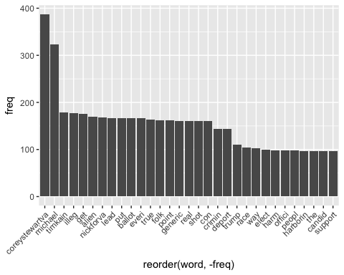

## Words Associated with coreystewartva and nickforva

To find out what words are associated with the candidates, I use a function called FindAssocs() on the dataset. For any given word, findAssocs() calculates its correlation with every other word in the dataset. Scores range from 0 to 1. A score of 1 means that two words always appear together, while a score of 0 means that they never appear together.

# which words are associated with "Corey Stewart"  
   
 findAssocs(tdm,"coreystewartva", 0.1)

## $coreystewartva  
## alien illeg crimin deport   
## 0.55 0.52 0.50 0.50   
## everi put harborin elect   
## 0.42 0.41 0.41 0.40   
## harm offici peopl way   
## 0.40 0.40 0.40 0.39   
## establish realdonaldtrump implemen trum   
## 0.31 0.27 0.27 0.26   
## fill politician prison singl   
## 0.26 0.26 0.26 0.26   
## spot first presid agenda   
## 0.26 0.25 0.25 0.25   
## never counti support entir   
## 0.25 0.23 0.23 0.21   
## fairfax major sanctuari well   
## 0.21 0.21 0.21 0.21   
## join larryoconnor plan today   
## 0.21 0.21 0.21 0.21   
## wmaldc schillingshow talk fix   
## 0.21 0.21 0.20 0.20   
## flat ill kain record   
## 0.20 0.20 0.20 0.20   
## charlottesvill icymi ploy spoke   
## 0.19 0.19 0.19 0.19   
## take girl hunt predat   
## 0.19 0.19 0.19 0.19   
## prey teenag citi america   
## 0.19 0.19 0.18 0.18   
## run tim alexandria arlington   
## 0.18 0.18 0.18 0.18   
## incredi ewjacksonsr show campaign   
## 0.18 0.17 0.15 0.15   
## gang man straw state   
## 0.15 0.15 0.15 0.14   
## time develop nuke weapon   
## 0.14 0.14 0.14 0.14   
## nuclear thing hand poll   
## 0.13 0.13 0.12 0.10

findAssocs(tdm,"nickforva", 0.1)

## $nickforva  
## give interview rmconserv throwback nick   
## 0.52 0.52 0.52 0.52 0.45   
## proud anoth best bring hope   
## 0.45 0.43 0.43 0.43 0.43   
## made donat michael liberti back   
## 0.43 0.42 0.42 0.42 0.38   
## candid race alexandria arlington amaz   
## 0.34 0.33 0.32 0.32 0.32   
## check inspir team truli virginian   
## 0.32 0.32 0.32 0.32 0.32   
## ewjacksonsr primari video incredi bless   
## 0.31 0.31 0.31 0.31 0.31   
## straw the poll new libertyris   
## 0.29 0.26 0.24 0.23 0.23   
## also deploy servic thank tour   
## 0.22 0.22 0.22 0.22 0.22   
## yrs door knock rain big   
## 0.22 0.20 0.20 0.20 0.18   
## inbox news nras organ acsd   
## 0.18 0.18 0.18 0.18 0.18   
## cant nrapvf rate natemaddencrtv curious   
## 0.18 0.17 0.17 0.17 0.17   
## dcaflight tempo everyth leader raiklin   
## 0.16 0.15 0.12 0.12 0.12   
## itschad clear gotten has jfradioshow   
## 0.12 0.12 0.12 0.12 0.12   
## skin under unload endors   
## 0.12 0.12 0.12 0.10

findAssocs(tdm,"ewjacksonsr",0.1 )

## $ewjacksonsr  
## alexandria arlington incredi straw poll   
## 0.98 0.98 0.95 0.91 0.80   
## new nickforva accept among derang   
## 0.79 0.31 0.21 0.21 0.21   
## hate hes prayer spread vulner   
## 0.21 0.21 0.21 0.21 0.21   
## michael coreystewartva   
## 0.19 0.17

## ANALYZING @coreystewartva Tweets period May 07-May 23

## Warning: Missing column names filled in: 'X1' [1]

## Parsed with column specification:  
## cols(  
## X1 = col_integer(),  
## text = col_character(),  
## favorited = col_logical(),  
## favoriteCount = col_integer(),  
## replyToSN = col_character(),  
## created = col_datetime(format = ""),  
## truncated = col_logical(),  
## replyToSID = col_double(),  
## id = col_double(),  
## replyToUID = col_double(),  
## statusSource = col_character(),  
## screenName = col_character(),  
## retweetCount = col_integer(),  
## isRetweet = col_logical(),  
## retweeted = col_logical(),  
## longitude = col_character(),  
## latitude = col_character()  
## )

## Warning: Missing column names filled in: 'X1' [1]

## Parsed with column specification:  
## cols(  
## X1 = col_integer(),  
## text = col_character(),  
## favorited = col_logical(),  
## favoriteCount = col_integer(),  
## replyToSN = col_character(),  
## created = col_datetime(format = ""),  
## truncated = col_logical(),  
## replyToSID = col_double(),  
## id = col_double(),  
## replyToUID = col_double(),  
## statusSource = col_character(),  
## screenName = col_character(),  
## retweetCount = col_integer(),  
## isRetweet = col_logical(),  
## retweeted = col_logical(),  
## longitude = col_character(),  
## latitude = col_character()  
## )

##### How many are retweets?  
   
 table(Stew.tweetdf$isRetweet)

##   
## FALSE TRUE   
## 1049 557

A total of 2265 tweets were sent out between May 07-May 23, and 773 out of 2265 tweets, or 0.34%, are retweets.

### WorldCloud of Most frequent Words

## Warning in wordcloud(names(freq), freq, min.freq = 50, rot.per = 0.2,  
## colors = dark2, : realdonaldtrump could not be fit on page. It will not be  
## plotted.

## Warning in wordcloud(names(freq), freq, min.freq = 50, rot.per = 0.2,  
## colors = dark2, : sykesforsen could not be fit on page. It will not be  
## plotted.

## Warning in wordcloud(names(freq), freq, min.freq = 50, rot.per = 0.2,  
## colors = dark2, : dannytarkanian could not be fit on page. It will not be  
## plotted.

## Warning in wordcloud(names(freq), freq, min.freq = 50, rot.per = 0.2,  
## colors = dark2, : timkain could not be fit on page. It will not be plotted.

## Warning in wordcloud(names(freq), freq, min.freq = 50, rot.per = 0.2,  
## colors = dark2, : lizcheney could not be fit on page. It will not be  
## plotted.

## Warning in wordcloud(names(freq), freq, min.freq = 50, rot.per = 0.2,  
## colors = dark2, : nickforva could not be fit on page. It will not be  
## plotted.

## Warning in wordcloud(names(freq), freq, min.freq = 50, rot.per = 0.2,  
## colors = dark2, : michael could not be fit on page. It will not be plotted.

## Warning in wordcloud(names(freq), freq, min.freq = 50, rot.per = 0.2,  
## colors = dark2, : trump could not be fit on page. It will not be plotted.

## Warning in wordcloud(names(freq), freq, min.freq = 50, rot.per = 0.2,  
## colors = dark2, : gwatson could not be fit on page. It will not be plotted.

## Warning in wordcloud(names(freq), freq, min.freq = 50, rot.per = 0.2,  
## colors = dark2, : cjrossiiiptr could not be fit on page. It will not be  
## plotted.

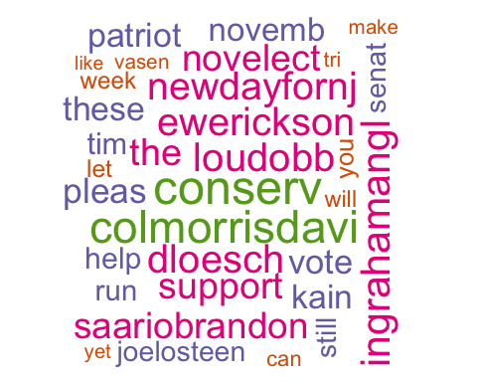

The word cloud is suggesting that the twitter handles of several people (@ColMorrisDavis, @Ingrahamangle, @LouDobbs,@dloesh, @ewerickson) are the most frequent terms that appear in the dataset of tweets relating to @coreystewartva.

### find tweets that use the word  
   
 mike <- VA.tweetdf[grep("ColMorrisDavi",VA.tweetdf$text),]  
   
 #### filter out retweets to only get original tweets  
 mike <- distinct(mike,text,.keep_all=TRUE)  
 mike <- mike[order(mike$retweetCount, decreasing=TRUE),]  
   
 head(select(mike,text,screenName,retweetCount,created), n=7)

## # A tibble: 0 x 4  
## # ... with 4 variables: text <chr>, screenName <chr>, retweetCount <int>,  
## # created <dttm>

mike <- VA.tweetdf[grep("IngrahamAngl",VA.tweetdf$text),]  
   
 #### filter out retweets to only get original tweets  
 mike <- distinct(mike,text,.keep_all=TRUE)  
 mike <- mike[order(mike$retweetCount, decreasing=TRUE),]  
   
 head(select(mike,text,screenName,retweetCount,created), n=7)

## # A tibble: 0 x 4  
## # ... with 4 variables: text <chr>, screenName <chr>, retweetCount <int>,  
## # created <dttm>

mike <- VA.tweetdf[grep("LouDobb",VA.tweetdf$text),]  
   
 #### filter out retweets to only get original tweets  
 mike <- distinct(mike,text,.keep_all=TRUE)  
 mike <- mike[order(mike$retweetCount, decreasing=TRUE),]  
   
 head(select(mike,text,screenName,retweetCount,created), n=7)

## # A tibble: 0 x 4  
## # ... with 4 variables: text <chr>, screenName <chr>, retweetCount <int>,  
## # created <dttm>

mike <- VA.tweetdf[grep("DLoesch",VA.tweetdf$text),]  
   
 #### filter out retweets to only get original tweets  
 mike <- distinct(mike,text,.keep_all=TRUE)  
 mike <- mike[order(mike$retweetCount, decreasing=TRUE),]  
   
 head(select(mike,text,screenName,retweetCount,created), n=7)

## # A tibble: 0 x 4  
## # ... with 4 variables: text <chr>, screenName <chr>, retweetCount <int>,  
## # created <dttm>

mike <- VA.tweetdf[grep("EWErickson",VA.tweetdf$text),]  
   
 #### filter out retweets to only get original tweets  
 mike <- distinct(mike,text,.keep_all=TRUE)  
 mike <- mike[order(mike$retweetCount, decreasing=TRUE),]  
   
 head(select(mike,text,screenName,retweetCount,created), n=7)

## # A tibble: 0 x 4  
## # ... with 4 variables: text <chr>, screenName <chr>, retweetCount <int>,  
## # created <dttm>

### Top 20 frequent terms

## word freq  
## realdonaldtrump realdonaldtrump 259  
## conserv conserv 188  
## colmorrisdavi colmorrisdavi 176  
## ingrahamangl ingrahamangl 153  
## loudobb loudobb 149  
## dloesch dloesch 148  
## ewerickson ewerickson 148  
## newdayfornj newdayfornj 145  
## the the 138  
## support support 137  
## novelect novelect 136  
## saariobrandon saariobrandon 134  
## sykesforsen sykesforsen 134  
## dannytarkanian dannytarkanian 133  
## pleas pleas 127  
## vote vote 123  
## patriot patriot 120  
## these these 120  
## kain kain 119  
## timkain timkain 118

##Frequent Words MINIMUM-75

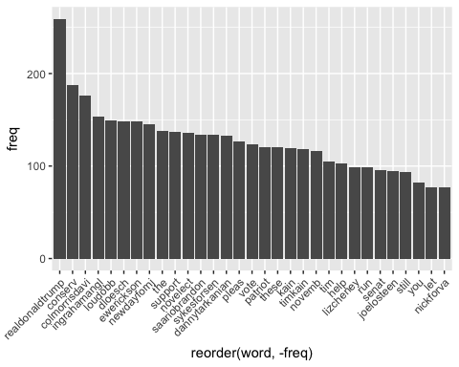

# which words are associated with coreystewartva

# which words are associated with "corey"  
   
 findAssocs(dtm,"coreystewartva", 0.1)

## $coreystewartva  
## director duke   
## 0.79 0.79   
## field david   
## 0.79 0.72   
## exchang promin   
## 0.71 0.71   
## appear worker   
## 0.63 0.63   
## defend donnyferguson   
## 0.50 0.40   
## view combat   
## 0.35 0.35   
## dure militaryappreciationmonth   
## 0.35 0.35   
## veteran randal   
## 0.35 0.35   
## campaign written   
## 0.28 0.25   
## rip twitter   
## 0.25 0.25   
## fed amend   
## 0.25 0.25   
## worth staff   
## 0.25 0.25   
## wound charlottesvill   
## 0.25 0.25   
## georg ralli   
## 0.25 0.25   
## degre photo   
## 0.20 0.15   
## loser isnt   
## 0.14 0.11   
## his prosecut   
## 0.11 0.11

findAssocs(dtm,"republican", 0.1)

## $republican  
## goodlatt pelosi option bill ryderellen   
## 0.45 0.45 0.36 0.33 0.32   
## accur authent bought buck cmte   
## 0.32 0.32 0.32 0.32 0.32   
## degener pass nuclear doj lovethedonald   
## 0.32 0.31 0.28 0.26 0.22   
## favor genflynn loyal current reason   
## 0.22 0.22 0.22 0.22 0.15   
## pretti they definit dude away   
## 0.14 0.13 0.12 0.12 0.11   
## enemi paid understand idiot isnt   
## 0.11 0.11 0.11 0.10 0.10

findAssocs(dtm, "realdonaldtrump", 0.1)

## $realdonaldtrump  
## loudobb dloesch ewerickson ingrahamangl colmorrisdavi   
## 0.73 0.73 0.73 0.71 0.62   
## lizcheney joelosteen lizch block yet   
## 0.58 0.57 0.40 0.39 0.36   
## wmaldc still schillingshow larryoconnor donaldjtrumpjr   
## 0.25 0.24 0.24 0.23 0.15   
## jerryfalwelljr rais therickcanton mickeylenin hand   
## 0.15 0.14 0.13 0.12 0.11   
## promis   
## 0.10

##### Most favorite tweets of the week talking about coreystewartva

##### Most retweeted tweets of the week talking about coreystewartva

##### Most favorite tweets of the week talking about coreystewartva  
 library(dplyr)  
 Stew.tweetdf <- Stew.tweetdf[order(Stew.tweetdf$favoriteCount, decreasing=TRUE),]  
   
 head(select(Stew.tweetdf,text,favoriteCount,created,screenName))

## # A tibble: 6 x 4  
## text  
## <chr>  
## 1 Yet I’m still blocked by @realDonaldTrump ... and @DLoesch and @EWErickson   
## 2 As an Eagle Scout, it’s disheartening to watch the Boy Scouts of America se  
## 3 Every illegal alien criminal should be deported and any elected official wh  
## 4 Liberals like @timkaine would import boatloads of serial murderers if it me  
## 5 Every single criminal illegal alien should be deported and their spot in pr  
## 6 "As flat as Tim Kaine’s record, I’ll fix that too. \n\n#VASen https://t.co/  
## # ... with 3 more variables: favoriteCount <int>, created <dttm>,  
## # screenName <chr>

#head(Stew.tweetdf$text)  
   
   
 ##### Most retweeted tweets of the week talking about coreystewartva  
 Stew.tweetdf <- Stew.tweetdf[order(Stew.tweetdf$retweetCount, decreasing=TRUE),]  
   
 head(select(Stew.tweetdf,text,retweetCount,created,screenName))

## # A tibble: 6 x 4  
## text  
## <chr>  
## 1 RT @DearWhitePeople: Slavery. Slavery is worse. https://t.co/acptOy8AZS  
## 2 RT @DearWhitePeople: Slavery. Slavery is worse. https://t.co/acptOy8AZS  
## 3 RT @realDonaldTrump: The Fake News is working overtime. Just reported that,  
## 4 "RT @DonaldJTrumpJr: And we’re out. Another promise fulfilled ✔️\n\n“When I  
## 5 RT @CoreyStewartVA: @IngrahamAngle said she is going to help us. I am honor  
## 6 RT @bigleaguepol: He wanted Hillary to win https://t.co/Ip9yQNpIM5  
## # ... with 3 more variables: retweetCount <int>, created <dttm>,  
## # screenName <chr>

#head(Stew.tweetdf$text)

### other than from coreystewart's account, most favorited

### other than from coreystewart's account, most retweeted

### other than from coreystewart's account, most favorited   
 temp <- filter(Stew.tweetdf, screenName != 'CoreyStewartVA')  
 temp <- temp[order(temp$favoriteCount, decreasing=TRUE),]  
 head(select(temp,text,favoriteCount,created,screenName))

## # A tibble: 6 x 4  
## text  
## <chr>  
## 1 Yet I’m still blocked by @realDonaldTrump ... and @DLoesch and @EWErickson   
## 2 The @GOP can run Minnesota’s favorite son of Virginia confederate heritage   
## 3 Perhaps @timkaine would say @CoreyStewartVA has an over-inflated sense of t  
## 4 2 weeks ago, conservatives dodged a bullet by rejecting Don Blankenship in   
## 5 "NEW Arlington and Alexandria #VASen Straw Poll!\n\n@NickForVA: 81.2%\n@Cor  
## 6 @ColMorrisDavis @realDonaldTrump @DLoesch @EWErickson @IngrahamAngle @LouDo  
## # ... with 3 more variables: favoriteCount <int>, created <dttm>,  
## # screenName <chr>

### other than from coreystewart's account, most retweeted  
 temp <- filter(Stew.tweetdf, screenName != 'CoreyStewartVA')  
 temp <- temp[order(temp$retweetCount, decreasing=TRUE),]  
 head(select(temp,text,retweetCount,created,screenName))

## # A tibble: 6 x 4  
## text  
## <chr>  
## 1 RT @DearWhitePeople: Slavery. Slavery is worse. https://t.co/acptOy8AZS  
## 2 RT @DearWhitePeople: Slavery. Slavery is worse. https://t.co/acptOy8AZS  
## 3 RT @CoreyStewartVA: @IngrahamAngle said she is going to help us. I am honor  
## 4 RT @Nov2018election: (1) PLEASE SUPPORT THESE CONSERVATIVE PATRIOTS IN NOVE  
## 5 RT @Nov2018election: (1) PLEASE SUPPORT THESE CONSERVATIVE PATRIOTS IN NOVE  
## 6 RT @Nov2018election: (1) PLEASE SUPPORT THESE CONSERVATIVE PATRIOTS IN NOVE  
## # ... with 3 more variables: retweetCount <int>, created <dttm>,  
## # screenName <chr>

### accounts that have the most total Retweets mentioning Corey Stewart

### accounts that have the most total Retweets mentioning Corey Stewart  
 x <- aggregate(temp$retweetCount, by=list(screenName=temp$screenName), FUN=sum)  
 x <- x[order(x$x, decreasing=TRUE),]  
 head(x)

## screenName x  
## 69 beautifulnerdme 60446  
## 825 vittoria_scardi 60446  
## 314 HDowning113 539  
## 353 janiceponchak 452  
## 778 TheGunGuy85 384  
## 566 Nov2018election 331

This Graph plots how frequently is the handle "coreystewartva" is tweeted per day.

##   
## Attaching package: 'scales'

## The following object is masked from 'package:readr':  
##   
## col_factor

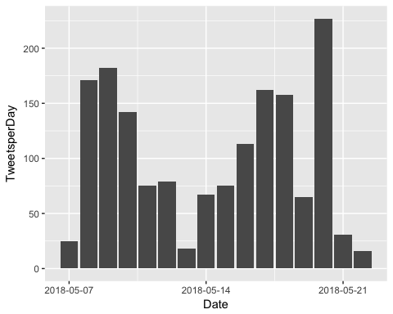

##### How many are retweets?

## Warning: Missing column names filled in: 'X1' [1]

## Parsed with column specification:  
## cols(  
## X1 = col_integer(),  
## text = col_character(),  
## favorited = col_logical(),  
## favoriteCount = col_integer(),  
## replyToSN = col_character(),  
## created = col_datetime(format = ""),  
## truncated = col_logical(),  
## replyToSID = col_double(),  
## id = col_double(),  
## replyToUID = col_double(),  
## statusSource = col_character(),  
## screenName = col_character(),  
## retweetCount = col_integer(),  
## isRetweet = col_logical(),  
## retweeted = col_logical(),  
## longitude = col_character(),  
## latitude = col_character()  
## )

##   
## FALSE TRUE   
## 485 2539

##### worldcloud

## Warning in wordcloud(names(freq), freq, min.freq = 40, rot.per = 0.2,  
## colors = dark2, : mondaymotiv could not be fit on page. It will not be  
## plotted.

## Warning in wordcloud(names(freq), freq, min.freq = 40, rot.per = 0.2,  
## colors = dark2, : campaign could not be fit on page. It will not be  
## plotted.

## Warning in wordcloud(names(freq), freq, min.freq = 40, rot.per = 0.2,  
## colors = dark2, : coreystewartva could not be fit on page. It will not be  
## plotted.

## Warning in wordcloud(names(freq), freq, min.freq = 40, rot.per = 0.2,  
## colors = dark2, : siddonsdan could not be fit on page. It will not be  
## plotted.

## Warning in wordcloud(names(freq), freq, min.freq = 40, rot.per = 0.2,  
## colors = dark2, : gregwesthalojm could not be fit on page. It will not be  
## plotted.

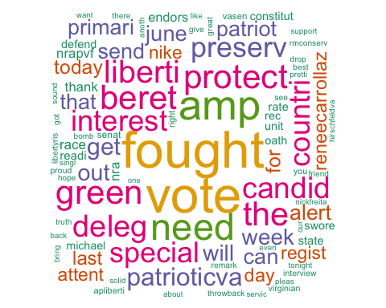

# Plot Word Frequencies

## word freq  
## fought fought 1372  
## vote vote 1358  
## amp amp 1094  
## need need 958  
## protect protect 844  
## beret beret 842  
## green green 842  
## the the 824  
## liberti liberti 776  
## deleg deleg 740  
## candid candid 721  
## interest interest 703  
## countri countri 691  
## special special 688  
## preserv preserv 684  
## patrioticva patrioticva 579  
## get get 544  
## out out 508  
## will will 493  
## week week 488

plot.tweet <- ggplot(subset(wf, freq>200), aes(x = reorder(word, -freq), y = freq)) +  
 geom_bar(stat = "identity") +   
 theme(axis.text.x=element_text(angle=45, hjust=1))  
 plot.tweet

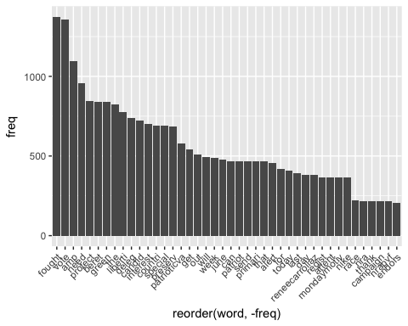

##### Most retweeted tweets of the week talking about nickforva  
 nick.tweetdf <- nick.tweetdf[order(nick.tweetdf$retweetCount, decreasing=TRUE),]  
   
 head(select(nick.tweetdf,text,retweetCount,created,screenName))

## # A tibble: 6 x 4  
## text  
## <chr>  
## 1 RT @President1Trump: Gun debate every American needs to watch! @timkaine Ch  
## 2 "RT @NickForVA: I fought to protect my country as a Green Beret. \n\nAs Del  
## 3 "RT @NickForVA: I fought to protect my country as a Green Beret. \n\nAs Del  
## 4 "RT @NickForVA: I fought to protect my country as a Green Beret. \n\nAs Del  
## 5 "RT @NickForVA: I fought to protect my country as a Green Beret. \n\nAs Del  
## 6 "RT @NickForVA: I fought to protect my country as a Green Beret. \n\nAs Del  
## # ... with 3 more variables: retweetCount <int>, created <dttm>,  
## # screenName <chr>

#head(nick.tweetdf$text)

##### Most favorite tweets of the week talking about nickforVA  
 nick.tweetdf <- as.data.frame(nick.tweetdf)  
 nick.tweetdf <- nick.tweetdf[order(nick.tweetdf$favoriteCount, decreasing=TRUE),]  
   
 head(select(nick.tweetdf,text,favoriteCount,created,screenName))

## text  
## 685 I fought to protect my country as a Green Beret. \n\nAs Delegate, I fought against special interests to preserve our… https://t.co/RA05LDnt4f  
## 1909 Arlington &amp; Alexandria Straw Poll results:\n\nNick Freitas - 81.2%\n\nCorey Stewart - 14.6%\n\nE.W. Jackson - 4.2% \n\nThank you, all!  
## 1192 \xed\xa0\xbd\xed\xba\xa8PATRIOT ALERT\xed\xa0\xbd\xed\xba\xa8\n\nVirginia in 3 weeks on June 12th we need to get out &amp; vote! \n\nWe need a candidate that can &amp; will… https://t.co/vOcevXALKU  
## 1907 I swore an oath to protect and defend the Constitution as a Green Beret, and I’m ready to do the same in the United… https://t.co/bUjtM1aHzV  
## 1724 Thank you again, @NRA &amp; @NRAPVF, for endorsing our campaign!\n\nI am the only candidate in this race with an A+ ratin… https://t.co/ROO7d2Njck  
## 1564 #MondayMotivation\n\n\xed\xa0\xbc\xed\xb7\xba\xed\xa0\xbc\xed\xb7\xb8 Attention Virginia \xed\xa0\xbc\xed\xb7\xba\xed\xa0\xbc\xed\xb7\xb8\n\nToday is the last day to register to vote in the primary! \n\nVOTE for N… https://t.co/sJa8xQHeNe  
## favoriteCount created screenName  
## 685 2287 2018-05-21 21:25:52 NickForVA  
## 1909 826 2018-05-20 02:35:25 NickForVA  
## 1192 542 2018-05-21 23:04:38 Patriotic_Va  
## 1907 448 2018-05-21 17:38:53 NickForVA  
## 1724 428 2018-05-16 20:23:04 NickForVA  
## 1564 391 2018-05-21 19:48:48 ReneeCarrollAZ

### other than from coreystewart's account, most favorited   
 temp <- filter(nick.tweetdf, screenName != 'NickForVA')  
 temp <- temp[order(temp$favoriteCount, decreasing=TRUE),]  
 head(select(temp,text,favoriteCount,created,screenName))

## text  
## 1 \xed\xa0\xbd\xed\xba\xa8PATRIOT ALERT\xed\xa0\xbd\xed\xba\xa8\n\nVirginia in 3 weeks on June 12th we need to get out &amp; vote! \n\nWe need a candidate that can &amp; will… https://t.co/vOcevXALKU  
## 2 #MondayMotivation\n\n\xed\xa0\xbc\xed\xb7\xba\xed\xa0\xbc\xed\xb7\xb8 Attention Virginia \xed\xa0\xbc\xed\xb7\xba\xed\xa0\xbc\xed\xb7\xb8\n\nToday is the last day to register to vote in the primary! \n\nVOTE for N… https://t.co/sJa8xQHeNe  
## 3 Proud to have made another donation to @NickForVA, our best hope for bringing liberty back to Virginia. The primary… https://t.co/3i8RLBsvqZ  
## 4 Throwback to @RMConservative's interview with @NickForVA. Nick is the only candidate in the #VASen race giving us t… https://t.co/X6TakzM3nY  
## 5 It’s a real treat to have my friend and US Senate candidate @NickForVA in the Shenandoah Valley tonight. Nick Freit… https://t.co/FtZShpb6W5  
## 6 Started on the campaign trail for @NickForVA today! I’m so excited to be campaigning for a man of true conservative… https://t.co/rDpunIzTgP  
## favoriteCount created screenName  
## 1 542 2018-05-21 23:04:38 Patriotic_Va  
## 2 391 2018-05-21 19:48:48 ReneeCarrollAZ  
## 3 72 2018-05-21 15:57:29 michael__1776  
## 4 52 2018-05-13 13:38:26 michael__1776  
## 5 51 2018-05-16 23:24:26 MarkObenshain  
## 6 46 2018-05-19 15:33:18 Kesterdaughter

### other than from coreystewart's account, most retweeted  
 temp <- filter(nick.tweetdf, screenName != 'NickForVA')  
 temp <- temp[order(temp$retweetCount, decreasing=TRUE),]  
 head(select(temp,text,retweetCount,created,screenName))

## text  
## 222 RT @President1Trump: Gun debate every American needs to watch! @timkaine Challenger &amp; Republican @NickForVA roils Virginia House on the #2A…  
## 223 RT @NickForVA: I fought to protect my country as a Green Beret. \n\nAs Delegate, I fought against special interests to preserve our liberty a…  
## 224 RT @NickForVA: I fought to protect my country as a Green Beret. \n\nAs Delegate, I fought against special interests to preserve our liberty a…  
## 225 RT @NickForVA: I fought to protect my country as a Green Beret. \n\nAs Delegate, I fought against special interests to preserve our liberty a…  
## 226 RT @NickForVA: I fought to protect my country as a Green Beret. \n\nAs Delegate, I fought against special interests to preserve our liberty a…  
## 227 RT @NickForVA: I fought to protect my country as a Green Beret. \n\nAs Delegate, I fought against special interests to preserve our liberty a…  
## retweetCount created screenName  
## 222 1209 2018-05-19 21:45:09 LeeSutton4  
## 223 740 2018-05-22 16:20:12 rgrobertsii  
## 224 740 2018-05-22 16:18:24 HokieGOP  
## 225 740 2018-05-22 16:08:30 DaWarco  
## 226 740 2018-05-22 16:03:28 The_Nitr0  
## 227 740 2018-05-22 15:58:50 AmyMeye20057495

### accounts that have the most total Retweets mentioning Corey Stewart  
 x <- aggregate(temp$retweetCount, by=list(screenName=temp$screenName), FUN=sum)  
 x <- x[order(x$x, decreasing=TRUE),]  
 head(x)

## screenName x  
## 1083 KJPritchard4 2480  
## 1310 michael__1776 2329  
## 1627 ReneeCarrollAZ 2297  
## 1773 SBelle1950 1995  
## 1136 LeeSutton4 1949  
## 1522 Phibear94 1857

library(ggplot2)  
 library(scales)

#Plotting how often nickforva is tweeted per day  
 nick.tweetdf$Date <- as.Date(nick.tweetdf$created)  
   
 time.freq <- as.data.frame(table(nick.tweetdf$Date))  
 colnames(time.freq) <- c("Date","TweetsperDay")  
 time.freq$Date <- as.Date(time.freq$Date)  
   
 ggplot(data = time.freq,aes(Date,TweetsperDay))+geom_bar(stat="identity")+scale_x_date(labels = date_format("%Y-%m-%d"))

