Georges Colbert

7/16/2018

## Loading required package: RColorBrewer

## Loading required package: NLP

##   
## Attaching package: 'dplyr'

## The following objects are masked from 'package:twitteR':  
##   
## id, location

## The following objects are masked from 'package:stats':  
##   
## filter, lag

## The following objects are masked from 'package:base':  
##   
## intersect, setdiff, setequal, union

##   
## Attaching package: 'ggplot2'

## The following object is masked from 'package:NLP':  
##   
## annotate

## Warning: Missing column names filled in: 'X1' [1]

## Parsed with column specification:  
## cols(  
## X1 = col_integer(),  
## text = col_character(),  
## favorited = col_logical(),  
## favoriteCount = col_integer(),  
## replyToSN = col_character(),  
## created = col_datetime(format = ""),  
## truncated = col_logical(),  
## replyToSID = col_double(),  
## id = col_double(),  
## replyToUID = col_double(),  
## statusSource = col_character(),  
## screenName = col_character(),  
## retweetCount = col_integer(),  
## isRetweet = col_logical(),  
## retweeted = col_logical(),  
## longitude = col_character(),  
## latitude = col_character()  
## )

# Total Number of tweets

nrow(VA.tweetdf)

## [1] 538

# Number of Tweets per Day

##   
## Attaching package: 'scales'

## The following object is masked from 'package:readr':  
##   
## col_factor

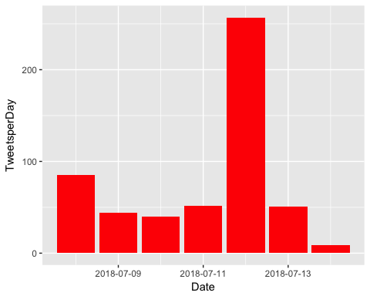

# How many are retweets?

##### How many are retweets?  
   
 table(VA.tweetdf$isRetweet)

##   
## FALSE TRUE   
## 70 468

q <- grepl("CoreyStewartVA|Corey|corey|Stewart|stewart", VA.tweetdf$text)  
  
 q <- table(q)  
q <- as.data.frame(q)  
  
colnames(q) <- c("Mentions Corey Stewart", "Count")  
  
q

## Mentions Corey Stewart Count  
## 1 FALSE 92  
## 2 TRUE 446

ggplot(q, aes(`Mentions Corey Stewart`, Count))+geom_bar(stat="identity", fill="red")+ ggtitle("Mentions Corey Stewart?")

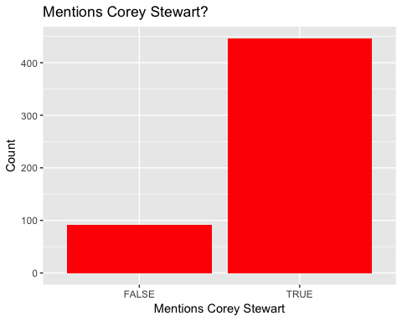

p <- grepl("Tim|tim|kaine|Kaine|timkaine", VA.tweetdf$text)  
  
 p <- table(p)  
   
 p <- as.data.frame(p)  
   
colnames(p) <- c("Mentions Tim Kaine", "Count")  
  
ggplot(p, aes(`Mentions Tim Kaine`, Count))+geom_bar(stat="identity", fill="blue")+ ggtitle("Mentions Tim Kaine?")

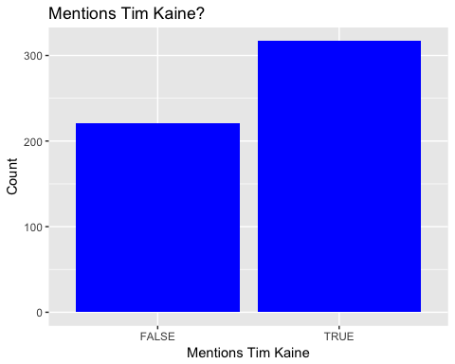

### list of top 6 favorite tweets of the period

## text  
## 1 Check out our new ad: Kaine attended an "Abolish ICE" rally on June 30 and has done nothing in D.C. but raise taxes… https://t.co/lrN6xz7oWM  
## 2 .@realDonaldTrump has brought America's economy back. \n\n&gt;Econ Growth is at 4%. \n&gt;Unemployment is at its lowest in 1… https://t.co/k5R0FN1yyp  
## 3 NEW: @timkaine raised $2.2M in Q2, bringing total raised this cycle to $18.2M. We've also made an early $5M investm… https://t.co/cvaH51ukyp  
## 4 My first map! 2014 #VASEN -- Huge thanks to @cinyc9 @JMilesColeman @SenhorRaposa @liberaljoy for helping out. https://t.co/Rk4uRAFMnQ  
## 5 .@TimKaine blocking out TV advertising time in #VaSen elex, booking $5M for the fall -- and it's not even August. D… https://t.co/trxxG8NyMW  
## 6 Glad to see Sen. @timkaine focusing on rural VA. #VASen https://t.co/Bnl8JDcYWw  
## favoriteCount created screenName  
## 1 467 2018-07-12 02:52:09 CoreyStewartVA  
## 2 241 2018-07-08 16:37:45 CoreyStewartVA  
## 3 55 2018-07-11 18:49:22 IanSams  
## 4 33 2018-07-10 07:14:18 ChazNuttycombe  
## 5 24 2018-07-11 18:25:35 RTDSchapiro  
## 6 20 2018-07-10 02:47:34 politico_chris

# top 6 retweeted tweets of the period

## text  
## 1 Check out our new ad: Kaine attended an "Abolish ICE" rally on June 30 and has done nothing in D.C. but raise taxes… https://t.co/lrN6xz7oWM  
## 2 .@realDonaldTrump has brought America's economy back. \n\n&gt;Econ Growth is at 4%. \n&gt;Unemployment is at its lowest in 1… https://t.co/k5R0FN1yyp  
## 3 NEW: @timkaine raised $2.2M in Q2, bringing total raised this cycle to $18.2M. We've also made an early $5M investm… https://t.co/cvaH51ukyp  
## 4 .@TimKaine blocking out TV advertising time in #VaSen elex, booking $5M for the fall -- and it's not even August. D… https://t.co/trxxG8NyMW  
## 5 Today @jfradioshow asked @DaveBratVA7th if he would campaign with @CoreyStewartVA or not.\n\nBrat spent ***4 minutes*… https://t.co/uQ0cAR0Emp  
## 6 My first map! 2014 #VASEN -- Huge thanks to @cinyc9 @JMilesColeman @SenhorRaposa @liberaljoy for helping out. https://t.co/Rk4uRAFMnQ  
## retweetCount created screenName  
## 1 298 2018-07-12 02:52:09 CoreyStewartVA  
## 2 108 2018-07-08 16:37:45 CoreyStewartVA  
## 3 12 2018-07-11 18:49:22 IanSams  
## 4 8 2018-07-11 18:25:35 RTDSchapiro  
## 5 8 2018-07-09 18:01:57 AndrewBatesNC  
## 6 6 2018-07-10 07:14:18 ChazNuttycombe

### Top ten retweets overall

In this case, there were tweets that were creeated before the week that were still being shared on Twitter and accumulating retweets.

I <- VA.tweetdf[order(VA.tweetdf$retweetCount, decreasing=TRUE),]  
  
  
 I <- I[!duplicated(I$text),]  
  
  
I <- head(select(I,text,retweetCount,created,screenName,isRetweet),10)  
   
 as.data.frame(I)

## text  
## 1 RT @CoreyStewartVA: Check out our new ad: Kaine attended an "Abolish ICE" rally on June 30 and has done nothing in D.C. but raise taxes, su…  
## 2 Check out our new ad: Kaine attended an "Abolish ICE" rally on June 30 and has done nothing in D.C. but raise taxes… https://t.co/lrN6xz7oWM  
## 3 RT @CoreyStewartVA: There are more jobs than people out of work, something the American economy has never experienced before!\n\nThank you, @…  
## 4 RT @CoreyStewartVA: .@realDonaldTrump has brought America's economy back. \n\n&gt;Econ Growth is at 4%. \n&gt;Unemployment is at its lowest in 18 ye…  
## 5 .@realDonaldTrump has brought America's economy back. \n\n&gt;Econ Growth is at 4%. \n&gt;Unemployment is at its lowest in 1… https://t.co/k5R0FN1yyp  
## 6 RT @SiriusXMPatriot: Fresh off his victory in the Republican #VASen Primary .@CoreyStewartVA says the #Democrats and @timkaine have betraye…  
## 7 RT @CoreyStewartVA: Yesterday, we rallied outside of the Red Hen with @realDonaldTrump supporters and @trump_bikers in Lexington!\n\nWatch ou…  
## 8 RT @CoreyStewartVA: At the Dale City Parade celebrating Independence Day\n\n #VaSen #MAGA #Virginia #July4th https://t.co/pxnJVQ1XlG  
## 9 RT @CoreyStewartVA: .@realDonaldTrump &amp; House unveiled the largest tax cut in history, bringing jobs back. Will Senate support? @TimKaine w…  
## 10 RT @CoreyStewartVA: Huge support at the Purcellville parade!\n\n#VASen #MAGA https://t.co/qCMzi4wSd0  
## retweetCount created screenName isRetweet  
## 1 298 2018-07-14 12:34:35 CarrierTo TRUE  
## 2 298 2018-07-12 02:52:09 CoreyStewartVA FALSE  
## 3 167 2018-07-12 02:41:34 slewfan TRUE  
## 4 108 2018-07-13 13:42:58 HDowning113 TRUE  
## 5 108 2018-07-08 16:37:45 CoreyStewartVA FALSE  
## 6 101 2018-07-13 19:31:52 RealLHunterJ TRUE  
## 7 78 2018-07-12 17:31:30 ggmsmolly TRUE  
## 8 65 2018-07-13 13:43:13 HDowning113 TRUE  
## 9 62 2018-07-10 00:44:55 R98250729 TRUE  
## 10 46 2018-07-12 03:07:22 mindset2growth TRUE

## accounts that have the most total Retweets

## screenName x  
## 8 CoreyStewartVA 406  
## 5 ChazNuttycombe 14  
## 16 IanSams 14  
## 2 AndrewBatesNC 8  
## 9 Croatansound 8  
## 26 RTDSchapiro 8

## Most Active Accounts (including Retweets)

## Var1 Freq  
## 73 Croatansound 15  
## 58 ChinWusu 9  
## 351 SackComedian 6  
## 50 CarrierTo 5  
## 56 ChazNuttycombe 5  
## 417 winegirl73 5

## Most Active Accounts

## Var1 Freq  
## 6 ChinWusu 8  
## 9 Croatansound 8  
## 28 SackComedian 5  
## 5 ChazNuttycombe 4  
## 16 IanSams 4  
## 31 TweetrHandle 4

# WORDCLOUD of most common used words

# WORDCLOUD of most common used words (Top 40)

library(wordcloud)  
 dark2 <- brewer.pal(6, "Dark2")  
 wordcloud(names(freq), freq, min.freq = 50, rot.per=0.2, colors=dark2,random.order = F)

## Warning in wordcloud(names(freq), freq, min.freq = 50, rot.per = 0.2,  
## colors = dark2, : coreystewartva could not be fit on page. It will not be  
## plotted.

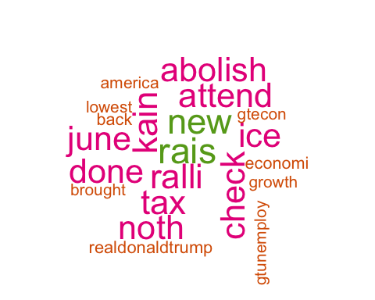

# List of The Top 15 Frequently used Words

## word freq  
## coreystewartva coreystewartva 428  
## rais rais 294  
## new new 288  
## kain kain 276  
## ralli ralli 275  
## tax tax 274  
## attend attend 272  
## check check 271  
## abolish abolish 270  
## done done 270  
## ice ice 270  
## june june 270  
## noth noth 270  
## realdonaldtrump realdonaldtrump 107  
## back back 104

# Plot of Words that Appear at least 75 times

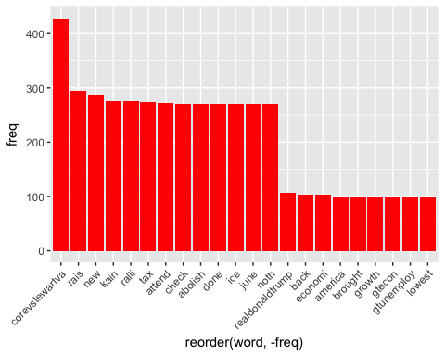

## Words Associated with

To find out what words are associated with the candidates, I use a function called FindAssocs() on the dataset. For any given word, findAssocs() calculates its correlation with every other word in the dataset. Scores range from 0 to 1. A score of 1 means that two words always appear together, while a score of 0 means that they never appear together.

# which words are associated with "Corey Stewart"  
   
 findAssocs(tdm,"coreystewartva", 0.1)

## $coreystewartva  
## ralli abolish attend done   
## 0.51 0.50 0.50 0.50   
## ice june noth check   
## 0.50 0.50 0.50 0.49   
## tax kain new rais   
## 0.49 0.47 0.37 0.30   
## back economi realdonaldtrump brought   
## 0.24 0.24 0.23 0.23   
## growth gtecon gtunemploy lowest   
## 0.23 0.23 0.23 0.23   
## america   
## 0.22

findAssocs(tdm,"timkain", 0.1)

## $timkain  
## also bring cycl earli   
## 0.56 0.56 0.56 0.56   
## made total weve invest   
## 0.56 0.56 0.56 0.53   
## iansam democrat advertis august   
## 0.48 0.45 0.45 0.45   
## block book elex fall   
## 0.45 0.45 0.45 0.42   
## rtdschapiro even time jenniferwexton   
## 0.42 0.40 0.40 0.32   
## abolishic answer lesliecockburn spanbergerva   
## 0.28 0.28 0.28 0.28   
## still elaineluriava hawkdiesel vabeachdem   
## 0.28 0.28 0.28 0.28   
## vademocrat gerryconnolli hillaryclinton want   
## 0.28 0.22 0.22 0.22   
## sackcomedian virginianpilot garrenshipley accus   
## 0.22 0.20 0.18 0.16   
## karl marx betray fresh   
## 0.16 0.16 0.16 0.16   
## siriusxmpatriot victori add qanon   
## 0.16 0.16 0.16 0.16   
## around came frankoanderson region   
## 0.16 0.16 0.16 0.16   
## basicallynhpolit hey laurahbry yeah   
## 0.16 0.16 0.16 0.16   
## coreystewart elect firekain takebackva   
## 0.16 0.16 0.16 0.16   
## investm bostoninform massachusett focus   
## 0.16 0.16 0.16 0.16   
## rural sen come isnt   
## 0.16 0.16 0.16 0.16   
## may pass shock cut   
## 0.16 0.16 0.16 0.16   
## histori largest unveil amer   
## 0.16 0.16 0.16 0.16   
## comey haitifir hear peterstrzok   
## 0.16 0.16 0.16 0.16   
## thing scotttaylorva like primari   
## 0.16 0.13 0.13 0.10   
## other that thedemocrat north   
## 0.10 0.10 0.10 0.10   
## hous scotus violentleft   
## 0.10 0.10 0.10

findAssocs(tdm,"trump",0.1 )

## $trump  
## conspir hack judg report   
## 0.58 0.58 0.58 0.58   
## russian suit toss vase   
## 0.58 0.58 0.58 0.58   
## cadinet harass lib mood   
## 0.58 0.58 0.58 0.58   
## reg repmaxinewat anoth cuckservativ   
## 0.58 0.58 0.58 0.58   
## deafen kavanaugh wonder silenc   
## 0.58 0.58 0.58 0.41   
## alleg potus pick dem   
## 0.41 0.41 0.33 0.28   
## therussiahoax this just call   
## 0.28 0.28 0.25 0.25   
## muellerwitchhunt think even like   
## 0.23 0.23 0.17 0.17   
## croatansound campaign amp   
## 0.16 0.14 0.11

## Warning: Missing column names filled in: 'X1' [1]

## Parsed with column specification:  
## cols(  
## X1 = col_integer(),  
## text = col_character(),  
## favorited = col_logical(),  
## favoriteCount = col_integer(),  
## replyToSN = col_character(),  
## created = col_datetime(format = ""),  
## truncated = col_logical(),  
## replyToSID = col_double(),  
## id = col_double(),  
## replyToUID = col_double(),  
## statusSource = col_character(),  
## screenName = col_character(),  
## retweetCount = col_integer(),  
## isRetweet = col_logical(),  
## retweeted = col_logical(),  
## longitude = col_character(),  
## latitude = col_character()  
## )

# Top 6 Negative Tweets

## text  
## 1 Stupid @CNN exposes team @RalphNortham organ harvesting #MedicalWarfare exploitation of disasters in Haiti yet can'… https://t.co/I47KoFjbjq  
## 2 Cult within a cult. Police Chief for Biscayne Park ( #Miami ) ordered select few to pick up random vagrants &amp; pin h… https://t.co/x63OdDTQ3z  
## 3 @Scotttaylorva with an epidemic of gun violence occurring across America, killing Americans every day, including sc… https://t.co/H5LNQYFY0o  
## 4 Has a Virginian I'm glad this "Sky is Falling" Democrat &amp; former Governor term is up, but he did leave a stain in R… https://t.co/PHfft32jy3  
## 5 It’s not enough for conservatives to be quiet &amp; not openly endorse. I need to know they find abhorrent behavior to… https://t.co/pTflQaCBXm  
## 6 \xed\xa0\xbe\xed\xb4\x94 @NickForVA is hitting the trail for GOP congressionals (who refuse to stump with @CoreyStewartVA btw) despite hav… https://t.co/F1nD0jKd7P  
## retweetCount created screenName  
## 1 0 2018-07-08 06:29:30 ChinWusu  
## 2 0 2018-07-14 05:15:23 CarrierTo  
## 3 0 2018-07-12 00:54:05 MatHelman  
## 4 0 2018-07-10 21:50:55 Croatansound  
## 5 0 2018-07-08 12:27:00 legal_lou  
## 6 0 2018-07-12 17:53:48 IanSams

# Top 6 Positive Tweets

## text  
## 1 "I am one of @Scotttaylorva's constituents. I'm not stupid, and I most definitely care what he thinks about… https://t.co/xqSZ6D1pVf  
## 2 Great news that the beautiful Happy Hands Club has endorsed both @CoreyStewartVA for #VAsen &amp; @kelliwardaz for… https://t.co/h90DZWCLgR  
## 3 My first map! 2014 #VASEN -- Huge thanks to @cinyc9 @JMilesColeman @SenhorRaposa @liberaljoy for helping out. https://t.co/Rk4uRAFMnQ  
## 4 @jfradioshow @newsadvance Pickle? By nominating @CoreyStewartVA, a tiny plurality of the Virginia GOP primary voter… https://t.co/5AqufN2212  
## 5 Glad to see Sen. @timkaine focusing on rural VA. #VASen https://t.co/Bnl8JDcYWw  
## 6 Today we are making some major changes in our senate battleground map: #NDSEN Tossup to Lean R, #NVSEN Tossup to Le… https://t.co/6tGYWLNMqx  
## retweetCount created screenName  
## 1 2 2018-07-10 16:55:46 IanSams  
## 2 1 2018-07-09 11:20:33 CarrierTo  
## 3 6 2018-07-10 07:14:18 ChazNuttycombe  
## 4 0 2018-07-14 00:55:44 aarongcigars  
## 5 0 2018-07-10 02:47:34 politico_chris  
## 6 0 2018-07-10 18:59:52 Decision_Desk

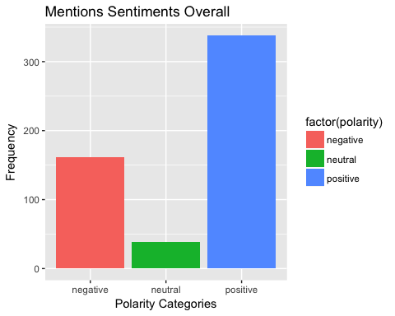 # WorldCloud of words used in top 50 most negative and top 50 most positive tweets

## Length Class Mode  
## negative.txt 2 PlainTextDocument list  
## positive.txt 2 PlainTextDocument list

colnames(tc2_matrix) <- c("negative Tweets", "Positive Tweets")  
comparison.cloud(tc2_matrix, max.words = 24,colors=brewer.pal(ncol(tc2_matrix),"Dark2"), random.order = FALSE)

## Warning in brewer.pal(ncol(tc2_matrix), "Dark2"): minimal value for n is 3, returning requested palette with 3 different levels

