#VASen Analysis

Georges Colbert

6/12/2018

**Period of June 03 to June 11**

## Loading required package: RColorBrewer

## Loading required package: NLP

##   
## Attaching package: 'dplyr'

## The following objects are masked from 'package:twitteR':  
##   
## id, location

## The following objects are masked from 'package:stats':  
##   
## filter, lag

## The following objects are masked from 'package:base':  
##   
## intersect, setdiff, setequal, union

## Warning: Missing column names filled in: 'X1' [1]

## Parsed with column specification:  
## cols(  
## X1 = col_integer(),  
## text = col_character(),  
## favorited = col_logical(),  
## favoriteCount = col_integer(),  
## replyToSN = col_character(),  
## created = col_datetime(format = ""),  
## truncated = col_logical(),  
## replyToSID = col_double(),  
## id = col_double(),  
## replyToUID = col_double(),  
## statusSource = col_character(),  
## screenName = col_character(),  
## retweetCount = col_integer(),  
## isRetweet = col_logical(),  
## retweeted = col_logical(),  
## longitude = col_character(),  
## latitude = col_character()  
## )

# Total Number of tweets

nrow(VA.tweetdf)

## [1] 7494

# How many are retweets?

##### How many are retweets?  
   
 table(VA.tweetdf$isRetweet)

##   
## FALSE TRUE   
## 369 7125

### list of top 6 favorite tweets of the period

## text  
## 1 Tomorrow is Election Day in Virginia &amp; I will be voting Republican. \n\nNothing is going to stop me from voting tomor… https://t.co/oaoZWEfLph  
## 2 I have an A+ rating from the @NRA and I am the only candidate endorsed by the @NRAPVF in this election. \n\nOur Secon… https://t.co/SZSEjVzAWF  
## 3 Don't let politicians deceive you. Vote Nick Freitas on June 12. #LibertyRising #VASen #VAPol https://t.co/AuA98g9Yua  
## 4 Only one day left until the primary and we must defeat @TimKaine in November!\n\nMake sure to vote tomorrow!… https://t.co/PbxT3Hwqt8  
## 5 Green Beret Combat Veteran and member of the Virginia House of Delegates @NickForVA will crush @timkaine this Novem… https://t.co/ctjDHqsGSs  
## 6 In three days - history will be made in the Commonwealth of Virginia.\n\nThank you to everyone who came out today in… https://t.co/MnMgqr1MCs  
## favoriteCount created screenName  
## 1 7065 2018-06-11 16:23:58 ScottPresler  
## 2 1439 2018-06-10 13:32:01 NickForVA  
## 3 1168 2018-06-10 20:25:24 NickForVA  
## 4 917 2018-06-11 13:12:26 NickForVA  
## 5 815 2018-06-10 16:12:14 Stump_for_Trump  
## 6 542 2018-06-09 17:40:06 NickForVA

# top 6 retweeted tweets of the period

## text  
## 1 Tomorrow is Election Day in Virginia &amp; I will be voting Republican. \n\nNothing is going to stop me from voting tomor… https://t.co/oaoZWEfLph  
## 2 I have an A+ rating from the @NRA and I am the only candidate endorsed by the @NRAPVF in this election. \n\nOur Secon… https://t.co/SZSEjVzAWF  
## 3 Green Beret Combat Veteran and member of the Virginia House of Delegates @NickForVA will crush @timkaine this Novem… https://t.co/ctjDHqsGSs  
## 4 Don't let politicians deceive you. Vote Nick Freitas on June 12. #LibertyRising #VASen #VAPol https://t.co/AuA98g9Yua  
## 5 Only one day left until the primary and we must defeat @TimKaine in November!\n\nMake sure to vote tomorrow!… https://t.co/PbxT3Hwqt8  
## 6 \xed\xa0\xbd\xed\xb4\xb4 VIRGINIA VOTE JUNE 12TH ✔️ \n\n\xed\xa0\xbd\xed\xb4\xb4COREY STEWART FOR US SENATE @CoreyStewartVA \n\n\xed\xa0\xbd\xed\xb4\xb4 CONSERVATIVE REPUBLICAN AND FORMER… https://t.co/njRWaTEK7y  
## retweetCount created screenName  
## 1 3083 2018-06-11 16:23:58 ScottPresler  
## 2 611 2018-06-10 13:32:01 NickForVA  
## 3 575 2018-06-10 16:12:14 Stump_for_Trump  
## 4 521 2018-06-10 20:25:24 NickForVA  
## 5 455 2018-06-11 13:12:26 NickForVA  
## 6 165 2018-06-07 18:20:56 Nov2018election

### Top ten retweets overall

In this case, there were tweets that were creeated before the week that were still being shared on Twitter and accumulating retweets.

I <- VA.tweetdf[order(VA.tweetdf$retweetCount, decreasing=TRUE),]  
  
  
 I <- I[!duplicated(I$text),]  
  
  
I <- head(select(I,text,retweetCount,created,screenName,isRetweet),10)  
   
 as.data.frame(I)

## text  
## 1 RT @ScottPresler: Tomorrow is Election Day in Virginia &amp; I will be voting Republican. \n\nNothing is going to stop me from voting tomorrow or…  
## 2 Tomorrow is Election Day in Virginia &amp; I will be voting Republican. \n\nNothing is going to stop me from voting tomor… https://t.co/oaoZWEfLph  
## 3 RT @NickForVA: I have an A+ rating from the @NRA and I am the only candidate endorsed by the @NRAPVF in this election. \n\nOur Second Amendme…  
## 4 I have an A+ rating from the @NRA and I am the only candidate endorsed by the @NRAPVF in this election. \n\nOur Secon… https://t.co/SZSEjVzAWF  
## 5 RT @Stump_for_Trump: Green Beret Combat Veteran and member of the Virginia House of Delegates @NickForVA will crush @timkaine this November…  
## 6 Green Beret Combat Veteran and member of the Virginia House of Delegates @NickForVA will crush @timkaine this Novem… https://t.co/ctjDHqsGSs  
## 7 RT @NickForVA: Don't let politicians deceive you. Vote Nick Freitas on June 12. #LibertyRising #VASen #VAPol https://t.co/AuA98g9Yua  
## 8 Don't let politicians deceive you. Vote Nick Freitas on June 12. #LibertyRising #VASen #VAPol https://t.co/AuA98g9Yua  
## 9 RT @NickForVA: Only one day left until the primary and we must defeat @TimKaine in November!\n\nMake sure to vote tomorrow!\n\n#LibertyRising #…  
## 10 Only one day left until the primary and we must defeat @TimKaine in November!\n\nMake sure to vote tomorrow!… https://t.co/PbxT3Hwqt8  
## retweetCount created screenName isRetweet  
## 1 3083 2018-06-11 23:59:33 premoujari TRUE  
## 2 3083 2018-06-11 16:23:58 ScottPresler FALSE  
## 3 611 2018-06-11 23:52:27 azkathmath TRUE  
## 4 611 2018-06-10 13:32:01 NickForVA FALSE  
## 5 575 2018-06-11 23:07:04 MDTyszka TRUE  
## 6 575 2018-06-10 16:12:14 Stump_for_Trump FALSE  
## 7 521 2018-06-11 23:42:40 andimriggs TRUE  
## 8 521 2018-06-10 20:25:24 NickForVA FALSE  
## 9 455 2018-06-11 23:56:56 pcakes3636 TRUE  
## 10 455 2018-06-11 13:12:26 NickForVA FALSE

## accounts that have the most total Retweets

## screenName x  
## 134 ScottPresler 3083  
## 107 NickForVA 2163  
## 32 CoreyStewartVA 830  
## 144 Stump_for_Trump 575  
## 109 Nov2018election 332  
## 101 michael__1776 206

## Most Active Accounts (including Retweets)

## Var1 Freq  
## 3224 MFEUZ3 89  
## 3231 michael__1776 89  
## 3534 Nov2018election 33  
## 2067 IanTreyParish 29  
## 2126 ItsChad 28  
## 3759 Phibear94 28

## Most Active Accounts

## Var1 Freq  
## 100 MFEUZ3 33  
## 128 RollinReisinger 23  
## 32 CoreyStewartVA 16  
## 101 michael__1776 12  
## 107 NickForVA 10  
## 7 ali 9

# WORDCLOUD of most common used words

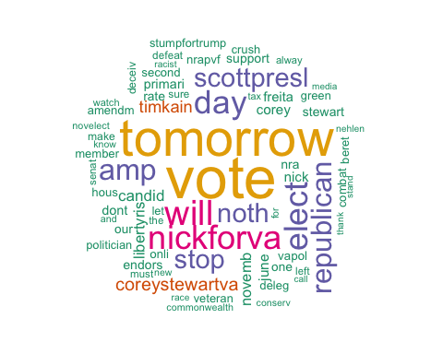

# List of The Top Ten Frequently used Words

## word freq  
## vote vote 5897  
## tomorrow tomorrow 5037  
## will will 3143  
## nickforva nickforva 2981  
## elect elect 2912  
## day day 2869  
## amp amp 2565  
## republican republican 2449  
## noth noth 2226  
## stop stop 2226  
## scottpresl scottpresl 2224  
## coreystewartva coreystewartva 1247  
## timkain timkain 1089  
## candid candid 958  
## libertyris libertyris 921

# Plot of Words that Appear at least 500 times

##   
## Attaching package: 'ggplot2'

## The following object is masked from 'package:NLP':  
##   
## annotate

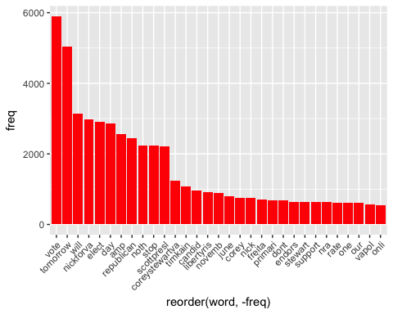

## Words Associated with

To find out what words are associated with the candidates, I use a function called FindAssocs() on the dataset. For any given word, findAssocs() calculates its correlation with every other word in the dataset. Scores range from 0 to 1. A score of 1 means that two words always appear together, while a score of 0 means that they never appear together.

# which words are associated with "Corey Stewart"  
   
 findAssocs(tdm,"coreystewartva", 0.1)

## $coreystewartva  
## novelect new stand for   
## 0.39 0.39 0.35 0.34   
## alway nevertrump nevertrumpnick estab   
## 0.34 0.33 0.33 0.31   
## far radio spread wide   
## 0.31 0.31 0.31 0.31   
## tru vagop former realdonaldtrump   
## 0.30 0.29 0.29 0.28   
## conserv antitr proamnesti stood   
## 0.27 0.27 0.27 0.27   
## check cut hdown stewart   
## 0.26 0.26 0.26 0.25   
## and attack were ive   
## 0.25 0.24 0.24 0.24   
## bigot oppon corey democrat   
## 0.23 0.22 0.20 0.19   
## vapolit billkristol enough tabl   
## 0.19 0.19 0.18 0.18   
## jackposobiec whaddya alien crimin   
## 0.18 0.18 0.18 0.18   
## deport everi illeg immin   
## 0.18 0.18 0.18 0.17   
## onslaught step tough withstand   
## 0.17 0.17 0.17 0.17   
## pro watch centuri dinner   
## 0.17 0.17 0.17 0.17   
## purpos religion talk version   
## 0.17 0.17 0.17 0.17   
## admit hey lie polit   
## 0.17 0.17 0.16 0.16   
## cri nickfreitasva silenc violentleft   
## 0.16 0.16 0.16 0.16   
## enforc worker declar jurisdict   
## 0.16 0.16 0.16 0.16   
## replac sanct fundrais kfile   
## 0.16 0.16 0.16 0.16   
## paid ryanobl opposit now   
## 0.16 0.16 0.15 0.15   
## fenc happi side law   
## 0.15 0.15 0.15 0.15   
## email tax your guy   
## 0.15 0.14 0.14 0.14   
## met traitor releas tonight   
## 0.14 0.14 0.14 0.14   
## you timphillipsafp miss antiamerican   
## 0.13 0.13 0.13 0.12   
## apolog imm kristol neocon   
## 0.12 0.12 0.12 0.12   
## warmong with congrat congression   
## 0.12 0.12 0.12 0.12   
## denverva district drai forward   
## 0.12 0.12 0.12 0.12   
## look hillaryclinton listen june   
## 0.12 0.12 0.11 0.11   
## paul racebait covet endorsemen   
## 0.11 0.11 0.11 0.11   
## motto semper sic similar   
## 0.11 0.11 0.11 0.11   
## tyranni list hero breitbartnew   
## 0.11 0.11 0.11 0.10   
## fan facebook show want   
## 0.10 0.10 0.10 0.10   
## allcap awesom cap fairfax   
## 0.10 0.10 0.10 0.10

findAssocs(tdm,"nickforva", 0.1)

## $nickforva  
## timkain libertyris novemb nra rate   
## 0.47 0.45 0.44 0.37 0.37   
## amendm nrapvf second deleg hous   
## 0.34 0.34 0.34 0.34 0.34   
## member beret combat crush green   
## 0.34 0.33 0.33 0.33 0.33   
## stumpfortrump veteran endors deceiv dont   
## 0.33 0.33 0.32 0.31 0.31   
## our vapol let onli sure   
## 0.30 0.30 0.30 0.29 0.29   
## make must defeat left politician   
## 0.28 0.28 0.27 0.27 0.27   
## candid nick thank freita market   
## 0.25 0.21 0.19 0.19 0.17   
## horri latest one june critic   
## 0.17 0.17 0.16 0.16 0.16   
## movement prolif vot came select   
## 0.16 0.16 0.16 0.16 0.16   
## think primari fact histori made   
## 0.16 0.15 0.15 0.15 0.15   
## three import staunch today media   
## 0.15 0.13 0.13 0.12 0.11   
## senat commonwealth host mov everyon   
## 0.11 0.11 0.11 0.11 0.11   
## racist honor   
## 0.11 0.10

findAssocs(tdm,"timkaine",0.1 )

## $timkaine  
## numeric(0)

# Number of Tweets per Day

##   
## Attaching package: 'scales'

## The following object is masked from 'package:readr':  
##   
## col_factor

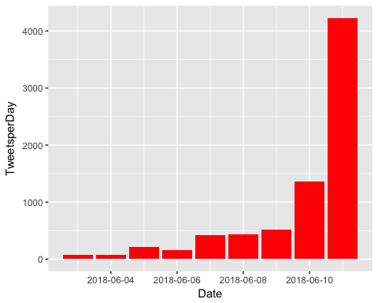

# Top 10 Negative Tweets

## text  
## 1 breaking coreystewava refuses to condemn and disavow neonazi paul nehlen who he called his herovasen //tco/l4sppp9tpd  
## 2 this is truly abhorrent and repugnant stuff here folks coreystewava should immediately drop out of the vasen //tco/z3vcpy6twk  
## 3 the bill lumaye show is live discussing1 the g7 canadas huge miscalculation amp trumps fight for america2 a //tco/ueip5btzyl  
## 4 every criminal illegal alien should be depoed and replaced with the politicians who declare their jurisdictions s //tco/iyardhehke  
## 5 in vasen nickforva says coreystewava's refusal to disavow paul nehlen and his racist views is especially dis //tco/ok3kdll6q0  
## 6 freitas in final web ad before vasen republican primaryi don't think corey stewa is a racist but i know he //tco/nng4wva62p  
## retweetCount created screenName  
## 1 10 2018-06-05 18:29:14 michael__1776  
## 2 0 2018-06-04 17:04:05 michael__1776  
## 3 5 2018-06-11 19:11:23 bigleaguepol  
## 4 51 2018-06-03 15:48:30 CoreyStewartVA  
## 5 3 2018-06-06 18:58:44 RollinReisinger  
## 6 10 2018-06-08 17:26:20 gmoomaw

# Top 10 Positive Tweets

## text  
## 1 tfw you pretend to be antiestablishment but then are happy to accept their suppovasen //tco/br0nf510kz  
## 2 conventional wisdom definitely pegs stewa as the favorite in the vasen r primary my preview of the race //tco/dxqummfw5t  
## 3 pretty cool afternoon hanging out with one future senator and one current senator good luck on tuesday //tco/a7vwxoyqlt  
## 4 chairman richardviguerie endorses nickforva hes a breath of fresh air and one of the more impressive conservat //tco/6nxfdeqvqk  
## 5 nickforva is the best choice for vasen some of us were lucky to know him right before his 2a speech read more //tco/yicezy1ozb  
## 6 lunchtime reading my preview of the virginia primary on june 12 with a special focus on the vasen gop primary amp //tco/vyehgrenns  
## retweetCount created screenName  
## 1 0 2018-06-09 16:40:58 michael__1776  
## 2 2 2018-06-07 11:32:12 geoffreyvs  
## 3 13 2018-06-09 19:31:28 CalliNorton  
## 4 2 2018-06-11 15:30:20 PatriotWriter  
## 5 13 2018-06-05 13:21:41 Gabby_Hoffman  
## 6 4 2018-06-07 17:23:44 geoffreyvs

