Contents

**OVERVIEW** 1

**1. DOWNLOAD** 1

**2. INSTALL – Git for Windows** 1

**3. INSTALL & CONFIGURE – TortoiseGit client** 1

**Git screenshots (download):** 2

**TortoiseGIT screenshots (post install setups):** 3

# **OVERVIEW**

This document serves as a guide for setting up Git connectivity with Toritoise Git client.

# **1. DOWNLOAD**

Start by downloading two programs needed for working with GitHub account.

DOWNLOAD : Git for Windows

* Git
* <https://git-scm.com/download/win>

DOWNLOAD : Tortoise Git client interface

* TortoiseGit – Windows Shell Interface to Git
* <https://tortoisegit.org/download/>

# **2. INSTALL – Git for Windows**

Install Git for Windows. This is very straight forward. Immediately you can begin using Git Bash command line to manager repostory files.

VIDEO

* Git Installation On Windows | How To Install Git on Windows 10 | Git Installation | Simplilearn - YouTube
* <https://www.youtube.com/watch?v=2j7fD92g-gE>

# **3. INSTALL & CONFIGURE – TortoiseGit client**

Install TortoiseGit client. There are a few steps involved to establish connectivity to the Git repository. The video link below includes necessary configuration steps. Configuration screenshots are also documented below.

VIDEO

* How to install and setup TortoiseGit then a demo with GitHub - YouTube
* <https://www.youtube.com/watch?v=fNPLuJTTto0>

STEPS

# **Git screenshots (download):**

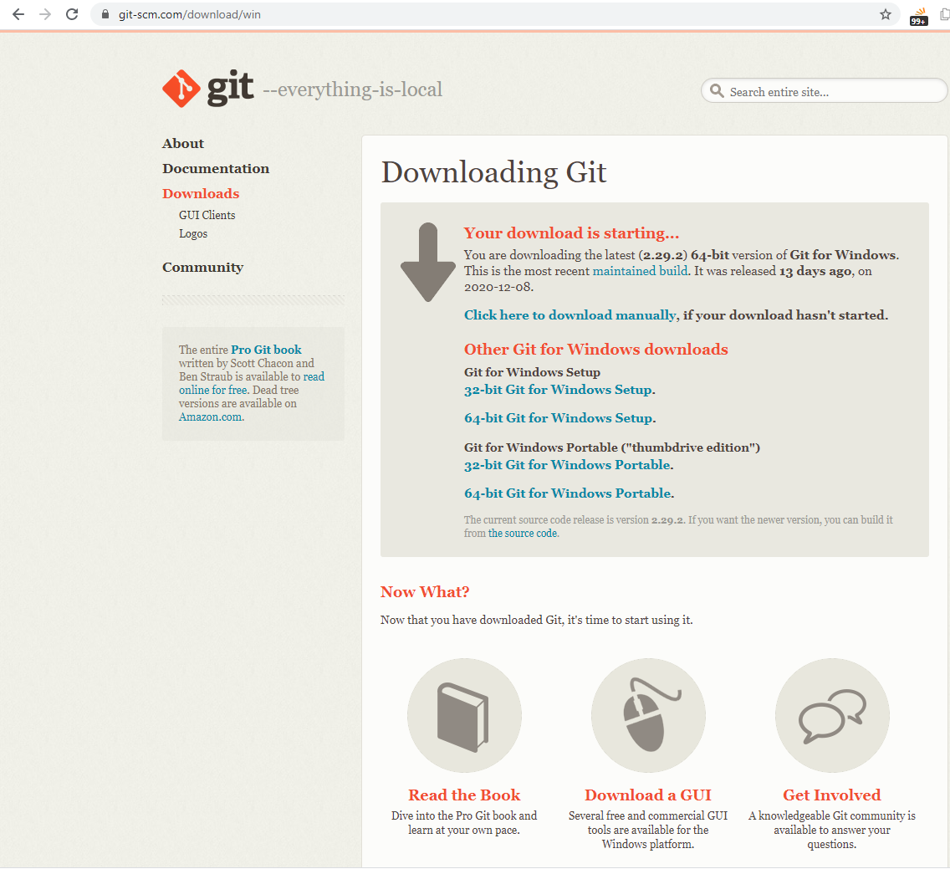

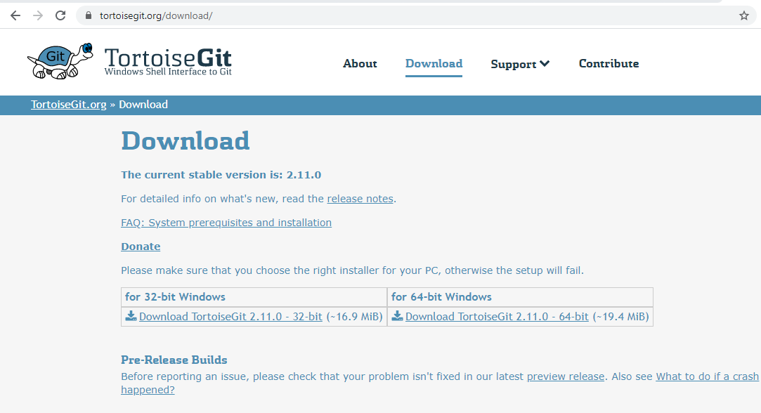

# **TortoiseGIT screenshots (post install setups):**

