Comprehensive Strategic Report 2025
Prepared by the Department of Innovation and Research

1. Executive Summary
This document presents a comprehensive overview of the organization’s strategic initiatives for the upcoming year 2025. It covers innovation programs, financial allocations, technological advancements, and sustainability goals. The report aims to provide clear insights into our roadmap, performance indicators, and expected outcomes.

2. Background and Context
Over the past decade, the company has undergone a significant transformation through digitalization and international expansion. In 2024, we achieved a 17% growth in operational efficiency, largely due to AI-driven process automation and improved interdepartmental coordination.

3. Key Performance Indicators (KPIs)
Indicator | Target 2024 | Target 2025
Revenue Growth | 8% | 12%
Employee Satisfaction | 82% | 90%
Carbon Footprint Reduction | −10% | −20%
New Patents Filed | 15 | 25

4. Financial Overview
The graph below illustrates the company’s revenue trajectory over the last five years. The consistent upward trend demonstrates the effectiveness of the implemented strategic policies and investments.
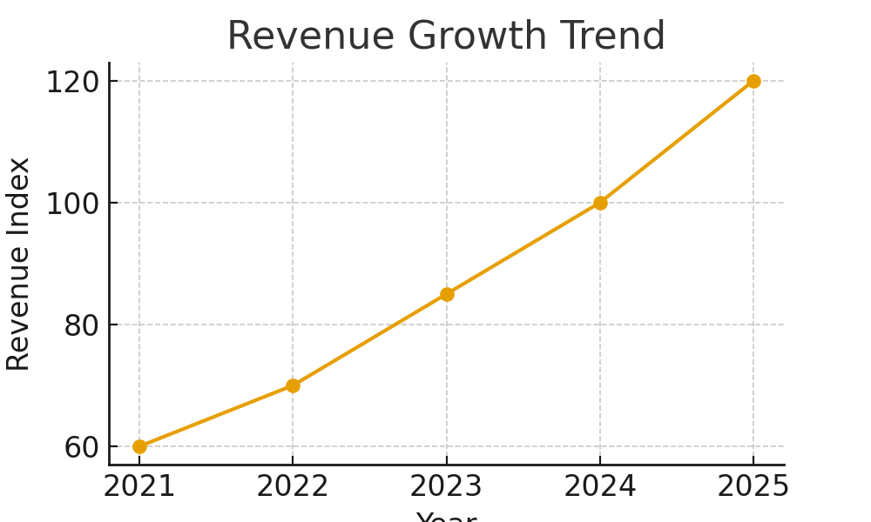

5. Vision and Objectives for 2025
Our primary objective for 2025 is to establish leadership in sustainable innovation. The company will continue investing in renewable energy, AI research, and international partnerships to reinforce its market position.
Additionally, our roadmap includes expanding into new markets in Asia and Africa, strengthening corporate social responsibility (CSR) initiatives, and fostering a more inclusive work environment through leadership training programs.

6. Conclusion
This report encapsulates our strategic vision and action plan for 2025. Through innovation, collaboration, and a commitment to sustainability, the company is positioned to achieve new milestones while maintaining its core values of integrity, excellence, and respect.
Sincerely,
Dr. Alexandra Hughes
Director of Strategic Development

