Sustainability Report 2025
Towards a Greener Future
This report outlines key sustainability initiatives for 2025.

Main Goals
- Reduce emissions
- Improve recycling
- Invest in green tech

Sustainability Metrics
Metric | 2024 | 2025 Target
CO2 Reduction | 10% | 20%
Renewable Energy | 30% | 50%

Environmental Commitment
Our mission is to make every process eco-friendly.
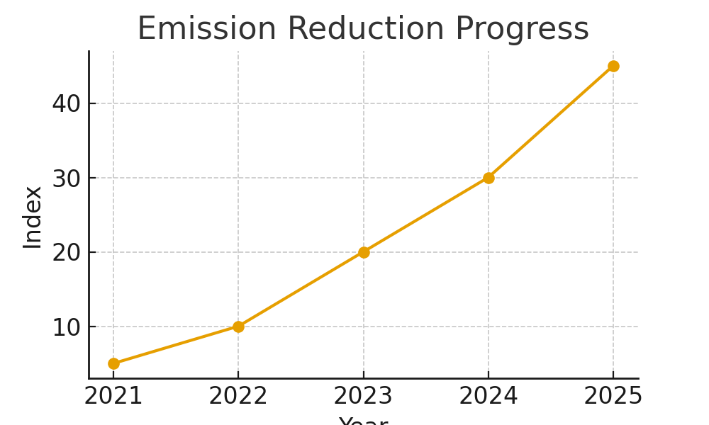

Carbon Tracking Script
def track_emissions(current, goal):
return (goal - current)/goal * 100

Conclusion
We remain committed to long-term sustainability.
Approved by: Automation Taskforce
Document Ref: SUSTAINABILITY_REPORT-2025

