Ultimate DOCX Demonstration Report 2025
A showcase of advanced document composition using Python-docx
This report demonstrates the variety of textual and graphical elements that can be programmatically generated in a Word document. The goal is to include as many different types of content as possible to simulate a complex professional file.

1. Mixed Lists
- Key points:
- Automated formatting with Python.
- Inclusion of shapes, images, and styles.
- Steps performed:
- Initialize document.
- Insert headings, paragraphs, and lists.
- Add graphical and tabular content.

2. Example Table
Category | Description | Status
Text | Bold, italic, colored, and underlined samples | Complete
Table | Structured content with borders | Complete
Graph | Matplotlib generated chart | Complete

3. Highlight Box
⚠️ Important Note:
This text is displayed inside a simulated rectangular box using paragraph borders.

4. Quotation
“Innovation distinguishes between a leader and a follower.” — Steve Jobs

5. Styled Text Samples
Red text Green text and Blue text.

6. Graphical Representation
Below is a sample bar chart generated via matplotlib:
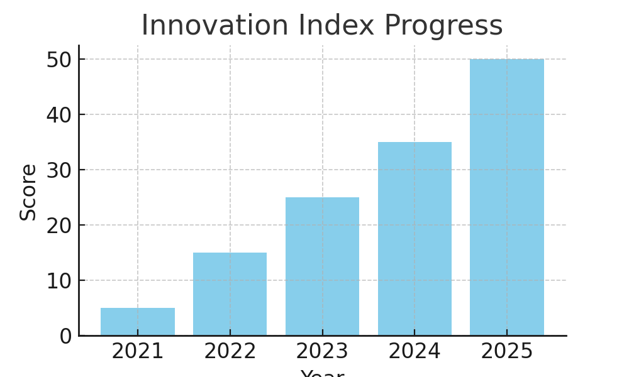

7. Code Example
def calculate_growth(current, previous):
return ((current - previous) / previous) * 100
growth = calculate_growth(120, 100)
print(f"Growth: {growth:.2f}%")

8. Conclusion
This document integrates nearly every Word object type — paragraphs, lists, tables, images, quotations, code blocks, and styled boxes. It illustrates the power of programmatic document generation.
Approved by: The Automation Taskforce
Document Reference: DOCX-DEMO-ULTIMATE-2025

