Comprehensive Strategic Report 2025
Prepared by the Department of Innovation and Research

1. Executive Summary
This report provides a detailed overview of strategic goals and performance indicators for the year 2025. It focuses on innovation, sustainability, and operational excellence as the key drivers of our corporate vision.

2. Background and Context
In 2024, the organization implemented a series of transformative initiatives that reshaped its digital infrastructure. Automation and artificial intelligence played a pivotal role in improving productivity and data-driven decision-making.

3. Key Performance Indicators (KPIs)
Indicator | 2024 | 2025 (Target)
Revenue Growth | 8% | 12%
Employee Satisfaction | 82% | 90%
Carbon Reduction | −10% | −20%
Patents Filed | 15 | 25

4. Financial Overview
The graph below shows the upward trend in revenue over the last five years, highlighting the impact of our digital transformation initiatives.
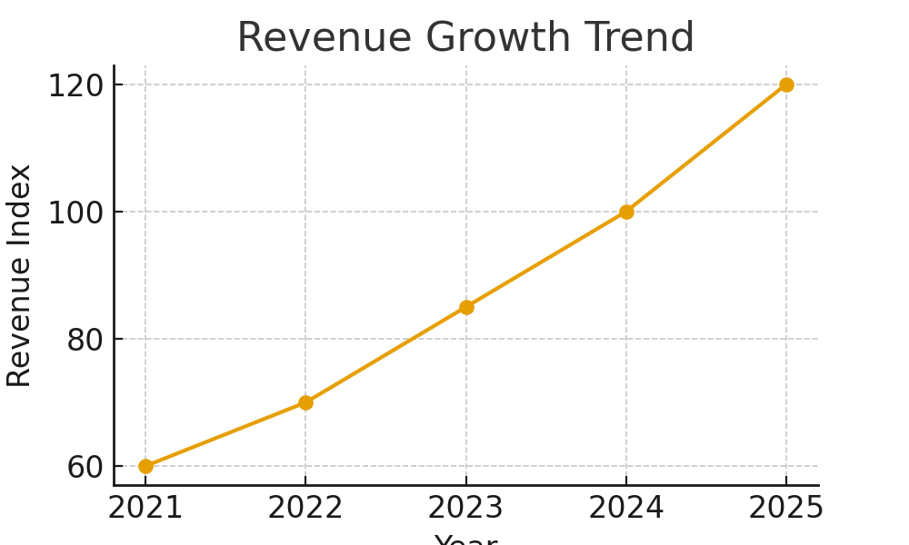

5. Vision and Objectives for 2025
The organization aims to lead in sustainable innovation. Strategic investments will focus on renewable technologies, cross-border partnerships, and ethical AI solutions.
In parallel, initiatives will target community engagement, workforce inclusion, and continuous learning programs to support long-term competitiveness.

6. Conclusion
This report outlines the direction and priorities for 2025. Through commitment, innovation, and collaboration, the company is set to achieve remarkable milestones while maintaining its dedication to excellence and responsibility.
Approved by: Corporate Strategy Board
Document Reference: STRAT-2025-INT-001

