Corporate Financial Summary Q4 2025
End-of-Year Overview
The Q4 2025 report covers profit margins, investments, and market stability.

Highlights
- Record profits
- New markets opened
- Debt reduction

Financial Indicators
Indicator | Q3 | Q4
Revenue Growth | 8% | 11%
EBITDA Margin | 25% | 28%

Investor Notice
All figures are preliminary and subject to audit.
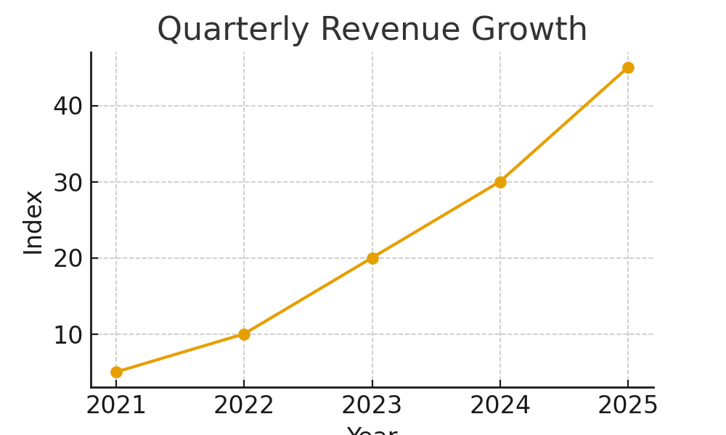

ROI Calculation
def roi(gain, cost):
return (gain - cost) / cost * 100

Conclusion
The financial outlook for 2026 remains positive.
Approved by: Automation Taskforce
Document Ref: FINANCIAL_SUMMARY-2025

