Technology Innovation Roadmap 2030
Vision and Strategic Goals
This roadmap defines technological milestones towards 2030.

Strategic Areas
- AI integration
- 5G expansion
- Green computing

Roadmap Overview
Phase | Period | Objective
Phase 1 | 2025–2026 | Infrastructure
Phase 2 | 2027–2030 | Global Deployment

Innovation Focus
Technology should empower sustainable global development.
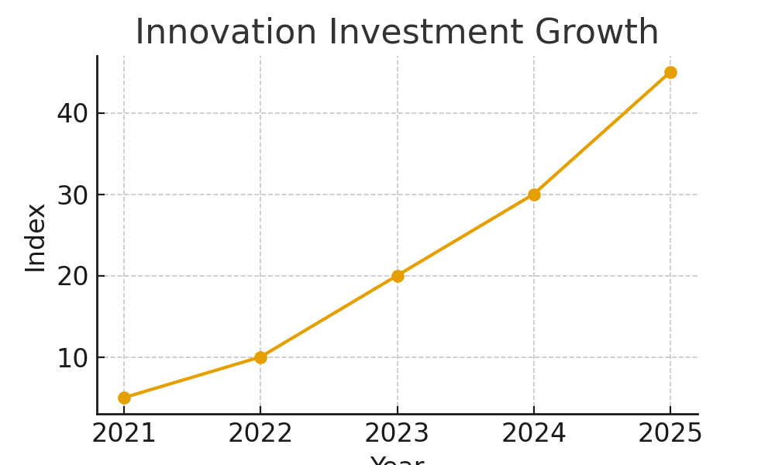

Timeline Data Example
timeline = ['2025', '2027', '2030']
objectives = ['Infra', 'Deploy', 'Optimize']

Conclusion
The next decade will be driven by responsible and impactful innovation.
Approved by: Automation Taskforce
Document Ref: INNOVATION_ROADMAP-2025

