


Pitch deck - SaaStr Europa 2019

clevergig is building the no. 1 WFM solution that enables temporary work agencies to grow their business

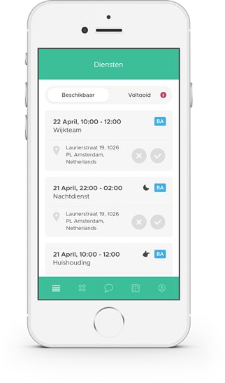
Executive summary
clevergig offers a smart, on-demand Workforce Management (WFM) solution
>50 Dutch temporary work agencies match 4K workers with 10K shifts each month
We operate in a clearly defined niche, using a B2B transactional SaaS model
We have built a repeatable sales model and embrace Product Led growth
Revenues stand at €15K MRR and are growing 15% MoM
We look to expand beyond the Netherlands as of 2020, most likely to the UK
To that end we are raising a €1M Seed round in the 2nd half of 2019

Labor is increasingly becoming on-demand in nature. Temporary work agencies play ever larger roles in matching workers with work

Our vision
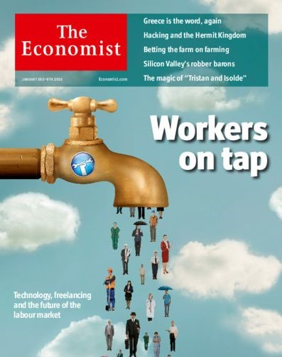
Consumers increasingly want products and services NOW and delivered to their door
As a result, the global economy is becoming ever more on-demand in nature
This has a huge impact on how labor is organized and sourced
Requiring quicker and smarter matching of workers with work, for shorter periods of time
The Economist, January 2015

As a temporary work agency, providing hourly workers to fill your clients’ urgent shift requests is a major hassle

Problem



Imagine a Personal Care company with several open shifts in the coming week
Request availability
Ask worker to fill shift
Provide shift details
Taking in request
Informing client on progress
Agency
Hourly worker
Client
Brief worker
Sign off hours
Worker feedback
An agency is asked for help and now needs to figure out who is available
And whom has the right skills and is a good fit for that client and shift
Many small agencies currently rely on Excel, phone and WhatsApp
Resulting in inefficient operations, limiting growth
Sign off hours

Meet clevergig. The smart on-demand WFM solution to quickly and easily match the right worker with open shifts

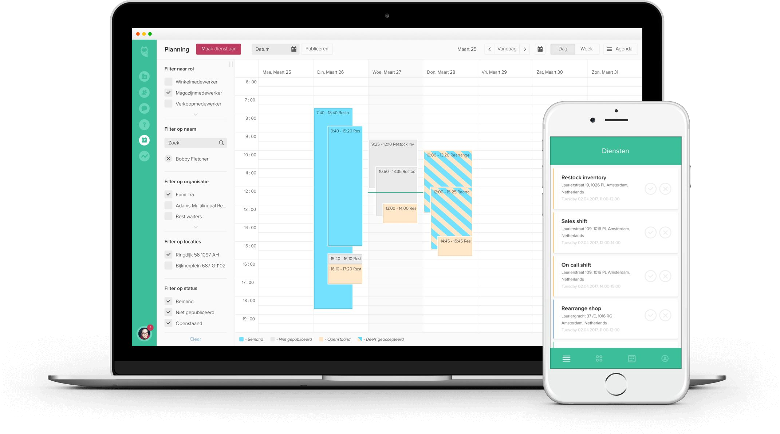
Solution
Worker provides availability
Agencies matches worker
and sends shift details
Client sees real-time status
Request shifts, approve hours
Agency
Hourly worker
Client
Worker sees info about client
Can log hour. All via app
clevergig is an intuitive and smart WFM tool (Software as a Service)
It optimizes three-way operations between agency, client and worker
Intermediaries thus easily match the right worker with open shifts
Increased automation enables agencies to grow
Our product is loved by our customers and used on a daily basis.

Networks effects add to our defensibility
Traction In-month MRR development
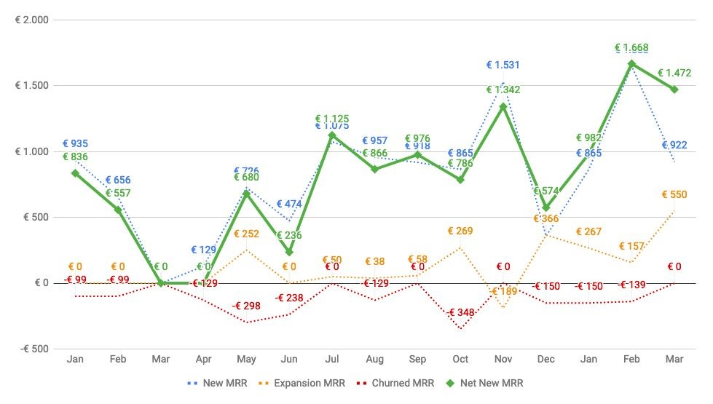
55 agencies now scheduling >10K shifts each month
Representing 70K hours of work via 4K workers
€15K in MRR, 15% MoM growth over last 15 months
€260 MRR per client, MRR expands by 50%, after year 1
30% of our leads come via worker referrals
Many workers work via several agencies

We use a 3-tier subscription model. MRR grows with higher usage of the product, on average by 50% in the 2nd year of usage
Business model and pricing
Small
Up to 200 shifts p.m.
Approx. 950 hours
€185
per month
Medium
Up to 400 shifts p.m.
Approx. 2.500 hours
€305
per month
Large
Up to 800 shifts p.m.
Approx. 6.250 hours
€485
per month
Enterprise
>
800 shifts p.m.
Tailored pricing
Contact Sales

Our team has a strong foundation in Tech and SaaS. We plan to expand primarily in Product and Growth roles

Michel Arnoud Sergey Dimon
CEO CCO CTO Front End

Europe alone provides tons of opportunities. Over 50K agencies represent a TAM of €200M in ARR

Market size
Short term growth areas include international expansion
Mid term opportunities include
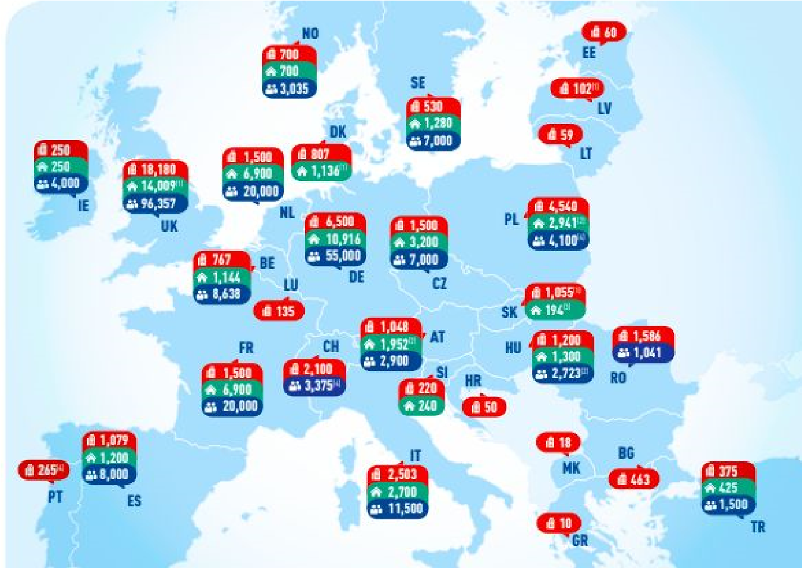



- Launching adjacent services such as Payroll and Recruiting services
Agencies
Branches
Internal staff
- Monetizing the worker app: workers pay a small monthly fee to use additional services. E.g. a detailed report of their earnings
- Expanding to similar use cases: companies with a pool of flexible workers, such as Security, Events, Facilities and Repair/Field Services
Source: Ciett, 2015

Product demo: press to view 5 minute video
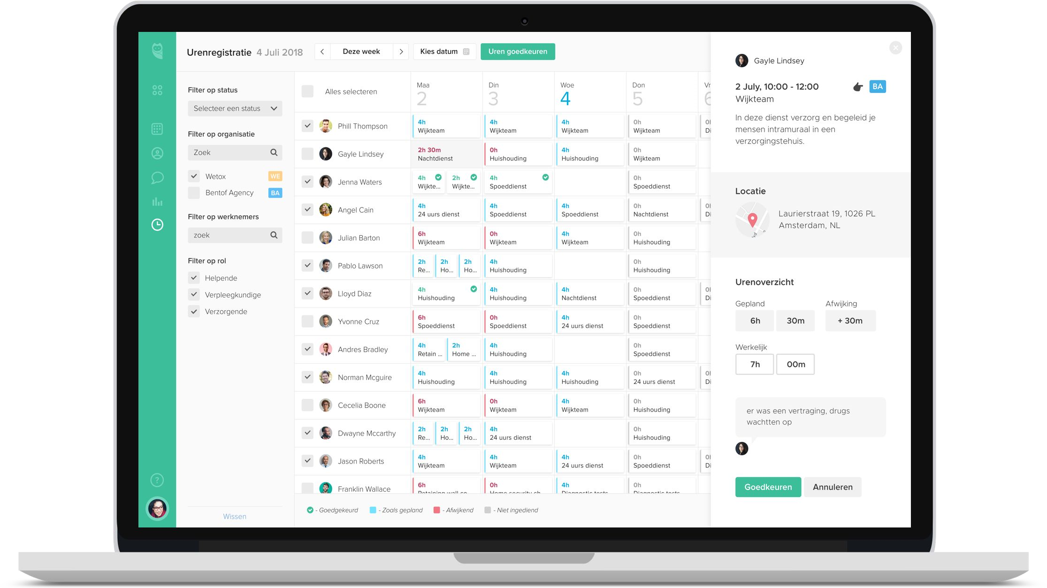
We are raising a €1M Seed round in the 2nd half of 2019 to dominate the

Netherlands and expand to the UK as of 2020

Use of funds
Our BHAG is €5M ARR by end of 2024, or some 1,500 clients
For that we will expand to several markets outside the Netherlands, starting with the UK in 2020
Funds will be used to grow the Product and Growth teams to a total of 20 end of 2020
- Product team will focus on allowing self discovery, signups and onboarding of the product
- Growth team will focus on outbound prospecting and inbound marketing
Want to know more? Feel free to reach out to us. Schedule a meeting or meet us at SaaStr Europa!

Schedule call or meeting

Contact
Michel Pilet
michel@clevergig.nl
+31 (0)6 4138 6545
clevergig BV 2019. All rights reserved.

Assuming €4K in ARR per branche ² EY Global Contingent Workforce Study (2017)

