
A modern spreadsheet for modern analysis

Two problems with spreadsheets

Not connected to live data. No team workflows.

- Not connected to live data






Today’s spreadsheets live in a silo.
CSV
CSV
CSV
CSV

To get data into a spreadsheet is slow, frustrating, and error-prone. Analyses are immediately static and out-of-date.

Steps for starting a simple SaaS revenue model, repeat whenever data changes.


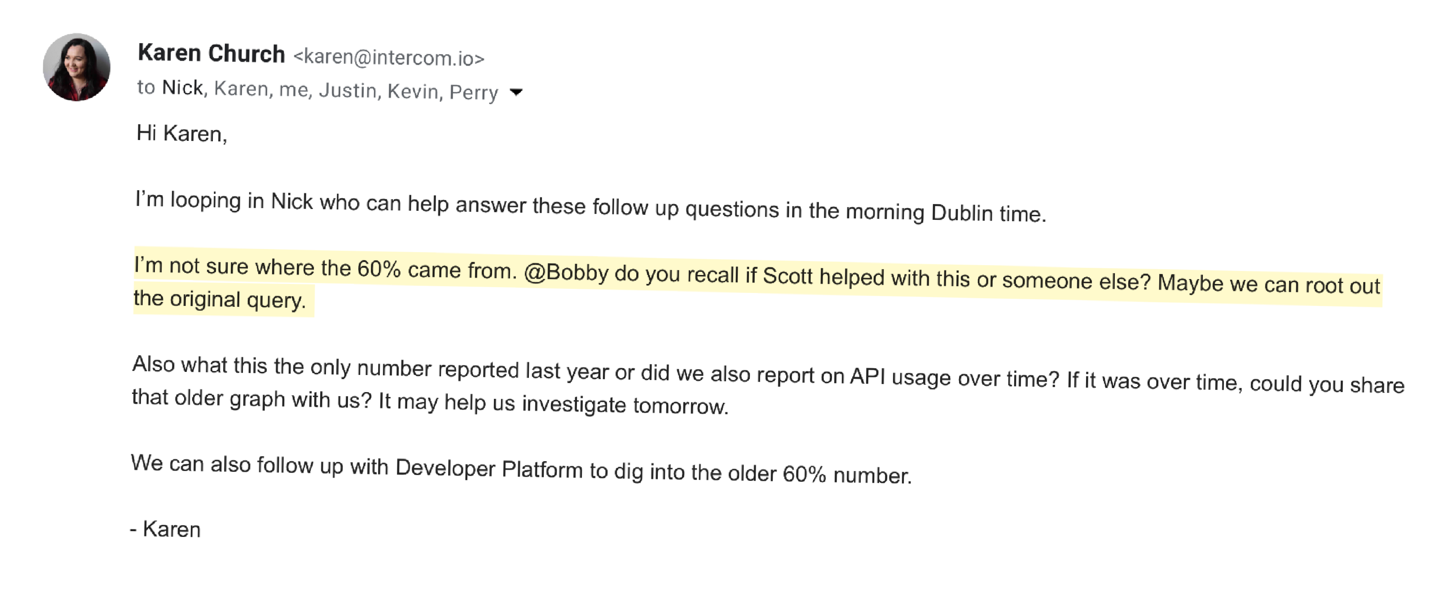

No team workflows

In today’s spreadsheets there’s no record of how an analysis comes together or how it evolves.

I have hundreds of emails like the one on the right.

Why this matters: our mission

To empower businesses to make good decisions.

No one solves these problems

Excel and Google Sheets
Too horizontal, have to support long tail of use-cases.

Business Intelligence tools
Designed for regular reporting, not analysis. Always used alongside Excel or Sheets.

Coda / Notion / Airtable / Smartsheets
Not for analysis.

Solution: Equals

A new vertically integrated spreadsheet, built around two pillars:

1. Data | 2. Team workflows
Data sheets w/ SQL. | Trace: get to source of a number.
Data sheets w/ Stripe, Netsuite, etc. | “Git model” for changes.
Scheduled and versioned updates. | Shared queries and formulas.
Modern spreadsheet
Cloud based. Sign up and get going in minutes. Targeted subset of excel functionality.

V1: Equals

A new vertically integrated spreadsheet, built around two pillars:

1. Data | 2. Team workflows
Data sheets w/ SQL. | Trace: get to source of a number.
Data sheets w/ Stripe, Netsuite, etc. | “Git model” for changes.
Scheduled and versioned updates. | Shared queries and formulas.
Modern spreadsheet
Cloud based. Sign up and get going in minutes. Targeted subset of excel functionality.

Founders


Bobby Pinero, Chief Executive Officer
As a member of the Exec team, scaled Intercom from $1M ARR to $180M+ ARR. Over 7 years, built and led FP&A, Accounting, Business Operations, Business Analytics, Product Analytics, Data Engineering, and Legal.


Ben McRedmond, Chief Product Officer
First employee at Intercom. As member of exec team, led Growth from $1M to $50M ARR. Scaled Growth to 30+ engineers, designers, product managers. After Intercom founded Consider, an email startup (2017-2020).

Plan

We are raising a seed round of around $4M:

- To fund an initial team for 24 months.

- To build V1 and demonstrate product market fit with a small number of paying users who deeply use the product.

Beyond this, we will raise again to invest further into product development and marketing working towards a product that every business can use.

