[1]

UCLA MAE 259 Homework 1

Zhengqi Zhong

*Abstract*— This electronic document is for the MAE 259 Class Homework 1 from UCLA.

# Problem 1

The implicit and explicit solutions is an animation, please run the Problem1_implicit.m and Problem1_explicit.m file. The figures under steady conditions. Blow is the simulation of final deformation of this 3-sphere model.

Figure : Final Deformation

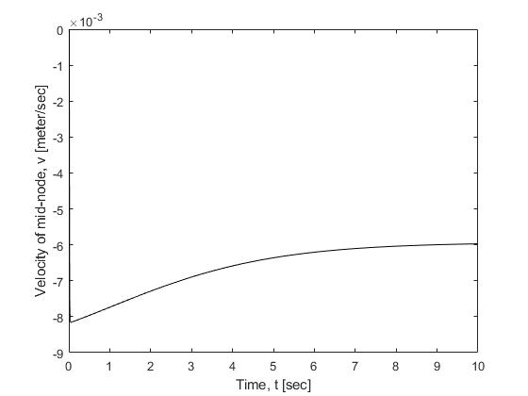The Time VS Velocity Plot is shown below:

Figure : Time VS Velocity

Problem 1 Questions:

1. If all the Radii of all the metal spheres are the same, the turning angle would not change, the rod would remain in a straight line and falling down slowly. Figure below shows the final deformation when radii of three sphere are the same: (Need to change the m2 value to equal m1 in Problem1.m file)

Figure : 3 Equal Radii Spheres Final Deformation

1. When increasing the step size (larger step size), the explicit method cannot solve the simulation anymore and the position simulation plot cannot be display successfully. However, the implicit method still able to find the solution successfully, with faster computation.

By decreasing the step size (smaller step size), the solving process is much slower, because of the larger computation, but both implicit and explicit methods able to give the correct answer.

# Problem 2

The Deformation Simulation of the Problem 2 is an animation, Please run the Matlab file Problem2.m.

## 1. Assignment 2 Questions 1

Vertical Position of Middle Node

Figure : Time VS Mid-Node Vertical Position

Velocity of Middle Node

Figure : Time VS Mid-Node Vertical Velocity

## 2. Assignment 2 Questions 2

Figure : 21 Node Final Deformation

## Assignment 2 Questions 3

Terminal Velocity VS Number of Node Plot shown below:

Figure : Terminal Velocity VS # Node

Terminal Velocity VS Step Size

Figure : Terminal Velocity VS Time Step Size

According to the Two plots above, the terminal velocity would every close to -0.00584 m/s. However, with the increasing number of Node or smaller step size, the terminal velocity would approach to this value of -0.00584 m/s

# Problem 3

The final deformation of the Beam under P = 2000 is shown below:

Figure : Beam Final Deformation at P=2000

## 1. Assignment 3: Maximum Displacement VS Time

The Y max reached the steady state around t = 0.075s. The Steady state maximum displacement is at -0.0371m. According to the Euler beam theory, the maximum steady state Displacement is -0.0380 m (According to Matlab code Problem3.m). The result is slightly different, but close enough. Euler Beam Theory valid for small displacement. (Calculation is in Matlab Problem3.m file)

Figure : Beam Maximum Displacement at P=2000

## 2. Assignment 3, Question 2

By changing the P from 2000 to 20000. The beam is experiencing large deformation which is shown below:

Figure : Beam Final Deformation at P = 20000

The Maximum Displacement VS Time is:

According to simulation, the maximum displacement at steady state is -0.2352 m. However, the theoretical prediction from Euler beam theory is -0.3804 m. Therefore, the prediction is not valid. We can say the Euler beam theory is not valid for large displacement (Calculation is in Matlab Problem3.m file, please manually change P value to 20000)

Figure : Beam Maximum Displacement at P=20000

1.