[1]

UCLA MAE 259 Homework 2

Zhengqi Zhong

*Abstract*— This electronic document is for the MAE 259 Class Homework 2 from UCLA.

# Chapter 7: Discrete Elastic Rods

The Simulation of the deformation is shown in the Matlab File HW2/code/Main.m. Please execute this file directly. The final deformation result is in Figure 1.

Figure 1: Final Deformation

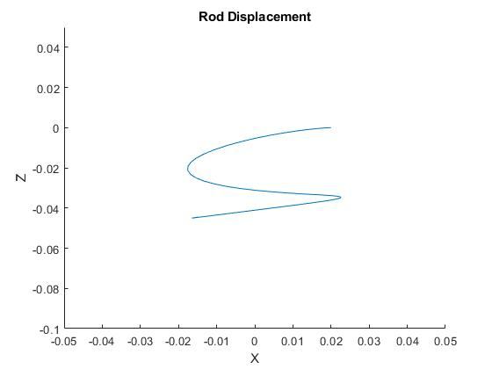

The Z-Coordinate of the last node (XN) with time is:

Figure 2: Last Node Displacement

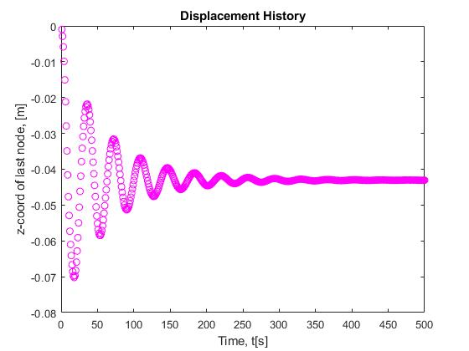

1.