# Working with phpMyAdmin

***Start phMyAdmin***

* 1. *Click* ***START*** *button in front of MySQL*
  2. *After the MySQL process starts, click* ***ADMIN*** *button*

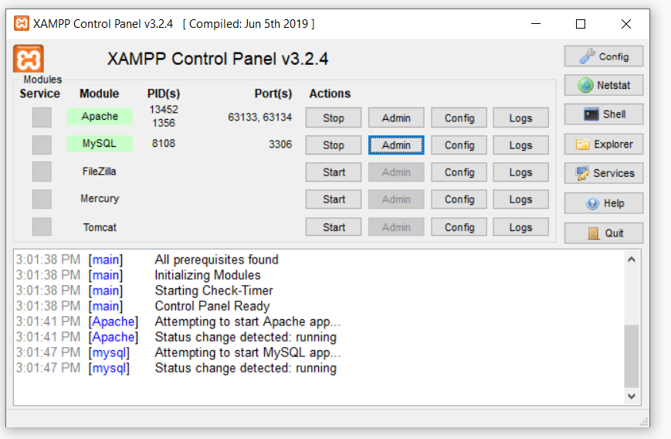

*To create a new database click* ***NEW***

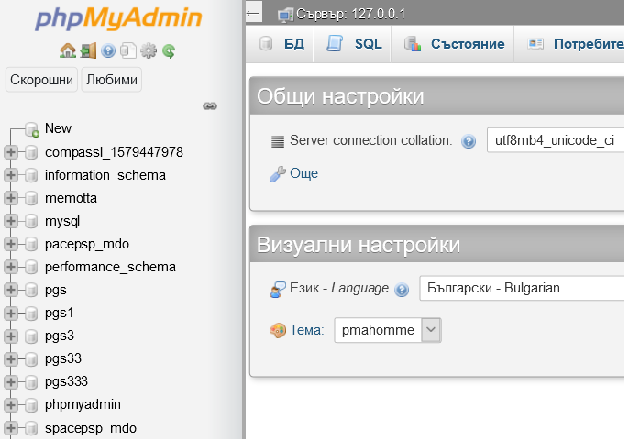

*Enter the name of the new_database - snake_case, english words!****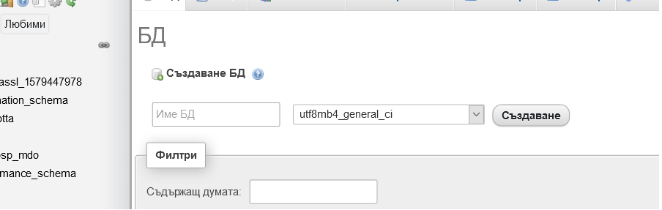***

*The newly created database - recipes, appears in the column* ***on the left***

**

*Click on* ***the name*** *of the newly created database*

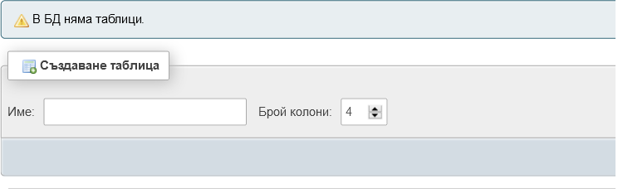

*The recipes database is still* ***empty****. You are ready to* ***create*** *recipes tables.*

*You can* ***add and edit*** *the database tables* ***now or later*** *if needed.*

*We can add the first table of The Recipes database design - the* ***products*** *table*

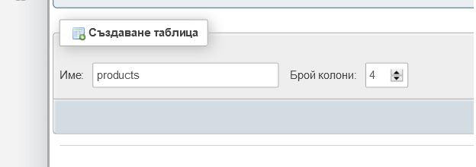

*You can set the* ***number of columns*** *in the table. You can increase/decrease the number of columns later if needed.*

*After the first table is set, it is the time to set* ***the names and other attributes of the table's columns****.*

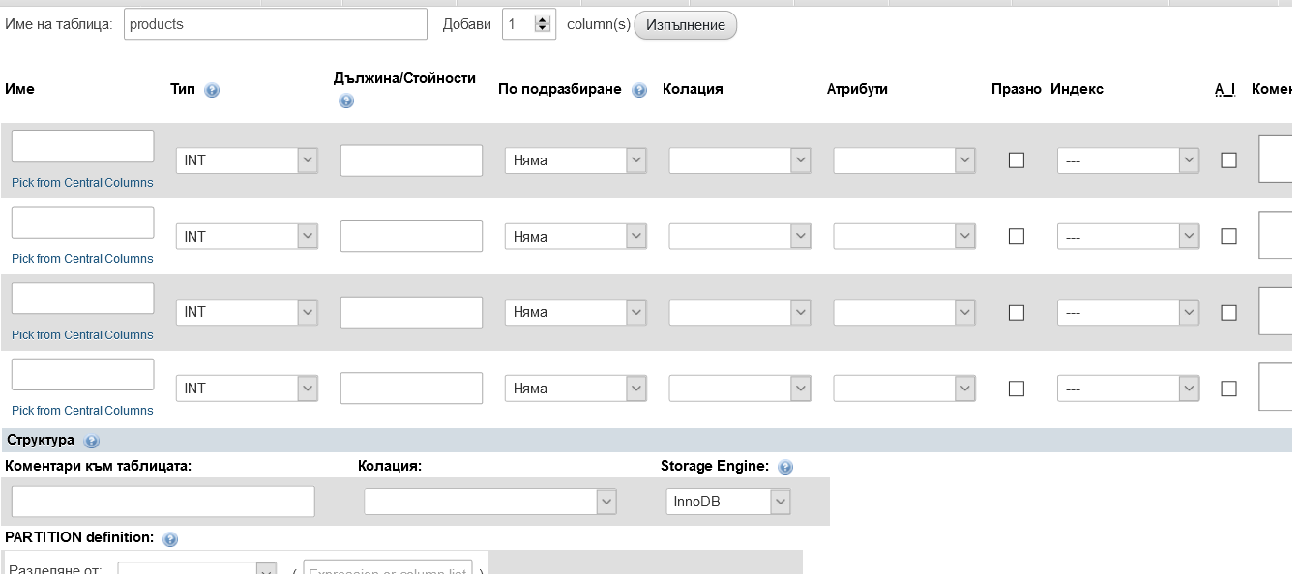

*Always start with the first column -* ***set it to be the table PRIMARY KEY*** *-*

* 1. ***set INDEX to be PRIMARY***
  2. *check the column* ***AUTO INCREMENT*** */AI/*

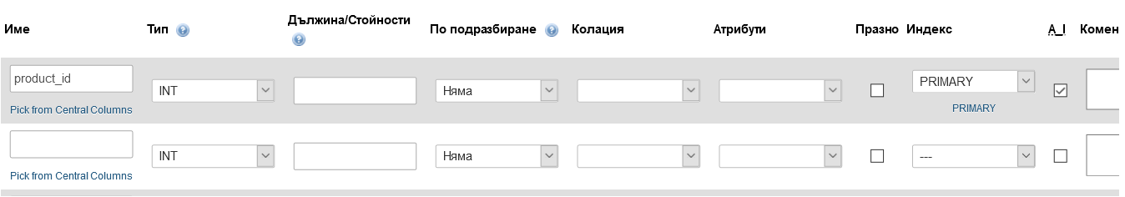

*After all columns` attributes have been filled in, you can see the newly created* ***table`s structure*** *in the* ***STRUCTURE*** *tab.*

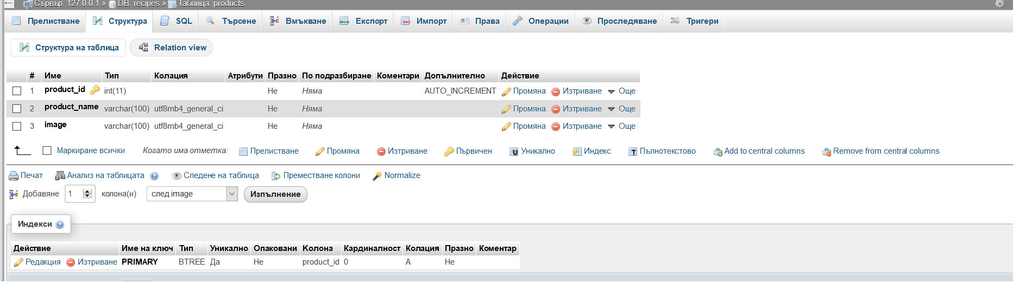

*From this tab you can* ***view or edit*** *table`s columns.*

*In the column* ***on the left*** *of the screen after you click the* ***+sign*** *in front of the database name - you can see the list of existing tables in the database.*

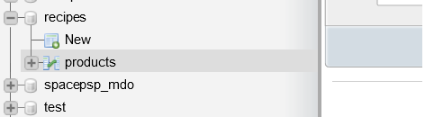

*Let’s create a second table -* ***product_categories***

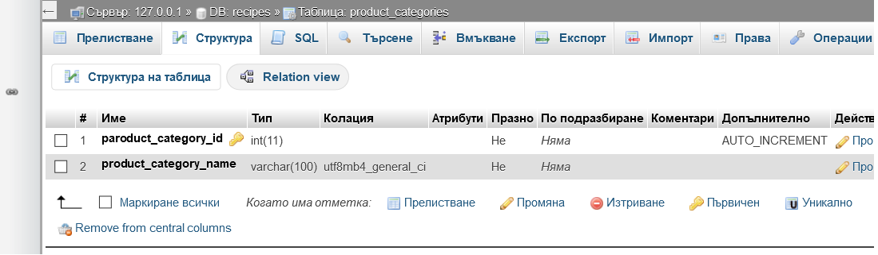

*In order* ***to connect the two tables*** *- in the recipes design the two tables are related via the product_category_id column, which presents in the both tables - we have to add such a column in the products table and to set it an index for faster querying.*

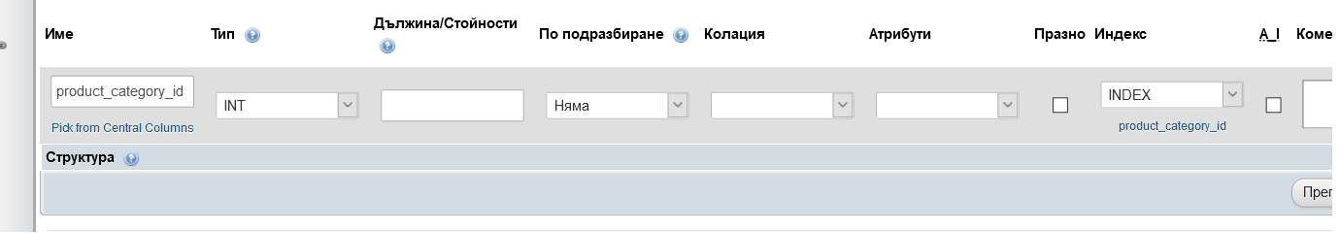



*The product_category_id column in the product table is a* ***FOREIGN KEY /FK/*** *and we have to set the foreign key constraint for the related tables.*

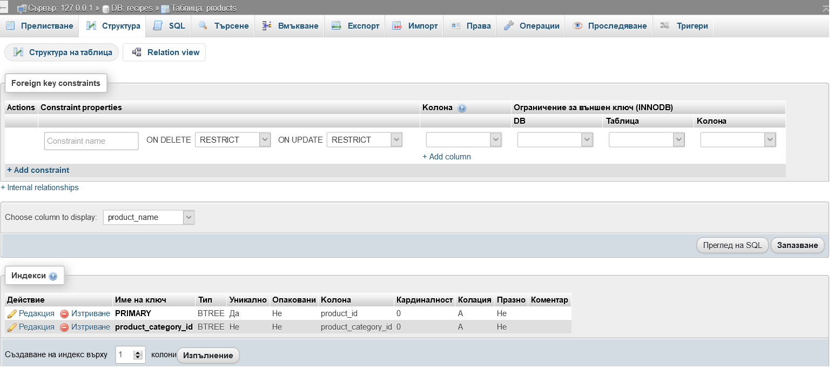

*We can insert manually data in the database tables from the* ***INSERT*** *tab.*

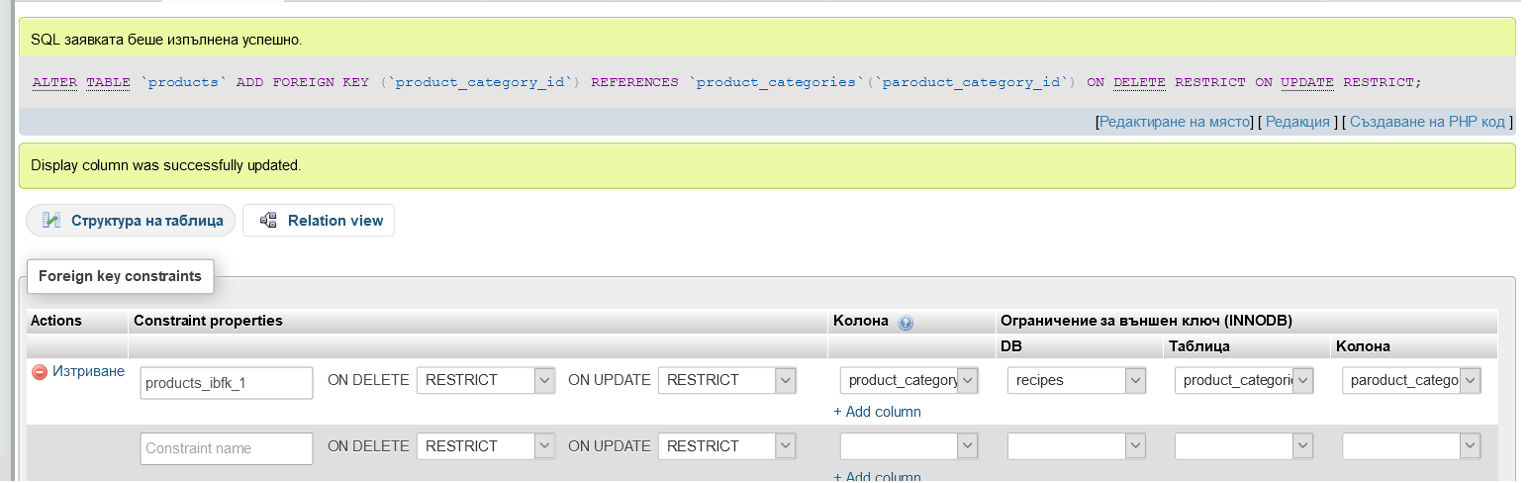

*From the* ***VIEW*** *tab you can see the data you`ve entered. You can change the data if you need to.*

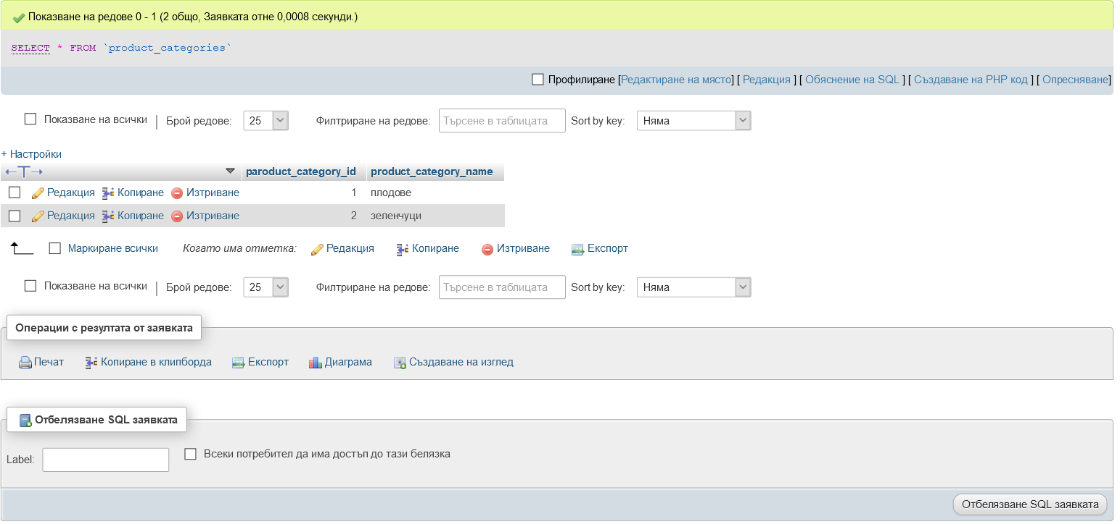

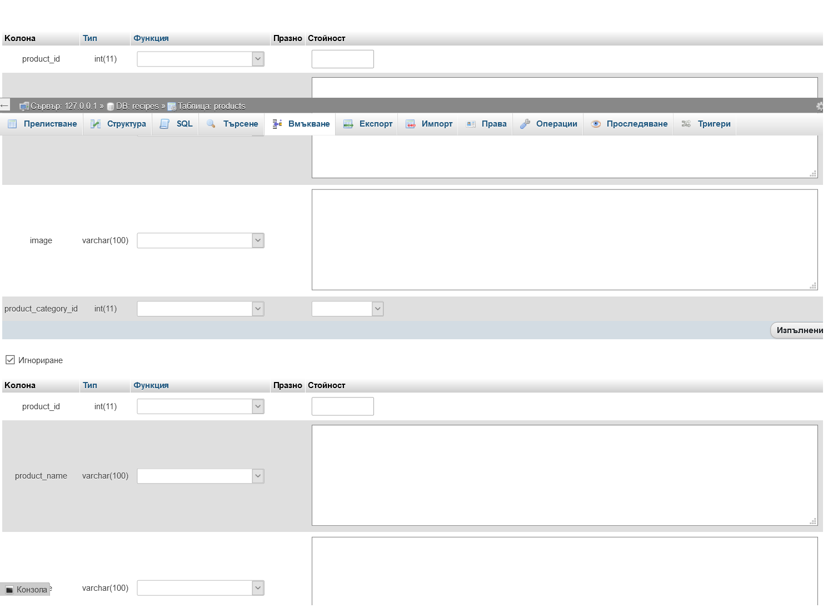

*From the* ***STRUCTURE*** *tab of the database you can see the list of existing tables.*

*You can* ***delete*** *a table from here if you have to.*

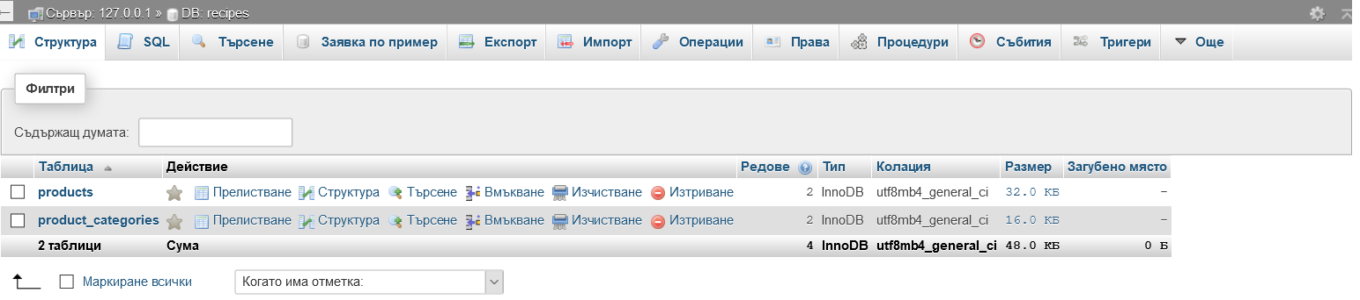

*To export an existing database from phpMyAdmin - click on tha* ***database name*** *you are going to export, then go to* ***EXPORT*** *tab. You will see a title -* ***EXPORTING TABLES FROM DATABASE RECIPES***

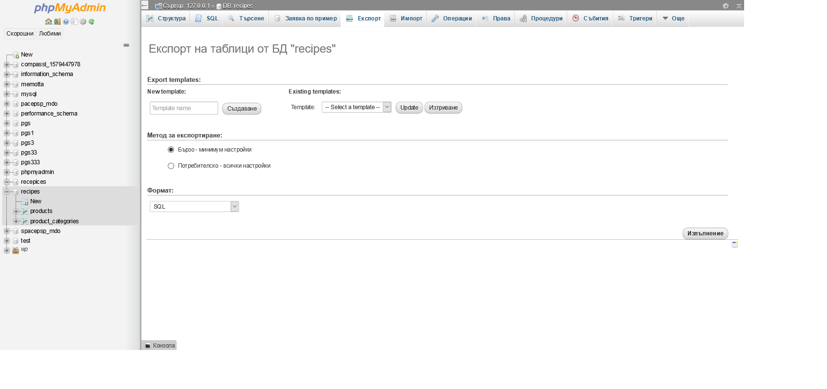

*To export* ***a table*** *from the database - click on* ***table name*** *and go to* ***EXPORT*** *tab.*

*You should see a title* ***EXPORTING ROWS FROM TABLE TABLE_NAME***

*To import a* ***.sql*** *file containing an exported database or table - go to* ***IMPORT*** *tab of an* ***EXISTING DATABASE****!*

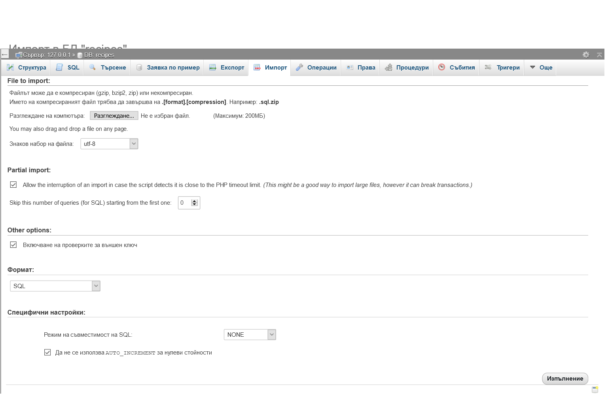

*Be careful not to import already existing tables in the database!*

*To* ***import a database*** *-* ***create empty database.***

*To* ***import a table*** *- check if table with the* ***same name exists*** *-* ***delete*** *the table and import the desired table from a file.*

*Let's* ***add new columns*** *to the products table.*

*Price table will store data of* ***decimal type****.*

*Product_calories column will have a* ***default value of 50*** */when we expect a value not to be required from the user when filling out a form, it is a good idea to set a default value - predefined, or NULL/*

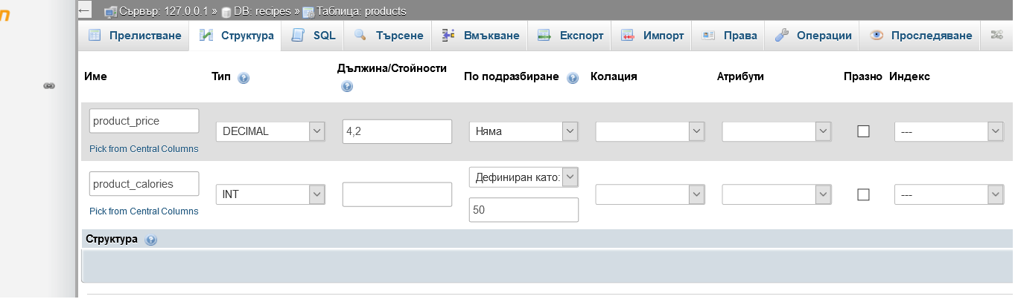

*The default values can be set later, though you should try to develop the final design of the database as much as you can.*

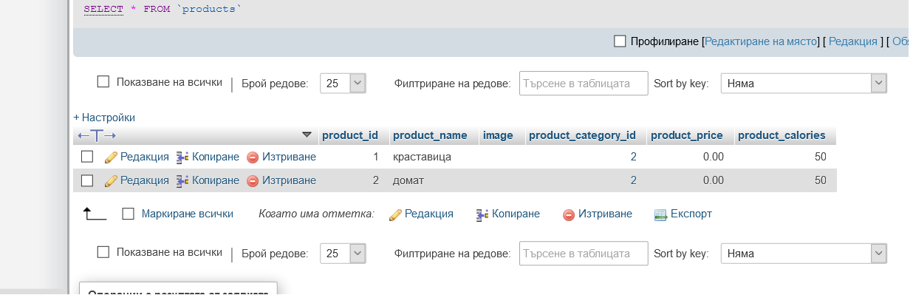

*If you`ve changed the column to have a* ***default value*** *-* ***do not forget to change the empty value*** *to the desired default column value.*

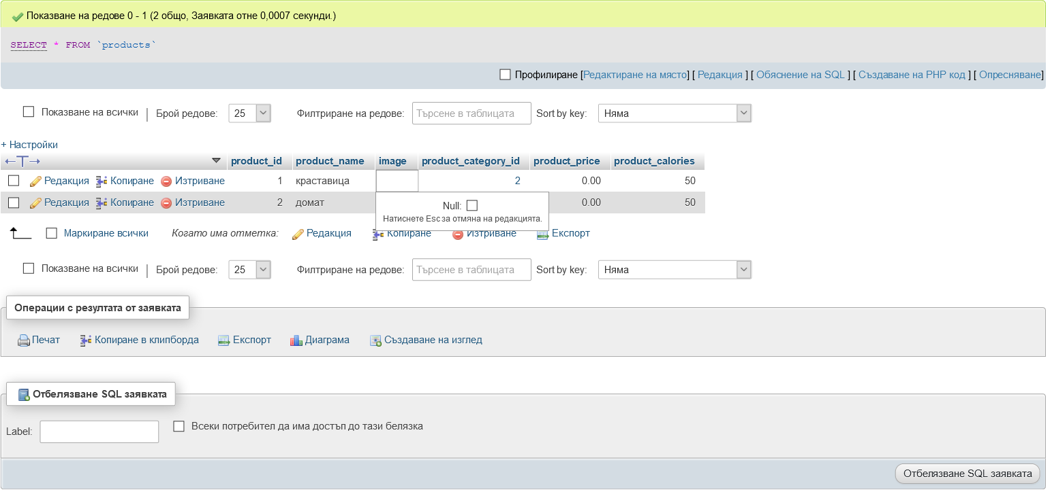

***A view of a table*** *in a database in phpMyAdmin - here you can view the* ***data type*** *expected to be stored in each columns, default values if present, th PK, FK, indexes.*

