Lab: Multidimensional Lists
Please, submit your source code solutions for the described problems to the Judge System.

Sum Matrix Elements
Write a program that reads a matrix from the console and prints:
- The sum of all numbers in the matrix
- The matrix itself
On the first line, you will receive the matrix sizes in the format "{rows}, {columns}". On the next rows, you will get elements for each column separated by a comma and a space ", ".

Examples
Input | Output
3, 6  7, 1, 3, 3, 2, 1  1, 3, 9, 8, 5, 6  4, 6, 7, 9, 1, 0 | 76  [[7, 1, 3, 3, 2, 1], [1, 3, 9, 8, 5, 6], [4, 6, 7, 9, 1, 0]]

Even Matrix
Write a program that receives a matrix of numbers and prints a new one only with the even numbers. Use nested comprehension for that problem.
On the first line, you will receive the rows of the matrix. On the next rows, you will get elements for each column separated with a comma and a space ", ".

Examples
Input | Output
2  1, 2, 3  4, 5, 6 | [[2], [4, 6]]
4  10, 33, 24, 5, 1  67, 34, 11, 110, 3  4, 12, 33, 63, 21  557, 45, 23, 55, 67 | [[10, 24], [34, 110], [4, 12], []]

Flattening Matrix
Write a program that receives a matrix and prints its flattened version (a list with all the values). For example, the flattened list of the matrix: [[1, 2], [3, 4]] will be [1, 2, 3, 4].
On the first line, you will receive the number of a matrix's rows. On the next rows, you will get the elements for each column separated with a comma and a space ", ".

Examples
Input | Output
2  1, 2, 3  4, 5, 6 | [1, 2, 3, 4, 5, 6]
3  10, 2, 21, 4  5, 20, 41, 9  6, 2, 4, 99 | [10, 2, 21, 4, 5, 20, 41, 9, 6, 2, 4, 99]

Sum Matrix Columns
Write a program that reads a matrix from the console and prints the sum for each column on separate lines.
On the first line, you will get matrix sizes in the format "{rows}, {columns}". On the next rows, you will get elements for each column separated with a single space.

Examples
Input | Output | Input | Output
3, 6  7 1 3 3 2 1  1 3 9 8 5 6  4 6 7 9 1 0 | 12  10  19  20  8  7 | 3, 3  1 2 3  4 5 6  7 8 9 | 12  15  18

Hints
- Read matrix sizes.
- On the next row lines, read the columns.
- Traverse the matrix and sum all elements in each column.
- Print the sum and continue with the other columns.

Primary Diagonal
Write a program that finds the sum of all numbers in a matrix's primary diagonal (runs from top left to bottom right). On the first line, you will receive an integer N – the size of a square matrix. The next N lines hold the values for each column - N numbers, separated by a single space.
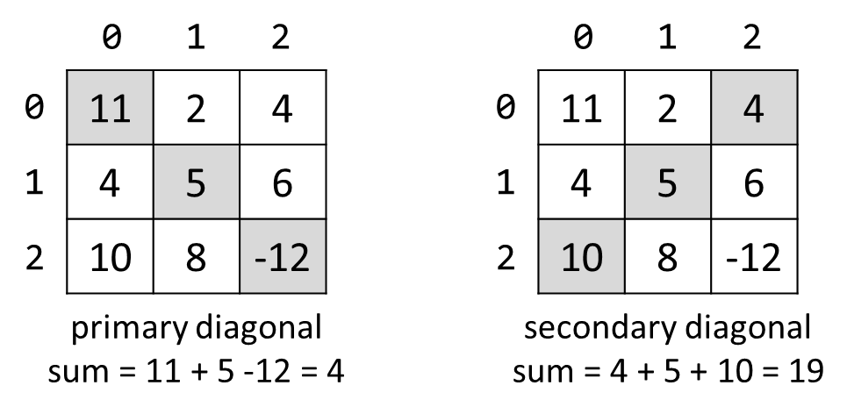

Examples
Input | Output | Input | Output
3  11 2 4  4 5 6  10 8 -12 | 4 | 3  1 2 3  4 5 6  7 8 9 | 15

Symbol in Matrix
Write a program that reads a number - N, representing the rows and columns of a square matrix. On the next N lines, you will receive rows of the matrix. Each row consists of ASCII characters. After that, you will receive a symbol. Find the first occurrence of that symbol in the matrix and print its position in the format: "({row}, {col})". It would help if you started searching from the top left. If there is no such symbol, print the message "{symbol} does not occur in the matrix".

Examples
Input | Output
3  ABC  DEF  X!@  ! | (2, 1)
4  asdd  xczc  qwee  qefw  4 | 4 does not occur in the matrix

Square with Maximum Sum
Write a program that reads a matrix from the console and finds the 2x2 top-left submatrix with the biggest sum of its values.
On the first line, you will get matrix sizes in the format "{rows}, {columns}". On the next rows, you will get elements for each column, separated with a comma and a space ", ".
You should print the found submatrix and the sum of its elements, as shown in the examples.

Examples
Input | Output
3, 6  7, 1, 3, 3, 2, 1  1, 3, 9, 8, 5, 6  4, 6, 7, 9, 1, 0 | 9 8  7 9  33
2, 4  10, 11, 12, 13  14, 15, 16, 17 | 12 13  16 17  58

Hints
- Be aware of IndexError
- If you find more than one max square, print the top-left one

