# File content search

* Problem
  + Search for a specified text inside the content of all files in a directory.
* Hints
  + Program would accept path to a directory and text to search for on the command line.

*e.g. java <program> /opt/files/ “version=1.0.0” --> where /opt/files/* is path to a directory on the local file system with arbitrary structure, nesting and content and “version=1.0.0” is text to search for inside the files in this directory.

* + The directory content structure can be arbitrary, containing different levels of nesting and different file types.
  + Have in mind that we could have archives (zip, jar, etc…) somewhere in the file tree - which means that we should search for the specified text in all of the files inside the archives.
  + Example:

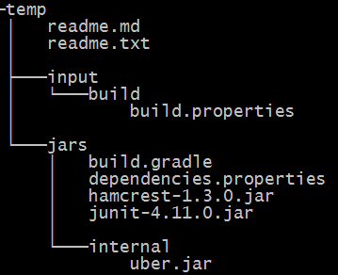

**Program should exit and return a list with all files in the folder, containing the specified text, sorted by the file size.**

* Assignment delivery and evaluation (what we will take into account):
  + Send the java code for above problem - make a zip or create github repo and provide a link.
  + Java code should compile and run.
  + We will be interested in "Object Oriented Design".
  + We will look for coding style, comments, Javadoc, unit tests, etc...