**Start semester  
Orientation phase  
Personal Experience Portfolio**

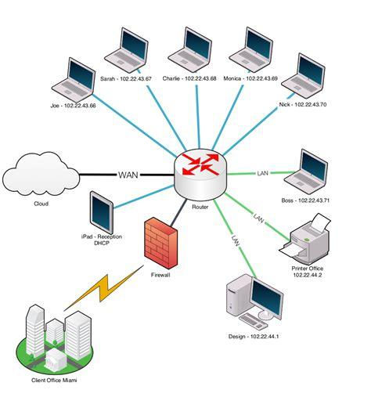

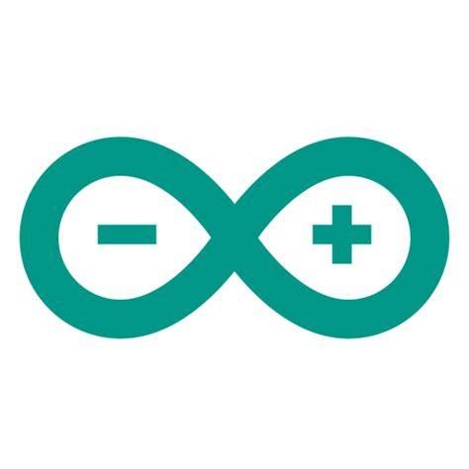



**Student name: Georgi Fidanov  
Student number: 548471**

**Class: P-CB09  
  
Version: 1.1  
Date: 10-9-2024**

# Purpose of this document

You fill in this document on a regular basis to demonstrate your understanding and growth and performance with respect to all the learning outcomes – both technical and professional.

You record and reflect on your work based on the feedback received from your teachers.

Both professional learning outcomes and technical learning outcomes can be found on the homepage of the Canvas course.

You may provide details under the following headings in this document, as evidence of your work, feedback, reflection, learning, growth, and goals for both professional and technical skills.

* Evidence of your relevant skills and abilities (find examples below this text)
* Which learning outcomes both professionally and technically did you work on
* Feedback that you received
* What was your approach?
* What went well and why, can you improve?
* What research did you do?
* Used Resources

Table of contents

Purpose of this document 2

Table of contents 3

Key Take aways in your portfolio 4

Week 1 5

Week 2 5

Week 3 5

Week 4 5

Week 5 6

Week 6 6

Week 7 6

Week 8 6

Validation of the Learning Outcomes 7

Technical Skills 8

ICT & Business 8

ICT & Infrastructure 8

ICT & Media Design 8

Software Engineering 9

ICT & Technology 9

Professional skills 10

Professional standard 10

Personal leadership 10

# Key Take aways in your portfolio

**Purpose:** The key takeaways section helps you capture the most meaningful insights each week. These takeaways are personal reminders of what truly resonated with you and will guide your future learning.

**Scientific support**

1. **Karpicke & Blunt, (2011).** Summarizing key points improves long-term retention.
2. **Brown et al., (2014).** Reflection and retrieval practice boost understanding and retention.

**How to create your key takeaways:**

1. It should NOT be: about what you DID and learned in class or at home. We also know our program and don’t need to read that here.
2. It should be about: meaningful moments: Choose up to a max of threekey takeaways that were significant to you each week.
3. It should be personal: Use your own words to describe why these moments mattered.
4. It should be concise: Write each takeaway in a few sentences and, not only a few keywords.

**Examples:**

**Week 1:** I found out that I really like Media design. I need to explore and see my potential in this field!

**Week 2:** Turns out professional skill days are very interesting! I'm learning so much about goal setting and approaches.

**Week 3:** Goal: Ask for help. I was too scared to ask for help and did the assignment myself, but it wasn’t easy.

**Week 4:** I really need to spend time on learning more about the Arduino.

**Week 8:** Don’t break the group agreement, I really hindered our group progress and communication."

Start from the next page 🡪

## Short intro

My name is Georgi, but all my friends call me Jojo (it’s easier to pronounce correctly). I have studied in a school related to programming which has developed my thinking in that sphere. In my free time I like to play sports and board games. I'm quite a big “rule shark” when it comes to them…

## Week 1

|  |  |
| --- | --- |
|  | 1. This week was really good for settling in and getting used to my new routine. I had a good time refreshing my memory with the tasks given - the figma, flowcharts, Fontys profile and python tasks. I didn’t find difficulties with almost anything this week. (For evidence I’ll include all my work into the weekly submission with this Pep. 2. On friday I talked with Faruk about my progress in Python. I showed him my completed tasks and he was happy with their completion and implementation and gave me the feedback to try new and unknown solutions, which will enlarge my knowledge pool in Python. This was a really positive interaction for me since I was wondering what to do.  3. I really enjoyed using my creativity this week, there wasn’t a task or question on which I was pressured to answer in a certain way. I had the freedom to use my imagination as I pleased. You could say I wasn’t as professional as someone could be, but I would say that I was teambuilding… |

## Week 2

|  | Key take aways of this week |
| --- | --- |
|  | 1.  2.  3. |

## Week 3

|  | Key take aways of this week |
| --- | --- |
|  | 1.  2.  3. |

## Week 4

|  | Key take aways of this week |
| --- | --- |
|  | 1.  2.  3. |

## Week 5

|  | Key take aways of this week |
| --- | --- |
|  | 1.  2.  3. |

## Week 6

|  | Key take aways of this week |
| --- | --- |
|  | 1.  2.  3. |

## Week 7

|  | Key take aways of this week |
| --- | --- |
|  | 1.  2.  3. |

## Week 8

|  | Key take aways of this week |
| --- | --- |
|  | 1.  2.  3. |

# Validation of the Learning Outcomes

**Purpose**

This section is the validation of your development and learning in each of the learning outcomes. You can find the instruction presentation video with some examples in the canvas course called: *“What do we expect?”.*

**Scientific support**

1. **Zimmerman (2002).** Becoming a self-regulated learner: Setting goals, self-monitoring, and self-assessment are crucial for effective learning.
2. **Gibbs (1988).** Learning by Doing: A guide to teaching and learning methods: experiential learning and structured reflection to inform future actions.

TIPS

* Use the learning cycle as your structure (make the parts of the cycle a header of your description)
* DO and include RESEARCH!
* Ask concrete and specific feedback (start your question with: *“can you give me advice on…”*
* Presentations of your work that represent your performance and skills as well as strengths and weaknesses.
* VALIDATIONS: show and not just tell. (Make photos/reflection videos, take screenshots)
* Update it regularly, it should be a documentation of a learning process
* We absolutely love to see proactive learning behaviors! Take initiative and show what you have learned.
* Aim to show multiple learning cycles for each learning outcomes. It should look *somewhat similar* to this, although a lot depends on the quality of the learning cycles and validation. Always make sure you get enough feedback on this of your semester coach.

***Check the first page of the CANVAS course to find an in-depth description of each of the learning outcomes of Semester 1***

# Technical Skills

### ICT & Business

You demonstrate how to convert data into information in order to achieve a recommendation that will make an improvement for a process in an organization.

*Start here creating evidence…..*

### ICT & Infrastructure

You demonstrate a self-developed, secured network environment with hosts and servers based on a specific application requirement (services).

*Start here creating evidence…..*

### ICT & Media Design

You are able to develop and implement interactive prototypes in an iterative process for the target users based on trends and developments.

*Start here creating evidence…..*

### Software Engineering

You develop software applications with attention for algorithmics and hereby demonstrate the basic skills of object-oriented programming.

*Start here creating evidence…..*

### ICT & Technology

You develop and programme interactive embedded systems in which you use sensors and actuators and apply various I/O techniques.

*Start here creating evidence…..*

# Professional skills

### Professional standard

You apply professional practice, both individually and in teams, in the areas of project organization, communication with stakeholders, exploratory research, and reporting.

*Start here creating evidence…..*

### Personal leadership

You take the initiative in asking for, and reflecting on, feedback. You identify your own core values as the basis for your study career and professional development.

*Start here creating evidence…..*