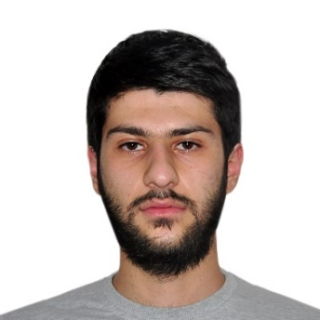

**GEORGI GHASABYAN**

**Curriculum Vitae**

**Cell (Armenia): +374 91801911**

**e-mail:** [**georgi.ghasabyan@gmail.com**](mailto:georgi.ghasabyan@gmail.com)

**CAREER OBJECTIVE:**

**To work in association with professional groups who offer me the opportunity for career advancement and professional growth.**

**LANGUAGES & COMPUTER SKILLS:**

* Armenian (native).
* English (good).
* Russian (good).
* HTML, CSS, JavaScript.
* Word, Excel, Access և Power Point.
* Adobe Photoshop, Adobe Illustrator.

**SKILLS:**

* Web development, Web-based programming and scripting languages (HTML, CSS, JAVASCRIPT).
* Good problem-solving skills.
* High attention to details and development projects.
* A positive attitude towards working within a team and being a team player.

**EDUCATION:**

**“ArmProf IT-Center Arman TM” – Web Development Courses**

**“AGH” Education Center - Web Design Courses**

**ACADEMIC CREDENTIALS:**

**Armenian State Institute of Physical Culture - Sports journalism and chess (bachelor degree)**

**\*Other information**: I served in the Armed Forces of Armenia (NKR, Martuni); not married.