# Our Service (100 points)

Create a Web page (HTML5 + CSS3) that looks and behaves like the screenshot below:

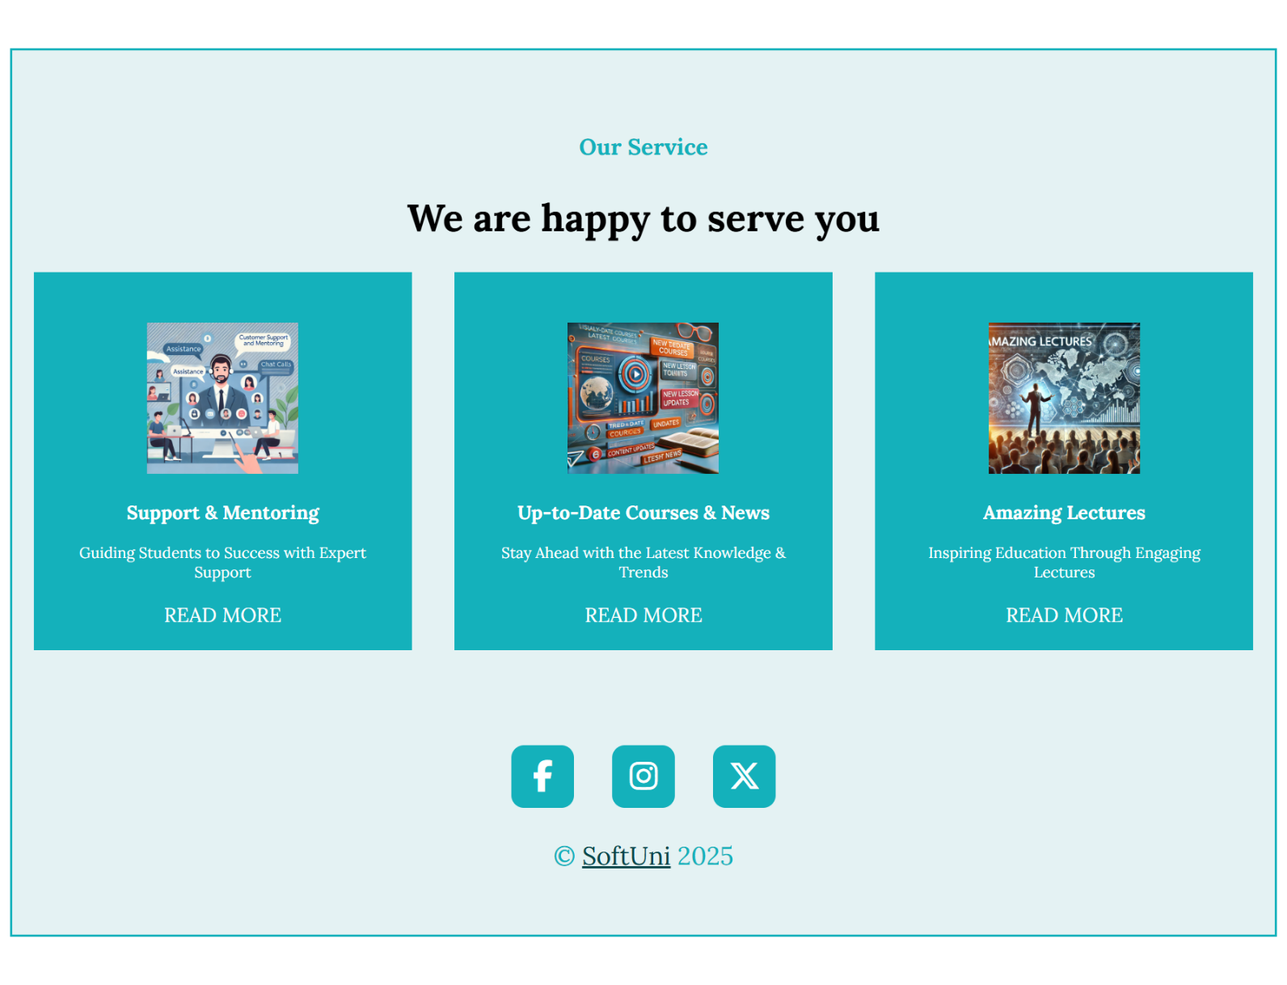

## Output

The output should be valid **HTML5** + **CSS3** + **Font Awesome icons** that implement the above web page.

* Use font 'Lora', sans-serif - already imported in the CSS file.
* The site should open correctly in the **latest** version of **Chrome**

**IMPORTANT: Do not change the structure of the provided exam resources. You may create files, but do not create new folders, rename existing ones, or move them to other directories.**

## Hints:

* **Background**: Use a **color picker tool** to identify the background color of the image and apply it to the frontend design.
* **Icons with Font Awesome**: Use **Font Awesome** to add the following icons to your frontend design: **X (Twitter)**, **Facebook**, **Instagram**.