Codebook for final2

Autogenerated data summary from dataMaid

2020-10-14 14:56:51

# Data report overview

The dataset examined has the following dimensions:

|  |  |
| --- | --- |
| Feature | Result |
| Number of observations | 6 |
| Number of variables | 562 |

# Codebook summary table

|  |  |  |  |  |  |
| --- | --- | --- | --- | --- | --- |
| Label | Variable | Class | # unique values | Missing | Description |
|  | **activity** | character | 6 | 0.00 % |  |
|  | **tBodyAcc.mean…X** | numeric | 6 | 0.00 % |  |
|  | **tBodyAcc.mean…Y** | numeric | 6 | 0.00 % |  |
|  | **tBodyAcc.mean…Z** | numeric | 6 | 0.00 % |  |
|  | **tBodyAcc.std…X** | numeric | 6 | 0.00 % |  |
|  | **tBodyAcc.std…Y** | numeric | 6 | 0.00 % |  |
|  | **tBodyAcc.std…Z** | numeric | 6 | 0.00 % |  |
|  | **tBodyAcc.mad…X** | numeric | 6 | 0.00 % |  |
|  | **tBodyAcc.mad…Y** | numeric | 6 | 0.00 % |  |
|  | **tBodyAcc.mad…Z** | numeric | 6 | 0.00 % |  |
|  | **tBodyAcc.max…X** | numeric | 6 | 0.00 % |  |
|  | **tBodyAcc.max…Y** | numeric | 6 | 0.00 % |  |
|  | **tBodyAcc.max…Z** | numeric | 6 | 0.00 % |  |
|  | **tBodyAcc.min…X** | numeric | 6 | 0.00 % |  |
|  | **tBodyAcc.min…Y** | numeric | 6 | 0.00 % |  |
|  | **tBodyAcc.min…Z** | numeric | 6 | 0.00 % |  |
|  | **tBodyAcc.sma..** | numeric | 6 | 0.00 % |  |
|  | **tBodyAcc.energy…X** | numeric | 6 | 0.00 % |  |
|  | **tBodyAcc.energy…Y** | numeric | 6 | 0.00 % |  |
|  | **tBodyAcc.energy…Z** | numeric | 6 | 0.00 % |  |
|  | **tBodyAcc.iqr…X** | numeric | 6 | 0.00 % |  |
|  | **tBodyAcc.iqr…Y** | numeric | 6 | 0.00 % |  |
|  | **tBodyAcc.iqr…Z** | numeric | 6 | 0.00 % |  |
|  | **tBodyAcc.entropy…X** | numeric | 6 | 0.00 % |  |
|  | **tBodyAcc.entropy…Y** | numeric | 6 | 0.00 % |  |
|  | **tBodyAcc.entropy…Z** | numeric | 6 | 0.00 % |  |
|  | **tBodyAcc.arCoeff…X.1** | numeric | 6 | 0.00 % |  |
|  | **tBodyAcc.arCoeff…X.2** | numeric | 6 | 0.00 % |  |
|  | **tBodyAcc.arCoeff…X.3** | numeric | 6 | 0.00 % |  |
|  | **tBodyAcc.arCoeff…X.4** | numeric | 6 | 0.00 % |  |
|  | **tBodyAcc.arCoeff…Y.1** | numeric | 6 | 0.00 % |  |
|  | **tBodyAcc.arCoeff…Y.2** | numeric | 6 | 0.00 % |  |
|  | **tBodyAcc.arCoeff…Y.3** | numeric | 6 | 0.00 % |  |
|  | **tBodyAcc.arCoeff…Y.4** | numeric | 6 | 0.00 % |  |
|  | **tBodyAcc.arCoeff…Z.1** | numeric | 6 | 0.00 % |  |
|  | **tBodyAcc.arCoeff…Z.2** | numeric | 6 | 0.00 % |  |
|  | **tBodyAcc.arCoeff…Z.3** | numeric | 6 | 0.00 % |  |
|  | **tBodyAcc.arCoeff…Z.4** | numeric | 6 | 0.00 % |  |
|  | **tBodyAcc.correlation…X.Y** | numeric | 6 | 0.00 % |  |
|  | **tBodyAcc.correlation…X.Z** | numeric | 6 | 0.00 % |  |
|  | **tBodyAcc.correlation…Y.Z** | numeric | 6 | 0.00 % |  |
|  | **tGravityAcc.mean…X** | numeric | 6 | 0.00 % |  |
|  | **tGravityAcc.mean…Y** | numeric | 6 | 0.00 % |  |
|  | **tGravityAcc.mean…Z** | numeric | 6 | 0.00 % |  |
|  | **tGravityAcc.std…X** | numeric | 6 | 0.00 % |  |
|  | **tGravityAcc.std…Y** | numeric | 6 | 0.00 % |  |
|  | **tGravityAcc.std…Z** | numeric | 6 | 0.00 % |  |
|  | **tGravityAcc.mad…X** | numeric | 6 | 0.00 % |  |
|  | **tGravityAcc.mad…Y** | numeric | 6 | 0.00 % |  |
|  | **tGravityAcc.mad…Z** | numeric | 6 | 0.00 % |  |
|  | **tGravityAcc.max…X** | numeric | 6 | 0.00 % |  |
|  | **tGravityAcc.max…Y** | numeric | 6 | 0.00 % |  |
|  | **tGravityAcc.max…Z** | numeric | 6 | 0.00 % |  |
|  | **tGravityAcc.min…X** | numeric | 6 | 0.00 % |  |
|  | **tGravityAcc.min…Y** | numeric | 6 | 0.00 % |  |
|  | **tGravityAcc.min…Z** | numeric | 6 | 0.00 % |  |
|  | **tGravityAcc.sma..** | numeric | 6 | 0.00 % |  |
|  | **tGravityAcc.energy…X** | numeric | 6 | 0.00 % |  |
|  | **tGravityAcc.energy…Y** | numeric | 6 | 0.00 % |  |
|  | **tGravityAcc.energy…Z** | numeric | 6 | 0.00 % |  |
|  | **tGravityAcc.iqr…X** | numeric | 6 | 0.00 % |  |
|  | **tGravityAcc.iqr…Y** | numeric | 6 | 0.00 % |  |
|  | **tGravityAcc.iqr…Z** | numeric | 6 | 0.00 % |  |
|  | **tGravityAcc.entropy…X** | numeric | 6 | 0.00 % |  |
|  | **tGravityAcc.entropy…Y** | numeric | 6 | 0.00 % |  |
|  | **tGravityAcc.entropy…Z** | numeric | 6 | 0.00 % |  |
|  | **tGravityAcc.arCoeff…X.1** | numeric | 6 | 0.00 % |  |
|  | **tGravityAcc.arCoeff…X.2** | numeric | 6 | 0.00 % |  |
|  | **tGravityAcc.arCoeff…X.3** | numeric | 6 | 0.00 % |  |
|  | **tGravityAcc.arCoeff…X.4** | numeric | 6 | 0.00 % |  |
|  | **tGravityAcc.arCoeff…Y.1** | numeric | 6 | 0.00 % |  |
|  | **tGravityAcc.arCoeff…Y.2** | numeric | 6 | 0.00 % |  |
|  | **tGravityAcc.arCoeff…Y.3** | numeric | 6 | 0.00 % |  |
|  | **tGravityAcc.arCoeff…Y.4** | numeric | 6 | 0.00 % |  |
|  | **tGravityAcc.arCoeff…Z.1** | numeric | 6 | 0.00 % |  |
|  | **tGravityAcc.arCoeff…Z.2** | numeric | 6 | 0.00 % |  |
|  | **tGravityAcc.arCoeff…Z.3** | numeric | 6 | 0.00 % |  |
|  | **tGravityAcc.arCoeff…Z.4** | numeric | 6 | 0.00 % |  |
|  | **tGravityAcc.correlation…X.Y** | numeric | 6 | 0.00 % |  |
|  | **tGravityAcc.correlation…X.Z** | numeric | 6 | 0.00 % |  |
|  | **tGravityAcc.correlation…Y.Z** | numeric | 6 | 0.00 % |  |
|  | **tBodyAccJerk.mean…X** | numeric | 6 | 0.00 % |  |
|  | **tBodyAccJerk.mean…Y** | numeric | 6 | 0.00 % |  |
|  | **tBodyAccJerk.mean…Z** | numeric | 6 | 0.00 % |  |
|  | **tBodyAccJerk.std…X** | numeric | 6 | 0.00 % |  |
|  | **tBodyAccJerk.std…Y** | numeric | 6 | 0.00 % |  |
|  | **tBodyAccJerk.std…Z** | numeric | 6 | 0.00 % |  |
|  | **tBodyAccJerk.mad…X** | numeric | 6 | 0.00 % |  |
|  | **tBodyAccJerk.mad…Y** | numeric | 6 | 0.00 % |  |
|  | **tBodyAccJerk.mad…Z** | numeric | 6 | 0.00 % |  |
|  | **tBodyAccJerk.max…X** | numeric | 6 | 0.00 % |  |
|  | **tBodyAccJerk.max…Y** | numeric | 6 | 0.00 % |  |
|  | **tBodyAccJerk.max…Z** | numeric | 6 | 0.00 % |  |
|  | **tBodyAccJerk.min…X** | numeric | 6 | 0.00 % |  |
|  | **tBodyAccJerk.min…Y** | numeric | 6 | 0.00 % |  |
|  | **tBodyAccJerk.min…Z** | numeric | 6 | 0.00 % |  |
|  | **tBodyAccJerk.sma..** | numeric | 6 | 0.00 % |  |
|  | **tBodyAccJerk.energy…X** | numeric | 6 | 0.00 % |  |
|  | **tBodyAccJerk.energy…Y** | numeric | 6 | 0.00 % |  |
|  | **tBodyAccJerk.energy…Z** | numeric | 6 | 0.00 % |  |
|  | **tBodyAccJerk.iqr…X** | numeric | 6 | 0.00 % |  |
|  | **tBodyAccJerk.iqr…Y** | numeric | 6 | 0.00 % |  |
|  | **tBodyAccJerk.iqr…Z** | numeric | 6 | 0.00 % |  |
|  | **tBodyAccJerk.entropy…X** | numeric | 6 | 0.00 % |  |
|  | **tBodyAccJerk.entropy…Y** | numeric | 6 | 0.00 % |  |
|  | **tBodyAccJerk.entropy…Z** | numeric | 6 | 0.00 % |  |
|  | **tBodyAccJerk.arCoeff…X.1** | numeric | 6 | 0.00 % |  |
|  | **tBodyAccJerk.arCoeff…X.2** | numeric | 6 | 0.00 % |  |
|  | **tBodyAccJerk.arCoeff…X.3** | numeric | 6 | 0.00 % |  |
|  | **tBodyAccJerk.arCoeff…X.4** | numeric | 6 | 0.00 % |  |
|  | **tBodyAccJerk.arCoeff…Y.1** | numeric | 6 | 0.00 % |  |
|  | **tBodyAccJerk.arCoeff…Y.2** | numeric | 6 | 0.00 % |  |
|  | **tBodyAccJerk.arCoeff…Y.3** | numeric | 6 | 0.00 % |  |
|  | **tBodyAccJerk.arCoeff…Y.4** | numeric | 6 | 0.00 % |  |
|  | **tBodyAccJerk.arCoeff…Z.1** | numeric | 6 | 0.00 % |  |
|  | **tBodyAccJerk.arCoeff…Z.2** | numeric | 6 | 0.00 % |  |
|  | **tBodyAccJerk.arCoeff…Z.3** | numeric | 6 | 0.00 % |  |
|  | **tBodyAccJerk.arCoeff…Z.4** | numeric | 6 | 0.00 % |  |
|  | **tBodyAccJerk.correlation…X.Y** | numeric | 6 | 0.00 % |  |
|  | **tBodyAccJerk.correlation…X.Z** | numeric | 6 | 0.00 % |  |
|  | **tBodyAccJerk.correlation…Y.Z** | numeric | 6 | 0.00 % |  |
|  | **tBodyGyro.mean…X** | numeric | 6 | 0.00 % |  |
|  | **tBodyGyro.mean…Y** | numeric | 6 | 0.00 % |  |
|  | **tBodyGyro.mean…Z** | numeric | 6 | 0.00 % |  |
|  | **tBodyGyro.std…X** | numeric | 6 | 0.00 % |  |
|  | **tBodyGyro.std…Y** | numeric | 6 | 0.00 % |  |
|  | **tBodyGyro.std…Z** | numeric | 6 | 0.00 % |  |
|  | **tBodyGyro.mad…X** | numeric | 6 | 0.00 % |  |
|  | **tBodyGyro.mad…Y** | numeric | 6 | 0.00 % |  |
|  | **tBodyGyro.mad…Z** | numeric | 6 | 0.00 % |  |
|  | **tBodyGyro.max…X** | numeric | 6 | 0.00 % |  |
|  | **tBodyGyro.max…Y** | numeric | 6 | 0.00 % |  |
|  | **tBodyGyro.max…Z** | numeric | 6 | 0.00 % |  |
|  | **tBodyGyro.min…X** | numeric | 6 | 0.00 % |  |
|  | **tBodyGyro.min…Y** | numeric | 6 | 0.00 % |  |
|  | **tBodyGyro.min…Z** | numeric | 6 | 0.00 % |  |
|  | **tBodyGyro.sma..** | numeric | 6 | 0.00 % |  |
|  | **tBodyGyro.energy…X** | numeric | 6 | 0.00 % |  |
|  | **tBodyGyro.energy…Y** | numeric | 6 | 0.00 % |  |
|  | **tBodyGyro.energy…Z** | numeric | 6 | 0.00 % |  |
|  | **tBodyGyro.iqr…X** | numeric | 6 | 0.00 % |  |
|  | **tBodyGyro.iqr…Y** | numeric | 6 | 0.00 % |  |
|  | **tBodyGyro.iqr…Z** | numeric | 6 | 0.00 % |  |
|  | **tBodyGyro.entropy…X** | numeric | 6 | 0.00 % |  |
|  | **tBodyGyro.entropy…Y** | numeric | 6 | 0.00 % |  |
|  | **tBodyGyro.entropy…Z** | numeric | 6 | 0.00 % |  |
|  | **tBodyGyro.arCoeff…X.1** | numeric | 6 | 0.00 % |  |
|  | **tBodyGyro.arCoeff…X.2** | numeric | 6 | 0.00 % |  |
|  | **tBodyGyro.arCoeff…X.3** | numeric | 6 | 0.00 % |  |
|  | **tBodyGyro.arCoeff…X.4** | numeric | 6 | 0.00 % |  |
|  | **tBodyGyro.arCoeff…Y.1** | numeric | 6 | 0.00 % |  |
|  | **tBodyGyro.arCoeff…Y.2** | numeric | 6 | 0.00 % |  |
|  | **tBodyGyro.arCoeff…Y.3** | numeric | 6 | 0.00 % |  |
|  | **tBodyGyro.arCoeff…Y.4** | numeric | 6 | 0.00 % |  |
|  | **tBodyGyro.arCoeff…Z.1** | numeric | 6 | 0.00 % |  |
|  | **tBodyGyro.arCoeff…Z.2** | numeric | 6 | 0.00 % |  |
|  | **tBodyGyro.arCoeff…Z.3** | numeric | 6 | 0.00 % |  |
|  | **tBodyGyro.arCoeff…Z.4** | numeric | 6 | 0.00 % |  |
|  | **tBodyGyro.correlation…X.Y** | numeric | 6 | 0.00 % |  |
|  | **tBodyGyro.correlation…X.Z** | numeric | 6 | 0.00 % |  |
|  | **tBodyGyro.correlation…Y.Z** | numeric | 6 | 0.00 % |  |
|  | **tBodyGyroJerk.mean…X** | numeric | 6 | 0.00 % |  |
|  | **tBodyGyroJerk.mean…Y** | numeric | 6 | 0.00 % |  |
|  | **tBodyGyroJerk.mean…Z** | numeric | 6 | 0.00 % |  |
|  | **tBodyGyroJerk.std…X** | numeric | 6 | 0.00 % |  |
|  | **tBodyGyroJerk.std…Y** | numeric | 6 | 0.00 % |  |
|  | **tBodyGyroJerk.std…Z** | numeric | 6 | 0.00 % |  |
|  | **tBodyGyroJerk.mad…X** | numeric | 6 | 0.00 % |  |
|  | **tBodyGyroJerk.mad…Y** | numeric | 6 | 0.00 % |  |
|  | **tBodyGyroJerk.mad…Z** | numeric | 6 | 0.00 % |  |
|  | **tBodyGyroJerk.max…X** | numeric | 6 | 0.00 % |  |
|  | **tBodyGyroJerk.max…Y** | numeric | 6 | 0.00 % |  |
|  | **tBodyGyroJerk.max…Z** | numeric | 6 | 0.00 % |  |
|  | **tBodyGyroJerk.min…X** | numeric | 6 | 0.00 % |  |
|  | **tBodyGyroJerk.min…Y** | numeric | 6 | 0.00 % |  |
|  | **tBodyGyroJerk.min…Z** | numeric | 6 | 0.00 % |  |
|  | **tBodyGyroJerk.sma..** | numeric | 6 | 0.00 % |  |
|  | **tBodyGyroJerk.energy…X** | numeric | 6 | 0.00 % |  |
|  | **tBodyGyroJerk.energy…Y** | numeric | 6 | 0.00 % |  |
|  | **tBodyGyroJerk.energy…Z** | numeric | 6 | 0.00 % |  |
|  | **tBodyGyroJerk.iqr…X** | numeric | 6 | 0.00 % |  |
|  | **tBodyGyroJerk.iqr…Y** | numeric | 6 | 0.00 % |  |
|  | **tBodyGyroJerk.iqr…Z** | numeric | 6 | 0.00 % |  |
|  | **tBodyGyroJerk.entropy…X** | numeric | 6 | 0.00 % |  |
|  | **tBodyGyroJerk.entropy…Y** | numeric | 6 | 0.00 % |  |
|  | **tBodyGyroJerk.entropy…Z** | numeric | 6 | 0.00 % |  |
|  | **tBodyGyroJerk.arCoeff…X.1** | numeric | 6 | 0.00 % |  |
|  | **tBodyGyroJerk.arCoeff…X.2** | numeric | 6 | 0.00 % |  |
|  | **tBodyGyroJerk.arCoeff…X.3** | numeric | 6 | 0.00 % |  |
|  | **tBodyGyroJerk.arCoeff…X.4** | numeric | 6 | 0.00 % |  |
|  | **tBodyGyroJerk.arCoeff…Y.1** | numeric | 6 | 0.00 % |  |
|  | **tBodyGyroJerk.arCoeff…Y.2** | numeric | 6 | 0.00 % |  |
|  | **tBodyGyroJerk.arCoeff…Y.3** | numeric | 6 | 0.00 % |  |
|  | **tBodyGyroJerk.arCoeff…Y.4** | numeric | 6 | 0.00 % |  |
|  | **tBodyGyroJerk.arCoeff…Z.1** | numeric | 6 | 0.00 % |  |
|  | **tBodyGyroJerk.arCoeff…Z.2** | numeric | 6 | 0.00 % |  |
|  | **tBodyGyroJerk.arCoeff…Z.3** | numeric | 6 | 0.00 % |  |
|  | **tBodyGyroJerk.arCoeff…Z.4** | numeric | 6 | 0.00 % |  |
|  | **tBodyGyroJerk.correlation…X.Y** | numeric | 6 | 0.00 % |  |
|  | **tBodyGyroJerk.correlation…X.Z** | numeric | 6 | 0.00 % |  |
|  | **tBodyGyroJerk.correlation…Y.Z** | numeric | 6 | 0.00 % |  |
|  | **tBodyAccMag.mean..** | numeric | 6 | 0.00 % |  |
|  | **tBodyAccMag.std..** | numeric | 6 | 0.00 % |  |
|  | **tBodyAccMag.mad..** | numeric | 6 | 0.00 % |  |
|  | **tBodyAccMag.max..** | numeric | 6 | 0.00 % |  |
|  | **tBodyAccMag.min..** | numeric | 6 | 0.00 % |  |
|  | **tBodyAccMag.sma..** | numeric | 6 | 0.00 % |  |
|  | **tBodyAccMag.energy..** | numeric | 6 | 0.00 % |  |
|  | **tBodyAccMag.iqr..** | numeric | 6 | 0.00 % |  |
|  | **tBodyAccMag.entropy..** | numeric | 6 | 0.00 % |  |
|  | **tBodyAccMag.arCoeff..1** | numeric | 6 | 0.00 % |  |
|  | **tBodyAccMag.arCoeff..2** | numeric | 6 | 0.00 % |  |
|  | **tBodyAccMag.arCoeff..3** | numeric | 6 | 0.00 % |  |
|  | **tBodyAccMag.arCoeff..4** | numeric | 6 | 0.00 % |  |
|  | **tGravityAccMag.mean..** | numeric | 6 | 0.00 % |  |
|  | **tGravityAccMag.std..** | numeric | 6 | 0.00 % |  |
|  | **tGravityAccMag.mad..** | numeric | 6 | 0.00 % |  |
|  | **tGravityAccMag.max..** | numeric | 6 | 0.00 % |  |
|  | **tGravityAccMag.min..** | numeric | 6 | 0.00 % |  |
|  | **tGravityAccMag.sma..** | numeric | 6 | 0.00 % |  |
|  | **tGravityAccMag.energy..** | numeric | 6 | 0.00 % |  |
|  | **tGravityAccMag.iqr..** | numeric | 6 | 0.00 % |  |
|  | **tGravityAccMag.entropy..** | numeric | 6 | 0.00 % |  |
|  | **tGravityAccMag.arCoeff..1** | numeric | 6 | 0.00 % |  |
|  | **tGravityAccMag.arCoeff..2** | numeric | 6 | 0.00 % |  |
|  | **tGravityAccMag.arCoeff..3** | numeric | 6 | 0.00 % |  |
|  | **tGravityAccMag.arCoeff..4** | numeric | 6 | 0.00 % |  |
|  | **tBodyAccJerkMag.mean..** | numeric | 6 | 0.00 % |  |
|  | **tBodyAccJerkMag.std..** | numeric | 6 | 0.00 % |  |
|  | **tBodyAccJerkMag.mad..** | numeric | 6 | 0.00 % |  |
|  | **tBodyAccJerkMag.max..** | numeric | 6 | 0.00 % |  |
|  | **tBodyAccJerkMag.min..** | numeric | 6 | 0.00 % |  |
|  | **tBodyAccJerkMag.sma..** | numeric | 6 | 0.00 % |  |
|  | **tBodyAccJerkMag.energy..** | numeric | 6 | 0.00 % |  |
|  | **tBodyAccJerkMag.iqr..** | numeric | 6 | 0.00 % |  |
|  | **tBodyAccJerkMag.entropy..** | numeric | 6 | 0.00 % |  |
|  | **tBodyAccJerkMag.arCoeff..1** | numeric | 6 | 0.00 % |  |
|  | **tBodyAccJerkMag.arCoeff..2** | numeric | 6 | 0.00 % |  |
|  | **tBodyAccJerkMag.arCoeff..3** | numeric | 6 | 0.00 % |  |
|  | **tBodyAccJerkMag.arCoeff..4** | numeric | 6 | 0.00 % |  |
|  | **tBodyGyroMag.mean..** | numeric | 6 | 0.00 % |  |
|  | **tBodyGyroMag.std..** | numeric | 6 | 0.00 % |  |
|  | **tBodyGyroMag.mad..** | numeric | 6 | 0.00 % |  |
|  | **tBodyGyroMag.max..** | numeric | 6 | 0.00 % |  |
|  | **tBodyGyroMag.min..** | numeric | 6 | 0.00 % |  |
|  | **tBodyGyroMag.sma..** | numeric | 6 | 0.00 % |  |
|  | **tBodyGyroMag.energy..** | numeric | 6 | 0.00 % |  |
|  | **tBodyGyroMag.iqr..** | numeric | 6 | 0.00 % |  |
|  | **tBodyGyroMag.entropy..** | numeric | 6 | 0.00 % |  |
|  | **tBodyGyroMag.arCoeff..1** | numeric | 6 | 0.00 % |  |
|  | **tBodyGyroMag.arCoeff..2** | numeric | 6 | 0.00 % |  |
|  | **tBodyGyroMag.arCoeff..3** | numeric | 6 | 0.00 % |  |
|  | **tBodyGyroMag.arCoeff..4** | numeric | 6 | 0.00 % |  |
|  | **tBodyGyroJerkMag.mean..** | numeric | 6 | 0.00 % |  |
|  | **tBodyGyroJerkMag.std..** | numeric | 6 | 0.00 % |  |
|  | **tBodyGyroJerkMag.mad..** | numeric | 6 | 0.00 % |  |
|  | **tBodyGyroJerkMag.max..** | numeric | 6 | 0.00 % |  |
|  | **tBodyGyroJerkMag.min..** | numeric | 6 | 0.00 % |  |
|  | **tBodyGyroJerkMag.sma..** | numeric | 6 | 0.00 % |  |
|  | **tBodyGyroJerkMag.energy..** | numeric | 6 | 0.00 % |  |
|  | **tBodyGyroJerkMag.iqr..** | numeric | 6 | 0.00 % |  |
|  | **tBodyGyroJerkMag.entropy..** | numeric | 6 | 0.00 % |  |
|  | **tBodyGyroJerkMag.arCoeff..1** | numeric | 6 | 0.00 % |  |
|  | **tBodyGyroJerkMag.arCoeff..2** | numeric | 6 | 0.00 % |  |
|  | **tBodyGyroJerkMag.arCoeff..3** | numeric | 6 | 0.00 % |  |
|  | **tBodyGyroJerkMag.arCoeff..4** | numeric | 6 | 0.00 % |  |
|  | **fBodyAcc.mean…X** | numeric | 6 | 0.00 % |  |
|  | **fBodyAcc.mean…Y** | numeric | 6 | 0.00 % |  |
|  | **fBodyAcc.mean…Z** | numeric | 6 | 0.00 % |  |
|  | **fBodyAcc.std…X** | numeric | 6 | 0.00 % |  |
|  | **fBodyAcc.std…Y** | numeric | 6 | 0.00 % |  |
|  | **fBodyAcc.std…Z** | numeric | 6 | 0.00 % |  |
|  | **fBodyAcc.mad…X** | numeric | 6 | 0.00 % |  |
|  | **fBodyAcc.mad…Y** | numeric | 6 | 0.00 % |  |
|  | **fBodyAcc.mad…Z** | numeric | 6 | 0.00 % |  |
|  | **fBodyAcc.max…X** | numeric | 6 | 0.00 % |  |
|  | **fBodyAcc.max…Y** | numeric | 6 | 0.00 % |  |
|  | **fBodyAcc.max…Z** | numeric | 6 | 0.00 % |  |
|  | **fBodyAcc.min…X** | numeric | 6 | 0.00 % |  |
|  | **fBodyAcc.min…Y** | numeric | 6 | 0.00 % |  |
|  | **fBodyAcc.min…Z** | numeric | 6 | 0.00 % |  |
|  | **fBodyAcc.sma..** | numeric | 6 | 0.00 % |  |
|  | **fBodyAcc.energy…X** | numeric | 6 | 0.00 % |  |
|  | **fBodyAcc.energy…Y** | numeric | 6 | 0.00 % |  |
|  | **fBodyAcc.energy…Z** | numeric | 6 | 0.00 % |  |
|  | **fBodyAcc.iqr…X** | numeric | 6 | 0.00 % |  |
|  | **fBodyAcc.iqr…Y** | numeric | 6 | 0.00 % |  |
|  | **fBodyAcc.iqr…Z** | numeric | 6 | 0.00 % |  |
|  | **fBodyAcc.entropy…X** | numeric | 6 | 0.00 % |  |
|  | **fBodyAcc.entropy…Y** | numeric | 6 | 0.00 % |  |
|  | **fBodyAcc.entropy…Z** | numeric | 6 | 0.00 % |  |
|  | **fBodyAcc.maxInds.X** | numeric | 6 | 0.00 % |  |
|  | **fBodyAcc.maxInds.Y** | numeric | 6 | 0.00 % |  |
|  | **fBodyAcc.maxInds.Z** | numeric | 6 | 0.00 % |  |
|  | **fBodyAcc.meanFreq…X** | numeric | 6 | 0.00 % |  |
|  | **fBodyAcc.meanFreq…Y** | numeric | 6 | 0.00 % |  |
|  | **fBodyAcc.meanFreq…Z** | numeric | 6 | 0.00 % |  |
|  | **fBodyAcc.skewness…X** | numeric | 6 | 0.00 % |  |
|  | **fBodyAcc.kurtosis…X** | numeric | 6 | 0.00 % |  |
|  | **fBodyAcc.skewness…Y** | numeric | 6 | 0.00 % |  |
|  | **fBodyAcc.kurtosis…Y** | numeric | 6 | 0.00 % |  |
|  | **fBodyAcc.skewness…Z** | numeric | 6 | 0.00 % |  |
|  | **fBodyAcc.kurtosis…Z** | numeric | 6 | 0.00 % |  |
|  | **fBodyAcc.bandsEnergy…1.8** | numeric | 6 | 0.00 % |  |
|  | **fBodyAcc.bandsEnergy…9.16** | numeric | 6 | 0.00 % |  |
|  | **fBodyAcc.bandsEnergy…17.24** | numeric | 6 | 0.00 % |  |
|  | **fBodyAcc.bandsEnergy…25.32** | numeric | 6 | 0.00 % |  |
|  | **fBodyAcc.bandsEnergy…33.40** | numeric | 6 | 0.00 % |  |
|  | **fBodyAcc.bandsEnergy…41.48** | numeric | 6 | 0.00 % |  |
|  | **fBodyAcc.bandsEnergy…49.56** | numeric | 6 | 0.00 % |  |
|  | **fBodyAcc.bandsEnergy…57.64** | numeric | 6 | 0.00 % |  |
|  | **fBodyAcc.bandsEnergy…1.16** | numeric | 6 | 0.00 % |  |
|  | **fBodyAcc.bandsEnergy…17.32** | numeric | 6 | 0.00 % |  |
|  | **fBodyAcc.bandsEnergy…33.48** | numeric | 6 | 0.00 % |  |
|  | **fBodyAcc.bandsEnergy…49.64** | numeric | 6 | 0.00 % |  |
|  | **fBodyAcc.bandsEnergy…1.24** | numeric | 6 | 0.00 % |  |
|  | **fBodyAcc.bandsEnergy…25.48** | numeric | 6 | 0.00 % |  |
|  | **fBodyAcc.bandsEnergy…1.8.1** | numeric | 6 | 0.00 % |  |
|  | **fBodyAcc.bandsEnergy…9.16.1** | numeric | 6 | 0.00 % |  |
|  | **fBodyAcc.bandsEnergy…17.24.1** | numeric | 6 | 0.00 % |  |
|  | **fBodyAcc.bandsEnergy…25.32.1** | numeric | 6 | 0.00 % |  |
|  | **fBodyAcc.bandsEnergy…33.40.1** | numeric | 6 | 0.00 % |  |
|  | **fBodyAcc.bandsEnergy…41.48.1** | numeric | 6 | 0.00 % |  |
|  | **fBodyAcc.bandsEnergy…49.56.1** | numeric | 6 | 0.00 % |  |
|  | **fBodyAcc.bandsEnergy…57.64.1** | numeric | 6 | 0.00 % |  |
|  | **fBodyAcc.bandsEnergy…1.16.1** | numeric | 6 | 0.00 % |  |
|  | **fBodyAcc.bandsEnergy…17.32.1** | numeric | 6 | 0.00 % |  |
|  | **fBodyAcc.bandsEnergy…33.48.1** | numeric | 6 | 0.00 % |  |
|  | **fBodyAcc.bandsEnergy…49.64.1** | numeric | 6 | 0.00 % |  |
|  | **fBodyAcc.bandsEnergy…1.24.1** | numeric | 6 | 0.00 % |  |
|  | **fBodyAcc.bandsEnergy…25.48.1** | numeric | 6 | 0.00 % |  |
|  | **fBodyAcc.bandsEnergy…1.8.2** | numeric | 6 | 0.00 % |  |
|  | **fBodyAcc.bandsEnergy…9.16.2** | numeric | 6 | 0.00 % |  |
|  | **fBodyAcc.bandsEnergy…17.24.2** | numeric | 6 | 0.00 % |  |
|  | **fBodyAcc.bandsEnergy…25.32.2** | numeric | 6 | 0.00 % |  |
|  | **fBodyAcc.bandsEnergy…33.40.2** | numeric | 6 | 0.00 % |  |
|  | **fBodyAcc.bandsEnergy…41.48.2** | numeric | 6 | 0.00 % |  |
|  | **fBodyAcc.bandsEnergy…49.56.2** | numeric | 6 | 0.00 % |  |
|  | **fBodyAcc.bandsEnergy…57.64.2** | numeric | 6 | 0.00 % |  |
|  | **fBodyAcc.bandsEnergy…1.16.2** | numeric | 6 | 0.00 % |  |
|  | **fBodyAcc.bandsEnergy…17.32.2** | numeric | 6 | 0.00 % |  |
|  | **fBodyAcc.bandsEnergy…33.48.2** | numeric | 6 | 0.00 % |  |
|  | **fBodyAcc.bandsEnergy…49.64.2** | numeric | 6 | 0.00 % |  |
|  | **fBodyAcc.bandsEnergy…1.24.2** | numeric | 6 | 0.00 % |  |
|  | **fBodyAcc.bandsEnergy…25.48.2** | numeric | 6 | 0.00 % |  |
|  | **fBodyAccJerk.mean…X** | numeric | 6 | 0.00 % |  |
|  | **fBodyAccJerk.mean…Y** | numeric | 6 | 0.00 % |  |
|  | **fBodyAccJerk.mean…Z** | numeric | 6 | 0.00 % |  |
|  | **fBodyAccJerk.std…X** | numeric | 6 | 0.00 % |  |
|  | **fBodyAccJerk.std…Y** | numeric | 6 | 0.00 % |  |
|  | **fBodyAccJerk.std…Z** | numeric | 6 | 0.00 % |  |
|  | **fBodyAccJerk.mad…X** | numeric | 6 | 0.00 % |  |
|  | **fBodyAccJerk.mad…Y** | numeric | 6 | 0.00 % |  |
|  | **fBodyAccJerk.mad…Z** | numeric | 6 | 0.00 % |  |
|  | **fBodyAccJerk.max…X** | numeric | 6 | 0.00 % |  |
|  | **fBodyAccJerk.max…Y** | numeric | 6 | 0.00 % |  |
|  | **fBodyAccJerk.max…Z** | numeric | 6 | 0.00 % |  |
|  | **fBodyAccJerk.min…X** | numeric | 6 | 0.00 % |  |
|  | **fBodyAccJerk.min…Y** | numeric | 6 | 0.00 % |  |
|  | **fBodyAccJerk.min…Z** | numeric | 6 | 0.00 % |  |
|  | **fBodyAccJerk.sma..** | numeric | 6 | 0.00 % |  |
|  | **fBodyAccJerk.energy…X** | numeric | 6 | 0.00 % |  |
|  | **fBodyAccJerk.energy…Y** | numeric | 6 | 0.00 % |  |
|  | **fBodyAccJerk.energy…Z** | numeric | 6 | 0.00 % |  |
|  | **fBodyAccJerk.iqr…X** | numeric | 6 | 0.00 % |  |
|  | **fBodyAccJerk.iqr…Y** | numeric | 6 | 0.00 % |  |
|  | **fBodyAccJerk.iqr…Z** | numeric | 6 | 0.00 % |  |
|  | **fBodyAccJerk.entropy…X** | numeric | 6 | 0.00 % |  |
|  | **fBodyAccJerk.entropy…Y** | numeric | 6 | 0.00 % |  |
|  | **fBodyAccJerk.entropy…Z** | numeric | 6 | 0.00 % |  |
|  | **fBodyAccJerk.maxInds.X** | numeric | 6 | 0.00 % |  |
|  | **fBodyAccJerk.maxInds.Y** | numeric | 6 | 0.00 % |  |
|  | **fBodyAccJerk.maxInds.Z** | numeric | 6 | 0.00 % |  |
|  | **fBodyAccJerk.meanFreq…X** | numeric | 6 | 0.00 % |  |
|  | **fBodyAccJerk.meanFreq…Y** | numeric | 6 | 0.00 % |  |
|  | **fBodyAccJerk.meanFreq…Z** | numeric | 6 | 0.00 % |  |
|  | **fBodyAccJerk.skewness…X** | numeric | 6 | 0.00 % |  |
|  | **fBodyAccJerk.kurtosis…X** | numeric | 6 | 0.00 % |  |
|  | **fBodyAccJerk.skewness…Y** | numeric | 6 | 0.00 % |  |
|  | **fBodyAccJerk.kurtosis…Y** | numeric | 6 | 0.00 % |  |
|  | **fBodyAccJerk.skewness…Z** | numeric | 6 | 0.00 % |  |
|  | **fBodyAccJerk.kurtosis…Z** | numeric | 6 | 0.00 % |  |
|  | **fBodyAccJerk.bandsEnergy…1.8** | numeric | 6 | 0.00 % |  |
|  | **fBodyAccJerk.bandsEnergy…9.16** | numeric | 6 | 0.00 % |  |
|  | **fBodyAccJerk.bandsEnergy…17.24** | numeric | 6 | 0.00 % |  |
|  | **fBodyAccJerk.bandsEnergy…25.32** | numeric | 6 | 0.00 % |  |
|  | **fBodyAccJerk.bandsEnergy…33.40** | numeric | 6 | 0.00 % |  |
|  | **fBodyAccJerk.bandsEnergy…41.48** | numeric | 6 | 0.00 % |  |
|  | **fBodyAccJerk.bandsEnergy…49.56** | numeric | 6 | 0.00 % |  |
|  | **fBodyAccJerk.bandsEnergy…57.64** | numeric | 6 | 0.00 % |  |
|  | **fBodyAccJerk.bandsEnergy…1.16** | numeric | 6 | 0.00 % |  |
|  | **fBodyAccJerk.bandsEnergy…17.32** | numeric | 6 | 0.00 % |  |
|  | **fBodyAccJerk.bandsEnergy…33.48** | numeric | 6 | 0.00 % |  |
|  | **fBodyAccJerk.bandsEnergy…49.64** | numeric | 6 | 0.00 % |  |
|  | **fBodyAccJerk.bandsEnergy…1.24** | numeric | 6 | 0.00 % |  |
|  | **fBodyAccJerk.bandsEnergy…25.48** | numeric | 6 | 0.00 % |  |
|  | **fBodyAccJerk.bandsEnergy…1.8.1** | numeric | 6 | 0.00 % |  |
|  | **fBodyAccJerk.bandsEnergy…9.16.1** | numeric | 6 | 0.00 % |  |
|  | **fBodyAccJerk.bandsEnergy…17.24.1** | numeric | 6 | 0.00 % |  |
|  | **fBodyAccJerk.bandsEnergy…25.32.1** | numeric | 6 | 0.00 % |  |
|  | **fBodyAccJerk.bandsEnergy…33.40.1** | numeric | 6 | 0.00 % |  |
|  | **fBodyAccJerk.bandsEnergy…41.48.1** | numeric | 6 | 0.00 % |  |
|  | **fBodyAccJerk.bandsEnergy…49.56.1** | numeric | 6 | 0.00 % |  |
|  | **fBodyAccJerk.bandsEnergy…57.64.1** | numeric | 6 | 0.00 % |  |
|  | **fBodyAccJerk.bandsEnergy…1.16.1** | numeric | 6 | 0.00 % |  |
|  | **fBodyAccJerk.bandsEnergy…17.32.1** | numeric | 6 | 0.00 % |  |
|  | **fBodyAccJerk.bandsEnergy…33.48.1** | numeric | 6 | 0.00 % |  |
|  | **fBodyAccJerk.bandsEnergy…49.64.1** | numeric | 6 | 0.00 % |  |
|  | **fBodyAccJerk.bandsEnergy…1.24.1** | numeric | 6 | 0.00 % |  |
|  | **fBodyAccJerk.bandsEnergy…25.48.1** | numeric | 6 | 0.00 % |  |
|  | **fBodyAccJerk.bandsEnergy…1.8.2** | numeric | 6 | 0.00 % |  |
|  | **fBodyAccJerk.bandsEnergy…9.16.2** | numeric | 6 | 0.00 % |  |
|  | **fBodyAccJerk.bandsEnergy…17.24.2** | numeric | 6 | 0.00 % |  |
|  | **fBodyAccJerk.bandsEnergy…25.32.2** | numeric | 6 | 0.00 % |  |
|  | **fBodyAccJerk.bandsEnergy…33.40.2** | numeric | 6 | 0.00 % |  |
|  | **fBodyAccJerk.bandsEnergy…41.48.2** | numeric | 6 | 0.00 % |  |
|  | **fBodyAccJerk.bandsEnergy…49.56.2** | numeric | 6 | 0.00 % |  |
|  | **fBodyAccJerk.bandsEnergy…57.64.2** | numeric | 6 | 0.00 % |  |
|  | **fBodyAccJerk.bandsEnergy…1.16.2** | numeric | 6 | 0.00 % |  |
|  | **fBodyAccJerk.bandsEnergy…17.32.2** | numeric | 6 | 0.00 % |  |
|  | **fBodyAccJerk.bandsEnergy…33.48.2** | numeric | 6 | 0.00 % |  |
|  | **fBodyAccJerk.bandsEnergy…49.64.2** | numeric | 6 | 0.00 % |  |
|  | **fBodyAccJerk.bandsEnergy…1.24.2** | numeric | 6 | 0.00 % |  |
|  | **fBodyAccJerk.bandsEnergy…25.48.2** | numeric | 6 | 0.00 % |  |
|  | **fBodyGyro.mean…X** | numeric | 6 | 0.00 % |  |
|  | **fBodyGyro.mean…Y** | numeric | 6 | 0.00 % |  |
|  | **fBodyGyro.mean…Z** | numeric | 6 | 0.00 % |  |
|  | **fBodyGyro.std…X** | numeric | 6 | 0.00 % |  |
|  | **fBodyGyro.std…Y** | numeric | 6 | 0.00 % |  |
|  | **fBodyGyro.std…Z** | numeric | 6 | 0.00 % |  |
|  | **fBodyGyro.mad…X** | numeric | 6 | 0.00 % |  |
|  | **fBodyGyro.mad…Y** | numeric | 6 | 0.00 % |  |
|  | **fBodyGyro.mad…Z** | numeric | 6 | 0.00 % |  |
|  | **fBodyGyro.max…X** | numeric | 6 | 0.00 % |  |
|  | **fBodyGyro.max…Y** | numeric | 6 | 0.00 % |  |
|  | **fBodyGyro.max…Z** | numeric | 6 | 0.00 % |  |
|  | **fBodyGyro.min…X** | numeric | 6 | 0.00 % |  |
|  | **fBodyGyro.min…Y** | numeric | 6 | 0.00 % |  |
|  | **fBodyGyro.min…Z** | numeric | 6 | 0.00 % |  |
|  | **fBodyGyro.sma..** | numeric | 6 | 0.00 % |  |
|  | **fBodyGyro.energy…X** | numeric | 6 | 0.00 % |  |
|  | **fBodyGyro.energy…Y** | numeric | 6 | 0.00 % |  |
|  | **fBodyGyro.energy…Z** | numeric | 6 | 0.00 % |  |
|  | **fBodyGyro.iqr…X** | numeric | 6 | 0.00 % |  |
|  | **fBodyGyro.iqr…Y** | numeric | 6 | 0.00 % |  |
|  | **fBodyGyro.iqr…Z** | numeric | 6 | 0.00 % |  |
|  | **fBodyGyro.entropy…X** | numeric | 6 | 0.00 % |  |
|  | **fBodyGyro.entropy…Y** | numeric | 6 | 0.00 % |  |
|  | **fBodyGyro.entropy…Z** | numeric | 6 | 0.00 % |  |
|  | **fBodyGyro.maxInds.X** | numeric | 6 | 0.00 % |  |
|  | **fBodyGyro.maxInds.Y** | numeric | 6 | 0.00 % |  |
|  | **fBodyGyro.maxInds.Z** | numeric | 6 | 0.00 % |  |
|  | **fBodyGyro.meanFreq…X** | numeric | 6 | 0.00 % |  |
|  | **fBodyGyro.meanFreq…Y** | numeric | 6 | 0.00 % |  |
|  | **fBodyGyro.meanFreq…Z** | numeric | 6 | 0.00 % |  |
|  | **fBodyGyro.skewness…X** | numeric | 6 | 0.00 % |  |
|  | **fBodyGyro.kurtosis…X** | numeric | 6 | 0.00 % |  |
|  | **fBodyGyro.skewness…Y** | numeric | 6 | 0.00 % |  |
|  | **fBodyGyro.kurtosis…Y** | numeric | 6 | 0.00 % |  |
|  | **fBodyGyro.skewness…Z** | numeric | 6 | 0.00 % |  |
|  | **fBodyGyro.kurtosis…Z** | numeric | 6 | 0.00 % |  |
|  | **fBodyGyro.bandsEnergy…1.8** | numeric | 6 | 0.00 % |  |
|  | **fBodyGyro.bandsEnergy…9.16** | numeric | 6 | 0.00 % |  |
|  | **fBodyGyro.bandsEnergy…17.24** | numeric | 6 | 0.00 % |  |
|  | **fBodyGyro.bandsEnergy…25.32** | numeric | 6 | 0.00 % |  |
|  | **fBodyGyro.bandsEnergy…33.40** | numeric | 6 | 0.00 % |  |
|  | **fBodyGyro.bandsEnergy…41.48** | numeric | 6 | 0.00 % |  |
|  | **fBodyGyro.bandsEnergy…49.56** | numeric | 6 | 0.00 % |  |
|  | **fBodyGyro.bandsEnergy…57.64** | numeric | 6 | 0.00 % |  |
|  | **fBodyGyro.bandsEnergy…1.16** | numeric | 6 | 0.00 % |  |
|  | **fBodyGyro.bandsEnergy…17.32** | numeric | 6 | 0.00 % |  |
|  | **fBodyGyro.bandsEnergy…33.48** | numeric | 6 | 0.00 % |  |
|  | **fBodyGyro.bandsEnergy…49.64** | numeric | 6 | 0.00 % |  |
|  | **fBodyGyro.bandsEnergy…1.24** | numeric | 6 | 0.00 % |  |
|  | **fBodyGyro.bandsEnergy…25.48** | numeric | 6 | 0.00 % |  |
|  | **fBodyGyro.bandsEnergy…1.8.1** | numeric | 6 | 0.00 % |  |
|  | **fBodyGyro.bandsEnergy…9.16.1** | numeric | 6 | 0.00 % |  |
|  | **fBodyGyro.bandsEnergy…17.24.1** | numeric | 6 | 0.00 % |  |
|  | **fBodyGyro.bandsEnergy…25.32.1** | numeric | 6 | 0.00 % |  |
|  | **fBodyGyro.bandsEnergy…33.40.1** | numeric | 6 | 0.00 % |  |
|  | **fBodyGyro.bandsEnergy…41.48.1** | numeric | 6 | 0.00 % |  |
|  | **fBodyGyro.bandsEnergy…49.56.1** | numeric | 6 | 0.00 % |  |
|  | **fBodyGyro.bandsEnergy…57.64.1** | numeric | 6 | 0.00 % |  |
|  | **fBodyGyro.bandsEnergy…1.16.1** | numeric | 6 | 0.00 % |  |
|  | **fBodyGyro.bandsEnergy…17.32.1** | numeric | 6 | 0.00 % |  |
|  | **fBodyGyro.bandsEnergy…33.48.1** | numeric | 6 | 0.00 % |  |
|  | **fBodyGyro.bandsEnergy…49.64.1** | numeric | 6 | 0.00 % |  |
|  | **fBodyGyro.bandsEnergy…1.24.1** | numeric | 6 | 0.00 % |  |
|  | **fBodyGyro.bandsEnergy…25.48.1** | numeric | 6 | 0.00 % |  |
|  | **fBodyGyro.bandsEnergy…1.8.2** | numeric | 6 | 0.00 % |  |
|  | **fBodyGyro.bandsEnergy…9.16.2** | numeric | 6 | 0.00 % |  |
|  | **fBodyGyro.bandsEnergy…17.24.2** | numeric | 6 | 0.00 % |  |
|  | **fBodyGyro.bandsEnergy…25.32.2** | numeric | 6 | 0.00 % |  |
|  | **fBodyGyro.bandsEnergy…33.40.2** | numeric | 6 | 0.00 % |  |
|  | **fBodyGyro.bandsEnergy…41.48.2** | numeric | 6 | 0.00 % |  |
|  | **fBodyGyro.bandsEnergy…49.56.2** | numeric | 6 | 0.00 % |  |
|  | **fBodyGyro.bandsEnergy…57.64.2** | numeric | 6 | 0.00 % |  |
|  | **fBodyGyro.bandsEnergy…1.16.2** | numeric | 6 | 0.00 % |  |
|  | **fBodyGyro.bandsEnergy…17.32.2** | numeric | 6 | 0.00 % |  |
|  | **fBodyGyro.bandsEnergy…33.48.2** | numeric | 6 | 0.00 % |  |
|  | **fBodyGyro.bandsEnergy…49.64.2** | numeric | 6 | 0.00 % |  |
|  | **fBodyGyro.bandsEnergy…1.24.2** | numeric | 6 | 0.00 % |  |
|  | **fBodyGyro.bandsEnergy…25.48.2** | numeric | 6 | 0.00 % |  |
|  | **fBodyAccMag.mean..** | numeric | 6 | 0.00 % |  |
|  | **fBodyAccMag.std..** | numeric | 6 | 0.00 % |  |
|  | **fBodyAccMag.mad..** | numeric | 6 | 0.00 % |  |
|  | **fBodyAccMag.max..** | numeric | 6 | 0.00 % |  |
|  | **fBodyAccMag.min..** | numeric | 6 | 0.00 % |  |
|  | **fBodyAccMag.sma..** | numeric | 6 | 0.00 % |  |
|  | **fBodyAccMag.energy..** | numeric | 6 | 0.00 % |  |
|  | **fBodyAccMag.iqr..** | numeric | 6 | 0.00 % |  |
|  | **fBodyAccMag.entropy..** | numeric | 6 | 0.00 % |  |
|  | **fBodyAccMag.maxInds** | numeric | 6 | 0.00 % |  |
|  | **fBodyAccMag.meanFreq..** | numeric | 6 | 0.00 % |  |
|  | **fBodyAccMag.skewness..** | numeric | 6 | 0.00 % |  |
|  | **fBodyAccMag.kurtosis..** | numeric | 6 | 0.00 % |  |
|  | **fBodyBodyAccJerkMag.mean..** | numeric | 6 | 0.00 % |  |
|  | **fBodyBodyAccJerkMag.std..** | numeric | 6 | 0.00 % |  |
|  | **fBodyBodyAccJerkMag.mad..** | numeric | 6 | 0.00 % |  |
|  | **fBodyBodyAccJerkMag.max..** | numeric | 6 | 0.00 % |  |
|  | **fBodyBodyAccJerkMag.min..** | numeric | 6 | 0.00 % |  |
|  | **fBodyBodyAccJerkMag.sma..** | numeric | 6 | 0.00 % |  |
|  | **fBodyBodyAccJerkMag.energy..** | numeric | 6 | 0.00 % |  |
|  | **fBodyBodyAccJerkMag.iqr..** | numeric | 6 | 0.00 % |  |
|  | **fBodyBodyAccJerkMag.entropy..** | numeric | 6 | 0.00 % |  |
|  | **fBodyBodyAccJerkMag.maxInds** | numeric | 6 | 0.00 % |  |
|  | **fBodyBodyAccJerkMag.meanFreq..** | numeric | 6 | 0.00 % |  |
|  | **fBodyBodyAccJerkMag.skewness..** | numeric | 6 | 0.00 % |  |
|  | **fBodyBodyAccJerkMag.kurtosis..** | numeric | 6 | 0.00 % |  |
|  | **fBodyBodyGyroMag.mean..** | numeric | 6 | 0.00 % |  |
|  | **fBodyBodyGyroMag.std..** | numeric | 6 | 0.00 % |  |
|  | **fBodyBodyGyroMag.mad..** | numeric | 6 | 0.00 % |  |
|  | **fBodyBodyGyroMag.max..** | numeric | 6 | 0.00 % |  |
|  | **fBodyBodyGyroMag.min..** | numeric | 6 | 0.00 % |  |
|  | **fBodyBodyGyroMag.sma..** | numeric | 6 | 0.00 % |  |
|  | **fBodyBodyGyroMag.energy..** | numeric | 6 | 0.00 % |  |
|  | **fBodyBodyGyroMag.iqr..** | numeric | 6 | 0.00 % |  |
|  | **fBodyBodyGyroMag.entropy..** | numeric | 6 | 0.00 % |  |
|  | **fBodyBodyGyroMag.maxInds** | numeric | 6 | 0.00 % |  |
|  | **fBodyBodyGyroMag.meanFreq..** | numeric | 6 | 0.00 % |  |
|  | **fBodyBodyGyroMag.skewness..** | numeric | 6 | 0.00 % |  |
|  | **fBodyBodyGyroMag.kurtosis..** | numeric | 6 | 0.00 % |  |
|  | **fBodyBodyGyroJerkMag.mean..** | numeric | 6 | 0.00 % |  |
|  | **fBodyBodyGyroJerkMag.std..** | numeric | 6 | 0.00 % |  |
|  | **fBodyBodyGyroJerkMag.mad..** | numeric | 6 | 0.00 % |  |
|  | **fBodyBodyGyroJerkMag.max..** | numeric | 6 | 0.00 % |  |
|  | **fBodyBodyGyroJerkMag.min..** | numeric | 6 | 0.00 % |  |
|  | **fBodyBodyGyroJerkMag.sma..** | numeric | 6 | 0.00 % |  |
|  | **fBodyBodyGyroJerkMag.energy..** | numeric | 6 | 0.00 % |  |
|  | **fBodyBodyGyroJerkMag.iqr..** | numeric | 6 | 0.00 % |  |
|  | **fBodyBodyGyroJerkMag.entropy..** | numeric | 6 | 0.00 % |  |
|  | **fBodyBodyGyroJerkMag.maxInds** | numeric | 6 | 0.00 % |  |
|  | **fBodyBodyGyroJerkMag.meanFreq..** | numeric | 6 | 0.00 % |  |
|  | **fBodyBodyGyroJerkMag.skewness..** | numeric | 6 | 0.00 % |  |
|  | **fBodyBodyGyroJerkMag.kurtosis..** | numeric | 6 | 0.00 % |  |
|  | **angle.tBodyAccMean.gravity.** | numeric | 6 | 0.00 % |  |
|  | **angle.tBodyAccJerkMean..gravityMean.** | numeric | 6 | 0.00 % |  |
|  | **angle.tBodyGyroMean.gravityMean.** | numeric | 6 | 0.00 % |  |
|  | **angle.tBodyGyroJerkMean.gravityMean.** | numeric | 6 | 0.00 % |  |
|  | **angle.X.gravityMean.** | numeric | 6 | 0.00 % |  |
|  | **angle.Y.gravityMean.** | numeric | 6 | 0.00 % |  |
|  | **angle.Z.gravityMean.** | numeric | 6 | 0.00 % |  |

# Variable list

## activity

* The variable is a key (distinct values for each observation).

## tBodyAcc.mean…X

|  |  |
| --- | --- |
| Feature | Result |
| Variable type | numeric |
| Number of missing obs. | 0 (0 %) |
| Number of unique values | 6 |
| Median | 0.27 |
| 1st and 3rd quartiles | 0.27; 0.28 |
| Min. and max. | 0.26; 0.29 |

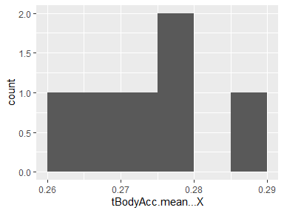

## tBodyAcc.mean…Y

|  |  |
| --- | --- |
| Feature | Result |
| Variable type | numeric |
| Number of missing obs. | 0 (0 %) |
| Number of unique values | 6 |
| Median | -0.02 |
| 1st and 3rd quartiles | -0.02; -0.02 |
| Min. and max. | -0.02; -0.01 |

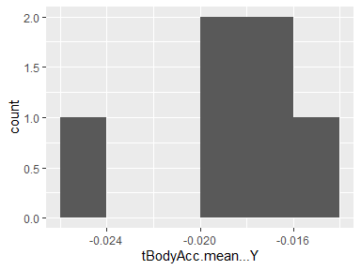

## tBodyAcc.mean…Z

|  |  |
| --- | --- |
| Feature | Result |
| Variable type | numeric |
| Number of missing obs. | 0 (0 %) |
| Number of unique values | 6 |
| Median | -0.11 |
| 1st and 3rd quartiles | -0.11; -0.1 |
| Min. and max. | -0.12; -0.1 |

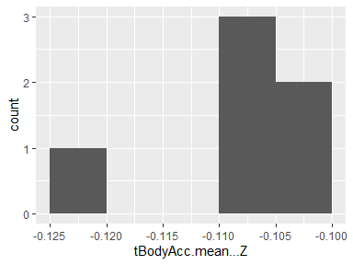

## tBodyAcc.std…X

|  |  |
| --- | --- |
| Feature | Result |
| Variable type | numeric |
| Number of missing obs. | 0 (0 %) |
| Number of unique values | 6 |
| Median | -0.64 |
| 1st and 3rd quartiles | -0.98; -0.29 |
| Min. and max. | -0.98; 0.01 |

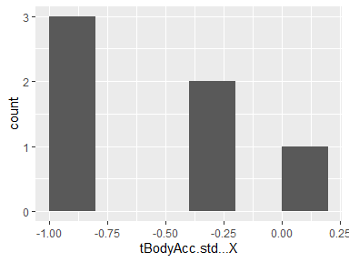

## tBodyAcc.std…Y

|  |  |
| --- | --- |
| Feature | Result |
| Variable type | numeric |
| Number of missing obs. | 0 (0 %) |
| Number of unique values | 6 |
| Median | -0.49 |
| 1st and 3rd quartiles | -0.93; -0.04 |
| Min. and max. | -0.96; 0.01 |

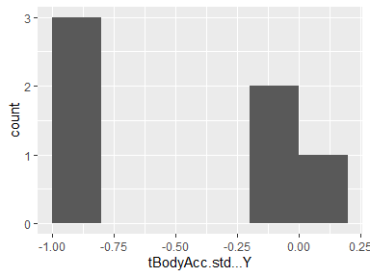

## tBodyAcc.std…Z

|  |  |
| --- | --- |
| Feature | Result |
| Variable type | numeric |
| Number of missing obs. | 0 (0 %) |
| Number of unique values | 6 |
| Median | -0.64 |
| 1st and 3rd quartiles | -0.94; -0.28 |
| Min. and max. | -0.96; -0.24 |

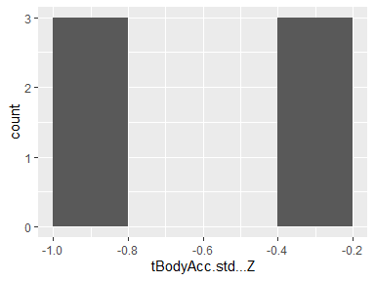

## tBodyAcc.mad…X

|  |  |
| --- | --- |
| Feature | Result |
| Variable type | numeric |
| Number of missing obs. | 0 (0 %) |
| Number of unique values | 6 |
| Median | -0.66 |
| 1st and 3rd quartiles | -0.98; -0.34 |
| Min. and max. | -0.99; -0.06 |

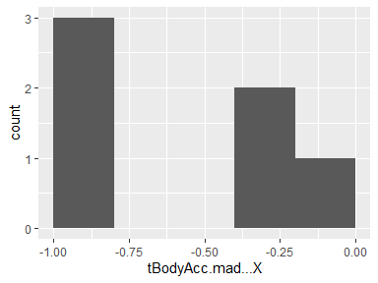

## tBodyAcc.mad…Y

|  |  |
| --- | --- |
| Feature | Result |
| Variable type | numeric |
| Number of missing obs. | 0 (0 %) |
| Number of unique values | 6 |
| Median | -0.49 |
| 1st and 3rd quartiles | -0.93; -0.06 |
| Min. and max. | -0.96; -0.04 |

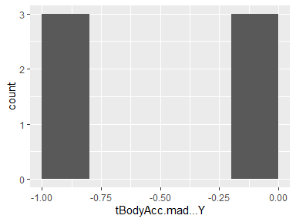

## tBodyAcc.mad…Z

|  |  |
| --- | --- |
| Feature | Result |
| Variable type | numeric |
| Number of missing obs. | 0 (0 %) |
| Number of unique values | 6 |
| Median | -0.63 |
| 1st and 3rd quartiles | -0.93; -0.29 |
| Min. and max. | -0.97; -0.26 |

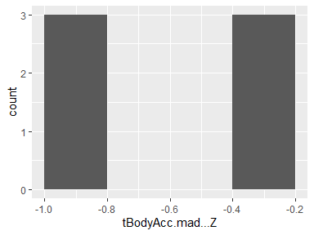

## tBodyAcc.max…X

|  |  |
| --- | --- |
| Feature | Result |
| Variable type | numeric |
| Number of missing obs. | 0 (0 %) |
| Number of unique values | 6 |
| Median | -0.52 |
| 1st and 3rd quartiles | -0.92; -0.05 |
| Min. and max. | -0.93; 0.36 |

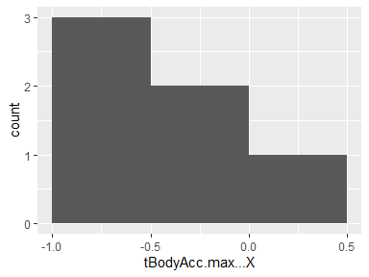

## tBodyAcc.max…Y

|  |  |
| --- | --- |
| Feature | Result |
| Variable type | numeric |
| Number of missing obs. | 0 (0 %) |
| Number of unique values | 6 |
| Median | -0.3 |
| 1st and 3rd quartiles | -0.53; -0.05 |
| Min. and max. | -0.55; 0 |

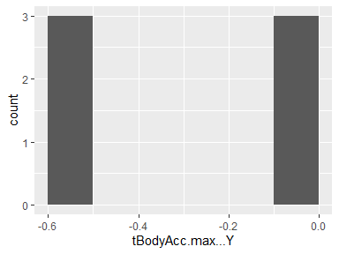

## tBodyAcc.max…Z

|  |  |
| --- | --- |
| Feature | Result |
| Variable type | numeric |
| Number of missing obs. | 0 (0 %) |
| Number of unique values | 6 |
| Median | -0.58 |
| 1st and 3rd quartiles | -0.78; -0.34 |
| Min. and max. | -0.8; -0.3 |

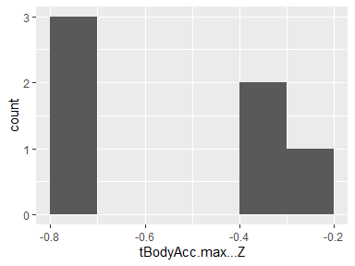

## tBodyAcc.min…X

|  |  |
| --- | --- |
| Feature | Result |
| Variable type | numeric |
| Number of missing obs. | 0 (0 %) |
| Number of unique values | 6 |
| Median | 0.53 |
| 1st and 3rd quartiles | 0.23; 0.82 |
| Min. and max. | 0.13; 0.83 |

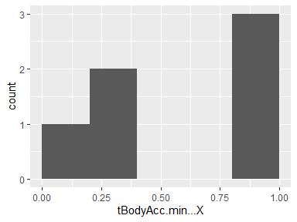

## tBodyAcc.min…Y

|  |  |
| --- | --- |
| Feature | Result |
| Variable type | numeric |
| Number of missing obs. | 0 (0 %) |
| Number of unique values | 6 |
| Median | 0.4 |
| 1st and 3rd quartiles | 0.11; 0.67 |
| Min. and max. | 0.02; 0.67 |

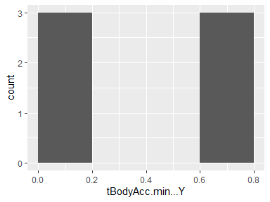

## tBodyAcc.min…Z

|  |  |
| --- | --- |
| Feature | Result |
| Variable type | numeric |
| Number of missing obs. | 0 (0 %) |
| Number of unique values | 6 |
| Median | 0.62 |
| 1st and 3rd quartiles | 0.4; 0.82 |
| Min. and max. | 0.27; 0.83 |

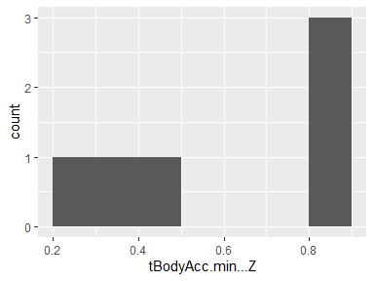

## tBodyAcc.sma..

|  |  |
| --- | --- |
| Feature | Result |
| Variable type | numeric |
| Number of missing obs. | 0 (0 %) |
| Number of unique values | 6 |
| Median | -0.57 |
| 1st and 3rd quartiles | -0.95; -0.17 |
| Min. and max. | -0.96; 0 |

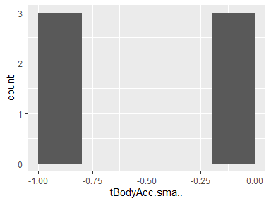

## tBodyAcc.energy…X

|  |  |
| --- | --- |
| Feature | Result |
| Variable type | numeric |
| Number of missing obs. | 0 (0 %) |
| Number of unique values | 6 |
| Median | -0.88 |
| 1st and 3rd quartiles | -1; -0.74 |
| Min. and max. | -1; -0.47 |

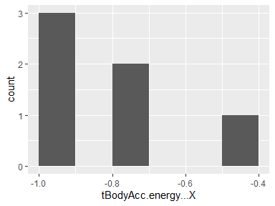

## tBodyAcc.energy…Y

|  |  |
| --- | --- |
| Feature | Result |
| Variable type | numeric |
| Number of missing obs. | 0 (0 %) |
| Number of unique values | 6 |
| Median | -0.91 |
| 1st and 3rd quartiles | -1; -0.81 |
| Min. and max. | -1; -0.78 |

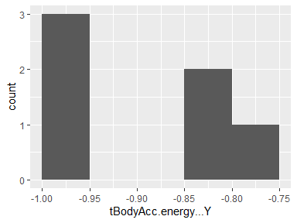

## tBodyAcc.energy…Z

|  |  |
| --- | --- |
| Feature | Result |
| Variable type | numeric |
| Number of missing obs. | 0 (0 %) |
| Number of unique values | 6 |
| Median | -0.89 |
| 1st and 3rd quartiles | -0.99; -0.75 |
| Min. and max. | -1; -0.72 |

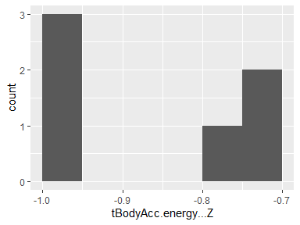

## tBodyAcc.iqr…X

|  |  |
| --- | --- |
| Feature | Result |
| Variable type | numeric |
| Number of missing obs. | 0 (0 %) |
| Number of unique values | 6 |
| Median | -0.72 |
| 1st and 3rd quartiles | -0.98; -0.43 |
| Min. and max. | -0.99; -0.25 |

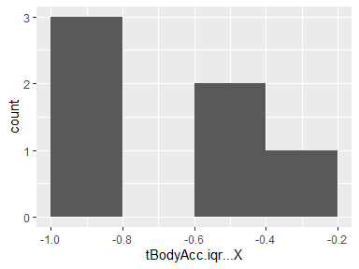

## tBodyAcc.iqr…Y

|  |  |
| --- | --- |
| Feature | Result |
| Variable type | numeric |
| Number of missing obs. | 0 (0 %) |
| Number of unique values | 6 |
| Median | -0.63 |
| 1st and 3rd quartiles | -0.94; -0.3 |
| Min. and max. | -0.97; -0.27 |

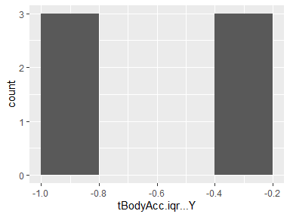

## tBodyAcc.iqr…Z

|  |  |
| --- | --- |
| Feature | Result |
| Variable type | numeric |
| Number of missing obs. | 0 (0 %) |
| Number of unique values | 6 |
| Median | -0.65 |
| 1st and 3rd quartiles | -0.93; -0.36 |
| Min. and max. | -0.97; -0.34 |

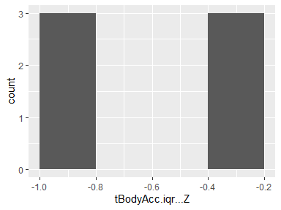

## tBodyAcc.entropy…X

|  |  |
| --- | --- |
| Feature | Result |
| Variable type | numeric |
| Number of missing obs. | 0 (0 %) |
| Number of unique values | 6 |
| Median | -0.07 |
| 1st and 3rd quartiles | -0.45; 0.27 |
| Min. and max. | -0.53; 0.41 |

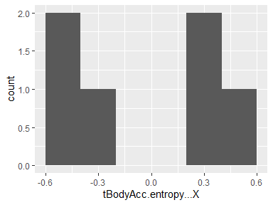

## tBodyAcc.entropy…Y

|  |  |
| --- | --- |
| Feature | Result |
| Variable type | numeric |
| Number of missing obs. | 0 (0 %) |
| Number of unique values | 6 |
| Median | -0.07 |
| 1st and 3rd quartiles | -0.41; 0.28 |
| Min. and max. | -0.55; 0.31 |

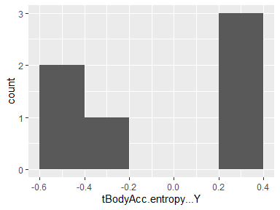

## tBodyAcc.entropy…Z

|  |  |
| --- | --- |
| Feature | Result |
| Variable type | numeric |
| Number of missing obs. | 0 (0 %) |
| Number of unique values | 6 |
| Median | -0.13 |
| 1st and 3rd quartiles | -0.39; 0.14 |
| Min. and max. | -0.47; 0.23 |

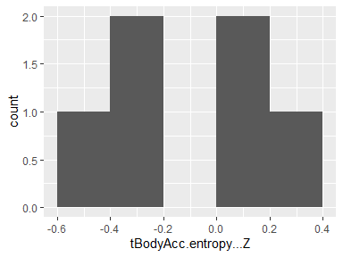

## tBodyAcc.arCoeff…X.1

|  |  |
| --- | --- |
| Feature | Result |
| Variable type | numeric |
| Number of missing obs. | 0 (0 %) |
| Number of unique values | 6 |
| Median | -0.18 |
| 1st and 3rd quartiles | -0.37; 0.1 |
| Min. and max. | -0.4; 0.17 |

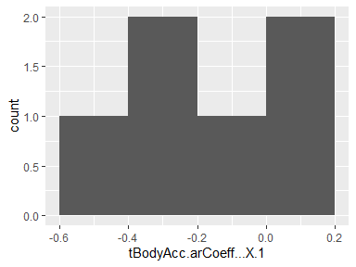

## tBodyAcc.arCoeff…X.2

|  |  |
| --- | --- |
| Feature | Result |
| Variable type | numeric |
| Number of missing obs. | 0 (0 %) |
| Number of unique values | 6 |
| Median | 0.13 |
| 1st and 3rd quartiles | -0.03; 0.28 |
| Min. and max. | -0.04; 0.31 |

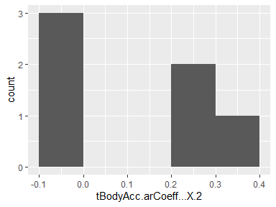

## tBodyAcc.arCoeff…X.3

|  |  |
| --- | --- |
| Feature | Result |
| Variable type | numeric |
| Number of missing obs. | 0 (0 %) |
| Number of unique values | 6 |
| Median | -0.03 |
| 1st and 3rd quartiles | -0.1; 0.06 |
| Min. and max. | -0.21; 0.08 |

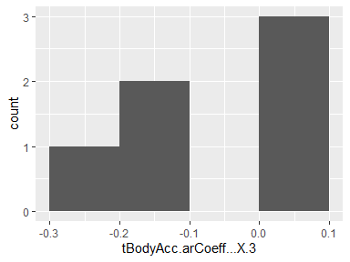

## tBodyAcc.arCoeff…X.4

|  |  |
| --- | --- |
| Feature | Result |
| Variable type | numeric |
| Number of missing obs. | 0 (0 %) |
| Number of unique values | 6 |
| Median | 0.08 |
| 1st and 3rd quartiles | 0.06; 0.14 |
| Min. and max. | -0.02; 0.3 |

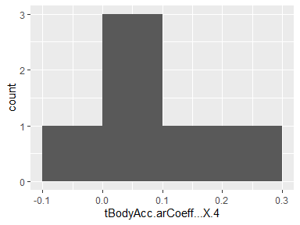

## tBodyAcc.arCoeff…Y.1

|  |  |
| --- | --- |
| Feature | Result |
| Variable type | numeric |
| Number of missing obs. | 0 (0 %) |
| Number of unique values | 6 |
| Median | -0.06 |
| 1st and 3rd quartiles | -0.18; 0.07 |
| Min. and max. | -0.25; 0.2 |

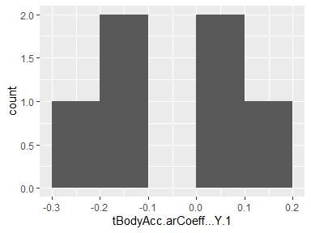

## tBodyAcc.arCoeff…Y.2

|  |  |
| --- | --- |
| Feature | Result |
| Variable type | numeric |
| Number of missing obs. | 0 (0 %) |
| Number of unique values | 6 |
| Median | 0.05 |
| 1st and 3rd quartiles | -0.07; 0.16 |
| Min. and max. | -0.09; 0.21 |

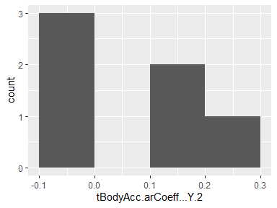

## tBodyAcc.arCoeff…Y.3

|  |  |
| --- | --- |
| Feature | Result |
| Variable type | numeric |
| Number of missing obs. | 0 (0 %) |
| Number of unique values | 6 |
| Median | 0.14 |
| 1st and 3rd quartiles | 0.1; 0.19 |
| Min. and max. | 0.07; 0.2 |

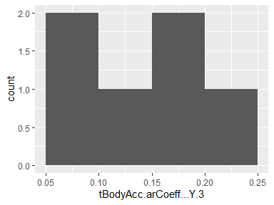

## tBodyAcc.arCoeff…Y.4

|  |  |
| --- | --- |
| Feature | Result |
| Variable type | numeric |
| Number of missing obs. | 0 (0 %) |
| Number of unique values | 6 |
| Median | 0 |
| 1st and 3rd quartiles | -0.02; 0 |
| Min. and max. | -0.08; 0.03 |

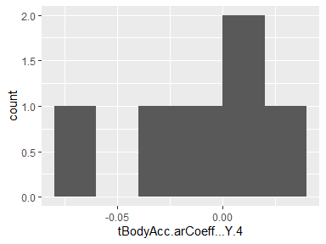

## tBodyAcc.arCoeff…Z.1

|  |  |
| --- | --- |
| Feature | Result |
| Variable type | numeric |
| Number of missing obs. | 0 (0 %) |
| Number of unique values | 6 |
| Median | 0 |
| 1st and 3rd quartiles | -0.14; 0.12 |
| Min. and max. | -0.28; 0.22 |

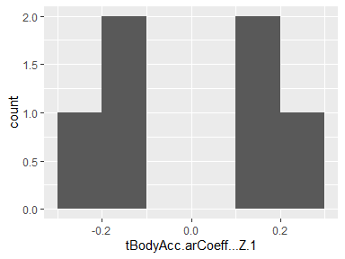

## tBodyAcc.arCoeff…Z.2

|  |  |
| --- | --- |
| Feature | Result |
| Variable type | numeric |
| Number of missing obs. | 0 (0 %) |
| Number of unique values | 6 |
| Median | 0.06 |
| 1st and 3rd quartiles | -0.07; 0.18 |
| Min. and max. | -0.08; 0.19 |

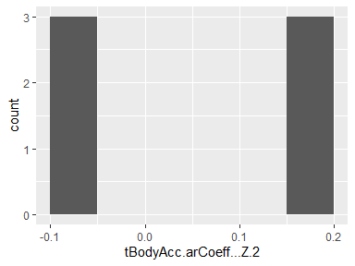

## tBodyAcc.arCoeff…Z.3

|  |  |
| --- | --- |
| Feature | Result |
| Variable type | numeric |
| Number of missing obs. | 0 (0 %) |
| Number of unique values | 6 |
| Median | 0.02 |
| 1st and 3rd quartiles | -0.04; 0.08 |
| Min. and max. | -0.06; 0.13 |

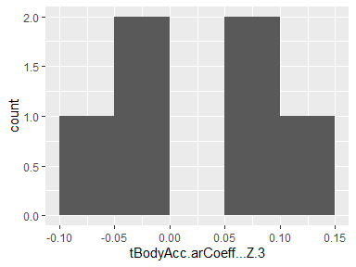

## tBodyAcc.arCoeff…Z.4

|  |  |
| --- | --- |
| Feature | Result |
| Variable type | numeric |
| Number of missing obs. | 0 (0 %) |
| Number of unique values | 6 |
| Median | -0.09 |
| 1st and 3rd quartiles | -0.13; -0.06 |
| Min. and max. | -0.17; 0 |

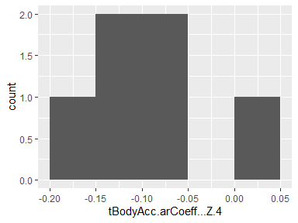

## tBodyAcc.correlation…X.Y

|  |  |
| --- | --- |
| Feature | Result |
| Variable type | numeric |
| Number of missing obs. | 0 (0 %) |
| Number of unique values | 6 |
| Median | -0.13 |
| 1st and 3rd quartiles | -0.22; -0.01 |
| Min. and max. | -0.4; 0.16 |

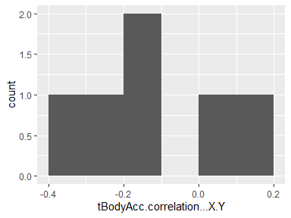

## tBodyAcc.correlation…X.Z

|  |  |
| --- | --- |
| Feature | Result |
| Variable type | numeric |
| Number of missing obs. | 0 (0 %) |
| Number of unique values | 6 |
| Median | -0.22 |
| 1st and 3rd quartiles | -0.25; -0.13 |
| Min. and max. | -0.35; -0.1 |

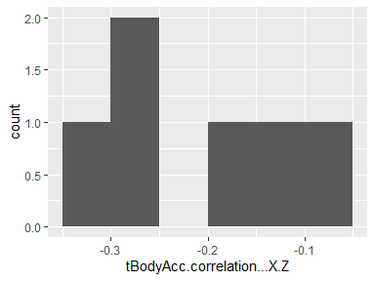

## tBodyAcc.correlation…Y.Z

|  |  |
| --- | --- |
| Feature | Result |
| Variable type | numeric |
| Number of missing obs. | 0 (0 %) |
| Number of unique values | 6 |
| Median | 0.13 |
| 1st and 3rd quartiles | 0.11; 0.16 |
| Min. and max. | -0.15; 0.22 |

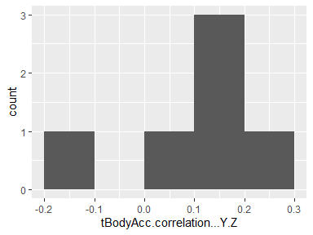

## tGravityAcc.mean…X

|  |  |
| --- | --- |
| Feature | Result |
| Variable type | numeric |
| Number of missing obs. | 0 (0 %) |
| Number of unique values | 6 |
| Median | 0.92 |
| 1st and 3rd quartiles | 0.89; 0.94 |
| Min. and max. | -0.39; 0.94 |

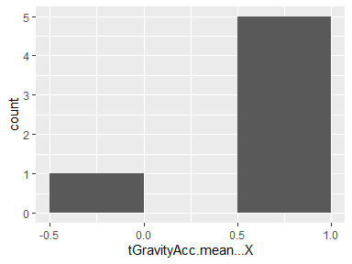

## tGravityAcc.mean…Y

|  |  |
| --- | --- |
| Feature | Result |
| Variable type | numeric |
| Number of missing obs. | 0 (0 %) |
| Number of unique values | 6 |
| Median | -0.18 |
| 1st and 3rd quartiles | -0.19; 0.01 |
| Min. and max. | -0.27; 0.59 |

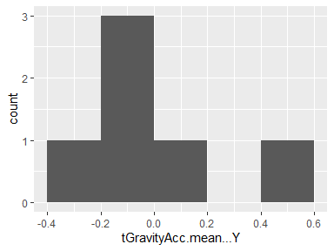

## tGravityAcc.mean…Z

|  |  |
| --- | --- |
| Feature | Result |
| Variable type | numeric |
| Number of missing obs. | 0 (0 %) |
| Number of unique values | 6 |
| Median | 0 |
| 1st and 3rd quartiles | -0.04; 0.1 |
| Min. and max. | -0.12; 0.5 |

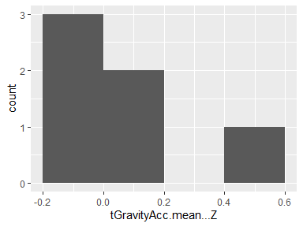

## tGravityAcc.std…X

|  |  |
| --- | --- |
| Feature | Result |
| Variable type | numeric |
| Number of missing obs. | 0 (0 %) |
| Number of unique values | 6 |
| Median | -0.97 |
| 1st and 3rd quartiles | -0.98; -0.95 |
| Min. and max. | -0.99; -0.95 |

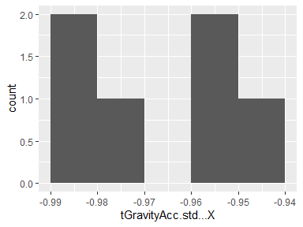

## tGravityAcc.std…Y

|  |  |
| --- | --- |
| Feature | Result |
| Variable type | numeric |
| Number of missing obs. | 0 (0 %) |
| Number of unique values | 6 |
| Median | -0.96 |
| 1st and 3rd quartiles | -0.97; -0.94 |
| Min. and max. | -0.98; -0.93 |

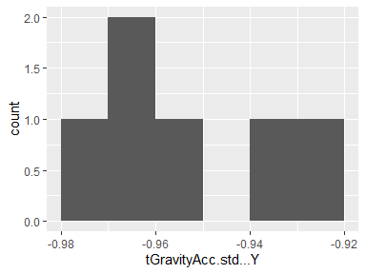

## tGravityAcc.std…Z

|  |  |
| --- | --- |
| Feature | Result |
| Variable type | numeric |
| Number of missing obs. | 0 (0 %) |
| Number of unique values | 6 |
| Median | -0.95 |
| 1st and 3rd quartiles | -0.96; -0.93 |
| Min. and max. | -0.97; -0.91 |

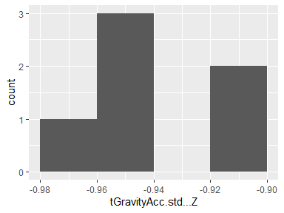

## tGravityAcc.mad…X

|  |  |
| --- | --- |
| Feature | Result |
| Variable type | numeric |
| Number of missing obs. | 0 (0 %) |
| Number of unique values | 6 |
| Median | -0.97 |
| 1st and 3rd quartiles | -0.98; -0.95 |
| Min. and max. | -0.99; -0.95 |

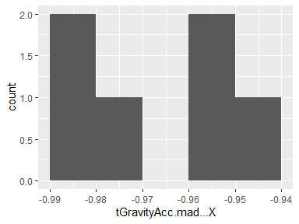

## tGravityAcc.mad…Y

|  |  |
| --- | --- |
| Feature | Result |
| Variable type | numeric |
| Number of missing obs. | 0 (0 %) |
| Number of unique values | 6 |
| Median | -0.96 |
| 1st and 3rd quartiles | -0.97; -0.94 |
| Min. and max. | -0.98; -0.93 |

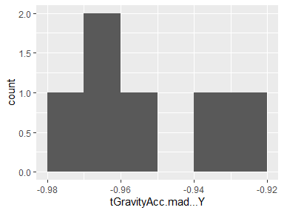

## tGravityAcc.mad…Z

|  |  |
| --- | --- |
| Feature | Result |
| Variable type | numeric |
| Number of missing obs. | 0 (0 %) |
| Number of unique values | 6 |
| Median | -0.95 |
| 1st and 3rd quartiles | -0.96; -0.93 |
| Min. and max. | -0.97; -0.91 |

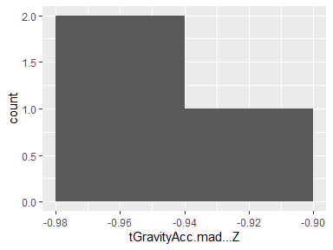

## tGravityAcc.max…X

|  |  |
| --- | --- |
| Feature | Result |
| Variable type | numeric |
| Number of missing obs. | 0 (0 %) |
| Number of unique values | 6 |
| Median | 0.85 |
| 1st and 3rd quartiles | 0.83; 0.87 |
| Min. and max. | -0.43; 0.87 |

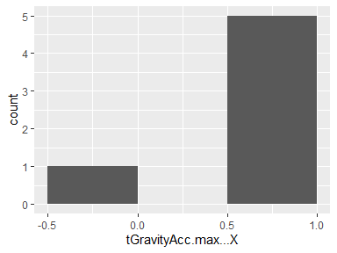

## tGravityAcc.max…Y

|  |  |
| --- | --- |
| Feature | Result |
| Variable type | numeric |
| Number of missing obs. | 0 (0 %) |
| Number of unique values | 6 |
| Median | -0.19 |
| 1st and 3rd quartiles | -0.2; 0 |
| Min. and max. | -0.27; 0.56 |

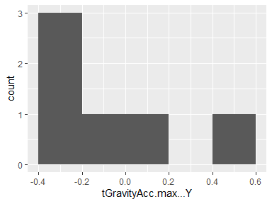

## tGravityAcc.max…Z

|  |  |
| --- | --- |
| Feature | Result |
| Variable type | numeric |
| Number of missing obs. | 0 (0 %) |
| Number of unique values | 6 |
| Median | 0 |
| 1st and 3rd quartiles | -0.03; 0.11 |
| Min. and max. | -0.11; 0.5 |

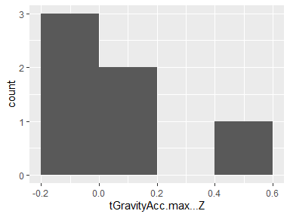

## tGravityAcc.min…X

|  |  |
| --- | --- |
| Feature | Result |
| Variable type | numeric |
| Number of missing obs. | 0 (0 %) |
| Number of unique values | 6 |
| Median | 0.93 |
| 1st and 3rd quartiles | 0.89; 0.95 |
| Min. and max. | -0.35; 0.96 |

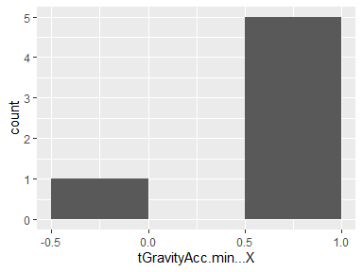

## tGravityAcc.min…Y

|  |  |
| --- | --- |
| Feature | Result |
| Variable type | numeric |
| Number of missing obs. | 0 (0 %) |
| Number of unique values | 6 |
| Median | -0.17 |
| 1st and 3rd quartiles | -0.17; 0.02 |
| Min. and max. | -0.26; 0.61 |

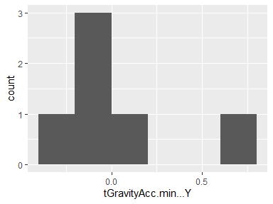

## tGravityAcc.min…Z

|  |  |
| --- | --- |
| Feature | Result |
| Variable type | numeric |
| Number of missing obs. | 0 (0 %) |
| Number of unique values | 6 |
| Median | -0.01 |
| 1st and 3rd quartiles | -0.05; 0.09 |
| Min. and max. | -0.14; 0.5 |

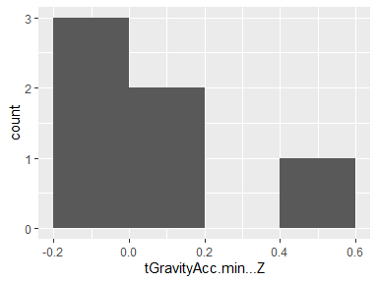

## tGravityAcc.sma..

|  |  |
| --- | --- |
| Feature | Result |
| Variable type | numeric |
| Number of missing obs. | 0 (0 %) |
| Number of unique values | 6 |
| Median | -0.24 |
| 1st and 3rd quartiles | -0.26; -0.02 |
| Min. and max. | -0.31; 0.09 |

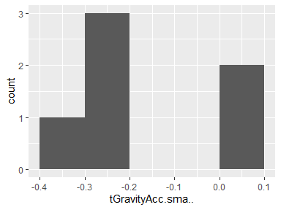

## tGravityAcc.energy…X

|  |  |
| --- | --- |
| Feature | Result |
| Variable type | numeric |
| Number of missing obs. | 0 (0 %) |
| Number of unique values | 6 |
| Median | 0.78 |
| 1st and 3rd quartiles | 0.71; 0.83 |
| Min. and max. | -0.97; 0.85 |

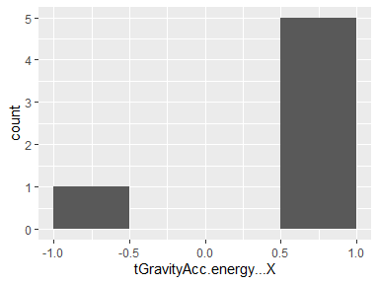

## tGravityAcc.energy…Y

|  |  |
| --- | --- |
| Feature | Result |
| Variable type | numeric |
| Number of missing obs. | 0 (0 %) |
| Number of unique values | 6 |
| Median | -0.9 |
| 1st and 3rd quartiles | -0.91; -0.84 |
| Min. and max. | -0.93; 0.18 |

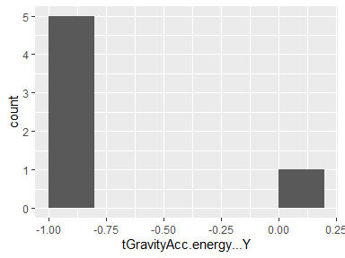

## tGravityAcc.energy…Z

|  |  |
| --- | --- |
| Feature | Result |
| Variable type | numeric |
| Number of missing obs. | 0 (0 %) |
| Number of unique values | 6 |
| Median | -0.94 |
| 1st and 3rd quartiles | -0.96; -0.91 |
| Min. and max. | -0.97; -0.21 |

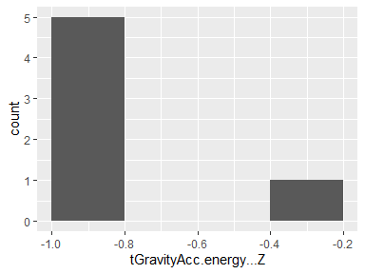

## tGravityAcc.iqr…X

|  |  |
| --- | --- |
| Feature | Result |
| Variable type | numeric |
| Number of missing obs. | 0 (0 %) |
| Number of unique values | 6 |
| Median | -0.97 |
| 1st and 3rd quartiles | -0.98; -0.96 |
| Min. and max. | -0.99; -0.95 |

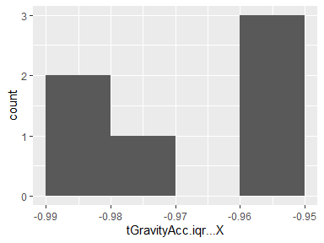

## tGravityAcc.iqr…Y

|  |  |
| --- | --- |
| Feature | Result |
| Variable type | numeric |
| Number of missing obs. | 0 (0 %) |
| Number of unique values | 6 |
| Median | -0.97 |
| 1st and 3rd quartiles | -0.97; -0.94 |
| Min. and max. | -0.98; -0.93 |

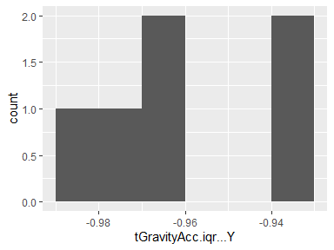

## tGravityAcc.iqr…Z

|  |  |
| --- | --- |
| Feature | Result |
| Variable type | numeric |
| Number of missing obs. | 0 (0 %) |
| Number of unique values | 6 |
| Median | -0.95 |
| 1st and 3rd quartiles | -0.96; -0.93 |
| Min. and max. | -0.98; -0.92 |

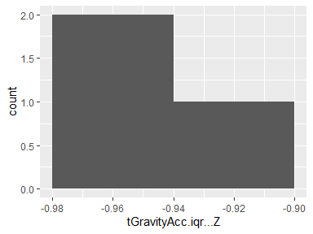

## tGravityAcc.entropy…X

|  |  |
| --- | --- |
| Feature | Result |
| Variable type | numeric |
| Number of missing obs. | 0 (0 %) |
| Number of unique values | 6 |
| Median | -0.69 |
| 1st and 3rd quartiles | -0.84; -0.59 |
| Min. and max. | -0.91; -0.38 |

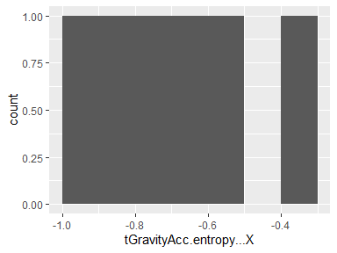

## tGravityAcc.entropy…Y

|  |  |
| --- | --- |
| Feature | Result |
| Variable type | numeric |
| Number of missing obs. | 0 (0 %) |
| Number of unique values | 6 |
| Median | -0.9 |
| 1st and 3rd quartiles | -0.93; -0.79 |
| Min. and max. | -0.96; -0.72 |

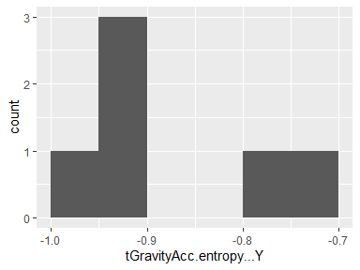

## tGravityAcc.entropy…Z

|  |  |
| --- | --- |
| Feature | Result |
| Variable type | numeric |
| Number of missing obs. | 0 (0 %) |
| Number of unique values | 6 |
| Median | -0.61 |
| 1st and 3rd quartiles | -0.65; -0.6 |
| Min. and max. | -0.68; -0.6 |

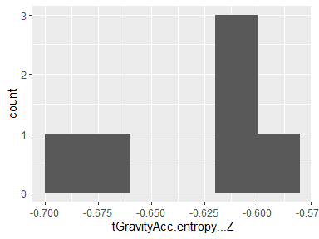

## tGravityAcc.arCoeff…X.1

|  |  |
| --- | --- |
| Feature | Result |
| Variable type | numeric |
| Number of missing obs. | 0 (0 %) |
| Number of unique values | 6 |
| Median | -0.49 |
| 1st and 3rd quartiles | -0.58; -0.38 |
| Min. and max. | -0.62; -0.34 |

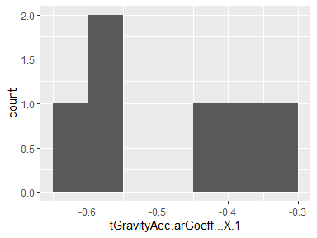

## tGravityAcc.arCoeff…X.2

|  |  |
| --- | --- |
| Feature | Result |
| Variable type | numeric |
| Number of missing obs. | 0 (0 %) |
| Number of unique values | 6 |
| Median | 0.51 |
| 1st and 3rd quartiles | 0.43; 0.63 |
| Min. and max. | 0.36; 0.67 |

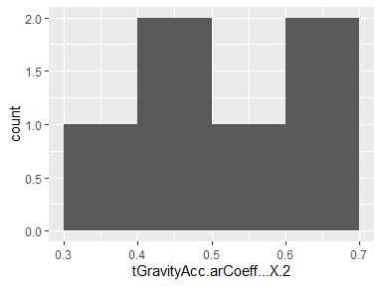

## tGravityAcc.arCoeff…X.3

|  |  |
| --- | --- |
| Feature | Result |
| Variable type | numeric |
| Number of missing obs. | 0 (0 %) |
| Number of unique values | 6 |
| Median | -0.56 |
| 1st and 3rd quartiles | -0.68; -0.47 |
| Min. and max. | -0.71; -0.39 |

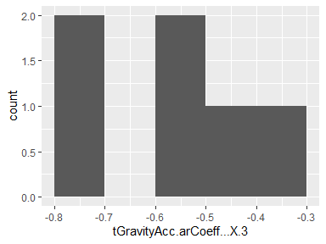

## tGravityAcc.arCoeff…X.4

|  |  |
| --- | --- |
| Feature | Result |
| Variable type | numeric |
| Number of missing obs. | 0 (0 %) |
| Number of unique values | 6 |
| Median | 0.6 |
| 1st and 3rd quartiles | 0.51; 0.72 |
| Min. and max. | 0.42; 0.77 |

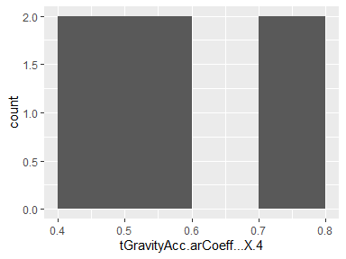

## tGravityAcc.arCoeff…Y.1

|  |  |
| --- | --- |
| Feature | Result |
| Variable type | numeric |
| Number of missing obs. | 0 (0 %) |
| Number of unique values | 6 |
| Median | -0.36 |
| 1st and 3rd quartiles | -0.49; -0.22 |
| Min. and max. | -0.51; -0.09 |

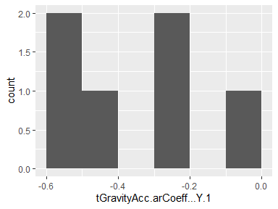

## tGravityAcc.arCoeff…Y.2

|  |  |
| --- | --- |
| Feature | Result |
| Variable type | numeric |
| Number of missing obs. | 0 (0 %) |
| Number of unique values | 6 |
| Median | 0.35 |
| 1st and 3rd quartiles | 0.19; 0.47 |
| Min. and max. | 0.11; 0.51 |

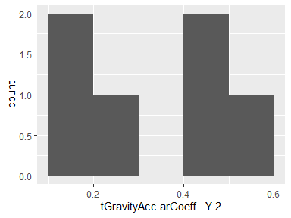

## tGravityAcc.arCoeff…Y.3

|  |  |
| --- | --- |
| Feature | Result |
| Variable type | numeric |
| Number of missing obs. | 0 (0 %) |
| Number of unique values | 6 |
| Median | -0.39 |
| 1st and 3rd quartiles | -0.47; -0.23 |
| Min. and max. | -0.55; -0.17 |

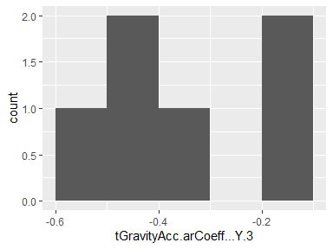

## tGravityAcc.arCoeff…Y.4

|  |  |
| --- | --- |
| Feature | Result |
| Variable type | numeric |
| Number of missing obs. | 0 (0 %) |
| Number of unique values | 6 |
| Median | 0.44 |
| 1st and 3rd quartiles | 0.33; 0.49 |
| Min. and max. | 0.21; 0.61 |

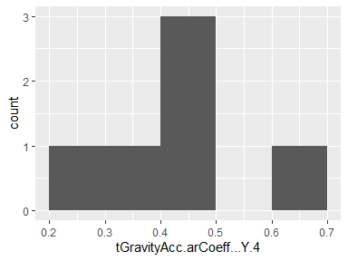

## tGravityAcc.arCoeff…Z.1

|  |  |
| --- | --- |
| Feature | Result |
| Variable type | numeric |
| Number of missing obs. | 0 (0 %) |
| Number of unique values | 6 |
| Median | -0.4 |
| 1st and 3rd quartiles | -0.53; -0.29 |
| Min. and max. | -0.61; -0.28 |

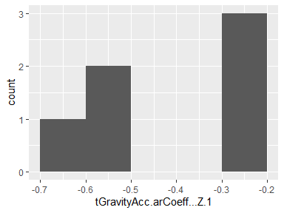

## tGravityAcc.arCoeff…Z.2

|  |  |
| --- | --- |
| Feature | Result |
| Variable type | numeric |
| Number of missing obs. | 0 (0 %) |
| Number of unique values | 6 |
| Median | 0.43 |
| 1st and 3rd quartiles | 0.34; 0.54 |
| Min. and max. | 0.3; 0.63 |

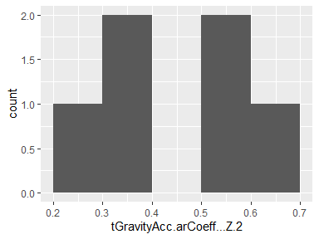

## tGravityAcc.arCoeff…Z.3

|  |  |
| --- | --- |
| Feature | Result |
| Variable type | numeric |
| Number of missing obs. | 0 (0 %) |
| Number of unique values | 6 |
| Median | -0.46 |
| 1st and 3rd quartiles | -0.54; -0.39 |
| Min. and max. | -0.66; -0.31 |

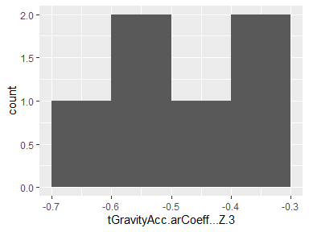

## tGravityAcc.arCoeff…Z.4

|  |  |
| --- | --- |
| Feature | Result |
| Variable type | numeric |
| Number of missing obs. | 0 (0 %) |
| Number of unique values | 6 |
| Median | 0.49 |
| 1st and 3rd quartiles | 0.43; 0.55 |
| Min. and max. | 0.32; 0.68 |

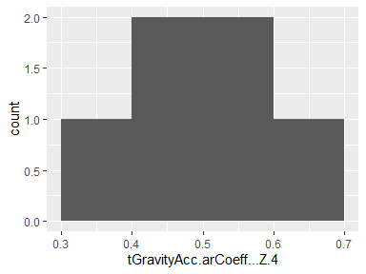

## tGravityAcc.correlation…X.Y

|  |  |
| --- | --- |
| Feature | Result |
| Variable type | numeric |
| Number of missing obs. | 0 (0 %) |
| Number of unique values | 6 |
| Median | 0.2 |
| 1st and 3rd quartiles | 0.08; 0.34 |
| Min. and max. | -0.33; 0.4 |

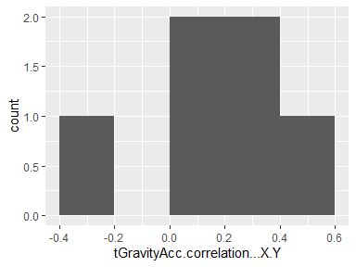

## tGravityAcc.correlation…X.Z

|  |  |
| --- | --- |
| Feature | Result |
| Variable type | numeric |
| Number of missing obs. | 0 (0 %) |
| Number of unique values | 6 |
| Median | 0 |
| 1st and 3rd quartiles | -0.27; 0.05 |
| Min. and max. | -0.46; 0.09 |

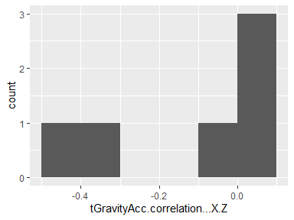

## tGravityAcc.correlation…Y.Z

|  |  |
| --- | --- |
| Feature | Result |
| Variable type | numeric |
| Number of missing obs. | 0 (0 %) |
| Number of unique values | 6 |
| Median | 0.12 |
| 1st and 3rd quartiles | 0.05; 0.19 |
| Min. and max. | -0.3; 0.31 |

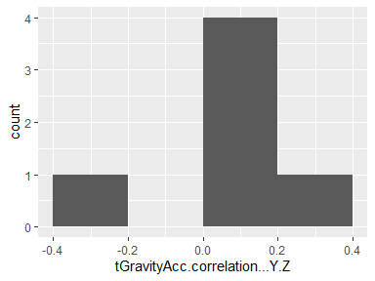

## tBodyAccJerk.mean…X

|  |  |
| --- | --- |
| Feature | Result |
| Variable type | numeric |
| Number of missing obs. | 0 (0 %) |
| Number of unique values | 6 |
| Median | 0.08 |
| 1st and 3rd quartiles | 0.07; 0.08 |
| Min. and max. | 0.07; 0.09 |

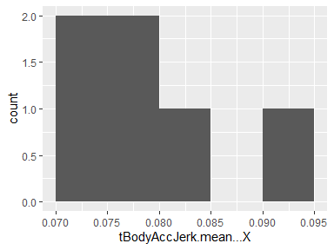

## tBodyAccJerk.mean…Y

|  |  |
| --- | --- |
| Feature | Result |
| Variable type | numeric |
| Number of missing obs. | 0 (0 %) |
| Number of unique values | 6 |
| Median | 0.01 |
| 1st and 3rd quartiles | 0; 0.01 |
| Min. and max. | 0; 0.01 |

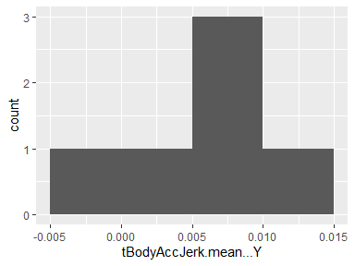

## tBodyAccJerk.mean…Z

|  |  |
| --- | --- |
| Feature | Result |
| Variable type | numeric |
| Number of missing obs. | 0 (0 %) |
| Number of unique values | 6 |
| Median | -0.01 |
| 1st and 3rd quartiles | -0.01; 0 |
| Min. and max. | -0.01; 0 |

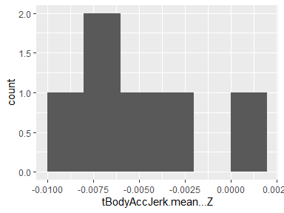

## tBodyAccJerk.std…X

|  |  |
| --- | --- |
| Feature | Result |
| Variable type | numeric |
| Number of missing obs. | 0 (0 %) |
| Number of unique values | 6 |
| Median | -0.67 |
| 1st and 3rd quartiles | -0.98; -0.27 |
| Min. and max. | -0.98; -0.09 |

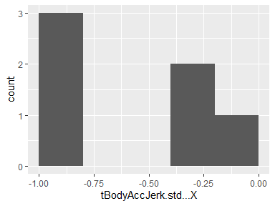

## tBodyAccJerk.std…Y

|  |  |
| --- | --- |
| Feature | Result |
| Variable type | numeric |
| Number of missing obs. | 0 (0 %) |
| Number of unique values | 6 |
| Median | -0.66 |
| 1st and 3rd quartiles | -0.97; -0.17 |
| Min. and max. | -0.97; -0.1 |

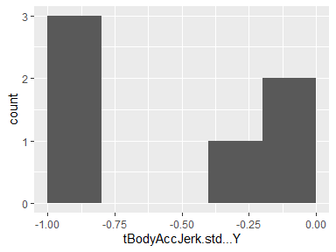

## tBodyAccJerk.std…Z

|  |  |
| --- | --- |
| Feature | Result |
| Variable type | numeric |
| Number of missing obs. | 0 (0 %) |
| Number of unique values | 6 |
| Median | -0.81 |
| 1st and 3rd quartiles | -0.98; -0.55 |
| Min. and max. | -0.98; -0.42 |

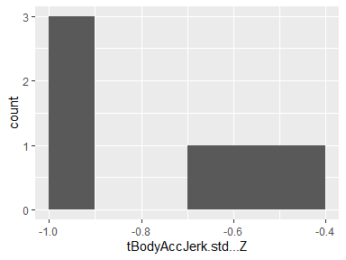

## tBodyAccJerk.mad…X

|  |  |
| --- | --- |
| Feature | Result |
| Variable type | numeric |
| Number of missing obs. | 0 (0 %) |
| Number of unique values | 6 |
| Median | -0.67 |
| 1st and 3rd quartiles | -0.98; -0.25 |
| Min. and max. | -0.99; -0.1 |

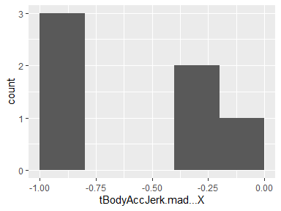

## tBodyAccJerk.mad…Y

|  |  |
| --- | --- |
| Feature | Result |
| Variable type | numeric |
| Number of missing obs. | 0 (0 %) |
| Number of unique values | 6 |
| Median | -0.64 |
| 1st and 3rd quartiles | -0.97; -0.15 |
| Min. and max. | -0.97; -0.09 |

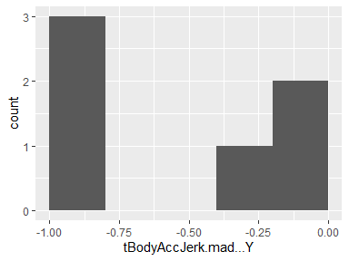

## tBodyAccJerk.mad…Z

|  |  |
| --- | --- |
| Feature | Result |
| Variable type | numeric |
| Number of missing obs. | 0 (0 %) |
| Number of unique values | 6 |
| Median | -0.8 |
| 1st and 3rd quartiles | -0.98; -0.53 |
| Min. and max. | -0.98; -0.42 |

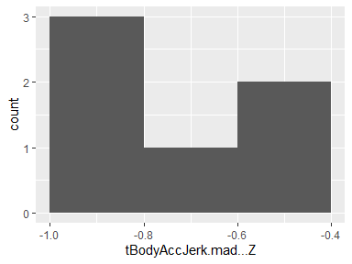

## tBodyAccJerk.max…X

|  |  |
| --- | --- |
| Feature | Result |
| Variable type | numeric |
| Number of missing obs. | 0 (0 %) |
| Number of unique values | 6 |
| Median | -0.76 |
| 1st and 3rd quartiles | -0.98; -0.45 |
| Min. and max. | -0.98; -0.16 |

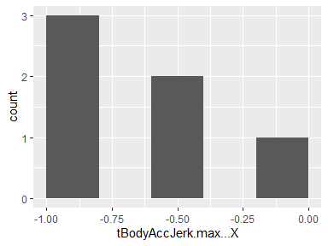

## tBodyAccJerk.max…Y

|  |  |
| --- | --- |
| Feature | Result |
| Variable type | numeric |
| Number of missing obs. | 0 (0 %) |
| Number of unique values | 6 |
| Median | -0.79 |
| 1st and 3rd quartiles | -0.98; -0.49 |
| Min. and max. | -0.98; -0.35 |

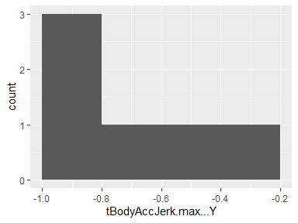

## tBodyAccJerk.max…Z

|  |  |
| --- | --- |
| Feature | Result |
| Variable type | numeric |
| Number of missing obs. | 0 (0 %) |
| Number of unique values | 6 |
| Median | -0.85 |
| 1st and 3rd quartiles | -0.98; -0.68 |
| Min. and max. | -0.98; -0.51 |

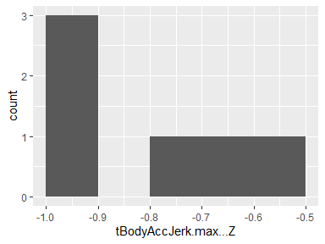

## tBodyAccJerk.min…X

|  |  |
| --- | --- |
| Feature | Result |
| Variable type | numeric |
| Number of missing obs. | 0 (0 %) |
| Number of unique values | 6 |
| Median | 0.6 |
| 1st and 3rd quartiles | 0.18; 0.97 |
| Min. and max. | 0.12; 0.98 |

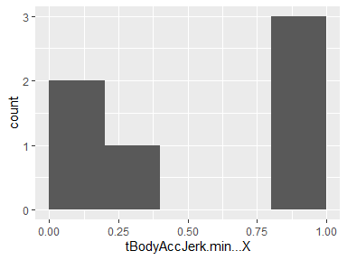

## tBodyAccJerk.min…Y

|  |  |
| --- | --- |
| Feature | Result |
| Variable type | numeric |
| Number of missing obs. | 0 (0 %) |
| Number of unique values | 6 |
| Median | 0.73 |
| 1st and 3rd quartiles | 0.36; 0.97 |
| Min. and max. | 0.23; 0.98 |

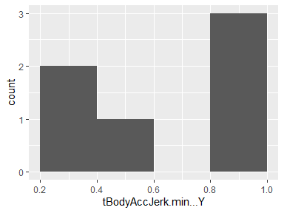

## tBodyAccJerk.min…Z

|  |  |
| --- | --- |
| Feature | Result |
| Variable type | numeric |
| Number of missing obs. | 0 (0 %) |
| Number of unique values | 6 |
| Median | 0.78 |
| 1st and 3rd quartiles | 0.51; 0.97 |
| Min. and max. | 0.39; 0.98 |

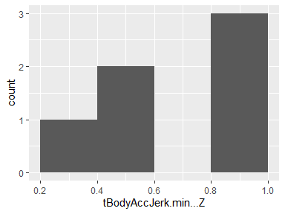

## tBodyAccJerk.sma..

|  |  |
| --- | --- |
| Feature | Result |
| Variable type | numeric |
| Number of missing obs. | 0 (0 %) |
| Number of unique values | 6 |
| Median | -0.69 |
| 1st and 3rd quartiles | -0.98; -0.28 |
| Min. and max. | -0.98; -0.16 |

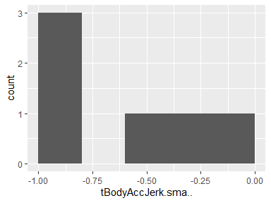

## tBodyAccJerk.energy…X

|  |  |
| --- | --- |
| Feature | Result |
| Variable type | numeric |
| Number of missing obs. | 0 (0 %) |
| Number of unique values | 6 |
| Median | -0.89 |
| 1st and 3rd quartiles | -1; -0.71 |
| Min. and max. | -1; -0.56 |

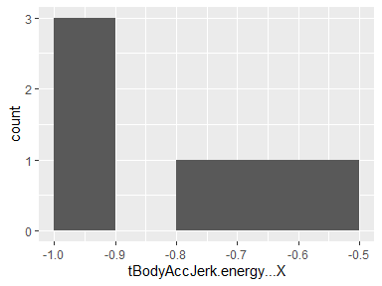

## tBodyAccJerk.energy…Y

|  |  |
| --- | --- |
| Feature | Result |
| Variable type | numeric |
| Number of missing obs. | 0 (0 %) |
| Number of unique values | 6 |
| Median | -0.89 |
| 1st and 3rd quartiles | -1; -0.61 |
| Min. and max. | -1; -0.55 |

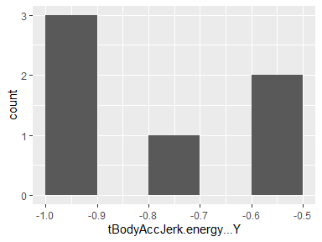

## tBodyAccJerk.energy…Z

|  |  |
| --- | --- |
| Feature | Result |
| Variable type | numeric |
| Number of missing obs. | 0 (0 %) |
| Number of unique values | 6 |
| Median | -0.96 |
| 1st and 3rd quartiles | -1; -0.88 |
| Min. and max. | -1; -0.81 |

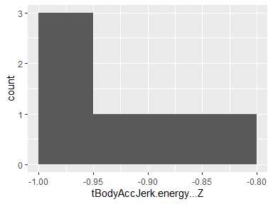

## tBodyAccJerk.iqr…X

|  |  |
| --- | --- |
| Feature | Result |
| Variable type | numeric |
| Number of missing obs. | 0 (0 %) |
| Number of unique values | 6 |
| Median | -0.66 |
| 1st and 3rd quartiles | -0.98; -0.23 |
| Min. and max. | -0.99; -0.11 |

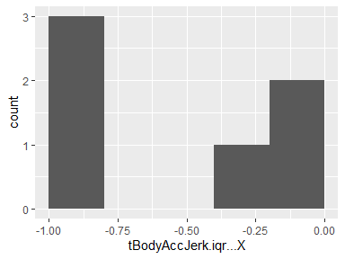

## tBodyAccJerk.iqr…Y

|  |  |
| --- | --- |
| Feature | Result |
| Variable type | numeric |
| Number of missing obs. | 0 (0 %) |
| Number of unique values | 6 |
| Median | -0.69 |
| 1st and 3rd quartiles | -0.97; -0.31 |
| Min. and max. | -0.98; -0.27 |

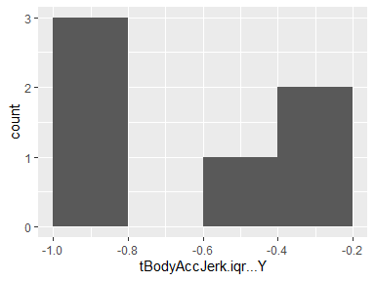

## tBodyAccJerk.iqr…Z

|  |  |
| --- | --- |
| Feature | Result |
| Variable type | numeric |
| Number of missing obs. | 0 (0 %) |
| Number of unique values | 6 |
| Median | -0.81 |
| 1st and 3rd quartiles | -0.98; -0.55 |
| Min. and max. | -0.98; -0.47 |

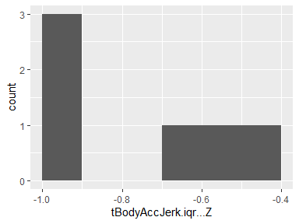

## tBodyAccJerk.entropy…X

|  |  |
| --- | --- |
| Feature | Result |
| Variable type | numeric |
| Number of missing obs. | 0 (0 %) |
| Number of unique values | 6 |
| Median | -0.02 |
| 1st and 3rd quartiles | -0.62; 0.6 |
| Min. and max. | -0.67; 0.69 |

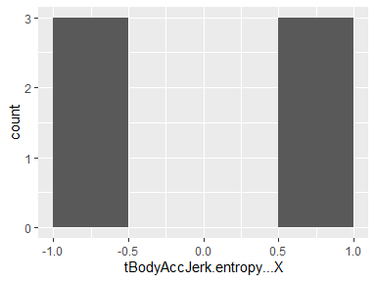

## tBodyAccJerk.entropy…Y

|  |  |
| --- | --- |
| Feature | Result |
| Variable type | numeric |
| Number of missing obs. | 0 (0 %) |
| Number of unique values | 6 |
| Median | -0.01 |
| 1st and 3rd quartiles | -0.62; 0.55 |
| Min. and max. | -0.66; 0.62 |

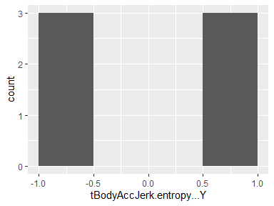

## tBodyAccJerk.entropy…Z

|  |  |
| --- | --- |
| Feature | Result |
| Variable type | numeric |
| Number of missing obs. | 0 (0 %) |
| Number of unique values | 6 |
| Median | -0.1 |
| 1st and 3rd quartiles | -0.65; 0.49 |
| Min. and max. | -0.66; 0.54 |

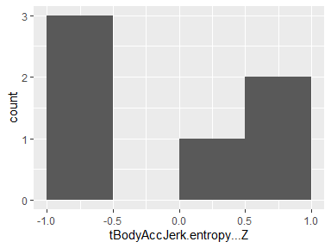

## tBodyAccJerk.arCoeff…X.1

|  |  |
| --- | --- |
| Feature | Result |
| Variable type | numeric |
| Number of missing obs. | 0 (0 %) |
| Number of unique values | 6 |
| Median | -0.14 |
| 1st and 3rd quartiles | -0.37; 0.11 |
| Min. and max. | -0.38; 0.15 |

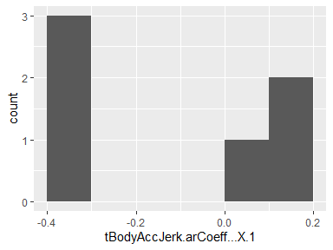

## tBodyAccJerk.arCoeff…X.2

|  |  |
| --- | --- |
| Feature | Result |
| Variable type | numeric |
| Number of missing obs. | 0 (0 %) |
| Number of unique values | 6 |
| Median | 0.18 |
| 1st and 3rd quartiles | 0.16; 0.21 |
| Min. and max. | 0.15; 0.25 |

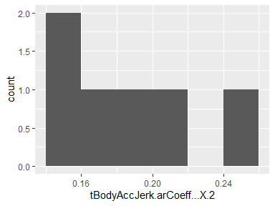

## tBodyAccJerk.arCoeff…X.3

|  |  |
| --- | --- |
| Feature | Result |
| Variable type | numeric |
| Number of missing obs. | 0 (0 %) |
| Number of unique values | 6 |
| Median | 0.1 |
| 1st and 3rd quartiles | -0.04; 0.17 |
| Min. and max. | -0.11; 0.22 |

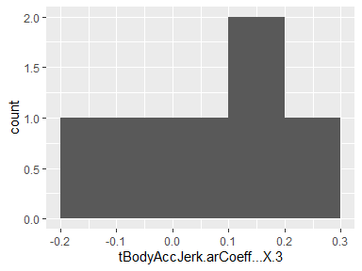

## tBodyAccJerk.arCoeff…X.4

|  |  |
| --- | --- |
| Feature | Result |
| Variable type | numeric |
| Number of missing obs. | 0 (0 %) |
| Number of unique values | 6 |
| Median | 0.12 |
| 1st and 3rd quartiles | 0.06; 0.23 |
| Min. and max. | 0.01; 0.26 |

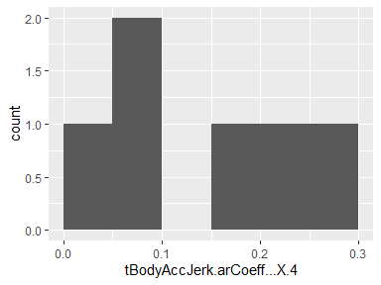

## tBodyAccJerk.arCoeff…Y.1

|  |  |
| --- | --- |
| Feature | Result |
| Variable type | numeric |
| Number of missing obs. | 0 (0 %) |
| Number of unique values | 6 |
| Median | -0.11 |
| 1st and 3rd quartiles | -0.25; 0.06 |
| Min. and max. | -0.29; 0.15 |

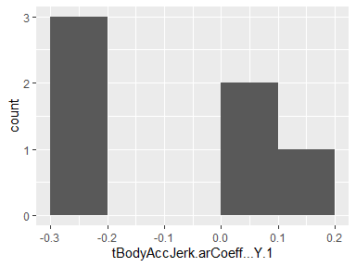

## tBodyAccJerk.arCoeff…Y.2

|  |  |
| --- | --- |
| Feature | Result |
| Variable type | numeric |
| Number of missing obs. | 0 (0 %) |
| Number of unique values | 6 |
| Median | 0.08 |
| 1st and 3rd quartiles | 0.02; 0.13 |
| Min. and max. | -0.01; 0.21 |

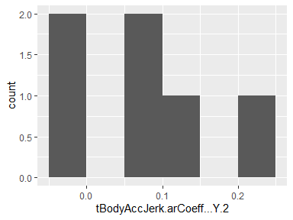

## tBodyAccJerk.arCoeff…Y.3

|  |  |
| --- | --- |
| Feature | Result |
| Variable type | numeric |
| Number of missing obs. | 0 (0 %) |
| Number of unique values | 6 |
| Median | 0.19 |
| 1st and 3rd quartiles | 0.14; 0.2 |
| Min. and max. | 0.08; 0.26 |

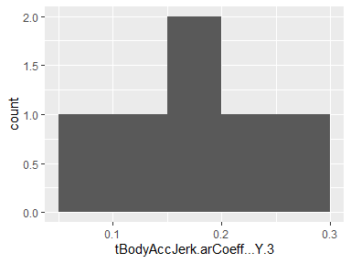

## tBodyAccJerk.arCoeff…Y.4

|  |  |
| --- | --- |
| Feature | Result |
| Variable type | numeric |
| Number of missing obs. | 0 (0 %) |
| Number of unique values | 6 |
| Median | 0.31 |
| 1st and 3rd quartiles | 0.25; 0.32 |
| Min. and max. | 0.22; 0.37 |

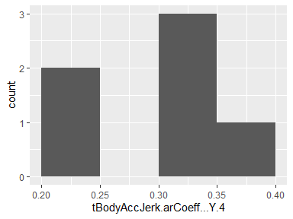

## tBodyAccJerk.arCoeff…Z.1

|  |  |
| --- | --- |
| Feature | Result |
| Variable type | numeric |
| Number of missing obs. | 0 (0 %) |
| Number of unique values | 6 |
| Median | -0.05 |
| 1st and 3rd quartiles | -0.18; 0.11 |
| Min. and max. | -0.29; 0.16 |

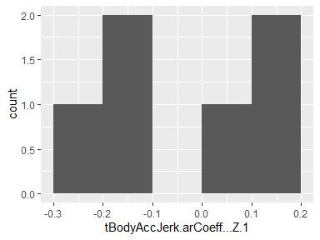

## tBodyAccJerk.arCoeff…Z.2

|  |  |
| --- | --- |
| Feature | Result |
| Variable type | numeric |
| Number of missing obs. | 0 (0 %) |
| Number of unique values | 6 |
| Median | 0.08 |
| 1st and 3rd quartiles | 0.06; 0.16 |
| Min. and max. | 0.03; 0.19 |

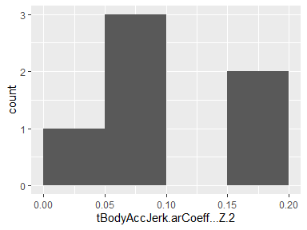

## tBodyAccJerk.arCoeff…Z.3

|  |  |
| --- | --- |
| Feature | Result |
| Variable type | numeric |
| Number of missing obs. | 0 (0 %) |
| Number of unique values | 6 |
| Median | 0.01 |
| 1st and 3rd quartiles | -0.02; 0.04 |
| Min. and max. | -0.14; 0.1 |

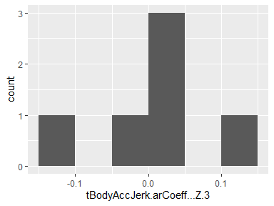

## tBodyAccJerk.arCoeff…Z.4

|  |  |
| --- | --- |
| Feature | Result |
| Variable type | numeric |
| Number of missing obs. | 0 (0 %) |
| Number of unique values | 6 |
| Median | 0.15 |
| 1st and 3rd quartiles | 0.06; 0.18 |
| Min. and max. | 0.02; 0.27 |

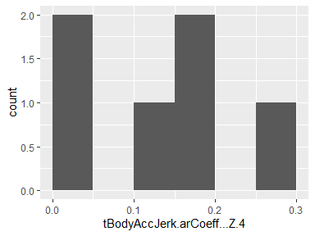

## tBodyAccJerk.correlation…X.Y

|  |  |
| --- | --- |
| Feature | Result |
| Variable type | numeric |
| Number of missing obs. | 0 (0 %) |
| Number of unique values | 6 |
| Median | -0.09 |
| 1st and 3rd quartiles | -0.21; -0.06 |
| Min. and max. | -0.27; -0.01 |

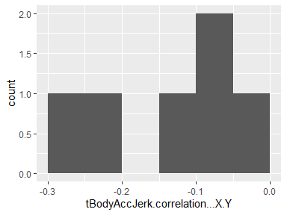

## tBodyAccJerk.correlation…X.Z

|  |  |
| --- | --- |
| Feature | Result |
| Variable type | numeric |
| Number of missing obs. | 0 (0 %) |
| Number of unique values | 6 |
| Median | -0.01 |
| 1st and 3rd quartiles | -0.05; 0.04 |
| Min. and max. | -0.14; 0.09 |

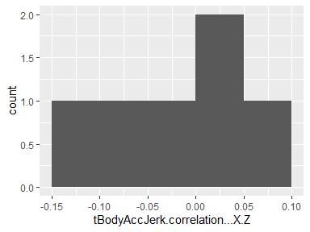

## tBodyAccJerk.correlation…Y.Z

|  |  |
| --- | --- |
| Feature | Result |
| Variable type | numeric |
| Number of missing obs. | 0 (0 %) |
| Number of unique values | 6 |
| Median | 0.04 |
| 1st and 3rd quartiles | 0.03; 0.09 |
| Min. and max. | -0.02; 0.18 |

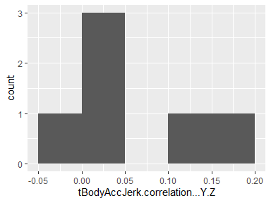

## tBodyGyro.mean…X

|  |  |
| --- | --- |
| Feature | Result |
| Variable type | numeric |
| Number of missing obs. | 0 (0 %) |
| Number of unique values | 6 |
| Median | -0.03 |
| 1st and 3rd quartiles | -0.04; -0.03 |
| Min. and max. | -0.1; -0.02 |

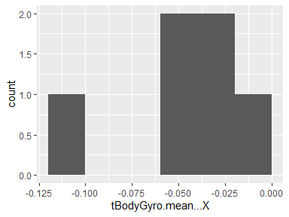

## tBodyGyro.mean…Y

|  |  |
| --- | --- |
| Feature | Result |
| Variable type | numeric |
| Number of missing obs. | 0 (0 %) |
| Number of unique values | 6 |
| Median | -0.07 |
| 1st and 3rd quartiles | -0.07; -0.07 |
| Min. and max. | -0.1; -0.05 |

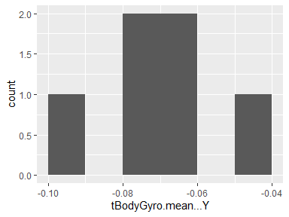

## tBodyGyro.mean…Z

|  |  |
| --- | --- |
| Feature | Result |
| Variable type | numeric |
| Number of missing obs. | 0 (0 %) |
| Number of unique values | 6 |
| Median | 0.09 |
| 1st and 3rd quartiles | 0.08; 0.1 |
| Min. and max. | 0.08; 0.12 |

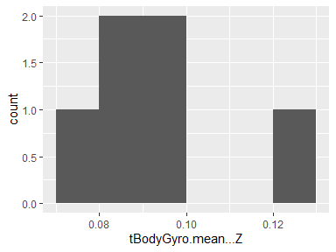

## tBodyGyro.std…X

|  |  |
| --- | --- |
| Feature | Result |
| Variable type | numeric |
| Number of missing obs. | 0 (0 %) |
| Number of unique values | 6 |
| Median | -0.71 |
| 1st and 3rd quartiles | -0.96; -0.48 |
| Min. and max. | -0.98; -0.37 |

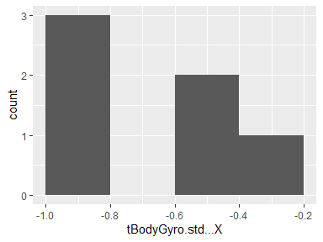

## tBodyGyro.std…Y

|  |  |
| --- | --- |
| Feature | Result |
| Variable type | numeric |
| Number of missing obs. | 0 (0 %) |
| Number of unique values | 6 |
| Median | -0.69 |
| 1st and 3rd quartiles | -0.96; -0.41 |
| Min. and max. | -0.97; -0.4 |

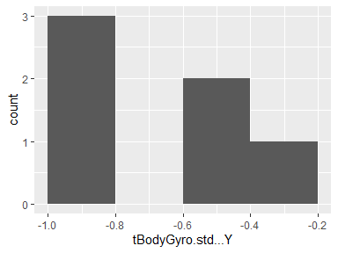

## tBodyGyro.std…Z

|  |  |
| --- | --- |
| Feature | Result |
| Variable type | numeric |
| Number of missing obs. | 0 (0 %) |
| Number of unique values | 6 |
| Median | -0.67 |
| 1st and 3rd quartiles | -0.95; -0.32 |
| Min. and max. | -0.97; -0.23 |

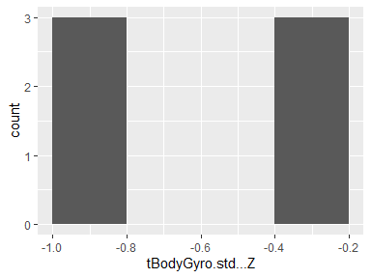

## tBodyGyro.mad…X

|  |  |
| --- | --- |
| Feature | Result |
| Variable type | numeric |
| Number of missing obs. | 0 (0 %) |
| Number of unique values | 6 |
| Median | -0.71 |
| 1st and 3rd quartiles | -0.97; -0.49 |
| Min. and max. | -0.98; -0.38 |

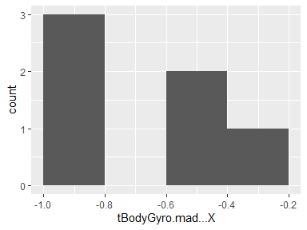

## tBodyGyro.mad…Y

|  |  |
| --- | --- |
| Feature | Result |
| Variable type | numeric |
| Number of missing obs. | 0 (0 %) |
| Number of unique values | 6 |
| Median | -0.7 |
| 1st and 3rd quartiles | -0.96; -0.43 |
| Min. and max. | -0.97; -0.4 |

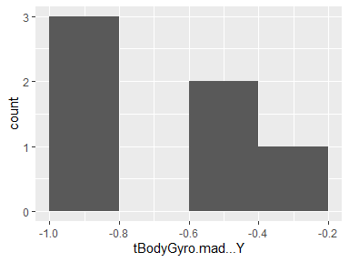

## tBodyGyro.mad…Z

|  |  |
| --- | --- |
| Feature | Result |
| Variable type | numeric |
| Number of missing obs. | 0 (0 %) |
| Number of unique values | 6 |
| Median | -0.69 |
| 1st and 3rd quartiles | -0.96; -0.36 |
| Min. and max. | -0.97; -0.25 |

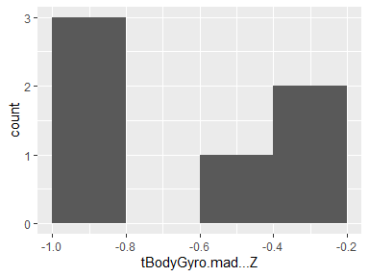

## tBodyGyro.max…X

|  |  |
| --- | --- |
| Feature | Result |
| Variable type | numeric |
| Number of missing obs. | 0 (0 %) |
| Number of unique values | 6 |
| Median | -0.64 |
| 1st and 3rd quartiles | -0.85; -0.44 |
| Min. and max. | -0.88; -0.39 |

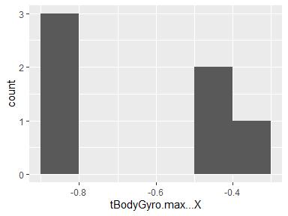

## tBodyGyro.max…Y

|  |  |
| --- | --- |
| Feature | Result |
| Variable type | numeric |
| Number of missing obs. | 0 (0 %) |
| Number of unique values | 6 |
| Median | -0.76 |
| 1st and 3rd quartiles | -0.93; -0.54 |
| Min. and max. | -0.94; -0.52 |

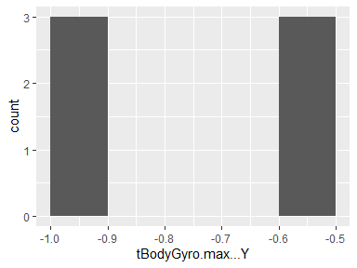

## tBodyGyro.max…Z

|  |  |
| --- | --- |
| Feature | Result |
| Variable type | numeric |
| Number of missing obs. | 0 (0 %) |
| Number of unique values | 6 |
| Median | -0.49 |
| 1st and 3rd quartiles | -0.72; -0.21 |
| Min. and max. | -0.73; -0.16 |

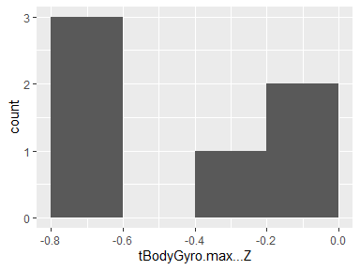

## tBodyGyro.min…X

|  |  |
| --- | --- |
| Feature | Result |
| Variable type | numeric |
| Number of missing obs. | 0 (0 %) |
| Number of unique values | 6 |
| Median | 0.63 |
| 1st and 3rd quartiles | 0.46; 0.82 |
| Min. and max. | 0.32; 0.83 |

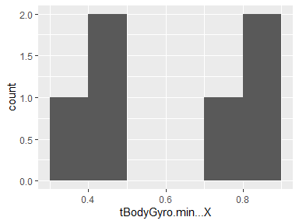

## tBodyGyro.min…Y

|  |  |
| --- | --- |
| Feature | Result |
| Variable type | numeric |
| Number of missing obs. | 0 (0 %) |
| Number of unique values | 6 |
| Median | 0.74 |
| 1st and 3rd quartiles | 0.58; 0.89 |
| Min. and max. | 0.54; 0.9 |

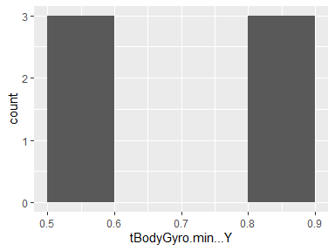

## tBodyGyro.min…Z

|  |  |
| --- | --- |
| Feature | Result |
| Variable type | numeric |
| Number of missing obs. | 0 (0 %) |
| Number of unique values | 6 |
| Median | 0.55 |
| 1st and 3rd quartiles | 0.31; 0.79 |
| Min. and max. | 0.2; 0.82 |

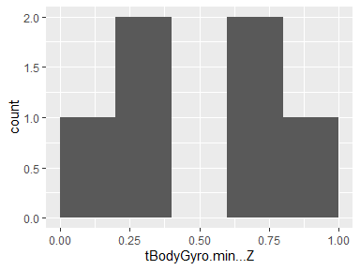

## tBodyGyro.sma..

|  |  |
| --- | --- |
| Feature | Result |
| Variable type | numeric |
| Number of missing obs. | 0 (0 %) |
| Number of unique values | 6 |
| Median | -0.62 |
| 1st and 3rd quartiles | -0.94; -0.22 |
| Min. and max. | -0.94; -0.19 |

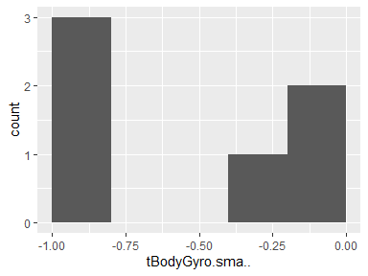

## tBodyGyro.energy…X

|  |  |
| --- | --- |
| Feature | Result |
| Variable type | numeric |
| Number of missing obs. | 0 (0 %) |
| Number of unique values | 6 |
| Median | -0.93 |
| 1st and 3rd quartiles | -1; -0.82 |
| Min. and max. | -1; -0.73 |

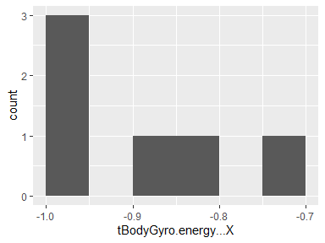

## tBodyGyro.energy…Y

|  |  |
| --- | --- |
| Feature | Result |
| Variable type | numeric |
| Number of missing obs. | 0 (0 %) |
| Number of unique values | 6 |
| Median | -0.9 |
| 1st and 3rd quartiles | -1; -0.8 |
| Min. and max. | -1; -0.79 |

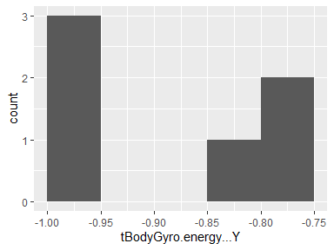

## tBodyGyro.energy…Z

|  |  |
| --- | --- |
| Feature | Result |
| Variable type | numeric |
| Number of missing obs. | 0 (0 %) |
| Number of unique values | 6 |
| Median | -0.9 |
| 1st and 3rd quartiles | -0.99; -0.76 |
| Min. and max. | -1; -0.69 |

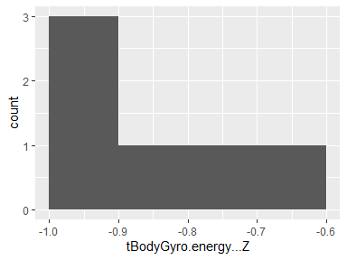

## tBodyGyro.iqr…X

|  |  |
| --- | --- |
| Feature | Result |
| Variable type | numeric |
| Number of missing obs. | 0 (0 %) |
| Number of unique values | 6 |
| Median | -0.72 |
| 1st and 3rd quartiles | -0.97; -0.48 |
| Min. and max. | -0.98; -0.39 |

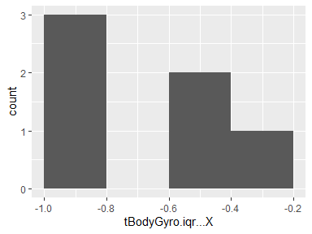

## tBodyGyro.iqr…Y

|  |  |
| --- | --- |
| Feature | Result |
| Variable type | numeric |
| Number of missing obs. | 0 (0 %) |
| Number of unique values | 6 |
| Median | -0.73 |
| 1st and 3rd quartiles | -0.97; -0.47 |
| Min. and max. | -0.97; -0.41 |

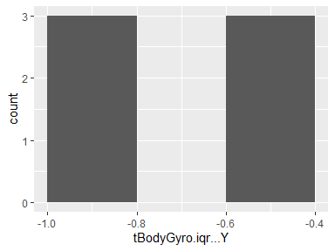

## tBodyGyro.iqr…Z

|  |  |
| --- | --- |
| Feature | Result |
| Variable type | numeric |
| Number of missing obs. | 0 (0 %) |
| Number of unique values | 6 |
| Median | -0.75 |
| 1st and 3rd quartiles | -0.96; -0.49 |
| Min. and max. | -0.98; -0.34 |

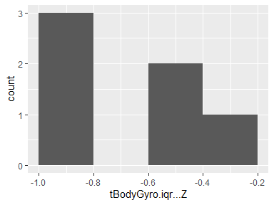

## tBodyGyro.entropy…X

|  |  |
| --- | --- |
| Feature | Result |
| Variable type | numeric |
| Number of missing obs. | 0 (0 %) |
| Number of unique values | 6 |
| Median | -0.07 |
| 1st and 3rd quartiles | -0.31; 0.06 |
| Min. and max. | -0.49; 0.13 |

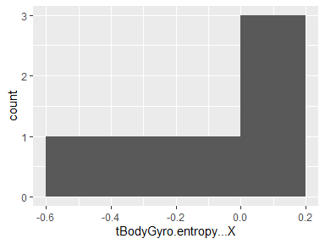

## tBodyGyro.entropy…Y

|  |  |
| --- | --- |
| Feature | Result |
| Variable type | numeric |
| Number of missing obs. | 0 (0 %) |
| Number of unique values | 6 |
| Median | -0.06 |
| 1st and 3rd quartiles | -0.3; 0.17 |
| Min. and max. | -0.31; 0.22 |

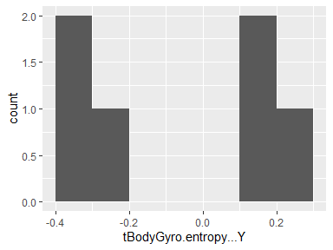

## tBodyGyro.entropy…Z

|  |  |
| --- | --- |
| Feature | Result |
| Variable type | numeric |
| Number of missing obs. | 0 (0 %) |
| Number of unique values | 6 |
| Median | -0.01 |
| 1st and 3rd quartiles | -0.3; 0.29 |
| Min. and max. | -0.36; 0.3 |

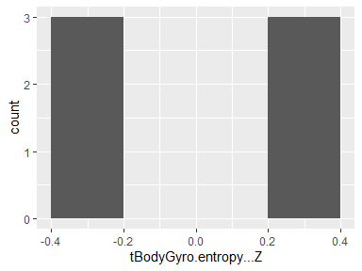

## tBodyGyro.arCoeff…X.1

|  |  |
| --- | --- |
| Feature | Result |
| Variable type | numeric |
| Number of missing obs. | 0 (0 %) |
| Number of unique values | 6 |
| Median | -0.3 |
| 1st and 3rd quartiles | -0.33; -0.1 |
| Min. and max. | -0.42; -0.02 |

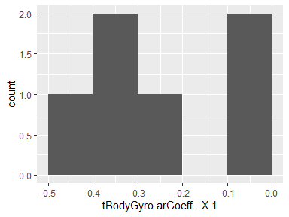

## tBodyGyro.arCoeff…X.2

|  |  |
| --- | --- |
| Feature | Result |
| Variable type | numeric |
| Number of missing obs. | 0 (0 %) |
| Number of unique values | 6 |
| Median | 0.2 |
| 1st and 3rd quartiles | 0.06; 0.27 |
| Min. and max. | 0.01; 0.3 |

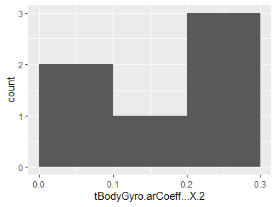

## tBodyGyro.arCoeff…X.3

|  |  |
| --- | --- |
| Feature | Result |
| Variable type | numeric |
| Number of missing obs. | 0 (0 %) |
| Number of unique values | 6 |
| Median | 0.09 |
| 1st and 3rd quartiles | 0.06; 0.15 |
| Min. and max. | 0.03; 0.17 |

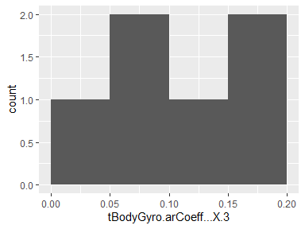

## tBodyGyro.arCoeff…X.4

|  |  |
| --- | --- |
| Feature | Result |
| Variable type | numeric |
| Number of missing obs. | 0 (0 %) |
| Number of unique values | 6 |
| Median | -0.06 |
| 1st and 3rd quartiles | -0.1; -0.06 |
| Min. and max. | -0.17; 0.03 |

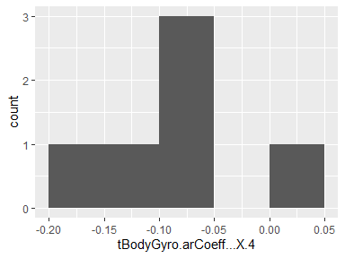

## tBodyGyro.arCoeff…Y.1

|  |  |
| --- | --- |
| Feature | Result |
| Variable type | numeric |
| Number of missing obs. | 0 (0 %) |
| Number of unique values | 6 |
| Median | -0.17 |
| 1st and 3rd quartiles | -0.24; -0.16 |
| Min. and max. | -0.36; -0.14 |

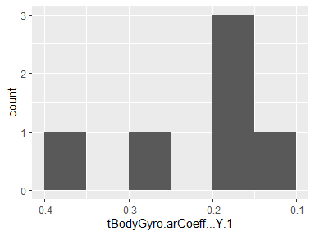

## tBodyGyro.arCoeff…Y.2

|  |  |
| --- | --- |
| Feature | Result |
| Variable type | numeric |
| Number of missing obs. | 0 (0 %) |
| Number of unique values | 6 |
| Median | 0.17 |
| 1st and 3rd quartiles | 0.11; 0.26 |
| Min. and max. | 0.1; 0.29 |

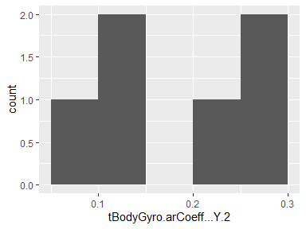

## tBodyGyro.arCoeff…Y.3

|  |  |
| --- | --- |
| Feature | Result |
| Variable type | numeric |
| Number of missing obs. | 0 (0 %) |
| Number of unique values | 6 |
| Median | -0.04 |
| 1st and 3rd quartiles | -0.13; 0 |
| Min. and max. | -0.15; 0.01 |

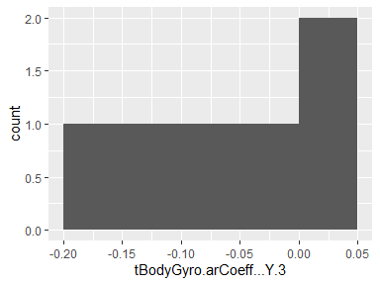

## tBodyGyro.arCoeff…Y.4

|  |  |
| --- | --- |
| Feature | Result |
| Variable type | numeric |
| Number of missing obs. | 0 (0 %) |
| Number of unique values | 6 |
| Median | 0.16 |
| 1st and 3rd quartiles | 0.13; 0.21 |
| Min. and max. | 0.02; 0.25 |

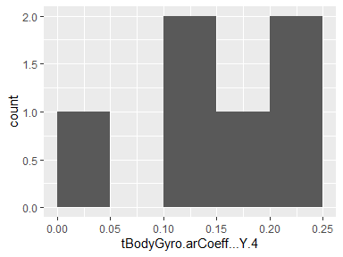

## tBodyGyro.arCoeff…Z.1

|  |  |
| --- | --- |
| Feature | Result |
| Variable type | numeric |
| Number of missing obs. | 0 (0 %) |
| Number of unique values | 6 |
| Median | -0.11 |
| 1st and 3rd quartiles | -0.26; 0.04 |
| Min. and max. | -0.34; 0.15 |

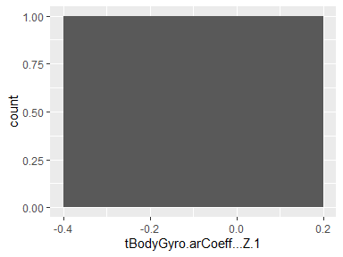

## tBodyGyro.arCoeff…Z.2

|  |  |
| --- | --- |
| Feature | Result |
| Variable type | numeric |
| Number of missing obs. | 0 (0 %) |
| Number of unique values | 6 |
| Median | 0.08 |
| 1st and 3rd quartiles | -0.08; 0.26 |
| Min. and max. | -0.13; 0.31 |

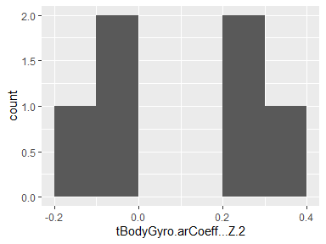

## tBodyGyro.arCoeff…Z.3

|  |  |
| --- | --- |
| Feature | Result |
| Variable type | numeric |
| Number of missing obs. | 0 (0 %) |
| Number of unique values | 6 |
| Median | -0.03 |
| 1st and 3rd quartiles | -0.14; 0.12 |
| Min. and max. | -0.23; 0.14 |

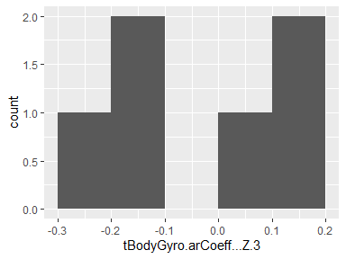

## tBodyGyro.arCoeff…Z.4

|  |  |
| --- | --- |
| Feature | Result |
| Variable type | numeric |
| Number of missing obs. | 0 (0 %) |
| Number of unique values | 6 |
| Median | 0.13 |
| 1st and 3rd quartiles | 0.08; 0.22 |
| Min. and max. | 0.03; 0.28 |

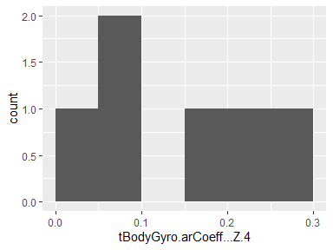

## tBodyGyro.correlation…X.Y

|  |  |
| --- | --- |
| Feature | Result |
| Variable type | numeric |
| Number of missing obs. | 0 (0 %) |
| Number of unique values | 6 |
| Median | -0.15 |
| 1st and 3rd quartiles | -0.17; -0.1 |
| Min. and max. | -0.31; -0.06 |

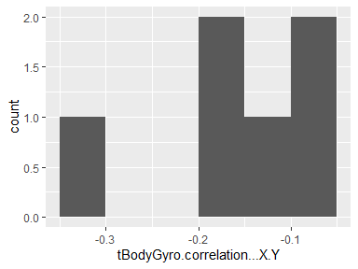

## tBodyGyro.correlation…X.Z

|  |  |
| --- | --- |
| Feature | Result |
| Variable type | numeric |
| Number of missing obs. | 0 (0 %) |
| Number of unique values | 6 |
| Median | 0.03 |
| 1st and 3rd quartiles | 0; 0.08 |
| Min. and max. | -0.01; 0.15 |

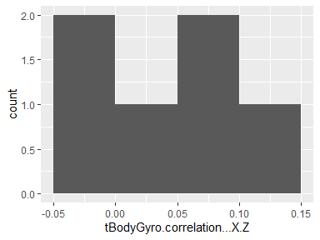

## tBodyGyro.correlation…Y.Z

|  |  |
| --- | --- |
| Feature | Result |
| Variable type | numeric |
| Number of missing obs. | 0 (0 %) |
| Number of unique values | 6 |
| Median | -0.04 |
| 1st and 3rd quartiles | -0.19; 0.05 |
| Min. and max. | -0.27; 0.09 |

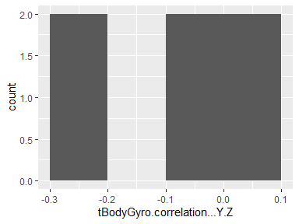

## tBodyGyroJerk.mean…X

|  |  |
| --- | --- |
| Feature | Result |
| Variable type | numeric |
| Number of missing obs. | 0 (0 %) |
| Number of unique values | 6 |
| Median | -0.1 |
| 1st and 3rd quartiles | -0.1; -0.09 |
| Min. and max. | -0.1; -0.07 |

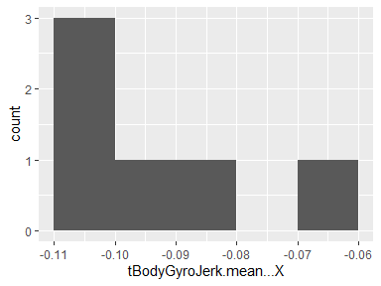

## tBodyGyroJerk.mean…Y

|  |  |
| --- | --- |
| Feature | Result |
| Variable type | numeric |
| Number of missing obs. | 0 (0 %) |
| Number of unique values | 6 |
| Median | -0.04 |
| 1st and 3rd quartiles | -0.04; -0.04 |
| Min. and max. | -0.05; -0.04 |

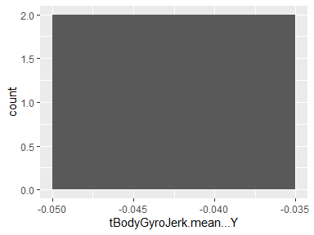

## tBodyGyroJerk.mean…Z

|  |  |
| --- | --- |
| Feature | Result |
| Variable type | numeric |
| Number of missing obs. | 0 (0 %) |
| Number of unique values | 6 |
| Median | -0.06 |
| 1st and 3rd quartiles | -0.06; -0.05 |
| Min. and max. | -0.06; -0.05 |

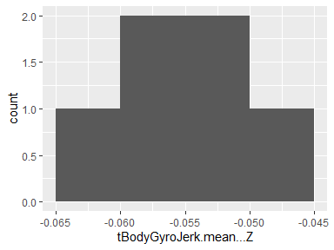

## tBodyGyroJerk.std…X

|  |  |
| --- | --- |
| Feature | Result |
| Variable type | numeric |
| Number of missing obs. | 0 (0 %) |
| Number of unique values | 6 |
| Median | -0.77 |
| 1st and 3rd quartiles | -0.97; -0.45 |
| Min. and max. | -0.98; -0.4 |

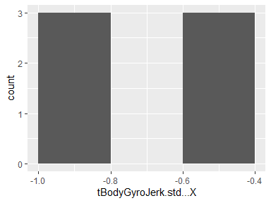

## tBodyGyroJerk.std…Y

|  |  |
| --- | --- |
| Feature | Result |
| Variable type | numeric |
| Number of missing obs. | 0 (0 %) |
| Number of unique values | 6 |
| Median | -0.83 |
| 1st and 3rd quartiles | -0.98; -0.57 |
| Min. and max. | -0.99; -0.52 |

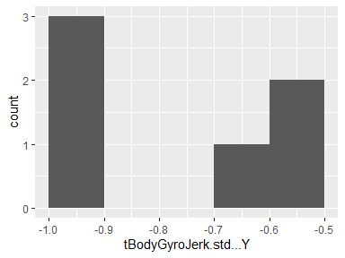

## tBodyGyroJerk.std…Z

|  |  |
| --- | --- |
| Feature | Result |
| Variable type | numeric |
| Number of missing obs. | 0 (0 %) |
| Number of unique values | 6 |
| Median | -0.76 |
| 1st and 3rd quartiles | -0.98; -0.49 |
| Min. and max. | -0.99; -0.34 |

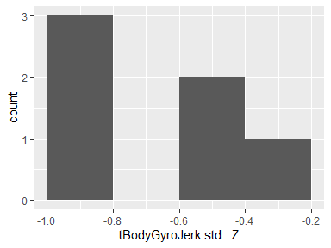

## tBodyGyroJerk.mad…X

|  |  |
| --- | --- |
| Feature | Result |
| Variable type | numeric |
| Number of missing obs. | 0 (0 %) |
| Number of unique values | 6 |
| Median | -0.77 |
| 1st and 3rd quartiles | -0.98; -0.45 |
| Min. and max. | -0.99; -0.41 |

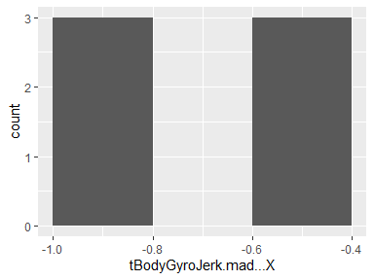

## tBodyGyroJerk.mad…Y

|  |  |
| --- | --- |
| Feature | Result |
| Variable type | numeric |
| Number of missing obs. | 0 (0 %) |
| Number of unique values | 6 |
| Median | -0.84 |
| 1st and 3rd quartiles | -0.98; -0.59 |
| Min. and max. | -0.99; -0.55 |

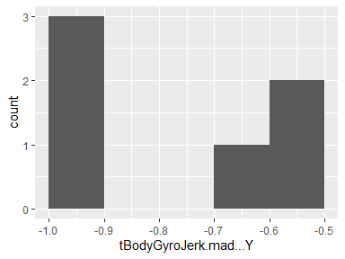

## tBodyGyroJerk.mad…Z

|  |  |
| --- | --- |
| Feature | Result |
| Variable type | numeric |
| Number of missing obs. | 0 (0 %) |
| Number of unique values | 6 |
| Median | -0.77 |
| 1st and 3rd quartiles | -0.98; -0.49 |
| Min. and max. | -0.99; -0.38 |

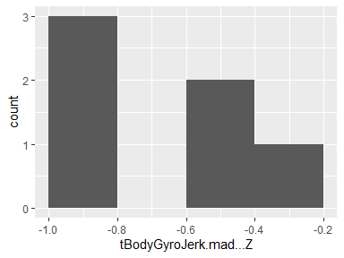

## tBodyGyroJerk.max…X

|  |  |
| --- | --- |
| Feature | Result |
| Variable type | numeric |
| Number of missing obs. | 0 (0 %) |
| Number of unique values | 6 |
| Median | -0.77 |
| 1st and 3rd quartiles | -0.97; -0.47 |
| Min. and max. | -0.98; -0.41 |

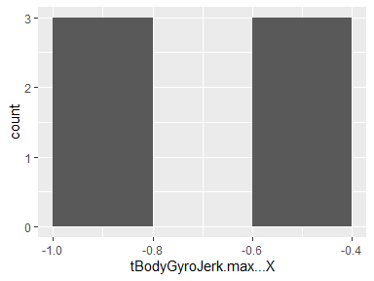

## tBodyGyroJerk.max…Y

|  |  |
| --- | --- |
| Feature | Result |
| Variable type | numeric |
| Number of missing obs. | 0 (0 %) |
| Number of unique values | 6 |
| Median | -0.85 |
| 1st and 3rd quartiles | -0.98; -0.63 |
| Min. and max. | -0.99; -0.55 |

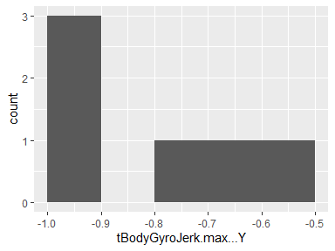

## tBodyGyroJerk.max…Z

|  |  |
| --- | --- |
| Feature | Result |
| Variable type | numeric |
| Number of missing obs. | 0 (0 %) |
| Number of unique values | 6 |
| Median | -0.78 |
| 1st and 3rd quartiles | -0.97; -0.51 |
| Min. and max. | -0.98; -0.28 |

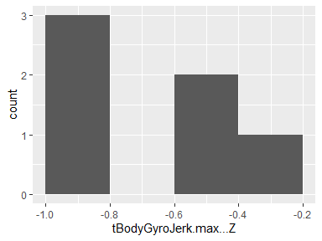

## tBodyGyroJerk.min…X

|  |  |
| --- | --- |
| Feature | Result |
| Variable type | numeric |
| Number of missing obs. | 0 (0 %) |
| Number of unique values | 6 |
| Median | 0.79 |
| 1st and 3rd quartiles | 0.54; 0.97 |
| Min. and max. | 0.43; 0.98 |

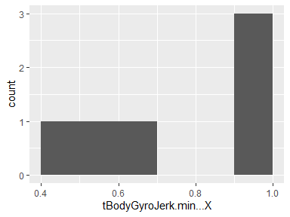

## tBodyGyroJerk.min…Y

|  |  |
| --- | --- |
| Feature | Result |
| Variable type | numeric |
| Number of missing obs. | 0 (0 %) |
| Number of unique values | 6 |
| Median | 0.86 |
| 1st and 3rd quartiles | 0.66; 0.98 |
| Min. and max. | 0.59; 0.99 |

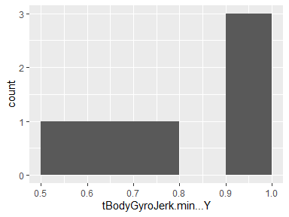

## tBodyGyroJerk.min…Z

|  |  |
| --- | --- |
| Feature | Result |
| Variable type | numeric |
| Number of missing obs. | 0 (0 %) |
| Number of unique values | 6 |
| Median | 0.81 |
| 1st and 3rd quartiles | 0.62; 0.98 |
| Min. and max. | 0.49; 0.99 |

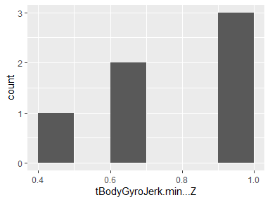

## tBodyGyroJerk.sma..

|  |  |
| --- | --- |
| Feature | Result |
| Variable type | numeric |
| Number of missing obs. | 0 (0 %) |
| Number of unique values | 6 |
| Median | -0.8 |
| 1st and 3rd quartiles | -0.98; -0.53 |
| Min. and max. | -0.99; -0.47 |

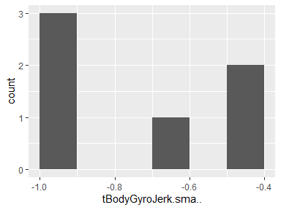

## tBodyGyroJerk.energy…X

|  |  |
| --- | --- |
| Feature | Result |
| Variable type | numeric |
| Number of missing obs. | 0 (0 %) |
| Number of unique values | 6 |
| Median | -0.95 |
| 1st and 3rd quartiles | -1; -0.84 |
| Min. and max. | -1; -0.8 |

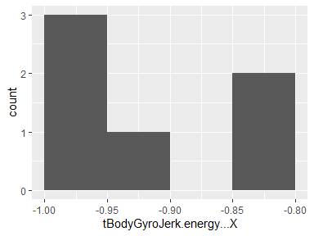

## tBodyGyroJerk.energy…Y

|  |  |
| --- | --- |
| Feature | Result |
| Variable type | numeric |
| Number of missing obs. | 0 (0 %) |
| Number of unique values | 6 |
| Median | -0.97 |
| 1st and 3rd quartiles | -1; -0.89 |
| Min. and max. | -1; -0.86 |

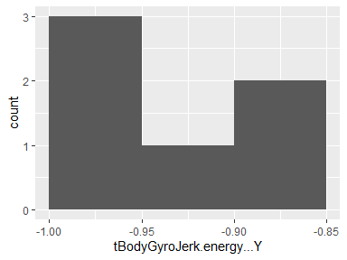

## tBodyGyroJerk.energy…Z

|  |  |
| --- | --- |
| Feature | Result |
| Variable type | numeric |
| Number of missing obs. | 0 (0 %) |
| Number of unique values | 6 |
| Median | -0.94 |
| 1st and 3rd quartiles | -1; -0.85 |
| Min. and max. | -1; -0.76 |

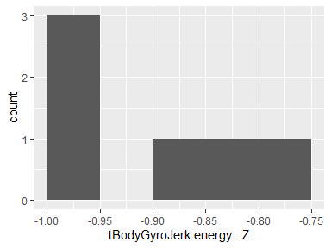

## tBodyGyroJerk.iqr…X

|  |  |
| --- | --- |
| Feature | Result |
| Variable type | numeric |
| Number of missing obs. | 0 (0 %) |
| Number of unique values | 6 |
| Median | -0.77 |
| 1st and 3rd quartiles | -0.98; -0.48 |
| Min. and max. | -0.99; -0.43 |

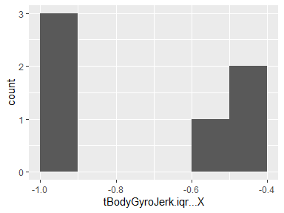

## tBodyGyroJerk.iqr…Y

|  |  |
| --- | --- |
| Feature | Result |
| Variable type | numeric |
| Number of missing obs. | 0 (0 %) |
| Number of unique values | 6 |
| Median | -0.85 |
| 1st and 3rd quartiles | -0.98; -0.62 |
| Min. and max. | -0.99; -0.58 |

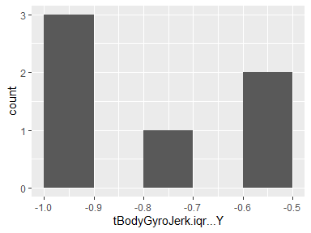

## tBodyGyroJerk.iqr…Z

|  |  |
| --- | --- |
| Feature | Result |
| Variable type | numeric |
| Number of missing obs. | 0 (0 %) |
| Number of unique values | 6 |
| Median | -0.78 |
| 1st and 3rd quartiles | -0.99; -0.53 |
| Min. and max. | -0.99; -0.45 |

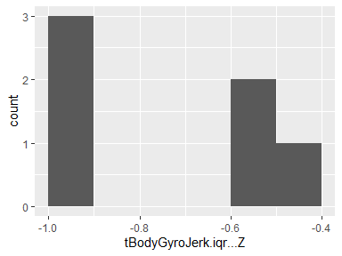

## tBodyGyroJerk.entropy…X

|  |  |
| --- | --- |
| Feature | Result |
| Variable type | numeric |
| Number of missing obs. | 0 (0 %) |
| Number of unique values | 6 |
| Median | 0.1 |
| 1st and 3rd quartiles | -0.46; 0.54 |
| Min. and max. | -0.54; 0.57 |

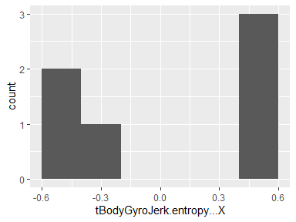

## tBodyGyroJerk.entropy…Y

|  |  |
| --- | --- |
| Feature | Result |
| Variable type | numeric |
| Number of missing obs. | 0 (0 %) |
| Number of unique values | 6 |
| Median | 0.09 |
| 1st and 3rd quartiles | -0.35; 0.56 |
| Min. and max. | -0.47; 0.59 |

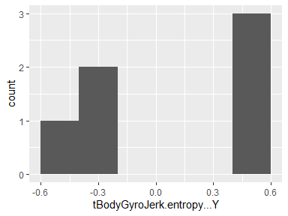

## tBodyGyroJerk.entropy…Z

|  |  |
| --- | --- |
| Feature | Result |
| Variable type | numeric |
| Number of missing obs. | 0 (0 %) |
| Number of unique values | 6 |
| Median | 0.09 |
| 1st and 3rd quartiles | -0.47; 0.57 |
| Min. and max. | -0.56; 0.61 |

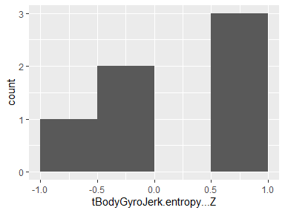

## tBodyGyroJerk.arCoeff…X.1

|  |  |
| --- | --- |
| Feature | Result |
| Variable type | numeric |
| Number of missing obs. | 0 (0 %) |
| Number of unique values | 6 |
| Median | -0.15 |
| 1st and 3rd quartiles | -0.18; 0.04 |
| Min. and max. | -0.21; 0.11 |

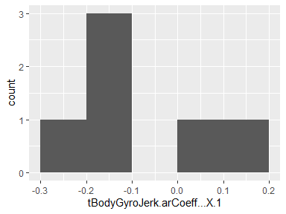

## tBodyGyroJerk.arCoeff…X.2

|  |  |
| --- | --- |
| Feature | Result |
| Variable type | numeric |
| Number of missing obs. | 0 (0 %) |
| Number of unique values | 6 |
| Median | 0.06 |
| 1st and 3rd quartiles | 0; 0.13 |
| Min. and max. | -0.04; 0.16 |

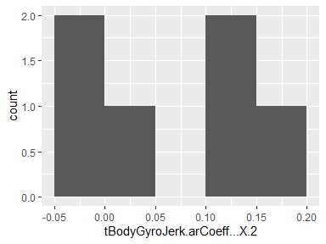

## tBodyGyroJerk.arCoeff…X.3

|  |  |
| --- | --- |
| Feature | Result |
| Variable type | numeric |
| Number of missing obs. | 0 (0 %) |
| Number of unique values | 6 |
| Median | 0.13 |
| 1st and 3rd quartiles | 0.11; 0.2 |
| Min. and max. | 0.09; 0.25 |

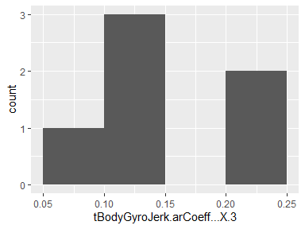

## tBodyGyroJerk.arCoeff…X.4

|  |  |
| --- | --- |
| Feature | Result |
| Variable type | numeric |
| Number of missing obs. | 0 (0 %) |
| Number of unique values | 6 |
| Median | 0.15 |
| 1st and 3rd quartiles | 0.13; 0.17 |
| Min. and max. | 0.08; 0.18 |

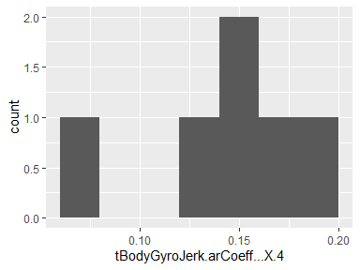

## tBodyGyroJerk.arCoeff…Y.1

|  |  |
| --- | --- |
| Feature | Result |
| Variable type | numeric |
| Number of missing obs. | 0 (0 %) |
| Number of unique values | 6 |
| Median | -0.15 |
| 1st and 3rd quartiles | -0.24; -0.11 |
| Min. and max. | -0.3; -0.06 |

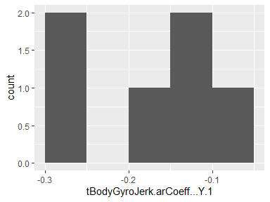

## tBodyGyroJerk.arCoeff…Y.2

|  |  |
| --- | --- |
| Feature | Result |
| Variable type | numeric |
| Number of missing obs. | 0 (0 %) |
| Number of unique values | 6 |
| Median | 0.24 |
| 1st and 3rd quartiles | 0.16; 0.26 |
| Min. and max. | 0.13; 0.29 |

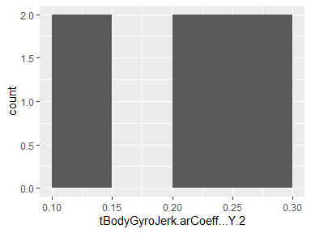

## tBodyGyroJerk.arCoeff…Y.3

|  |  |
| --- | --- |
| Feature | Result |
| Variable type | numeric |
| Number of missing obs. | 0 (0 %) |
| Number of unique values | 6 |
| Median | 0.07 |
| 1st and 3rd quartiles | 0.05; 0.09 |
| Min. and max. | 0.01; 0.17 |

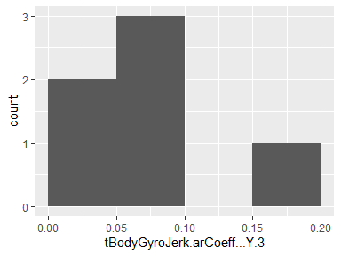

## tBodyGyroJerk.arCoeff…Y.4

|  |  |
| --- | --- |
| Feature | Result |
| Variable type | numeric |
| Number of missing obs. | 0 (0 %) |
| Number of unique values | 6 |
| Median | 0.08 |
| 1st and 3rd quartiles | 0.04; 0.1 |
| Min. and max. | 0.01; 0.14 |

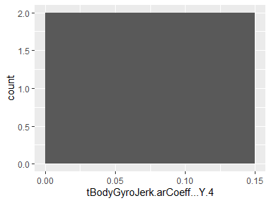

## tBodyGyroJerk.arCoeff…Z.1

|  |  |
| --- | --- |
| Feature | Result |
| Variable type | numeric |
| Number of missing obs. | 0 (0 %) |
| Number of unique values | 6 |
| Median | -0.06 |
| 1st and 3rd quartiles | -0.25; 0.14 |
| Min. and max. | -0.28; 0.24 |

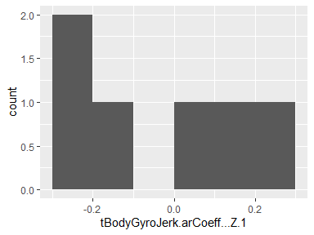

## tBodyGyroJerk.arCoeff…Z.2

|  |  |
| --- | --- |
| Feature | Result |
| Variable type | numeric |
| Number of missing obs. | 0 (0 %) |
| Number of unique values | 6 |
| Median | 0.06 |
| 1st and 3rd quartiles | -0.06; 0.19 |
| Min. and max. | -0.09; 0.24 |

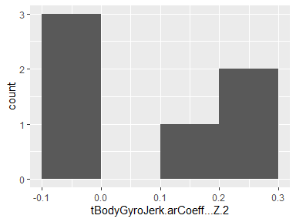

## tBodyGyroJerk.arCoeff…Z.3

|  |  |
| --- | --- |
| Feature | Result |
| Variable type | numeric |
| Number of missing obs. | 0 (0 %) |
| Number of unique values | 6 |
| Median | 0.07 |
| 1st and 3rd quartiles | 0.02; 0.15 |
| Min. and max. | 0; 0.22 |

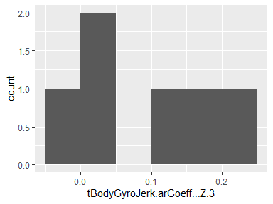

## tBodyGyroJerk.arCoeff…Z.4

|  |  |
| --- | --- |
| Feature | Result |
| Variable type | numeric |
| Number of missing obs. | 0 (0 %) |
| Number of unique values | 6 |
| Median | 0.01 |
| 1st and 3rd quartiles | -0.05; 0.08 |
| Min. and max. | -0.09; 0.13 |

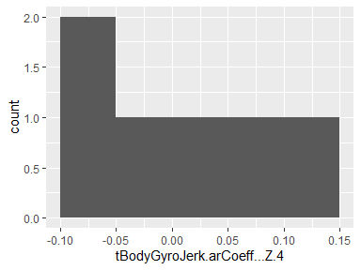

## tBodyGyroJerk.correlation…X.Y

|  |  |
| --- | --- |
| Feature | Result |
| Variable type | numeric |
| Number of missing obs. | 0 (0 %) |
| Number of unique values | 6 |
| Median | 0.03 |
| 1st and 3rd quartiles | 0.01; 0.04 |
| Min. and max. | -0.01; 0.07 |

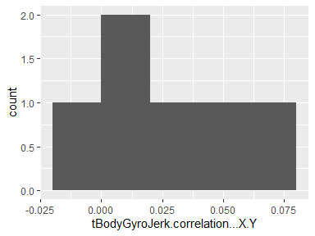

## tBodyGyroJerk.correlation…X.Z

|  |  |
| --- | --- |
| Feature | Result |
| Variable type | numeric |
| Number of missing obs. | 0 (0 %) |
| Number of unique values | 6 |
| Median | 0.06 |
| 1st and 3rd quartiles | 0.02; 0.08 |
| Min. and max. | 0; 0.08 |

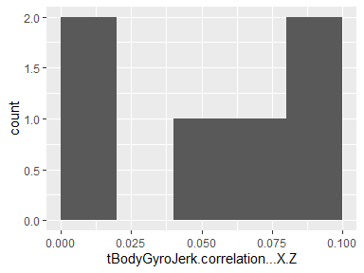

## tBodyGyroJerk.correlation…Y.Z

|  |  |
| --- | --- |
| Feature | Result |
| Variable type | numeric |
| Number of missing obs. | 0 (0 %) |
| Number of unique values | 6 |
| Median | -0.06 |
| 1st and 3rd quartiles | -0.07; -0.05 |
| Min. and max. | -0.16; -0.05 |

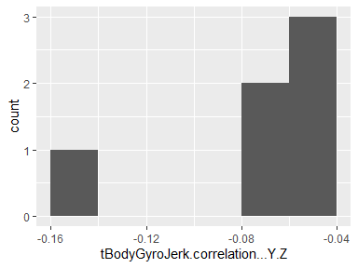

## tBodyAccMag.mean..

|  |  |
| --- | --- |
| Feature | Result |
| Variable type | numeric |
| Number of missing obs. | 0 (0 %) |
| Number of unique values | 6 |
| Median | -0.57 |
| 1st and 3rd quartiles | -0.95; -0.16 |
| Min. and max. | -0.96; 0.02 |

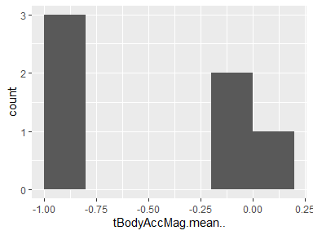

## tBodyAccMag.std..

|  |  |
| --- | --- |
| Feature | Result |
| Variable type | numeric |
| Number of missing obs. | 0 (0 %) |
| Number of unique values | 6 |
| Median | -0.65 |
| 1st and 3rd quartiles | -0.94; -0.3 |
| Min. and max. | -0.95; 0.05 |

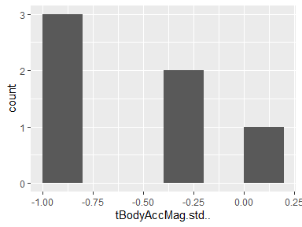

## tBodyAccMag.mad..

|  |  |
| --- | --- |
| Feature | Result |
| Variable type | numeric |
| Number of missing obs. | 0 (0 %) |
| Number of unique values | 6 |
| Median | -0.69 |
| 1st and 3rd quartiles | -0.95; -0.4 |
| Min. and max. | -0.95; -0.1 |

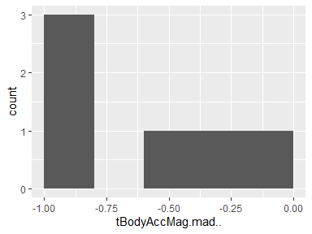

## tBodyAccMag.max..

|  |  |
| --- | --- |
| Feature | Result |
| Variable type | numeric |
| Number of missing obs. | 0 (0 %) |
| Number of unique values | 6 |
| Median | -0.6 |
| 1st and 3rd quartiles | -0.94; -0.22 |
| Min. and max. | -0.95; 0.1 |

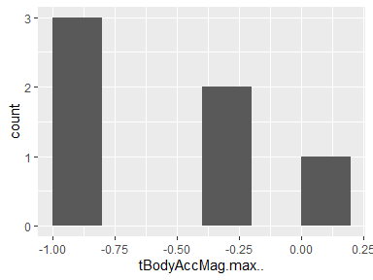

## tBodyAccMag.min..

|  |  |
| --- | --- |
| Feature | Result |
| Variable type | numeric |
| Number of missing obs. | 0 (0 %) |
| Number of unique values | 6 |
| Median | -0.84 |
| 1st and 3rd quartiles | -0.99; -0.67 |
| Min. and max. | -0.99; -0.65 |

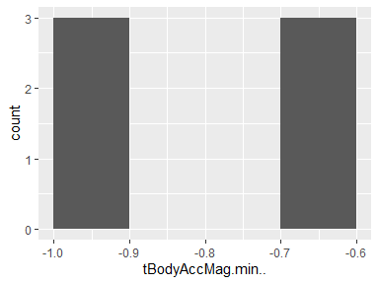

## tBodyAccMag.sma..

|  |  |
| --- | --- |
| Feature | Result |
| Variable type | numeric |
| Number of missing obs. | 0 (0 %) |
| Number of unique values | 6 |
| Median | -0.57 |
| 1st and 3rd quartiles | -0.95; -0.16 |
| Min. and max. | -0.96; 0.02 |

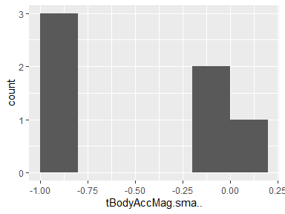

## tBodyAccMag.energy..

|  |  |
| --- | --- |
| Feature | Result |
| Variable type | numeric |
| Number of missing obs. | 0 (0 %) |
| Number of unique values | 6 |
| Median | -0.82 |
| 1st and 3rd quartiles | -0.99; -0.63 |
| Min. and max. | -1; -0.41 |

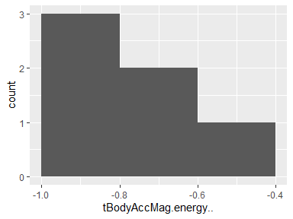

## tBodyAccMag.iqr..

|  |  |
| --- | --- |
| Feature | Result |
| Variable type | numeric |
| Number of missing obs. | 0 (0 %) |
| Number of unique values | 6 |
| Median | -0.73 |
| 1st and 3rd quartiles | -0.95; -0.51 |
| Min. and max. | -0.96; -0.32 |

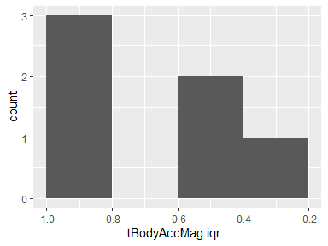

## tBodyAccMag.entropy..

|  |  |
| --- | --- |
| Feature | Result |
| Variable type | numeric |
| Number of missing obs. | 0 (0 %) |
| Number of unique values | 6 |
| Median | 0.22 |
| 1st and 3rd quartiles | -0.41; 0.77 |
| Min. and max. | -0.48; 0.84 |

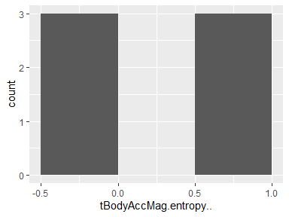

## tBodyAccMag.arCoeff..1

|  |  |
| --- | --- |
| Feature | Result |
| Variable type | numeric |
| Number of missing obs. | 0 (0 %) |
| Number of unique values | 6 |
| Median | -0.01 |
| 1st and 3rd quartiles | -0.22; 0.03 |
| Min. and max. | -0.31; 0.13 |

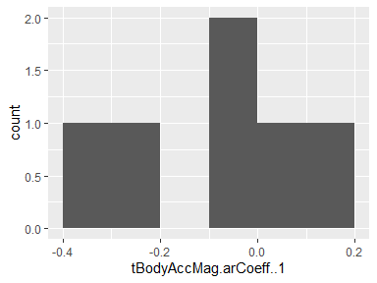

## tBodyAccMag.arCoeff..2

|  |  |
| --- | --- |
| Feature | Result |
| Variable type | numeric |
| Number of missing obs. | 0 (0 %) |
| Number of unique values | 6 |
| Median | -0.01 |
| 1st and 3rd quartiles | -0.06; 0.14 |
| Min. and max. | -0.12; 0.2 |

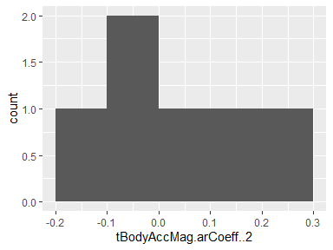

## tBodyAccMag.arCoeff..3

|  |  |
| --- | --- |
| Feature | Result |
| Variable type | numeric |
| Number of missing obs. | 0 (0 %) |
| Number of unique values | 6 |
| Median | 0.05 |
| 1st and 3rd quartiles | -0.04; 0.14 |
| Min. and max. | -0.07; 0.16 |

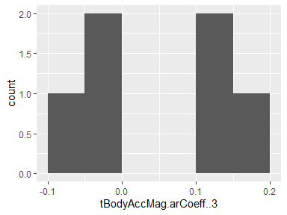

## tBodyAccMag.arCoeff..4

|  |  |
| --- | --- |
| Feature | Result |
| Variable type | numeric |
| Number of missing obs. | 0 (0 %) |
| Number of unique values | 6 |
| Median | -0.06 |
| 1st and 3rd quartiles | -0.13; 0.05 |
| Min. and max. | -0.2; 0.08 |

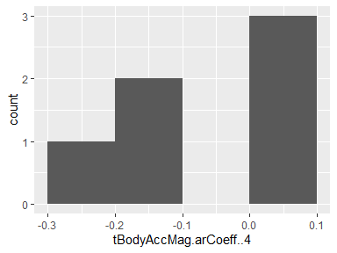

## tGravityAccMag.mean..

|  |  |
| --- | --- |
| Feature | Result |
| Variable type | numeric |
| Number of missing obs. | 0 (0 %) |
| Number of unique values | 6 |
| Median | -0.57 |
| 1st and 3rd quartiles | -0.95; -0.16 |
| Min. and max. | -0.96; 0.02 |

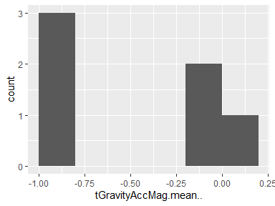

## tGravityAccMag.std..

|  |  |
| --- | --- |
| Feature | Result |
| Variable type | numeric |
| Number of missing obs. | 0 (0 %) |
| Number of unique values | 6 |
| Median | -0.65 |
| 1st and 3rd quartiles | -0.94; -0.3 |
| Min. and max. | -0.95; 0.05 |

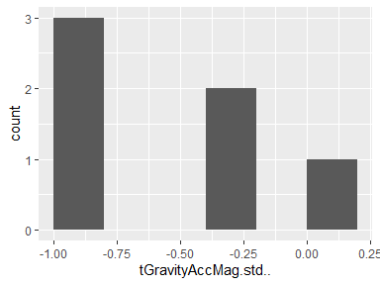

## tGravityAccMag.mad..

|  |  |
| --- | --- |
| Feature | Result |
| Variable type | numeric |
| Number of missing obs. | 0 (0 %) |
| Number of unique values | 6 |
| Median | -0.69 |
| 1st and 3rd quartiles | -0.95; -0.4 |
| Min. and max. | -0.95; -0.1 |

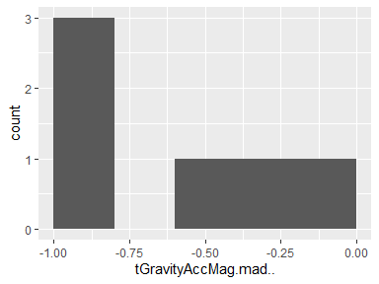

## tGravityAccMag.max..

|  |  |
| --- | --- |
| Feature | Result |
| Variable type | numeric |
| Number of missing obs. | 0 (0 %) |
| Number of unique values | 6 |
| Median | -0.6 |
| 1st and 3rd quartiles | -0.94; -0.22 |
| Min. and max. | -0.95; 0.1 |

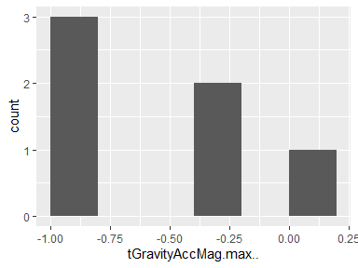

## tGravityAccMag.min..

|  |  |
| --- | --- |
| Feature | Result |
| Variable type | numeric |
| Number of missing obs. | 0 (0 %) |
| Number of unique values | 6 |
| Median | -0.84 |
| 1st and 3rd quartiles | -0.99; -0.67 |
| Min. and max. | -0.99; -0.65 |

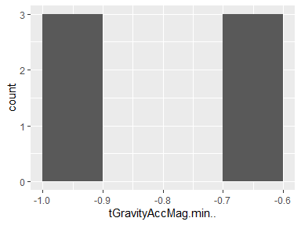

## tGravityAccMag.sma..

|  |  |
| --- | --- |
| Feature | Result |
| Variable type | numeric |
| Number of missing obs. | 0 (0 %) |
| Number of unique values | 6 |
| Median | -0.57 |
| 1st and 3rd quartiles | -0.95; -0.16 |
| Min. and max. | -0.96; 0.02 |

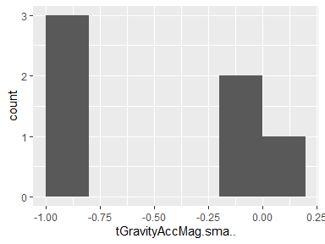

## tGravityAccMag.energy..

|  |  |
| --- | --- |
| Feature | Result |
| Variable type | numeric |
| Number of missing obs. | 0 (0 %) |
| Number of unique values | 6 |
| Median | -0.82 |
| 1st and 3rd quartiles | -0.99; -0.63 |
| Min. and max. | -1; -0.41 |

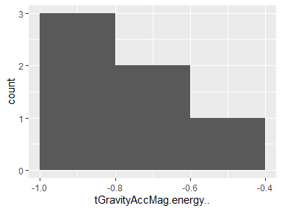

## tGravityAccMag.iqr..

|  |  |
| --- | --- |
| Feature | Result |
| Variable type | numeric |
| Number of missing obs. | 0 (0 %) |
| Number of unique values | 6 |
| Median | -0.73 |
| 1st and 3rd quartiles | -0.95; -0.51 |
| Min. and max. | -0.96; -0.32 |

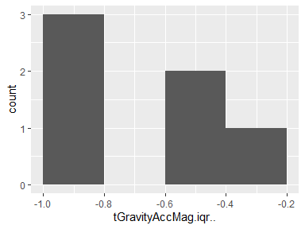

## tGravityAccMag.entropy..

|  |  |
| --- | --- |
| Feature | Result |
| Variable type | numeric |
| Number of missing obs. | 0 (0 %) |
| Number of unique values | 6 |
| Median | 0.22 |
| 1st and 3rd quartiles | -0.41; 0.77 |
| Min. and max. | -0.48; 0.84 |

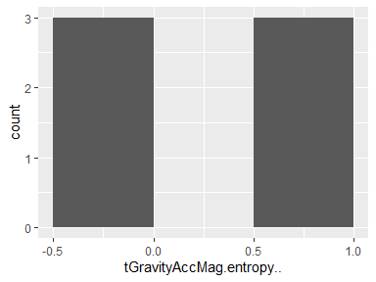

## tGravityAccMag.arCoeff..1

|  |  |
| --- | --- |
| Feature | Result |
| Variable type | numeric |
| Number of missing obs. | 0 (0 %) |
| Number of unique values | 6 |
| Median | -0.01 |
| 1st and 3rd quartiles | -0.22; 0.03 |
| Min. and max. | -0.31; 0.13 |

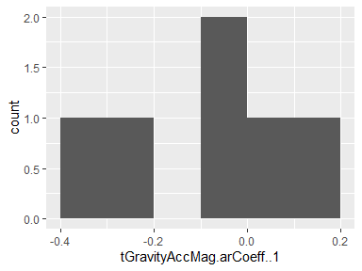

## tGravityAccMag.arCoeff..2

|  |  |
| --- | --- |
| Feature | Result |
| Variable type | numeric |
| Number of missing obs. | 0 (0 %) |
| Number of unique values | 6 |
| Median | -0.01 |
| 1st and 3rd quartiles | -0.06; 0.14 |
| Min. and max. | -0.12; 0.2 |

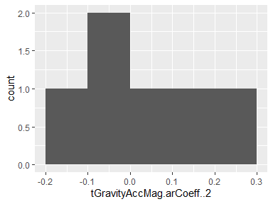

## tGravityAccMag.arCoeff..3

|  |  |
| --- | --- |
| Feature | Result |
| Variable type | numeric |
| Number of missing obs. | 0 (0 %) |
| Number of unique values | 6 |
| Median | 0.05 |
| 1st and 3rd quartiles | -0.04; 0.14 |
| Min. and max. | -0.07; 0.16 |

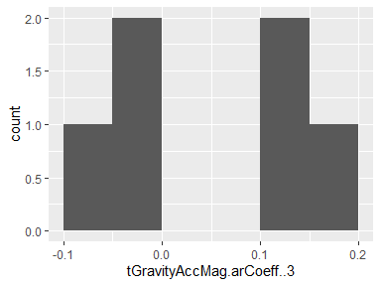

## tGravityAccMag.arCoeff..4

|  |  |
| --- | --- |
| Feature | Result |
| Variable type | numeric |
| Number of missing obs. | 0 (0 %) |
| Number of unique values | 6 |
| Median | -0.06 |
| 1st and 3rd quartiles | -0.13; 0.05 |
| Min. and max. | -0.2; 0.08 |

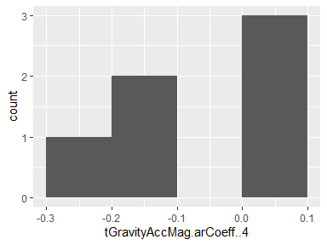

## tBodyAccJerkMag.mean..

|  |  |
| --- | --- |
| Feature | Result |
| Variable type | numeric |
| Number of missing obs. | 0 (0 %) |
| Number of unique values | 6 |
| Median | -0.69 |
| 1st and 3rd quartiles | -0.98; -0.28 |
| Min. and max. | -0.98; -0.16 |

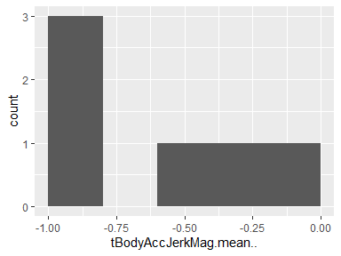

## tBodyAccJerkMag.std..

|  |  |
| --- | --- |
| Feature | Result |
| Variable type | numeric |
| Number of missing obs. | 0 (0 %) |
| Number of unique values | 6 |
| Median | -0.67 |
| 1st and 3rd quartiles | -0.97; -0.24 |
| Min. and max. | -0.98; -0.05 |

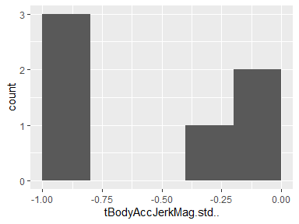

## tBodyAccJerkMag.mad..

|  |  |
| --- | --- |
| Feature | Result |
| Variable type | numeric |
| Number of missing obs. | 0 (0 %) |
| Number of unique values | 6 |
| Median | -0.7 |
| 1st and 3rd quartiles | -0.98; -0.28 |
| Min. and max. | -0.98; -0.08 |

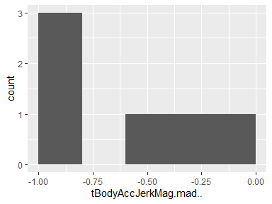

## tBodyAccJerkMag.max..

|  |  |
| --- | --- |
| Feature | Result |
| Variable type | numeric |
| Number of missing obs. | 0 (0 %) |
| Number of unique values | 6 |
| Median | -0.66 |
| 1st and 3rd quartiles | -0.97; -0.27 |
| Min. and max. | -0.97; -0.12 |

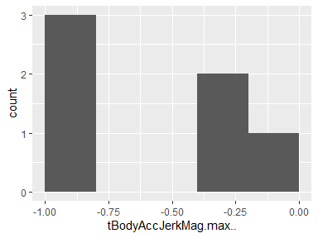

## tBodyAccJerkMag.min..

|  |  |
| --- | --- |
| Feature | Result |
| Variable type | numeric |
| Number of missing obs. | 0 (0 %) |
| Number of unique values | 6 |
| Median | -0.8 |
| 1st and 3rd quartiles | -0.98; -0.58 |
| Min. and max. | -0.98; -0.55 |

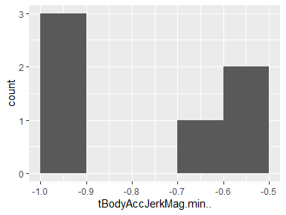

## tBodyAccJerkMag.sma..

|  |  |
| --- | --- |
| Feature | Result |
| Variable type | numeric |
| Number of missing obs. | 0 (0 %) |
| Number of unique values | 6 |
| Median | -0.69 |
| 1st and 3rd quartiles | -0.98; -0.28 |
| Min. and max. | -0.98; -0.16 |

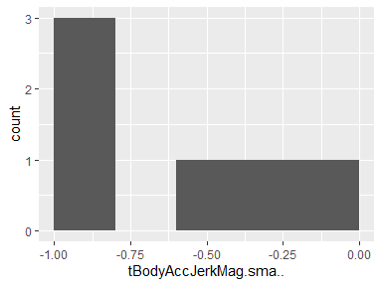

## tBodyAccJerkMag.energy..

|  |  |
| --- | --- |
| Feature | Result |
| Variable type | numeric |
| Number of missing obs. | 0 (0 %) |
| Number of unique values | 6 |
| Median | -0.9 |
| 1st and 3rd quartiles | -1; -0.71 |
| Min. and max. | -1; -0.58 |

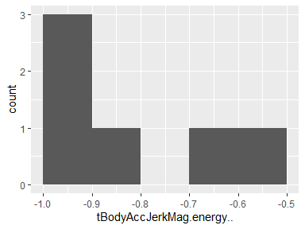

## tBodyAccJerkMag.iqr..

|  |  |
| --- | --- |
| Feature | Result |
| Variable type | numeric |
| Number of missing obs. | 0 (0 %) |
| Number of unique values | 6 |
| Median | -0.76 |
| 1st and 3rd quartiles | -0.98; -0.38 |
| Min. and max. | -0.98; -0.22 |

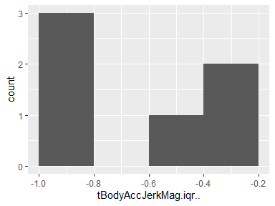

## tBodyAccJerkMag.entropy..

|  |  |
| --- | --- |
| Feature | Result |
| Variable type | numeric |
| Number of missing obs. | 0 (0 %) |
| Number of unique values | 6 |
| Median | 0 |
| 1st and 3rd quartiles | -0.69; 0.7 |
| Min. and max. | -0.71; 0.76 |

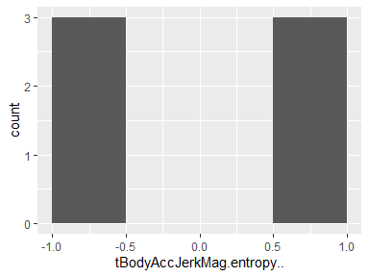

## tBodyAccJerkMag.arCoeff..1

|  |  |
| --- | --- |
| Feature | Result |
| Variable type | numeric |
| Number of missing obs. | 0 (0 %) |
| Number of unique values | 6 |
| Median | 0.09 |
| 1st and 3rd quartiles | -0.09; 0.22 |
| Min. and max. | -0.13; 0.24 |

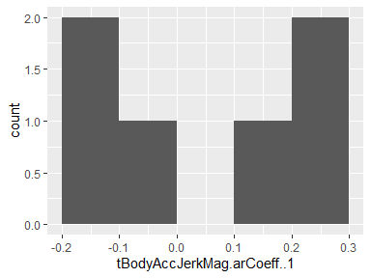

## tBodyAccJerkMag.arCoeff..2

|  |  |
| --- | --- |
| Feature | Result |
| Variable type | numeric |
| Number of missing obs. | 0 (0 %) |
| Number of unique values | 6 |
| Median | -0.06 |
| 1st and 3rd quartiles | -0.14; 0.11 |
| Min. and max. | -0.17; 0.18 |

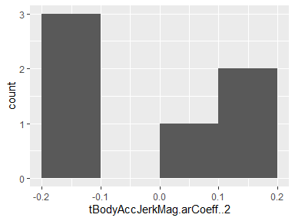

## tBodyAccJerkMag.arCoeff..3

|  |  |
| --- | --- |
| Feature | Result |
| Variable type | numeric |
| Number of missing obs. | 0 (0 %) |
| Number of unique values | 6 |
| Median | -0.1 |
| 1st and 3rd quartiles | -0.13; -0.07 |
| Min. and max. | -0.18; -0.07 |

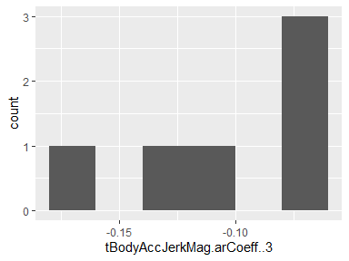

## tBodyAccJerkMag.arCoeff..4

|  |  |
| --- | --- |
| Feature | Result |
| Variable type | numeric |
| Number of missing obs. | 0 (0 %) |
| Number of unique values | 6 |
| Median | -0.05 |
| 1st and 3rd quartiles | -0.07; 0.01 |
| Min. and max. | -0.11; 0.13 |

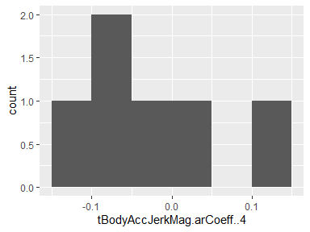

## tBodyGyroMag.mean..

|  |  |
| --- | --- |
| Feature | Result |
| Variable type | numeric |
| Number of missing obs. | 0 (0 %) |
| Number of unique values | 6 |
| Median | -0.62 |
| 1st and 3rd quartiles | -0.94; -0.24 |
| Min. and max. | -0.95; -0.19 |

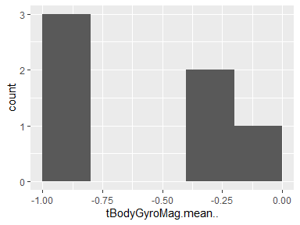

## tBodyGyroMag.std..

|  |  |
| --- | --- |
| Feature | Result |
| Variable type | numeric |
| Number of missing obs. | 0 (0 %) |
| Number of unique values | 6 |
| Median | -0.67 |
| 1st and 3rd quartiles | -0.94; -0.42 |
| Min. and max. | -0.95; -0.31 |

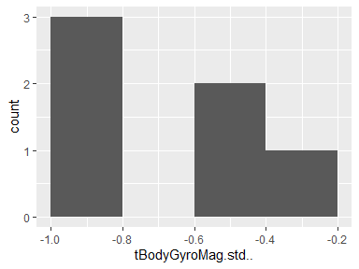

## tBodyGyroMag.mad..

|  |  |
| --- | --- |
| Feature | Result |
| Variable type | numeric |
| Number of missing obs. | 0 (0 %) |
| Number of unique values | 6 |
| Median | -0.65 |
| 1st and 3rd quartiles | -0.93; -0.36 |
| Min. and max. | -0.95; -0.24 |

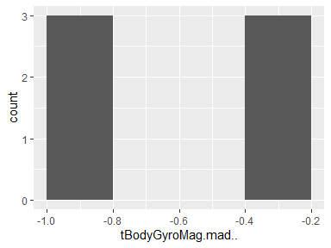

## tBodyGyroMag.max..

|  |  |
| --- | --- |
| Feature | Result |
| Variable type | numeric |
| Number of missing obs. | 0 (0 %) |
| Number of unique values | 6 |
| Median | -0.7 |
| 1st and 3rd quartiles | -0.95; -0.46 |
| Min. and max. | -0.96; -0.35 |

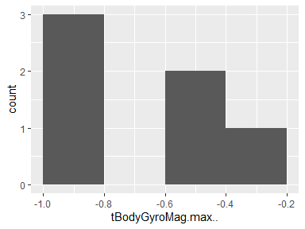

## tBodyGyroMag.min..

|  |  |
| --- | --- |
| Feature | Result |
| Variable type | numeric |
| Number of missing obs. | 0 (0 %) |
| Number of unique values | 6 |
| Median | -0.74 |
| 1st and 3rd quartiles | -0.94; -0.5 |
| Min. and max. | -0.96; -0.35 |

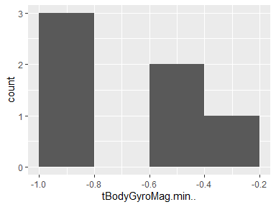

## tBodyGyroMag.sma..

|  |  |
| --- | --- |
| Feature | Result |
| Variable type | numeric |
| Number of missing obs. | 0 (0 %) |
| Number of unique values | 6 |
| Median | -0.62 |
| 1st and 3rd quartiles | -0.94; -0.24 |
| Min. and max. | -0.95; -0.19 |

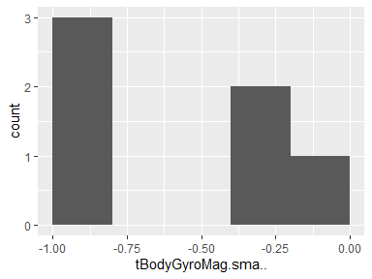

## tBodyGyroMag.energy..

|  |  |
| --- | --- |
| Feature | Result |
| Variable type | numeric |
| Number of missing obs. | 0 (0 %) |
| Number of unique values | 6 |
| Median | -0.87 |
| 1st and 3rd quartiles | -0.99; -0.69 |
| Min. and max. | -0.99; -0.64 |

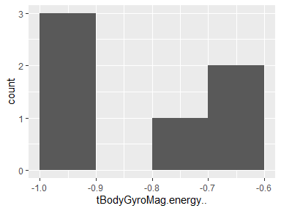

## tBodyGyroMag.iqr..

|  |  |
| --- | --- |
| Feature | Result |
| Variable type | numeric |
| Number of missing obs. | 0 (0 %) |
| Number of unique values | 6 |
| Median | -0.67 |
| 1st and 3rd quartiles | -0.94; -0.39 |
| Min. and max. | -0.95; -0.29 |

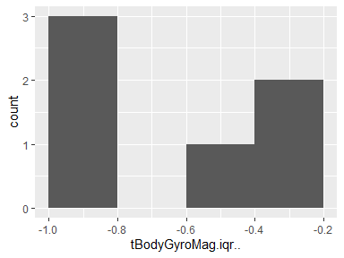

## tBodyGyroMag.entropy..

|  |  |
| --- | --- |
| Feature | Result |
| Variable type | numeric |
| Number of missing obs. | 0 (0 %) |
| Number of unique values | 6 |
| Median | 0.34 |
| 1st and 3rd quartiles | 0.03; 0.55 |
| Min. and max. | -0.06; 0.71 |

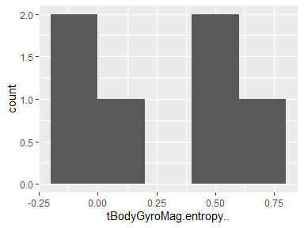

## tBodyGyroMag.arCoeff..1

|  |  |
| --- | --- |
| Feature | Result |
| Variable type | numeric |
| Number of missing obs. | 0 (0 %) |
| Number of unique values | 6 |
| Median | 0.03 |
| 1st and 3rd quartiles | -0.12; 0.09 |
| Min. and max. | -0.16; 0.11 |

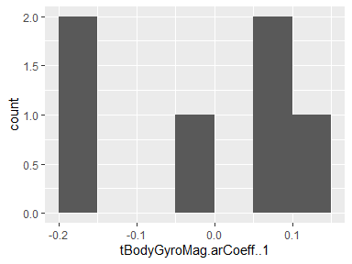

## tBodyGyroMag.arCoeff..2

|  |  |
| --- | --- |
| Feature | Result |
| Variable type | numeric |
| Number of missing obs. | 0 (0 %) |
| Number of unique values | 6 |
| Median | -0.11 |
| 1st and 3rd quartiles | -0.14; -0.01 |
| Min. and max. | -0.19; 0.06 |

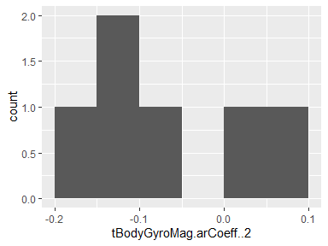

## tBodyGyroMag.arCoeff..3

|  |  |
| --- | --- |
| Feature | Result |
| Variable type | numeric |
| Number of missing obs. | 0 (0 %) |
| Number of unique values | 6 |
| Median | 0.1 |
| 1st and 3rd quartiles | 0.07; 0.15 |
| Min. and max. | 0; 0.17 |

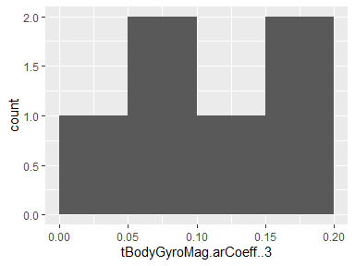

## tBodyGyroMag.arCoeff..4

|  |  |
| --- | --- |
| Feature | Result |
| Variable type | numeric |
| Number of missing obs. | 0 (0 %) |
| Number of unique values | 6 |
| Median | -0.02 |
| 1st and 3rd quartiles | -0.08; 0.01 |
| Min. and max. | -0.16; 0.02 |

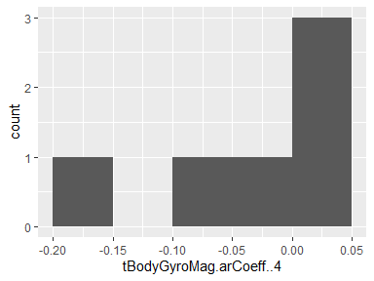

## tBodyGyroJerkMag.mean..

|  |  |
| --- | --- |
| Feature | Result |
| Variable type | numeric |
| Number of missing obs. | 0 (0 %) |
| Number of unique values | 6 |
| Median | -0.8 |
| 1st and 3rd quartiles | -0.98; -0.52 |
| Min. and max. | -0.99; -0.46 |

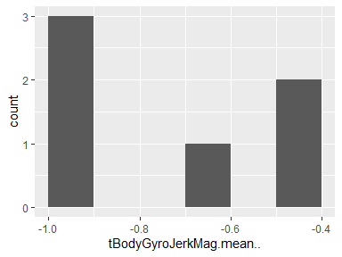

## tBodyGyroJerkMag.std..

|  |  |
| --- | --- |
| Feature | Result |
| Variable type | numeric |
| Number of missing obs. | 0 (0 %) |
| Number of unique values | 6 |
| Median | -0.82 |
| 1st and 3rd quartiles | -0.97; -0.56 |
| Min. and max. | -0.98; -0.46 |

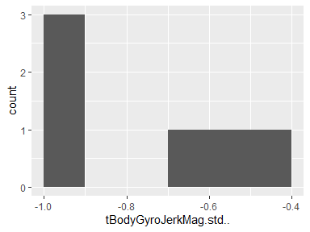

## tBodyGyroJerkMag.mad..

|  |  |
| --- | --- |
| Feature | Result |
| Variable type | numeric |
| Number of missing obs. | 0 (0 %) |
| Number of unique values | 6 |
| Median | -0.83 |
| 1st and 3rd quartiles | -0.98; -0.59 |
| Min. and max. | -0.99; -0.51 |

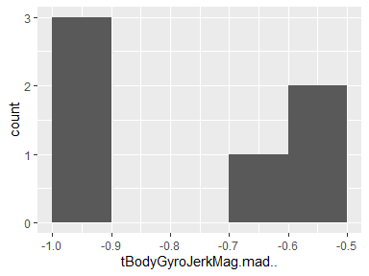

## tBodyGyroJerkMag.max..

|  |  |
| --- | --- |
| Feature | Result |
| Variable type | numeric |
| Number of missing obs. | 0 (0 %) |
| Number of unique values | 6 |
| Median | -0.82 |
| 1st and 3rd quartiles | -0.97; -0.58 |
| Min. and max. | -0.98; -0.47 |

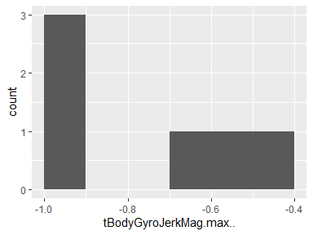

## tBodyGyroJerkMag.min..

|  |  |
| --- | --- |
| Feature | Result |
| Variable type | numeric |
| Number of missing obs. | 0 (0 %) |
| Number of unique values | 6 |
| Median | -0.82 |
| 1st and 3rd quartiles | -0.98; -0.6 |
| Min. and max. | -0.99; -0.56 |

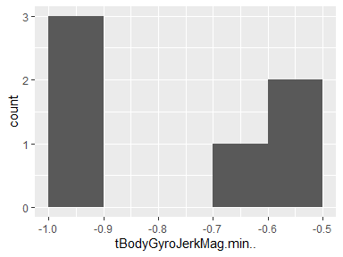

## tBodyGyroJerkMag.sma..

|  |  |
| --- | --- |
| Feature | Result |
| Variable type | numeric |
| Number of missing obs. | 0 (0 %) |
| Number of unique values | 6 |
| Median | -0.8 |
| 1st and 3rd quartiles | -0.98; -0.52 |
| Min. and max. | -0.99; -0.46 |

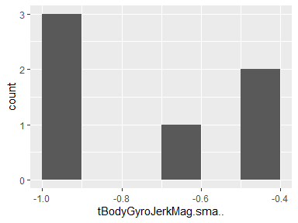

## tBodyGyroJerkMag.energy..

|  |  |
| --- | --- |
| Feature | Result |
| Variable type | numeric |
| Number of missing obs. | 0 (0 %) |
| Number of unique values | 6 |
| Median | -0.96 |
| 1st and 3rd quartiles | -1; -0.87 |
| Min. and max. | -1; -0.83 |

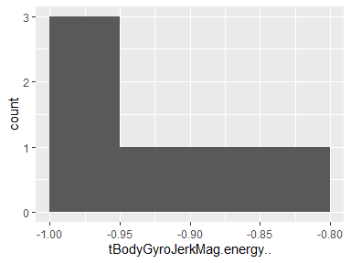

## tBodyGyroJerkMag.iqr..

|  |  |
| --- | --- |
| Feature | Result |
| Variable type | numeric |
| Number of missing obs. | 0 (0 %) |
| Number of unique values | 6 |
| Median | -0.84 |
| 1st and 3rd quartiles | -0.98; -0.61 |
| Min. and max. | -0.99; -0.56 |

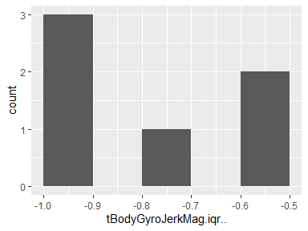

## tBodyGyroJerkMag.entropy..

|  |  |
| --- | --- |
| Feature | Result |
| Variable type | numeric |
| Number of missing obs. | 0 (0 %) |
| Number of unique values | 6 |
| Median | 0.24 |
| 1st and 3rd quartiles | -0.36; 0.84 |
| Min. and max. | -0.51; 0.85 |

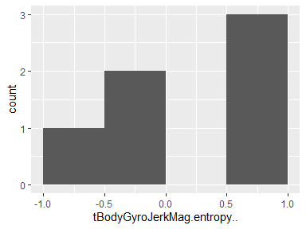

## tBodyGyroJerkMag.arCoeff..1

|  |  |
| --- | --- |
| Feature | Result |
| Variable type | numeric |
| Number of missing obs. | 0 (0 %) |
| Number of unique values | 6 |
| Median | 0.28 |
| 1st and 3rd quartiles | 0.24; 0.36 |
| Min. and max. | 0.2; 0.43 |

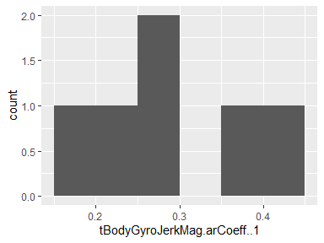

## tBodyGyroJerkMag.arCoeff..2

|  |  |
| --- | --- |
| Feature | Result |
| Variable type | numeric |
| Number of missing obs. | 0 (0 %) |
| Number of unique values | 6 |
| Median | -0.24 |
| 1st and 3rd quartiles | -0.28; -0.18 |
| Min. and max. | -0.35; -0.14 |

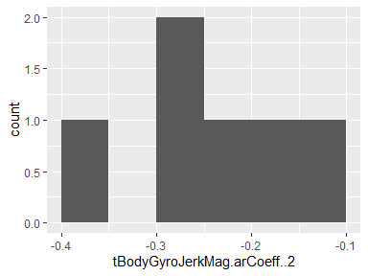

## tBodyGyroJerkMag.arCoeff..3

|  |  |
| --- | --- |
| Feature | Result |
| Variable type | numeric |
| Number of missing obs. | 0 (0 %) |
| Number of unique values | 6 |
| Median | -0.07 |
| 1st and 3rd quartiles | -0.09; -0.05 |
| Min. and max. | -0.16; -0.03 |

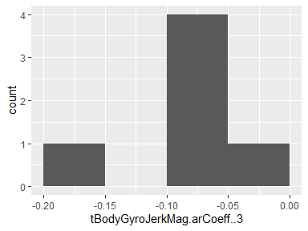

## tBodyGyroJerkMag.arCoeff..4

|  |  |
| --- | --- |
| Feature | Result |
| Variable type | numeric |
| Number of missing obs. | 0 (0 %) |
| Number of unique values | 6 |
| Median | -0.08 |
| 1st and 3rd quartiles | -0.14; -0.02 |
| Min. and max. | -0.17; 0 |

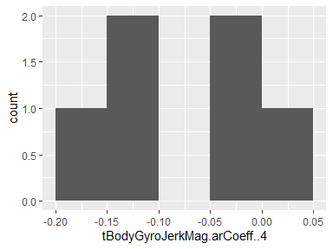

## fBodyAcc.mean…X

|  |  |
| --- | --- |
| Feature | Result |
| Variable type | numeric |
| Number of missing obs. | 0 (0 %) |
| Number of unique values | 6 |
| Median | -0.64 |
| 1st and 3rd quartiles | -0.98; -0.3 |
| Min. and max. | -0.98; -0.05 |

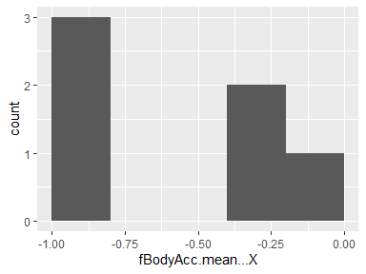

## fBodyAcc.mean…Y

|  |  |
| --- | --- |
| Feature | Result |
| Variable type | numeric |
| Number of missing obs. | 0 (0 %) |
| Number of unique values | 6 |
| Median | -0.55 |
| 1st and 3rd quartiles | -0.94; -0.08 |
| Min. and max. | -0.96; 0.02 |

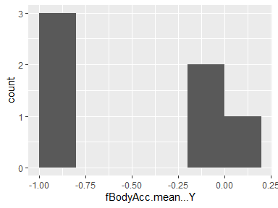

## fBodyAcc.mean…Z

|  |  |
| --- | --- |
| Feature | Result |
| Variable type | numeric |
| Number of missing obs. | 0 (0 %) |
| Number of unique values | 6 |
| Median | -0.68 |
| 1st and 3rd quartiles | -0.96; -0.4 |
| Min. and max. | -0.97; -0.26 |

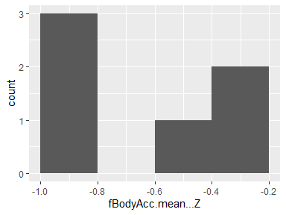

## fBodyAcc.std…X

|  |  |
| --- | --- |
| Feature | Result |
| Variable type | numeric |
| Number of missing obs. | 0 (0 %) |
| Number of unique values | 6 |
| Median | -0.65 |
| 1st and 3rd quartiles | -0.98; -0.28 |
| Min. and max. | -0.98; 0.03 |

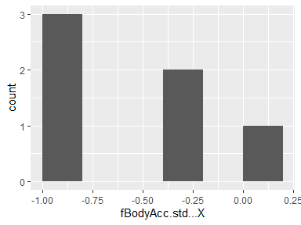

## fBodyAcc.std…Y

|  |  |
| --- | --- |
| Feature | Result |
| Variable type | numeric |
| Number of missing obs. | 0 (0 %) |
| Number of unique values | 6 |
| Median | -0.5 |
| 1st and 3rd quartiles | -0.93; -0.07 |
| Min. and max. | -0.96; -0.05 |

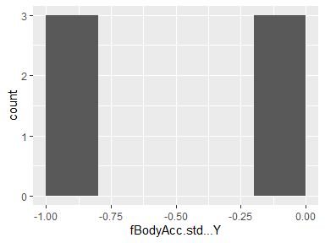

## fBodyAcc.std…Z

|  |  |
| --- | --- |
| Feature | Result |
| Variable type | numeric |
| Number of missing obs. | 0 (0 %) |
| Number of unique values | 6 |
| Median | -0.65 |
| 1st and 3rd quartiles | -0.93; -0.31 |
| Min. and max. | -0.96; -0.24 |

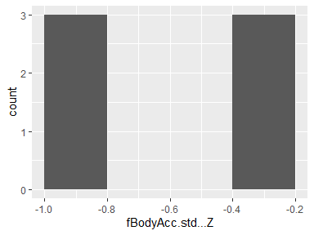

## fBodyAcc.mad…X

|  |  |
| --- | --- |
| Feature | Result |
| Variable type | numeric |
| Number of missing obs. | 0 (0 %) |
| Number of unique values | 6 |
| Median | -0.61 |
| 1st and 3rd quartiles | -0.98; -0.24 |
| Min. and max. | -0.98; 0.04 |

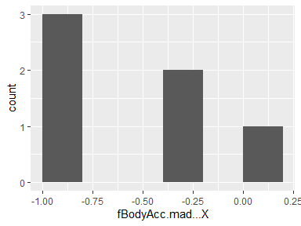

## fBodyAcc.mad…Y

|  |  |
| --- | --- |
| Feature | Result |
| Variable type | numeric |
| Number of missing obs. | 0 (0 %) |
| Number of unique values | 6 |
| Median | -0.52 |
| 1st and 3rd quartiles | -0.94; -0.06 |
| Min. and max. | -0.96; 0.03 |

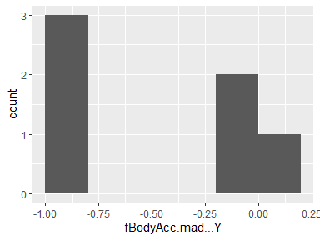

## fBodyAcc.mad…Z

|  |  |
| --- | --- |
| Feature | Result |
| Variable type | numeric |
| Number of missing obs. | 0 (0 %) |
| Number of unique values | 6 |
| Median | -0.65 |
| 1st and 3rd quartiles | -0.95; -0.32 |
| Min. and max. | -0.97; -0.23 |

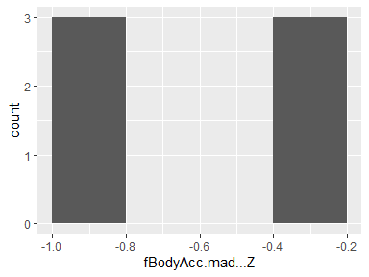

## fBodyAcc.max…X

|  |  |
| --- | --- |
| Feature | Result |
| Variable type | numeric |
| Number of missing obs. | 0 (0 %) |
| Number of unique values | 6 |
| Median | -0.71 |
| 1st and 3rd quartiles | -0.98; -0.38 |
| Min. and max. | -0.99; -0.07 |

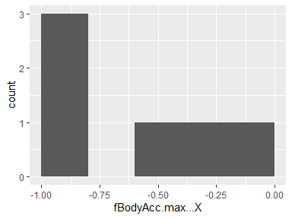

## fBodyAcc.max…Y

|  |  |
| --- | --- |
| Feature | Result |
| Variable type | numeric |
| Number of missing obs. | 0 (0 %) |
| Number of unique values | 6 |
| Median | -0.66 |
| 1st and 3rd quartiles | -0.93; -0.36 |
| Min. and max. | -0.96; -0.26 |

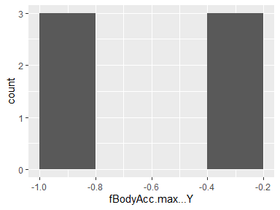

## fBodyAcc.max…Z

|  |  |
| --- | --- |
| Feature | Result |
| Variable type | numeric |
| Number of missing obs. | 0 (0 %) |
| Number of unique values | 6 |
| Median | -0.66 |
| 1st and 3rd quartiles | -0.92; -0.4 |
| Min. and max. | -0.96; -0.25 |

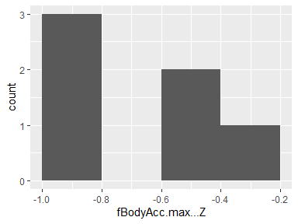

## fBodyAcc.min…X

|  |  |
| --- | --- |
| Feature | Result |
| Variable type | numeric |
| Number of missing obs. | 0 (0 %) |
| Number of unique values | 6 |
| Median | -0.87 |
| 1st and 3rd quartiles | -0.98; -0.75 |
| Min. and max. | -0.99; -0.69 |

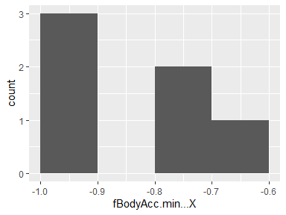

## fBodyAcc.min…Y

|  |  |
| --- | --- |
| Feature | Result |
| Variable type | numeric |
| Number of missing obs. | 0 (0 %) |
| Number of unique values | 6 |
| Median | -0.89 |
| 1st and 3rd quartiles | -0.97; -0.78 |
| Min. and max. | -0.98; -0.75 |

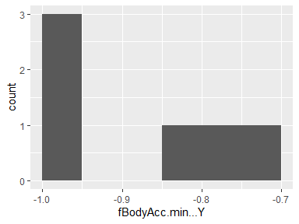

## fBodyAcc.min…Z

|  |  |
| --- | --- |
| Feature | Result |
| Variable type | numeric |
| Number of missing obs. | 0 (0 %) |
| Number of unique values | 6 |
| Median | -0.92 |
| 1st and 3rd quartiles | -0.98; -0.85 |
| Min. and max. | -0.99; -0.83 |

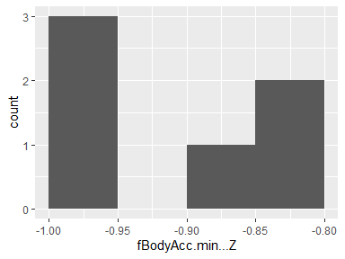

## fBodyAcc.sma..

|  |  |
| --- | --- |
| Feature | Result |
| Variable type | numeric |
| Number of missing obs. | 0 (0 %) |
| Number of unique values | 6 |
| Median | -0.57 |
| 1st and 3rd quartiles | -0.96; -0.16 |
| Min. and max. | -0.97; 0.04 |

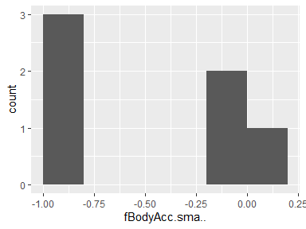

## fBodyAcc.energy…X

|  |  |
| --- | --- |
| Feature | Result |
| Variable type | numeric |
| Number of missing obs. | 0 (0 %) |
| Number of unique values | 6 |
| Median | -0.88 |
| 1st and 3rd quartiles | -1; -0.74 |
| Min. and max. | -1; -0.47 |

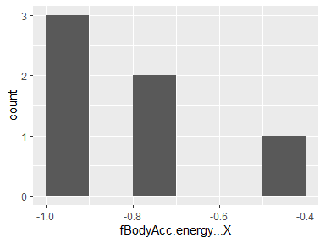

## fBodyAcc.energy…Y

|  |  |
| --- | --- |
| Feature | Result |
| Variable type | numeric |
| Number of missing obs. | 0 (0 %) |
| Number of unique values | 6 |
| Median | -0.76 |
| 1st and 3rd quartiles | -0.99; -0.5 |
| Min. and max. | -1; -0.43 |

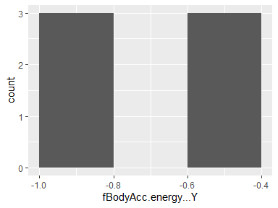

## fBodyAcc.energy…Z

|  |  |
| --- | --- |
| Feature | Result |
| Variable type | numeric |
| Number of missing obs. | 0 (0 %) |
| Number of unique values | 6 |
| Median | -0.87 |
| 1st and 3rd quartiles | -0.99; -0.72 |
| Min. and max. | -1; -0.68 |

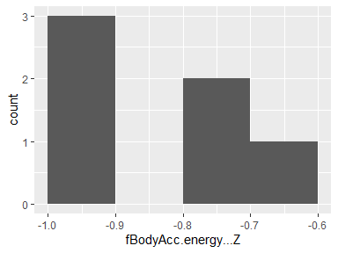

## fBodyAcc.iqr…X

|  |  |
| --- | --- |
| Feature | Result |
| Variable type | numeric |
| Number of missing obs. | 0 (0 %) |
| Number of unique values | 6 |
| Median | -0.68 |
| 1st and 3rd quartiles | -0.97; -0.32 |
| Min. and max. | -0.98; -0.11 |

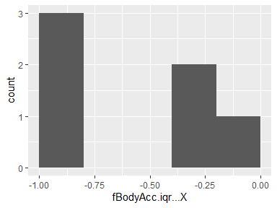

## fBodyAcc.iqr…Y

|  |  |
| --- | --- |
| Feature | Result |
| Variable type | numeric |
| Number of missing obs. | 0 (0 %) |
| Number of unique values | 6 |
| Median | -0.69 |
| 1st and 3rd quartiles | -0.97; -0.28 |
| Min. and max. | -0.97; -0.16 |

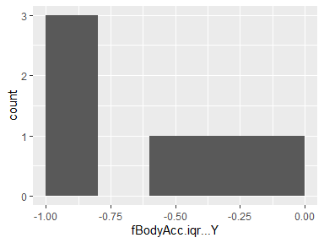

## fBodyAcc.iqr…Z

|  |  |
| --- | --- |
| Feature | Result |
| Variable type | numeric |
| Number of missing obs. | 0 (0 %) |
| Number of unique values | 6 |
| Median | -0.78 |
| 1st and 3rd quartiles | -0.97; -0.54 |
| Min. and max. | -0.97; -0.36 |

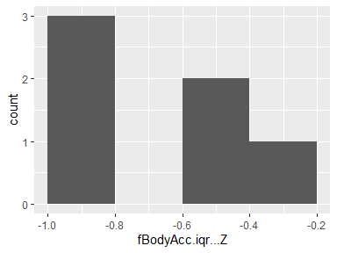

## fBodyAcc.entropy…X

|  |  |
| --- | --- |
| Feature | Result |
| Variable type | numeric |
| Number of missing obs. | 0 (0 %) |
| Number of unique values | 6 |
| Median | -0.15 |
| 1st and 3rd quartiles | -0.82; 0.54 |
| Min. and max. | -0.87; 0.65 |

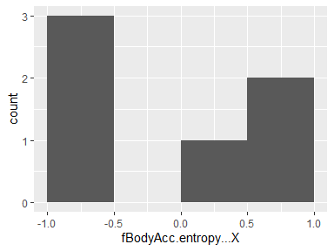

## fBodyAcc.entropy…Y

|  |  |
| --- | --- |
| Feature | Result |
| Variable type | numeric |
| Number of missing obs. | 0 (0 %) |
| Number of unique values | 6 |
| Median | -0.12 |
| 1st and 3rd quartiles | -0.73; 0.5 |
| Min. and max. | -0.83; 0.56 |

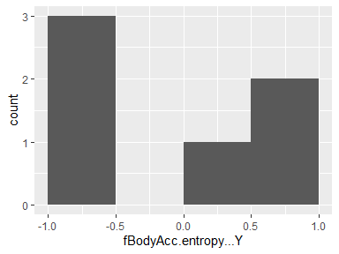

## fBodyAcc.entropy…Z

|  |  |
| --- | --- |
| Feature | Result |
| Variable type | numeric |
| Number of missing obs. | 0 (0 %) |
| Number of unique values | 6 |
| Median | -0.18 |
| 1st and 3rd quartiles | -0.71; 0.39 |
| Min. and max. | -0.78; 0.51 |

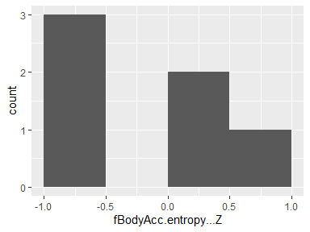

## fBodyAcc.maxInds.X

|  |  |
| --- | --- |
| Feature | Result |
| Variable type | numeric |
| Number of missing obs. | 0 (0 %) |
| Number of unique values | 6 |
| Median | -0.76 |
| 1st and 3rd quartiles | -0.78; -0.7 |
| Min. and max. | -0.87; -0.6 |

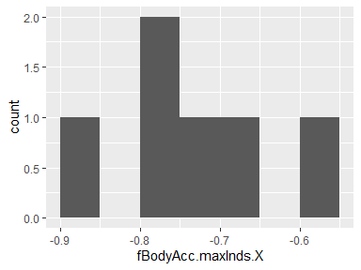

## fBodyAcc.maxInds.Y

|  |  |
| --- | --- |
| Feature | Result |
| Variable type | numeric |
| Number of missing obs. | 0 (0 %) |
| Number of unique values | 6 |
| Median | -0.79 |
| 1st and 3rd quartiles | -0.87; -0.72 |
| Min. and max. | -0.93; -0.68 |

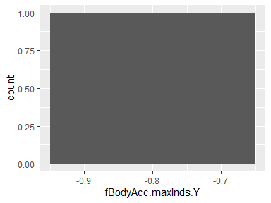

## fBodyAcc.maxInds.Z

|  |  |
| --- | --- |
| Feature | Result |
| Variable type | numeric |
| Number of missing obs. | 0 (0 %) |
| Number of unique values | 6 |
| Median | -0.85 |
| 1st and 3rd quartiles | -0.9; -0.78 |
| Min. and max. | -0.95; -0.71 |

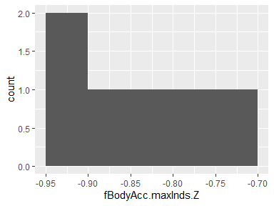

## fBodyAcc.meanFreq…X

|  |  |
| --- | --- |
| Feature | Result |
| Variable type | numeric |
| Number of missing obs. | 0 (0 %) |
| Number of unique values | 6 |
| Median | -0.25 |
| 1st and 3rd quartiles | -0.36; -0.07 |
| Min. and max. | -0.43; 0.04 |

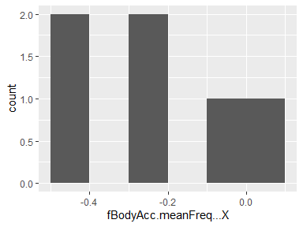

## fBodyAcc.meanFreq…Y

|  |  |
| --- | --- |
| Feature | Result |
| Variable type | numeric |
| Number of missing obs. | 0 (0 %) |
| Number of unique values | 6 |
| Median | 0.03 |
| 1st and 3rd quartiles | -0.03; 0.06 |
| Min. and max. | -0.16; 0.19 |

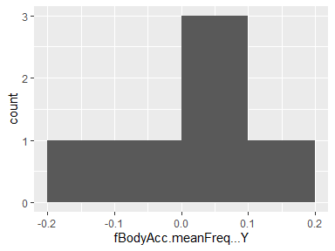

## fBodyAcc.meanFreq…Z

|  |  |
| --- | --- |
| Feature | Result |
| Variable type | numeric |
| Number of missing obs. | 0 (0 %) |
| Number of unique values | 6 |
| Median | 0.08 |
| 1st and 3rd quartiles | 0.04; 0.09 |
| Min. and max. | -0.23; 0.24 |

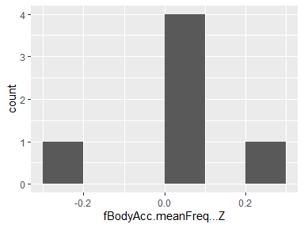

## fBodyAcc.skewness…X

|  |  |
| --- | --- |
| Feature | Result |
| Variable type | numeric |
| Number of missing obs. | 0 (0 %) |
| Number of unique values | 6 |
| Median | -0.05 |
| 1st and 3rd quartiles | -0.33; 0.04 |
| Min. and max. | -0.5; 0.07 |

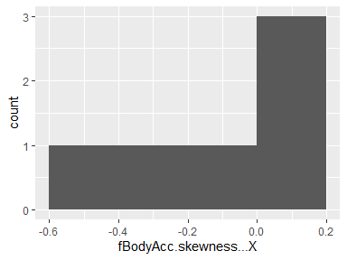

## fBodyAcc.kurtosis…X

|  |  |
| --- | --- |
| Feature | Result |
| Variable type | numeric |
| Number of missing obs. | 0 (0 %) |
| Number of unique values | 6 |
| Median | -0.41 |
| 1st and 3rd quartiles | -0.66; -0.28 |
| Min. and max. | -0.81; -0.25 |

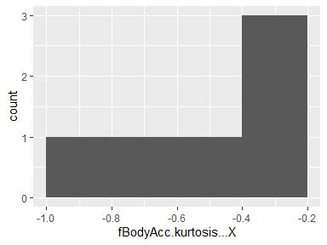

## fBodyAcc.skewness…Y

|  |  |
| --- | --- |
| Feature | Result |
| Variable type | numeric |
| Number of missing obs. | 0 (0 %) |
| Number of unique values | 6 |
| Median | -0.27 |
| 1st and 3rd quartiles | -0.37; -0.18 |
| Min. and max. | -0.47; -0.13 |

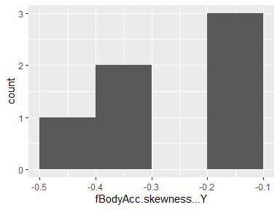

## fBodyAcc.kurtosis…Y

|  |  |
| --- | --- |
| Feature | Result |
| Variable type | numeric |
| Number of missing obs. | 0 (0 %) |
| Number of unique values | 6 |
| Median | -0.57 |
| 1st and 3rd quartiles | -0.69; -0.5 |
| Min. and max. | -0.8; -0.45 |

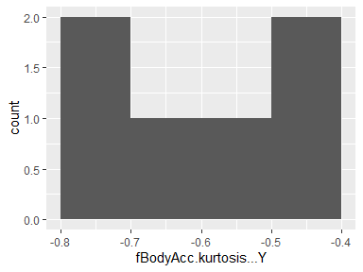

## fBodyAcc.skewness…Z

|  |  |
| --- | --- |
| Feature | Result |
| Variable type | numeric |
| Number of missing obs. | 0 (0 %) |
| Number of unique values | 6 |
| Median | -0.26 |
| 1st and 3rd quartiles | -0.34; -0.13 |
| Min. and max. | -0.48; -0.05 |

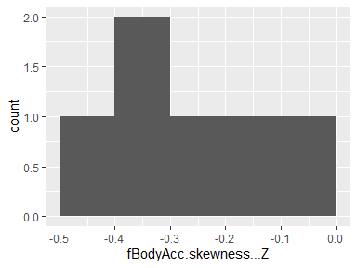

## fBodyAcc.kurtosis…Z

|  |  |
| --- | --- |
| Feature | Result |
| Variable type | numeric |
| Number of missing obs. | 0 (0 %) |
| Number of unique values | 6 |
| Median | -0.5 |
| 1st and 3rd quartiles | -0.58; -0.4 |
| Min. and max. | -0.71; -0.27 |

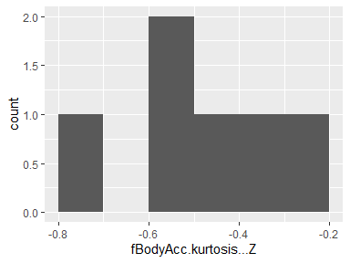

## fBodyAcc.bandsEnergy…1.8

|  |  |
| --- | --- |
| Feature | Result |
| Variable type | numeric |
| Number of missing obs. | 0 (0 %) |
| Number of unique values | 6 |
| Median | -0.9 |
| 1st and 3rd quartiles | -1; -0.74 |
| Min. and max. | -1; -0.43 |

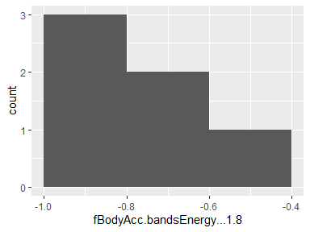

## fBodyAcc.bandsEnergy…9.16

|  |  |
| --- | --- |
| Feature | Result |
| Variable type | numeric |
| Number of missing obs. | 0 (0 %) |
| Number of unique values | 6 |
| Median | -0.9 |
| 1st and 3rd quartiles | -1; -0.77 |
| Min. and max. | -1; -0.69 |

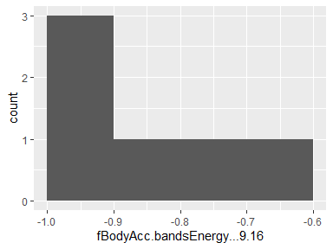

## fBodyAcc.bandsEnergy…17.24

|  |  |
| --- | --- |
| Feature | Result |
| Variable type | numeric |
| Number of missing obs. | 0 (0 %) |
| Number of unique values | 6 |
| Median | -0.91 |
| 1st and 3rd quartiles | -1; -0.69 |
| Min. and max. | -1; -0.62 |

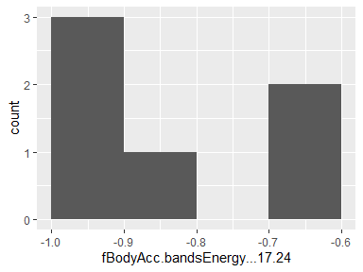

## fBodyAcc.bandsEnergy…25.32

|  |  |
| --- | --- |
| Feature | Result |
| Variable type | numeric |
| Number of missing obs. | 0 (0 %) |
| Number of unique values | 6 |
| Median | -0.93 |
| 1st and 3rd quartiles | -1; -0.79 |
| Min. and max. | -1; -0.65 |

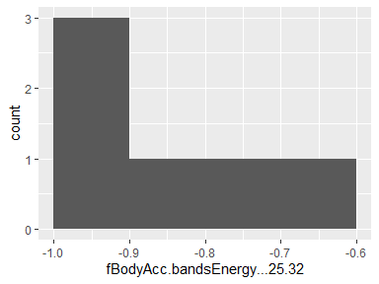

## fBodyAcc.bandsEnergy…33.40

|  |  |
| --- | --- |
| Feature | Result |
| Variable type | numeric |
| Number of missing obs. | 0 (0 %) |
| Number of unique values | 6 |
| Median | -0.94 |
| 1st and 3rd quartiles | -1; -0.86 |
| Min. and max. | -1; -0.74 |

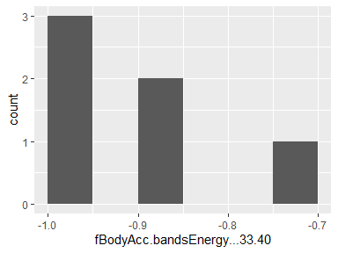

## fBodyAcc.bandsEnergy…41.48

|  |  |
| --- | --- |
| Feature | Result |
| Variable type | numeric |
| Number of missing obs. | 0 (0 %) |
| Number of unique values | 6 |
| Median | -0.94 |
| 1st and 3rd quartiles | -1; -0.86 |
| Min. and max. | -1; -0.75 |

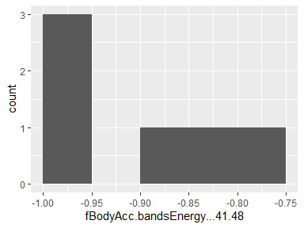

## fBodyAcc.bandsEnergy…49.56

|  |  |
| --- | --- |
| Feature | Result |
| Variable type | numeric |
| Number of missing obs. | 0 (0 %) |
| Number of unique values | 6 |
| Median | -0.96 |
| 1st and 3rd quartiles | -1; -0.91 |
| Min. and max. | -1; -0.86 |

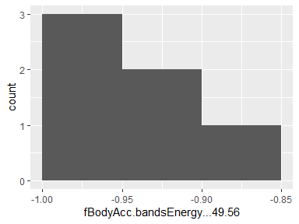

## fBodyAcc.bandsEnergy…57.64

|  |  |
| --- | --- |
| Feature | Result |
| Variable type | numeric |
| Number of missing obs. | 0 (0 %) |
| Number of unique values | 6 |
| Median | -0.97 |
| 1st and 3rd quartiles | -1; -0.93 |
| Min. and max. | -1; -0.89 |

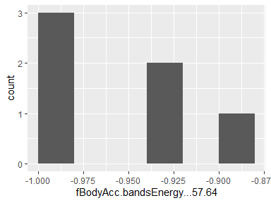

## fBodyAcc.bandsEnergy…1.16

|  |  |
| --- | --- |
| Feature | Result |
| Variable type | numeric |
| Number of missing obs. | 0 (0 %) |
| Number of unique values | 6 |
| Median | -0.88 |
| 1st and 3rd quartiles | -1; -0.73 |
| Min. and max. | -1; -0.45 |

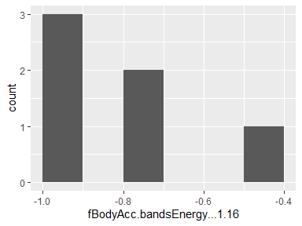

## fBodyAcc.bandsEnergy…17.32

|  |  |
| --- | --- |
| Feature | Result |
| Variable type | numeric |
| Number of missing obs. | 0 (0 %) |
| Number of unique values | 6 |
| Median | -0.9 |
| 1st and 3rd quartiles | -1; -0.67 |
| Min. and max. | -1; -0.57 |

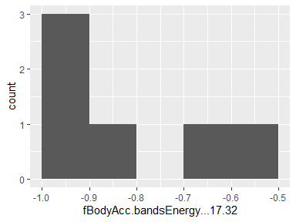

## fBodyAcc.bandsEnergy…33.48

|  |  |
| --- | --- |
| Feature | Result |
| Variable type | numeric |
| Number of missing obs. | 0 (0 %) |
| Number of unique values | 6 |
| Median | -0.94 |
| 1st and 3rd quartiles | -1; -0.86 |
| Min. and max. | -1; -0.74 |

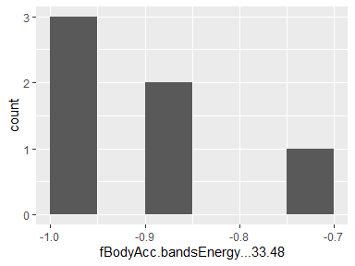

## fBodyAcc.bandsEnergy…49.64

|  |  |
| --- | --- |
| Feature | Result |
| Variable type | numeric |
| Number of missing obs. | 0 (0 %) |
| Number of unique values | 6 |
| Median | -0.96 |
| 1st and 3rd quartiles | -1; -0.92 |
| Min. and max. | -1; -0.87 |

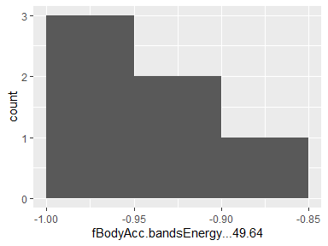

## fBodyAcc.bandsEnergy…1.24

|  |  |
| --- | --- |
| Feature | Result |
| Variable type | numeric |
| Number of missing obs. | 0 (0 %) |
| Number of unique values | 6 |
| Median | -0.88 |
| 1st and 3rd quartiles | -1; -0.73 |
| Min. and max. | -1; -0.46 |

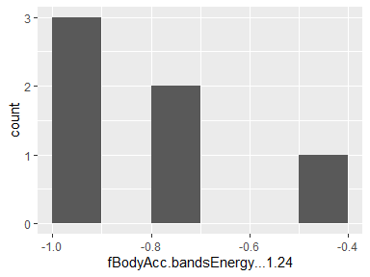

## fBodyAcc.bandsEnergy…25.48

|  |  |
| --- | --- |
| Feature | Result |
| Variable type | numeric |
| Number of missing obs. | 0 (0 %) |
| Number of unique values | 6 |
| Median | -0.92 |
| 1st and 3rd quartiles | -1; -0.78 |
| Min. and max. | -1; -0.63 |

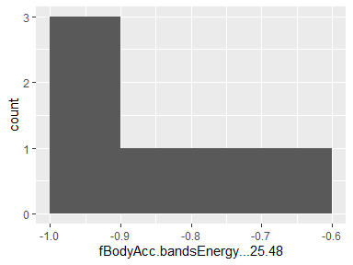

## fBodyAcc.bandsEnergy…1.8.1

|  |  |
| --- | --- |
| Feature | Result |
| Variable type | numeric |
| Number of missing obs. | 0 (0 %) |
| Number of unique values | 6 |
| Median | -0.81 |
| 1st and 3rd quartiles | -0.99; -0.57 |
| Min. and max. | -1; -0.5 |

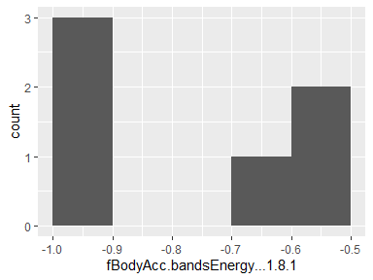

## fBodyAcc.bandsEnergy…9.16.1

|  |  |
| --- | --- |
| Feature | Result |
| Variable type | numeric |
| Number of missing obs. | 0 (0 %) |
| Number of unique values | 6 |
| Median | -0.9 |
| 1st and 3rd quartiles | -1; -0.69 |
| Min. and max. | -1; -0.6 |

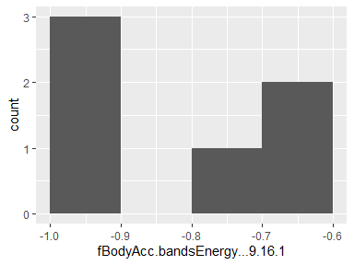

## fBodyAcc.bandsEnergy…17.24.1

|  |  |
| --- | --- |
| Feature | Result |
| Variable type | numeric |
| Number of missing obs. | 0 (0 %) |
| Number of unique values | 6 |
| Median | -0.92 |
| 1st and 3rd quartiles | -1; -0.7 |
| Min. and max. | -1; -0.6 |

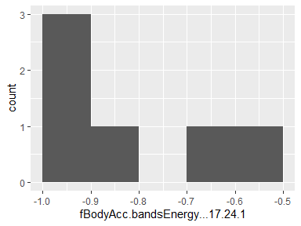

## fBodyAcc.bandsEnergy…25.32.1

|  |  |
| --- | --- |
| Feature | Result |
| Variable type | numeric |
| Number of missing obs. | 0 (0 %) |
| Number of unique values | 6 |
| Median | -0.93 |
| 1st and 3rd quartiles | -1; -0.79 |
| Min. and max. | -1; -0.7 |

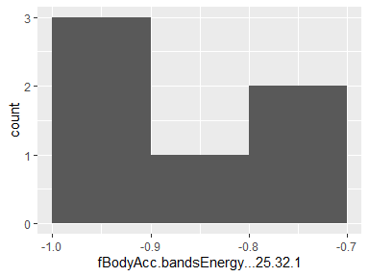

## fBodyAcc.bandsEnergy…33.40.1

|  |  |
| --- | --- |
| Feature | Result |
| Variable type | numeric |
| Number of missing obs. | 0 (0 %) |
| Number of unique values | 6 |
| Median | -0.93 |
| 1st and 3rd quartiles | -1; -0.8 |
| Min. and max. | -1; -0.71 |

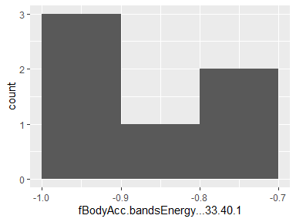

## fBodyAcc.bandsEnergy…41.48.1

|  |  |
| --- | --- |
| Feature | Result |
| Variable type | numeric |
| Number of missing obs. | 0 (0 %) |
| Number of unique values | 6 |
| Median | -0.91 |
| 1st and 3rd quartiles | -1; -0.76 |
| Min. and max. | -1; -0.7 |

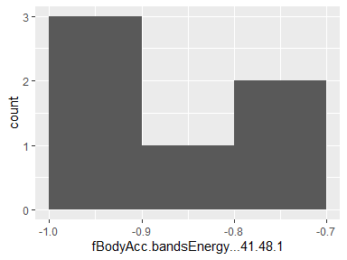

## fBodyAcc.bandsEnergy…49.56.1

|  |  |
| --- | --- |
| Feature | Result |
| Variable type | numeric |
| Number of missing obs. | 0 (0 %) |
| Number of unique values | 6 |
| Median | -0.93 |
| 1st and 3rd quartiles | -1; -0.8 |
| Min. and max. | -1; -0.76 |

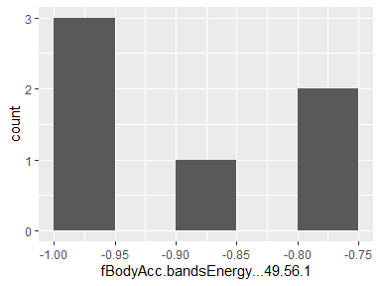

## fBodyAcc.bandsEnergy…57.64.1

|  |  |
| --- | --- |
| Feature | Result |
| Variable type | numeric |
| Number of missing obs. | 0 (0 %) |
| Number of unique values | 6 |
| Median | -0.95 |
| 1st and 3rd quartiles | -1; -0.9 |
| Min. and max. | -1; -0.88 |

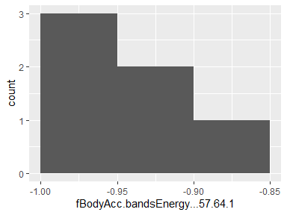

## fBodyAcc.bandsEnergy…1.16.1

|  |  |
| --- | --- |
| Feature | Result |
| Variable type | numeric |
| Number of missing obs. | 0 (0 %) |
| Number of unique values | 6 |
| Median | -0.76 |
| 1st and 3rd quartiles | -0.99; -0.52 |
| Min. and max. | -1; -0.45 |

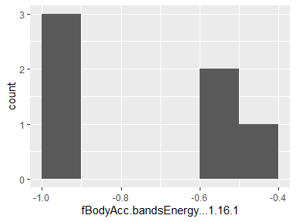

## fBodyAcc.bandsEnergy…17.32.1

|  |  |
| --- | --- |
| Feature | Result |
| Variable type | numeric |
| Number of missing obs. | 0 (0 %) |
| Number of unique values | 6 |
| Median | -0.91 |
| 1st and 3rd quartiles | -1; -0.64 |
| Min. and max. | -1; -0.53 |

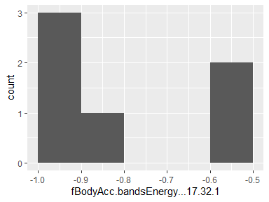

## fBodyAcc.bandsEnergy…33.48.1

|  |  |
| --- | --- |
| Feature | Result |
| Variable type | numeric |
| Number of missing obs. | 0 (0 %) |
| Number of unique values | 6 |
| Median | -0.91 |
| 1st and 3rd quartiles | -1; -0.76 |
| Min. and max. | -1; -0.68 |

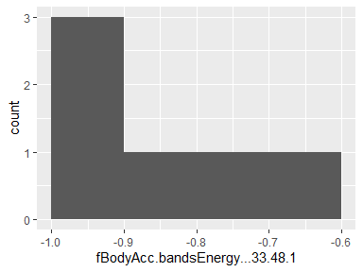

## fBodyAcc.bandsEnergy…49.64.1

|  |  |
| --- | --- |
| Feature | Result |
| Variable type | numeric |
| Number of missing obs. | 0 (0 %) |
| Number of unique values | 6 |
| Median | -0.94 |
| 1st and 3rd quartiles | -1; -0.84 |
| Min. and max. | -1; -0.8 |

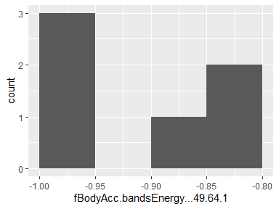

## fBodyAcc.bandsEnergy…1.24.1

|  |  |
| --- | --- |
| Feature | Result |
| Variable type | numeric |
| Number of missing obs. | 0 (0 %) |
| Number of unique values | 6 |
| Median | -0.76 |
| 1st and 3rd quartiles | -0.99; -0.51 |
| Min. and max. | -1; -0.44 |

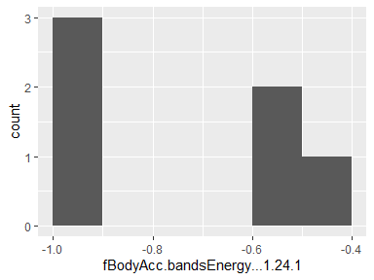

## fBodyAcc.bandsEnergy…25.48.1

|  |  |
| --- | --- |
| Feature | Result |
| Variable type | numeric |
| Number of missing obs. | 0 (0 %) |
| Number of unique values | 6 |
| Median | -0.92 |
| 1st and 3rd quartiles | -1; -0.75 |
| Min. and max. | -1; -0.7 |

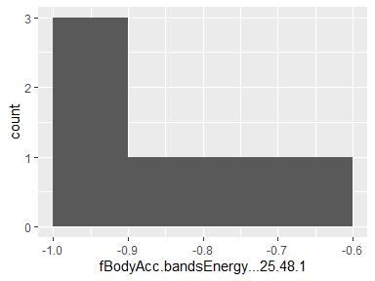

## fBodyAcc.bandsEnergy…1.8.2

|  |  |
| --- | --- |
| Feature | Result |
| Variable type | numeric |
| Number of missing obs. | 0 (0 %) |
| Number of unique values | 6 |
| Median | -0.9 |
| 1st and 3rd quartiles | -0.99; -0.78 |
| Min. and max. | -1; -0.69 |

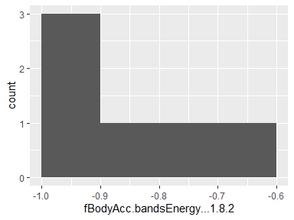

## fBodyAcc.bandsEnergy…9.16.2

|  |  |
| --- | --- |
| Feature | Result |
| Variable type | numeric |
| Number of missing obs. | 0 (0 %) |
| Number of unique values | 6 |
| Median | -0.93 |
| 1st and 3rd quartiles | -1; -0.85 |
| Min. and max. | -1; -0.71 |

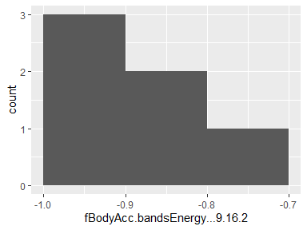

## fBodyAcc.bandsEnergy…17.24.2

|  |  |
| --- | --- |
| Feature | Result |
| Variable type | numeric |
| Number of missing obs. | 0 (0 %) |
| Number of unique values | 6 |
| Median | -0.97 |
| 1st and 3rd quartiles | -1; -0.87 |
| Min. and max. | -1; -0.8 |

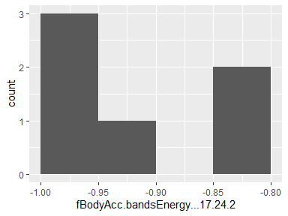

## fBodyAcc.bandsEnergy…25.32.2

|  |  |
| --- | --- |
| Feature | Result |
| Variable type | numeric |
| Number of missing obs. | 0 (0 %) |
| Number of unique values | 6 |
| Median | -0.98 |
| 1st and 3rd quartiles | -1; -0.94 |
| Min. and max. | -1; -0.89 |

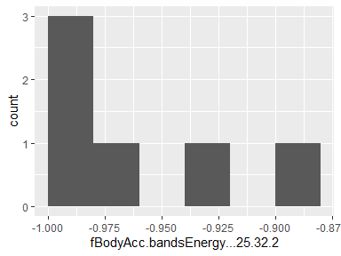

## fBodyAcc.bandsEnergy…33.40.2

|  |  |
| --- | --- |
| Feature | Result |
| Variable type | numeric |
| Number of missing obs. | 0 (0 %) |
| Number of unique values | 6 |
| Median | -0.98 |
| 1st and 3rd quartiles | -1; -0.94 |
| Min. and max. | -1; -0.91 |

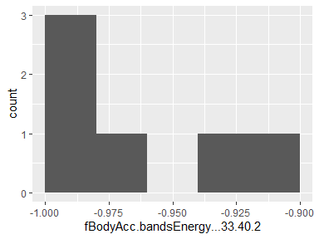

## fBodyAcc.bandsEnergy…41.48.2

|  |  |
| --- | --- |
| Feature | Result |
| Variable type | numeric |
| Number of missing obs. | 0 (0 %) |
| Number of unique values | 6 |
| Median | -0.96 |
| 1st and 3rd quartiles | -1; -0.9 |
| Min. and max. | -1; -0.84 |

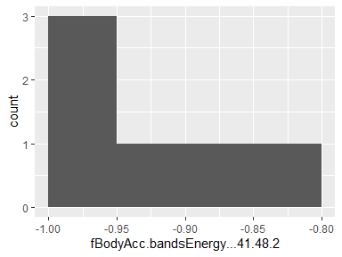

## fBodyAcc.bandsEnergy…49.56.2

|  |  |
| --- | --- |
| Feature | Result |
| Variable type | numeric |
| Number of missing obs. | 0 (0 %) |
| Number of unique values | 6 |
| Median | -0.96 |
| 1st and 3rd quartiles | -1; -0.91 |
| Min. and max. | -1; -0.85 |

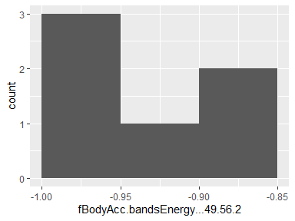

## fBodyAcc.bandsEnergy…57.64.2

|  |  |
| --- | --- |
| Feature | Result |
| Variable type | numeric |
| Number of missing obs. | 0 (0 %) |
| Number of unique values | 6 |
| Median | -0.96 |
| 1st and 3rd quartiles | -1; -0.93 |
| Min. and max. | -1; -0.91 |

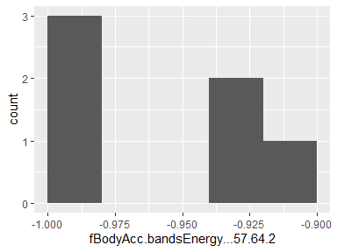

## fBodyAcc.bandsEnergy…1.16.2

|  |  |
| --- | --- |
| Feature | Result |
| Variable type | numeric |
| Number of missing obs. | 0 (0 %) |
| Number of unique values | 6 |
| Median | -0.89 |
| 1st and 3rd quartiles | -0.99; -0.74 |
| Min. and max. | -1; -0.71 |

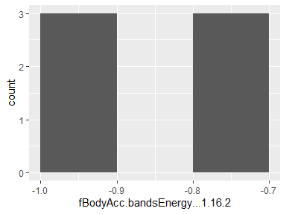

## fBodyAcc.bandsEnergy…17.32.2

|  |  |
| --- | --- |
| Feature | Result |
| Variable type | numeric |
| Number of missing obs. | 0 (0 %) |
| Number of unique values | 6 |
| Median | -0.97 |
| 1st and 3rd quartiles | -1; -0.89 |
| Min. and max. | -1; -0.84 |

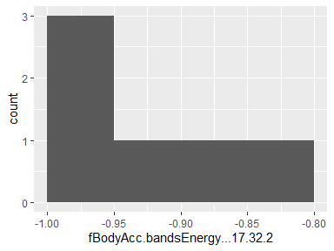

## fBodyAcc.bandsEnergy…33.48.2

|  |  |
| --- | --- |
| Feature | Result |
| Variable type | numeric |
| Number of missing obs. | 0 (0 %) |
| Number of unique values | 6 |
| Median | -0.98 |
| 1st and 3rd quartiles | -1; -0.93 |
| Min. and max. | -1; -0.88 |

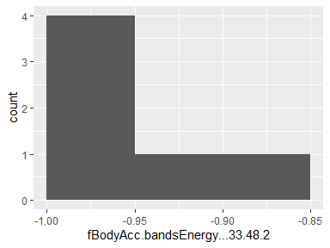

## fBodyAcc.bandsEnergy…49.64.2

|  |  |
| --- | --- |
| Feature | Result |
| Variable type | numeric |
| Number of missing obs. | 0 (0 %) |
| Number of unique values | 6 |
| Median | -0.96 |
| 1st and 3rd quartiles | -1; -0.91 |
| Min. and max. | -1; -0.87 |

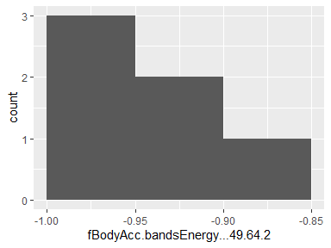

## fBodyAcc.bandsEnergy…1.24.2

|  |  |
| --- | --- |
| Feature | Result |
| Variable type | numeric |
| Number of missing obs. | 0 (0 %) |
| Number of unique values | 6 |
| Median | -0.88 |
| 1st and 3rd quartiles | -0.99; -0.72 |
| Min. and max. | -1; -0.7 |

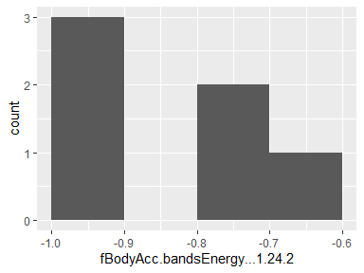

## fBodyAcc.bandsEnergy…25.48.2

|  |  |
| --- | --- |
| Feature | Result |
| Variable type | numeric |
| Number of missing obs. | 0 (0 %) |
| Number of unique values | 6 |
| Median | -0.98 |
| 1st and 3rd quartiles | -1; -0.94 |
| Min. and max. | -1; -0.89 |

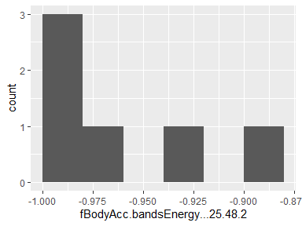

## fBodyAccJerk.mean…X

|  |  |
| --- | --- |
| Feature | Result |
| Variable type | numeric |
| Number of missing obs. | 0 (0 %) |
| Number of unique values | 6 |
| Median | -0.69 |
| 1st and 3rd quartiles | -0.98; -0.32 |
| Min. and max. | -0.98; -0.13 |

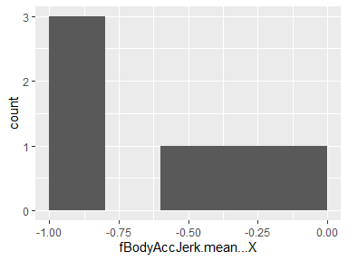

## fBodyAccJerk.mean…Y

|  |  |
| --- | --- |
| Feature | Result |
| Variable type | numeric |
| Number of missing obs. | 0 (0 %) |
| Number of unique values | 6 |
| Median | -0.67 |
| 1st and 3rd quartiles | -0.97; -0.22 |
| Min. and max. | -0.97; -0.14 |

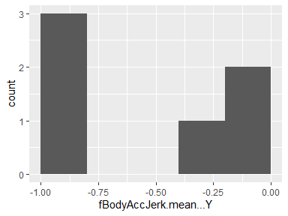

## fBodyAccJerk.mean…Z

|  |  |
| --- | --- |
| Feature | Result |
| Variable type | numeric |
| Number of missing obs. | 0 (0 %) |
| Number of unique values | 6 |
| Median | -0.79 |
| 1st and 3rd quartiles | -0.98; -0.52 |
| Min. and max. | -0.98; -0.38 |

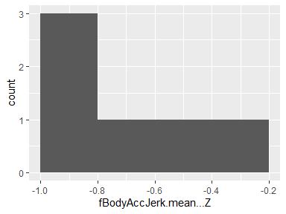

## fBodyAccJerk.std…X

|  |  |
| --- | --- |
| Feature | Result |
| Variable type | numeric |
| Number of missing obs. | 0 (0 %) |
| Number of unique values | 6 |
| Median | -0.69 |
| 1st and 3rd quartiles | -0.98; -0.28 |
| Min. and max. | -0.98; -0.14 |

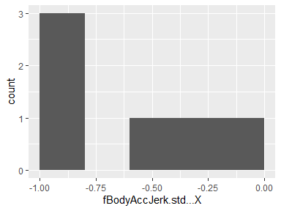

## fBodyAccJerk.std…Y

|  |  |
| --- | --- |
| Feature | Result |
| Variable type | numeric |
| Number of missing obs. | 0 (0 %) |
| Number of unique values | 6 |
| Median | -0.67 |
| 1st and 3rd quartiles | -0.97; -0.19 |
| Min. and max. | -0.97; -0.09 |

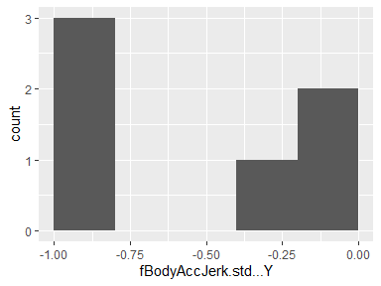

## fBodyAccJerk.std…Z

|  |  |
| --- | --- |
| Feature | Result |
| Variable type | numeric |
| Number of missing obs. | 0 (0 %) |
| Number of unique values | 6 |
| Median | -0.83 |
| 1st and 3rd quartiles | -0.98; -0.58 |
| Min. and max. | -0.98; -0.47 |

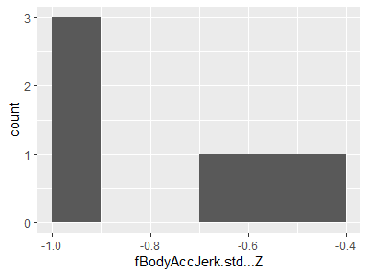

## fBodyAccJerk.mad…X

|  |  |
| --- | --- |
| Feature | Result |
| Variable type | numeric |
| Number of missing obs. | 0 (0 %) |
| Number of unique values | 6 |
| Median | -0.63 |
| 1st and 3rd quartiles | -0.98; -0.17 |
| Min. and max. | -0.98; 0.03 |

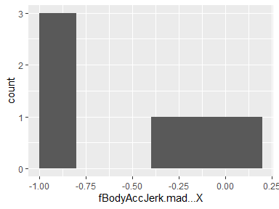

## fBodyAccJerk.mad…Y

|  |  |
| --- | --- |
| Feature | Result |
| Variable type | numeric |
| Number of missing obs. | 0 (0 %) |
| Number of unique values | 6 |
| Median | -0.68 |
| 1st and 3rd quartiles | -0.97; -0.19 |
| Min. and max. | -0.97; -0.13 |

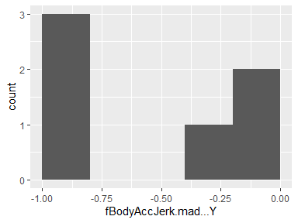

## fBodyAccJerk.mad…Z

|  |  |
| --- | --- |
| Feature | Result |
| Variable type | numeric |
| Number of missing obs. | 0 (0 %) |
| Number of unique values | 6 |
| Median | -0.81 |
| 1st and 3rd quartiles | -0.98; -0.55 |
| Min. and max. | -0.98; -0.42 |

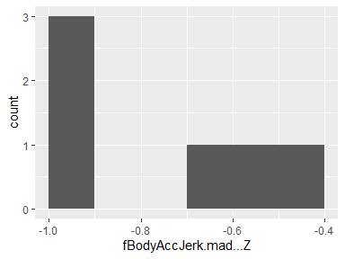

## fBodyAccJerk.max…X

|  |  |
| --- | --- |
| Feature | Result |
| Variable type | numeric |
| Number of missing obs. | 0 (0 %) |
| Number of unique values | 6 |
| Median | -0.75 |
| 1st and 3rd quartiles | -0.99; -0.39 |
| Min. and max. | -0.99; -0.29 |

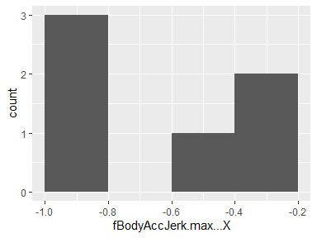

## fBodyAccJerk.max…Y

|  |  |
| --- | --- |
| Feature | Result |
| Variable type | numeric |
| Number of missing obs. | 0 (0 %) |
| Number of unique values | 6 |
| Median | -0.74 |
| 1st and 3rd quartiles | -0.98; -0.36 |
| Min. and max. | -0.98; -0.25 |

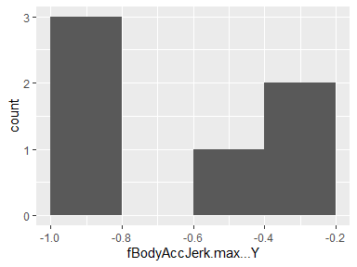

## fBodyAccJerk.max…Z

|  |  |
| --- | --- |
| Feature | Result |
| Variable type | numeric |
| Number of missing obs. | 0 (0 %) |
| Number of unique values | 6 |
| Median | -0.85 |
| 1st and 3rd quartiles | -0.98; -0.61 |
| Min. and max. | -0.98; -0.54 |

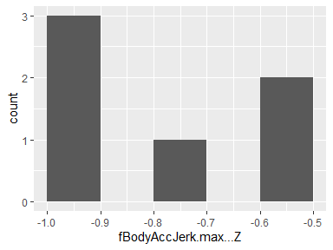

## fBodyAccJerk.min…X

|  |  |
| --- | --- |
| Feature | Result |
| Variable type | numeric |
| Number of missing obs. | 0 (0 %) |
| Number of unique values | 6 |
| Median | -0.89 |
| 1st and 3rd quartiles | -0.99; -0.78 |
| Min. and max. | -0.99; -0.72 |

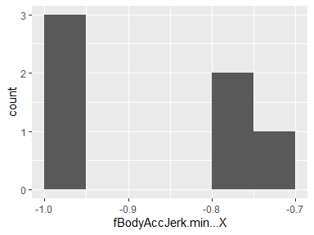

## fBodyAccJerk.min…Y

|  |  |
| --- | --- |
| Feature | Result |
| Variable type | numeric |
| Number of missing obs. | 0 (0 %) |
| Number of unique values | 6 |
| Median | -0.87 |
| 1st and 3rd quartiles | -0.98; -0.72 |
| Min. and max. | -0.99; -0.68 |

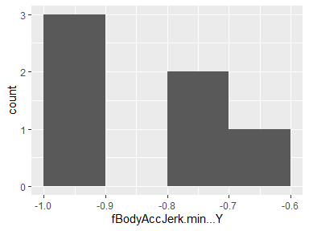

## fBodyAccJerk.min…Z

|  |  |
| --- | --- |
| Feature | Result |
| Variable type | numeric |
| Number of missing obs. | 0 (0 %) |
| Number of unique values | 6 |
| Median | -0.9 |
| 1st and 3rd quartiles | -0.98; -0.79 |
| Min. and max. | -0.98; -0.76 |

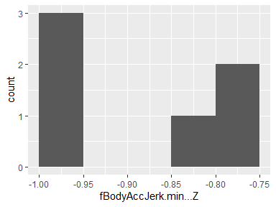

## fBodyAccJerk.sma..

|  |  |
| --- | --- |
| Feature | Result |
| Variable type | numeric |
| Number of missing obs. | 0 (0 %) |
| Number of unique values | 6 |
| Median | -0.67 |
| 1st and 3rd quartiles | -0.97; -0.24 |
| Min. and max. | -0.98; -0.07 |

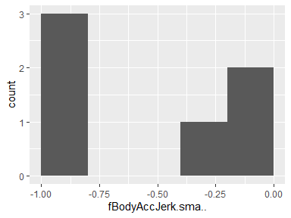

## fBodyAccJerk.energy…X

|  |  |
| --- | --- |
| Feature | Result |
| Variable type | numeric |
| Number of missing obs. | 0 (0 %) |
| Number of unique values | 6 |
| Median | -0.89 |
| 1st and 3rd quartiles | -1; -0.71 |
| Min. and max. | -1; -0.56 |

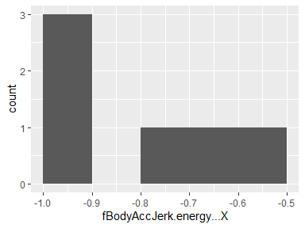

## fBodyAccJerk.energy…Y

|  |  |
| --- | --- |
| Feature | Result |
| Variable type | numeric |
| Number of missing obs. | 0 (0 %) |
| Number of unique values | 6 |
| Median | -0.89 |
| 1st and 3rd quartiles | -1; -0.61 |
| Min. and max. | -1; -0.55 |

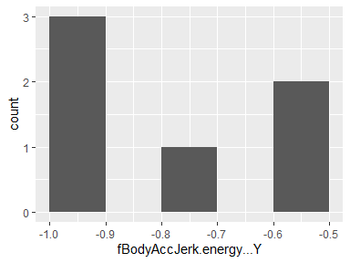

## fBodyAccJerk.energy…Z

|  |  |
| --- | --- |
| Feature | Result |
| Variable type | numeric |
| Number of missing obs. | 0 (0 %) |
| Number of unique values | 6 |
| Median | -0.96 |
| 1st and 3rd quartiles | -1; -0.88 |
| Min. and max. | -1; -0.81 |

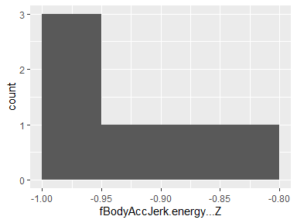

## fBodyAccJerk.iqr…X

|  |  |
| --- | --- |
| Feature | Result |
| Variable type | numeric |
| Number of missing obs. | 0 (0 %) |
| Number of unique values | 6 |
| Median | -0.67 |
| 1st and 3rd quartiles | -0.98; -0.28 |
| Min. and max. | -0.98; -0.05 |

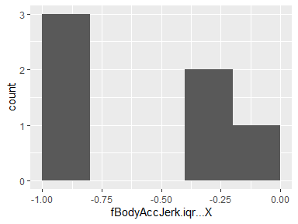

## fBodyAccJerk.iqr…Y

|  |  |
| --- | --- |
| Feature | Result |
| Variable type | numeric |
| Number of missing obs. | 0 (0 %) |
| Number of unique values | 6 |
| Median | -0.75 |
| 1st and 3rd quartiles | -0.98; -0.42 |
| Min. and max. | -0.98; -0.34 |

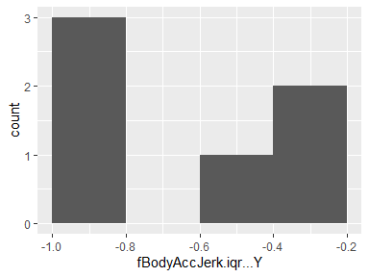

## fBodyAccJerk.iqr…Z

|  |  |
| --- | --- |
| Feature | Result |
| Variable type | numeric |
| Number of missing obs. | 0 (0 %) |
| Number of unique values | 6 |
| Median | -0.81 |
| 1st and 3rd quartiles | -0.98; -0.58 |
| Min. and max. | -0.98; -0.44 |

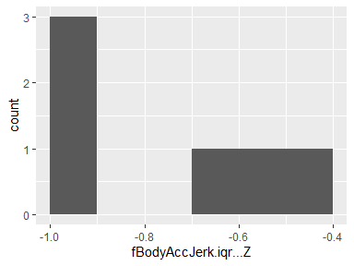

## fBodyAccJerk.entropy…X

|  |  |
| --- | --- |
| Feature | Result |
| Variable type | numeric |
| Number of missing obs. | 0 (0 %) |
| Number of unique values | 6 |
| Median | -0.23 |
| 1st and 3rd quartiles | -0.92; 0.51 |
| Min. and max. | -0.94; 0.63 |

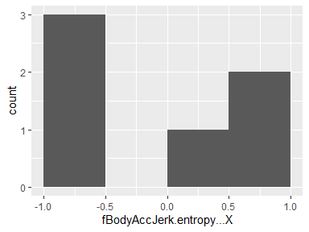

## fBodyAccJerk.entropy…Y

|  |  |
| --- | --- |
| Feature | Result |
| Variable type | numeric |
| Number of missing obs. | 0 (0 %) |
| Number of unique values | 6 |
| Median | -0.24 |
| 1st and 3rd quartiles | -0.91; 0.51 |
| Min. and max. | -0.93; 0.58 |

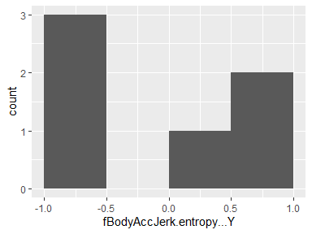

## fBodyAccJerk.entropy…Z

|  |  |
| --- | --- |
| Feature | Result |
| Variable type | numeric |
| Number of missing obs. | 0 (0 %) |
| Number of unique values | 6 |
| Median | -0.37 |
| 1st and 3rd quartiles | -0.91; 0.26 |
| Min. and max. | -0.93; 0.41 |

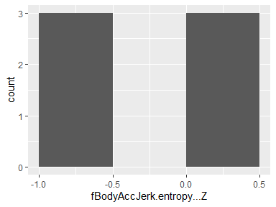

## fBodyAccJerk.maxInds.X

|  |  |
| --- | --- |
| Feature | Result |
| Variable type | numeric |
| Number of missing obs. | 0 (0 %) |
| Number of unique values | 6 |
| Median | -0.33 |
| 1st and 3rd quartiles | -0.6; -0.22 |
| Min. and max. | -0.69; -0.21 |

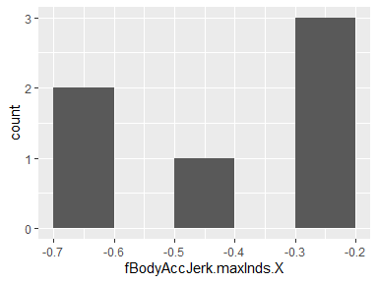

## fBodyAccJerk.maxInds.Y

|  |  |
| --- | --- |
| Feature | Result |
| Variable type | numeric |
| Number of missing obs. | 0 (0 %) |
| Number of unique values | 6 |
| Median | -0.38 |
| 1st and 3rd quartiles | -0.42; -0.37 |
| Min. and max. | -0.55; -0.28 |

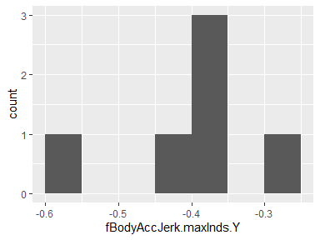

## fBodyAccJerk.maxInds.Z

|  |  |
| --- | --- |
| Feature | Result |
| Variable type | numeric |
| Number of missing obs. | 0 (0 %) |
| Number of unique values | 6 |
| Median | -0.29 |
| 1st and 3rd quartiles | -0.32; -0.25 |
| Min. and max. | -0.53; -0.21 |

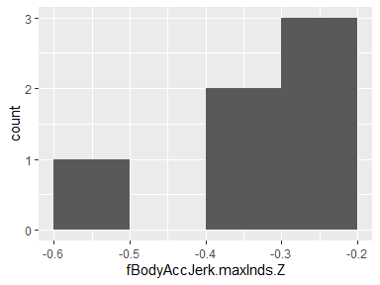

## fBodyAccJerk.meanFreq…X

|  |  |
| --- | --- |
| Feature | Result |
| Variable type | numeric |
| Number of missing obs. | 0 (0 %) |
| Number of unique values | 6 |
| Median | -0.06 |
| 1st and 3rd quartiles | -0.29; 0.17 |
| Min. and max. | -0.34; 0.2 |

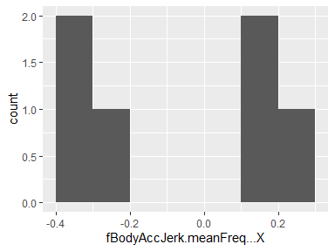

## fBodyAccJerk.meanFreq…Y

|  |  |
| --- | --- |
| Feature | Result |
| Variable type | numeric |
| Number of missing obs. | 0 (0 %) |
| Number of unique values | 6 |
| Median | -0.25 |
| 1st and 3rd quartiles | -0.36; -0.09 |
| Min. and max. | -0.46; 0.03 |

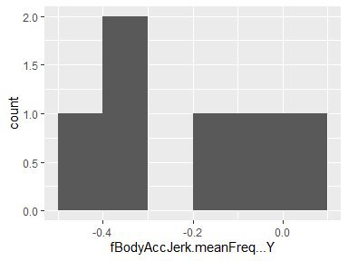

## fBodyAccJerk.meanFreq…Z

|  |  |
| --- | --- |
| Feature | Result |
| Variable type | numeric |
| Number of missing obs. | 0 (0 %) |
| Number of unique values | 6 |
| Median | -0.12 |
| 1st and 3rd quartiles | -0.25; 0.01 |
| Min. and max. | -0.42; 0.08 |

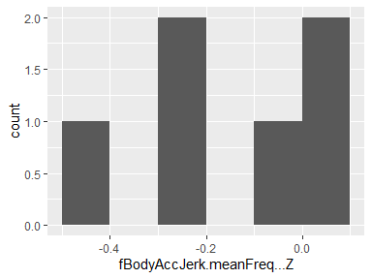

## fBodyAccJerk.skewness…X

|  |  |
| --- | --- |
| Feature | Result |
| Variable type | numeric |
| Number of missing obs. | 0 (0 %) |
| Number of unique values | 6 |
| Median | -0.31 |
| 1st and 3rd quartiles | -0.43; -0.18 |
| Min. and max. | -0.45; -0.09 |

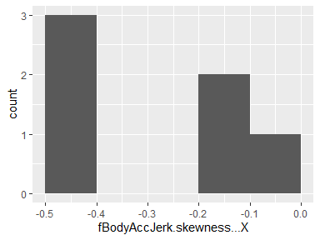

## fBodyAccJerk.kurtosis…X

|  |  |
| --- | --- |
| Feature | Result |
| Variable type | numeric |
| Number of missing obs. | 0 (0 %) |
| Number of unique values | 6 |
| Median | -0.71 |
| 1st and 3rd quartiles | -0.79; -0.63 |
| Min. and max. | -0.81; -0.56 |

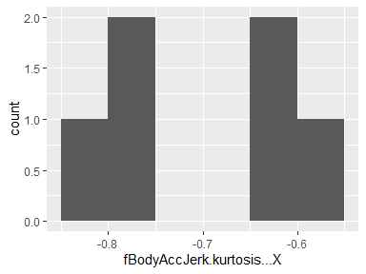

## fBodyAccJerk.skewness…Y

|  |  |
| --- | --- |
| Feature | Result |
| Variable type | numeric |
| Number of missing obs. | 0 (0 %) |
| Number of unique values | 6 |
| Median | -0.42 |
| 1st and 3rd quartiles | -0.49; -0.35 |
| Min. and max. | -0.5; -0.25 |

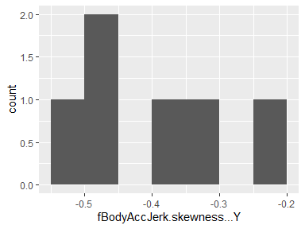

## fBodyAccJerk.kurtosis…Y

|  |  |
| --- | --- |
| Feature | Result |
| Variable type | numeric |
| Number of missing obs. | 0 (0 %) |
| Number of unique values | 6 |
| Median | -0.84 |
| 1st and 3rd quartiles | -0.87; -0.81 |
| Min. and max. | -0.88; -0.74 |

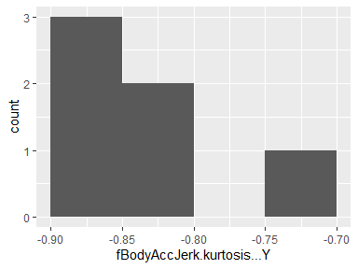

## fBodyAccJerk.skewness…Z

|  |  |
| --- | --- |
| Feature | Result |
| Variable type | numeric |
| Number of missing obs. | 0 (0 %) |
| Number of unique values | 6 |
| Median | -0.49 |
| 1st and 3rd quartiles | -0.57; -0.44 |
| Min. and max. | -0.6; -0.33 |

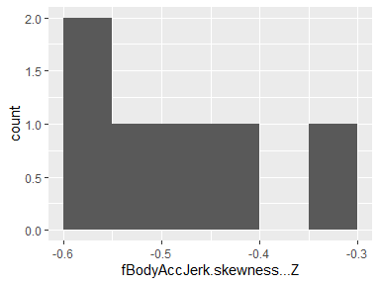

## fBodyAccJerk.kurtosis…Z

|  |  |
| --- | --- |
| Feature | Result |
| Variable type | numeric |
| Number of missing obs. | 0 (0 %) |
| Number of unique values | 6 |
| Median | -0.83 |
| 1st and 3rd quartiles | -0.86; -0.8 |
| Min. and max. | -0.88; -0.72 |

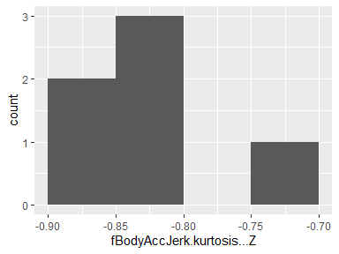

## fBodyAccJerk.bandsEnergy…1.8

|  |  |
| --- | --- |
| Feature | Result |
| Variable type | numeric |
| Number of missing obs. | 0 (0 %) |
| Number of unique values | 6 |
| Median | -0.92 |
| 1st and 3rd quartiles | -1; -0.83 |
| Min. and max. | -1; -0.57 |

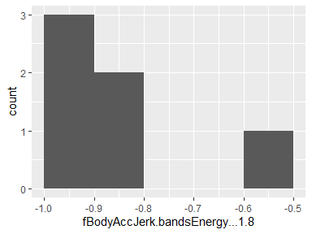

## fBodyAccJerk.bandsEnergy…9.16

|  |  |
| --- | --- |
| Feature | Result |
| Variable type | numeric |
| Number of missing obs. | 0 (0 %) |
| Number of unique values | 6 |
| Median | -0.9 |
| 1st and 3rd quartiles | -1; -0.74 |
| Min. and max. | -1; -0.7 |

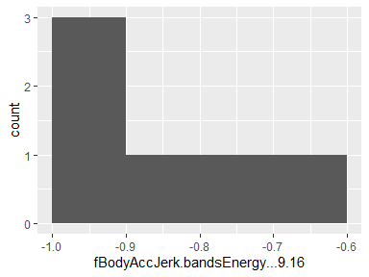

## fBodyAccJerk.bandsEnergy…17.24

|  |  |
| --- | --- |
| Feature | Result |
| Variable type | numeric |
| Number of missing obs. | 0 (0 %) |
| Number of unique values | 6 |
| Median | -0.92 |
| 1st and 3rd quartiles | -1; -0.72 |
| Min. and max. | -1; -0.66 |

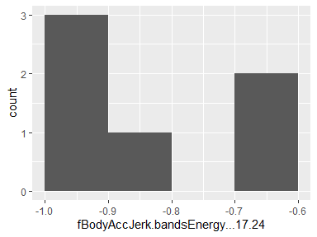

## fBodyAccJerk.bandsEnergy…25.32

|  |  |
| --- | --- |
| Feature | Result |
| Variable type | numeric |
| Number of missing obs. | 0 (0 %) |
| Number of unique values | 6 |
| Median | -0.93 |
| 1st and 3rd quartiles | -1; -0.79 |
| Min. and max. | -1; -0.65 |

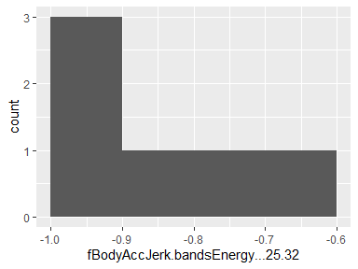

## fBodyAccJerk.bandsEnergy…33.40

|  |  |
| --- | --- |
| Feature | Result |
| Variable type | numeric |
| Number of missing obs. | 0 (0 %) |
| Number of unique values | 6 |
| Median | -0.94 |
| 1st and 3rd quartiles | -1; -0.87 |
| Min. and max. | -1; -0.75 |

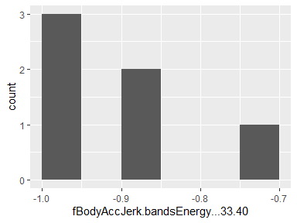

## fBodyAccJerk.bandsEnergy…41.48

|  |  |
| --- | --- |
| Feature | Result |
| Variable type | numeric |
| Number of missing obs. | 0 (0 %) |
| Number of unique values | 6 |
| Median | -0.93 |
| 1st and 3rd quartiles | -1; -0.83 |
| Min. and max. | -1; -0.72 |

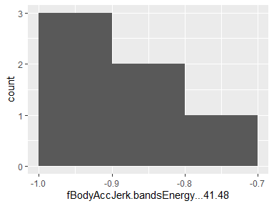

## fBodyAccJerk.bandsEnergy…49.56

|  |  |
| --- | --- |
| Feature | Result |
| Variable type | numeric |
| Number of missing obs. | 0 (0 %) |
| Number of unique values | 6 |
| Median | -0.96 |
| 1st and 3rd quartiles | -1; -0.9 |
| Min. and max. | -1; -0.84 |

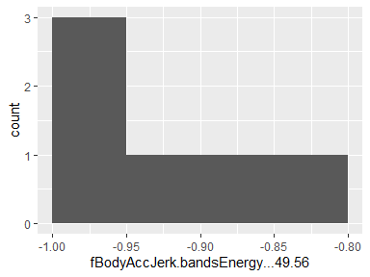

## fBodyAccJerk.bandsEnergy…57.64

|  |  |
| --- | --- |
| Feature | Result |
| Variable type | numeric |
| Number of missing obs. | 0 (0 %) |
| Number of unique values | 6 |
| Median | -0.99 |
| 1st and 3rd quartiles | -1; -0.97 |
| Min. and max. | -1; -0.96 |

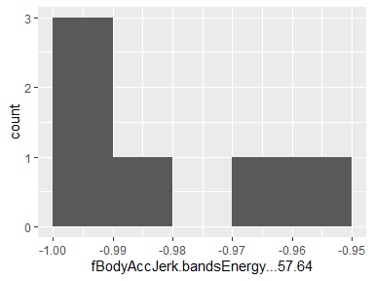

## fBodyAccJerk.bandsEnergy…1.16

|  |  |
| --- | --- |
| Feature | Result |
| Variable type | numeric |
| Number of missing obs. | 0 (0 %) |
| Number of unique values | 6 |
| Median | -0.9 |
| 1st and 3rd quartiles | -1; -0.76 |
| Min. and max. | -1; -0.61 |

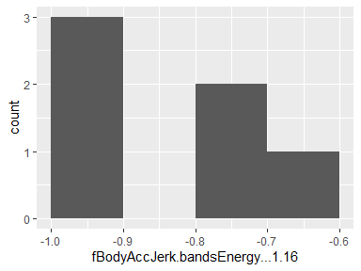

## fBodyAccJerk.bandsEnergy…17.32

|  |  |
| --- | --- |
| Feature | Result |
| Variable type | numeric |
| Number of missing obs. | 0 (0 %) |
| Number of unique values | 6 |
| Median | -0.91 |
| 1st and 3rd quartiles | -1; -0.68 |
| Min. and max. | -1; -0.58 |

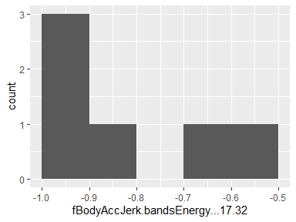

## fBodyAccJerk.bandsEnergy…33.48

|  |  |
| --- | --- |
| Feature | Result |
| Variable type | numeric |
| Number of missing obs. | 0 (0 %) |
| Number of unique values | 6 |
| Median | -0.93 |
| 1st and 3rd quartiles | -1; -0.84 |
| Min. and max. | -1; -0.72 |

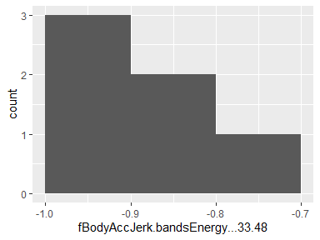

## fBodyAccJerk.bandsEnergy…49.64

|  |  |
| --- | --- |
| Feature | Result |
| Variable type | numeric |
| Number of missing obs. | 0 (0 %) |
| Number of unique values | 6 |
| Median | -0.96 |
| 1st and 3rd quartiles | -1; -0.9 |
| Min. and max. | -1; -0.84 |

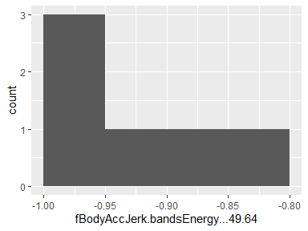

## fBodyAccJerk.bandsEnergy…1.24

|  |  |
| --- | --- |
| Feature | Result |
| Variable type | numeric |
| Number of missing obs. | 0 (0 %) |
| Number of unique values | 6 |
| Median | -0.89 |
| 1st and 3rd quartiles | -1; -0.7 |
| Min. and max. | -1; -0.56 |

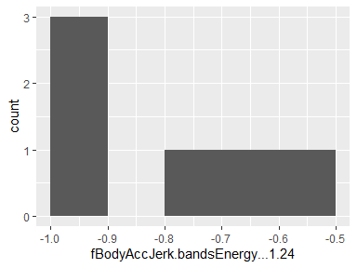

## fBodyAccJerk.bandsEnergy…25.48

|  |  |
| --- | --- |
| Feature | Result |
| Variable type | numeric |
| Number of missing obs. | 0 (0 %) |
| Number of unique values | 6 |
| Median | -0.91 |
| 1st and 3rd quartiles | -1; -0.74 |
| Min. and max. | -1; -0.55 |

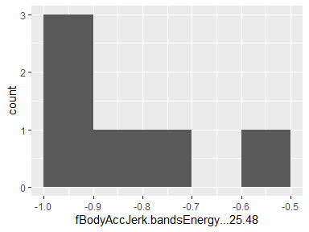

## fBodyAccJerk.bandsEnergy…1.8.1

|  |  |
| --- | --- |
| Feature | Result |
| Variable type | numeric |
| Number of missing obs. | 0 (0 %) |
| Number of unique values | 6 |
| Median | -0.84 |
| 1st and 3rd quartiles | -1; -0.67 |
| Min. and max. | -1; -0.55 |

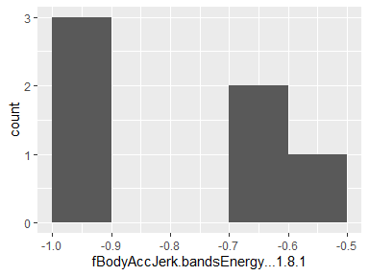

## fBodyAccJerk.bandsEnergy…9.16.1

|  |  |
| --- | --- |
| Feature | Result |
| Variable type | numeric |
| Number of missing obs. | 0 (0 %) |
| Number of unique values | 6 |
| Median | -0.91 |
| 1st and 3rd quartiles | -1; -0.73 |
| Min. and max. | -1; -0.66 |

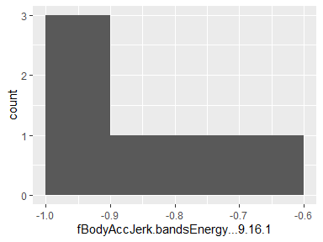

## fBodyAccJerk.bandsEnergy…17.24.1

|  |  |
| --- | --- |
| Feature | Result |
| Variable type | numeric |
| Number of missing obs. | 0 (0 %) |
| Number of unique values | 6 |
| Median | -0.91 |
| 1st and 3rd quartiles | -1; -0.65 |
| Min. and max. | -1; -0.51 |

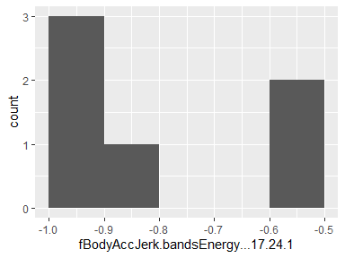

## fBodyAccJerk.bandsEnergy…25.32.1

|  |  |
| --- | --- |
| Feature | Result |
| Variable type | numeric |
| Number of missing obs. | 0 (0 %) |
| Number of unique values | 6 |
| Median | -0.94 |
| 1st and 3rd quartiles | -1; -0.8 |
| Min. and max. | -1; -0.72 |

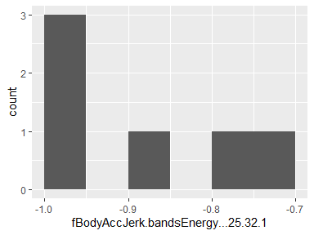

## fBodyAccJerk.bandsEnergy…33.40.1

|  |  |
| --- | --- |
| Feature | Result |
| Variable type | numeric |
| Number of missing obs. | 0 (0 %) |
| Number of unique values | 6 |
| Median | -0.94 |
| 1st and 3rd quartiles | -1; -0.83 |
| Min. and max. | -1; -0.76 |

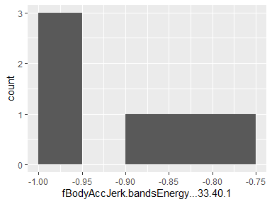

## fBodyAccJerk.bandsEnergy…41.48.1

|  |  |
| --- | --- |
| Feature | Result |
| Variable type | numeric |
| Number of missing obs. | 0 (0 %) |
| Number of unique values | 6 |
| Median | -0.92 |
| 1st and 3rd quartiles | -1; -0.75 |
| Min. and max. | -1; -0.68 |

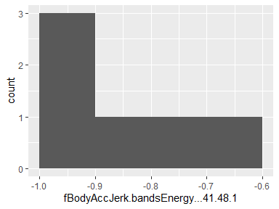

## fBodyAccJerk.bandsEnergy…49.56.1

|  |  |
| --- | --- |
| Feature | Result |
| Variable type | numeric |
| Number of missing obs. | 0 (0 %) |
| Number of unique values | 6 |
| Median | -0.95 |
| 1st and 3rd quartiles | -1; -0.84 |
| Min. and max. | -1; -0.81 |

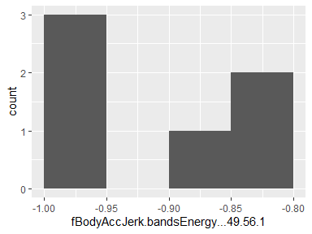

## fBodyAccJerk.bandsEnergy…57.64.1

|  |  |
| --- | --- |
| Feature | Result |
| Variable type | numeric |
| Number of missing obs. | 0 (0 %) |
| Number of unique values | 6 |
| Median | -0.98 |
| 1st and 3rd quartiles | -1; -0.94 |
| Min. and max. | -1; -0.92 |

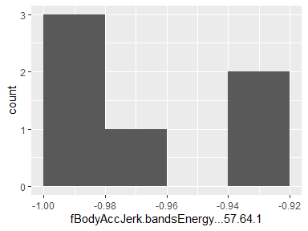

## fBodyAccJerk.bandsEnergy…1.16.1

|  |  |
| --- | --- |
| Feature | Result |
| Variable type | numeric |
| Number of missing obs. | 0 (0 %) |
| Number of unique values | 6 |
| Median | -0.88 |
| 1st and 3rd quartiles | -1; -0.68 |
| Min. and max. | -1; -0.58 |

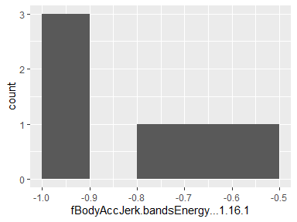

## fBodyAccJerk.bandsEnergy…17.32.1

|  |  |
| --- | --- |
| Feature | Result |
| Variable type | numeric |
| Number of missing obs. | 0 (0 %) |
| Number of unique values | 6 |
| Median | -0.91 |
| 1st and 3rd quartiles | -1; -0.65 |
| Min. and max. | -1; -0.51 |

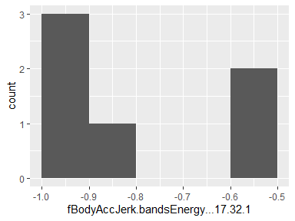

## fBodyAccJerk.bandsEnergy…33.48.1

|  |  |
| --- | --- |
| Feature | Result |
| Variable type | numeric |
| Number of missing obs. | 0 (0 %) |
| Number of unique values | 6 |
| Median | -0.92 |
| 1st and 3rd quartiles | -1; -0.76 |
| Min. and max. | -1; -0.67 |

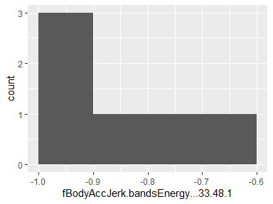

## fBodyAccJerk.bandsEnergy…49.64.1

|  |  |
| --- | --- |
| Feature | Result |
| Variable type | numeric |
| Number of missing obs. | 0 (0 %) |
| Number of unique values | 6 |
| Median | -0.95 |
| 1st and 3rd quartiles | -1; -0.85 |
| Min. and max. | -1; -0.82 |

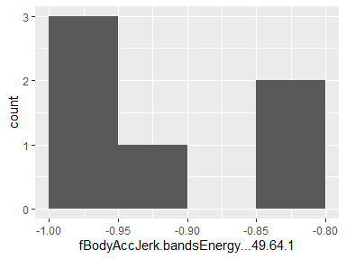

## fBodyAccJerk.bandsEnergy…1.24.1

|  |  |
| --- | --- |
| Feature | Result |
| Variable type | numeric |
| Number of missing obs. | 0 (0 %) |
| Number of unique values | 6 |
| Median | -0.88 |
| 1st and 3rd quartiles | -1; -0.59 |
| Min. and max. | -1; -0.52 |

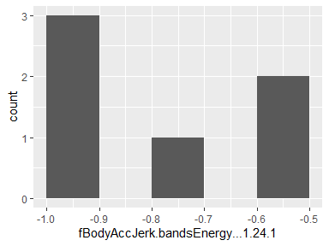

## fBodyAccJerk.bandsEnergy…25.48.1

|  |  |
| --- | --- |
| Feature | Result |
| Variable type | numeric |
| Number of missing obs. | 0 (0 %) |
| Number of unique values | 6 |
| Median | -0.93 |
| 1st and 3rd quartiles | -1; -0.76 |
| Min. and max. | -1; -0.72 |

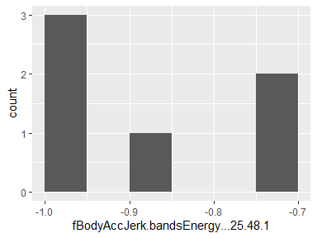

## fBodyAccJerk.bandsEnergy…1.8.2

|  |  |
| --- | --- |
| Feature | Result |
| Variable type | numeric |
| Number of missing obs. | 0 (0 %) |
| Number of unique values | 6 |
| Median | -0.91 |
| 1st and 3rd quartiles | -1; -0.82 |
| Min. and max. | -1; -0.8 |

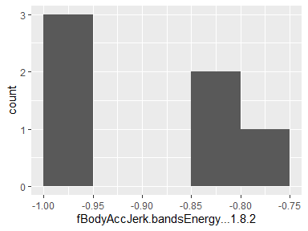

## fBodyAccJerk.bandsEnergy…9.16.2

|  |  |
| --- | --- |
| Feature | Result |
| Variable type | numeric |
| Number of missing obs. | 0 (0 %) |
| Number of unique values | 6 |
| Median | -0.93 |
| 1st and 3rd quartiles | -1; -0.84 |
| Min. and max. | -1; -0.7 |

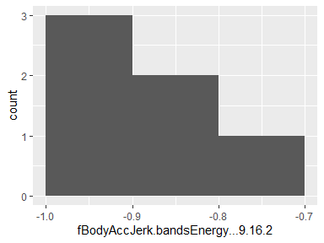

## fBodyAccJerk.bandsEnergy…17.24.2

|  |  |
| --- | --- |
| Feature | Result |
| Variable type | numeric |
| Number of missing obs. | 0 (0 %) |
| Number of unique values | 6 |
| Median | -0.97 |
| 1st and 3rd quartiles | -1; -0.88 |
| Min. and max. | -1; -0.82 |

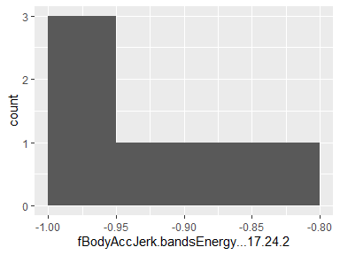

## fBodyAccJerk.bandsEnergy…25.32.2

|  |  |
| --- | --- |
| Feature | Result |
| Variable type | numeric |
| Number of missing obs. | 0 (0 %) |
| Number of unique values | 6 |
| Median | -0.98 |
| 1st and 3rd quartiles | -1; -0.94 |
| Min. and max. | -1; -0.9 |

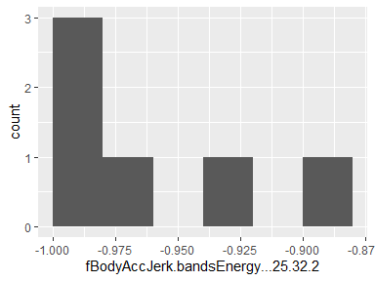

## fBodyAccJerk.bandsEnergy…33.40.2

|  |  |
| --- | --- |
| Feature | Result |
| Variable type | numeric |
| Number of missing obs. | 0 (0 %) |
| Number of unique values | 6 |
| Median | -0.98 |
| 1st and 3rd quartiles | -1; -0.95 |
| Min. and max. | -1; -0.91 |

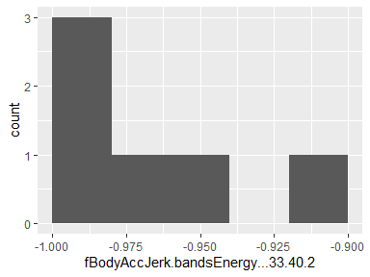

## fBodyAccJerk.bandsEnergy…41.48.2

|  |  |
| --- | --- |
| Feature | Result |
| Variable type | numeric |
| Number of missing obs. | 0 (0 %) |
| Number of unique values | 6 |
| Median | -0.97 |
| 1st and 3rd quartiles | -1; -0.91 |
| Min. and max. | -1; -0.85 |

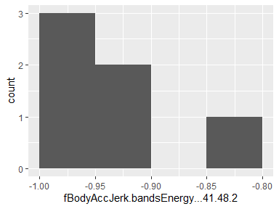

## fBodyAccJerk.bandsEnergy…49.56.2

|  |  |
| --- | --- |
| Feature | Result |
| Variable type | numeric |
| Number of missing obs. | 0 (0 %) |
| Number of unique values | 6 |
| Median | -0.96 |
| 1st and 3rd quartiles | -1; -0.89 |
| Min. and max. | -1; -0.82 |

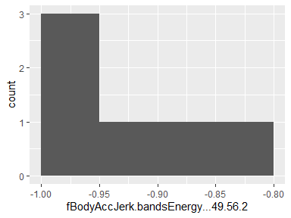

## fBodyAccJerk.bandsEnergy…57.64.2

|  |  |
| --- | --- |
| Feature | Result |
| Variable type | numeric |
| Number of missing obs. | 0 (0 %) |
| Number of unique values | 6 |
| Median | -0.98 |
| 1st and 3rd quartiles | -1; -0.95 |
| Min. and max. | -1; -0.93 |

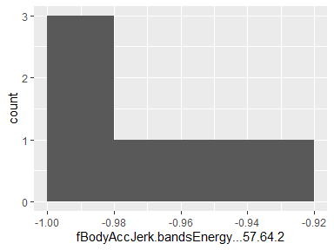

## fBodyAccJerk.bandsEnergy…1.16.2

|  |  |
| --- | --- |
| Feature | Result |
| Variable type | numeric |
| Number of missing obs. | 0 (0 %) |
| Number of unique values | 6 |
| Median | -0.91 |
| 1st and 3rd quartiles | -1; -0.8 |
| Min. and max. | -1; -0.67 |

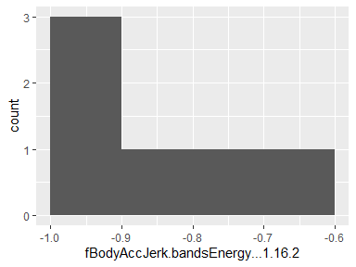

## fBodyAccJerk.bandsEnergy…17.32.2

|  |  |
| --- | --- |
| Feature | Result |
| Variable type | numeric |
| Number of missing obs. | 0 (0 %) |
| Number of unique values | 6 |
| Median | -0.98 |
| 1st and 3rd quartiles | -1; -0.91 |
| Min. and max. | -1; -0.86 |

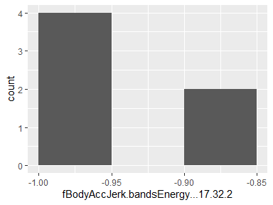

## fBodyAccJerk.bandsEnergy…33.48.2

|  |  |
| --- | --- |
| Feature | Result |
| Variable type | numeric |
| Number of missing obs. | 0 (0 %) |
| Number of unique values | 6 |
| Median | -0.98 |
| 1st and 3rd quartiles | -1; -0.93 |
| Min. and max. | -1; -0.89 |

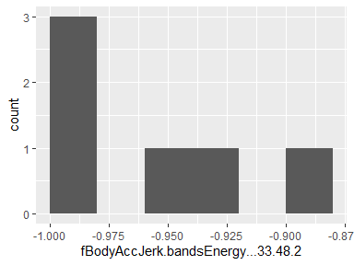

## fBodyAccJerk.bandsEnergy…49.64.2

|  |  |
| --- | --- |
| Feature | Result |
| Variable type | numeric |
| Number of missing obs. | 0 (0 %) |
| Number of unique values | 6 |
| Median | -0.96 |
| 1st and 3rd quartiles | -1; -0.89 |
| Min. and max. | -1; -0.82 |

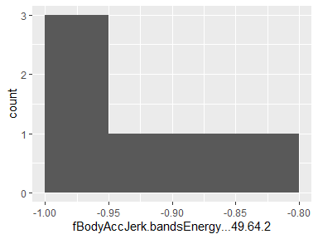

## fBodyAccJerk.bandsEnergy…1.24.2

|  |  |
| --- | --- |
| Feature | Result |
| Variable type | numeric |
| Number of missing obs. | 0 (0 %) |
| Number of unique values | 6 |
| Median | -0.94 |
| 1st and 3rd quartiles | -1; -0.83 |
| Min. and max. | -1; -0.73 |

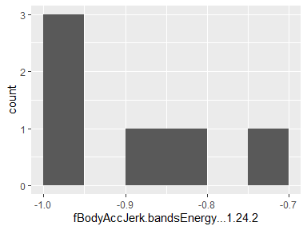

## fBodyAccJerk.bandsEnergy…25.48.2

|  |  |
| --- | --- |
| Feature | Result |
| Variable type | numeric |
| Number of missing obs. | 0 (0 %) |
| Number of unique values | 6 |
| Median | -0.98 |
| 1st and 3rd quartiles | -1; -0.94 |
| Min. and max. | -1; -0.89 |

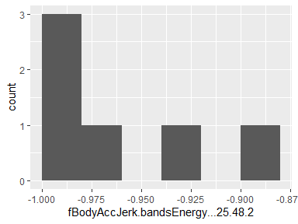

## fBodyGyro.mean…X

|  |  |
| --- | --- |
| Feature | Result |
| Variable type | numeric |
| Number of missing obs. | 0 (0 %) |
| Number of unique values | 6 |
| Median | -0.67 |
| 1st and 3rd quartiles | -0.96; -0.37 |
| Min. and max. | -0.98; -0.26 |

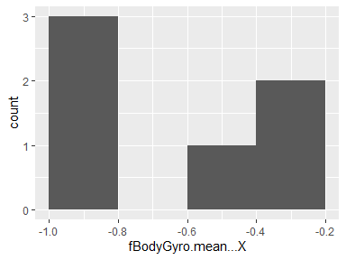

## fBodyGyro.mean…Y

|  |  |
| --- | --- |
| Feature | Result |
| Variable type | numeric |
| Number of missing obs. | 0 (0 %) |
| Number of unique values | 6 |
| Median | -0.72 |
| 1st and 3rd quartiles | -0.96; -0.44 |
| Min. and max. | -0.97; -0.39 |

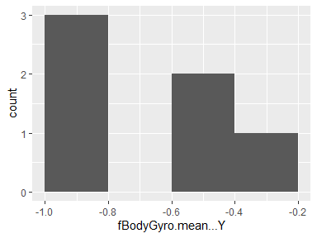

## fBodyGyro.mean…Z

|  |  |
| --- | --- |
| Feature | Result |
| Variable type | numeric |
| Number of missing obs. | 0 (0 %) |
| Number of unique values | 6 |
| Median | -0.64 |
| 1st and 3rd quartiles | -0.96; -0.31 |
| Min. and max. | -0.97; -0.2 |

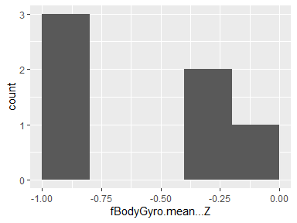

## fBodyGyro.std…X

|  |  |
| --- | --- |
| Feature | Result |
| Variable type | numeric |
| Number of missing obs. | 0 (0 %) |
| Number of unique values | 6 |
| Median | -0.73 |
| 1st and 3rd quartiles | -0.97; -0.51 |
| Min. and max. | -0.98; -0.41 |

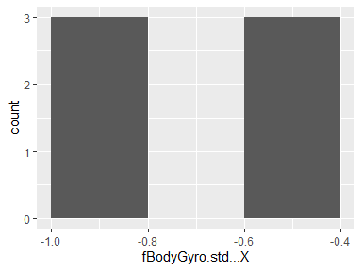

## fBodyGyro.std…Y

|  |  |
| --- | --- |
| Feature | Result |
| Variable type | numeric |
| Number of missing obs. | 0 (0 %) |
| Number of unique values | 6 |
| Median | -0.7 |
| 1st and 3rd quartiles | -0.96; -0.41 |
| Min. and max. | -0.97; -0.35 |

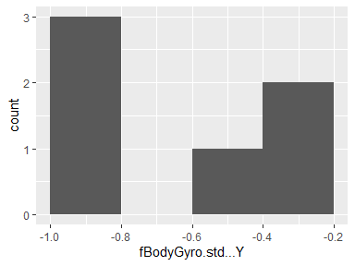

## fBodyGyro.std…Z

|  |  |
| --- | --- |
| Feature | Result |
| Variable type | numeric |
| Number of missing obs. | 0 (0 %) |
| Number of unique values | 6 |
| Median | -0.7 |
| 1st and 3rd quartiles | -0.96; -0.42 |
| Min. and max. | -0.97; -0.29 |

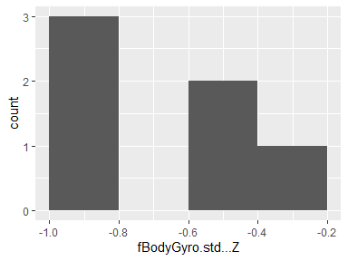

## fBodyGyro.mad…X

|  |  |
| --- | --- |
| Feature | Result |
| Variable type | numeric |
| Number of missing obs. | 0 (0 %) |
| Number of unique values | 6 |
| Median | -0.68 |
| 1st and 3rd quartiles | -0.96; -0.42 |
| Min. and max. | -0.98; -0.31 |

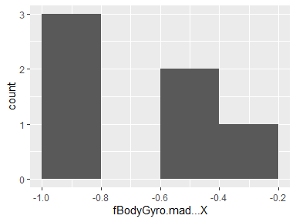

## fBodyGyro.mad…Y

|  |  |
| --- | --- |
| Feature | Result |
| Variable type | numeric |
| Number of missing obs. | 0 (0 %) |
| Number of unique values | 6 |
| Median | -0.72 |
| 1st and 3rd quartiles | -0.96; -0.46 |
| Min. and max. | -0.97; -0.44 |

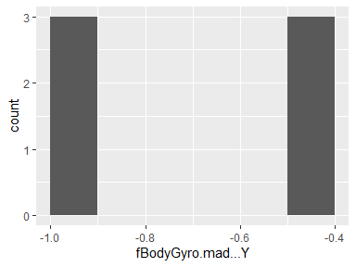

## fBodyGyro.mad…Z

|  |  |
| --- | --- |
| Feature | Result |
| Variable type | numeric |
| Number of missing obs. | 0 (0 %) |
| Number of unique values | 6 |
| Median | -0.64 |
| 1st and 3rd quartiles | -0.96; -0.28 |
| Min. and max. | -0.97; -0.23 |

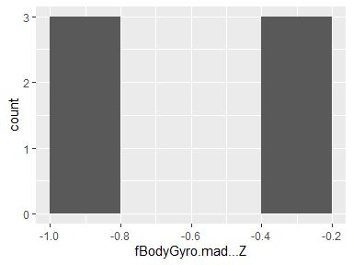

## fBodyGyro.max…X

|  |  |
| --- | --- |
| Feature | Result |
| Variable type | numeric |
| Number of missing obs. | 0 (0 %) |
| Number of unique values | 6 |
| Median | -0.74 |
| 1st and 3rd quartiles | -0.97; -0.51 |
| Min. and max. | -0.98; -0.4 |

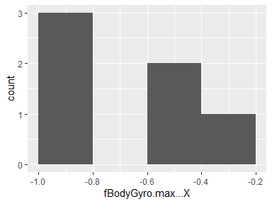

## fBodyGyro.max…Y

|  |  |
| --- | --- |
| Feature | Result |
| Variable type | numeric |
| Number of missing obs. | 0 (0 %) |
| Number of unique values | 6 |
| Median | -0.79 |
| 1st and 3rd quartiles | -0.97; -0.55 |
| Min. and max. | -0.97; -0.42 |

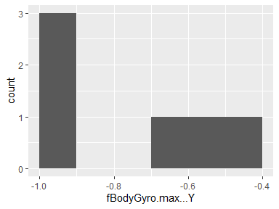

## fBodyGyro.max…Z

|  |  |
| --- | --- |
| Feature | Result |
| Variable type | numeric |
| Number of missing obs. | 0 (0 %) |
| Number of unique values | 6 |
| Median | -0.79 |
| 1st and 3rd quartiles | -0.97; -0.59 |
| Min. and max. | -0.98; -0.4 |

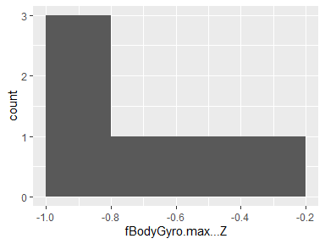

## fBodyGyro.min…X

|  |  |
| --- | --- |
| Feature | Result |
| Variable type | numeric |
| Number of missing obs. | 0 (0 %) |
| Number of unique values | 6 |
| Median | -0.93 |
| 1st and 3rd quartiles | -0.99; -0.87 |
| Min. and max. | -0.99; -0.86 |

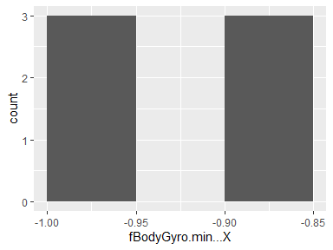

## fBodyGyro.min…Y

|  |  |
| --- | --- |
| Feature | Result |
| Variable type | numeric |
| Number of missing obs. | 0 (0 %) |
| Number of unique values | 6 |
| Median | -0.91 |
| 1st and 3rd quartiles | -0.98; -0.82 |
| Min. and max. | -0.99; -0.8 |

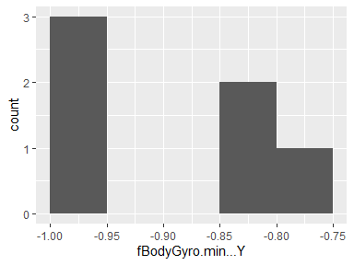

## fBodyGyro.min…Z

|  |  |
| --- | --- |
| Feature | Result |
| Variable type | numeric |
| Number of missing obs. | 0 (0 %) |
| Number of unique values | 6 |
| Median | -0.91 |
| 1st and 3rd quartiles | -0.98; -0.84 |
| Min. and max. | -0.98; -0.82 |

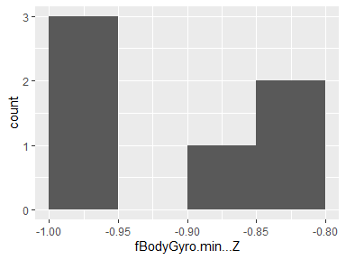

## fBodyGyro.sma..

|  |  |
| --- | --- |
| Feature | Result |
| Variable type | numeric |
| Number of missing obs. | 0 (0 %) |
| Number of unique values | 6 |
| Median | -0.66 |
| 1st and 3rd quartiles | -0.96; -0.35 |
| Min. and max. | -0.97; -0.25 |

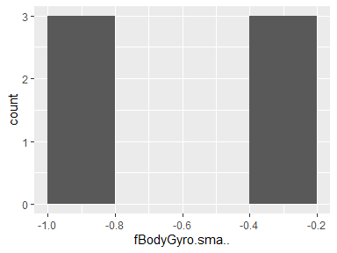

## fBodyGyro.energy…X

|  |  |
| --- | --- |
| Feature | Result |
| Variable type | numeric |
| Number of missing obs. | 0 (0 %) |
| Number of unique values | 6 |
| Median | -0.93 |
| 1st and 3rd quartiles | -1; -0.85 |
| Min. and max. | -1; -0.78 |

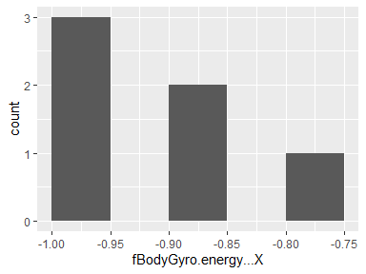

## fBodyGyro.energy…Y

|  |  |
| --- | --- |
| Feature | Result |
| Variable type | numeric |
| Number of missing obs. | 0 (0 %) |
| Number of unique values | 6 |
| Median | -0.9 |
| 1st and 3rd quartiles | -1; -0.8 |
| Min. and max. | -1; -0.79 |

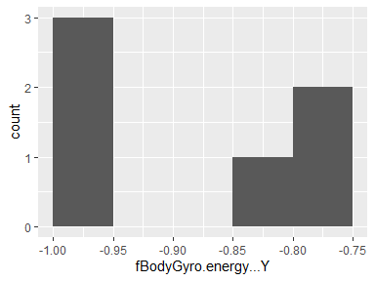

## fBodyGyro.energy…Z

|  |  |
| --- | --- |
| Feature | Result |
| Variable type | numeric |
| Number of missing obs. | 0 (0 %) |
| Number of unique values | 6 |
| Median | -0.89 |
| 1st and 3rd quartiles | -1; -0.74 |
| Min. and max. | -1; -0.68 |

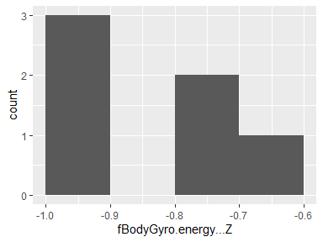

## fBodyGyro.iqr…X

|  |  |
| --- | --- |
| Feature | Result |
| Variable type | numeric |
| Number of missing obs. | 0 (0 %) |
| Number of unique values | 6 |
| Median | -0.73 |
| 1st and 3rd quartiles | -0.97; -0.41 |
| Min. and max. | -0.98; -0.31 |

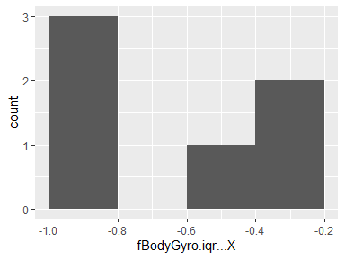

## fBodyGyro.iqr…Y

|  |  |
| --- | --- |
| Feature | Result |
| Variable type | numeric |
| Number of missing obs. | 0 (0 %) |
| Number of unique values | 6 |
| Median | -0.78 |
| 1st and 3rd quartiles | -0.97; -0.54 |
| Min. and max. | -0.98; -0.43 |

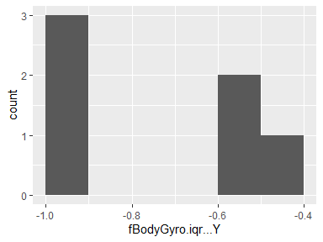

## fBodyGyro.iqr…Z

|  |  |
| --- | --- |
| Feature | Result |
| Variable type | numeric |
| Number of missing obs. | 0 (0 %) |
| Number of unique values | 6 |
| Median | -0.72 |
| 1st and 3rd quartiles | -0.97; -0.43 |
| Min. and max. | -0.98; -0.22 |

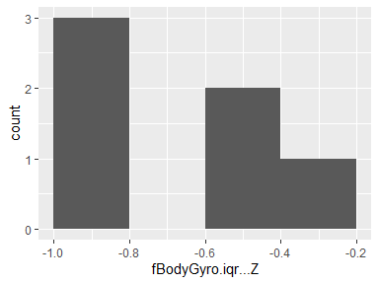

## fBodyGyro.entropy…X

|  |  |
| --- | --- |
| Feature | Result |
| Variable type | numeric |
| Number of missing obs. | 0 (0 %) |
| Number of unique values | 6 |
| Median | 0.01 |
| 1st and 3rd quartiles | -0.58; 0.52 |
| Min. and max. | -0.67; 0.58 |

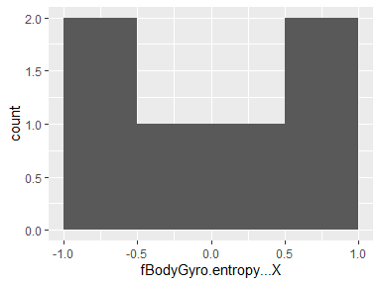

## fBodyGyro.entropy…Y

|  |  |
| --- | --- |
| Feature | Result |
| Variable type | numeric |
| Number of missing obs. | 0 (0 %) |
| Number of unique values | 6 |
| Median | 0 |
| 1st and 3rd quartiles | -0.5; 0.55 |
| Min. and max. | -0.58; 0.62 |

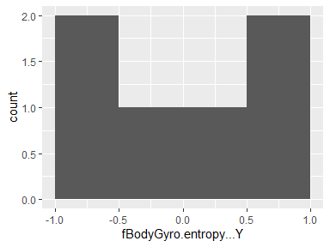

## fBodyGyro.entropy…Z

|  |  |
| --- | --- |
| Feature | Result |
| Variable type | numeric |
| Number of missing obs. | 0 (0 %) |
| Number of unique values | 6 |
| Median | -0.08 |
| 1st and 3rd quartiles | -0.62; 0.44 |
| Min. and max. | -0.7; 0.55 |

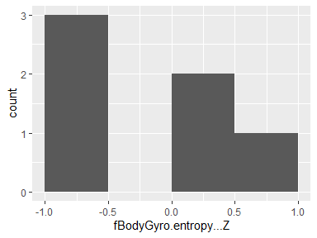

## fBodyGyro.maxInds.X

|  |  |
| --- | --- |
| Feature | Result |
| Variable type | numeric |
| Number of missing obs. | 0 (0 %) |
| Number of unique values | 6 |
| Median | -0.89 |
| 1st and 3rd quartiles | -0.91; -0.86 |
| Min. and max. | -0.95; -0.85 |

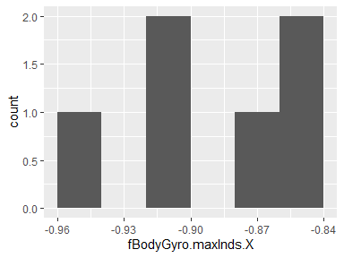

## fBodyGyro.maxInds.Y

|  |  |
| --- | --- |
| Feature | Result |
| Variable type | numeric |
| Number of missing obs. | 0 (0 %) |
| Number of unique values | 6 |
| Median | -0.84 |
| 1st and 3rd quartiles | -0.88; -0.65 |
| Min. and max. | -0.9; -0.57 |

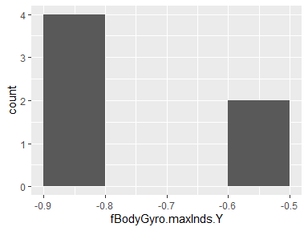

## fBodyGyro.maxInds.Z

|  |  |
| --- | --- |
| Feature | Result |
| Variable type | numeric |
| Number of missing obs. | 0 (0 %) |
| Number of unique values | 6 |
| Median | -0.86 |
| 1st and 3rd quartiles | -0.89; -0.73 |
| Min. and max. | -0.91; -0.64 |

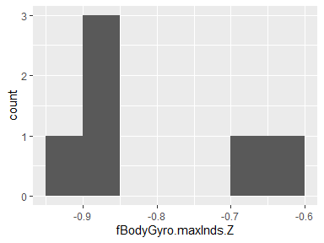

## fBodyGyro.meanFreq…X

|  |  |
| --- | --- |
| Feature | Result |
| Variable type | numeric |
| Number of missing obs. | 0 (0 %) |
| Number of unique values | 6 |
| Median | -0.1 |
| 1st and 3rd quartiles | -0.19; -0.01 |
| Min. and max. | -0.26; 0.05 |

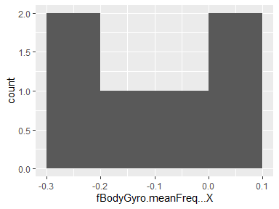

## fBodyGyro.meanFreq…Y

|  |  |
| --- | --- |
| Feature | Result |
| Variable type | numeric |
| Number of missing obs. | 0 (0 %) |
| Number of unique values | 6 |
| Median | -0.17 |
| 1st and 3rd quartiles | -0.23; -0.08 |
| Min. and max. | -0.32; -0.02 |

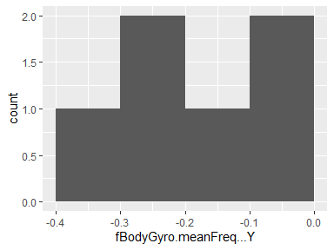

## fBodyGyro.meanFreq…Z

|  |  |
| --- | --- |
| Feature | Result |
| Variable type | numeric |
| Number of missing obs. | 0 (0 %) |
| Number of unique values | 6 |
| Median | -0.05 |
| 1st and 3rd quartiles | -0.11; -0.01 |
| Min. and max. | -0.25; 0.11 |

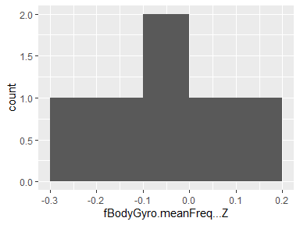

## fBodyGyro.skewness…X

|  |  |
| --- | --- |
| Feature | Result |
| Variable type | numeric |
| Number of missing obs. | 0 (0 %) |
| Number of unique values | 6 |
| Median | -0.17 |
| 1st and 3rd quartiles | -0.22; -0.11 |
| Min. and max. | -0.33; -0.09 |

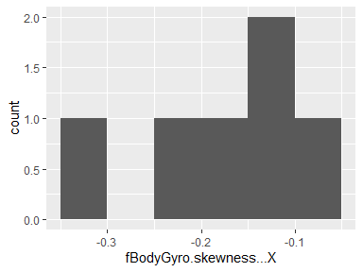

## fBodyGyro.kurtosis…X

|  |  |
| --- | --- |
| Feature | Result |
| Variable type | numeric |
| Number of missing obs. | 0 (0 %) |
| Number of unique values | 6 |
| Median | -0.47 |
| 1st and 3rd quartiles | -0.54; -0.45 |
| Min. and max. | -0.63; -0.42 |

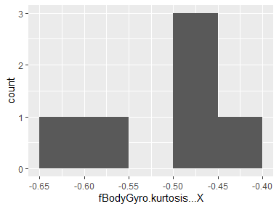

## fBodyGyro.skewness…Y

|  |  |
| --- | --- |
| Feature | Result |
| Variable type | numeric |
| Number of missing obs. | 0 (0 %) |
| Number of unique values | 6 |
| Median | -0.17 |
| 1st and 3rd quartiles | -0.26; -0.11 |
| Min. and max. | -0.45; -0.03 |

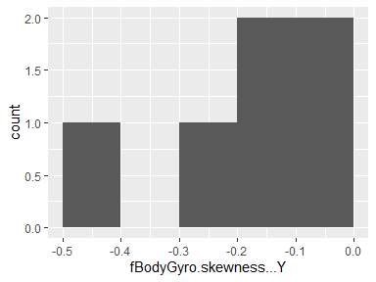

## fBodyGyro.kurtosis…Y

|  |  |
| --- | --- |
| Feature | Result |
| Variable type | numeric |
| Number of missing obs. | 0 (0 %) |
| Number of unique values | 6 |
| Median | -0.55 |
| 1st and 3rd quartiles | -0.63; -0.44 |
| Min. and max. | -0.79; -0.36 |

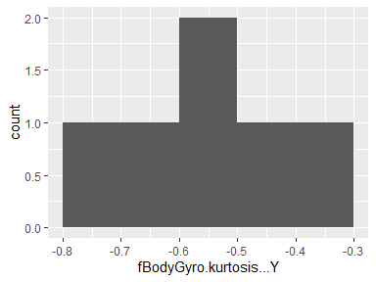

## fBodyGyro.skewness…Z

|  |  |
| --- | --- |
| Feature | Result |
| Variable type | numeric |
| Number of missing obs. | 0 (0 %) |
| Number of unique values | 6 |
| Median | -0.22 |
| 1st and 3rd quartiles | -0.27; -0.15 |
| Min. and max. | -0.42; 0.02 |

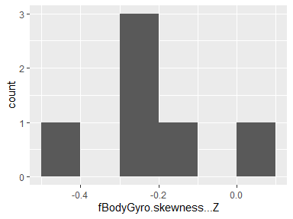

## fBodyGyro.kurtosis…Z

|  |  |
| --- | --- |
| Feature | Result |
| Variable type | numeric |
| Number of missing obs. | 0 (0 %) |
| Number of unique values | 6 |
| Median | -0.53 |
| 1st and 3rd quartiles | -0.61; -0.47 |
| Min. and max. | -0.73; -0.29 |

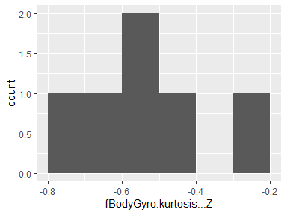

## fBodyGyro.bandsEnergy…1.8

|  |  |
| --- | --- |
| Feature | Result |
| Variable type | numeric |
| Number of missing obs. | 0 (0 %) |
| Number of unique values | 6 |
| Median | -0.94 |
| 1st and 3rd quartiles | -1; -0.87 |
| Min. and max. | -1; -0.81 |

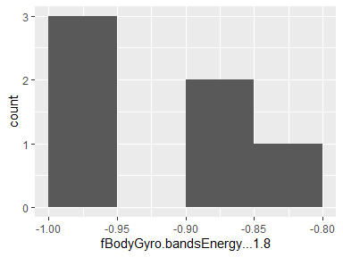

## fBodyGyro.bandsEnergy…9.16

|  |  |
| --- | --- |
| Feature | Result |
| Variable type | numeric |
| Number of missing obs. | 0 (0 %) |
| Number of unique values | 6 |
| Median | -0.94 |
| 1st and 3rd quartiles | -1; -0.84 |
| Min. and max. | -1; -0.81 |

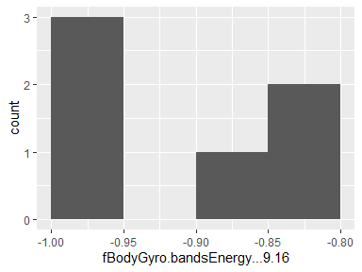

## fBodyGyro.bandsEnergy…17.24

|  |  |
| --- | --- |
| Feature | Result |
| Variable type | numeric |
| Number of missing obs. | 0 (0 %) |
| Number of unique values | 6 |
| Median | -0.95 |
| 1st and 3rd quartiles | -1; -0.84 |
| Min. and max. | -1; -0.8 |

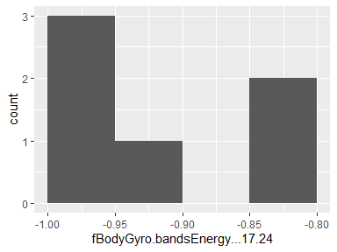

## fBodyGyro.bandsEnergy…25.32

|  |  |
| --- | --- |
| Feature | Result |
| Variable type | numeric |
| Number of missing obs. | 0 (0 %) |
| Number of unique values | 6 |
| Median | -0.97 |
| 1st and 3rd quartiles | -1; -0.91 |
| Min. and max. | -1; -0.89 |

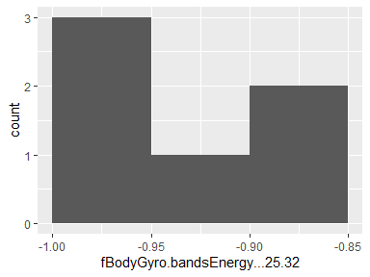

## fBodyGyro.bandsEnergy…33.40

|  |  |
| --- | --- |
| Feature | Result |
| Variable type | numeric |
| Number of missing obs. | 0 (0 %) |
| Number of unique values | 6 |
| Median | -0.97 |
| 1st and 3rd quartiles | -1; -0.9 |
| Min. and max. | -1; -0.86 |

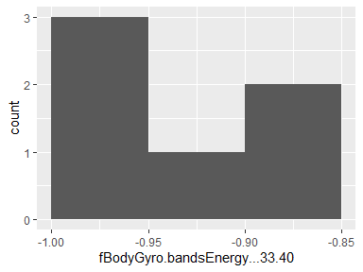

## fBodyGyro.bandsEnergy…41.48

|  |  |
| --- | --- |
| Feature | Result |
| Variable type | numeric |
| Number of missing obs. | 0 (0 %) |
| Number of unique values | 6 |
| Median | -0.96 |
| 1st and 3rd quartiles | -1; -0.91 |
| Min. and max. | -1; -0.88 |

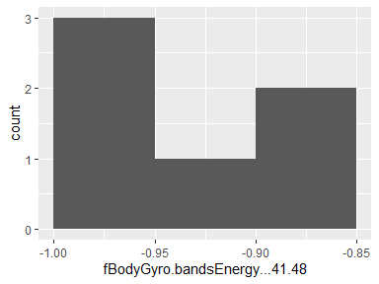

## fBodyGyro.bandsEnergy…49.56

|  |  |
| --- | --- |
| Feature | Result |
| Variable type | numeric |
| Number of missing obs. | 0 (0 %) |
| Number of unique values | 6 |
| Median | -0.97 |
| 1st and 3rd quartiles | -1; -0.93 |
| Min. and max. | -1; -0.92 |

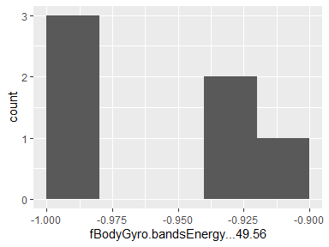

## fBodyGyro.bandsEnergy…57.64

|  |  |
| --- | --- |
| Feature | Result |
| Variable type | numeric |
| Number of missing obs. | 0 (0 %) |
| Number of unique values | 6 |
| Median | -0.98 |
| 1st and 3rd quartiles | -1; -0.95 |
| Min. and max. | -1; -0.94 |

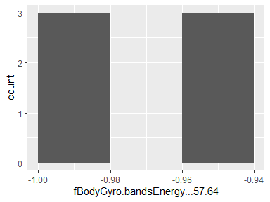

## fBodyGyro.bandsEnergy…1.16

|  |  |
| --- | --- |
| Feature | Result |
| Variable type | numeric |
| Number of missing obs. | 0 (0 %) |
| Number of unique values | 6 |
| Median | -0.93 |
| 1st and 3rd quartiles | -1; -0.86 |
| Min. and max. | -1; -0.79 |

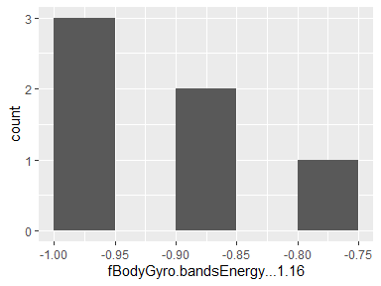

## fBodyGyro.bandsEnergy…17.32

|  |  |
| --- | --- |
| Feature | Result |
| Variable type | numeric |
| Number of missing obs. | 0 (0 %) |
| Number of unique values | 6 |
| Median | -0.95 |
| 1st and 3rd quartiles | -1; -0.83 |
| Min. and max. | -1; -0.8 |

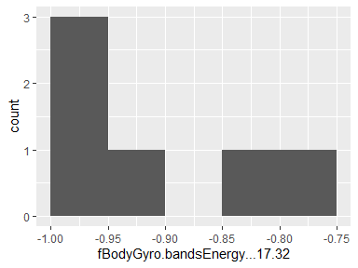

## fBodyGyro.bandsEnergy…33.48

|  |  |
| --- | --- |
| Feature | Result |
| Variable type | numeric |
| Number of missing obs. | 0 (0 %) |
| Number of unique values | 6 |
| Median | -0.96 |
| 1st and 3rd quartiles | -1; -0.89 |
| Min. and max. | -1; -0.85 |

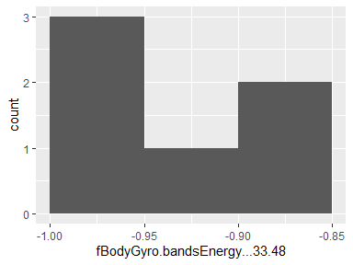

## fBodyGyro.bandsEnergy…49.64

|  |  |
| --- | --- |
| Feature | Result |
| Variable type | numeric |
| Number of missing obs. | 0 (0 %) |
| Number of unique values | 6 |
| Median | -0.97 |
| 1st and 3rd quartiles | -1; -0.94 |
| Min. and max. | -1; -0.93 |

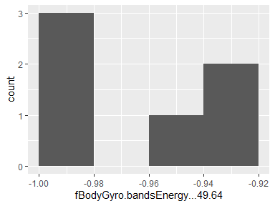

## fBodyGyro.bandsEnergy…1.24

|  |  |
| --- | --- |
| Feature | Result |
| Variable type | numeric |
| Number of missing obs. | 0 (0 %) |
| Number of unique values | 6 |
| Median | -0.93 |
| 1st and 3rd quartiles | -1; -0.86 |
| Min. and max. | -1; -0.79 |

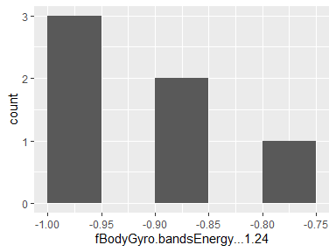

## fBodyGyro.bandsEnergy…25.48

|  |  |
| --- | --- |
| Feature | Result |
| Variable type | numeric |
| Number of missing obs. | 0 (0 %) |
| Number of unique values | 6 |
| Median | -0.97 |
| 1st and 3rd quartiles | -1; -0.9 |
| Min. and max. | -1; -0.88 |

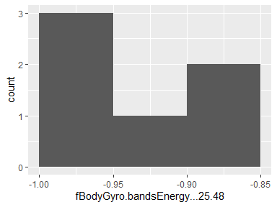

## fBodyGyro.bandsEnergy…1.8.1

|  |  |
| --- | --- |
| Feature | Result |
| Variable type | numeric |
| Number of missing obs. | 0 (0 %) |
| Number of unique values | 6 |
| Median | -0.93 |
| 1st and 3rd quartiles | -1; -0.81 |
| Min. and max. | -1; -0.73 |

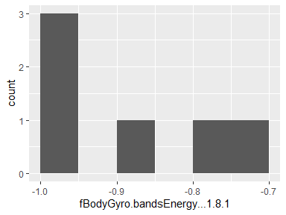

## fBodyGyro.bandsEnergy…9.16.1

|  |  |
| --- | --- |
| Feature | Result |
| Variable type | numeric |
| Number of missing obs. | 0 (0 %) |
| Number of unique values | 6 |
| Median | -0.97 |
| 1st and 3rd quartiles | -1; -0.93 |
| Min. and max. | -1; -0.89 |

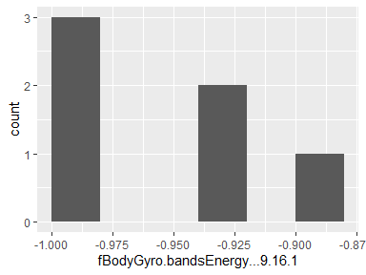

## fBodyGyro.bandsEnergy…17.24.1

|  |  |
| --- | --- |
| Feature | Result |
| Variable type | numeric |
| Number of missing obs. | 0 (0 %) |
| Number of unique values | 6 |
| Median | -0.98 |
| 1st and 3rd quartiles | -1; -0.93 |
| Min. and max. | -1; -0.91 |

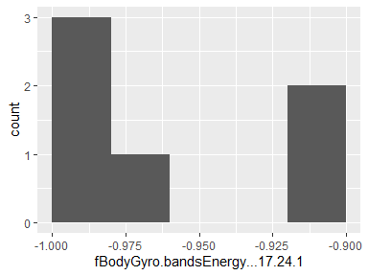

## fBodyGyro.bandsEnergy…25.32.1

|  |  |
| --- | --- |
| Feature | Result |
| Variable type | numeric |
| Number of missing obs. | 0 (0 %) |
| Number of unique values | 6 |
| Median | -0.99 |
| 1st and 3rd quartiles | -1; -0.94 |
| Min. and max. | -1; -0.92 |

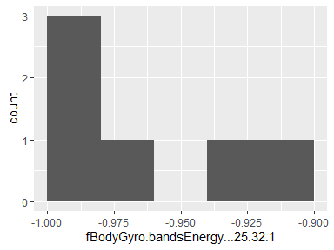

## fBodyGyro.bandsEnergy…33.40.1

|  |  |
| --- | --- |
| Feature | Result |
| Variable type | numeric |
| Number of missing obs. | 0 (0 %) |
| Number of unique values | 6 |
| Median | -0.99 |
| 1st and 3rd quartiles | -1; -0.96 |
| Min. and max. | -1; -0.94 |

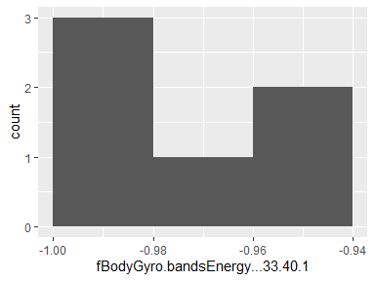

## fBodyGyro.bandsEnergy…41.48.1

|  |  |
| --- | --- |
| Feature | Result |
| Variable type | numeric |
| Number of missing obs. | 0 (0 %) |
| Number of unique values | 6 |
| Median | -0.98 |
| 1st and 3rd quartiles | -1; -0.93 |
| Min. and max. | -1; -0.9 |

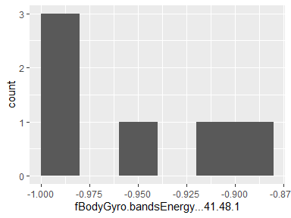

## fBodyGyro.bandsEnergy…49.56.1

|  |  |
| --- | --- |
| Feature | Result |
| Variable type | numeric |
| Number of missing obs. | 0 (0 %) |
| Number of unique values | 6 |
| Median | -0.97 |
| 1st and 3rd quartiles | -1; -0.92 |
| Min. and max. | -1; -0.88 |

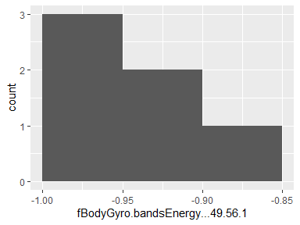

## fBodyGyro.bandsEnergy…57.64.1

|  |  |
| --- | --- |
| Feature | Result |
| Variable type | numeric |
| Number of missing obs. | 0 (0 %) |
| Number of unique values | 6 |
| Median | -0.98 |
| 1st and 3rd quartiles | -1; -0.96 |
| Min. and max. | -1; -0.95 |

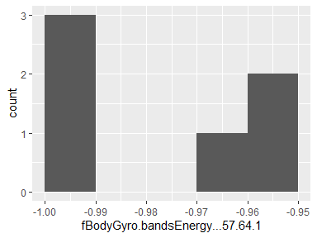

## fBodyGyro.bandsEnergy…1.16.1

|  |  |
| --- | --- |
| Feature | Result |
| Variable type | numeric |
| Number of missing obs. | 0 (0 %) |
| Number of unique values | 6 |
| Median | -0.92 |
| 1st and 3rd quartiles | -1; -0.82 |
| Min. and max. | -1; -0.77 |

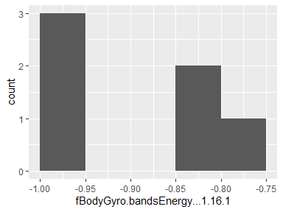

## fBodyGyro.bandsEnergy…17.32.1

|  |  |
| --- | --- |
| Feature | Result |
| Variable type | numeric |
| Number of missing obs. | 0 (0 %) |
| Number of unique values | 6 |
| Median | -0.98 |
| 1st and 3rd quartiles | -1; -0.91 |
| Min. and max. | -1; -0.89 |

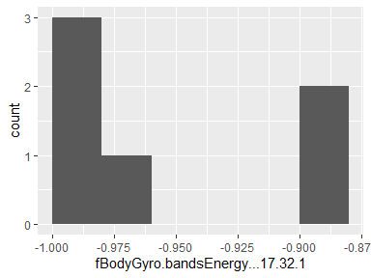

## fBodyGyro.bandsEnergy…33.48.1

|  |  |
| --- | --- |
| Feature | Result |
| Variable type | numeric |
| Number of missing obs. | 0 (0 %) |
| Number of unique values | 6 |
| Median | -0.99 |
| 1st and 3rd quartiles | -1; -0.95 |
| Min. and max. | -1; -0.93 |

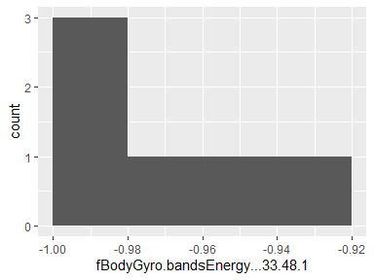

## fBodyGyro.bandsEnergy…49.64.1

|  |  |
| --- | --- |
| Feature | Result |
| Variable type | numeric |
| Number of missing obs. | 0 (0 %) |
| Number of unique values | 6 |
| Median | -0.97 |
| 1st and 3rd quartiles | -1; -0.92 |
| Min. and max. | -1; -0.9 |

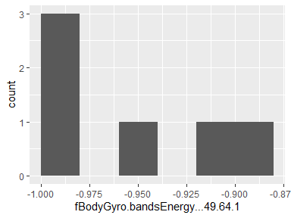

## fBodyGyro.bandsEnergy…1.24.1

|  |  |
| --- | --- |
| Feature | Result |
| Variable type | numeric |
| Number of missing obs. | 0 (0 %) |
| Number of unique values | 6 |
| Median | -0.9 |
| 1st and 3rd quartiles | -1; -0.79 |
| Min. and max. | -1; -0.77 |

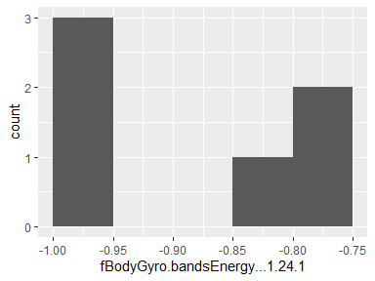

## fBodyGyro.bandsEnergy…25.48.1

|  |  |
| --- | --- |
| Feature | Result |
| Variable type | numeric |
| Number of missing obs. | 0 (0 %) |
| Number of unique values | 6 |
| Median | -0.99 |
| 1st and 3rd quartiles | -1; -0.94 |
| Min. and max. | -1; -0.92 |

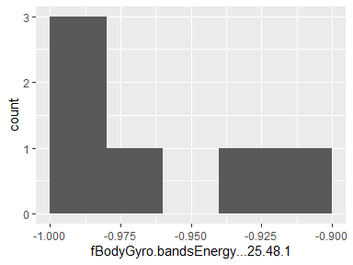

## fBodyGyro.bandsEnergy…1.8.2

|  |  |
| --- | --- |
| Feature | Result |
| Variable type | numeric |
| Number of missing obs. | 0 (0 %) |
| Number of unique values | 6 |
| Median | -0.92 |
| 1st and 3rd quartiles | -1; -0.83 |
| Min. and max. | -1; -0.71 |

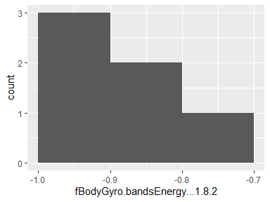

## fBodyGyro.bandsEnergy…9.16.2

|  |  |
| --- | --- |
| Feature | Result |
| Variable type | numeric |
| Number of missing obs. | 0 (0 %) |
| Number of unique values | 6 |
| Median | -0.95 |
| 1st and 3rd quartiles | -1; -0.89 |
| Min. and max. | -1; -0.8 |

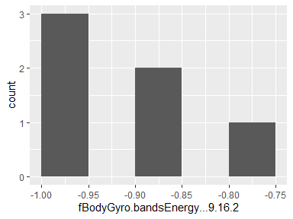

## fBodyGyro.bandsEnergy…17.24.2

|  |  |
| --- | --- |
| Feature | Result |
| Variable type | numeric |
| Number of missing obs. | 0 (0 %) |
| Number of unique values | 6 |
| Median | -0.96 |
| 1st and 3rd quartiles | -1; -0.88 |
| Min. and max. | -1; -0.81 |

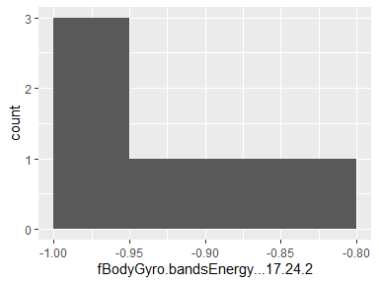

## fBodyGyro.bandsEnergy…25.32.2

|  |  |
| --- | --- |
| Feature | Result |
| Variable type | numeric |
| Number of missing obs. | 0 (0 %) |
| Number of unique values | 6 |
| Median | -0.98 |
| 1st and 3rd quartiles | -1; -0.93 |
| Min. and max. | -1; -0.88 |

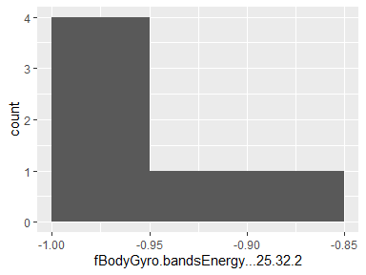

## fBodyGyro.bandsEnergy…33.40.2

|  |  |
| --- | --- |
| Feature | Result |
| Variable type | numeric |
| Number of missing obs. | 0 (0 %) |
| Number of unique values | 6 |
| Median | -0.98 |
| 1st and 3rd quartiles | -1; -0.95 |
| Min. and max. | -1; -0.9 |

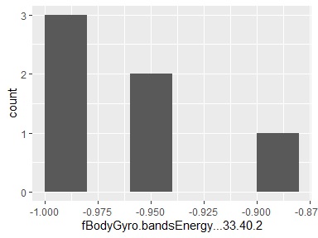

## fBodyGyro.bandsEnergy…41.48.2

|  |  |
| --- | --- |
| Feature | Result |
| Variable type | numeric |
| Number of missing obs. | 0 (0 %) |
| Number of unique values | 6 |
| Median | -0.97 |
| 1st and 3rd quartiles | -1; -0.93 |
| Min. and max. | -1; -0.88 |

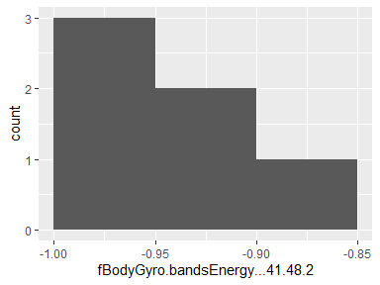

## fBodyGyro.bandsEnergy…49.56.2

|  |  |
| --- | --- |
| Feature | Result |
| Variable type | numeric |
| Number of missing obs. | 0 (0 %) |
| Number of unique values | 6 |
| Median | -0.96 |
| 1st and 3rd quartiles | -1; -0.91 |
| Min. and max. | -1; -0.86 |

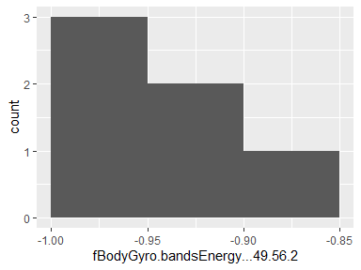

## fBodyGyro.bandsEnergy…57.64.2

|  |  |
| --- | --- |
| Feature | Result |
| Variable type | numeric |
| Number of missing obs. | 0 (0 %) |
| Number of unique values | 6 |
| Median | -0.98 |
| 1st and 3rd quartiles | -1; -0.94 |
| Min. and max. | -1; -0.93 |

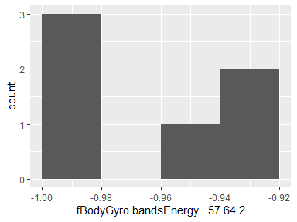

## fBodyGyro.bandsEnergy…1.16.2

|  |  |
| --- | --- |
| Feature | Result |
| Variable type | numeric |
| Number of missing obs. | 0 (0 %) |
| Number of unique values | 6 |
| Median | -0.91 |
| 1st and 3rd quartiles | -1; -0.78 |
| Min. and max. | -1; -0.69 |

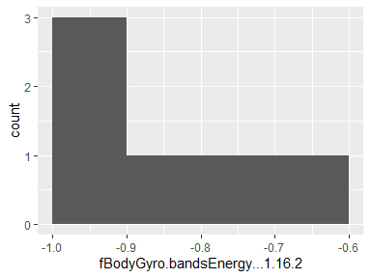

## fBodyGyro.bandsEnergy…17.32.2

|  |  |
| --- | --- |
| Feature | Result |
| Variable type | numeric |
| Number of missing obs. | 0 (0 %) |
| Number of unique values | 6 |
| Median | -0.95 |
| 1st and 3rd quartiles | -1; -0.85 |
| Min. and max. | -1; -0.76 |

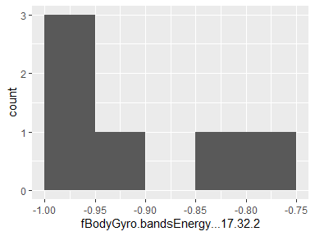

## fBodyGyro.bandsEnergy…33.48.2

|  |  |
| --- | --- |
| Feature | Result |
| Variable type | numeric |
| Number of missing obs. | 0 (0 %) |
| Number of unique values | 6 |
| Median | -0.97 |
| 1st and 3rd quartiles | -1; -0.95 |
| Min. and max. | -1; -0.89 |

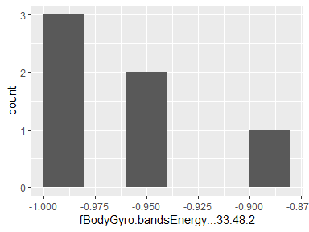

## fBodyGyro.bandsEnergy…49.64.2

|  |  |
| --- | --- |
| Feature | Result |
| Variable type | numeric |
| Number of missing obs. | 0 (0 %) |
| Number of unique values | 6 |
| Median | -0.96 |
| 1st and 3rd quartiles | -1; -0.93 |
| Min. and max. | -1; -0.89 |

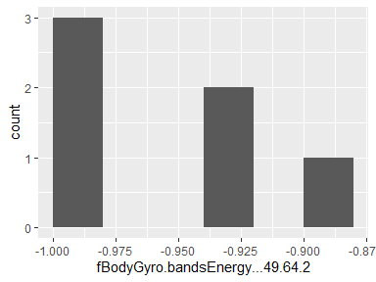

## fBodyGyro.bandsEnergy…1.24.2

|  |  |
| --- | --- |
| Feature | Result |
| Variable type | numeric |
| Number of missing obs. | 0 (0 %) |
| Number of unique values | 6 |
| Median | -0.9 |
| 1st and 3rd quartiles | -1; -0.75 |
| Min. and max. | -1; -0.68 |

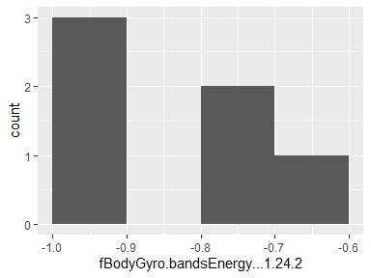

## fBodyGyro.bandsEnergy…25.48.2

|  |  |
| --- | --- |
| Feature | Result |
| Variable type | numeric |
| Number of missing obs. | 0 (0 %) |
| Number of unique values | 6 |
| Median | -0.97 |
| 1st and 3rd quartiles | -1; -0.94 |
| Min. and max. | -1; -0.88 |

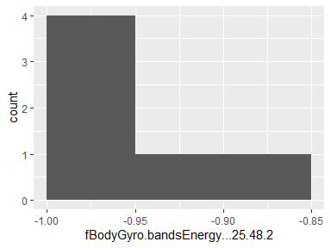

## fBodyAccMag.mean..

|  |  |
| --- | --- |
| Feature | Result |
| Variable type | numeric |
| Number of missing obs. | 0 (0 %) |
| Number of unique values | 6 |
| Median | -0.62 |
| 1st and 3rd quartiles | -0.95; -0.28 |
| Min. and max. | -0.96; 0.08 |

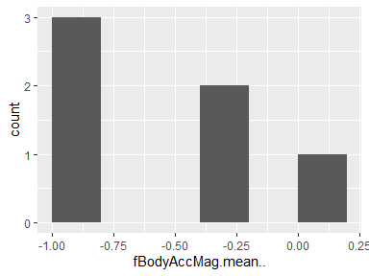

## fBodyAccMag.std..

|  |  |
| --- | --- |
| Feature | Result |
| Variable type | numeric |
| Number of missing obs. | 0 (0 %) |
| Number of unique values | 6 |
| Median | -0.72 |
| 1st and 3rd quartiles | -0.94; -0.42 |
| Min. and max. | -0.95; -0.13 |

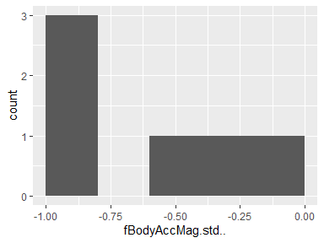

## fBodyAccMag.mad..

|  |  |
| --- | --- |
| Feature | Result |
| Variable type | numeric |
| Number of missing obs. | 0 (0 %) |
| Number of unique values | 6 |
| Median | -0.66 |
| 1st and 3rd quartiles | -0.94; -0.3 |
| Min. and max. | -0.95; 0.06 |

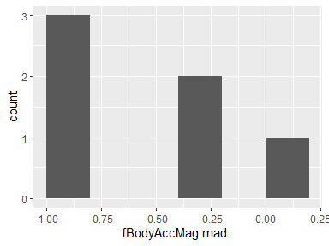

## fBodyAccMag.max..

|  |  |
| --- | --- |
| Feature | Result |
| Variable type | numeric |
| Number of missing obs. | 0 (0 %) |
| Number of unique values | 6 |
| Median | -0.81 |
| 1st and 3rd quartiles | -0.95; -0.59 |
| Min. and max. | -0.96; -0.41 |

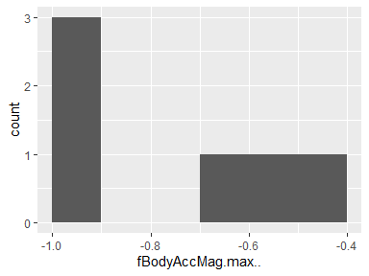

## fBodyAccMag.min..

|  |  |
| --- | --- |
| Feature | Result |
| Variable type | numeric |
| Number of missing obs. | 0 (0 %) |
| Number of unique values | 6 |
| Median | -0.9 |
| 1st and 3rd quartiles | -0.97; -0.81 |
| Min. and max. | -0.98; -0.75 |

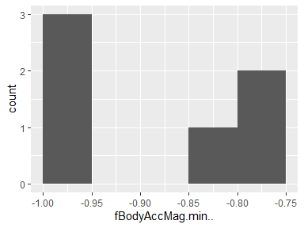

## fBodyAccMag.sma..

|  |  |
| --- | --- |
| Feature | Result |
| Variable type | numeric |
| Number of missing obs. | 0 (0 %) |
| Number of unique values | 6 |
| Median | -0.62 |
| 1st and 3rd quartiles | -0.95; -0.28 |
| Min. and max. | -0.96; 0.08 |

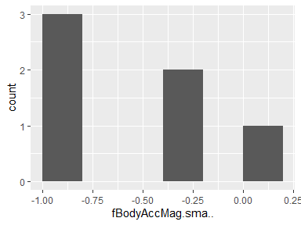

## fBodyAccMag.energy..

|  |  |
| --- | --- |
| Feature | Result |
| Variable type | numeric |
| Number of missing obs. | 0 (0 %) |
| Number of unique values | 6 |
| Median | -0.88 |
| 1st and 3rd quartiles | -0.99; -0.74 |
| Min. and max. | -0.99; -0.42 |

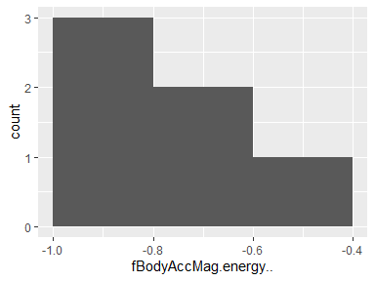

## fBodyAccMag.iqr..

|  |  |
| --- | --- |
| Feature | Result |
| Variable type | numeric |
| Number of missing obs. | 0 (0 %) |
| Number of unique values | 6 |
| Median | -0.72 |
| 1st and 3rd quartiles | -0.97; -0.47 |
| Min. and max. | -0.98; -0.18 |

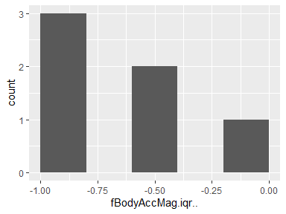

## fBodyAccMag.entropy..

|  |  |
| --- | --- |
| Feature | Result |
| Variable type | numeric |
| Number of missing obs. | 0 (0 %) |
| Number of unique values | 6 |
| Median | -0.14 |
| 1st and 3rd quartiles | -0.77; 0.45 |
| Min. and max. | -0.81; 0.64 |

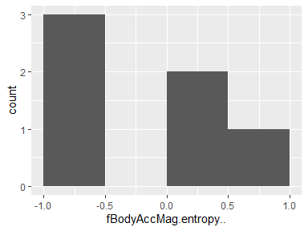

## fBodyAccMag.maxInds

|  |  |
| --- | --- |
| Feature | Result |
| Variable type | numeric |
| Number of missing obs. | 0 (0 %) |
| Number of unique values | 6 |
| Median | -0.76 |
| 1st and 3rd quartiles | -0.87; -0.64 |
| Min. and max. | -0.91; -0.55 |

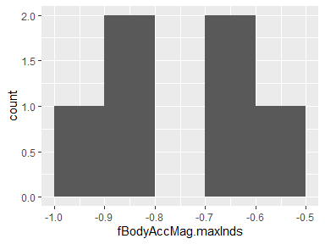

## fBodyAccMag.meanFreq..

|  |  |
| --- | --- |
| Feature | Result |
| Variable type | numeric |
| Number of missing obs. | 0 (0 %) |
| Number of unique values | 6 |
| Median | 0.06 |
| 1st and 3rd quartiles | 0.02; 0.15 |
| Min. and max. | -0.05; 0.25 |

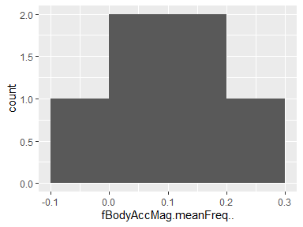

## fBodyAccMag.skewness..

|  |  |
| --- | --- |
| Feature | Result |
| Variable type | numeric |
| Number of missing obs. | 0 (0 %) |
| Number of unique values | 6 |
| Median | -0.35 |
| 1st and 3rd quartiles | -0.41; -0.32 |
| Min. and max. | -0.5; -0.27 |

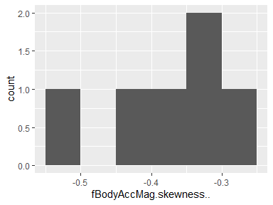

## fBodyAccMag.kurtosis..

|  |  |
| --- | --- |
| Feature | Result |
| Variable type | numeric |
| Number of missing obs. | 0 (0 %) |
| Number of unique values | 6 |
| Median | -0.64 |
| 1st and 3rd quartiles | -0.72; -0.58 |
| Min. and max. | -0.77; -0.56 |

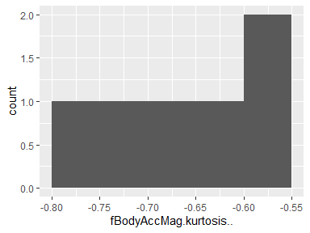

## fBodyBodyAccJerkMag.mean..

|  |  |
| --- | --- |
| Feature | Result |
| Variable type | numeric |
| Number of missing obs. | 0 (0 %) |
| Number of unique values | 6 |
| Median | -0.66 |
| 1st and 3rd quartiles | -0.97; -0.24 |
| Min. and max. | -0.98; -0.05 |

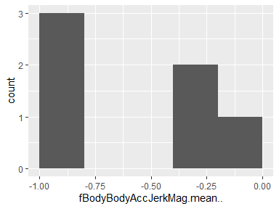

## fBodyBodyAccJerkMag.std..

|  |  |
| --- | --- |
| Feature | Result |
| Variable type | numeric |
| Number of missing obs. | 0 (0 %) |
| Number of unique values | 6 |
| Median | -0.69 |
| 1st and 3rd quartiles | -0.97; -0.26 |
| Min. and max. | -0.98; -0.05 |

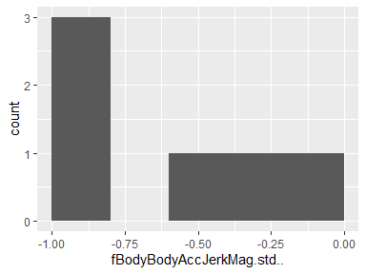

## fBodyBodyAccJerkMag.mad..

|  |  |
| --- | --- |
| Feature | Result |
| Variable type | numeric |
| Number of missing obs. | 0 (0 %) |
| Number of unique values | 6 |
| Median | -0.66 |
| 1st and 3rd quartiles | -0.97; -0.22 |
| Min. and max. | -0.97; -0.03 |

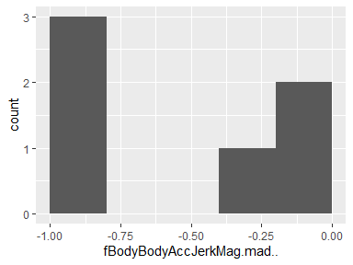

## fBodyBodyAccJerkMag.max..

|  |  |
| --- | --- |
| Feature | Result |
| Variable type | numeric |
| Number of missing obs. | 0 (0 %) |
| Number of unique values | 6 |
| Median | -0.74 |
| 1st and 3rd quartiles | -0.98; -0.34 |
| Min. and max. | -0.98; -0.11 |

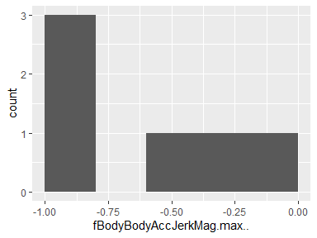

## fBodyBodyAccJerkMag.min..

|  |  |
| --- | --- |
| Feature | Result |
| Variable type | numeric |
| Number of missing obs. | 0 (0 %) |
| Number of unique values | 6 |
| Median | -0.82 |
| 1st and 3rd quartiles | -0.98; -0.61 |
| Min. and max. | -0.98; -0.51 |

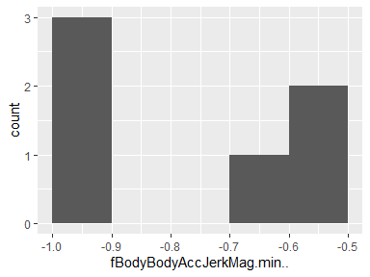

## fBodyBodyAccJerkMag.sma..

|  |  |
| --- | --- |
| Feature | Result |
| Variable type | numeric |
| Number of missing obs. | 0 (0 %) |
| Number of unique values | 6 |
| Median | -0.66 |
| 1st and 3rd quartiles | -0.97; -0.24 |
| Min. and max. | -0.98; -0.05 |

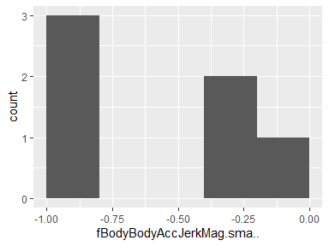

## fBodyBodyAccJerkMag.energy..

|  |  |
| --- | --- |
| Feature | Result |
| Variable type | numeric |
| Number of missing obs. | 0 (0 %) |
| Number of unique values | 6 |
| Median | -0.9 |
| 1st and 3rd quartiles | -1; -0.69 |
| Min. and max. | -1; -0.51 |

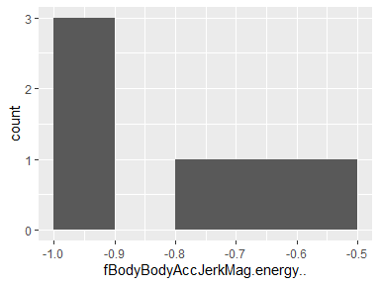

## fBodyBodyAccJerkMag.iqr..

|  |  |
| --- | --- |
| Feature | Result |
| Variable type | numeric |
| Number of missing obs. | 0 (0 %) |
| Number of unique values | 6 |
| Median | -0.7 |
| 1st and 3rd quartiles | -0.98; -0.36 |
| Min. and max. | -0.98; -0.2 |

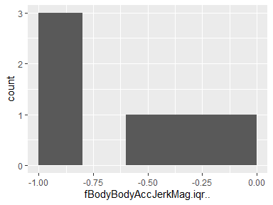

## fBodyBodyAccJerkMag.entropy..

|  |  |
| --- | --- |
| Feature | Result |
| Variable type | numeric |
| Number of missing obs. | 0 (0 %) |
| Number of unique values | 6 |
| Median | -0.31 |
| 1st and 3rd quartiles | -0.91; 0.33 |
| Min. and max. | -0.94; 0.47 |

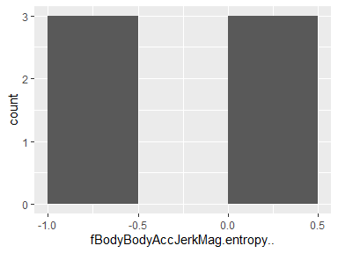

## fBodyBodyAccJerkMag.maxInds

|  |  |
| --- | --- |
| Feature | Result |
| Variable type | numeric |
| Number of missing obs. | 0 (0 %) |
| Number of unique values | 6 |
| Median | -0.89 |
| 1st and 3rd quartiles | -0.89; -0.87 |
| Min. and max. | -0.9; -0.84 |

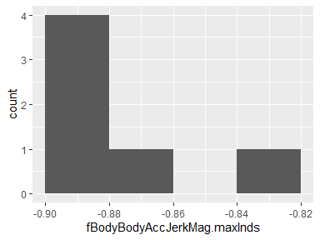

## fBodyBodyAccJerkMag.meanFreq..

|  |  |
| --- | --- |
| Feature | Result |
| Variable type | numeric |
| Number of missing obs. | 0 (0 %) |
| Number of unique values | 6 |
| Median | 0.16 |
| 1st and 3rd quartiles | 0.04; 0.26 |
| Min. and max. | 0.01; 0.29 |

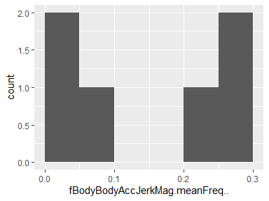

## fBodyBodyAccJerkMag.skewness..

|  |  |
| --- | --- |
| Feature | Result |
| Variable type | numeric |
| Number of missing obs. | 0 (0 %) |
| Number of unique values | 6 |
| Median | -0.33 |
| 1st and 3rd quartiles | -0.46; -0.02 |
| Min. and max. | -0.49; 0.07 |

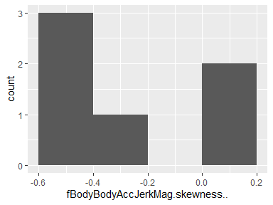

## fBodyBodyAccJerkMag.kurtosis..

|  |  |
| --- | --- |
| Feature | Result |
| Variable type | numeric |
| Number of missing obs. | 0 (0 %) |
| Number of unique values | 6 |
| Median | -0.64 |
| 1st and 3rd quartiles | -0.75; -0.35 |
| Min. and max. | -0.76; -0.23 |

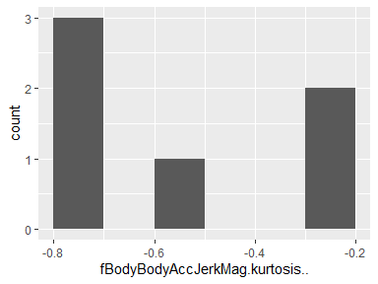

## fBodyBodyGyroMag.mean..

|  |  |
| --- | --- |
| Feature | Result |
| Variable type | numeric |
| Number of missing obs. | 0 (0 %) |
| Number of unique values | 6 |
| Median | -0.72 |
| 1st and 3rd quartiles | -0.95; -0.46 |
| Min. and max. | -0.96; -0.34 |

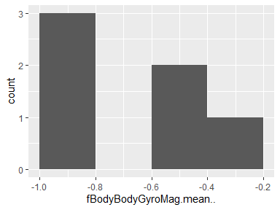

## fBodyBodyGyroMag.std..

|  |  |
| --- | --- |
| Feature | Result |
| Variable type | numeric |
| Number of missing obs. | 0 (0 %) |
| Number of unique values | 6 |
| Median | -0.72 |
| 1st and 3rd quartiles | -0.94; -0.48 |
| Min. and max. | -0.95; -0.41 |

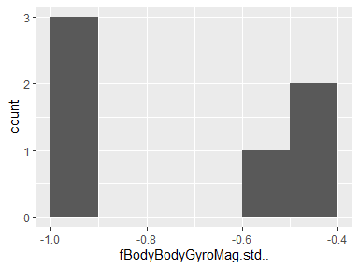

## fBodyBodyGyroMag.mad..

|  |  |
| --- | --- |
| Feature | Result |
| Variable type | numeric |
| Number of missing obs. | 0 (0 %) |
| Number of unique values | 6 |
| Median | -0.7 |
| 1st and 3rd quartiles | -0.94; -0.44 |
| Min. and max. | -0.96; -0.35 |

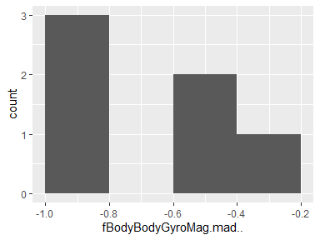

## fBodyBodyGyroMag.max..

|  |  |
| --- | --- |
| Feature | Result |
| Variable type | numeric |
| Number of missing obs. | 0 (0 %) |
| Number of unique values | 6 |
| Median | -0.76 |
| 1st and 3rd quartiles | -0.94; -0.55 |
| Min. and max. | -0.95; -0.49 |

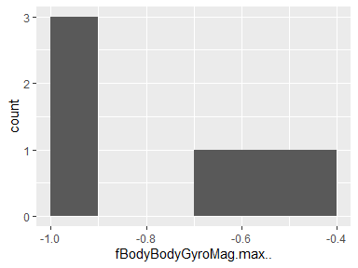

## fBodyBodyGyroMag.min..

|  |  |
| --- | --- |
| Feature | Result |
| Variable type | numeric |
| Number of missing obs. | 0 (0 %) |
| Number of unique values | 6 |
| Median | -0.91 |
| 1st and 3rd quartiles | -0.97; -0.82 |
| Min. and max. | -0.97; -0.77 |

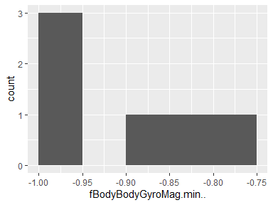

## fBodyBodyGyroMag.sma..

|  |  |
| --- | --- |
| Feature | Result |
| Variable type | numeric |
| Number of missing obs. | 0 (0 %) |
| Number of unique values | 6 |
| Median | -0.72 |
| 1st and 3rd quartiles | -0.95; -0.46 |
| Min. and max. | -0.96; -0.34 |

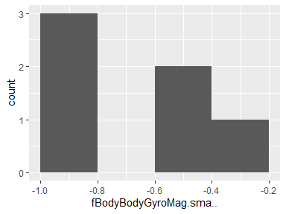

## fBodyBodyGyroMag.energy..

|  |  |
| --- | --- |
| Feature | Result |
| Variable type | numeric |
| Number of missing obs. | 0 (0 %) |
| Number of unique values | 6 |
| Median | -0.9 |
| 1st and 3rd quartiles | -0.99; -0.81 |
| Min. and max. | -1; -0.74 |

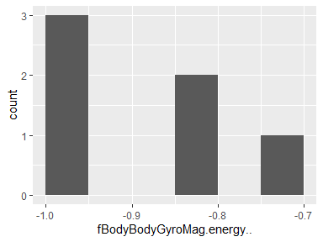

## fBodyBodyGyroMag.iqr..

|  |  |
| --- | --- |
| Feature | Result |
| Variable type | numeric |
| Number of missing obs. | 0 (0 %) |
| Number of unique values | 6 |
| Median | -0.73 |
| 1st and 3rd quartiles | -0.96; -0.49 |
| Min. and max. | -0.97; -0.39 |

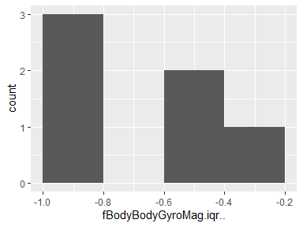

## fBodyBodyGyroMag.entropy..

|  |  |
| --- | --- |
| Feature | Result |
| Variable type | numeric |
| Number of missing obs. | 0 (0 %) |
| Number of unique values | 6 |
| Median | -0.01 |
| 1st and 3rd quartiles | -0.54; 0.51 |
| Min. and max. | -0.62; 0.58 |

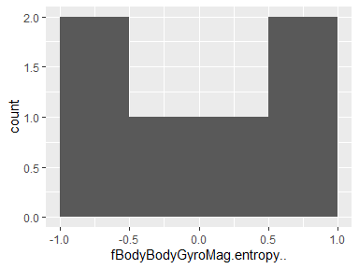

## fBodyBodyGyroMag.maxInds

|  |  |
| --- | --- |
| Feature | Result |
| Variable type | numeric |
| Number of missing obs. | 0 (0 %) |
| Number of unique values | 6 |
| Median | -0.92 |
| 1st and 3rd quartiles | -0.95; -0.88 |
| Min. and max. | -0.95; -0.67 |

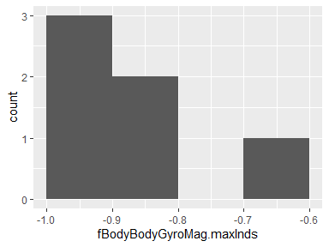

## fBodyBodyGyroMag.meanFreq..

|  |  |
| --- | --- |
| Feature | Result |
| Variable type | numeric |
| Number of missing obs. | 0 (0 %) |
| Number of unique values | 6 |
| Median | -0.04 |
| 1st and 3rd quartiles | -0.13; 0.06 |
| Min. and max. | -0.21; 0.2 |

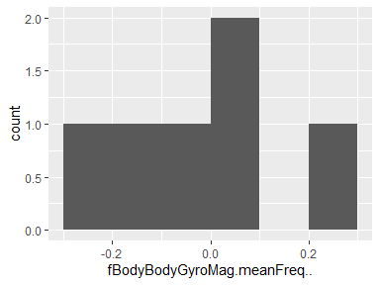

## fBodyBodyGyroMag.skewness..

|  |  |
| --- | --- |
| Feature | Result |
| Variable type | numeric |
| Number of missing obs. | 0 (0 %) |
| Number of unique values | 6 |
| Median | -0.27 |
| 1st and 3rd quartiles | -0.38; -0.22 |
| Min. and max. | -0.44; -0.18 |

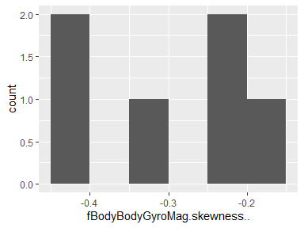

## fBodyBodyGyroMag.kurtosis..

|  |  |
| --- | --- |
| Feature | Result |
| Variable type | numeric |
| Number of missing obs. | 0 (0 %) |
| Number of unique values | 6 |
| Median | -0.6 |
| 1st and 3rd quartiles | -0.69; -0.53 |
| Min. and max. | -0.73; -0.49 |

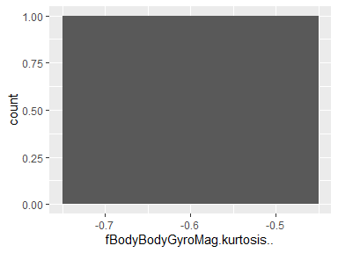

## fBodyBodyGyroJerkMag.mean..

|  |  |
| --- | --- |
| Feature | Result |
| Variable type | numeric |
| Number of missing obs. | 0 (0 %) |
| Number of unique values | 6 |
| Median | -0.82 |
| 1st and 3rd quartiles | -0.97; -0.57 |
| Min. and max. | -0.98; -0.47 |

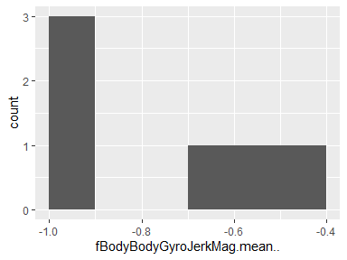

## fBodyBodyGyroJerkMag.std..

|  |  |
| --- | --- |
| Feature | Result |
| Variable type | numeric |
| Number of missing obs. | 0 (0 %) |
| Number of unique values | 6 |
| Median | -0.84 |
| 1st and 3rd quartiles | -0.97; -0.59 |
| Min. and max. | -0.98; -0.49 |

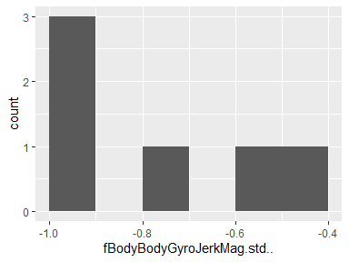

## fBodyBodyGyroJerkMag.mad..

|  |  |
| --- | --- |
| Feature | Result |
| Variable type | numeric |
| Number of missing obs. | 0 (0 %) |
| Number of unique values | 6 |
| Median | -0.82 |
| 1st and 3rd quartiles | -0.97; -0.56 |
| Min. and max. | -0.98; -0.46 |

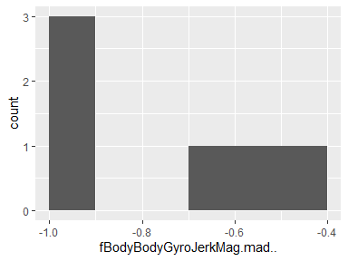

## fBodyBodyGyroJerkMag.max..

|  |  |
| --- | --- |
| Feature | Result |
| Variable type | numeric |
| Number of missing obs. | 0 (0 %) |
| Number of unique values | 6 |
| Median | -0.86 |
| 1st and 3rd quartiles | -0.98; -0.61 |
| Min. and max. | -0.99; -0.53 |

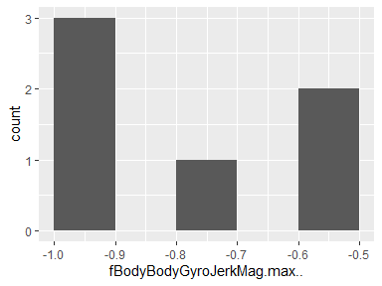

## fBodyBodyGyroJerkMag.min..

|  |  |
| --- | --- |
| Feature | Result |
| Variable type | numeric |
| Number of missing obs. | 0 (0 %) |
| Number of unique values | 6 |
| Median | -0.89 |
| 1st and 3rd quartiles | -0.98; -0.74 |
| Min. and max. | -0.99; -0.69 |

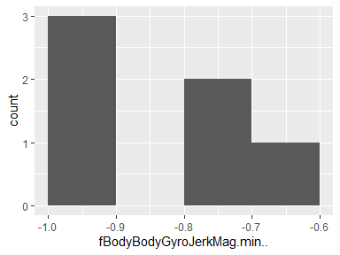

## fBodyBodyGyroJerkMag.sma..

|  |  |
| --- | --- |
| Feature | Result |
| Variable type | numeric |
| Number of missing obs. | 0 (0 %) |
| Number of unique values | 6 |
| Median | -0.82 |
| 1st and 3rd quartiles | -0.97; -0.57 |
| Min. and max. | -0.98; -0.47 |

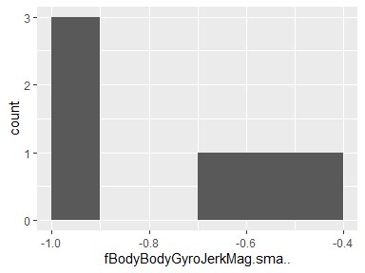

## fBodyBodyGyroJerkMag.energy..

|  |  |
| --- | --- |
| Feature | Result |
| Variable type | numeric |
| Number of missing obs. | 0 (0 %) |
| Number of unique values | 6 |
| Median | -0.97 |
| 1st and 3rd quartiles | -1; -0.88 |
| Min. and max. | -1; -0.83 |

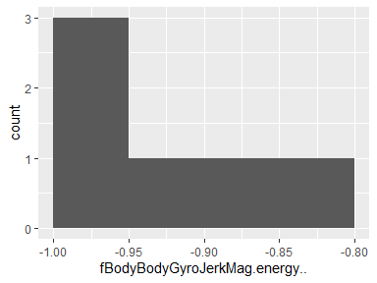

## fBodyBodyGyroJerkMag.iqr..

|  |  |
| --- | --- |
| Feature | Result |
| Variable type | numeric |
| Number of missing obs. | 0 (0 %) |
| Number of unique values | 6 |
| Median | -0.81 |
| 1st and 3rd quartiles | -0.97; -0.56 |
| Min. and max. | -0.98; -0.47 |

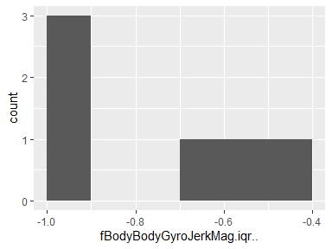

## fBodyBodyGyroJerkMag.entropy..

|  |  |
| --- | --- |
| Feature | Result |
| Variable type | numeric |
| Number of missing obs. | 0 (0 %) |
| Number of unique values | 6 |
| Median | -0.24 |
| 1st and 3rd quartiles | -0.76; 0.35 |
| Min. and max. | -0.85; 0.43 |

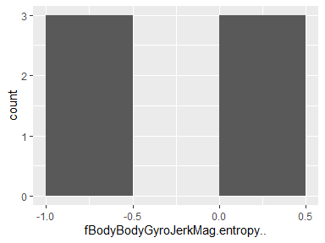

## fBodyBodyGyroJerkMag.maxInds

|  |  |
| --- | --- |
| Feature | Result |
| Variable type | numeric |
| Number of missing obs. | 0 (0 %) |
| Number of unique values | 6 |
| Median | -0.9 |
| 1st and 3rd quartiles | -0.92; -0.88 |
| Min. and max. | -0.94; -0.87 |

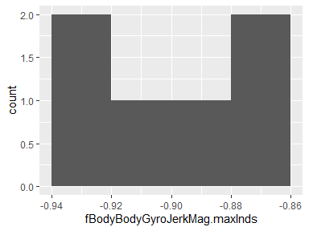

## fBodyBodyGyroJerkMag.meanFreq..

|  |  |
| --- | --- |
| Feature | Result |
| Variable type | numeric |
| Number of missing obs. | 0 (0 %) |
| Number of unique values | 6 |
| Median | 0.13 |
| 1st and 3rd quartiles | 0.09; 0.17 |
| Min. and max. | 0.06; 0.19 |

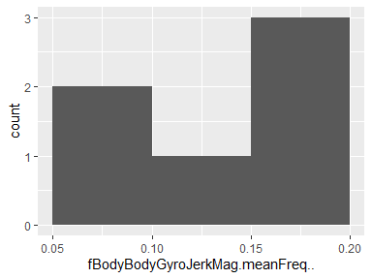

## fBodyBodyGyroJerkMag.skewness..

|  |  |
| --- | --- |
| Feature | Result |
| Variable type | numeric |
| Number of missing obs. | 0 (0 %) |
| Number of unique values | 6 |
| Median | -0.32 |
| 1st and 3rd quartiles | -0.35; -0.21 |
| Min. and max. | -0.38; -0.09 |

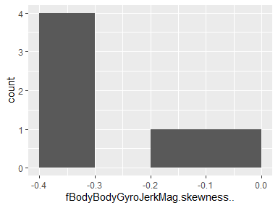

## fBodyBodyGyroJerkMag.kurtosis..

|  |  |
| --- | --- |
| Feature | Result |
| Variable type | numeric |
| Number of missing obs. | 0 (0 %) |
| Number of unique values | 6 |
| Median | -0.64 |
| 1st and 3rd quartiles | -0.67; -0.54 |
| Min. and max. | -0.69; -0.41 |

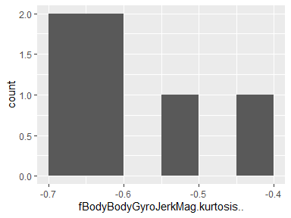

## angle.tBodyAccMean.gravity.

|  |  |
| --- | --- |
| Feature | Result |
| Variable type | numeric |
| Number of missing obs. | 0 (0 %) |
| Number of unique values | 6 |
| Median | 0 |
| 1st and 3rd quartiles | 0; 0.01 |
| Min. and max. | -0.04; 0.05 |

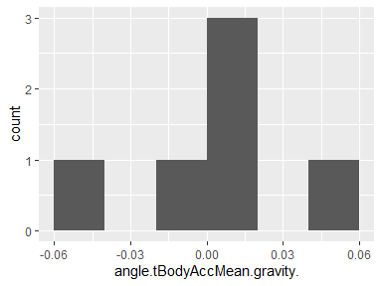

## angle.tBodyAccJerkMean..gravityMean.

|  |  |
| --- | --- |
| Feature | Result |
| Variable type | numeric |
| Number of missing obs. | 0 (0 %) |
| Number of unique values | 6 |
| Median | 0 |
| 1st and 3rd quartiles | 0; 0.01 |
| Min. and max. | -0.01; 0.01 |

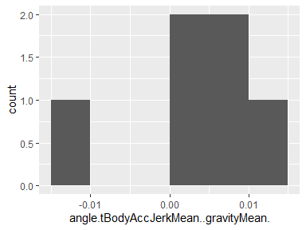

## angle.tBodyGyroMean.gravityMean.

|  |  |
| --- | --- |
| Feature | Result |
| Variable type | numeric |
| Number of missing obs. | 0 (0 %) |
| Number of unique values | 6 |
| Median | 0.02 |
| 1st and 3rd quartiles | 0.01; 0.04 |
| Min. and max. | -0.07; 0.25 |

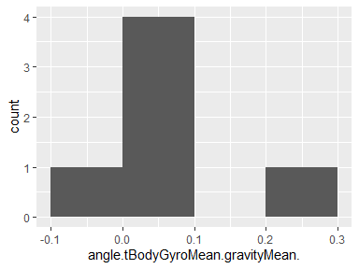

## angle.tBodyGyroJerkMean.gravityMean.

|  |  |
| --- | --- |
| Feature | Result |
| Variable type | numeric |
| Number of missing obs. | 0 (0 %) |
| Number of unique values | 6 |
| Median | -0.01 |
| 1st and 3rd quartiles | -0.04; 0.01 |
| Min. and max. | -0.09; 0.02 |

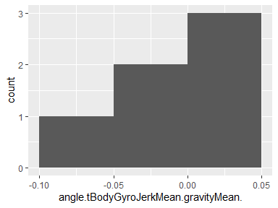

## angle.X.gravityMean.

|  |  |
| --- | --- |
| Feature | Result |
| Variable type | numeric |
| Number of missing obs. | 0 (0 %) |
| Number of unique values | 6 |
| Median | -0.76 |
| 1st and 3rd quartiles | -0.77; -0.67 |
| Min. and max. | -0.79; 0.53 |

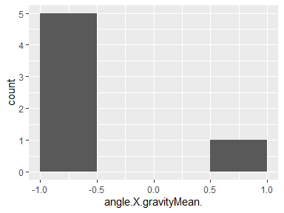

## angle.Y.gravityMean.

|  |  |
| --- | --- |
| Feature | Result |
| Variable type | numeric |
| Number of missing obs. | 0 (0 %) |
| Number of unique values | 6 |
| Median | 0.21 |
| 1st and 3rd quartiles | 0.07; 0.21 |
| Min. and max. | -0.42; 0.27 |

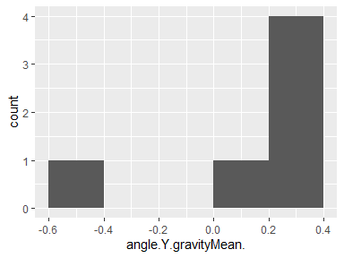

## angle.Z.gravityMean.

|  |  |
| --- | --- |
| Feature | Result |
| Variable type | numeric |
| Number of missing obs. | 0 (0 %) |
| Number of unique values | 6 |
| Median | 0.02 |
| 1st and 3rd quartiles | -0.05; 0.05 |
| Min. and max. | -0.38; 0.11 |

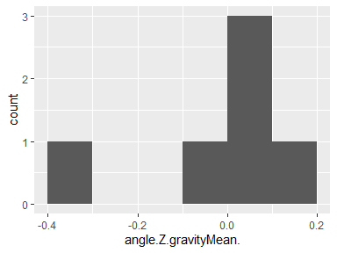

Report generation information:

* Created by: GeorgiNgE (username: Georgi).
* Report creation time: Wed Oct 14 2020 14:56:58
* Report was run from directory: D:/Git/proiecte/Getting and Cleaning Data Course Project
* dataMaid v1.4.0 [Pkg: 2019-12-10 from CRAN (R 3.6.3)]
* R version 3.6.3 (2020-02-29).
* Platform: x86_64-w64-mingw32/x64 (64-bit)(Windows 10 x64 (build 19041)).
* Function call: dataMaid::makeDataReport(data = final2, mode = c("summarize", "visualize", "check"), smartNum = FALSE, file = "codebook_final2.Rmd", checks = list(character = "showAllFactorLevels", factor = "showAllFactorLevels", labelled = "showAllFactorLevels", haven_labelled = "showAllFactorLevels", numeric = NULL, integer = NULL, logical = NULL, Date = NULL), listChecks = FALSE, maxProbVals = Inf, codebook = TRUE, reportTitle = "Codebook for final2")