
AI for Developers – January 2026
Individual Project Assignment

Project Description
CookingIdeaGenerator is a full-stack web application that helps users generate meal ideas from ingredients they already have at home. The app starts with one ingredient field and allows the user to add additional fields dynamically (up to ten). After submitting ingredients, the system searches for matching recipes on the web and returns 2-3 suggestions. The result list can be refreshed to fetch alternative recipes, and each result includes a direct recipe link. If web lookup fails, the backend returns local fallback suggestions so the application remains usable.
System Scope and Requirements
Implemented scope includes a React + Vite frontend, Node.js + Express backend, and API-driven recipe suggestions. The frontend supports dynamic ingredient input, Next/Back controls, Enter-key navigation, validation messaging, Generate/Clear flows, and a Suggestions card with Refresh functionality. The backend validates payloads, normalizes ingredients, queries recipe data, prioritizes English/popular sources, and returns structured JSON to the UI. Project structure follows README: frontend/ for UI and backend/ for API server.

System Architecture – Modules
The system is organized into four practical modules aligned with the user journey: enter ingredients -> request suggestions -> visualize results -> iterate with refresh/clear.
1) Frontend UI module: React components for ingredient management, action buttons (Next, Back, Generate, Clear), helper/error states, and suggestion rendering with links.
2) Backend API module: Express routes, request validation, CORS, and response shaping.
3) Web recipe module: ingredient-based search, candidate enrichment, ranking by match/popularity, and exclusion logic for refresh results.
4) UX/Design module: styling, button hierarchy, background image treatment, card transparency, keyboard flow, and footer branding.

Development Process per Module
Overview: Development was iterative. First, project scaffolding and dependency setup were completed; second, backend routes and frontend API integration were connected; third, dynamic input and refresh behaviors were implemented; and finally, UI polish and usability refinements were applied. README run workflow was used constantly: backend terminal (cd backend, npm install, npm run dev) and frontend terminal (cd frontend, npm install, npm run dev).
Module 1 - Frontend (React + Vite): Approach and reasoning: keep interaction beginner-friendly while supporting flexible input count. Workflow: implement dynamic fields, focus management for newly created inputs, Enter-key progression, button-state logic, and second-card refresh action. Testing strategy: manual click/keyboard scenarios and repeated build checks (npm run build) after each UI change.
Module 2 - Backend (Express API): Approach and reasoning: centralize business logic in one suggestions endpoint to keep frontend simple. Workflow: implement GET /api/health and POST /api/suggestions, normalize ingredient arrays, validate bounds, and return consistent suggestion objects with source labels. Testing strategy: endpoint checks from PowerShell using Invoke-RestMethod and browser verification of health route.
Module 3 - Web recipe discovery and ranking: Approach and reasoning: return useful, readable, and relevant recipes. Workflow: search by ingredients, aggregate candidates, enrich with details, prioritize English/popular recipe sources, and accept optional excludeNames to avoid repeating current suggestions when user clicks Refresh. Testing strategy: send identical ingredient requests with and without exclusion list and compare response sets.
Module 4 - UX and visual polish: Approach and reasoning: improve clarity and engagement without overcomplicating architecture. Workflow: refine typography, card sizing/transparency, label readability, helper-message contrast, button color consistency, subtitle/title positioning, and footer placement. Testing strategy: visual checks under different states (no results, loading, refreshed results, cleared state) and responsive checks on narrower widths.

Key prompts/interactions (examples)
1) Build a backend suggestions route with validation and fallback behavior.
2) Add a Refresh button in the Suggestions card that performs a new web search and replaces old results.
3) Add keyboard-first UX: when creating the next ingredient field, auto-focus it and support Enter to move/create next field.
I want to create a simple Full-stack web application 'Cooking Idea Generator'. I am a beginner developer and I want to use modern and easy technologies.
Please do the following:
Technology stack: Use React (Vite) for the frontend and Node.js with Express for the backend. For the database (if needed later) we will use a local JSON file to start.
Functionality: The user enters few ingredients in text fields. When pressing a button, the application should suggest 2-3 meal ideas (may be predefined in the backend).
Structure: Create the base project folder with two subfolders: frontend and backend.
Instructions: Give me step-by-step commands that I need to execute in the VS Code terminal to run both parts.
Explanations: Add comments in the code so that I understand which part does what.
Start by creating the folder structure and the basic backend server.

Challenges & Tool Comparison
Main challenges included API variability (missing fields, changing candidate quality), balancing strict filtering with useful results, ensuring refresh returns alternative suggestions, and preserving clean UX rules for button state logic. Another challenge was maintaining visual readability over a rich photo background while keeping cards transparent.
Tool support: GitHub Copilot accelerated implementation with rapid incremental edits across frontend and backend. It was especially useful for synchronized refactors (e.g., refresh behavior requiring backend + frontend changes), focused CSS adjustments, and quick validation loops during iterative UI tuning.
If development continues: add automated tests (API contract tests and component tests), move fallback data to a local JSON store as initial database layer, add optional cuisine/type filters, improve ranking signals for popularity, and deploy both frontend and backend for public access.

Working System Evidence
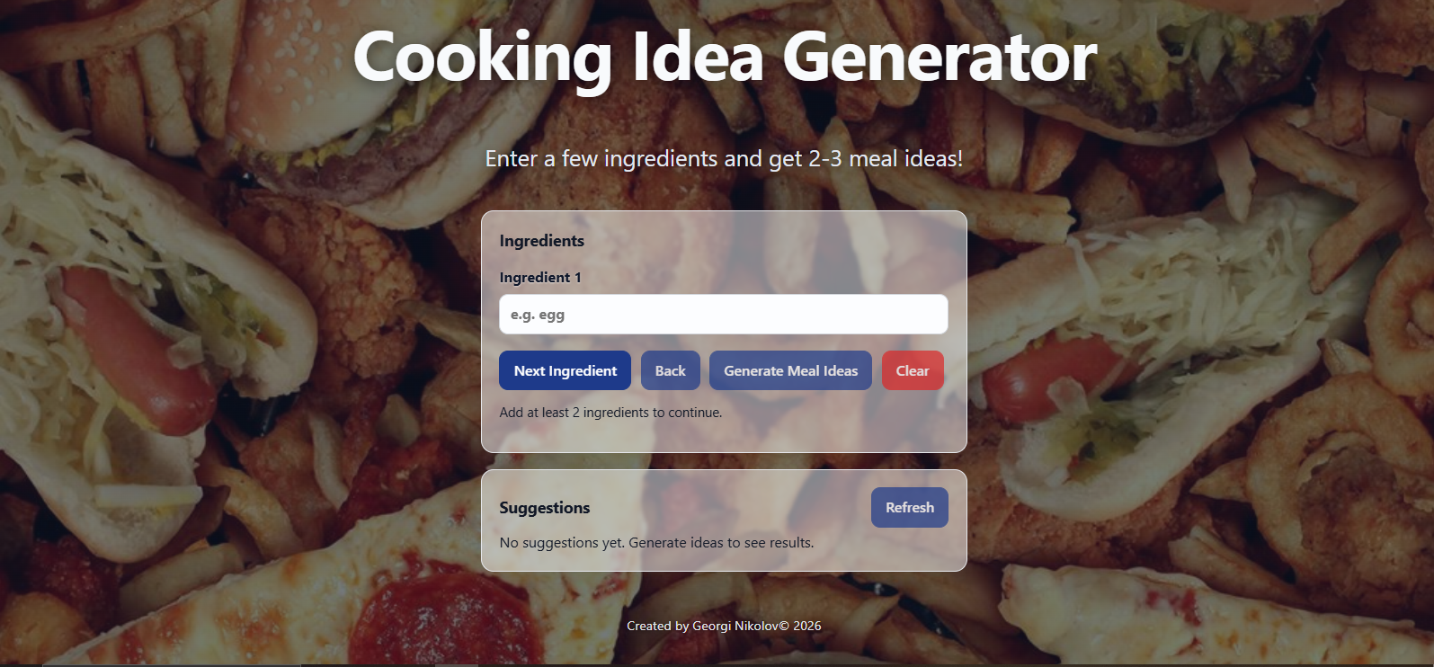
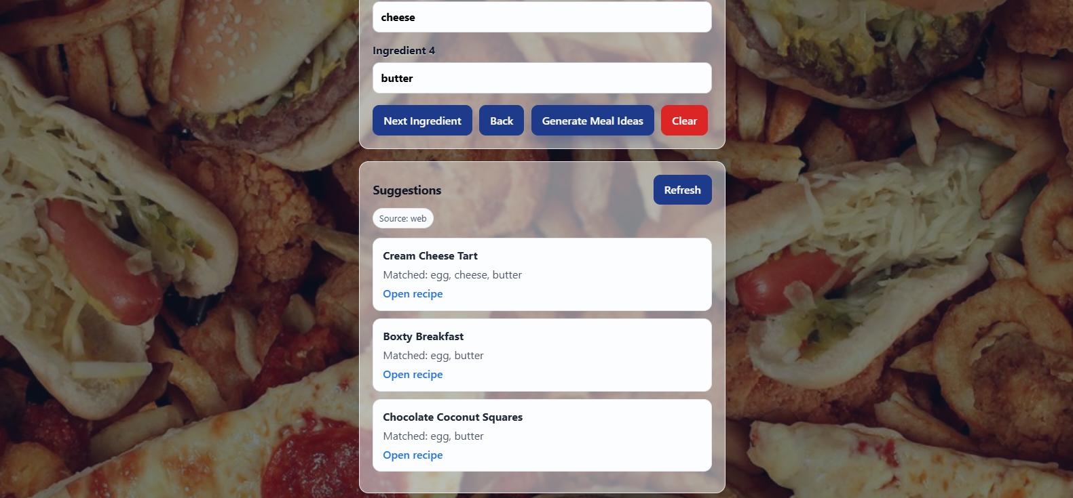
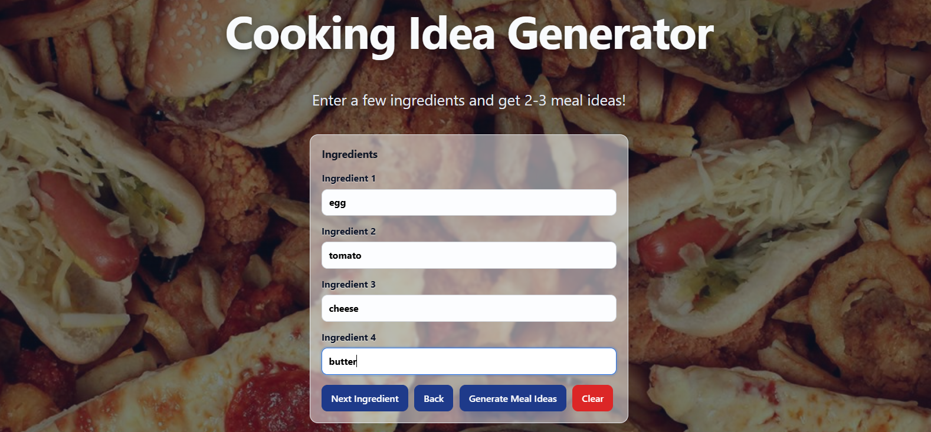

Repository
https://github.com/GeorgiNikolov80/CookingIdeaGenerator

Submission Format
https://docs.google.com/document/d/1UBcdWHQJ41xi-Rt7B4prr9Ojkrxs5hJbM2N37bfLHRc/edit?tab=t.0

