//>mysql -u root -e “cretate database eshop”// - create database first
php bin/console doctrine:generate:entity
AppBundle:Product: /Shortcut name:
name,
price(string:decimal, Scale:2),
description: text, is nullable:yes

AppBundle:Category
name
Results are : Entity folder with:
Product.php
Category.php
Repository folder
rename table name to plural(product>> products)
========
php bin/console doctrine:schema:update --dump-sql
php bin/console doctrine:schema:update --force
=======
Product: (property category ~~~ колона)- прави колона category_id
annotations – add FK(category_id) references categories(id)
php bin/console doctrine:schema:update –force

DefaultController:
//get all products..
index.twig:
<a href="new">New Product</a>
<table></table>
DefaultController:
public function newProduct()...
=============
create form:
AppBundle dir:
create symfony form ProductType
ProductType:
$builder->add('name')
->add('price')
->add('description', TextareaType::class)
->add('save', SubmitType::class);
$resolver->setDefault('data_class', Product::class);
DefaultController:
public function newProduct()…
$product,$form,return…. create edit.twig
edit.html.twig:
{{ form(form) }} -визуализира формата
index.twig:
<tr>{{ path('edit',{'id':product.id}) }}</tr>
DefaultController:
public function editProduct()….annotations…
Product:
private $category; add getter/setter
ProductType:
->add('category', EntityType::class...
'class' => Category::class,
'choice_label' => 'name',
'placeholder' => 'Choose category'

====MariaDB====
insert
C:\xampp\mysql>set path=%PATH%;C:\xampp\mysql\bin;
>mysql -u root symfonyDBAL
insert into categories (name) values ('food'),('drinks'),('others');
index.twig:
<td>{{ product.category.name }}</td>
Category:
private $products //annotations

//create custum query:
ProductRepository:
public function getListCategories()

======create tag=======~~Table Tag
php bin/console doctrine:generate:entity
AppBundle:Tag (---> създава таблица Tag)
name(unique:yes)
>> dump sql –force

//връзваме tag с product:
Product:
private $tags...(annotations)....>> dump sql --force
add getter/setter

ProductType:
->add('tags', EntityType::class...
index.twig:
{{ product.tags|join...}}
Tag:
//magic method
public function __toString()...

public function getCategory()
add bootstrap in base.twig

===REST API==
div class container:
create sApiController:
annotations - входна точка api(@Route(‘/api’)изнасяме я извън екшъните):

php ../composer.phar require jms/erializer-bundle… или
tools>composer>manage dependencies:
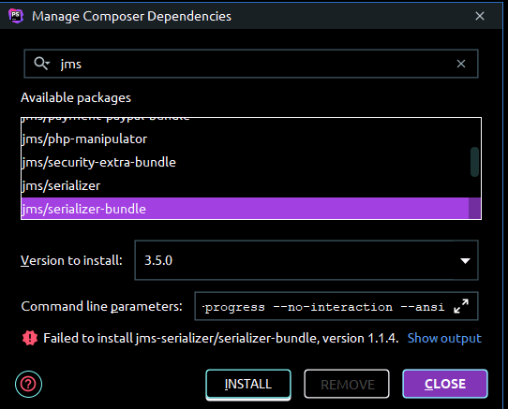

AppKernel: добавяме:
new JMS\SerializerBundle\JMSSerializerBundle,
public function getProducts()….(
public function response($data): Response //преизползваем метод
public function createProducts //annotations()

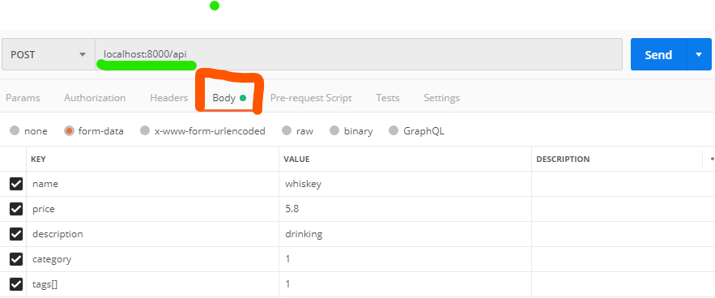

public function getProduct(int $id)
public function updateProduct(Request $request, int $id) ….put
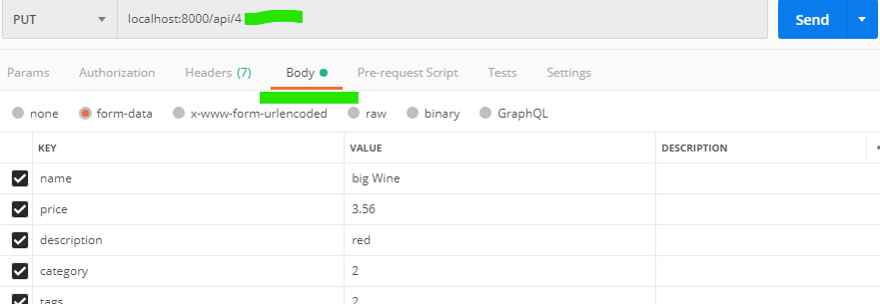

public function deleteProduct(int $id)
import database file:
\EShop>mysql -u root < ..\geography_database.sql
=======
Product:
private $country; //getter,setter
>php bin/console doctrine:schema:update –dump-sql
>php bin/console doctrine:schema:update –force
ProductType:
->add('country', TextType::class)
edit.twig:
autocomplete:
<script>
$(document).ready(function () {
$( "#country" ).autocomplete({ /#country – намери елемент с id = “country”
source: "/api/countries",
select:function (event, ui) {
$('#country').val(ui.item.country_name);
return false;
}
}).data('uiAutocomplete')
._renderItem = function (ul,item) {
return $( "<li></li>" ).data("item.autocomplete", item)
.append(item.country_name)
.appendTo( ul );
};
});
</script>
{% block stylesheets %}
{{ parent() }}
<script src="https://code.jquery.com/jquery-1.12.4.js"></script>
<script src="https://code.jquery.com/ui/1.12.1/jquery-ui.js"></script>
{% endblock %}
ApiController:
public function getCountries()
SELECT…..
index.twig:
<td>{{ product.country|join(',')}}</td>

