Astrology Consultations

My project is a astrology consulting platform.

Currently hosted on Azure at https://jelanie-za-jivot.azurewebsites.net/

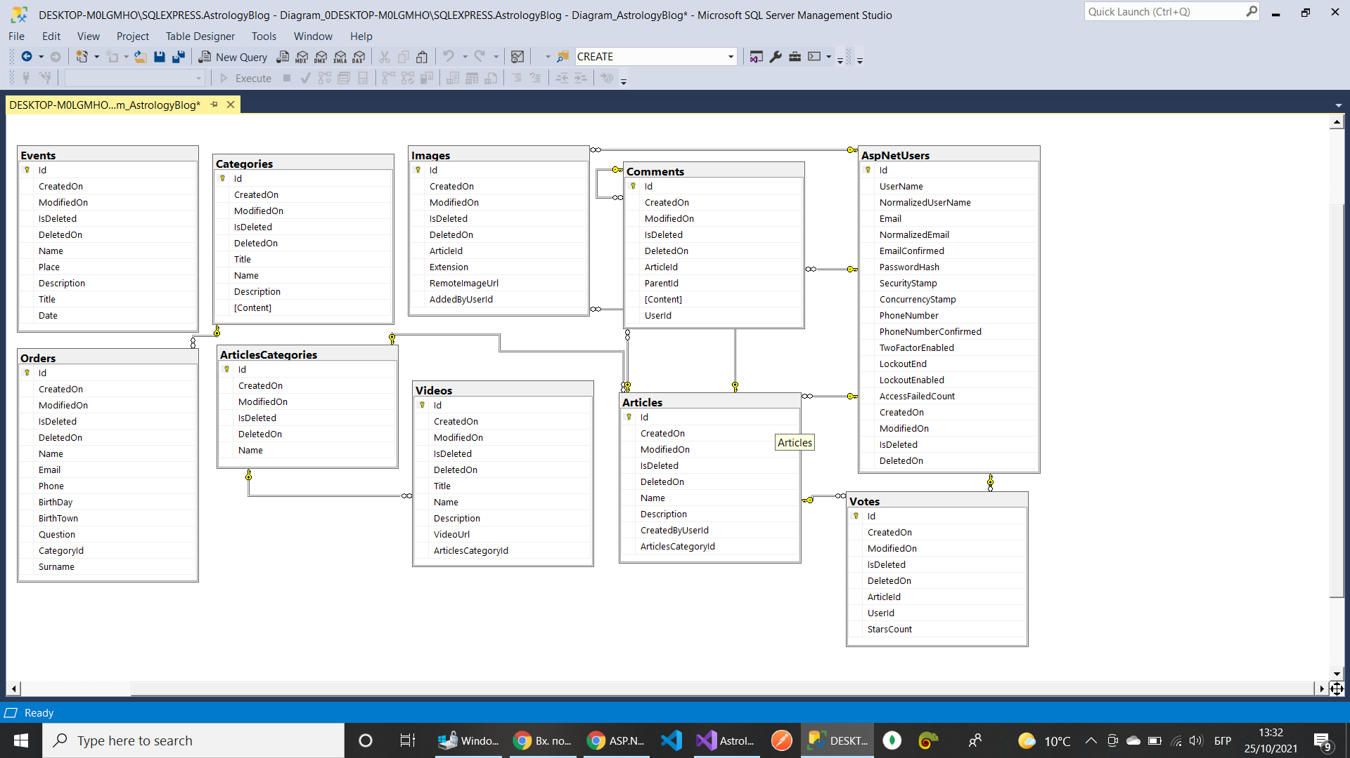

Tech Stack:

ASP.NET Core,

Entity Framework,

SQL Server,

CSS,

HTML,

Bootstrap 5,

JavaScript,

jQuery,

SendGrid

And others