**Course Project**

Faculty of Industrial Technology

**Faculty number**: 361223025

**Student:** Georgi Vasilev

**Project:** Pizza Ordering App

**Supervisor:** Veska Gancheva

**Course Project Assignment**

Design and implement an application that serves as a pizza ordering system.

1. Define a class Item with private attributes for the item munher and price

a) Add suitable constructors, destructor, access methods, and a method to print information

2. Define a class Pizza as a subclass e of the Item class with additional private atributes for size

(M/L) and topping sauce (YES/NO)

a) Add suitable constructors, destructor, access methods,

b) Override the method to print the complete information about a pizza

3. Define main() function to process information about ondered pizzas:

a) Input data for N pizzas (where N<50) from the keyboard and add them into an array.

b) Print information about all pizzas

c) Print the total order amount, including 20% VAT (If there is a topping, the price increases by 2.50 BGN without VAT)

d) Print information about all ordered pizzas with size L

**Requirements for project documentation**

The documentation should contain:

title page with student's data, supervisor,

text of the assignment,

general block diagram of the developed application,

description of the used modules (classes) elements and purpose; general description of how the program works (input/output);

listing of the program source code,

results of program implementation (control example).

**Block Scheme**

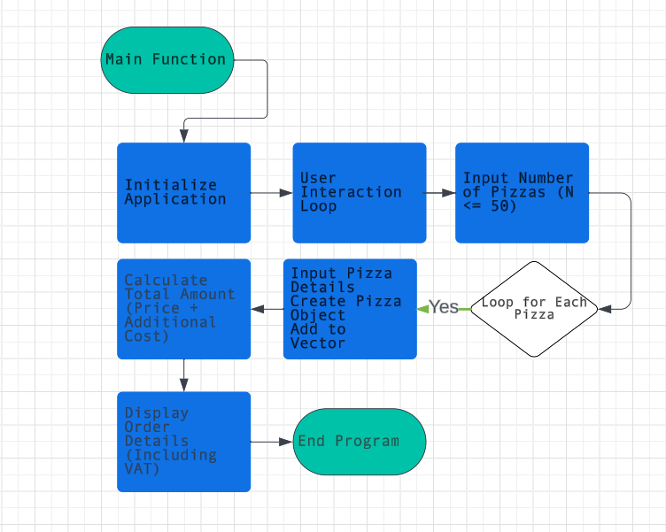

**File item.cpp**

#include <iostream>

#include <iomanip>

class Item {

private:

    int itemNumber;

    double price;

public:

    // Constructor

    Item(int num, double p) : itemNumber(num), price(p) {}

    // Destructor

    ~Item() {}

    // Access methods

    int getItemNumber() const { return itemNumber; }

    double getPrice() const { return price; }

    // Method to print item info

    virtual void printInfo() const {

        std::cout << "Pizza Number: " << itemNumber

                  << ", Price: 10.00 BGN"

                  << std::endl;

    }

};

**File pizza.cpp**

#include "Item.cpp"

#include <iostream>

class Pizza : public Item {

private:

    char size;        // S, M, L

    bool hasTopping;  // true (YES) / false (NO)

public:

    // Constructor

    Pizza(int num, char sz, bool topping)

        : Item(num, 10.0), size(sz), hasTopping(topping) {}

    // Method to print pizza info (overrides Item's printInfo)

    void printInfo() const override {

        Item::printInfo();  // Call base class printInfo to display item details

        std::cout << "Size: " << size

                  << ", Topping: " << (hasTopping ? "YES" : "NO")

                  << std::endl;

    }

    // Additional cost for topping

    double additionalCost() const {

        return hasTopping ? 2.50 : 0.0;

    }

};

**File execute.cpp**

#include <iostream>

#include <vector>

#include "Pizza.cpp"

// Function to print pizzas with a specific size

void printPizzasBySize(const std::vector<Pizza>& pizzas, char targetSize) {

std::cout << "\n--- Pizzas with Size '" << targetSize << "' ---\n";

for (const auto& pizza : pizzas) {

if (pizza.getSize() == targetSize) {

pizza.printInfo();

}

}

}

int main() {

    // Create a vector to store Pizza objects

    std::vector<Pizza> pizzas;

    // Ask the user to input the number of pizzas

    int N;

    std::cout << "Enter number of pizzas (N <= 50): ";

    std::cin >> N;

    // Ensure N does not exceed 50

    if (N > 50) N = 50;

   // Loop to get details for each pizza

        for (int i = 0; i < N; ++i) {

            int num;

            char size;

            bool topping;

            // Get the pizza number

            std::cout << "Enter pizza number: ";

            std::cin >> num;

            // Get the size of the pizza (S/M/L)

            std::cout << "Choose size (S/M/L): ";

            std::cin >> size;

            // Ask if the pizza has a topping (1 for YES / 0 for NO)

            std::cout << "Does the pizza have topping? (1 for YES / 0 for NO): ";

            std::cin >> topping;

            // Create a Pizza object with fixed price (10 BGN) and user-provided details, then add it to the vector

            Pizza pizza(num, size, topping);

            // Add the created Pizza object to the vector of pizzas

            pizzas.push_back(pizza);

        }

    // Calculate and display the total order amount

    double total = 0.0;

    for (const auto& pizza : pizzas) {

        pizza.printInfo(); // Display pizza details

        total += pizza.getPrice() + pizza.additionalCost();

    }

    // Calculate VAT (20%)

    double vat = total * 0.20;

    // Display the total order amount including VAT

    std::cout << "Total Order Amount (including VAT): $" << std::fixed << std::setprecision(2) << total + vat << std::endl;

//Print only the L sized pizzas

printPizzasBySize(pizzas, 'L');

    return 0;

}

**Screenshot of the console results**

