Xbee Configuration
GT Off-Road Racing | Data Acquisitions
Evelyn Craven
10/25/2020

Table of Contents
1.0 Overview/Function 2
2.0 Hardware Reference 3
2.1 Xbee 3 Pro
2.2 Xbee USB Explorer 3
3.0 Software Theory of Operation 4
4.0 Revision History 5
5.0 References 6
5.1 Parts List
5.2 Tutorial Link

1.0 Overview/Function

2.0 Hardware Reference

2.1 Xbee 3 Pro
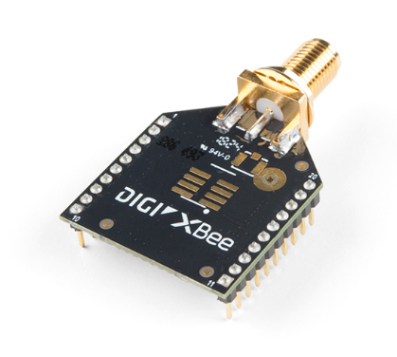
2.2 Xbee Explorer USB

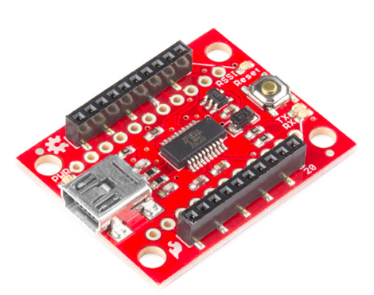3.0 Software Theory of Operation

https://learn.sparkfun.com/tutorials/exploring-xbees-and-xctu/all#configuring-networks

Follow the steps in the tutorial.

For firmware installation, select Zigbee 3.0 TH. For the network ID (PAN ID), choose 1998.
4.0 Revision History

5.0 References

5.1 Parts List
Part | Qty. | Unit Price | Desc.
Xbee 3 Pro | 1 |  | Xbee 3 Pro
Xbee Explorer USB | 1 |  | micro USB to USB explorer for Xbee

5.2 Tutorial Link
https://learn.sparkfun.com/tutorials/exploring-xbees-and-xctu/all#configuring-networks

