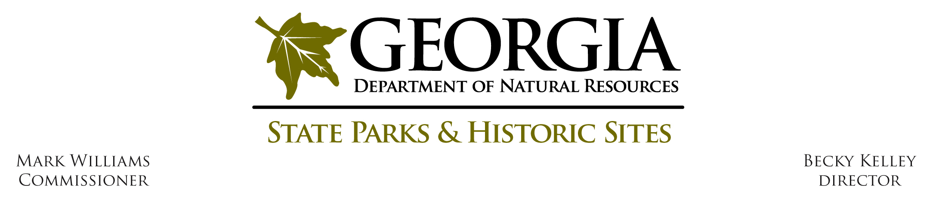
Operating Procedure # O - F - 3

Subject: Friend’s Funding/Monthly Report

Effective Date: April 1, 2015

Revision Date: April 6, 2015

Procedure Statement:

Managers must obtain written region approval before accepting any goods or services purchased by the park/sites Friends groups exceeding $250. All accepted Friend’s purchases (any amount) will be reported on the quarterly “Friend’s Purchases Report”. Managers are to avoid any transactions that can be perceived to personally benefit an employee including repairs or supplies to state owned residences. The division’s view for Friend’s funds are projects that benefit the park/site or for programs that encourage increased visitation.

Definitions:

Friend’s Purchase: Any purchase of a good or service.

Retail/Consignment: An item purchased to be resold in the retail area.

Procedure:

Any Friend’s purchases made for the site/park exceeding $250 will need prior approval from the region office in writing. A scanned or hard copy will be kept with the quarterly ‘Friend’s Purchases Report”.

All equipment purchases should be in accordance with the DNR Asset Management guidelines on the DNR Intranet as well as the State Of Georgia Accounting Office in regards to Capital Assets, specifically Capital Asset Contribution and Donation which can be found at the following link:

http://sao.georgia.gov/sites/sao.georgia.gov/files/imported/vgn/images/portal/cit_1210/15/29/173188970AM_CapitalAssetsGeneral_Reformatted.pdf

All items valued over $1,000 and firearms regardless of cost (i.e. period muskets) should be included with the site’s Capital Asset List (asset management list in peoplesoft). Site Managers should submit information containing equipment type, acquisition cost (even if donated), acquisition date, etc. to DNR Asset Management and request a decal for the item. The Site Manager should ensure the decal is affixed to the equipment.

All items valued under $1,000 should be listed on the sites Under 1,000 asset management list and should have a non-props decal (yellow in color) affixed to the equipment. Non-props decals can be obtained from the Region Offices.

If the Friend’s wish to fund a staff dinner, the park manager must follow these guidelines:

The division will approve 1 staff appreciation dinner each calendar year with a spending limit of $25 per employee attending the function. The limit includes all dinner expenditures including decorations. Region office must be notified of the dinner prior to the event.

The division will also approve employee retirement and departures recommended by the park/site manager. Same limits as staff appreciation dinners apply.

ALL Friend’s purchases made for the site/park will be listed on the quarterly “Friend’s Purchases Report”.

Region office will check for written approvals for purchases over $250. Any discrepancies will be reported to the Assistant Chief.

Park staff shall NOT have access to or be on signature cards of Friend’s accounts. (ex. Credit Cards, Bank Cards, Checks)

Park staff shall NOT be reimbursed for any purchases from Friend’s accounts.

Friend’s retail/consignment purchases must follow consignment procedures.

Authority: not applicable.

Attachments:

Attachment 1 – Friend’s Purchases Report

