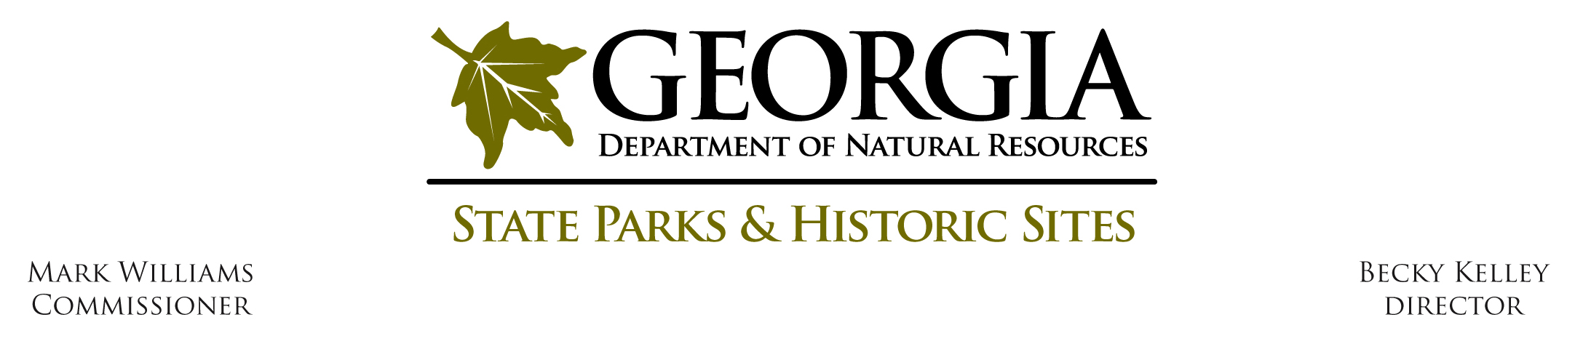

Operating Procedure O - S - 4

Subject: Social Media Guidelines

Effective Date: March 1, 2015

Procedure Statement:

Social media sites are effective tools for sharing information with citizens, building support for and collaboration with our division, increasing visitation and revenue, and improving communication with our stakeholders and visitors. Sites which have the resources to create and actively manage social media accounts are encouraged to do so.

Definitions:

Administrator: the person who created and manages the account. Once established, some accounts can have more than one administrator.

Social networks: websites/apps such as Facebook or Twitter

Sharing platforms: websites/apps such as Instagram or YouTube

Procedure:

Read the DNR’s Standard Operating Procedure for Appropriate Social Media Use, HR018, found on the intranet. Also read the rules for social media use as a DNR representative referenced in HR018.

Define your goals in using social media to promote your site. Decide what you hope to achieve, who you wish to engage, and what content you plan to share before determining what platform to use. Social networking sites are beneficial when used correctly and managed frequently. Improperly used, they can reflect poorly on your site, our division and DNR. Do not create an account simply to have one.

Identify a social media coordinator who is a permanent staff member at your site, not a volunteer or seasonal employee. Choose someone who has time to manage the platform almost daily.
Consider who will be able to manage the account in the future, because affective accounts should be used for many years.

Discuss your plans with your Region Manager and the division’s Public Affairs Coordinator before opening an account.

When setting up an account, use your site’s email rather than an individual’s email. Keep records of passwords and share them with your Region Manager and the division’s Public Affairs Coordinator.
Once an account is open, add the division’s Public Affairs Coordinator as an administrator (when possible).

Establish accounts under your park/site’s full name rather than your Friends group or another volunteer group. Accounts identified as “Friends of/volunteer” that are actually managed by the park should be re-named (if possible). Sites managed only by volunteers are discouraged. If a volunteer site already exists, an employee of the park should also have administrative access to the account.

All accounts must be clearly identified by the site’s full name and as part of the Georgia Department of Natural Resources. When possible, include the site phone number and website.

Anything published to social accounts is considered official communications from the DNR.

Authority:
Not applicable

Attachments:
Attachment 1 – Facebook Guidelines

Reference:
Office of Human Resources, Standard Operating Procedure, HR 018

http://dnrnet.dnr.state.ga.us/sop

