101 ADMINISTRATION OF THE DEPARTMENT AND DIVISION 12/11
101.1 THE GEORGIA DEPARTMENT OF NATURAL RESOURCES
A. Created in 1972 by the Executive Reorganization Act under Governor Jimmy Carter, the Department of Natural Resources (DNR) initially assumed responsibility for functions which had been directed by thirty- three state agencies, assisted by fourteen boards of directors.
B. DNR is separated into separate divisions, including Environmental Protection (EPD); Coastal Resources (CRD); Wildlife Resources (WRD) ,Parks, Recreation and Historic Sites (PRHS), Historic Preservation (HPD) (Organization chart attached).
D. As was constitutionally stipulated in the Executive Reorganization Act, DNR is regulated by a fifteen-member board of directors; members are appointed to seven-year staggered terms by the Governor and confirmed by the State Senate.
E. The board is comprised of one member from each of Georgia's congressional districts, one to represent the coastal counties and four from the state-at-large, with no more than two members residing within the same congressional district.
F. While no specific qualifications are established for member selection, federal environmental statutes do require that the board contain a sufficient number of members who are free from a possible conflict of interest; this is to better ensure that the board will be able to conduct hearings in an unbiased atmosphere. For example, a majority of the board members should not hold any type of environmental permit, as such permits are issued through DNR.
G. The responsibilities of the DNR Board are to:
- establish the general policies of the Department of Natural Resources;
- adopt rules and regulations concerning the environment, game and fish, parks and recreation and coastal resources;
- conduct appeal hearings based on action taken by DNR;
- appoint the DNR Commissioner, the Director of the Environmental Protection Division, and the Department Hearing Officers, as well as to confirm appointments of directors for the remaining three divisions.

101.2 COMMISSIONER OF THE DEPARTMENT OF NATURAL RESOURCES
A. Appointed by the board of directors and subject to approval by the Governor, the Commissioner of the Department of Natural Resources serves for an unspecified time. Although he serves at the pleasure of the Board, the Commissioner cannot be dismissed without the concurrence of the Governor.
B. As Chief Executive of the department, the Commissioner is responsible for administering board policies, as well as the mandates of the Governor and the Georgia General Assembly, overseeing the day-to-day operations of DNR.

101.3 VISION AND MISSION STATEMENTS
The Georgia Department of Natural Resources; Parks, Recreation, and Historic Sites Division has adopted the following Vision and Mission Statements to establish purpose and direction for all of its employees.
A. VISION
To protect our state's natural beauty and historic integrity while providing opportunities for public enjoyment and education.
B. MISSIONUsing our system's diversity and a commitment to excellence as our strengths, we will be a national model for quality service, resource protection, outdoor recreational opportunities, ecosystems management and interpretation of our heritage. We will provide an excellent work environment for our employees through effective leadership, proper training, challenging opportunities and a guarantee of fair treatment.

101.4 CORE VALUES
- Stewardship of our state’s natural, cultural, and historical resources is fundamental to the understanding of our past and the well-being of our future.
- Protection of the integrity of each site’s unique resources dictates the level of public use.
- Engaging our visitors in meaningful educational and outdoor recreational programs is vital to their appreciation of the resources we are entrusted to protect.
- Customers demand affordable, quality services and facilities in a safe, positive environment.
- Significant and positive connections exist between our state’s natural and cultural heritage sites and the local communities around them.
- As public servants and caretakers of the public’s funds, we must apply best business practices to all operational activities.

101.5 CHAIN OF COMMAND
A. In an organization as large and as diversified as the Parks, Recreation, and Historic Sites Division of DNR, it is essential that every employee know and follow the chain of command. Chain of command refers to a specific and defined supervisory order based on rank within the organization.
B. The Division Director, which is the highest ranking manager in the Parks, Recreation and Historic Sites Division, supervises the section chiefs, which make up the next management level. The section chiefs, in turn, supervise region or unit managers on the next management level. From that level there continues to be a descending order of supervision throughout the organization to the lowest ranking employee. This supervisory chain of command can be better visualized by referring to the organization charts in this section.
C. The purpose for using the chain of command is to allow each management level to exercise the appropriate amount of authority in decision making and problem solving. It is of equal importance to provide a system which allows each employee direct contact and communications with the next highest ranking manager of the organization. Communications and work efficiency would totally breakdown if there was no systematic approach to supervision. For example, if every employee called the Division Director on every matter concerning the operation, the Director would not be able to respond adequately to any request and would not be able to fulfill the functions of his job. For this reason, Division employees are required to communicate through each level both up and down the chain of command. There may be some special conditions when an employee is authorized to skip the chain of command. These special conditions would include: emergency situations requiring immediate response; when an employee is requested or directed to perform an illegal, immoral, or unsafe act; when immediate communications is critical for solving a problem, etc.
101.6 SUPERVISOR'S RESPONSIBILITIES TO SUBORDINATES
Realize, as a supervisor, that subordinates will follow you if you prove to them that you understand their needs, and you try to help them meet their needs better than anyone else. Therefore, all supervisors in our organization must recognize their obligations to subordinates, as well as their responsibilities to them, in order to gain their respect, cooperation, and team effort. To achieve this goal, a supervisor must meet the following responsibilities to the employees under their supervision:
A. Consider subordinate employees at all times as individuals and important human beings and respect them.
B. Do a good job of representing your employees to top management.
C. Make every effort to interpret and explain Division and Departmental policies accurately to your subordinates at all times.
D. Be a good example to subordinates.
E. Go out of the way to pat an employee on the back publicly when he or she does a job exceptionally well.
F. When it is necessary to reprimand an employee, do it in private. (Always remember: Praise in public and reprimand in private.)
G. Let employees know that you are giving them every opportunity to develop and improve their skills and earnings.
H. Always evaluate people carefully and objectively; judge them honestly; never permit individual personalities or prejudices to cloud your objective opinions.
I. Always try to improve your confidence in dealing with subordinates by being considerate, firm, and fair in your individual dealings with them.
J. Always place an employee on a job according to skill, ability, and attitude.
K. Never pass the buck if something goes wrong in your department; always assume the responsibility for the action or the job done by the employees under your supervision.
L. Get to know subordinates individually; learn as much as you can about their individual interests, likes, and dislikes.
M. Always take time to give proper and adequate instruction to new hires and make them feel at home through proper job orientation.
N. Always be alert to keeping your work area safe and clean; be ever mindful of the importance of good, clean, and safe working conditions.
101.7 EMPLOYEE'S RESPONSIBILITIES TO IMMEDIATE SUPERVISOR
Every employee within an organization must assume several responsibilities. One important area of this responsibility is to the immediate supervisor. It is the policy of the agency that every employee fulfill the following duties and obligations to the immediate supervisor on a regular, recurring basis:
A. Cooperate with the immediate supervisor.
B. Obey the immediate supervisor's instructions and execute then in detail.
C. Inform supervisor of all changes in working conditions and other phases of production.
D. Prepare for greater responsibility by learning to stand in for supervisor as requested.
E. Report the outcome of any important phase of the task or service operation fully, simply, and accurately to immediate supervisor when requested.
F. Show courtesy and respect to immediate supervisor at all times.
G. Look for better ways of doing things, and offer ideas and suggestions for improvements to immediate supervisor.
H. Make every effort to relieve immediate supervisor of job details whenever possible.
I. Always assume full responsibility for work assigned.
J. Assume responsibility for work of subordinates.

101.8 LIST OF ACTIVE FIELD SITE LOCATIONS AND CLASSIFICATIONS
Region 1
Black Rock Mountain, satellite Cloudland Canyon, Class III
Dahlonega Gold Museum, satellite Etowah Mounds, satellite
Fort Mountain, Class III Hart, satellite-SORA
James H. Floyd, Class III Richard B. Russell, Class III
Moccasin Creek, satellite New Echota, Class II
Pickett’s Mill, satellite Tallulah Gorge, Class III
Traveler’s Rest, satellite Tugaloo, Class III
Vann House, satellite Amicalola Falls, Class III
Unicoi, Class III Red Top Mountain , Class III
Vogel, Class III Smithgall Woods*
Don Carter* Hardman Farm*
Rocky Mountain PFA Resaca*
Buck Shoals* Mossy Creek*

Region 2
A.H. Stephens, Class II Crooked River, Class II
Elijah Clark, Class III Fort King George, Class I
Fort McAllister, Class II Fort Morris, satellite
General Coffee, Class II George L. Smith, Class II
Gordonia – Alatamaha, Class II Hamburg, satellite - SORA
Hofwyl Plantation, satellite Laura S. Walker, Class III
Magnolia Springs, Class II Mistletoe, Class II
Stephen C. Foster, Class III Skidaway Island, Class II
Victoria Bryant, Class II Watson Mill Bridge, SORA
Wormsloe, Class II Little Ocmulgee, Class III
Reynolds Mansion, Class II Bobby Brown, satellite-SORA
Ball’s Ferry*

Region 3
F.D. Roosevelt, Class III Florence Marina, Class III
Georgia Veterans, Class III Hard Labor Creek, Class III
High Falls, Class II Indian Springs, Class III
Jarrell Plantation, satellite Kolomoki Mounds, Class II
George T. Bagby, Class III Little White House, Class III
Panola Mountain, Class II Fort Yargo, Class III
Providence Canyon, satellite Reed Bingham, Class II
Seminole, Class II Chattahoochee Bend, Class II
Sweetwater Creek, Class II Bush Head Shoals*
S.A.M. Shortline Standing Boy Creek*
Flat Creek*

Golf Courses
Meadow Links at George T. Bagby The Creek at Hard Labor
The Lakes Course at Laura S. Walker The Wallace Adams Course @ Little Ocmulgee.
Arrowhead Pointe at Richard B. Russell Highland Walk at Victoria Bryant
Brazell’s Creek at Gordonia-Alatamaha

* Denotes PRHS site that is planned for development but not open to the public.

101.9 ORGANIZATION STRUCTURE OF PARKS, RECREATION AND HISTORIC SITES DIVISION

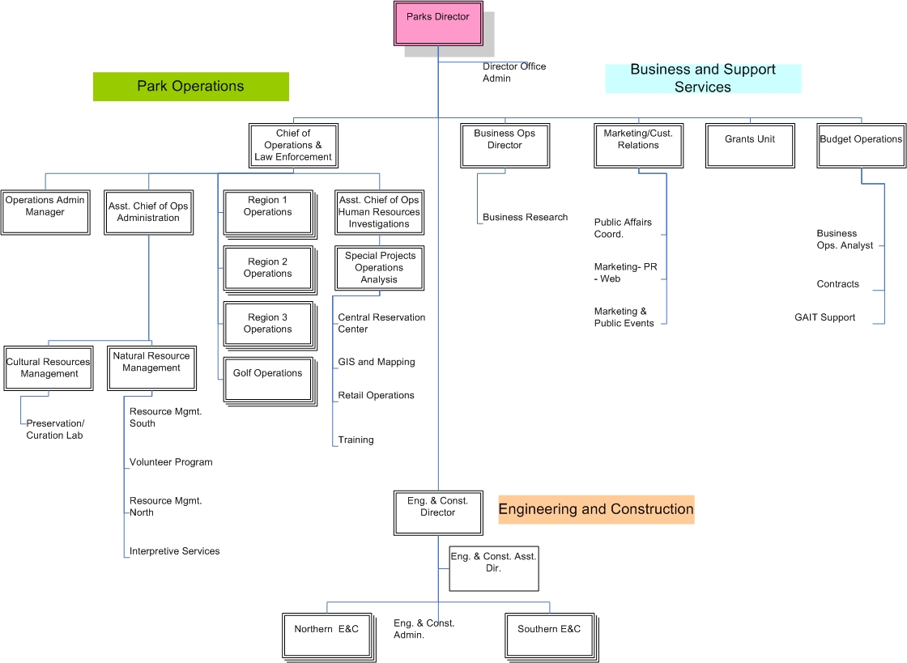

101.11 MAP OF STATE PARK FIELD OPERATIONS BY REGION
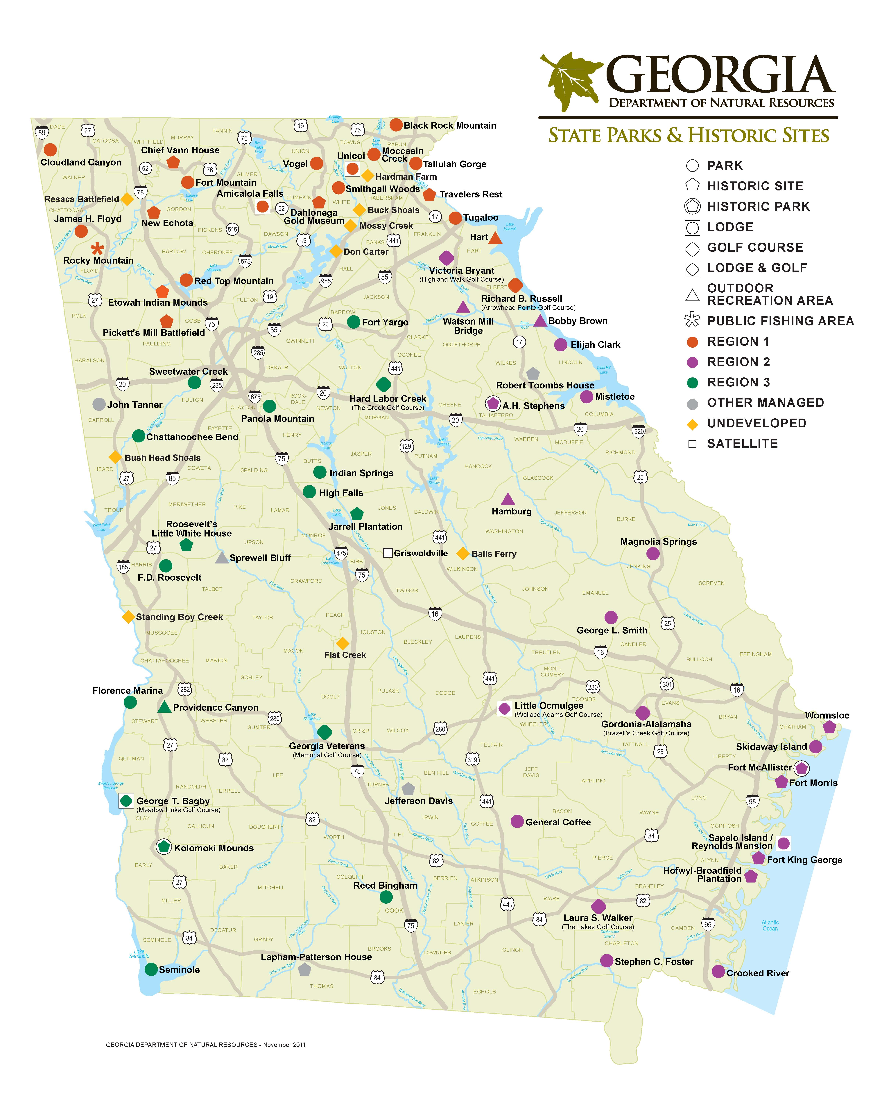

101.12 ORGANIZATION STRUCTURE OF DNR

