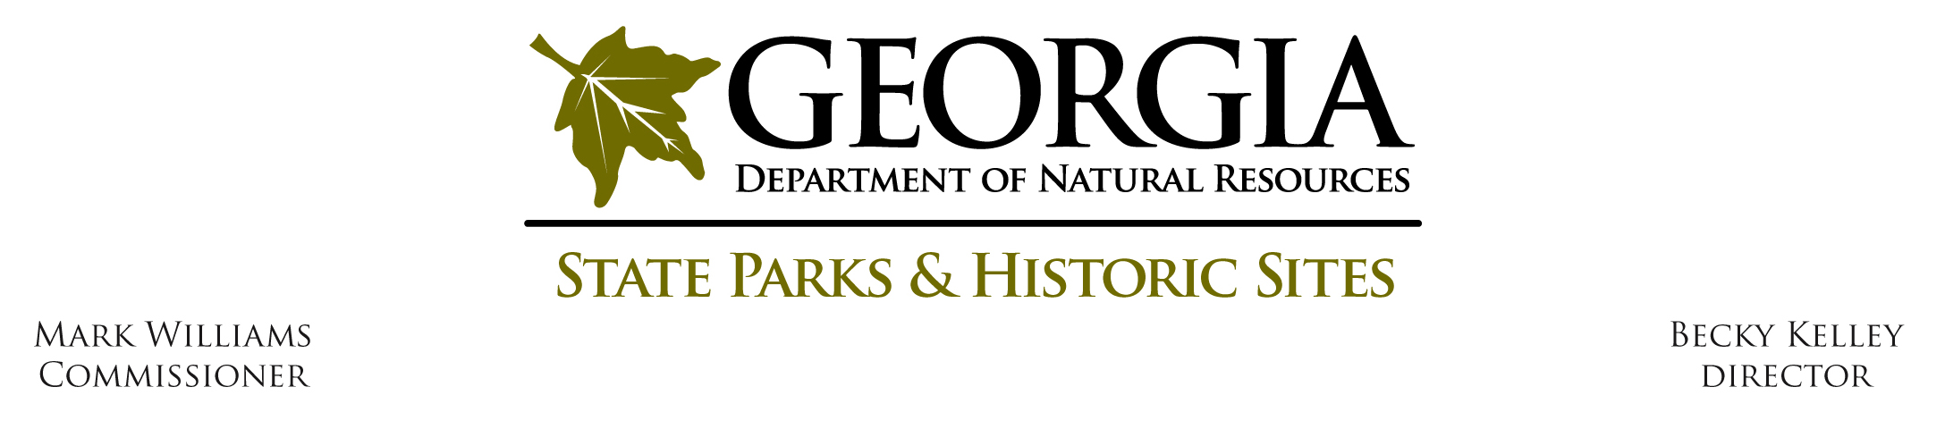
Standard Operating Procedure
Operating SOP # O-C-4

Subject: Concession Agreements

Effective Date: February 5th, 2019

Policy Statement:
A written contract signed by the Director, or his/her designee, is necessary to allow an individual, group, club or organization to conduct a fund-raising event on state property.
Definitions:
Short Term Concession Agreement: Events lasting anywhere from one to seven days.
Long Term Concession Agreement: Agreements which last greater than 90 consecutive days in a FY or multiple FY’s (maximum of 5 years). These agreements could be concession agreements, qualified management agreements, sub-leases, rental agreements, etc. These types of agreements are for individuals or organizations that operate a business (e.g. a beach concession, horseback riding, marina, etc.) on state park property.
Park Operated Events: Park hosted events where all moneys are collected by and retained by the park.
USACE Properties: Park properties that are under a United States Army Corps of Engineers Lease agreement. These include: Red Top Mountain State Park; Don Carter State Park; Elijah Clark State Park; Florence Marina State Park; Hart State Park, Mistletoe State Park; Richard B. Russell State Park; Seminole State Park; Tugaloo State Park.
Contract Specialist: Currently Mallory Barfield, mallory.barfield@gadnr.org
Operations Manager: Currently Terry Trowbridge, terry.trowbridge@gadnr.org

Procedure:
Short Term Concession Agreements: Event applications must be received by the Division Headquarters office at least 4-6 weeks prior to the event.
1. The person, group, club or organization wishing to conduct a special event, fishing tournament, fireworks display, or sell food at a special event must complete and submit an event application (Attachment 1) to the Site Manager.
2. If the Site Manager approves the request, the application should be completed and signed by the Site Manager and sent to their Region Manager for approval.
3. Once approved, the Region Manager should forward the signed application to the contract specialist in the Division Headquarters office where the concession agreement will be prepared for signatures.
Long Term Concession Agreements: Event applications must be received by the Division Headquarters office at least 10 weeks prior to the business opening. The Site Manager is responsible for day-to-day monitoring of the operation to ensure contract compliance and should work with the concessionaire or renter to resolve any issues or problems that may arise.
1. Steps 1-2 of the Short Term concession agreement process apply here.
2. A background check is required for any Long Term concession operation where the concessionaire will have unsupervised access to guests on state park property. The Site and Region office must ensure that a background check consent form is completed along with the event application, and that results are processed and reviewed before the application is sent to the Operations Manager for final approval.
- If the concessionaire has already conducted background checks on all people involved in their operation that will have unsupervised access to the public, then they would need to confirm what types of background checks have already been completed, along with a list of all the people who received those checks.
- For concession operations that already have a background check policy in place, they would need to send a copy of their policy to the Operations Manager for review and approval before the operation can begin.
3. Once the Region office has approved the event application form, the approved form should be submitted to the Operations Manager for final approval before being submitted to the Contract Specialist.
4. Once all approvals and signatures have been obtained, the event application must be submitted to the Contract Specialist to complete the agreement process.
Park Operated Events: No concession agreement is required for events that the park hosts, unless:
1. The park has hired an outside vendor who will be making a profit from operating their services on park property.
2. They are a food and/or beverage vendor. All food and beverage vendors at all special events, whether or not site sponsored, must be covered under a concession agreement.
Events on USACE Leased Properties: All concession agreements issued at a site that holds a lease agreement with the United States Army Corps of Engineers must obtain prior written approval for each concession agreement from their main Army Corps contact. This written approval must be submitted with the event application to the Contract Specialist before a concession agreement can be drafted.
Authority:
O.C.G.A. 12-3-9(a); 12-3-10(b); 12-3-32(a)(9);
Regulations 391-1-.05(12)(e)
Attachments:
Attachment 1: Event Application
Attachment 2: Concession Agreement Fee Structure
Attachment 3: Fishing Tournament Procedures
Attachment 4: Background Check Consent Form
Attachment 5: Concession Agreements Requirements and Process
Attachment 6: Drone Use Checklist

