
Georgia State Parks Golf Pass & Membership Programs

Georgia State Park Membership Card
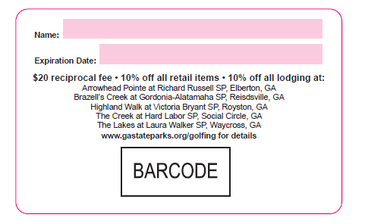
With the membership card guests will be able to enjoy the following perks:
- $20 Reciprocal fee at any Georgia State Park Golf Course
- 10% off all lodging at any Georgia State Park Golf Course
- 10% off all retail at any Georgia State Park Golf Course
Terms & Conditions
- Not valid with any other promotions or discounts
- Valid for annual individual memberships only
- Georgia State Park Membership Cards & Georgia State Park Golf Pass Cards cannot be used simultaneously
- Expires 1 year after purchase date
Ringing up Procedures:
1)All cards are in inventory, so these are inventorable items (they are in inventory)
2)In order to track customers with their card number please ring up cards as instructed below:
1)Ring up to Product ID:490974
2)Enter expiration date of card (write in expiration date with a sharpie on the back of card as well)

3) Scan the bar code on the back of the card and it will populate the pass number (card number) or
or you can enter it in manually

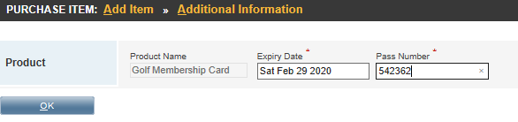

4)Click on CHANGE CUSTOMER DO NOT SKIP THIS STEP
5) Go to find customer and search by phone number
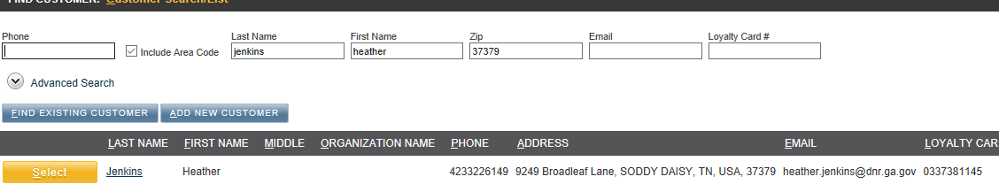
6) If the customer does not have an email address you must enter in the email address
You must enter in the email address DO NOT SKIP THIS STEP
7) If the customer is new, ENTER IN ALL CUSTOMER INFORMATION INCLUDING; EMAIL ADDRESS
PHONE NUMBER & ADDRESS DO NOT SKIP THIS STEP
8) Proceed to checkout

INDIVIDUAL MEMBERSHIP RATES
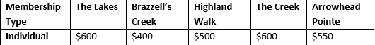

Ringing up Procedures for Membership Card retail & Lodging Discount
- Ring up lodging discount to Discount Name: 10% Georgia Golf Membership Discount/ Promo Code: GMEM10%
- Ring up POS retail discount to Discount Name: 10% Golf Membership Discount-POS/Promo Code: GMEM10%

Georgia State Golf Pass Cards
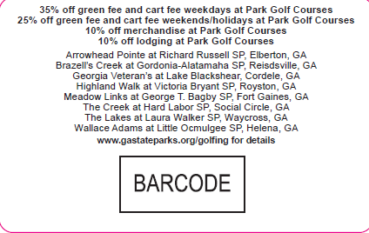
With the Georgia State Golf Pass Card our guests will be able to enjoy the following perks:
- 25% off cart fees & green fees weekend and holidays
- 35% off cart fees & green fees weekdays
- 10% off all lodging at any Georgia State Park Golf Course
- 10% off all retail at any Georgia State Park Golf Course
Terms & Conditions:
- Not valid with any other promotions or discounts
- Valid for annual individual memberships only
- Georgia State Park Membership Cards & Georgia State Park Golf Pass Cards cannot be used simultaneously
- Expires 1 year after purchase date

Ringing up Procedures:
1)All cards are in inventory, so these are inventorable items (they are in inventory)
2)In order to track customers with their card number please ring up cards as instructed below:
- Ring up Product ID:490973
- Enter expiration date of card (write in expiration date with a sharpie on the back of card as well)
- Scan the bar code on the back of the card and it will populate the number the pass number (card number) or you can enter it in manually
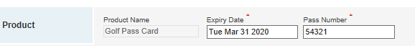
- Click on Change Customer DO NOT SKIP THIS STEP
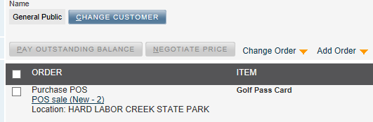
- Go to find customer and search by phone number
- If the customer does not have an email address YOU MUST ENTER IN AN EMAIL ADDDRESS for them DO NOT SKIP THIS STEP
- If the customer is new ENTER IN ALL CUSTOMER INFORMATION INCLUDING; PHONE NUMBER, EMAIL ADDRESS & ADDRESS DO NOT SKIP THIS STEP
- Proceed to check-out
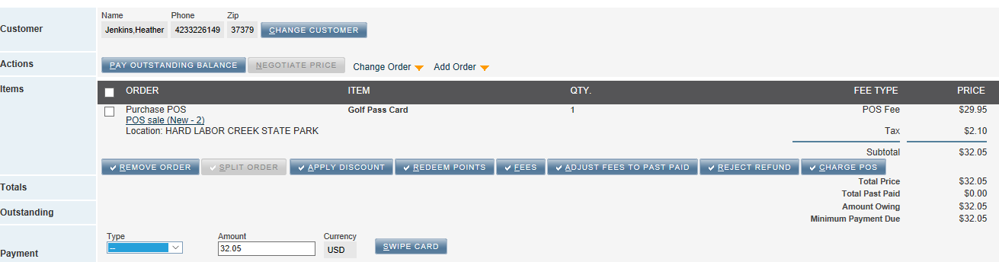

Golf Pass Card Cart Fee & Greens Fee Discounts
1)Each course has been assigned Golf Pass Card POS Buttons
2) All course fees include the 25% weekend discount or the 35% weekday discount
3) When ringing up fees for the Golf Pass Card you will ring up both a Cart Fee & a Greens Fee
4) You will not ring up any other discounts; exceptions apply to Veterans Disability Discounts

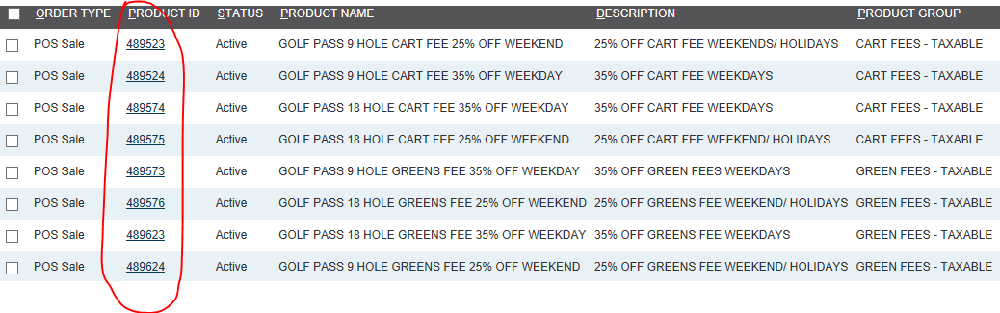

Ringing up Procedures for Golf Pass Card Retail & Lodging Discount
- Ring up lodging discount to Discount Name: 10% Georgia State Park Golf Pass Discount/ Promo Code: GPASS10%
- Ring up POS retail discount to Discount Name: 10% Georgia State Park Golf Pass Discount-POS/Promo Code: GPASS10%

As always I am here to answer any questions. Please call me at 470-865-0072 or email at heather.jenkins@dnr.ga.gov

