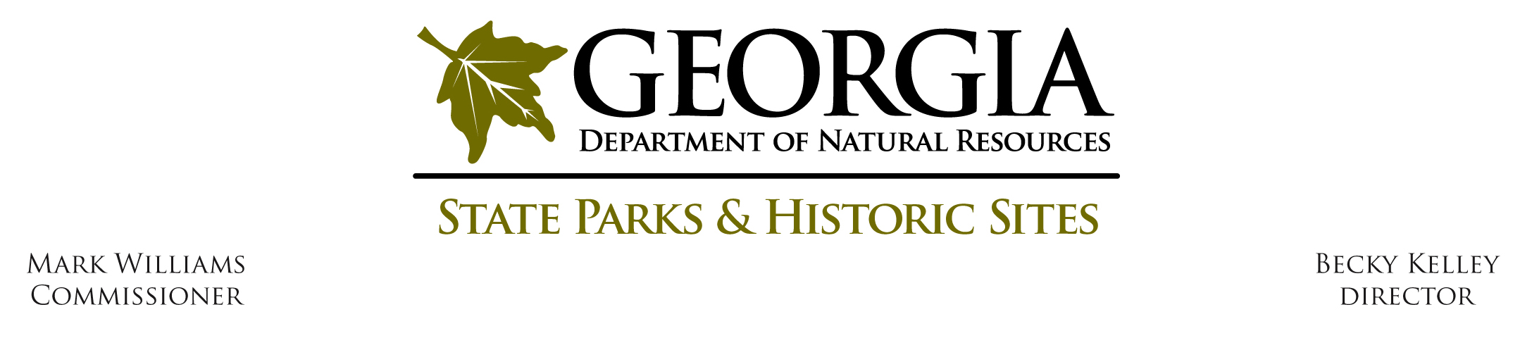
Operating Procedure # O - U - 2

Subject: Uniform Appearance Standard

Effective Date: July 1, 2015

Procedure Statement:

As stated in PRHS Operating Procedure O-U-1, the Parks, Recreation and Historic Sites Division establishes and maintains a standard Uniform Procedure for certain personnel who are in positions involving visitor services, maintenance and security on state parks and historic sites in order that they may be more easily recognized, to improve associate safety, to increase visitor and property security, and to enhance the professionalism and esprit de corps of this specially designated group of associates.

In addition to standards for uniform items, this procedure provides a standard for the uniform appearance. Personnel who wear the uniform specified in O-U-1 will be responsible for conformity to this procedure.

Definitions:
None.

Procedure:

All uniformed employees shall maintain a neat, well-groomed appearance while on duty. The wearing of combinations of various articles other than those prescribed by these regulations is prohibited. Only uniforms and items prescribed herein or as issued shall be worn.

No jewelry, watch chains or similar items shall appear exposed on the uniform. Personalized belt buckles are not allowed. Chains, religious medals, watch fobs and other personal or jewelry items, if worn, may not be visible. The wearing of a wrist watch, I. D. bracelet, ring or medical alert jewelry is authorized as long as the style is sufficiently conservative to not draw attention to it. One pair of earrings in the lower ear lobe that do not dangle and are conservative is authorized for women. Any other visible body piercing is not allowed.

Approved Service Pins as described in PHRS Operating Procedure O-U-1 are allowed.

The following belt accessories are approved provided that they are conservative in style and design so that they do not draw attention to themselves: key ring holder, folding knife holster, belt first aid kit, flashlight, radio and any other approved equipment holster for law enforcement personnel.

Undershirts shall be white v-neck or crew-neck.

A black turtleneck can be worn under long sleeve shirt only.

Employees shall maintain a clean personal hygiene with no offensive body odor or overly strong perfumes or cologne. Employees shall begin each workday wearing a clean and wrinkle free uniform.

Associates shall keep shirt tails tucked in at all times. Short sleeve shirts shall not be rolled up. Shirts worn without a tie shall have the top button only (the tie button) unbuttoned.

Shoes and boots shall be kept clean.

Hair:

All employees shall maintain hair that is clean and combed in an orderly manner. Hair length for men shall be conservative as to not draw attention to it. Women may wear hair accessories that are neutral in color, conservative and do not draw attention. Prohibited hair style examples are, but not limited to, mohawk, mullet, or etched design.

Male Employees

Men shall maintain hair length so there is no hair below the collar or the lobe of the ear. Hair shall present a tapered appearance on the back and sides of the head. Other conservative hairstyles that meet these criteria are acceptable. Hair is to be natural in color and conservative to not draw attention to it.

Sideburns are acceptable as long as they are clean, trimmed and tapered, with the ends clean-shaven in a horizontal line. The sideburns may not extend lower than the lobe of the ears.

Mustaches are acceptable as long as they are kept trimmed and clean. Mustaches may not be grown below the corners of the mouth, nor may they be twisted or curled on the ends. Exceptions may be made by region manager for historical interpretation for any class other than L.E.

Beards are not acceptable for associates with law enforcement. This restriction, however, may be waived upon presentation of a medical doctor's written statement that shaving the beard will adversely affect the associate's health. Religious requirements will be considered. Beards on non-enforcement personnel are allowed provided they are clean and well maintained and to not pose a safety hazard.

Female Employees

Women shall maintain clean hair that is combed in an orderly manner. The length is not specified; however, it will be considered a violation of policy for a female associate to wear her hair in a manner, which creates a safety hazard for her or others. A female associate can be required to wear her hair up above the collar for the performance of duties when, in the opinion of her supervisor, long hair is inappropriate. Hair is to be natural in color and conservative to not draw attention to it.

Facial makeup is authorized for women provided that it is conservative in color and application. If, in the opinion of the supervisor, makeup draws attention to itself, the associate may be required to soften or eliminate it.

Fingernails shall be conservative in length (e.g. in no way hampering or impeding the associate's ability to perform his/her job duties and not drawing attention to themselves). Female employees may wear nail polish that is naturally colored and moderate in application.

Only approved ball cap or campaign hat is to be worn.

Staff should not use tobacco in front of the public or indoors. There should be a designated smoking area, which is not in front of the public, nor in front of entryways of buildings. Staff should not be in contact or speak with the public with tobacco in their mouth. Staff should not smoke in any state vehicle.

No visible tattoos are permissible.

Staff that have visible tattoos must wear the long sleeve uniform shirt, or long pants to be in compliance.

Cosmetic tattoos for female employees are acceptable if they are moderate and look natural (i.e. Eyebrow tattoos in place of natural eyebrows are acceptable, providing they are naturally colored and otherwise do not draw unnecessary attention).

Body modification to any area of the body, which is visible while wearing the uniform or business attire, is prohibited. Body modifications include but are not limited to:

Tongue splitting or bifurcation.

The complete or trans-dermal implantation of any object(s) other than hair replacement.

Abnormal shaping of the ears, eyes or nose.

Abnormal filing of the teeth.

Branding or scarification.

Body piercing to any area of the body, which is visible while wearing the uniform or business attire, is prohibited. Body piercing includes but is not limited to:

Tongue piercing.

Facial piercing including eyebrows, lips, nose or any other parts of the face.

Ear piercing except the allowable piercing as described above and is as follows: One pair of earrings in the lower ear lobe that do not dangle and are conservative is authorized for women. Ear “plugs” are not permissible for female or male employees.

Authority:
Not applicable.

Attachments:

None.

