GEORGIA DEPARTMENT ADMINISTRATIVE
OF NATURAL RESOURCES PROCEDURE

SECTION  Accounting (Parks and Historic Sites Division Only) | PAGE NO.  1 OF 2
SUBJECT:  Handling Bad Checks | DATE  8/1/2008

Purpose: To attempt to collect the money for checks returned unpaid by the bank. When these attempts fail, turn the records over to the Accounts Payable Unit of the Office of Administrative Services for further action.

Requirements: Once a bad check is received back at the site, site staff will follow the outlined procedure to either recover the funds or reimburse the operating account for the site

Responsibility | Action
Park Staff | - Receive a check that has been returned unpaid.
 | - Complete a deposit ticket to redeposit the check. (See Sample A)
- Is the check returned a second time?
  - No - No further action is necessary
  - Yes - Attempt to obtain the money from the person responsible by telephone and/or certified letter (A $25 fee should be collected in addition to the amount of the bad check for processing. Amount due to park is bad check amount +$25)
- Is money received?
  - If Yes –
    - Deposit the total (bad check amount +$25 fee) in the park account as redeposit or replacement for bad check.
    - Write check to DNR for the $25 and send to Cash management
  - If No – complete steps below
    - Subtract the amount from your cash disbursement journal (bank balance) by entering the amount of bad check under the “check amount” column and under “Other” column
    - Complete a request for payment. (See Sample B)
    - Attach the bad check (original plus three copies of the front and back) and a copy of your Cash Disbursement Journal to the request form.
    - Send these documents to the Accounts Payable Unit of the Office of Administrative Services.

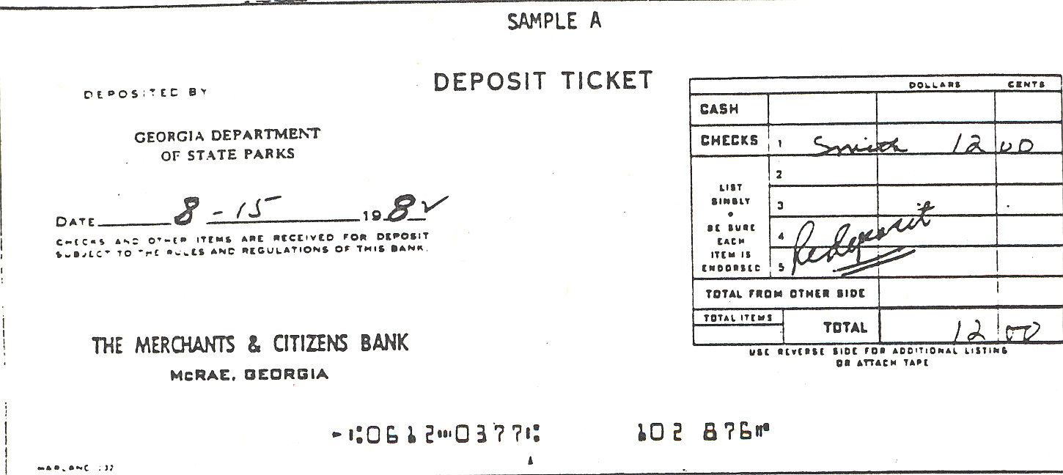
 |  |  |  |  |  | SAMPLE B
(PLEASE PRINT )
REGULAR VOUCHER
(Request for Payment)
 | VOUCHER # |  |  |  |  |  |  |  |  | GROSS AMOUNT |  | 45.00
 | (ACCOUNTING USE ONLY)
 | VENDOR # |  |  |  |  |  |  | 0000010691-183 |  | FUND: |  | 10100 |  |  |  |  | BUDGET YR: |  |  | 2007
 | (ACCOUNTING USE ONLY)
 | VENDOR NAME |  | INDIAN SPRINGS STATE PARK
 | INVOICE DATE |  | 4/28/2005 |  |  |  |  |  |  | INVOICE # |  | REF&RES&TEL4/28/05ISSP
 |  |  |  |  |  |  |  |  |  | DEPARTMENT |  | FUND SOURCE | PROGRAM |  |  |  | CLASS
ITEM | AMOUNT |  | ACCOUNT |  |  |  | DESCRIPTION |  |  | (Old Organization) |  | (Old Program) | (New - OPB) |  |  |  | (Sub-Class) |  |  | PROJECT
1 | 45.00 |  | 441270 |  |  |  | BAD CHECK |  |  | " |  | " | 60082 |  |  |  |  |  |  | "
2
3
4
5
When paying Bad Checks: Attach Original Check plus 3 copies of the check front & back along with a copy of the Cash Disbursements Journal.
 |  |  |  |  |  | FEI # |  |  |  |  | Approval Signature
 |  |  |  |  |  | Prepared By: |  |  |  |  | Entered By:

