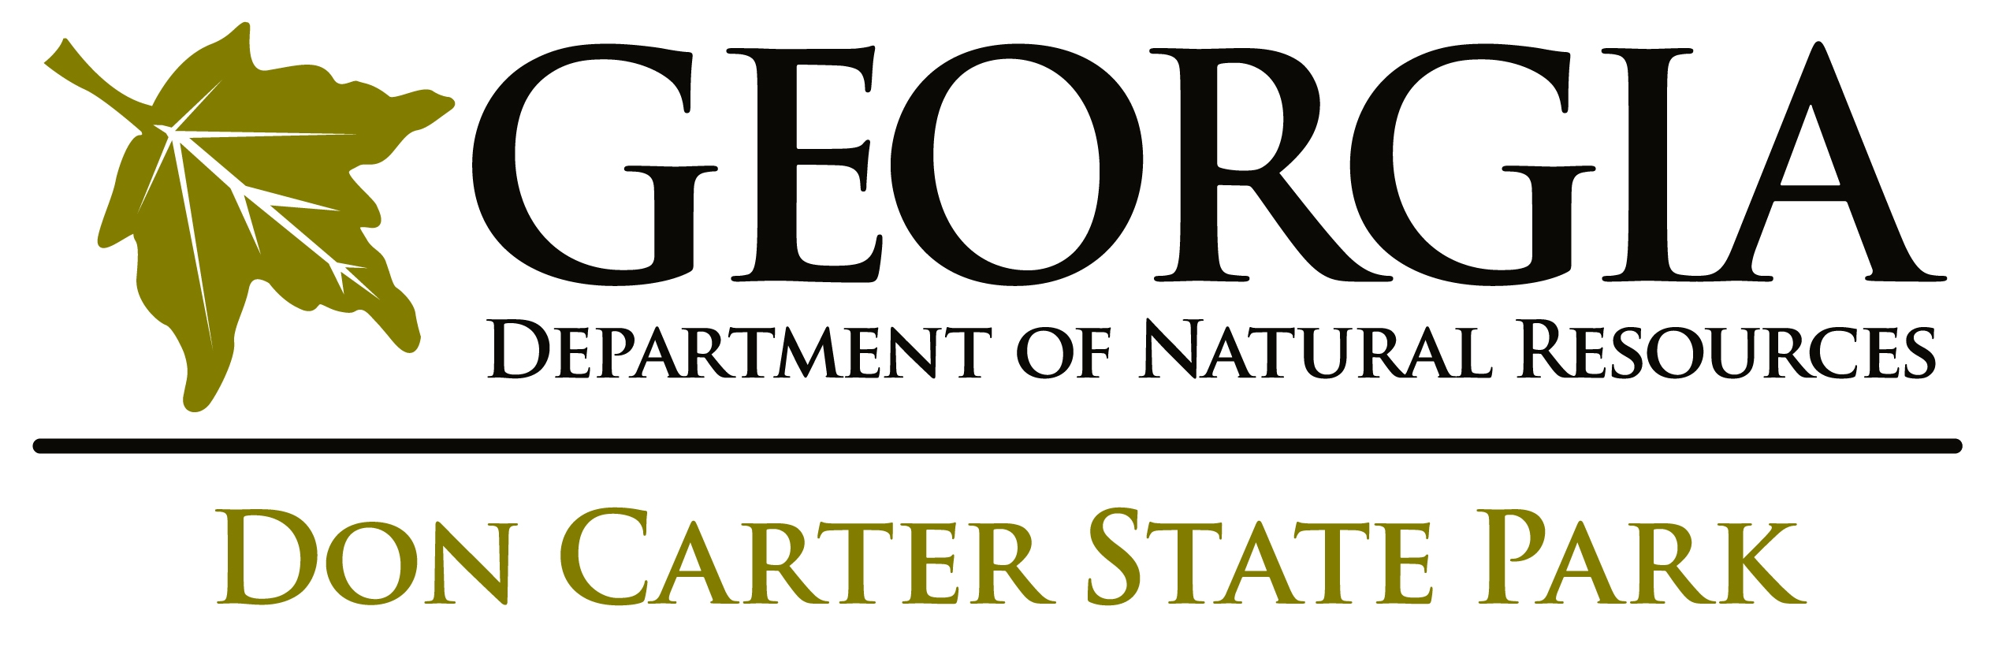

ANNUAL PROGRAM & RECREATION ACTION PLAN 2016

For Year Time Period: January 2016 – December 2016

Plans should be revised annually in August – September to submit to the Region Office by November 1st. All events and volunteer calendar projects should be posted on the GASP website by November 30th each year. Be sure all the program and recreation goals in this plan are realistic and achievable within the next calendar year.

Program Attendance | FY13 | FY14 | FY15
Public Interpretive
Group Tour
Special Events **
School Programs
Outreach Programs
TOTAL PROGRAM ATTENDANCE
Recreational Amenities | FY13 | FY14 | FY15
Bike Rentals
Boat Rentals
Fishing Loaner Program
Disc Golf
Miniature Golf
Other:
TOTAL RECREATION RENTALS
TOTAL PARK ATTENDANCE***
Current Dedicated Staff, Or Available Staff for Interpretive Efforts:

- Part Time Naturalist, Year Round, Jade Suster
- Site Manager, Erin Kenner
- Assistant Site Manager, Thomas Bailey
- Volunteers upon availability

Top Successes of 2015

- The Hike and Paddle program expanded to a monthly program due to the demand from guests making it the most consistent and popular ongoing program.

Program and Recreation Goals Achieved from 2015 Plan

Program Goals:

- Ex. Expanded winter programming by adding Night Sky Watch and Park Nights, City Lights Hike and increased frequency of Jr. Ranger Day Camps, New Manchester History Hikes, and Native American Heritage Hikes.
- Posted photos and program updates at least once each week on Facebook. Consolidated the many pages about the park into one official page and generated 354 likes.

Recreation Goals:
- Ex. Established and implemented new rental rates for all boats. Each type of vessel is unique in Active to allow for revenue tracking.

Program and Recreation Goals for 2016

Program Goals for 2016
*Note that the number of goals for Programs and Recreation may vary from site to site. Be sure to include Goals that are realistic and achievable for the upcoming year.

Program Goal 1:

Write your first goal here.

Actions needed to accomplish this goal (assign a name(s) to each action)

- List action items here with assigned staff and dates to accomplish by if applicable.

Program Goal 2:

Blah blah

Actions needed to accomplish this goal

- Steps…

Program Goal 3:

Blah blah

Actions needed to accomplish this goal

- Steps…

Recreation Goals for 2016

Recreation Goal 1:

Write your first goal here.

Actions needed to accomplish this goal (assign a name(s) to each action)

- List action items here with assigned staff and dates to accomplish by if applicable.

Recreation Goal 2:

Blah blah

Actions needed to accomplish this goal

- Steps…

Recreation Goal 3:

Blah blah

Actions needed to accomplish this goal

- Steps…

Active Programs Proposed for 2016
Indicate those which are new events; if it is an annual event – how many years has it been offered.

Special Events 2015
- Example: Friday, July 26 – Saturday, July 27, 2014: Folk Life Festival: Annual Event – 20 + years
- Saturday March 15th, 2015 – Spring Fest annual event; 2nd year (Ellen)

Required State-Wide Special Events:
- Annual Program Theme 2016 “Hidden Gems” This is a recommendation from the Programming Advisory Committee. Each year all sites should offer a program that ties into the Annual State-wide theme that will be marketed as a state-wide effort. For the 2016 theme, think about a “hidden gem” on your park that the public cannot find online or without coming to your program. For example, at Unicoi State Park there is a fault line that runs through the park. Along the Lake Trail there is a large rock outcrop that has folds of mica (fool’s gold) and quartz where guests can see a visual example of the fault line. This “hidden gem” or feature is something that the park staff knows about but the public would not find on their own. This could be incorporated into a Gold Fever themed program with a guided hike interpreting the history of the discovery of gold in White County along with gold panning.
- First Day Hike – January 1, 2016 (Suzanne) *Note that this event is done in partnership with other State Parks through the National Association of State Park Directors and in partnership with Recreation.gov
- Get Outdoors in June 2015 – Date – description of event. (Tanner ) *Note that in June you should host at least one event that ties into “Get Outdoors Month”, a National Initiative. Include this in either the Title or Description of your event that it is in honor or “Get Outdoors Month”.
- National Trails Day – Saturday, June 4, 2016 *Note that this is done in partnership with the American Hiking Society. We need to list all events on both the PRHS website and on the AHS/NTD website: http://www.americanhiking.org/events/
- Your State Park Day – September 26, 2015 – description of event. ( Suzanne) *Note that this day is usually done in partnership with the Friends of Georgia State Parks and on National Public Lands Day. Events need to be listed on both the PRHS website and on the NPLD website at http://publiclandsday.org/register-site. Create a title for this event htat describes more about the work projects you have planned. Ex. “Sandpiper Trail Cleanup – Your State Parks Day”

Recommendations for strengthening Special Events 2016:
- List ways you can improve or expand events from previous years.
- Blah

Public Programming
modify this section to read the way you can commit to offering these programs for the year.
Public Programs will primarily be offered by the Part-time Naturalist and if they are not available the Manager, Assistant Manager or other staff/volunteers will offer public programs in order to maintain program schedules:

Winter: Public Programs are offered two days a week from December – February and one Special Event
- Spring: Public Programs are offered two days a week from March – May. One or more Special Event(s) in addition to school programs offered in this period.
- Summer: Programs are offered 3-4 days a week from Memorial Day – end of July. Two or more Special Event(s) or group programs offered in this period.
- Fall: Programs are offered two days a week from August – November. Two or more Special Event(s) or group offered in this period.

School Group Goals:
- List goals here specific to School programs and list how many you offer that correlate to GPS.
- Don Carter will complete XXX programs to students that correlate with the GPS.

Group Program Goals:
- List goals here specific to Group Programs. Ex. Begin targeting schools, businesses and community organizations with email, flyers, social media ; Develop a group booking process including notebook, calendar, confirmation paperwork, and the GPS standards.

Out Reach Program Goals:
- List goals here specific to Outreach Programs Ex. Foster greater relationship with local community by conduct more programs at venues such as REI Kennesaw and Bartow County Libraries (Interpretive Staff currently conduct a few programs each year at these locations.) - Marcus

Resource Management Issues to address with Programming
- List goals here specific to Resource Management that will be interpreted for the site. Ex: Recycling Efforts on park; Invasive Plant removal
- Offer control burn education workshop for public- Amy-program before scheduled burn (TBD)

Program goals to target audiences not currently engaging:

- Think about who you are not reaching and how you can reach them. Ex: Reach the College age/Millennial generation with park programs through the addition of group overnight trips to Grover Island and create volunteer opportunities with kayak cleanups and partnerships with Cumberland Island; Target local neighborhoods through marketing directed to Homeowner’s Associations for Increased visitation from local suburban families

Offer Volunteer Opportunities
It is required State-wide to offer at least one monthly opportunity for volunteers to help with a project, activity or program. These should be posted online in the Georgia State Park under the Volunteer calendar if it is a work project. If it is an activity or event that requires volunteer assistance, list it also on that calendar, but specify what is needed. Ex. Volunteers needed to help set up for the Pioneer Harvest Festival. Work day Wednesday, November 12, 2014 – 10:00 a.m. – 2:00 p.m. Track all annual volunteer hours for grant matching.
- January – Extreme Habitat Makeover at the pond installing fish havens. (Jason)
- February – ( )
- March – ( )
- April – ( )
- May – ( )
- June – ( )
- July– ( )
- August – ( )
- September – ( )
- October – ( )
- November – ( )
- December – ( )

Passive Programs Proposed for 2016

Bulletin Boards/Information Kiosks

Example goals below:
- Construct and install Trailhead Bulletin board at Iron Hill Trail. (September 2016 – Ellen)

Exhibits

- Goals for exhibits here, list staff who will complete & a completion date.

Self-guided Tools

- Goals for self-guided tools ex. develop a tree id guide; update cottage binders to include…, list staff who will complete & a completion date

Trails

- Goals for trail maintenance or re-blazing, nature trail sign cleaning, build benches, etc. , list staff who will complete & a completion date

Training

- List any training for any staff for the year. Ex. Kathy to attend the seasonal training in May.

Marketing/publicity:

- Examples of goals:
- Learn how to use new social media sites and use more to promote all programs: Twitter, Snapchat, Instagram, YouTube, Flicker, etc. , list staff who will complete & a completion date
- Use Active Works to send email blasts about upcoming Special Events, Packages, Discounts, etc. , list staff who will complete & a completion date

Future Interpretive or Recreational Considerations:
- List goals that are long term that cannot be accomplished in the next year, but may be able to add to the following year’s Action Plan.
- Seek out greater growth and networking in local school system (Jackie, Wade, Jason)
- Dog park

Current Inventory of Interpretive Tools, Equipment, Reference Material & Recreational Equipment:
Itemize all load-n-go (resource) boxes, resource books, equipment, etc. examples: -
- Itemize all load-n-go boxes, resource books, equipment, etc. examples: note if you have a list in Excel or different format, this is fine to send as an additional attachment.
- Native American Crafts load-n-go
- Georgia Rocks load-n-go
- Night Hike load-n-go
- Discovery box

Programming Needs
List needs that help to reach goals. Itemize and list estimated cost on the Google Doc here:

https://docs.google.com/spreadsheets/d/1xjzgbBG2MJPbtGqP4vASCUqAEX5pZxAuftDuKtF5rVQ/edit#gid=1541925240

