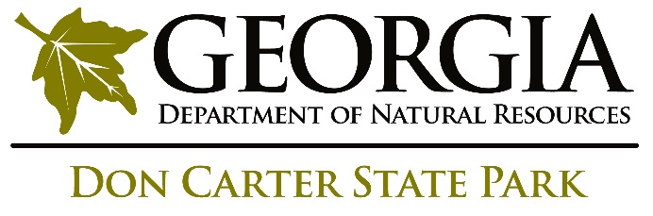

ANNUAL PROGRAM & RECREATION ACTION PLAN 2019

For Year Time Period: January 2019 – December 2019

Program Attendance – NOTE this is the only section in this plan that is based on the Fiscal Year as that is how we calculate our attendance. | FY16 | FY17 | FY18 | FY19 GOALS
Public Interpretive
Group Tour
Special Events **
School Programs
Outreach Programs
TOTAL PROGRAM ATTENDANCE
TOTAL PARK ATTENDANCE***
Current Dedicated Staff, Or Available Staff for Interpretive Efforts:

- List

Top Successes of 2018

- List

Program and Recreation Goals Achieved from 2018 Plan

Program Goals:

- List

Recreation Goals:

- List

Program and Recreation Goals for 2019

Program Goals for 2019

Program Goal 1:

Write your first goal here.

Actions needed to accomplish this goal

- List action items here with assigned staff and dates to accomplish by.

Program Goal 2:

Blah blah

Actions needed to accomplish this goal

- Steps…

Recreation Goals for 2018

Recreation Goal 1:

Write your first goal here.

Actions needed to accomplish this goal

- List action items here with assigned staff and dates to accomplish by.

Recreation Goal 2:

Blah blah

Actions needed to accomplish this goal

- Steps…

Special Event Programs Proposed for 2019
Indicate those which are new events; if it is an annual event – how many years has it been offered.

Special Events 2019

- List

Required State-Wide Special Events:

- Annual Program Theme 2019 - TBD
  - list
- First Day Hike – January 1, 2019 OR Super Museum Sunday, February 10, 2019
- Get Outdoors in June 2019 – list info
- National Trails Day – Saturday, June 1, 2019 – list info
- Your State Park Day – September 28, 2019 list info

Recommendations for strengthening Special Events 2018:

- Write here

target audiences not currently engaging:

- Who and how

Passive Programs Proposed for 2019

Passive Program Goal 1:

Write your first goal here.

Actions needed to accomplish this goal

List action items here with assigned staff and dates to accomplish by.

Passive Program Goal 2:

Write your first goal here.

Actions needed to accomplish this goal

List action items here with assigned staff and dates to accomplish by.

Future Interpretive or Recreational Considerations:

- Write here

Programming Needs From Site Budget

List all programming items that will be purchased out of the site budget to reach the goals listed in this plan here:

Item | Quantity | Price per item | Total expense

Interpretive Unit Program Fund Request:

Request funds through this link to the One Drive Form. Write a note about who did this request and when or if none is requested this FY.

