A.H. Stephens State Historic Park

Business & Management Plan


Prepared June 2011; Finalized December 2012

Direction 2015 – Sustainable Business Planning

Table of Contents

Executive Summary…………………………………………………………………………………………………………………………………3

Site and Operations Assessment ……………………………………………………………………………………………………………..7
Site Inventory and Facility Assessment……………………………………………………………………………………………….7
Operational Assessment……………………………………………………………………………………………………………………10
Financial Performance Assessment…………………………………………………………………………………………………..15

Business and Management Plan…………………………………………………………………………………………………………….18
Business Goals…………………………………………………………………………………………………………………………………..18
Classification of Programs and Services……………………………………………………………………………………………20
Partnership Development Plan………………………………………………………………………………………………………….21
Marketing and Sales Plan…………………………………………………………………………………………………………………..22
Revenue Generation Plan………………………………………………………………………………………………………………….24
Expense Management Plan………………………………………………………………………………………………………………..26
Financial Pro Forma……………………………………………………………………………………………………………………………27

Action Plan…………………………………………………………………………………………………………………………………………….30

Executive Summary
The Parks, Recreation and Historic Sites Division (PRHSD) of the Georgia Department of Natural Resources (DNR) is transitioning the management of A. H. Stephens State Historic Park to operate more like a business, reflecting the Direction 2015 – Sustainable Business Planning initiative to improve the fiscal performance and management of the state parks and historic sites system. This business and management plan is designed to help the site recover more operating expenses through earned revenues, productive partnerships, and innovative programs.

Site Fact Sheet
Site Name | A. H. Stephens State Park
Site Manager | Andre McLendon
Region Manager | Tommy Turk
Date of Business Plan completion | 6/10/11
Site size | 1,200 acres
Total number of visitors (FY 2010) | 48,508
Total operating budget (FY 2010) | $ 346,993
Total earned revenues (FY 2010) | $ 163,759
Operational cost recovery (FY 2010) | 47%
Average operating cost per visitor (FY 2010) | $ 7.15
Average earned revenue per visitor (FY 2010) | $ 3.78
Average cost recovery (FY 2008 – 2010) | 47%
Target cost recovery (FY 2015) | 74%
Total full-time employees | 4
Total part-time employees | 3
Primary service markets | Metro Atlanta, Macon, Augusta
Primary attractors/visitor appeal factors | Home of Vice President of Confederacy, CCC group camp, equestrian facilities, campsites & cottages, group/picnic shelters, fishing & boating lakes
Leading opportunities for improved site performance | Expanded visitation and overnight occupancy, additional recreational opportunities, updated exhibits and additional equestrian facilities

Site Summary and Key Attractions
This pretty park west of Augusta is known for its Confederate history, CCC history, and equestrian facilities. Overnight guests can choose from lakeside cottages or a modern campground, while large groups can enjoy privacy in the park’s group camp or pioneer campground. Horseback riders can explore 12 miles of trails and stay overnight in their own primitive campground. Visitors can enjoy geocaching, fishing and boating, while also learning about a key official in the American Civil War. Named after the Vice President of the Confederacy and governor of Georgia, A. H. Stephens State Historic Park features a Confederate museum with one of the finest collections of Civil War artifacts in Georgia. Stephen’s home, Liberty Hall, is renovated to its 1875 style, fully furnished and open for tours.

Key Attractions
The amenities or features listed below are those that seem to be most popular for visitors.
- Confederate Museum and Liberty Hall
- CCC Group Camp
- RV/tent campground and 4 cottages
- Equestrian trails and campground
- Group shelter, 3 picnic shelters
- 3 fishing lakes (Buncombe, Federal and Liberty) and boating
- Nature trails
- Nearby Lake Oconee area

Financial Targets
The table below details the total operating expenses and earned revenues for A. H. Stephens State Park over the last three years (2008 – 2010). This table also calculates total cost per visitor and revenues per visitor during these operating years, and details the target financial performance goals in the context of achieving at least 74% cost recovery. This table also calculates the necessary change from 2010 operating expenses and revenues.
A. H. Stephens State Park | Target Visitation Growth from 2010 | Target Change in Visitation
Visitation Assumptions | 30% | 7,300
 | 2008 | 2009 | 2010 | 2015 Target
Visitors | 45,346 | 38,040 | 48,508 | 63,060
Total Expenses | $ 417,091 | $ 311,443 | $ 346,993 | $ 300,000
Total Revenues | $ 156,442 | $ 158,377 | $ 163,759 | $ 223,386
Cost per Visitor | $ 7.15 | $ 8.19 | $ 7.15 | $ 4.76
Revenue per Visitor | $ 3.45 | $ 4.16 | $ 3.38 | $ 3.54
State Financial Support per Visitor | $ (3.70) | $ (4.02) | $ (3.78) | $ (1.21)
Total Cost Recovery | 38% | 51% | 47% | 74%
Change from 2010 Expenses |  |  |  | $ (46,993)
Percent Change from 2010 Expenses |  |  |  | -13.54%
Change from 2010 Revenues |  |  |  | $ 59,627
Percent Change from 2010 Revenues |  |  |  | 36.41%

Key Recommendations

Primary / Short Term Recommendations
- Operate the site using cost-based accounting, including the net cost recovery achieved annually.
- Conduct in-park surveys annually to assess how well customer satisfaction levels are being met. AHS should strive to have 90% of visitors responding to ‘Comment Cards’ report that they were either ‘satisfied’ or ‘very satisfied’ (or some comparable metric to be developed). Programs or services that fall below that standard should be critically reviewed, enhanced, and results monitored; those with a history of poor performance should be considered for elimination.
- Collect a statistically-valid sample of ZIP code data from visitors in a non-intrusive way to gauge their origins and demographics (e.g., age, ethnicity, income, etc.) and use the results to improve programming and marketing efforts to appeal to a broader audience.
- Utilize a minimum of six special events annually to help draw more visitors to the site.
- Seek local partners to help support operations, programs, and service delivery and for cross-marketing purposes.
- Sustain sufficient non-labor operational funding or reduce staff so that required staff operational costs (with benefits) do not exceed 60% of the total operational budget.
- Enhance facilities and program offerings to provide a minimum of 10 unique experiences for each visitor while maintaining at least a 90% customer satisfaction rating.
- Manage A.H. Stephens and satellite operations according to well-defined maintenance, program and operational standards monitored and enforced by region managers and senior management.
- Partner with local Chambers of Commerce, Historical Society, or other destination marketing organizations (DMOs) to promote AHS.
- Engage Friends members in the business plan as a partner to help the site meet or exceed its sustainability goals.

- Review and update rates at the site on an annual basis to recover the total net cost of service for important and visitor-supported services.
- Track total economic impact of the site on the local communities and region and share with decision-makers, elected officials, local business operators, and others to demonstrate the impact of AHS.
- Develop a more detailed analysis of labor requirements of all major park functions to match the right position with the right job at the right pay.
- Develop funding to provide additional training to site staff for improved business management and marketing effectiveness.
- Construct and upgrade facilities and amenities at the site that are likely to have a cost recovery level at or above 100%. Suggestions include the addition of yurts in the campground, additional cottages, etc.
- Develop immediate partner/amenity packages with local attractions such as the British American Sporting Club (hunting and sporting clays) and the Durhamtown Plantation and Sportsman’s Club (motocross track).

Secondary / Long Term Recommendations
- Evaluate and adjust hourly staffing rules to allow full-time employment for hourly employees and thereby more scheduling and operational efficiencies.
- Continue partnering with Friends chapter to promote several large special events each year.
- Convert the small information cabin in Camp Stephens into a retail store which will be run part time by volunteers or park staff. The increased sales of retail items associated with AHS will increase site generated revenues.
- Renovate the interior of the CCC Fire Tower and convert it into a museum/nature center run by campground hosts (this project will be funded by a matching grant from Friends). This project will add another unique experience to AHS and provide new programming offerings.
- Install electrical hook-ups in the equestrian campground (funded by a matching grant through Friends). This project will increase overnight stay usage and generate revenue.
- Build at least two additional cottages to generate more revenue. Additional cottages will enable AHS to serve larger user groups that we were not able to serve in the past .
- Build 4 yurts on Lake Buncombe to generate more revenue.
- Construct horse stalls for use by cottage equestrian guests.

Site and Operations Assessment
This site and operations assessment is a culmination of analyses and findings from a review of the condition of facilities, infrastructure, and operations at A. H. Stephens State Park. The findings and observations are not intended to be an exhaustive review of all issues present, but provide a basic understanding of the predominant issues that contribute to the site’s current operating conditions. The assessment includes the following:
- Site Inventory and Facility Assessment
- Operational Assessment
- Financial Assessment
Site Inventory and Facility Assessment

Methodology
Facility and asset conditions are rated using a differential scale of excellent, good, fair, or poor. Descriptions of conditions that are attributed to each of these findings are also provided.
Scale of Conditions
Rating | General Description
Excellent | Facilities/amenities are in ‘excellent’ condition when they show little or no maintenance or repair problems. Facilities do not feature any major design or operational issues or flaws that contribute to diminished use or increased maintenance or upkeep. Facilities are easy to clean and maintain in order to place them back into public use and the users perceive them to be in excellent shape.
Good | Facilities/amenities are in ‘good’ condition when they show only minor maintenance or repair problems. Most maintenance issues with these facilities typically appear to be the result of age and/or heavy use. Facilities may only feature minor design or operational issues that contribute to diminished use or increased maintenance or upkeep. Facilities are moderately easy to clean and maintain in order to place them back into service and the users perceive them to be adequate for their use, but probably not in excellent shape.
Fair | Facilities/amenities are in ‘fair’ condition when they show significant maintenance or repair problems. Facilities generally exhibit ongoing maintenance issues that appear to be the result of age, heavy use, or design or operational flaws. Some maintenance and repair needs may compound their fair condition by being deferred because of budget and/or resource limitations. Facilities require more effort to clean and maintain before placing them back into service and the users may perceive them as being less than adequate for their use and in a state of deterioration. The facility or structure may need of major repair or replacement.
Poor | Facilities/amenities are in ‘poor’ condition when they show significant, on-going maintenance or repair problems that ultimately may result in suspended use for repair/replacement. Maintenance and repair issues are possibly the result of poor maintenance and clearly the result of age, heavy use, or design or operational flaws. Problems with the facilities are often compounded over time due to consistently-deferred maintenance and repair because of budget and/or resource limitations. Facilities may feature major design or operational issues that contribute to diminished use or increased maintenance or upkeep. Facilities require excessive effort to clean and maintain before placing them back into service and the users often perceive them as being inadequate for their use and in a state of serious deterioration. The facility or structure may need of major repair or replacement.

Inventory and Assessment
The table below is an inventory of facilities and amenities at A. H. Stephens State Park, and provides the assessed condition of each as reviewed in May, 2011.

Site Asset / Amenity | Quantity | Condition
Total Acreage | 1,200 | Good
Visitor Center | 1 | Good
Confederate Museum | 1 | Poor
Liberty Hall | 1 | Good
Cottages | 4 | Good
Campsites | 25 | Good
Equestrian Campsites | 18 | Good
Group Camp | 1 | Good ( roofing)
Group Shelter | 1 | Good
Hiking Trails | 2 | Good
Picnic Shelters | 3 | Good
Pioneer Campground | 1 | Good
Pool (Closed) | 1 | Good
Comfort Stations | 1 | Good
Boat Ramp | 1 | Poor
Maintenance Facility | 1 | Good
Linen Barn | 1 | Good
Playgrounds | 2 | Good
CCC Firetower | 1 | Good ( interior work)
CCC Springhouse | 1 | Good
CCC Meter House | 1 | Good
Manager Residence | 1 | Good
Asst. Manager Residence | 1 | Good
GC Swimming Dock | 1 | Poor
Day Use Restroom | 1 | Good
CCC Lily Pool | 1 | Fair (concrete)
Elementary School | 1 | Poor
Equestrian Restroom | 1 | Good

Prioritized Facility Needs
Based on the facility inventory and assessment, these prioritized needs have been identified. Each need has been aligned with a priority category of high, moderate, or low to support future decision making regarding project sequencing, investment of public resources, and meeting community expectations. The priority assignment for each need is not a measure of importance. Rather, these recommended priorities reflect a phased implementation approach over the next several years.

Facility Need | Priority Assignment
Construct 4-5 yurts on Lake Buncombe | Low
Construct 2 additional cottages | Low
Install boat docks at cottages area | High
Replace campground comfort stations | High
Renovate CCC Fire Tower into museum/nature center | Moderate
Install electrical hookups at equestrian campground | High
Convert small information cabin in group camp into retail store | High
Renovate Confederate Museum | High
Stalls and bathhouse at equestrian campground | Moderate
Install picnic pads and fire rings at cottages | Moderate
Conversion of old school property or demolish | High
Replace terra cotta drain lines in group camp | High
Group Camp roofing | High
Repair Boat Ramp | High
Repair dam at Buncombe Lake | High

Priorities include addition of two additional cottages, construction of four yurts, conversion of the old pool building into a larger group shelter, repair of the gate valves at Lake Federal and Lake Buncombe, and construction of a concrete boat ramp at Lake Buncombe.

Operational Assessment
The Operational Assessment includes:
- An inventory and classification of programs and services being provided at the site
- A review of staffing at the site
- A review of concessionaires and partners operating at the site
- Visitation and customer satisfaction

Inventory and Classification of Programs and Services
Programs and services are classified into one of three major categories:
1) Core or Essential Services
2) Important Services
3) Visitor Supported Services
Programs and services at the site are classified into these categories based in part on the mission and public mandates for both the site and the agency. For the programs and services in each of these categories, there are financial performance expectations that will define how services are funded and evaluated.

Category 1 – Core Services [Largely supported by tax funds]
Core programs, services and facilities are those the agency must provide and/or are essential in order to capably govern and meet statutory requirements. The failure of the agency to provide Category 1 services at adequate levels could result in significant negative consequences for the public and the resources under protection. The criteria for programs or services to be classified as core or essential are:
- The services are mandated by the agency’s law or charter or are contractually obligated by agreement to provide the services.
- The services are essential to protecting and supporting the public’s health and safety.
- The services protect and maintain valuable assets and infrastructure.
- The services would generally and reasonably be expected and supported by residents, businesses, customers and partners.
- The services are those that cannot or should not be provided by the private sector.
- The services provide a sound investment of public funds.
The following programs and services offered at A. H. Stephens State Park have been identified as core services:
- Public safety
- Protection of cultural and natural resources
- Maintenance of site, grounds, facilities and infrastructure
- Public access to the site and its resources

Category 2 – Important Services [Supported by a balance of tax funds and earned revenues]
Important programs, services and facilities are those the agency should provide, and are important to governing and effectively serving residents, businesses, customers and partners. Providing Category 2 services expands or enhances the agency’s ability to provide and sustain its core services. The criteria for programs or services to be classified as important are:
- The services expand, enhance or support identified core services.
- The services are broadly supported and utilized by the community, and are considered an appropriate, important, and valuable public good. Public support may be conditional upon the manner by which the services are paid for or funded.
- The services generate income or revenue that offsets some or all of the operating cost and/or are deemed to provide economic, social or environmental outcomes or results.
The following programs and services offered at A. H. Stephens State Park have been identified as important services:
- Picnicking, shelters and trails
- Camping facilities
- Group camp
- Visitor Center and site administration
- Site appropriate education, interpretation and recreational opportunities

Category 3 – Visitor Supported Services [Almost exclusively supported by earned revenue]
Visitor supported programs, services and facilities are those discretionary services that the agency may provide when additional funding or revenue exists to offset the cost of providing those services. Category 3 services provide added value above and beyond what is required or expected. The criteria for programs or services to be classified as visitor supported are:
- The services expand, enhance or support core services or important services and the quality of life of the visitors, community or stakeholders.
- The services are supported, valued and well utilized and provide an appropriate and valuable public benefit.
- The services generate income or funding from sponsorships, grants, user fees or other sources that offset some or all of their cost and/or provides a meaningful return on investment.

- The services can possibly be provided through outsourcing or use of concessionaires, providing opportunities for community enterprises that may not otherwise be provided by the agency.

The following programs and services offered at A. H. Stephens State Park have been identified as visitor supported services:
- Overnight cottage rentals
- Special events
- Retail operations in visitor center and gift shops

Staffing Assessment
Labor costs at A. H. Stephens State Park represent the largest area of budgetary expense at an average of 60% of the total operating budget each year for the last three complete years, which is lower than the target of total labor costs (including benefits) not exceeding 65% of the site’s total operating expenditures. The tables below and on the following page provide a basic review of the current staffing at the site.
Full Time Equivalent Employees
Position / Title | Quantity (FTE) | Vacancies | Annual Hours
Park Manager 2 | 1 | 0 | 2600
Park Asst. Manager 1 | 1 | 0 | 2600
Senior Park Ranger | 1 | 0 | 2080
Secretary 1 | 1 | 0 | 2080
Utility Worker 1 | 0 | 1 | 2080
TOTAL | 4 | 1 | 11,440

Part Time Employees
Position / Title | Quantity (FTE) | Vacancies | Hours
Park Services Worker (Hourly | 3 | 0 | 4524
TOTAL | 3 | 0 | 4,524

Labor Support
Labor Support | Annual Hours
Volunteers | 2080
Community Service Workers | 540
Engineering and Construction Crews | 0
Resource Management Crews | 20
Prison Crew Detail | 0
TOTAL | 2,640

Total Labor Hours
Labor Type | Annual Hours
Full Time Equivalent Employees | 11,440
Part Time Employees | 4,524
Labor Support | 2,640
TOTAL Annual Labor Hours | 18,604

Labor Budget Summary

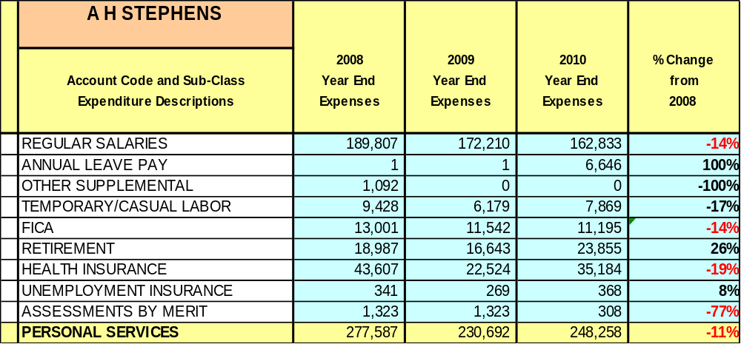

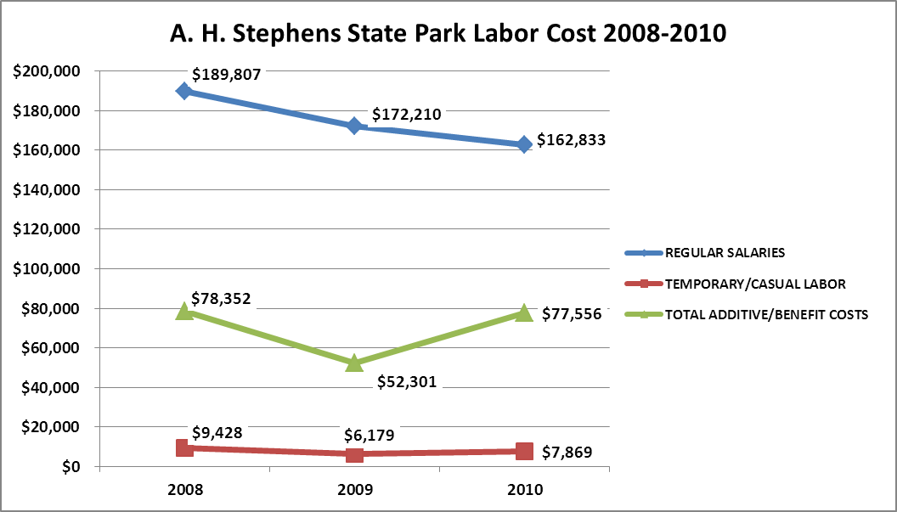

Visitation and Occupancy
Overall annual visitation to the site has increased from 2008 to 2010, increasing by 7% or over 3,000 visitors. This is largely attributed to increase in group camp usage and operational adjustments.

Year | Total Visitation
2008 | 45,346
2009 | 38,040
2010 | 48,508

Occupancy for the overnight accommodations at A. H. Stephen State Park the last three years is detailed in the table below. Overall occupancy has trended downward from 2008 to 2010. This is largely attributed to the economic downturn; however, group camp occupancy has risen each year. Camping occupancy will be rising due to the improvements at the equestrian area, particularly having power and able to take reservations. Cottage occupancy is a victim of the poor economy but the area between Augusta and Atlanta will continue to grow and attract business.

Year | Camping Occupancy | Cottage Occupancy | Group Camp Occupancy
2008 | 21.47% | 49.01% | 39%
2009 | 20.34% | 37.52% | 45%
2010 | 17.60% | 35.86% | 44%

Customer Service and Satisfaction

A. H. Stephens State Park | Year | Customer Satisfaction Level
 | 2009 | 80%
 | 2010 | 93%

Financial Performance Assessment

Operational Expenses
A summary of total operating expenses at A. H. Stephens State Park from 2008 to 2010, as well as their percent change from 2008 are provided in the table below.

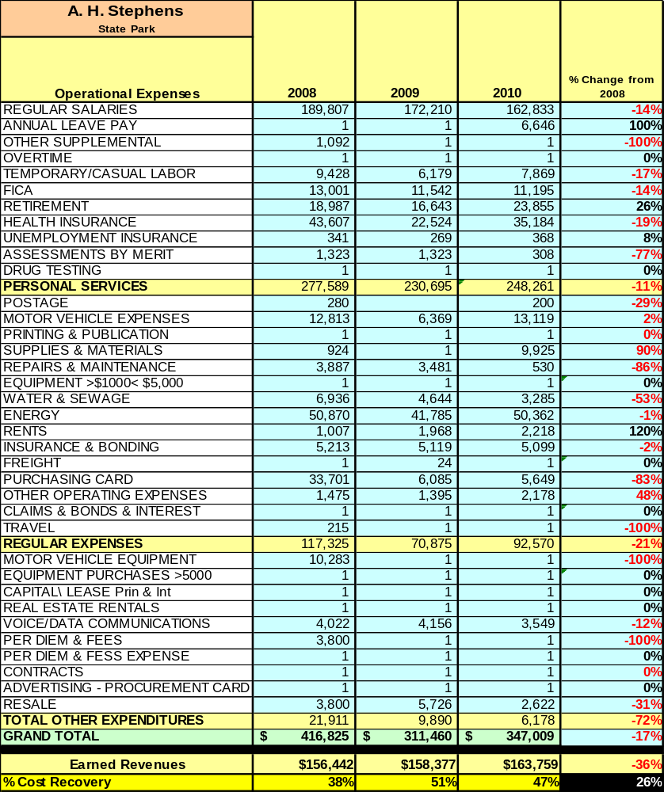

Earned Revenues
Earned revenues at A.H. Stephens have increased since 2008, which is largely attributed to an increase in group rental, facility enhancements and rate adjustments. Monthly earned revenues for the last two years (see table on the following page) indicate that the total annual revenue increased 2% from 2009 to 2010, with the largest increases in monthly revenues in October (38%), April (23%), and August (15%), etc., and the largest decreases in the months of January (-16%), February (-30%) and March (-22%).

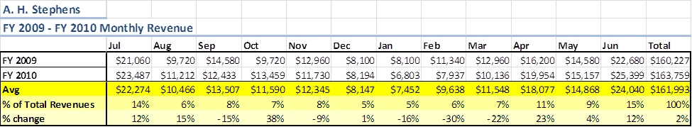The graphs below illustrate the monthly revenue trends each year and the average percent of total annual revenue earned each month.
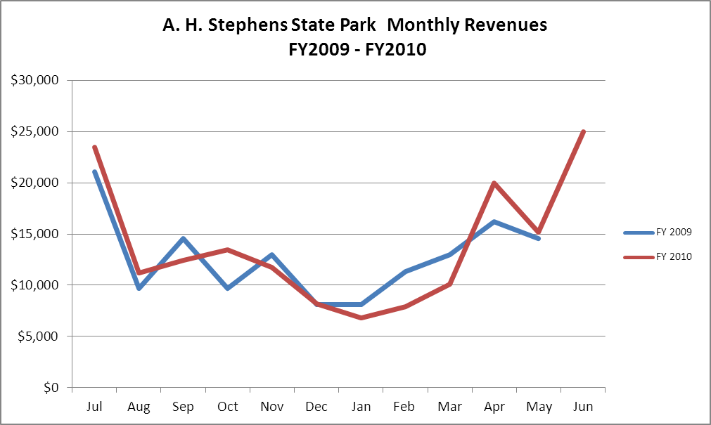

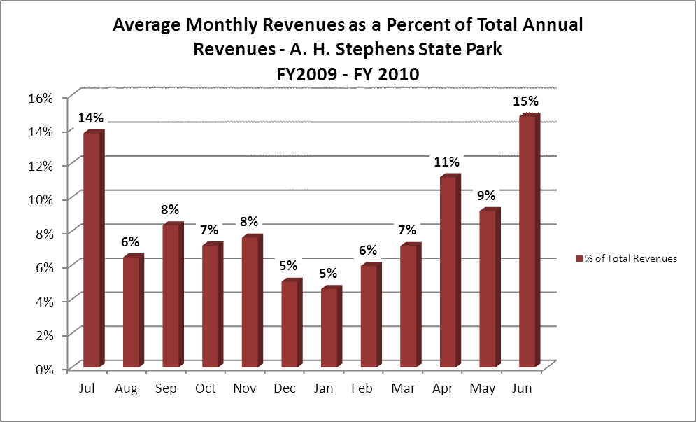

Cost Recovery Trends
A.H. Stephens has achieved an average cost recovery of 45% of annual operational expenses through earned revenues from FY 2008 to FY 2010. This is detailed and illustrated in the table and graph below.
Year | Operational  Expenses | Earned  Revenues | Percent Cost  Recovery
2008 | $ 466,812 | $ 156,442 | 38%
2009 | $ 311,443 | $ 158,377 | 51%
2010 | $ 346,993 | $ 163,759 | 47%
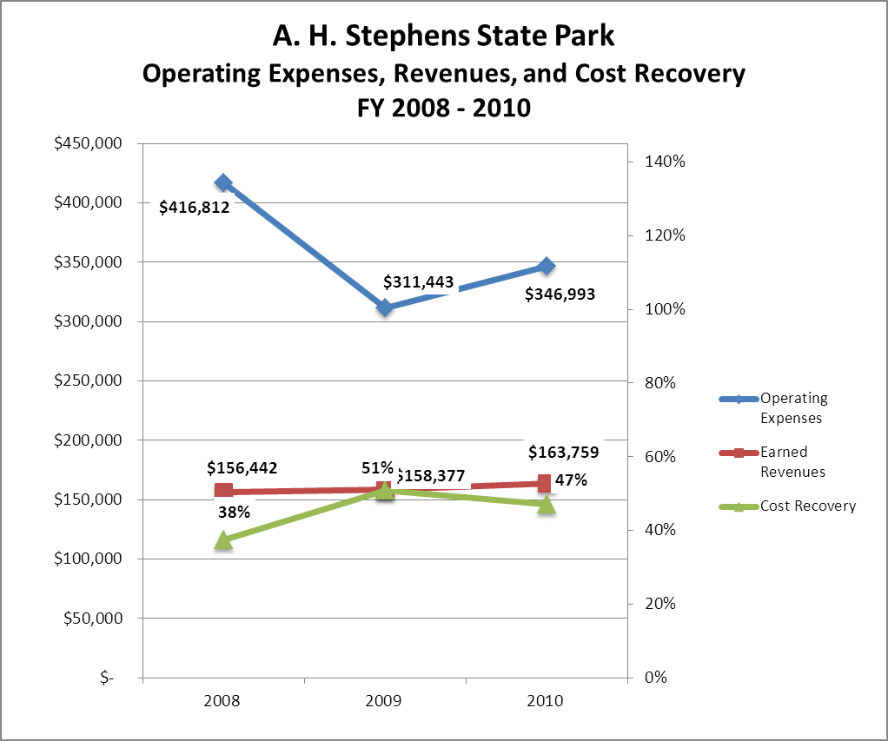

Review of Pricing
Data on rate information is available as far back as 2003, but only the last five years are evaluated. There has been some growth in fees charged at A. H. Stephens State Park since 2005, with the largest increase being the cottages. A table detailing the rates for A. H. Stephens is provided below.
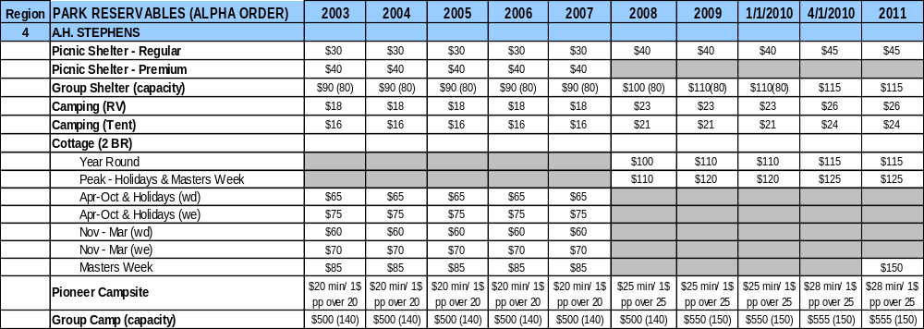

Business and Management Plan

Business Goals
The following goals serve as the foundation for the key recommendations and strategies in this business plan for A. H. Stephens State Park.

Enhance Cost Recovery of Site Operations
A. H. Stephens can improve revenues by pursuing strategies to increase visitation, which would include special events.

Enhance Revenue Generation Strategies
A. H. Stephens will improve revenue generation through improving overnight occupancy, continued development of equestrian camping area and horse trails, expanding retail sales, fee adjustments as needed and increasing the number of special events held at the site. (Two additional cottages, construction of four yurts, convert the old pool building into a larger group shelter, repair gate valves at Lake federal and Lake Buncombe, construction of a concrete boat ramp at Lake Buncombe.)

Expand Special Events at the Site
The expansion of facilities and amenities to host larger events or programs on site is important in order to generate more revenue. These events include weddings, receptions, festivals, etc. Continue to develop the open field by the school for community events and special activities.

Improve the Diversity and Innovation of Recreational and Interpretive Programs
A. H. Stephens has a lot of room for growth in this category. AHS has a great collection of artifacts, great nature trails and historic facilities that can offer new awesome experiences for visitors. AHS needs to upgrade the exhibits in the museum to capture a wider range of age groups. AHS also needs to create lookout wildlife viewing points and signage. The CCC tower can be converted into a mini museum/nature center for programs or a game room for campers. It can be run by the campground host by tracking revenues with a cash register. With the large acreage of the park, additional hiking and biking opportunities are also desirable.

Improve the Effectiveness of Marketing and Sales
The effectiveness for marketing and promotional activities of AHS could be improved to produce greater visitation and revenues during peak, shoulder, and off seasons. This could be achieved in part through a shift in the existing marketing approach to one that is more targeted and focused on experiential and inspirational messaging geared towards health, stewardship, recreation, etc. Additionally, partnerships with nearby attractions and amenities in the region should improve the ability of the site to maintain an increased and steady flow of visitors and revenue throughout the year.

Establish Greater Consistency of Managing and Monitoring Customer Service & Satisfaction
AHS plans to improve the consistency of managing and monitoring customer service and satisfaction by conducting on-site surveys annually to assess how well customer satisfaction levels are being met. AHS will strive to have 90% of visitors responding to “Comment Card” reports that they were either ‘satisfied’ for ‘very satisfied’ (or some comparable metric to be developed). Programs or services that fall below that standard should be critically reviewed, enhanced, and results monitored; those with a history of poor performance will be evaluated and potentially considered for elimination.

Expand Partnership Opportunities
Given the breadth of partnership opportunities available to AHS, multiple priorities will drive partnership opportunities for the site. This will include expanding service partnerships in which alternative and related providers in the community support the provision of programs and services to visitors at AHS; expanding vendor partners to reduce the costs of materials and supplies, and related services needed by the site; and seeking co-branding partners to off-set event and program costs, and to expand awareness of site programs and facilities in the site’s market area. We will also engage Friends members in the business plan as a partner to help the site meet or exceed its sustainability goals and continue to partner with equestrian groups to develop the equestrian areas.

Classification of Programs and Services
The tables below summarize the classifications of programs and services at A. H. Stephens as either core, important, or visitor supported and projects a range of cost recovery percentages that might be achieved for each. These classifications establish financial performance goals for each category of services that are linked to the recommendations and strategies of this business plan.

Core Services
Program / Service | Target Cost Recovery
Public safety | 0%
Protection of cultural and natural resources | 0%
Maintenance of site, grounds, facilities and infrastructure | 0%
Public access to the site and its resources | 25%

Important Services
Program / Service | Target Cost Recovery
Picnicking, shelters and trails | 60%
Camping facilities | 95%
Group camp | 100%
Visitor Center / site administration | 50%
Site appropriate education, interpretation and recreational opportunities | 50%

Visitor Supported
Program / Service | Target Cost Recovery
Overnight cottage rentals | 125%
Special events | 95%
Retail operations at visitor center/ gift shops | 100%

Partnership Development Plan
The table below summarizes existing partners and targeted partnerships by classification (operational, vendor, service, and co-branding, funding partners) and by organizational type.
 | Public  Partners | Not-for-profit  Partners | Private/Enterprise Partners
Operational Partners | - Taliferro County SO, EMS ,Fire Dept | - Friends of AHS
Vendor Partners |  |  | - Georgia Power  - Coca Cola  - British American Sporting club  - Durhamtown Plantation & Sportsmans Club
Service Partners | - City of Crawfordville | - Chamber of Commerce | - Ga Farm Bureau
Co-branding Partners | - Rockdale trail blazers  - CTHA  - BCHA  - Dancing Pines
Funding Resource Development Partner | - United Daughters of the Confederacy  - Taliaferro Co. Historical society | - Friends of AHS  - Friends of Ga State Parks

Marketing and Sales Plan

Marketing and Sales Goals
Marketing and sales goals for A. H. Stephens are based on the following desired outcomes:
- Increased cottage occupancy
- Increased group camp/ camping occupancy
- Increased picnic shelter/group shelter occupancy
In order to meet these goals, examples of specific target outcomes were identified in the areas detailed in the table below.
Area  of Focus | Current  Performance | Goal  by 2011 | Goal  by 2012 | Goal  by 2015
Overall Visitation | 48,508 | 49,000 | 49,478 | 54,159
Special Events | 2,000 | 2,500 | 3,000 | 5,000
Marketing and Promotion Strategies

Publicity and Social Media
AHS will approach marketing and publicity planning using the following guidelines and themes:
- Event Publicity
Major events benefit by having short stories in local, regional, and statewide newspapers and online social media hooks planted that run three to four weeks in advance of the event up to the date of the event itself. Stories and media need to be cultivated with contacts and online sales channels several weeks in advance of the time the stories need to run. Special interest interviews on morning, noon, and evening television news programs, radio interviews on popular rush-hour programs, and blogs on known affinity online sites should also be included.

- Program Publicity
Special and unique programs should have feature stories in magazines, weekly newspapers, and daily newspapers that are aimed at placements as front-page or sectional front-page stories. These stories are most effective if they run shortly before the season that the featured program begins. This will likely require several weeks of advanced planning with media contacts. Similar coverage on television and radio should also be considered. If pre-publicity cannot be generated, post-publicity can help promote future programs.
- Site Publicity
Site publicity focusing on a single site or sub-set of sites requires more intense planning efforts to attract multiple writers and editors from target publications. Each site could host several seasonal media familiarization tours (with 10 to 15 writers or editors) to familiarize them with the site and its benefits and amenities. Stories and features resulting from such tours typically take between two and six months to materialize so the tours should focus on experiences, benefits, and programs that would be available when the stories are expected to run.
Examples and suggested opportunities for events, programs and related publicity efforts based on the themes described above at A. H. Stephens State Park are provided in the table below.

Event Publicity | Program Publicity | Site Publicity
AHS Fall Festival | Junior Ranger Day Camps | AHS Birthday Celebration
Try the Parks ( races ) | Family fun Day | Civil War Medicine
Annual-Sportsman’s Barbeque | Sr. Fishing Rodeo | Victorian Christmas  At Liberty Hall
AHS Spring Festival | Kids fishing Rodeo | Life in the C.C.C

Packaging
Examples and suggested packages for A. H. Stephens are provided in the table below.
Package | Package Details
Value-Added Cottage packages | Cottage & Boat rental
Extended Stay Campsite package | Special rate for a 7-14 day stay
Extended Stay Cottage package | Special rate for a 14 day stay
Stay and Shoot | Camping/Cottage package with British-American Sporting Club
Sleep and Ride | Camping/Cottage package with stall and trail fees
Stay and Moto | Camping/Cottage package with Dunhamtown Plantation

Group Sales
Types of groups within which specific target customers can be identified for A. H. Stephens are listed below:
- Churches  - Families  - Special  interest clubs | - Schools  - Colleges  - Associations | - Public agencies  - Reenactment groups

Incentivizing New and Repeat Visitation
A. H. Stephens will utilize the following strategies and/or incentives to encourage new and repeat visitation starting in FY 2012:
- Group / bulk pricing – flat fees for paddle boat and group shelter rental, Group camp and cottage rental combo, Historic site packages with rentals and tour packages with other Historic attractions through surrounding chamber of commerce’s.
- Discounts for frequent visitors stay 10 nights next night free.
- Monthly or Quarterly lottery. ( win a free night or weekend camping )
- Tour both the C.C.C Tower and the Historic Site for a discount price
Marketing and Sales Metric Goals
The following marketing and sales metric goals and/or others will be monitored and progress reported:
- Loyalty and repeat customers = over 50% of AHS customers repeat their visit in a 12 month period.
- Brand confidence & customers-recruiting-customers = Customers referrals equal a minimum of 50% of our business.
Revenue Generation Plan

Revenue / Cost Recovery Goals
A.H Stephens has set a financial goal of increasing annual revenues 3% annually between 2012 and 2015. The largest revenue growth opportunity is most likely in the shoulder season months May & August through November. The table below details projected revenue growth leading up to 2015, based upon a nominal growth of revenues each year.
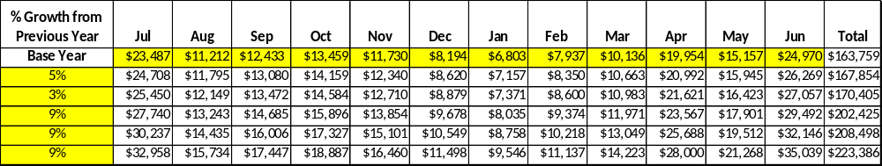

These projections would result in a total of 36.5% cumulative growth in total annual revenues between FY2010 and FY2015. If operational expenses can be managed with a cumulative reduction of 8% between FY 2010 and FY 2015, then the overall cost recovery of the site will be approximately 78% in FY 2015 at these projected revenue levels. This is higher than the annual financial performance of the site in FY 2010, which was operated at 47% cost recovery in that year.

Revenue Generation Strategies

Pricing Plan

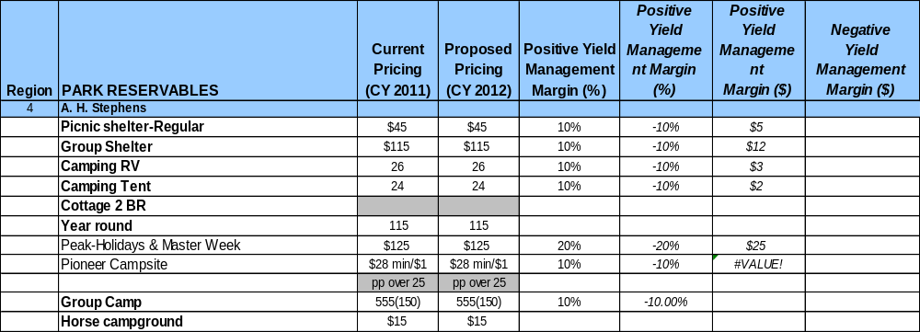

Innovative Programming and Special Events Plan

Program or Event | Theme or Purpose | Scheduled Date/Season | Frequency | Target Participation | Target  User Fee | Target Cost Recovery
Spring Festival |  | Spring | Yearly | 500-1000 | $5 | 155%
Fall Festival |  | Fall | Yearly | 500-1000 | $5 | 155%
Sportsman Barbeque | Opening hunting season | October | Yearly | 100-200 | $10 | 150%
CTHA | Poker ride | May & Nov | Two per year | 50-75 | $8 - $25 | 170%
ACTHA | Venue | Oct. & March | Two per year | 50-100 | $8 - $25 | 170%

Partnerships and Concessions Plan

Service / Partnership | Term of Service | Financial Objective | Contract Manager
Dept. discount promotions | 1 year | Generate revenue | Park Mgr
Food concessions | 1 year | Generate revenue & overnight stay | Park Mgr

Expense Management Plan
Personnel Assignments
The following actions will be taken to proactively manage labor costs via personnel assignments and classifications.

Action | Timeline | Outcome
Continue to cross train staff at Hamburg and AHS to reduce labor cost. | Immediate | Better support for events at AHS and HB.
Train volunteers to conduct tours of the Historic Site | Immediate | Reduction in labor cost
Re-evaluate maintenance and housekeeping needs (purchase equipment / or tools to get the job done faster with less personnel, etc.) | Immediate | Increased efficiency and cross support of programs and ops.

Management Techniques
The following actions will be taken to proactively manage labor costs via management techniques.

Action | Timeline | Outcome
Increase the use of volunteers for grounds maintenance. | Immediate | Better use of labor to meet customer expectations and reduce labor cost.
Increase the use of volunteers to operate the Historic Site. | Immediate | Reduction in labor cost.

Adjusted Levels of Service
The following actions will be taken to proactively manage labor costs via reduced levels of service.

Action | Timeline | Outcome
Reduction of hours of operation at the Historic Site. | 2012 | Better balance service to customers at this key location; close operation at times when traffic is slow. Conduct guided tours for groups only upon request when normally closed.

Financial Pro Forma
The following five-year financial pro forma projects operating expenses, earned revenues and cost recovery through FY 2015. These pro forma are based on the strategies and desired outcomes identified in this business plan, especially the revenue generation and expense management plans, and are linked to corresponding performance goals.

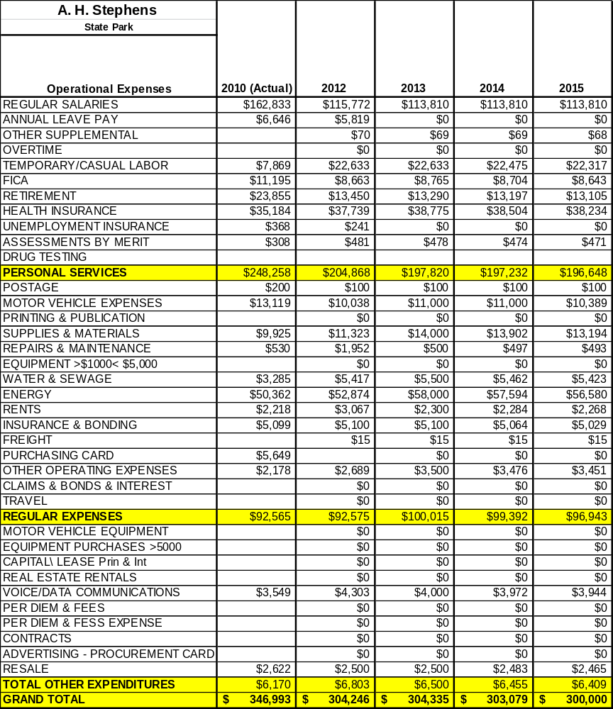
Expense Pro Forma

Revenue Pro Forma
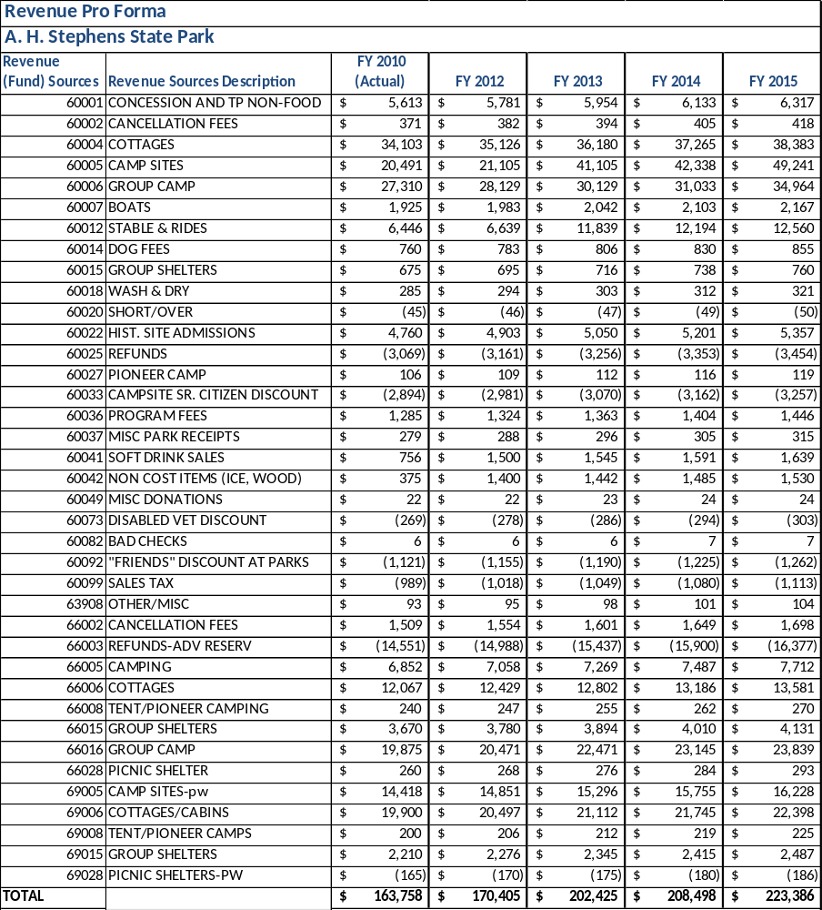

Total / Cost Recovery Pro Forma
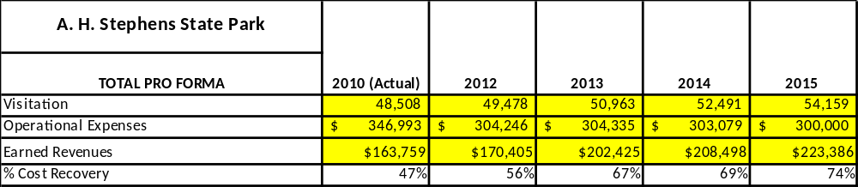

Action Plan
ACTION PLAN
Site: |  | Site Manager: |  |  | Date:
Month:
Strategy | Tasks | Costs / Funding | Revenues / ROI | Responsibilities | Metrics

ACTION PLAN
Site: |  | Site Manager: |  |  | Date:
Month:
Strategy | Tasks | Costs / Funding | Revenues / ROI | Responsibilities | Metrics

This is the average of the last three years – FY 2008, FY 2009, and FY 2010
Current employees, not including vacancies.
Current employees, not including vacancies.
Major population centers within a two-hour drive from the site

