Black Rock Mountain State Park
Business & Management Plan


Prepared June 2011; Finalized February 2013

Direction 2015 – Sustainable Business Planning

Table of Contents

Executive Summary 3

Site and Operations Assessment 8
Site Inventory and Facility Assessment 9
Operational Assessment 10
Financial Performance Assessment 16

Business and Management Plan 20
Business Goals 20
Classification of Programs and Services 21
Partnership Development Plan 22
Marketing and Sales Plan 24
Revenue Generation Plan 26
Expense Management Plan 29
Financial Pro Forma 30

Action Plan 33

Executive Summary
The Parks, Recreation and Historic Sites Division (PRHSD) of the Georgia Department of Natural Resources (DNR) is transitioning the management of Black Rock Mountain State Park to operate more like a business, reflecting the Direction 2015 – Sustainable Business Planning initiative to improve the fiscal performance and management of the state parks and historic sites system. This business and management plan is designed to help the site recover more operating expenses through earned revenues, productive partnerships, and innovative programs.

Site Fact Sheet

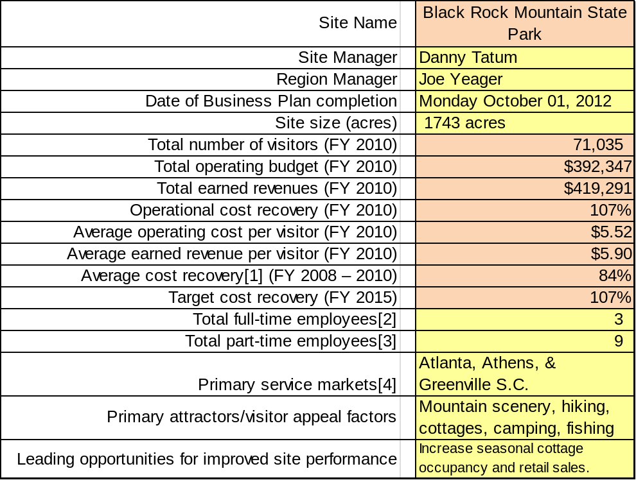

Site Summary and Key Attractions
Black Rock Mountain State Park is a 1743-acre park located astride the Eastern Continental Divide on the crest of the southern Blue Ridge Mountains. The park is largely undeveloped, except for the visitor-use facilities along Black Rock Mountain’s narrow spine. With a summit elevation of 3,640 feet, along with three other peaks above 3,000 feet, Black Rock Mountain is Georgia’s highest state park. Located in central Rabun County, approximately five miles south of the North Carolina border, Black Rock Mountain is approximately 100 miles northeast of metropolitan Atlanta.
Scenic overlooks along Black Rock Mountain Parkway provide sweeping vistas of the Southern Appalachians that extend for more than 80 miles. On a clear day, park visitors can see high-rise dorms at Clemson University in South Carolina and the highest peaks in the Great Smoky Mountains National Park in North Carolina and Tennessee.
The park is noted for its diversity of spring wildflowers and relatively cool summertime temperatures (average July temperature only 70 degrees), resembling those of New England. Autumn colors across the mountain are stunning, and during the winter, snow can blanket the park’s higher elevations for weeks at a time.

Key Attractions
The amenities or features listed below are those that seem to be most popular for visitors.
- 11-mile trail system featuring scenic overlooks, lush Appalachian forests, and cascading streams
- Ten rental cottages (five with scenic vistas)
- 44 RV campsites with water, electricity, and cable television hook-ups
- 12 walk-in tent sites
- 17-acre Black Rock Lake (stocked with rainbow trout, bass, bream, catfish, and yellow perch)
- Summit visitor center with retail sales and natural history exhibits
- Two picnic shelters and 25 individual picnic tables
- Scenic overlooks alongside Black Rock Mountain Parkway
- Camp Tsatu-gi Pioneer Camping Area

Financial Targets
The following table details the total operating expenses and earned revenues for Black Rock Mountain State Park over the last three years (2008 – 2010). This table also calculates total cost per visitor and revenues per visitor during these operating years, and details the target financial performance goals in the context of achieving at least 107% cost recovery. This table also calculates the necessary change from 2010 operating expenses and revenues.

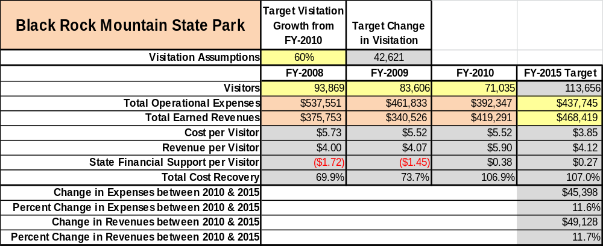

Key Recommendations
Primary / Short Term Recommendations
- Using funds from Black Rock Buddies (BRB) Friends Chapter, renew lapsed membership in Rabun County Chamber of Commerce for marketing assistance and referrals for filling vacant cottages/campsites.

- Replace vacant Utility Worker position with part-time 1508 position to better utilize labor funding.

- As visitor center expansion project proceeds, expand merchandise selection and enhance merchandise presentation to increase retail sales.

- Partner with local area BSA troops for assistance with special projects, trail maintenance, landscaping, etc.

- Continue working with BRB Friends Chapter for general program support including funding assistance for projects, equipment, and various supplies and materials and for volunteer assistance during special events.

- Pursue grant funding through BRB Friends Chapter and state-wide Friends organization for assistance with construction of much needed parking for Trading Post, Marie Mellinger Center and Ada-hi Falls Trailhead.

- Coordinate more closely with Division marketing unit to better utilize Division website and social media such as Facebook to promote park programs and special events and to fill last-minute vacancies in cottages and campsites.

- Examine off-season rate structure, especially for cottages, to evaluate the price point which will maximize occupancy in an effort to dramatically reduce weekend vacancies.

- Evaluate potential package partners such as Chattooga River outfitters and winter recreation businesses. Determine what opportunities exist to package and jointly promote their facilities.

- Continue partnering with local business, wildlife-support organizations, and local agencies for funding support for special events such as Fishing Rodeo and Happy Birthday, America!

- Coordinate with Rabun County government for monthly corrections detail assistance with labor-intense chores such as steep-slope weed trimming, dam clearing, and storm debris clean-up.

- Evaluate the viability of expanding backpacking and camping program opportunities offered by outfitters such as REI.

Secondary / Long Term Recommendations
- Give strong consideration toward the construction of five additional rental cottages on Pioneer Road immediately below cottages 6 – 9.

- Expand the park’s camping area by constructing additional walk-in sites on the northwest side of the Eastern Continental Divide, just beyond RV campsite 48.

Site and Operations Assessment
This site and operations assessment is a culmination of analyses and findings from a review of the condition of facilities, infrastructure, and operations at Black Rock Mountain State Park. The findings and observations are not intended to be an exhaustive review of all issues present, but provide a basic understanding of the predominant issues that contribute to the site’s current operating conditions. The assessment includes the following:
- Site Inventory and Facility Assessment
- Operational Assessment
- Financial Assessment
Site Inventory and Facility Assessment

Methodology
Facility and asset conditions are rated using a differential scale of excellent, good, fair, or poor. Descriptions of conditions that are attributed to each of these findings are also provided.
Scale of Conditions
Rating | General Description
Excellent | Facilities/amenities are in ‘excellent’ condition when they show little or no maintenance or repair problems. Facilities do not feature any major design or operational issues or flaws that contribute to diminished use or increased maintenance or upkeep. Facilities are easy to clean and maintain in order to place them back into public use and the users perceive them to be in excellent shape.
Good | Facilities/amenities are in ‘good’ condition when they show only minor maintenance or repair problems. Most maintenance issues with these facilities typically appear to be the result of age and/or heavy use. Facilities may only feature minor design or operational issues that contribute to diminished use or increased maintenance or upkeep. Facilities are moderately easy to clean and maintain in order to place them back into service and the users perceive them to be adequate for their use, but probably not in excellent shape.
Fair | Facilities/amenities are in ‘fair’ condition when they show significant maintenance or repair problems. Facilities generally exhibit ongoing maintenance issues that appear to be the result of age, heavy use, or design or operational flaws. Some maintenance and repair needs may compound their fair condition by being deferred because of budget and/or resource limitations. Facilities require more effort to clean and maintain before placing them back into service and the users may perceive them as being less than adequate for their use and in a state of deterioration. The facility or structure may need of major repair or replacement.
Poor | Facilities/amenities are in ‘poor’ condition when they show significant, on-going maintenance or repair problems that ultimately may result in suspended use for repair/replacement. Maintenance and repair issues are possibly the result of poor maintenance and clearly the result of age, heavy use, or design or operational flaws. Problems with the facilities are often compounded over time due to consistently-deferred maintenance and repair because of budget and/or resource limitations. Facilities may feature major design or operational issues that contribute to diminished use or increased maintenance or upkeep. Facilities require excessive effort to clean and maintain before placing them back into service and the users often perceive them as being inadequate for their use and in a state of serious deterioration. The facility or structure may need of major repair or replacement.

Inventory and Assessment
The table below is an inventory of facilities and amenities at Black Rock Mountain State Park, and provides the assessed condition of each as reviewed in May, 2011.
Site Asset / Amenity | Quantity | Condition
Total Park Acreage | 1,743 | Good
Rental Cottages | 10 | Good
Housekeeping Operations | 1 | Good
Camp Tsatu-gi Pioneer Cabin | 1 | Good
Adirondack Shelters (Pioneer) | 4 | Fair
Pit Privy Facility (Pioneer) | 1 | Fair
Summit Visitor Center | 1 | Fair
Naturalist Quarters | 1 | Poor
Picnic Shelters | 2 | Fair
Marie Mellinger Center | 1 | Excellent
Trading Post | 1 | Excellent
Blue Ridge Amphitheatre | 1 | Good
Campground Comfort Stations | 3 | Fair
Park Maintenance Center | 1 | Good
Park Ranger’s Residence | 1 | Excellent
Asst. Manager’s Residence | 1 | Good
Campground Storage Building | 1 | Fair
Pump Houses | 4 | Fair
Water Treatment Plant | 1 | Good
Scenic Overlook Decks | 3 | Fair
Park Trail System (miles) | 11 | Fair

Prioritized Facility Needs
Based on the facility inventory and assessment, these prioritized needs have been identified. Each need has been aligned with a priority category of high, moderate, or low to support future decision making regarding project sequencing, investment of public resources, and meeting community expectations. The priority assignment for each need is not a measure of importance. Rather, these recommended priorities reflect a phased implementation approach over the next several years.

Facility Need | Priority Assignment
Cottage exterior painting (#6 - #10 especially) | High
Repair Pole Barn wall | High
Campground Storage Building exterior painting | Moderate
Naturalist quarters (replace exterior siding, doors, windows) | Moderate
Blue Amphitheatre Stage roof repairs (significant tornado damage) | Moderate

Operational Assessment
The Operational Assessment includes:
- An inventory and classification of programs and services being provided at the site
- A review of staffing at the site
- A review of concessionaires and partners operating at the site
- Visitation and customer satisfaction

Inventory and Classification of Programs and Services
Programs and services are classified into one of three major categories:
1) Core or Essential Services
2) Important Services
3) Visitor Supported Services
Programs and services at the site are classified into these categories based in part on the mission and public mandates for both the site and the agency. For the services in each of these categories, there are financial performance expectations that will define how services are funded and evaluated.

Category 1 – Core Services [Largely supported by tax funds]
Core programs, services and facilities are those the agency must provide and/or are essential in order to capably govern and meet statutory requirements. The failure of the agency to provide Category 1 services at adequate levels could result in significant negative consequences for the public and the resources under protection. The criteria for services to be classified as core or essential are:
- The services are mandated by the agency’s law or charter or are contractually obligated by agreement to provide the services.
- The services are essential to protecting and supporting the public’s health and safety.
- The services protect and maintain valuable assets and infrastructure.
- The services would generally and reasonably be expected and supported by residents, businesses, customers and partners.
- The services are those that cannot or should not be provided by the private sector.
- The services provide a sound investment of public funds.
The following services offered at Black Rock Mountain have been identified as core services:
- Resource management and natural feature protection of the park’s natural resources.
- Maintaining reasonable public access to the park’s various facilities.
- Public safety and law enforcement.
- Proper maintenance and safe operation of public drinking water system in compliance with all applicable Environmental Protection Division drinking water regulations.
- Management and maintenance of Black Rock Lake Dam, in compliance with EPD Safe Dams Program regulations and recommendations of U.S. Natural Resource Conservation Service.

Category 2 – Important Services [Supported by a balance of tax funds and earned revenues]
Important programs, services and facilities are those the agency should provide, and are important to governing and effectively serving residents, businesses, customers and partners. Providing Category 2 services expands or enhances the agency’s ability to provide and sustain its core services. The criteria for programs or services to be classified as important are:
- The services expand, enhance or support identified core services.
- The services are broadly supported and utilized by the community, and are considered an appropriate, important, and valuable public good. Public support may be conditional upon the manner by which the services are paid for or funded.
- The services generate income or revenue that offsets some or all of the operating cost and/or are deemed to provide economic, social or environmental outcomes or results.
The following services offered at Black Rock Mountain have been identified as important services:
- Trail System management and maintenance, including backcountry camping.
- Scenic Overlook management and maintenance (including regular vista management and clearing practices).
- Fisheries management for Black Rock Lake.
- Management and maintenance of public picnic facilities, including covered shelters and individual picnic tables
- Interpretive and recreational programming and special events.

Category 3 – Visitor Supported Services [Almost exclusively supported by earned revenue]
Visitor supported programs, services and facilities are those discretionary services that the agency may provide when additional funding or revenue exists to offset the cost of providing those services. Category 3 services provide added value above and beyond what is required or expected. The criteria for programs or services to be classified as visitor supported are:
- The services expand, enhance or support core services or important services and the quality of life of the visitors, community or stakeholders.
- The services are supported, valued and well utilized and provide an appropriate and valuable public benefit.
- The services generate income or funding from sponsorships, grants, user fees or other sources that offset some or all of their cost and/or provides a meaningful return on investment.

- The services can possibly be provided through outsourcing or use of concessionaires, providing opportunities for community enterprises that may not otherwise be provided by the agency.

The following services offered at Black Rock Mountain have been identified as visitor supported:
- Summit Visitor Center and Campground Trading Post retail operations.
- Rental cottages.
- Campground operations (including RV and Walk-in camping areas).

Staffing Assessment
Labor costs at Black Rock Mountain State Park represent the largest area of budgetary expense at an average of 63% of the total operating budget each year for the last three complete years, which is slightly lower than the target of total labor costs (including benefits) not exceeding 65% of the site’s total operating expenditures. The tables below and on the following pages provide a basic review of the current staffing at the site.
Full Time Equivalent Employees
Position / Title | Quantity (FTE) | Vacancies | Annual Hours
State Park Manager II | 0 | 1 | 0
Asst. Park Manager I | 1 | 0 | 2500
Park Ranger | 1 | 0 | 2080
General Trades Craftsman | 0 | 1 | 0
Utility Worker | 0 | 1 | 0
Housekeeper | 0 | 1 | 0
Secretary | 1 | 0 | 2080
Clerk | 0 | 1 | 0
TOTAL | 3 | 5 | 6,660
Part Time Employees
Position / Title | Quantity (FTE) | Vacancies | Hours
Maintenance Worker | 1 | 0 | 1508
Park Naturalist | 1 | 0 | 680
Housekeepers | 3 | 0 | 1248
ParkPass Kiosk Attendant | 1 | 0 | 850
Trading Post Clerk | 1 | 0 | 960
Park Service Worker | 2 | 0 | 1920
TOTAL | 9 | 0 | 7,166
Labor Support
Labor Support | Annual Hours
Volunteers | 820
Community Service Workers | 120
Engineering and Construction Crews | 1280
Resource Management Crews | 40
Rabun County DOC Detail (one day/month) | 42
DNR-controlled DOC Detail | 160
TOTAL | 2,462
Total Labor Hours
Labor Type | Annual Hours
Full Time Equivalent Employees | 6,660
Part Time Employees | 7,166
Labor Support | 2,462
TOTAL Annual Labor Hours | 16,288

Labor Budget Summary
The table below and the chart on the following page depict the dramatic decline in park labor expenses from FY 2008 to FY 2010. In FY 2008 one of Black Rock’s two housekeeping positions became vacant. During FY 2009, three maintenance positions (utility worker, general trades craftsman, and park ranger) became vacant. These vacancies dropped the cost of regular salaries by more than a third (34%) during this period. In an effort to compensate for the void left by these open positions, the park expanded the use of its 1508 positions, increasing the cost of temporary labor by 14%.

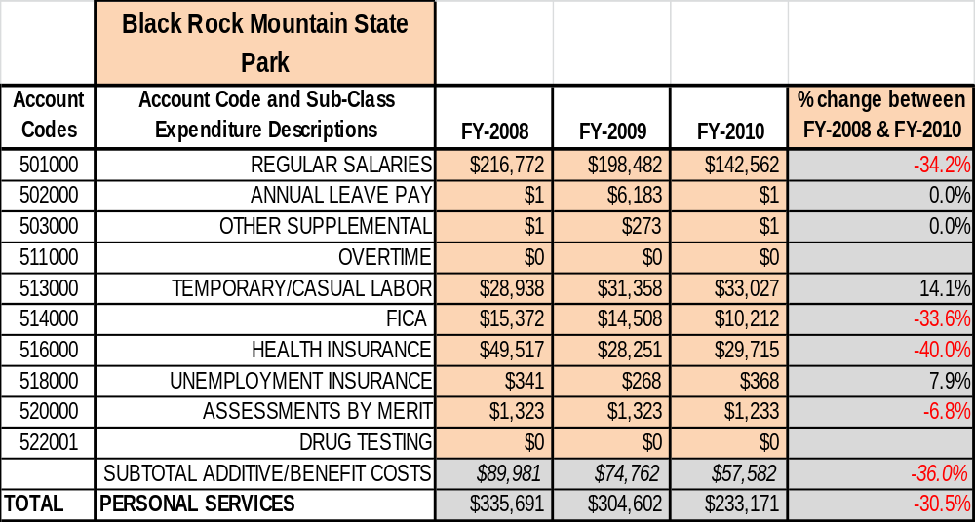

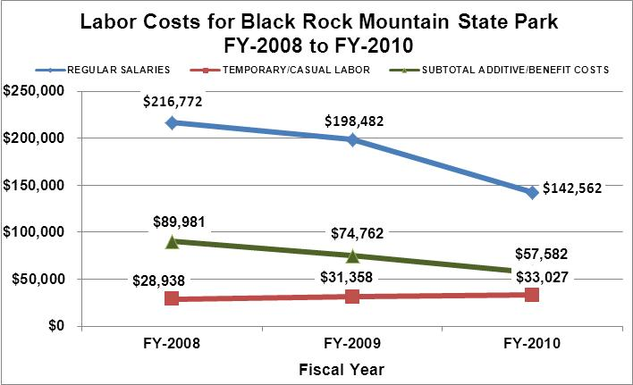

Visitation and Occupancy
Overall annual visitation to the park has trended downward from 2008 to 2010, decreasing by 24% or almost 23,000 visitors. This curious trend is somewhat perplexing and difficult to fully explain, but may be partially attributed to the fact that the park’s rental cottages were closed for renovations for over four months during 2009, as well as some unusually severe winter weather during 2010 that resulted in the cancellation of a very large number of weekend reservations. Still, park managers will be continuing to closely examine visitation figures during the current and upcoming fiscal years to determine if this downward trend is continuing or represents, instead, only a temporary anomaly.
Year | Total Visitation
2008 | 93,869
2009 | 83,606
2010 | 71,035

Occupancy for the overnight accommodations at Black Rock Mountain State Park the last three years is detailed in the table below. Overall occupancy in the camping area has trended upward from 2008 to 2010, increasing by 8 percentage points, from 24% to 32%. This may be attributed to a struggling economy in which many people have been looking for destinations closer to home in an effort to save money.
Cottage occupancy, on the other hand, has fluctuated. The 19-point decrease in 2009 is largely attributed to the fact that the park’s cottages were closed for over four months for renovations. Occupancy during 2010 rebounded by 9 percentage points (47% from 38%) from the year before, but was still 10 points lower than 2008. This may largely be the result of several months of extreme winter weather during 2010 when ice and snow required the cancellation of numerous weekend reservations.

Year | Camping Occupancy | Cottage Occupancy
2008 | 24% | 57%
2009 | 25% | 38%
2010 | 32% | 47%

Customer Service and Satisfaction
Park visitors continue to give Black Rock Mountain State Park very high marks in regard to their overall level of satisfaction with their park visit. Park surveys during 2009 and 2010 reflect a 100% level of park visitors describing that they were either “satisfied” or “highly satisfied” with their visit to the park (see chart below).
In addition, comment cards returned by park visitors also reflect a very high level of visitor satisfaction, and a high number of individual park staff members were singled out by name as helping to make that guest’s visit more enjoyable.
The park staff recognizes that it must remain highly focused and ever-diligent to continue to earn these high marks. Complacency can very easily result in a slow, but certain erosion in the satisfaction that park visitors experience and report.

Site | Year | Customer Satisfaction Level
Black Rock Mountain State Park | 2009 | 100% satisfied/highly satisfied
Black Rock Mountain State Park | 2010 | 100% satisfied/highly satisfied

Financial Performance Assessment

Operational Expenses
A summary of total operating expenses at Black Rock Mountain State Park from 2008 to 2010, as well as their percent change from 2008 are provided in the table below.
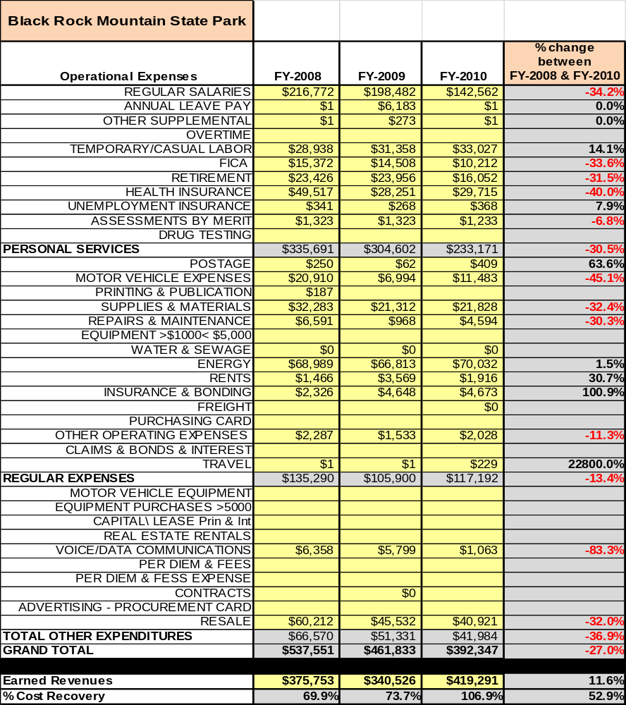

Earned Revenues
Earned revenues at Black Rock Mountain State Park have increased since 2009, which are largely
attributed to the corresponding increase in both campsite and cottage occupancy, as well as adjustments in cottage and campsite rates. Monthly earned revenues for the last two years (see table below) indicate that the total annual revenue increased 24% from 2009 to 2010, with the largest increases in monthly revenues in July (15%), June (14%), and October (13%).

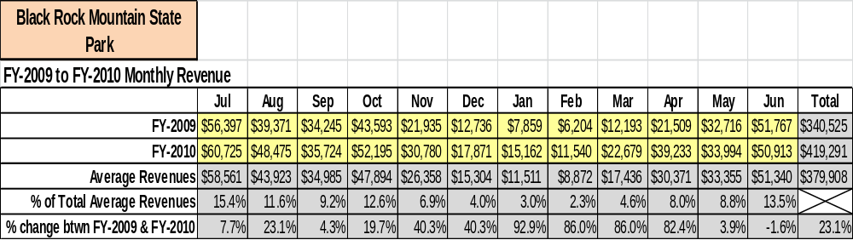

The graphs below illustrate the monthly revenue trends each year and the average percent of total
annual revenue earned each month.

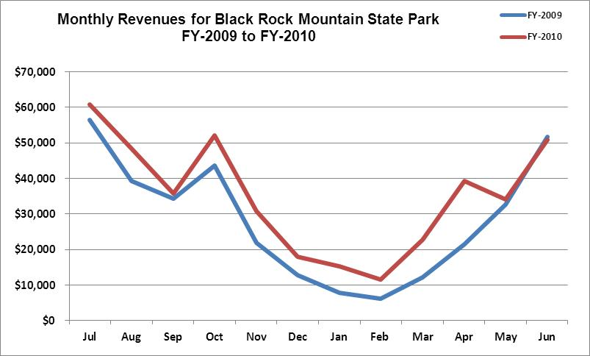

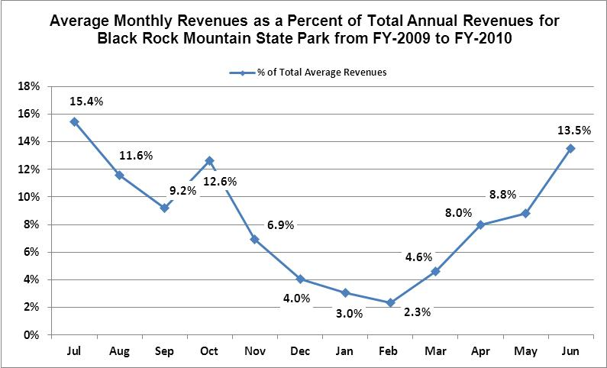

Cost Recovery Trends
Black Rock Mountain has achieved an average cost recovery of 84% of annual operational expenses through earned revenues from FY 2008 to FY 2010, and actually achieved a profit of 7% during FY 2010 (107% cost recovery) during a year in which almost half of the park’s salaried positions remained vacant and labor costs plummeted. Expenses, revenues, and cost recovery during the last three fiscal years are detailed and illustrated in the table and graph below.
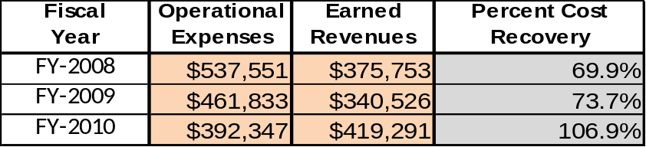

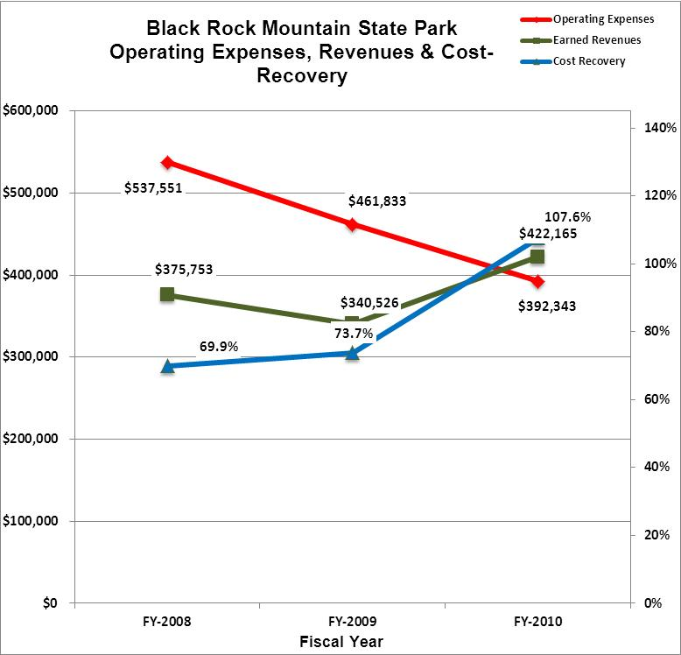

Review of Pricing
The table below illustrates the rate structure for various Black Rock Mountain facilities for the six-year period from 2005 to 2010. After a three year period of flat rates (2005-2007), the Division began to more aggressively restructure the park’s user fees.
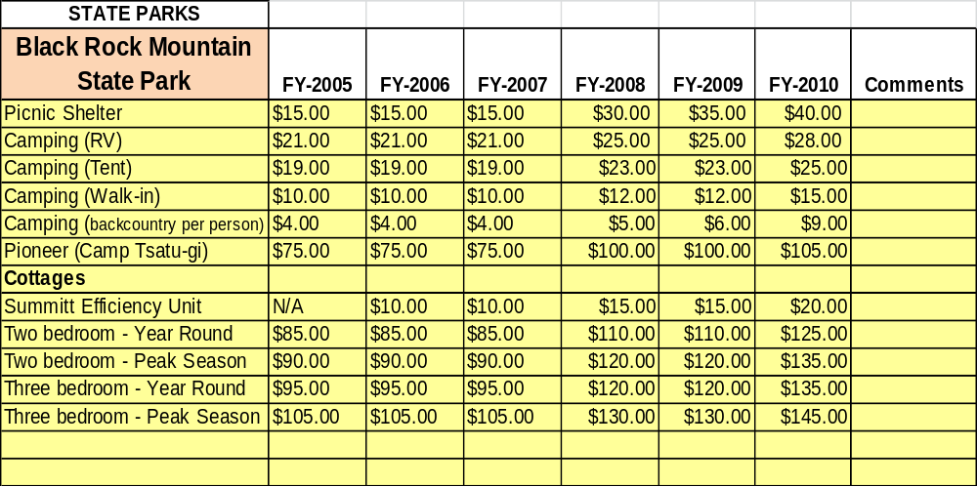

Business and Management Plan

Business Goals
The following goals serve as the foundation for the key recommendations and strategies in this business plan for Black Rock Mountain State Park.

Maximize Reasonable Cost Recovery of Park Operations
During FY 2008 and 2009, the park’s cost recovery ranged from 70-74%. During FY 2010, with a drastic decrease in labor costs due to vacant positions, the park’s cost recovery rose to 107%, with the park posting the first yearly profit in its 58-year history. Certainly, this was a cause for celebration, but it was quickly recognized that the factors that made this possible were largely artificial and very difficult to sustain over the long term. The goal of park management is to identify strategies to carefully manage labor costs, while having the manpower to adequately maintain quality facilities and attractive features.

Enhance Revenue Generation Strategies
Presently, it would appear that the best opportunities to generate increased revenue will occur on two fronts. First, park management has been disappointed with the recent drop-off in cottage occupancy during the early spring time frame and between Labor Day/leaf season (October/early Nov). We propose an evaluation with region-level and Division-level management staff of adjusting cottage rates during these times periods. With Black Rock being closed from Dec. 1st through March 15th, the reopening of Black Rock needs to be promoted to the highest degree. With more aggressive pricing, along with better marketing, our goal is to get the cottages full again not only during the above mentioned time frames, but through the spring, summer, and fall periods. Second, the recent renovation and expansion of the summit visitor center is a huge asset to enhance or revenue. Resale revenue has increased with our new visitor center/displays and resale items. This project has been exciting and will offer new opportunities to expand our retail selections and better merchandise these items. We are extremely optimistic that the renovation/expansion will continue to result in increased resale revenue.

Expand Special Events at the Site
With the completion and opening of the Marie Mellinger Center, there exists a more solid infrastructure for improved and expanded special events. The missing component remains adequate parking, but the cutout and construction of the current 12 to 15 vehicle parking lot has greatly assisted in this concern. We propose to continue to look at an additional parking lot area so that the Mellinger Center can be rented out during our open season, which would be an excellent revenue generation tool.

Improve the Diversity and Innovation of Recreational and Interpretive Programs
Park managers support creative and innovative new programs, such as those provided by private companies like REI, and will continue to explore new ways to bring in additional park visitors. With the unification of the Rabun County state parks, interpretive programs can be expanded by all three parks working together on new programs. For example, the Junior Ranger program involved all three parks this year with events at each one. Participants gave excellent remarks on this being done. Plans are for more types of programming events being joined together at each park.

Improve the Effectiveness of Marketing and Sales
We need to do a better job of working with the Division’s Marketing Unit to take advantage of social networking sites such as Facebook to promote the park and advertise “last-minute” availability. We can also use this strategy to better market special events and special programs. We cannot underestimate the reach of some of these sites and the additional exposure that they can generate. In addition, opportunities exist to more effectively utilize the services of the Rabun County Welcome Center, operated and managed by the Chamber of Commerce, to generate more referral activity, especially in regard to last-minute availability. This type of marketing assistance is far more focused than what can be achieved through the Division marketing staff due to location and timing: the customer is already physically in the community, just three miles away, and is looking for overnight accommodations not at some point in the future, but right now. The park played an active role in the local Chamber for a number of years, but in the early 2000s new directives prohibited state money being spent on Chamber memberships. Newer guidelines, however, encourage parks to utilize Friends chapters for payment of chamber dues, and Black Rock should take advantage of that avenue to rejoin the Chamber

Establish Greater Consistency of Managing and Monitoring Customer Service & Satisfaction
Customer satisfaction and customer service have always been one of the park’s strongest areas. We stress in staff meetings the importance of good quality customer service and park managers work hard to coach associates toward this goal. In surveys conducted in 2009 and 2010, 100% of park guests reported being satisfied or highly satisfied with their park experience. Management staff will continue to lead by example and work to develop and demonstrate superior customer contact skills. Our goal will be to maintain that 100% customer satisfaction level.

Expand Partnership Opportunities
Black Rock Mountain has the unique opportunity to increase and expand its partnerships with Moccasin Creek and Tallulah Gorge. With the unification of all three parks under one management, staffs are working together on all aspects of park operations and this has greatly enhanced our capabilities. The park should also explore expanding partnerships with other divisions or agencies, including WRD’s Fisheries Management Section or the United States Forest Service. Additional partners might include the local chapters of Trout Unlimited and the National Wild Turkey Federation.

Classification of Programs and Services
The tables below summarize the classifications and services at Black Rock Mountain as either core, important, or visitor supported and projects a range of cost recovery percentages that might be achieved for each. These classifications establish financial performance goals for each category of services that are linked to the recommendations and strategies of this business plan.

Core Services
Program / Service | Target Cost Recovery
Resource management and natural feature protection of the park’s natural resources. | 0%
Maintaining reasonable access public access to park facilities | 0%
Public safety and law enforcement | 0%
Proper maintenance and safe operation of public drinking water system | 0%
Management and maintenance of Black Rock Lake Dam | 0%

Important Services
Program / Service | Target Cost Recovery
Trail system management and maintenance, including backcountry camping | 100%
Scenic overlook management/maintenance, including vista clearing | 100%
Fisheries management for Black Rock Lake | 100%
Management/maintenance of picnic facilities, including shelters and tables | 110%
Interpretive and recreational programming/special events | 125 - 130%

Visitor Supported
Program / Service | Target Cost Recovery
Summit visitor center and Campground Trading Post retail operations | 140%
Rental Cottages | 150 – 200%
Campground operations (including RV, tent, and walk-in camping) | 100 – 125%

Partnership Development Plan
The table below summarizes existing partners and targeted partnerships by classification (operational, vendor, service, co-branding, funding partners) and by organizational type.

 | Public Partners | Not-for-profit Partners | Private / Enterprise Partners
Operational Partners | - Lake Burton Fish Hatchery  - DNR Law Enforcement
Vendor Partners |  |  | - Coca-Cola  - Hillside Orchards  - Georgia Power Co.
Service Partners | - Rabun County Government  - U.S. Forest Service | - Chamber of Commerce  - BSA Troops  - Trout Unlimited  - National Wild Turkey Federation
Co-branding Partners | - Tallulah Gorge State Park  - Moccasin Creek State Park  - Clayton Police Department |  | - Wal-Mart  - The Dillard House  - River Vista RV Resort  - REI  - Southeastern Expeditions  - Scaly Mountain
Funding Resource Development Partner |  | - Friends of Georgia State Parks  - Black Rock Buddies Friends Chapter

Marketing and Sales Plan

Marketing and Sales Goals
Marketing and sales goals for Black Rock Mountain are based on the following desired outcomes:
- Increase cottage occupancy, particularly in regard to early spring and early fall.
- Increase campground occupancy, especially during weekends following major three-day holidays where a significant drop-off is often experienced.
- Improve visitor center retail sales through new products and displays.
In order to meet these goals, examples of specific target outcomes were identified in the areas detailed in the table below.

Area  of Focus | Current  Performance | Goal  by 2011 | Goal  by 2012 | Goal  by 2015
Cottage Occupancy | 47% | 49% | 51% | 55%
Campground Occupancy | 32% | 34% | 36% | 40%
Resale Revenue | $80,270 | $84,800 | $85,713 | $88,181

Marketing and Promotion Strategies

Publicity and Social Media
Black Rock Mountain will approach marketing and publicity planning using the following guidelines and themes:
- Event publicity
Major events benefit by having short stories in local, regional, and statewide newspapers and online social media hooks planted that run three to four weeks in advance of the event up to the date of the event itself. Stories and media need to be cultivated with contacts and online sales channels several weeks in advance of the time the stories need to run. Special interest interviews on morning, noon, and evening television news programs, radio interviews on popular rush-hour programs, and blogs on known affinity online sites should also be included.
- Program publicity
Special and unique programs should have feature stories in magazines, local and regional weekly newspapers, and statewide daily newspapers that are aimed at placements as front-page or sectional front-page stories. These stories are most effective if they run shortly before the season that the featured program begins. This will likely require several weeks of advanced planning with media contacts. Similar coverage on television and radio should also be considered. If pre-publicity cannot be generated, post-publicity can help promote future programs.

- Site Publicity
Site publicity focusing on a single site or sub-set of sites requires more intense planning efforts to attract multiple writers and editors from target publications. The site could host several seasonal media familiarization tours (with 10 to 15 writers or editors) to familiarize them with the site and its benefits and amenities. Stories and features resulting from such tours typically take between two and six months to materialize so the tours should focus on experiences, benefits, and programs that would be available when the stories are expected to run.
Examples and suggested opportunities for events, programs and related publicity efforts based on the themes described above at Black Rock Mountain are provided in the table below.
Event Publicity | Program Publicity | Site Publicity
Junior Fishing Rodeo | Autumn Leaf Watch | Elderhostel Program
Happy Birthday, America! | Mountains of Spring Wildflowers | “Wild and Scenic” Whitewater Weekends
 | Fall Backpacking Clinic | Winter Wonderland
 | Junior Ranger Day Camp | Black Rock Butterflies

Packaging
Examples and suggested packages for Black Rock Mountain State Park are provided in the table below.
Package | Package Details
“High Country-High Water” Package | Two-night cottage stay with Section III or Section IV Chattooga River Trip for two people with Southeastern Expeditions

Group Sales
Types of groups within which specific target customers can be identified for Black Rock Mountain are listed below:
- Trail Running Clubs  - Boy Scout Troops  - Schools | - Bird Watching Organizations  - Churches  - Colleges and Universities | - Butterfly Enthusiasts  - Girl Scouts/Campfire Girls  - Adventure Organizations

Incentivizing New and Repeat Visitation
Black Rock Mountain State Park will utilize the following strategies and/or incentives to encourage new and repeat visitation starting in FY 2012:
Evaluate the feasibility of initiating the cottage packages described above with Southeastern Expeditions and Scaly Mountain.
Marketing and Sales Metric Goals
The following marketing and sales metric goals and/or others will be monitored and progress reported at Black Rock Mountain:
- Loyalty and repeat customers = 40% of overnight customers will repeat their visit within a 12 month period.
- Brand confidence & customers-recruiting-customers = 30% of new overnight guests respond that they heard about the park through other visitors.
Revenue Generation Plan
Revenue / Cost Recovery Goals
Black Rock Mountain State Park has set a financial goal of increasing annual revenues between 1 and 2% annually between 2012 and 2015. With Black Rock State Park being closed from December 1st through March 15th each year, the table below is misleading. There will be no revenue during this time period, unless special circumstances allow it (such as a movie production company leasing out the park for an agreed upon time period during the closed period). The table below details projected revenue growth leading up to 2015, based upon a nominal growth of revenues each year. The percentage growth is projected low to account for the closed period.

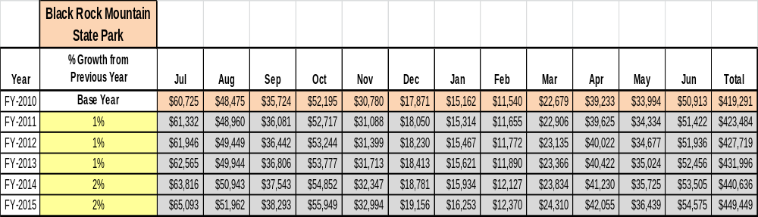

With signs of an economic recovery evident as FY 2012 draws to a close, park managers are optimistic that a total growth in revenue of over 5% between FY 2013 and FY 2015 is feasible and realistic. During the same three-year period, with austere spending measures in place, operational expenses are projected to grow less than 3%. If these projections prove accurate, Black Rock Mountain can achieve a long-term cost recovery of 100% plus.
Revenue Generation Strategies

Pricing Plan
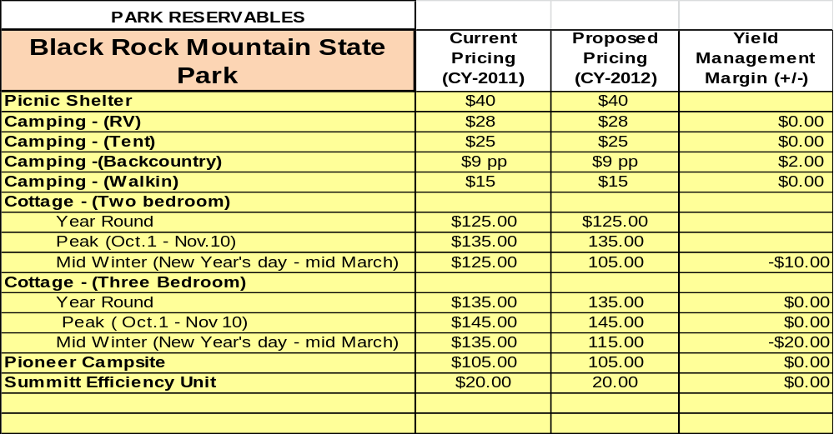

Innovative Programming and Special Events Plan

Program/  Event | Theme / Purpose | Scheduled Date/Season | Frequency | Target Participation | Target User Fee | Target Cost Recovery
Black Rock Lake Trail Hike | Lake Habitat study | May-November | Weekly | 8-10 | $3 | 200%
Ada-hi Falls Hike | View Waterfall | May-Nov. | Weekly | 18-20 | $2 | 225%
Norma Campbell Cove Hike | View springs & sensitive botanical areas | May-Nov. | Weekly | 8 | $2 | 150%
Springhouse Trail Hike | View sensitive botanical areas | May-Nov. | Weekly | 8 | $2 | 150%
Lake Critter Study | Explore lake animal, insect life | May-Sept. | Weekly | 18-20 | $3 | 200%
Leaf Print | Nature Art | May- Sept. | Weekly | 20-22 | $2 | 225%
Snakes | Snake ID Program | May-Sept. | Weekly | 6 | $2 | 140%
Paper making | Recycling Program | May-Sept. | Weekly | 8 | $2 | 150%
Nature Journal | Interpretive Program | May-Sept. | Weekly | 14 | $2 | 200%
Potluck Dinner | Community Social Event | May-Nov. | Weekly | 35 | $2 | 400%
Fishing Rodeo | Special Event | May | Annually | 75 | $0 | Community Sponsored
Jr. Ranger Camp | Special Event | One week in summer | Annually | 15 | $35 | 200%
Happy Birthday, America! | Special Event | July 4th weekend | Annually | 225 | $5 | 125%

Partnerships and Concessions Plan

Service / Partnership | Term of Service | Financial Objective | Contract Manager
SouthernLINC Equipment for park personnel | 2 years | No-cost radio/telecommunications | Region Manager
Assistance with supplies, materials, and equipment from Black Rock Buddies | On-going | Reduced cost for operational expenses | Park Manager
BSA Eagle Scout projects, Scout volunteer service days | On-going | No-cost or reduced cost landscaping, trail work, special projects | Park Manager
Chamber of Commerce referrals | On-going | Increased cottage and camping occupancy | Park Manager
Cottage/Campsite packages with river outfitters or winter outdoor recreation sites | On-going | Shared revenue/increased occupancy | Region Manager
Special event prize donations w/local businesses | 1 year | No-cost prizes/snacks, refreshments | Park Manager

Expense Management Plan
Personnel Assignments
The following actions will be taken to proactively manage labor costs via personnel assignments and classifications.

Action | Timeline | Outcome
Park Manager II position will not be filled | 2011 | Annual cost reduction of $30,000 plus.
Convert vacant Utility Worker to 1508 hourly | July, 2011 | Annual cost reduction of $6,049
Scale back wintertime housekeeping 1508 | January, 2012 | Annual cost reduction of $6,864

Management Techniques
The following actions will be taken to proactively manage labor costs via management techniques.

Action | Timeline | Outcome
Utilize monthly Rabun County Corrections Detail for steep-slope weed-trimming in camping area | Late spring-early fall, 2011 | Annual cost reduction of $720 (96 hours @$7.50/hr.)
Utilize weekly volunteer for summit raking, leaf blowing, weeding, cleaning, litter pick-up) | Spring – fall, 2011 | Annual cost reduction of $1,200 (160 hours @$7.50)
Utilize trail volunteers for removal of fallen trees and encroaching vegetation, erosion control, re-blazing | Year-round | Annual cost reduction of $1,800 (240 hours @$7.50)

Adjusted Levels of Service
The following actions will be taken to proactively manage labor and supply costs via reduced levels of service.

Action | Timeline | Outcome
Close entire park | Dec. 1st through March 15th each year. | Expenditure/labor savings of $12,888.02 comparing FY10 & FY12
Reduce mowing schedules along Black Rock Mtn. Parkway/summit areas to every other week | Summer, 2011 | Cost reduction of $960 in labor 96 hrs. @$10/hr. + 60 gal. gas ($210) $1170 total savings

Financial Pro Forma
The following five-year financial pro forma projects operating expenses, earned revenues and cost recovery through FY 2015. These pro forma are based on the strategies and desired outcomes identified in this business plan, especially the revenue generation and expense management plans, and are linked to corresponding performance goals. Every attempt was made to be realistic. FY 2015 expenses, while higher than FY 2010, are still more than 10% lower than in FY 2008. It should be noted that FY 2010 expenses were an aberration, reflecting an unusual situation when almost half of the park’s salaried positions were vacant. Expenses for FY 2012 and beyond more accurately account for the park’s current staffing levels. Also, the projected increases in resale expenses reflect a corresponding increase in projected retail revenue, by any measure a positive goal since the result would be an increase in profits.

Expense Pro Forma

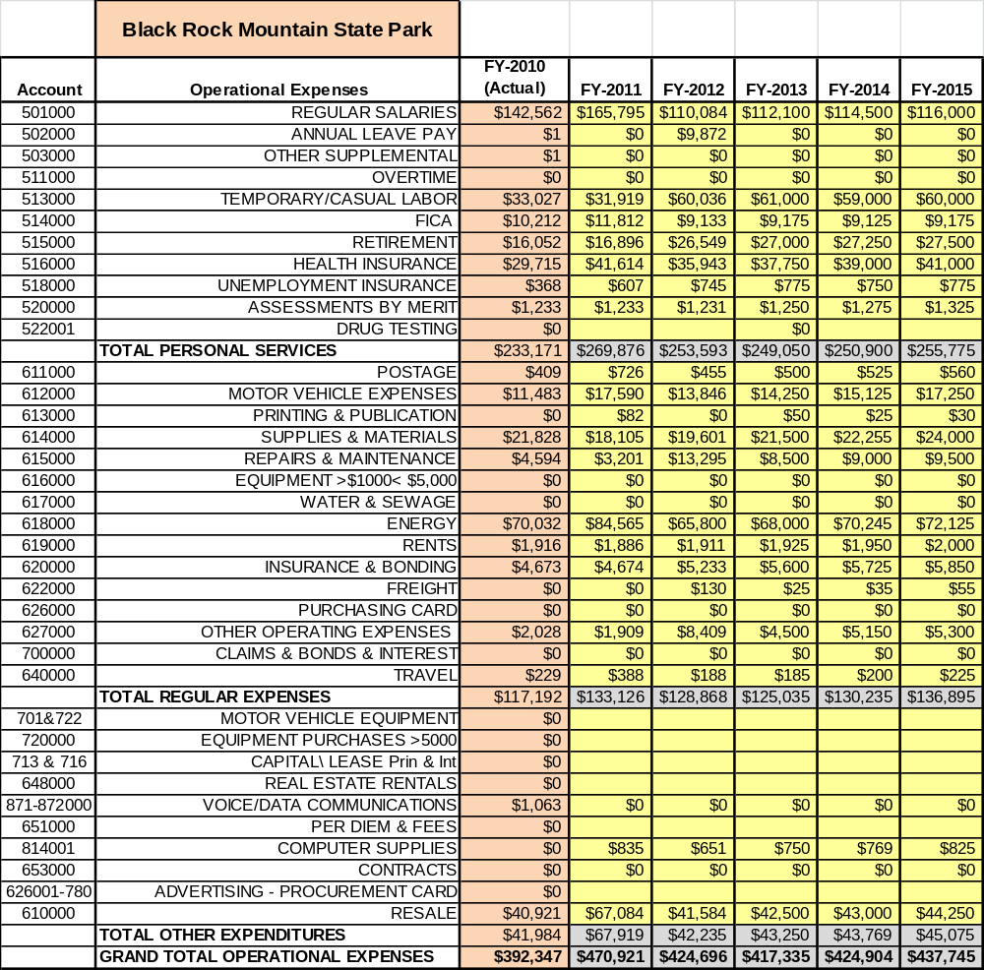

Revenue Pro Forma
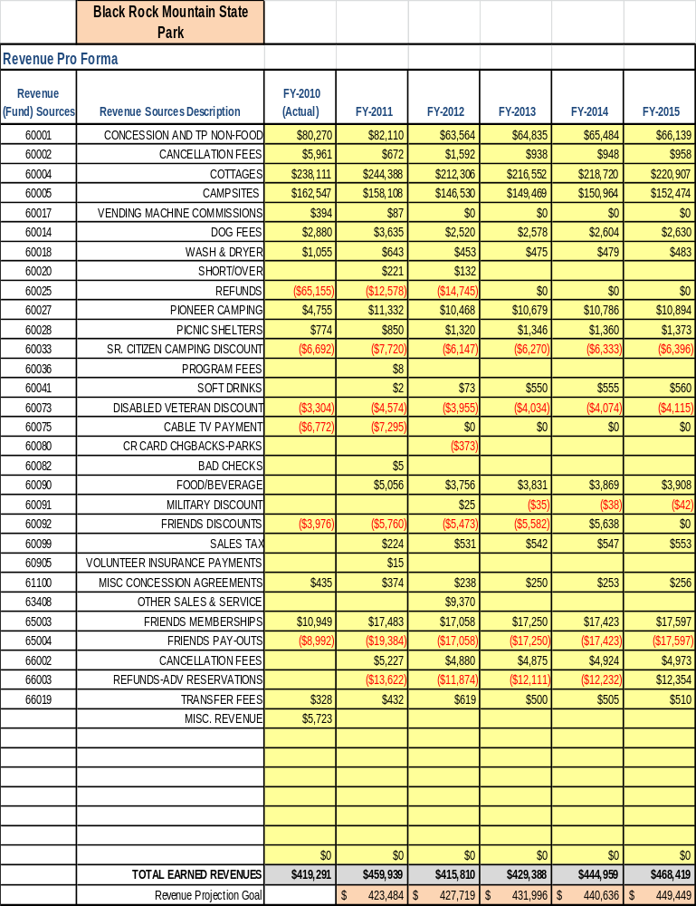

Total / Cost Recovery Pro Forma
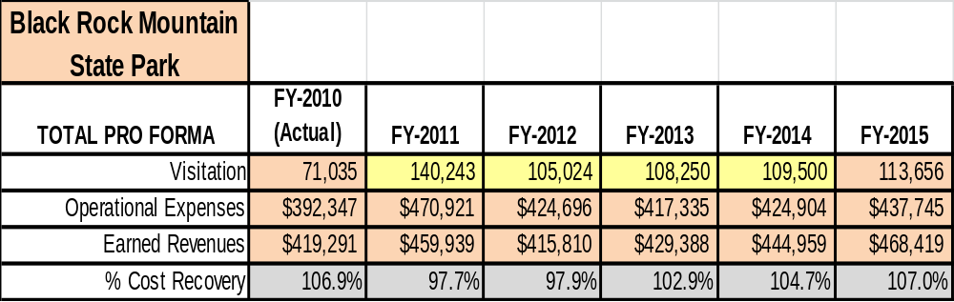

Action Plan
ACTION PLAN
Site: |  | Site Manager: |  |  | Date:
Month:
Strategy | Tasks | Costs / Funding | Revenues / ROI | Responsibilities | Metrics

ACTION PLAN
Site: |  | Site Manager: |  |  | Date:
Month:
Strategy | Tasks | Costs / Funding | Revenues / ROI | Responsibilities | Metrics

