Site Name
Business & Management Plan

June 2011
Direction 2015 – Sustainable Business Planning

Table of Contents

Executive Summary 3

Site and Operations Assessment 6
Site Inventory and Facility Assessment 6
Operational Assessment 8
Financial Performance Assessment 14

Business and Management Plan 17
Business Goals 17
Classification of Programs and Services 17
Partnership Development Plan 18
Marketing and Sales Plan 19
Revenue Generation Plan 21
Expense Management Plan 23
Financial Pro Forma 24

Action Plan 26

Executive Summary
The Parks, Recreation and Historic Sites Division (PRHSD) of the Georgia Department of Natural Resources (DNR) is transitioning the management of ________________________________ to operate more like a business, reflecting the Direction 2015 – Sustainable Business Planning initiative to improve the fiscal performance and management of the state parks and historic sites system. This business and management plan is designed to help the site recover more operating expenses through earned revenues, productive partnerships, and innovative programs.

Site Fact Sheet
Site Name
Site Manager
Region Manager
Date of Business Plan completion
Site size
Total number of visitors (FY 2010)
Total operating budget (FY 2010)
Total earned revenues (FY 2010)
Operational cost recovery (FY 2010)
Average operating cost per visitor (FY 2010)
Average earned revenue per visitor (FY 2010)
Average cost recovery (FY 2008 – 2010)
Target cost recovery (FY 2015)
Total full-time employees
Total part-time employees
Primary service markets
Primary attractors/visitor appeal factors
Leading opportunities for improved site performance

Site Summary and Key Attractions
The 163-acre site of LWH is located in a rural setting, roughly 70 miles from major population centers in Georgia like Atlanta and Macon and 40 miles from Columbus. It is roughly 50 miles from Interstate 75 and 30 miles from Interstate 85. The relative isolation of LWH will prove a challenge to achieving the identified cost recovery target.

Key Attractions
The amenities or features listed below are those that seem to be most popular for visitors.
- ????
- ????
- ????
- ????
- ????
- ????
- ????
- ????
- ????

Financial Targets
The table below details the total operating expenses and earned revenues for _____________________ over the last three years (2008 – 2010). This table also calculates total cost per visitor and revenues per visitor during these operating years, and details the target financial performance goals in the context of achieving at least __% cost recovery. This table also calculates the necessary change from 2010 operating expenses and revenues.
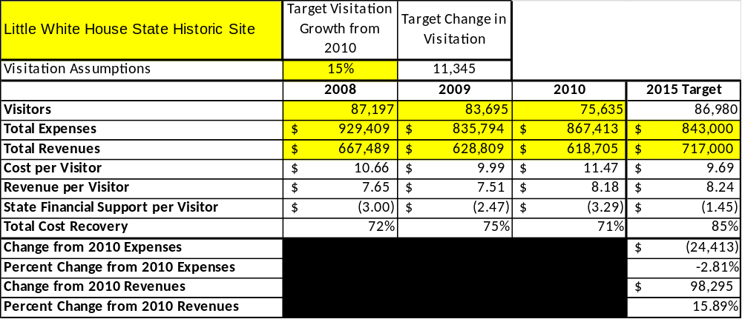
This is the Financial Targets Table located in the toolkit.

Key Recommendations

Primary / Short Term Recommendations
- ????

Secondary / Long Term Recommendations
- ????

Site and Operations Assessment
This site and operations assessment is a culmination of analyses and findings from a review of the condition of facilities, infrastructure, and operations at _______________________. The findings and observations are not intended to be an exhaustive review of all issues present, but provide a basic understanding of the predominant issues that contribute to the site’s current operating conditions. The assessment includes the following:
- Site Inventory and Facility Assessment
- Operational Assessment
- Financial Assessment
Site Inventory and Facility Assessment

Methodology
Facility and asset conditions are rated using a differential scale of excellent, good, fair, or poor. Descriptions of conditions that are attributed to each of these findings are also provided.
Scale of Conditions
Rating | General Description
Excellent | Facilities/amenities are in ‘excellent’ condition when they show little or no maintenance or repair problems. Facilities do not feature any major design or operational issues or flaws that contribute to diminished use or increased maintenance or upkeep. Facilities are easy to clean and maintain in order to place them back into public use and the users perceive them to be in excellent shape.
Good | Facilities/amenities are in ‘good’ condition when they show only minor maintenance or repair problems. Most maintenance issues with these facilities typically appear to be the result of age and/or heavy use. Facilities may only feature minor design or operational issues that contribute to diminished use or increased maintenance or upkeep. Facilities are moderately easy to clean and maintain in order to place them back into service and the users perceive them to be adequate for their use, but probably not in excellent shape.
Fair | Facilities/amenities are in ‘fair’ condition when they show significant maintenance or repair problems. Facilities generally exhibit ongoing maintenance issues that appear to be the result of age, heavy use, or design or operational flaws. Some maintenance and repair needs may compound their fair condition by being deferred because of budget and/or resource limitations. Facilities require more effort to clean and maintain before placing them back into service and the users may perceive them as being less than adequate for their use and in a state of deterioration. The facility or structure may need of major repair or replacement.
Poor | Facilities/amenities are in ‘poor’ condition when they show significant, on-going maintenance or repair problems that ultimately may result in suspended use for repair/replacement. Maintenance and repair issues are possibly the result of poor maintenance and clearly the result of age, heavy use, or design or operational flaws. Problems with the facilities are often compounded over time due to consistently-deferred maintenance and repair because of budget and/or resource limitations. Facilities may feature major design or operational issues that contribute to diminished use or increased maintenance or upkeep. Facilities require excessive effort to clean and maintain before placing them back into service and the users often perceive them as being inadequate for their use and in a state of serious deterioration. The facility or structure may need of major repair or replacement.

Inventory and Assessment
The table below is an inventory of facilities and amenities at ___________________, and provides the assessed condition of each as reviewed in ___________ (month, year).
Site Asset / Amenity | Quantity | Condition

Prioritized Facility Needs
Based on the facility inventory and assessment, these prioritized needs have been identified. Each need has been aligned with a priority category of high, moderate, or low to support future decision making regarding project sequencing, investment of public resources, and meeting community expectations. The priority assignment for each need is not a measure of importance. Rather, these recommended priorities reflect a phased implementation approach over the next several years.
Facility Need | Priority Assignment

Operational Assessment
The Operational Assessment includes:
- An inventory and classification of programs and services being provided at the site
- A review of staffing at the site
- A review of concessionaires and partners operating at the site
- Visitation and customer satisfaction

Inventory and Classification of Programs and Services
Programs and services are classified into one of three major categories:
1) Core or Essential Services
2) Important Services
3) Visitor Supported Services
Programs and services at the site are classified into these categories based in part on the mission and public mandates for both the site and the agency. For the programs and services in each of these categories, there are financial performance expectations that will define how services are funded and evaluated.

Category 1 – Core Services [Largely supported by tax funds]
Core programs, services and facilities are those the agency must provide and/or are essential in order to capably govern and meet statutory requirements. The failure of the agency to provide Category 1 services at adequate levels could result in significant negative consequences for the public and the resources under protection. The criteria for programs or services to be classified as core or essential are:
- The services are mandated by the agency’s law or charter or are contractually obligated by agreement to provide the services.
- The services are essential to protecting and supporting the public’s health and safety.
- The services protect and maintain valuable assets and infrastructure.
- The services would generally and reasonably be expected and supported by residents, businesses, customers and partners.
- The services are those that cannot or should not be provided by the private sector.
- The services provide a sound investment of public funds.
The following programs and services offered at ___________________ have been identified as core services:
- ???
- ???
- ???
- ???
- ???
- ???

Category 2 – Important Services [Supported by a balance of tax funds and earned revenues]
Important programs, services and facilities are those the agency should provide, and are important to governing and effectively serving residents, businesses, customers and partners. Providing Category 2 services expands or enhances the agency’s ability to provide and sustain its core services. The criteria for programs or services to be classified as important are:
- The services expand, enhance or support identified core services.
- The services are broadly supported and utilized by the community, and are considered an appropriate, important, and valuable public good. Public support may be conditional upon the manner by which the services are paid for or funded.
- The services generate income or revenue that offsets some or all of the operating cost and/or are deemed to provide economic, social or environmental outcomes or results.

The following programs and services offered at ___________________ have been identified as important services:
- ???
- ???
- ???
- ???
- ???
- ???

Category 3 – Visitor Supported Services [Almost exclusively supported by earned revenue]
Visitor supported programs, services and facilities are those discretionary services that the agency may provide when additional funding or revenue exists to offset the cost of providing those services. Category 3 services provide added value above and beyond what is required or expected. The criteria for programs or services to be classified as visitor supported are:
- The services expand, enhance or support core services or important services and the quality of life of the visitors, community or stakeholders.
- The services are supported, valued and well utilized and provide an appropriate and valuable public benefit.
- The services generate income or funding from sponsorships, grants, user fees or other sources that offset some or all of their cost and/or provides a meaningful return on investment.

- The services can possibly be provided through outsourcing or use of concessionaires, providing opportunities for community enterprises that may not otherwise be provided by the agency.

The following programs and services offered at ___________________ have been identified as visitor supported services:
- ???
- ???
- ???
- ???
- ???
- ???

Staffing Assessment
Labor costs at ___________________ represent the largest area of budgetary expense at an average of __% of the total operating budget each year for the last three complete years, which is (higher/lower) than the target of total labor costs (including benefits) not exceeding 65% of the site’s total operating expenditures. The tables below and on the following page provide a basic review of the current staffing at the site.
Full Time Equivalent Employees
Position / Title | Quantity (FTE) | Vacancies | Annual Hours
TOTAL

Part Time Employees
Position / Title | Quantity (FTE) | Vacancies | Hours
TOTAL

Labor Support
Labor Support | Annual Hours
Volunteers

Community Service Workers
Engineering and Construction Crews
Resource Management Crews
TOTAL

Total Labor Hours
Labor Type | Annual Hours
Full Time Equivalent Employees

Part Time Employees
Labor Support
TOTAL Annual Labor Hours

Labor Budget Summary
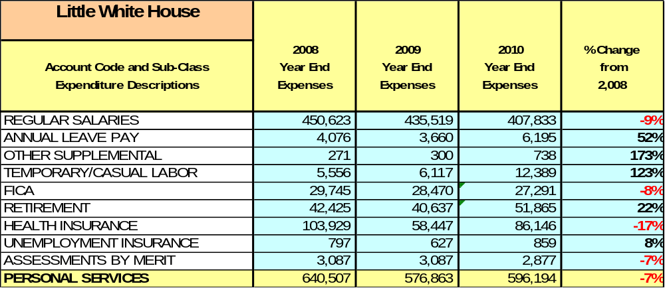
This is the Labor Budget Summary Table located in the toolkit.

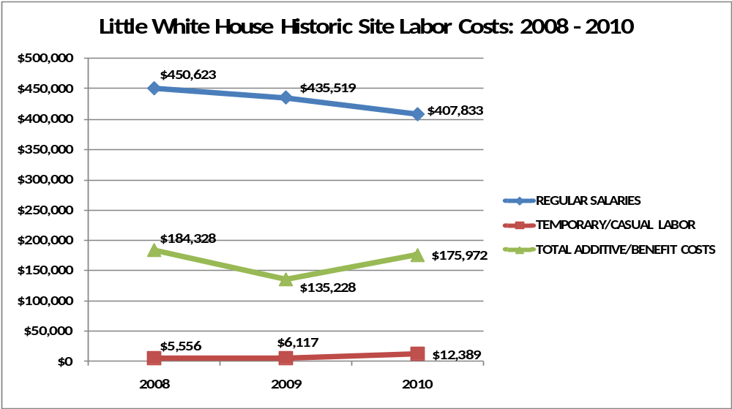
This is the Site Labor Costs Graph located in the toolkit.

Visitation and Occupancy
Overall annual visitation to the site has trended (upward/downward) from 2008 to 2010, (increasing/decreasing) by __% or over #### visitors. This is largely attributed to ___________.
Year | Total Visitation
2008
2009
2010
Occupancy for the overnight accommodations at _____________________ the last three years is detailed in the table below. Overall occupancy has trended (upward/downward) from 2008 to 2010, (increasing/decreasing) by __%. This is largely attributed to ___________.
Year | Facility Occupancy | Facility Occupancy | Facility Occupancy | Facility Occupancy | Facility Occupancy | Facility Occupancy
2008
2009
2010

The graph below illustrates visitation and occupancy over the last three years.
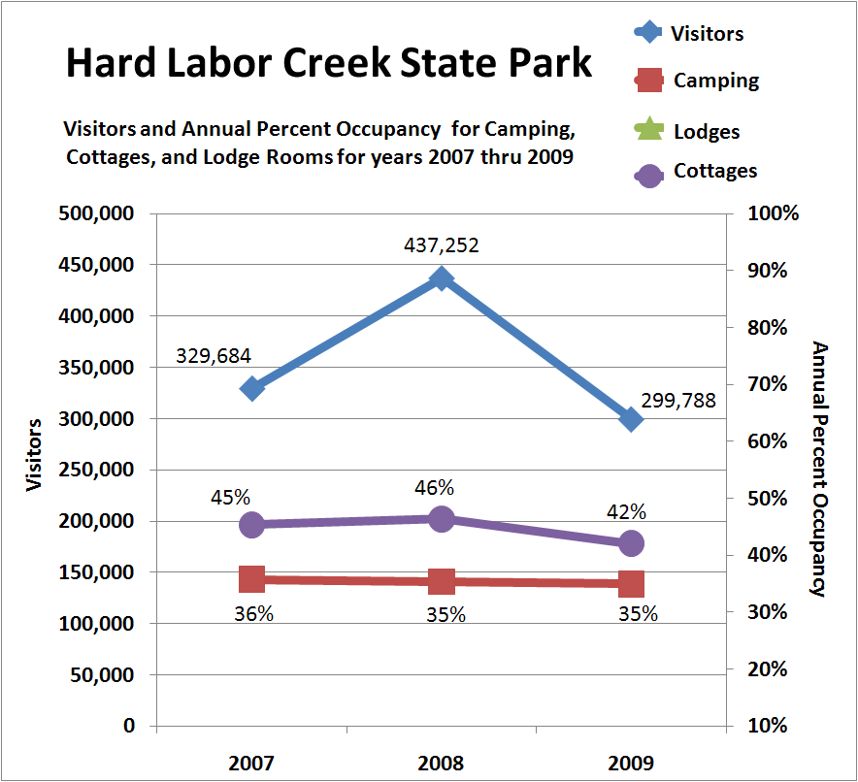
This is the Site Visitation/Occupancy Graph located in the toolkit.

Customer Service and Satisfaction

Site | Year | Customer Satisfaction Level
 | 2009
 | 2010
Financial Performance Assessment

Operational Expenses
A summary of total operating expenses at _________________________ from 2008 to 2010, as well as their percent change from 2008 are provided in the table below.
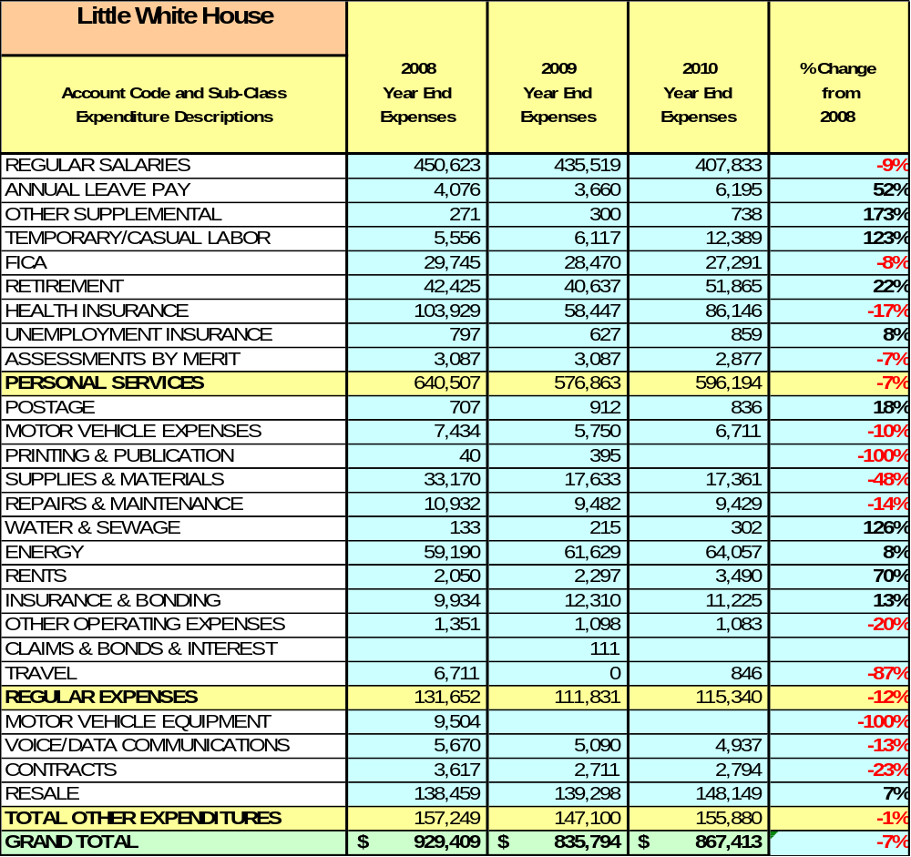
This is the Operational Expenses Table located in the toolkit.

Earned Revenues
Earned revenues at ____________________ have increased/decreased since 2008, which is largely attributed to the corresponding increase/decrease in overall visitation.
Monthly earned revenues for the last two years (see table on the following page) indicate that the total annual revenue increased/decreased __% from 2009 to 2010, with the largest increases in monthly revenues in month (__%), month (__%), and month (__%), etc., and the largest decreases in the months of month (__%), month (__%), month (__%), and month (__%), etc..

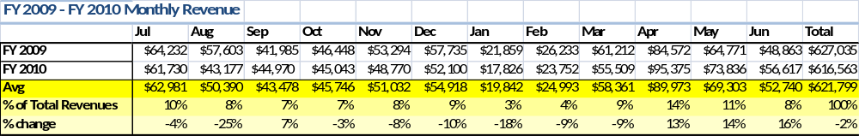
This is the Monthly Revenues Table located in the toolkit.

The graphs below illustrate the monthly revenue trends each year and the average percent of total annual revenue earned each month.
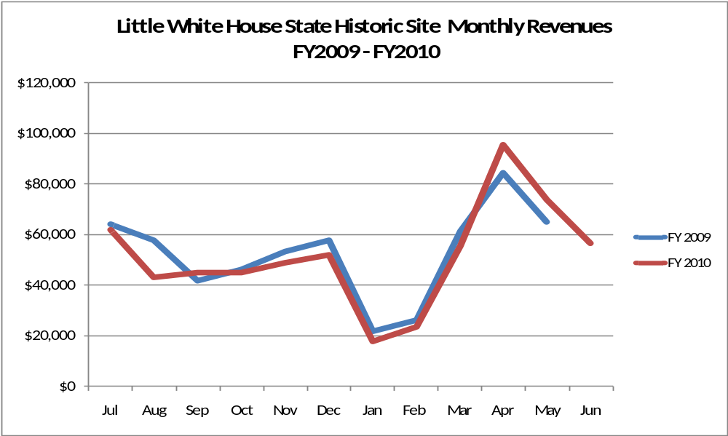
This is the Monthly Revenues Graph #1 located in the toolkit.

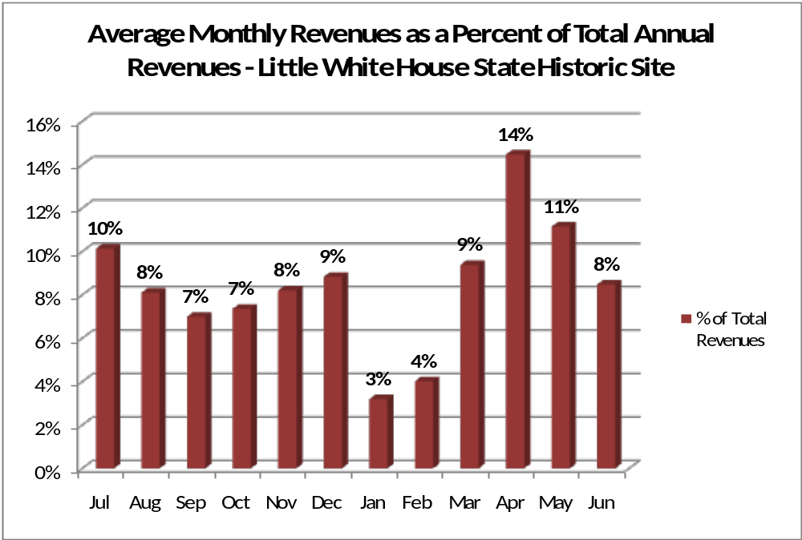
This is the Monthly Revenues Graph #2 located in the toolkit.

Cost Recovery Trends
________________ has achieved an average cost recovery of __% of annual operational expenses through earned revenues from FY 2008 to FY 2010. This is detailed and illustrated in the table and graph below.
Year | Operational  Expenses | Earned  Revenues | Percent Cost  Recovery
2008
2009
2010
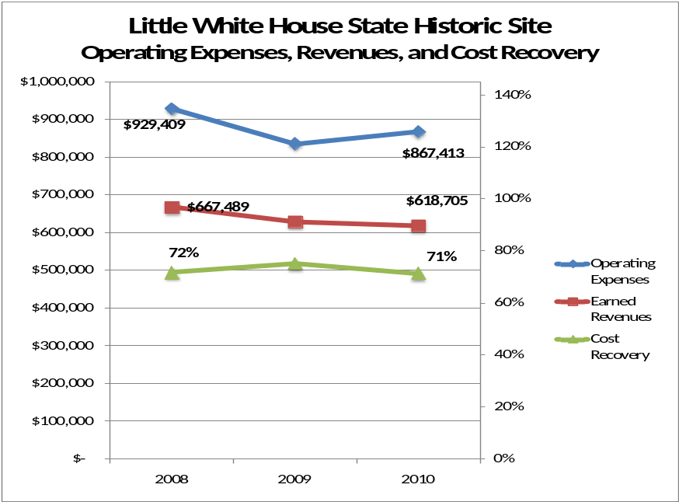
This is the Expenses, Revenues, CR Graph located in the toolkit.

Review of Pricing
Data on rate information is available as far back as 2002, but only the last five years are evaluated. There has been notable growth in fees charged at ________________since 2005, with the largest increase being __________________. A table detailing the rates for ________________is provided below.
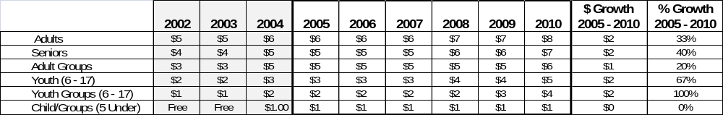
This is the Pricing Review Table located in the toolkit.
Business and Management Plan

Business Goals
The following goals serve as the foundation for the key recommendations and strategies in this business plan for _________________________________.

Enhance Cost Recovery of Site Operations
?????

Enhance Revenue Generation Strategies
?????

Expand Special Events at the Site
?????

Improve the Diversity and Innovation of Recreational and Interpretive Programs
?????

Improve the Effectiveness of Marketing and Sales
?????

Establish Greater Consistency of Managing and Monitoring Customer Service & Satisfaction
?????

Expand Partnership Opportunities
?????

Classification of Programs and Services
The tables below summarize the classifications of programs and services at ________________as either core, important, or visitor supported and projects a range of cost recovery percentages that might be achieved for each. These classifications establish financial performance goals for each category of services that are linked to the recommendations and strategies of this business plan.
Core Services
Program / Service | Target Cost Recovery

Important Services
Program / Service | Target Cost Recovery

Visitor Supported
Program / Service | Target Cost Recovery

Partnership Development Plan
The table below summarizes existing partners and targeted partnerships by classification (operational, vendor, service, co-branding, funding partners) and by organizational type.
 | Public Partners | Not-for-profit Partners | Private / Enterprise Partners
Operational Partners
Vendor Partners
Service Partners
Co-branding Partners
Funding Resource Development Partner

Marketing and Sales Plan

Marketing and Sales Goals
Marketing and sales goals for __________________________ are based on the following desired outcomes:
- ????
- ????
- ????
In order to meet these goals, examples of specific target outcomes were identified in the areas detailed in the table below.
Area  of Focus | Current  Performance | Goal  by 2011 | Goal  by 2012 | Goal  by 2015
Marketing and Promotion Strategies

Publicity and Social Media
__________________________ will approach marketing and publicity planning using the following guidelines and themes:
- Event publicity
Major events benefit by having short stories in local, regional, and statewide newspapers and online social media hooks planted that run three to four weeks in advance of the event up to the date of the event itself. Stories and media need to be cultivated with contacts and online sales channels several weeks in advance of the time the stories need to run. Special interest interviews on morning, noon, and evening television news programs, radio interviews on popular rush-hour programs, and blogs on known affinity online sites should also be included.
- Program publicity
Special and unique programs should have feature stories in magazines, local and regional weekly newspapers, and statewide daily newspapers that are aimed at placements as front-page or sectional front-page stories. These stories are most effective if they run shortly before the season that the featured program begins. This will likely require several weeks of advanced planning with media contacts. Similar coverage on television and radio should also be considered. If pre-publicity cannot be generated, post-publicity can help promote future programs.
- Site Publicity
Site publicity focusing on a single site or sub-set of sites requires more intense planning efforts to attract multiple writers and editors from target publications. Each site could host several seasonal media familiarization tours (with 10 to 15 writers or editors) to familiarize them with the site and its benefits and amenities. Stories and features resulting from such tours typically take between two and six months to materialize so the tours should focus on experiences, benefits, and programs that would be available when the stories are expected to run.
Examples and suggested opportunities for events, programs and related publicity efforts based on the themes described above at __________________________ are provided in the table below.
Event Publicity | Program Publicity | Site Publicity

Packaging
Examples and suggested packages for ____________________ are provided in the table below.
Package | Package Details

Group Sales
Types of groups within which specific target customers can be identified for __________________ are listed below:
- ???? | - ???? | - ????

Incentivizing New and Repeat Visitation
__________________________ will utilize the following strategies and/or incentives to encourage new and repeat visitation starting in FY 2012:
- ????
- ????

Marketing and Sales Metric Goals
The following marketing and sales metric goals and/or others will be monitored and progress reported at __________________________:
- Loyalty and repeat customers = __________________________.
- Brand confidence & customers-recruiting-customers = __________________________.
Revenue Generation Plan
Revenue / Cost Recovery Goals
__________________________has set a financial goal of increasing annual revenues ___% annually between 2012 and 2015. The largest revenue growth opportunity is most likely __________________________. The table below details projected revenue growth leading up to 2015, based upon a nominal growth of revenues each year.

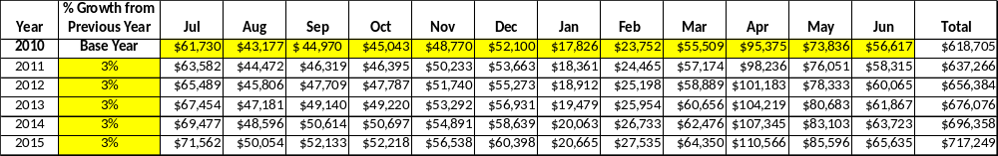
This is the Revenue Growth Projection Table located in the toolkit.

These projections would result in a total of ___% cumulative growth in total annual revenues between FY2010 and FY2015. If operational expenses can be managed with a cumulative increase / reduction of ___% between FY 2010 and FY 2015, then the overall cost recovery of the site will be approximately ___% in FY 2015 at these projected revenue levels. This is higher than the annual financial performance of the site in FY 2010, which was operated at ___% cost recovery in that year.
Revenue Generation Strategies

Pricing Plan
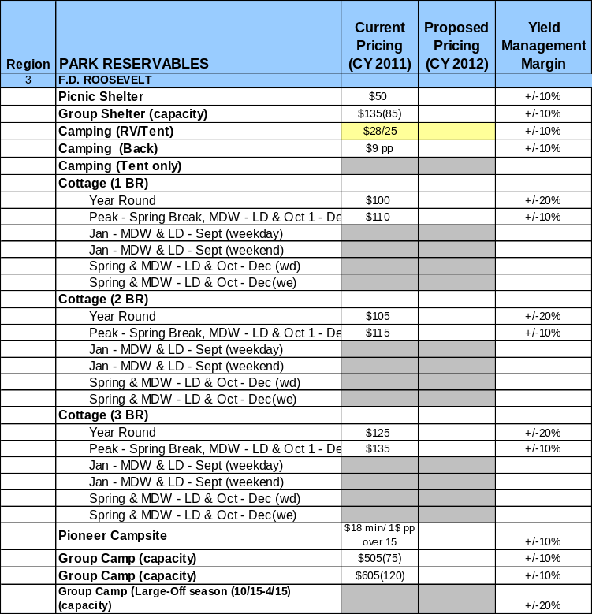
This is the Pricing Forecasts Table located in the toolkit.

Innovative Programming and Special Events Plan
Program / Event | Theme / Purpose | Scheduled Date/Season | Frequency | Target Participation | Target User Fee | Target Cost Recovery

Partnerships and Concessions Plan
Service / Partnership | Term of Service | Financial Objective | Contract Manager

Expense Management Plan
Personnel Assignments
The following actions will be taken to proactively manage labor costs via personnel assignments and classifications.
Action | Timeline | Outcome

Management Techniques
The following actions will be taken to proactively manage labor costs via management techniques.
Action | Timeline | Outcome

Adjusted Levels of Service
The following actions will be taken to proactively manage labor costs via reduced levels of service.
Action | Timeline | Outcome

Financial Pro Forma
The following five-year financial pro forma projects operating expenses, earned revenues and cost recovery through FY 2015. These pro forma are based on the strategies and desired outcomes identified in this business plan, especially the revenue generation and expense management plans, and are linked to corresponding performance goals.

Expense Pro Forma
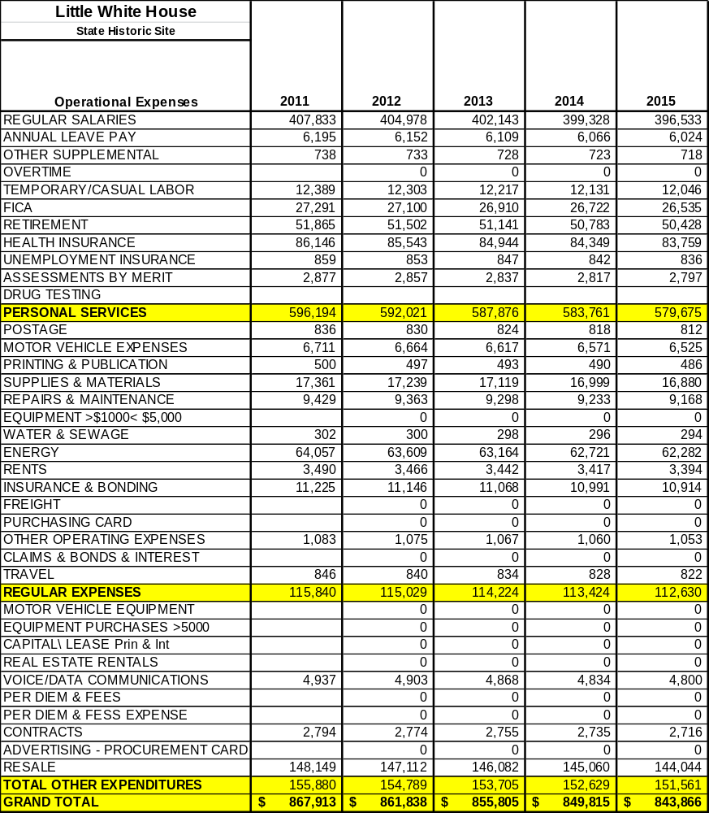
This is the Expense Pro Forma located in the toolkit.

Revenue Pro Forma
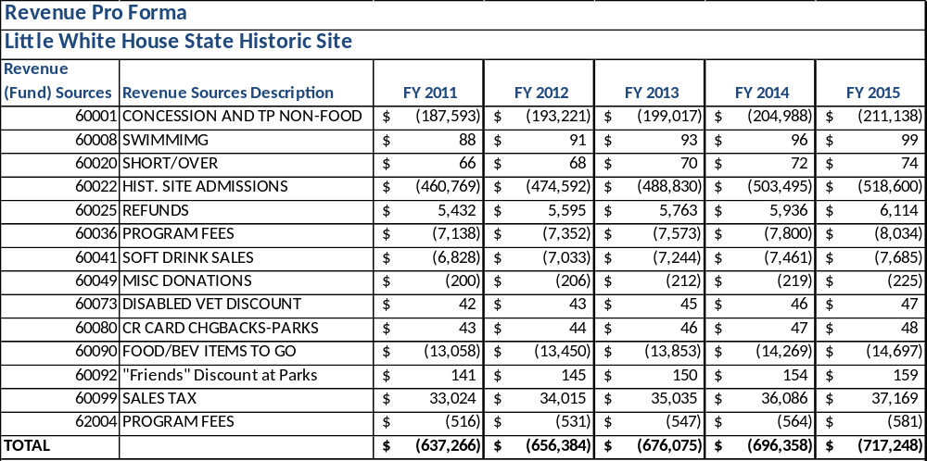
This is the Revenue Pro Forma located in the toolkit.

Total / Cost Recovery Pro Forma
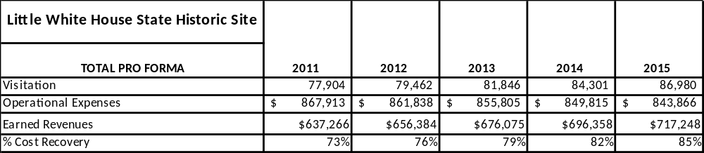
This is the Total Pro Forma located in the toolkit.

Action Plan
ACTION PLAN
Site: |  | Site Manager: |  |  | Date:
Month:
Strategy | Tasks | Costs / Funding | Revenues / ROI | Responsibilities | Metrics

ACTION PLAN
Site: |  | Site Manager: |  |  | Date:
Month:
Strategy | Tasks | Costs / Funding | Revenues / ROI | Responsibilities | Metrics

This is the average of the last three years – FY 2008, FY 2009, and FY 2010
Current employees, not including vacancies.
Current employees, not including vacancies.
Major population centers within a two-hour drive from the site

