APRIL 2011
Direction 2015 Sustainable Business Planning

Georgia State Parks and Historic Sites
Planning Manual
Business & Management Plan

Table of Contents

Introduction 3
Best Practices for Improving Financial Performance 3
Assumptions and Caveats 4
Sustainable Site Operations 5

Business Planning Process 10
Business Plan Development Steps for Site Managers 11

Developing an Executive Summary 12
Site Fact Sheet 12
Site Summary and Key Attractions 12
Financial Targets 12
Key Recommendations 13

Developing a Site and Operations Assessment 14
Site Inventory and Facility Assessment 14
Operational Assessment 16
Financial Performance Assessment 22

Developing a Business and Management Plan 26
Summary of Business Goals 26
Classification of Programs and Services 28
Partnership Development Plan 29
Marketing and Sales Plan 31
Revenue Generation Plan 36
Expense Management Plan 41
Financial Pro Forma 43

Glossary 45
Developing an Action Plan 47

Introduction
In August 2010, the Parks, Recreation and Historic Sites Division (PRHSD) of the Department of Natural Resources (DNR) began an initiative to guide the Division toward a higher level of fiscal sustainability known as ‘Direction 2015’ (D15). PRHSD seeks to transition the management of its sites to operate more like businesses, with a greater degree of fiscal sustainability, in order to achieve a system-wide ‘cost recovery’ approaching 75% by the year 2015.
As a component of the D15 initiative, PRHSD is completing site business plans for all 65 units in the system by the end of FY 2012. The objectives of this business planning process for PRHSD are to identify the greatest opportunities for sites to improve their overall financial performance, to achieve financially sustainable operations with less dependence on funding from the state’s general fund, and to elevate the unique value the sites provide to the community, region, and state of Georgia.

Best Practices for Improving Financial Performance
Financial performance of state parks and historic sites is improved by increasing earned revenues and/or by reducing operating expenses, which is often referred to as a cost recovery ratio. Improving cost recovery can be a double-edged sword, however, where short-term goals are achieved by underfunding the capital and operational needs of the site, deferring maintenance, and making operational reductions that reduce service quality. The most sustainable practices for improving cost recovery are:
- Understand the total costs of providing services
- Establish appropriate and measureable performance goals for each service and function
- Reduce and eliminate wasteful spending in operations
- Establish and protect spending that reinforces the integrity of the site and its services
- Improve revenue generation through pricing, partnerships, programs, and other innovations
The greatest challenge with performing a total cost of service analysis for the system and all sites of PRHSD is to distinguish between what are the current total costs of service and what are the optimal costs of service. This is a priority for the agency because it is doubtful additional funding will be available to support operations within the next five to ten years, and in fact current funding may likely be further reduced.
In order to achieve 75% cost recovery as a system, total costs of service and earned revenues must be better balanced. Given the market and economic constraints of the sites and their operating environment, it is reasonable to expect revenues to increase within the range of 5% - 15% over the next five years. This can be attained through the strategies and best practices listed above and described in more detail throughout this manual.
Additional operational expenses can be justified as long are there are additional revenues to support those costs at or above the 75% cost recovery rate. For example, $1,000,000 in more operational costs could be justified as long as an additional $750,000 in revenues is the minimal result. If these revenues are not possible or likely, then expenses should be reduced to match the realistic expectation for additional revenues. It is critical that sites, amenities and services that have the potential and capacity to generate revenues that exceed 75% of operational costs strive to do so in order to compensate for those that are unable to significantly contribute to the Division’s cost recovery goals.
Large or notable increases in visitation can make a significant difference for improving earned revenue opportunities; therefore, services or experiences that add little costs but attract new or larger markets are desired. State parks and historic sites are typically volume-based business operations because of the pricing constraints of being a public service. Estimates for the targeted total costs of service and earned revenues are largely dependent on total visitation to the site.
Although recent increases in cost recovery have largely been the result of budget cutting measures (some of which may not be sustainable), this business planning manual outlines means to increase the revenue-generating potential and capacity of PRHSD by improving existing services as well as proposing new opportunities. These include, but are not limited to:

- Increasing overall visitation, usage and occupancy of key revenue generating assets in the system
  - Overnight accommodations
  - Meeting / group facilities
  - Golf courses
  - Recreational / interpretive services
  - Retail sales
  - Day use facilities

- Organizing and hosting special events (e.g., music, arts, wine festivals)
- Organizing and hosting private events (e.g., weddings, etc.)
- Updating pricing philosophy and strategies to enhance customer value, establish a tiered level of service, and improve revenue generation from traditional services and functions
- Seeking partnership and concessionaire agreements to support site operations, local cross-marketing efforts, and fund development
- Strategically investing in facilities and amenities
  - Broaden appeal of sites
  - Improve revenue generation
  - Update and enhance aged infrastructure and facilities
- Enhancing marketing and sales effectiveness of the system and of local sites to engage current and potential users

Assumptions and Caveats
Although there has been a negative trend in PRHSD visitation over the last four years, several external factors are believed to have played a significant role in that trend (e.g., spike in gas prices in 2008, national and state economic recessions, extreme weather conditions, changing lifestyles). A combination of the new business and management approaches proposed here, along with a moderation of these external factors, is expected to result in visitation levels that can recover fully and perhaps even surpass recent highs. Other assumptions and caveats include:

- The path to achieve greater sustainability for PRHSD is a work-in-progress through uncharted territory requiring transition time and operational flexibility.
- PRHSD has exhausted the primary cost saving opportunities in its system. The focus now should be on creating greater efficiencies by transitioning to a sustainable business model and increasing revenues through marketing and sales efforts.
- PRHSD’s ability to increase revenues is impacted by many factors beyond its control (weather, gas prices, continued depressed economy, etc.). However, the Division will continue to constantly monitor operations and be enact corrective actions to stay within its budget.
- Continued operational funding support, especially for ‘core’ costs, is paramount to PRHSD’s ability to ensure safe and inviting park and historic site experiences and to protect its natural and cultural resources.
- Capital investments focused on properly maintaining PRHSD’s assets and on facilities with the potential to maximize cost recovery is essential to achieve greater sustainability (current deferred maintenance needs exceed $120 million).
- The continued and growing support of statewide and chapter Friends of Georgia State Parks and Historic Sites is one of PRHSD’s greatest assets. Their efforts to promote, preserve and support Georgia’s state parks and historic sites are directly aligned with the Division’s strategic business plan (Direction 2015).

Sustainable Site Operations
Evaluating the operational sustainability of Georgia State Parks and Historic Sites is a major goal of the D15 initiative and the business plans for each of the sites. The purpose of establishing evaluation standards is to identify at what threshold operations of any site or the system fails to be sustainable (or conversely at what threshold it can successfully attain and retain sustainability).
PRHSD is a responsible steward of the natural and cultural assets under its care, the assets and amenities of state parks and historic sites, and the financial resources provided by the State of Georgia for operating and maintaining the system. Drastic expense reductions that are often the result of state financial woes can threaten the ability of PRHSD to fulfill its stewardship responsibilities. Consequently, the following thresholds and corresponding actions have been identified as the most prudent response to circumstances that evolve to become unsustainable.

Sustainability Thresholds
Sustainability thresholds are “trigger points” where operations of the site or the system have become unsustainable either by way of circumstances, budget cuts or management decisions. The thresholds outlined in the table below have been developed with the following assumptions:
- Loss of operational resources should be addressed through strategic reductions in service aligned with the mission and essential functions of sites and the agency.
- Strategic operational reductions need to address the reduction of fundamental programs, services and functions of state parks and historic sites, and not just the elimination of ancillary support expenses.
- Operational reductions beyond a certain point reduce and possibly eliminate the capability of sites to operate sustainably.
- Operation of state parks and historic sites below sustainable thresholds is not responsible stewardship of public assets and resources.
- Sustainable operation of the PRHSD system requires 75% recovery of all operational expenses through earned or ancillary revenues at the system level.
- Expending more than 65% of the annual operational budget on personnel expenses (with benefits) is typically not sustainable.
- Expending less than 5-7% of the annual operational budget on materials and supplies typically does not adequately support the programs and services of each site.
- Reducing annual capital asset maintenance and repair funding to less than 2-4% of the total value of assets (not including land value) typically is not sufficient to keep assets and amenities in safe, working condition.
The table below details the sustainability thresholds and recommended actions for PRHSD’s sites and its system.
Operational Function | Threshold / Resource Level | Action
Personnel | If personnel expenses exceed 65% of the total annual operational budget | One or more of the following actions should be taken:  - Reduction in force  - Alternative or reduced scheduling  - Alternative personnel options  - Elimination of programs, services, or functions
Materials and Supplies | If material and supply expenses are reduced to levels that do not support program or service needs, or less than 5-7% of the total annual operational budget | One or more of the following actions should be taken:  - Alternative management options  - Elimination of programs, services, or functions
Programs and Services | If programs and services do not perform to the established standards identified in the site’s Business Plan based upon categorization as essential, important, or visitor-supported | One or more of the following actions should be taken:  - Improved earned revenues and cost recovery within six to nine months  - Alternative management options of programs, services, or functions  - Reduction or elimination of programs, services, or functions  - Temporary or permanent closure of facilities
General Maintenance | If maintenance expenses are reduced to levels that do not permit the cleaning and maintenance of facilities / amenities for safe public use | One or more of the following actions should be taken:  - Alternative or reduced scheduling  - Alternative personnel options  - Alternative management options  - Elimination of services or functions  - Temporary or permanent closure of facilities
Earned Revenues | If earned revenues fall below the target recovery of total annual operational costs of the site | One or more of the following actions should be taken:  - Improved earned revenues and cost recovery within six to nine months  - Alternative management options of programs, services, or functions  - Elimination of programs, services, or functions  - Temporary or permanent closure of facilities
Capital Asset Maintenance | If annual capital asset maintenance and repair resources are reduced to levels that are insufficient for keeping assets and amenities in safe working condition; or to less than 2-4% of the total value of assets not including land value | One or more of the following actions should be taken:  - Additional resources obtained within twelve months  - Alternative operations of assets to reduce usage impact or worsening conditions  - Temporary or permanent closure of facilities

Key Recommendations for Sites
Operational recommendations are detailed below that support the outcomes of the D15 sustainability initiative and can be considered for inclusion in each site’s business plan.

Primary / Short Term Recommendations (not in priority order)
- Operate the PRHSD system and individual sites using cost-based accounting, including the net cost recovery achieved annually.
- Conduct on-site surveys annually to assess how well customer satisfaction levels are being met. Sites should strive to have 90% of visitors responding to ‘Comment Cards’ report that they were either ‘satisfied’ or ‘very satisfied’ (or some comparable metric to be developed). Programs or services that fall below that standard should be critically reviewed, enhanced, and results monitored; those with a history of poor performance should be considered for elimination.
- Pursue opportunities to employ concessionaires or private or public service providers on-site if they can be more cost-effective or provide desirable services, programs or amenities the Division cannot.
- Collect a statistically-valid sample of ZIP code data from day visitors in a non-intrusive way to gauge their origins and demographics (e.g., age, ethnicity, income, etc.) and use the results to improve programming and marketing efforts to appeal to a broader audience.
- Utilize a minimum of six special events annually to help draw more visitors to the site.
- Seek local partners to help support operations, programs, and service delivery and for cross-marketing purposes.
- Sustain sufficient non-labor operational funding or reduce staff so that required staff operational costs (with benefits) do not exceed 65% of the total operational budget.
- Enhance facilities and program offerings to provide a minimum of 10 unique experiences for each visitor while maintaining at least a 90% customer satisfaction rating.
- Manage sites according to well-defined maintenance, programming and operational standards, monitored and enforced by region managers and senior management.
- Partner with local Chambers of Commerce or other destination marketing organizations (DMOs) to promote local sites.
- Continue to work with the statewide and chapter Friends of Georgia State Parks and Historic Sites to help raise funds or provide volunteers for improvements and program support.
- Perform a thorough net cost-of-service analysis on major functions of site operations, including a detailed analysis of labor requirements by task. Thereafter, update costs to deliver services on a biennial schedule.
- Review and update rates at the site on an annual basis to meet cost recovery targets for important and visitor supported services.
- Enhance retail operations at each site to increase site generated revenues.
- Track total economic impact of the sites on the local communities and region and share with decision-makers, elected officials, local business operators and others to demonstrate the impact of each site.
- Develop a more detailed analysis of labor requirements of all major park functions to match the right position with the right job at the right pay.
- Develop funding to provide additional training to site staff for improved business management and marketing effectiveness.
- Construct and upgrade facilities and amenities that are likely to have a cost recovery level at or above 100%.
- Add more youth and family focused services, programs and amenities at state parks and historic sites that appeal to younger audiences, families and educational groups.
- Add more services, programs and amenities at state parks and historic sites that appeal to older adults.
- Manage each state park and historic site using at least 10 performance measures. It is critical that the system evolves to adopt additional performance measures over time. These could include the following:
- Capacity management by amenity
- Revenue versus expenses based against anticipated budget
- Cost center goals for efficiency and revenue development are met at 95% of the goal
- Customer satisfaction is at least 90%
- Retention of the core market with return visits at least once each year at 70% or greater
- Two to four percent (2-4%) of the total asset value in the site is funded annually for maintenance and repairs
- Each state park and historic site maximizes the partnerships in place that help them to manage the resources and provide services at the site
- Each state park and historic site has access to site-specific marketing funding equal to at least 5-7% of its annual operating budget committed to promoting the site in the region and the state
- Each state park and historic site effectively manages constituent groups to maintain balanced and appropriate park use
- Each state park and historic site leverages annual volunteer hours equal to a minimum of 15% of paid staff hours
- Equipment replacement is based on a schedule that is met at a 95% level annually
- Each state park and historic site has a Friends group that raises funds equal to a minimum of 5% of the annual operating budget at the site to support the maintenance and operations of the site

Secondary / Long Term Recommendations (not in priority order)
- Establish a reserve fund or revolving account that allows for earned revenues above a certain percentage of operational cost recovery to be reinvested in the system.
- Improve the recreational amenities at state parks and historic sites to meet the needs of modern and emerging uses, including addressing the recreational preferences of a diverse public.
- Engage local communities, user groups, and private organizations to improve connectivity between and within sites through trail development and maintenance projects.
- Install an improved retail point-of-sale and inventory tracking system.

Things to Avoid
- Do not achieve cost recovery goals by eliminating funds that support facility and infrastructure maintenance and long-term integrity of the system and its assets.
- Do not reduce operating costs solely by reducing non-labor expenses below 35% of the total operational budget. Operational cost reductions that focus predominantly on non-labor expenses does not improve the overall efficiency of the sites, but rather only creates a group of employees that has less functionality in the system.

Business Planning Process
The business planning process for each site will include multiple steps as detailed below. This document contains the process of developing a business plan, not the business plan template.
- Training Workshops – All site managers participate in training workshops on the D15 Sustainable Business Planning initiative and the business planning process, template and tools.
- Comprehensive Assessment – Each site manager performs an assessment of their site facilities, operations, and financial performance, using tools provided in this manual and the template.
- Business Plan Development – Each site manager develops and tailors multiple components of the Business Plan Template to their site’s unique circumstances, including:
  - Business Goals – Standard goals have been established that are aligned with the system objectives of the D15 initiative must be tailored and detailed for each site.
  - Classification of Programs and Services – The programs and services of each site must be classified with corresponding cost recovery targets established for each.
  - Partnership Development Plan – Site managers must identify partnership opportunities, including existing partnerships, that will support achieving the targeted business goals.
  - Marketing and Sales Plan – Goals, strategies and metrics must be developed to support the marketing and sales outcomes that enable each site’s business goals to be achieved.
  - Revenue Generation Plan – Cost recovery goals and strategies for each site must be projected using visitation, occupancy, pricing, programming and partnerships.
  - Expense Management Plan – Each site must detail strategies for managing operational expenses through appropriate personnel assignments, management techniques, and adjustments in levels of service.
  - Financial Pro Forma – A detailed pro forma of visitation, expenses and revenues for each site must be developed that projects the next five operating years.
  - Action Plan – Site managers must complete a monthly action plan for each fiscal year that identifies the tasks for attaining the business goals and key recommendations.
Other related processes and plans that will be developed by PRHSD staff subsequent to the site business planning process are detailed below:
- Service Market Analysis – Identification and review of the service markets of each site based on a detailed zip code analysis and competitive/complementary market analysis.
- Resource Management Plan – A detailed inventory and management plan for each site, based on best practices for managing the site’s natural and cultural resources.
- Cost of Service Accounting and Analysis – Modifications to the existing accounting system will enable sites to track specific costs aligned by major operational and maintenance functions. A detailed cost of service analysis will be performed with data collected during FY 2012.
- Operations and Maintenance Standards – A working group of PRHSD staff will develop operations and maintenance standards, linked to resource management plans and cost of service accounting/analyses, that can be adapted at each site to achieve its cost recovery goals.

Business Plan Development Steps for Site Managers
Site managers will be asked to utilize this business planning manual as a guide for developing business plans for each site. This manual contains:
- helpful background information
- required methodology
- system-wide assumptions and principles for the business planning process
- required business plan structure
- helpful examples from the test sites (Little White House and Hard Labor Creek)
- explanation of electronic tools and spreadsheets in companion toolkit to aid in data collection and analysis
Each site will develop a business plan utilizing the format and sections detailed below. which are also outlined in the separate Business Plan Template. Additional guidance is available from the test site business plans that have been developed in coordination with this manual. All tables and additional tools are available in the toolkit supplement.

Business Plan Format
Each site-specific business plan must contain the following sections:
- Executive Summary
  - Site Fact Sheet
  - Site Summary and Key Attractions
  - Financial Targets
  - Key Recommendations
- Assessment of Operations, Facilities & Finances
  - Operational Assessment
  - Site and Facilities Assessment
  - Financial Assessment
- Business Management Plan
  - Business Goals
  - Classification of Programs and Services
  - Marketing and Sales Plan
  - Revenue Generation Plan
  - Expense Management Plan
  - Financial Pro Forma
- Action Plan
  - Strategies
  - Tasks
  - Costs / Funding
  - Revenues / ROI
  - Responsibilities
  - Metrics

Developing an Executive Summary
Business plans for each site begin with an Executive Summary that includes the following four sections:

Site Fact Sheet
A site fact sheet should be completed for each site business plan that includes the following information:
- Site Name
- Site Manager / Region Manager
- Date of plan development
- Site size (acres)
- Current visitation and occupancy (based on FY 2010 actuals)
- Current operating budget (based on FY 2010 actuals)
  - Operating expenses
  - Earned revenues
  - Cost recovery (ROI)
- Current average cost and revenues per visitor (based on FY 2010 actuals)
- Number of current full-time and part-time employees (filled / allocated)
- Primary service market (travel or mileage radius and major population areas)
- Primary attractors / visitor appeal factors of the site
- Leading opportunities for improved site performance

Site Summary and Key Attractions
A brief narrative summary of the site’s key attractions (unique resources, assets, facilities, programs, and services, etc.) should be provided for each business plan. An example from LWH is provided below:
The 163-acre site of LWH is located in a rural setting, roughly 70 miles from major population centers in Georgia like Atlanta and Macon and 40 miles from Columbus. It is roughly 50 miles from Interstate 75 and 30 miles from Interstate 85. The most popular amenities of the site are:
- Little White House
- Memorial Museum
- Servant’s Quarters
- Guest House
- Flag and Stone Walk
- Historic Pool Complex
- Legacy Exhibit
- Gift Shop
- Interpretive programs and special events

Financial Targets
Financial targets should include a 2015 cost recovery target similar to the table shown below that is based on past performance for the last three fiscal years (FY 2008 – 2010) and the financial pro forma for the next five fiscal years (FY 2011 – 2015). In their business plans, site managers must identify the target cost recovery for the years leading up to 2015. This target should be derived from completion of the financial pro forma, and should strive to be an improvement from the status quo of 5% - 10%+.
This section of the Executive Summary will include a table provided in the toolkit supplement and illustrated in the test site plans. The table for LWH is provided below as an example.
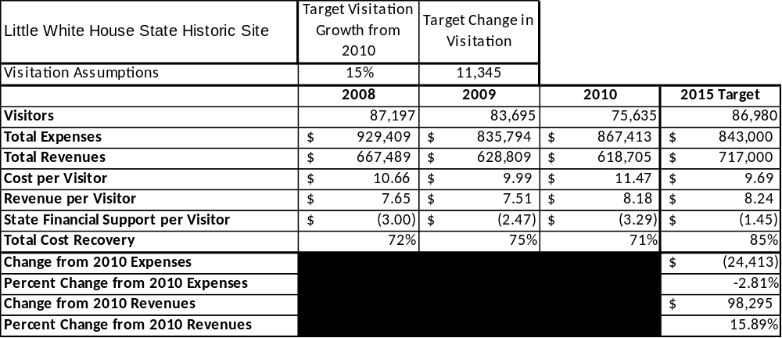

Key Recommendations
This business planning manual provides key recommendations for the system that each site should relate to their unique circumstances. These recommendations have been identified above in the Introduction – Sustainable Site Operations section of this manual and can be tailored to each site. In some cases, additional or different recommendations may be developed for a site based upon the site and region manager’s approach for improving operations.
Specific recommendations for each site will be derived from the business planning process and should be listed as ‘primary’ and ‘secondary’ as in the Introduction – Sustainable Site Operations section above in this planning manual. Primary recommendations are considered to be short term, and secondary recommendations are considered to be more long term and ongoing.
Developing a Site and Operations Assessment
A site assessment is a culmination of analyses and findings from a review of the condition of facilities, infrastructure and operations at each site. The findings and observations are not intended to be an exhaustive review of all issues at each site, but should reflect a basic understanding of the predominant issues that contribute to a site’s current operating conditions and future prospects. These findings will serve as the foundation from which ambitious, yet realistic, recommendations are developed.
The objectives of the assessments are to:
- Identify existing site and operational conditions
- Identify potential areas for improvement or enhancement
- Provide a defensible foundation for recommendations
Three major areas of focus should be included in the assessments:
- Site Inventory and Facility Assessment
- Operational Assessment
- Financial Assessment

Site Inventory and Facility Assessment
A site inventory and facility assessment should be performed by the site manager and region manager. All major facilities and infrastructure should be inventories and inspected, with existing conditions rated using the methodology and the scale provided below.

Methodology
Facility and asset conditions are rated using a differential scale of excellent, good, fair, or poor. Descriptions of conditions that are attributed to each of these findings are also provided.
Scale of Conditions
Rating | General Description
Excellent | Facilities/amenities are in ‘excellent’ condition when they show little or no maintenance or repair problems. Facilities do not feature any major design or operational issues or flaws that contribute to diminished use or increased maintenance or upkeep. Facilities are easy to clean and maintain in order to place them back into public use and the users perceive them to be in excellent shape.
Good | Facilities/amenities are in ‘good’ condition when they show only minor maintenance or repair problems. Most maintenance issues with these facilities typically appear to be the result of age and/or heavy use. Facilities may only feature minor design or operational issues that contribute to diminished use or increased maintenance or upkeep. Facilities are moderately easy to clean and maintain in order to place them back into service and the users perceive them to be adequate for their use, but probably not in excellent shape.
Fair | Facilities/amenities are in ‘fair’ condition when they show significant maintenance or repair problems. Facilities generally exhibit ongoing maintenance issues that appear to be the result of age, heavy use, or design or operational flaws. Some maintenance and repair needs may compound their fair condition by being deferred because of budget and/or resource limitations. Facilities require more effort to clean and maintain before placing them back into service and the users may perceive them as being less than adequate for their use and in a state of deterioration. The facility or structure may need of major repair or replacement.
Poor | Facilities/amenities are in ‘poor’ condition when they show significant, on-going maintenance or repair problems that ultimately may result in suspended use for repair/replacement. Maintenance and repair issues are possibly the result of poor maintenance and clearly the result of age, heavy use, or design or operational flaws. Problems with the facilities are often compounded over time due to consistently-deferred maintenance and repair because of budget and/or resource limitations. Facilities may feature major design or operational issues that contribute to diminished use or increased maintenance or upkeep. Facilities require excessive effort to clean and maintain before placing them back into service and the users often perceive them as being inadequate for their use and in a state of serious deterioration. The facility or structure may need of major repair or replacement.

Inventory and Assessment
The table below is an example from Little White House. This table is available in the toolkit supplement to this manual.
Site Asset / Amenity | Quantity | Condition
Total acreage | 163 | Good
Little White House | 1 | Fair
Memorial Museum | 1 | Good
Servant’s Quarters | 1 | Fair
Guest House | 1 | Fair
Flag and Stone Walk | 1 | Poor (being refurbished)
Historic Pool Complex | 1 | Poor
Legacy Building | 1 | Good
Gift Shop | 1 | Fair
Maintenance Complex | 1 | Good
Picnic Area | 3 | Poor
Office Area | 1 | Fair
Manager’s Residence | 1 | Fair
Pump house building | 1 | Good
Willys Pavilion | 1 | Fair
Marine Corps Sentry Posts | 9 | Fair
Secret Service Post | 1 | Poor

Prioritized Facility Needs
Based on the facility inventory and assessment, prioritized needs should be identified by aligning each need with a priority category of high, moderate, or low to support future decision making regarding project sequencing, investment of public resources, and meeting community expectations. The priority assignment for each need is not a measure of importance; rather, these recommended priorities should reflect a phased implementation approach over the next several years. The needs and priorities listed in the table below are examples from Little White House. This table is available in the toolkit supplement to this manual.
Facility Need | Priority Assignment
Event area / program space addition | High
Improved signage at entrance and roadway | High
Theater improvements including seat backs | High
Upgrade lighting in Museum | High
Updated / enhanced landscaping | High
Storage area of gift shop | Moderate
Interactive / updated displays and exhibits | Moderate
Memorial Fountain improvements | Moderate
Water irrigation system for landscaping | Moderate
Nature boardwalk | Low
Enlarge Visitor Center | Low

Operational Assessment
This includes:
- An inventory and classification of programs and services being provided at the site
- A review of current staffing at the site
- A review of concessionaires and partners operating at the site
- A summary of current visitation and customer satisfaction

Inventory and Classification of Programs and Services
Each site should inventory all programs and services and classify these by the three major categories listed below. More detailed definitions of these categories are also provided to assist the process of classifying programs and services. Actual cost recovery targets that correspond to the expectations defined for each service classification will be not identified for specific programs at each site until the Business Management Plan section of the site’s business plan.
- Core or Essential Services
- Important Services
- Visitor Supported Services
Programs and services at each site are classified into these categories based in part on the mission and public mandates for both the site and the agency. There are cost recovery expectations that will define how services are funded and evaluated for each classification. A table detailing these categories and their overall cost recovery expectations is provided below.

Service  Category | Description | Cost Recovery Expectations
Core | Services the agency must provide to meet its mission, and statutory and/or regulatory obligations; maintains valuable assets and infrastructure investments; essential to protect visitor safety; preserves the integrity of natural and cultural resources; reasonably expected and supported (or demanded) by visitors | Largely supported by taxes with little or no cost recovery
Important | Services the agency should provide or are important to effectively serve visitors; may expand or enhance provision of core services; broadly supported and utilized by visitors, although support may be conditional upon the perceived benefit, quality, and pricing of the services | Supported by a balance of taxes & earned revenues
Visitor Supported | Services the agency may provide when they are fiscally sustainable through visitor support; add value above and beyond what is required or expected of the agency’s core functions; are easy opportunities to integrate alternative providers and operators into providing services at one or more sites | Heavily or fully supported by earned revenues

Making these distinctions helps agency leadership monitor the success of programs, adjust offerings and prices, and manage the financial outcomes of each site’s major functions. This is illustrated in the diagram below.
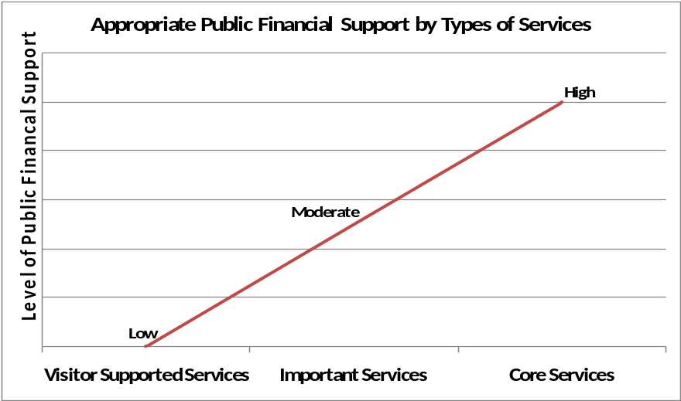

The classifications of services listed below are examples from Little White House and Hard Labor Creek.

Examples of Category 1 – Core Services [Largely supported by tax funds]
- Active management of the natural / cultural resources in order to protect their integrity
- Artifact management
- Support for researchers
- Open and public access to the site and its resources
- Site appropriate education, interpretation, and recreational opportunities
- Public safety
- Maintenance of grounds, facilities and infrastructure
- Self-directed and site appropriate education, interpretation, and recreational opportunities

Examples of Category 2 – Important Services [Supported by a balance of tax funds and earned revenues]
- Lake activities / beach area
- Picnicking / day use
- Tent camping
- Trails
- Group camping areas
- Visitor center

Examples of Category 3 – Visitor Supported Services [Almost exclusively supported by earned revenue]
- Gift shop
- Special events
- Equestrian activities
- RV camping
- Improved accommodations (lodges, cottages, yurts, etc.)
- Golf
- Food service
- Meeting facilities

Staffing Assessment
Labor costs represent the largest area of budgetary expense for the PRHSD system. Based upon industry best practices, the total labor costs (including benefits) of each site typically should not exceed 65% of its total annual operational expenses. To perform a staffing assessment, each site must adhere to the following steps:
- Inventory all full-time salary and part-time hourly employees currently working at each site, including vacant positions that are still currently allocated to the site. Annual hours worked for each position must also be included.
- Inventory all labor support provided by volunteers, community service workers, prison labor crews, engineering and construction crews, and natural resource management crews. Estimated annual hours worked for each source of labor support must also be included.
- Inventory all contracted labor or services including concessionaires. Estimated annual hours worked for each contractor or concessionaire must also be included.
- Table summary of labor / benefits expenses for the last three years.
- Graph of labor / benefit expenses over the last three years which details the following:
  - Regular salaries
  - Temporary/casual labor
  - Total benefit costs

Staffing Inventory
The tables below provide a basic review of the current staffing at Little White House. The tables to use for this section of the business plan are available in the toolkit supplement to this manual.
Full Time Equivalent Employees
Position / Title | Current Quantity (filled FTE positions) | Vacancies | Hours
Historic Site Manager | 1 | 0 | 2,600
Secretary 2 | 1 | 0 | 2,080
Interpretive Ranger | 2 | 0 | 4,160
General Clerk | 0 | 1 | 2,080
Maintenance Engineer | 1 | 0 | 2,340
Sales Manager 2 | 1 | 0 | 2,340
Utility Worker 1 | 2 | 1 | 4,160
Assistance Manager 2 | 0 | 1 | 2,600
Exhibit Guide | 7 | 2 | 14,560
General Trades Craftsman | 1 | 0 | 2,080
TOTAL | 16 | 5 | 39,000

Part Time Employees
Position / Title | Current Quantity (filled FTE positions) | Vacancies | Hours
Tour Guide | 2 | 2 | 3,016
TOTAL | 2 | 2 | 3,016

Labor Support
Labor Support | Annual Hours
Volunteers | 1,000
Community Service Workers | 0
Engineering and Construction Crews | 40
Resource Management Crews | 0
TOTAL | 1,040

Total Labor Hours
Labor Type | Annual Hours
Full Time Equivalent Employees | 39,000
Part Time Employees | 3,016
Labor Support | 1,040
TOTAL Annual Labor Hours | 43,056

Labor Budget Summary
Each site should provide the following table and graph summarizing total labor costs for the last three years. The table is based on data available from the site’s Form-14, and the graph is accessed in the toolkit supplement to this manual.
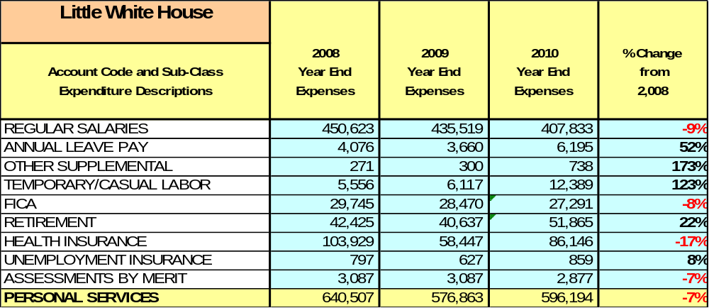

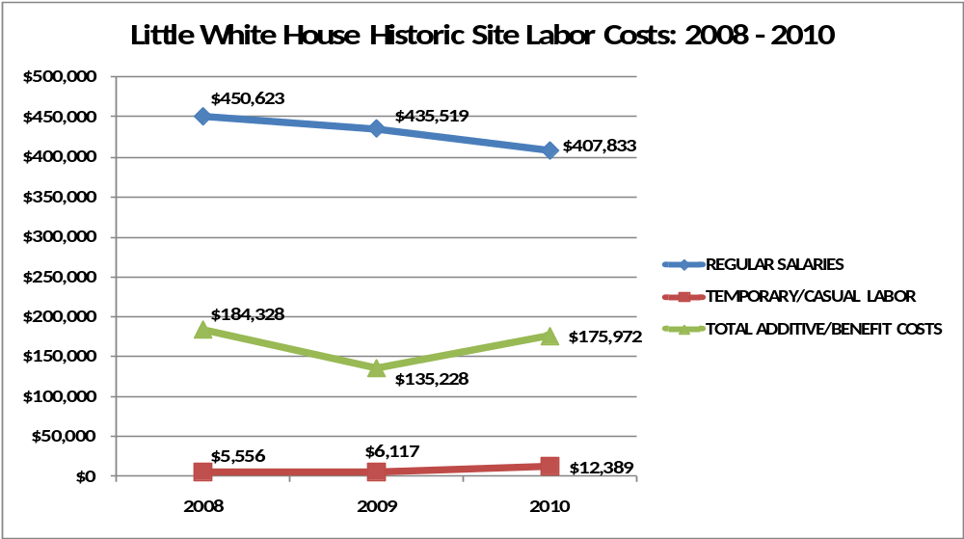

Visitation and Occupancy
Each site must summarize visitation and occupancy for at least the last three years. Occupancy will only apply to sites with overnight facilities. The tables and graphs are available in the toolkit supplement to this manual; the data needed will be forwarded separately to site managers by Division staff. Below is an example from Hard Labor Creek of how this information should be included.
Annual visitation to the park has increased by approximately 15%, or 50,000 visitors from 2007 to 2010, with a 31% decrease (137,000) from 2008 to 2009, and a 27% increase (80,000) from 2009 to 2010.
- 2007 – 329,684
- 2008 – 437,252
- 2009 – 299,768
- 2010 – 379,542

Occupancy for the overnight accommodations at Hard Labor Creek State Park has remained somewhat flat over the last three years. The table below details occupancy for cottages and the campground from 2007 to 2010.
Year | Cottage Occupancy | Campground Occupancy
2007 | 45% | 36%
2008 | 46% | 35%
2009 | 42% | 35%
2010 | 38% | 41%

The graph below illustrates visitation and occupancy over the last three years.
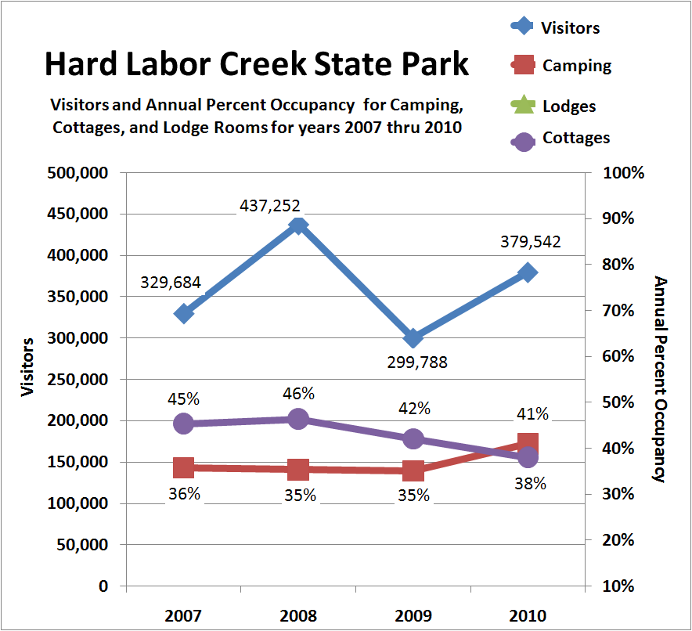

Customer Service and Satisfaction
Currently the system monitors customer service at each site through paper, hard copy customer comment cards. These cards are not collected in a statistically valid method, are often only reviewed to identify areas of customer service concerns or issues, and are not consistently used for managing customer service performance issues overall at the sites. The sites, however, are generally well known for a high level of customer satisfaction, with the heavy majority of customers responding that their expectations were either ‘satisfied’ or ‘very satisfied.’
Site specific business plans should include a summary of customer service / satisfaction ratings from at least the last three years if available. An example from Hard Labor Creek is provided below. This table is available in the toolkit supplement of this manual; the database of customer satisfaction ratings will be forwarded separately to site managers by Division staff.

Site | Year | Customer Satisfaction Level
Hard Labor Creek State Park | 2009 | 81%
Hard Labor Creek State Park | 2010 | 75%
The Creek Golf Course | 2009 | 100%
The Creek Golf Course | 2010 | No Cards Collected

Financial Performance Assessment
The financial performance assessment should include the following:
- Operational expenses for the last three fiscal years
- Earned revenues for the last three fiscal years
- Cost recovery ratio for the last three fiscal years
- Review of pricing

Operational Expenses
Data and tables for summarizing operational expenses at each site are available from the site’s Form-14.
A summary of total operating expenses from 2008 to 2010, as well as their percent change from 2008 are provided in the table below and the graph on the following page.

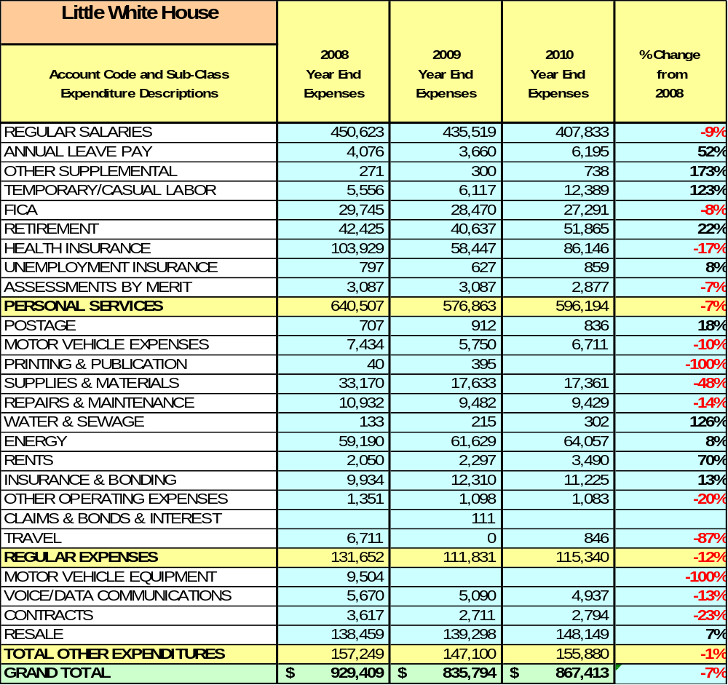

Earned Revenues
Data for summarizing earned revenues at each site are available from the site’s Form-14; the required tables are available in the toolkit supplement to this manual. An example from the Little White House of the required narrative descriptions, tables, and graphs are provided below.
Earned revenues at Little White House State Historic Site have decreased since 2008, which is largely attributed to the corresponding decrease in overall visitation.
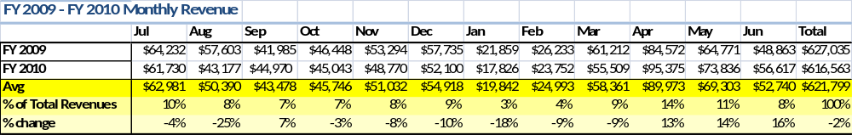
Monthly earned revenues for the last two years (see table below) indicate that the total annual revenue decreased 2% from 2009 to 2010, with the largest decreases in monthly revenues during the months of August (25%), December (10%), and January (18%), and the largest increases in revenues during the months of September (7%), April (13%), May (14%), and June (16%). The months of increased revenue were not sufficient to account for lost revenues in the remaining months.

The graphs below illustrate the monthly revenue trends each year and the average percent of total annual revenue earned each month.
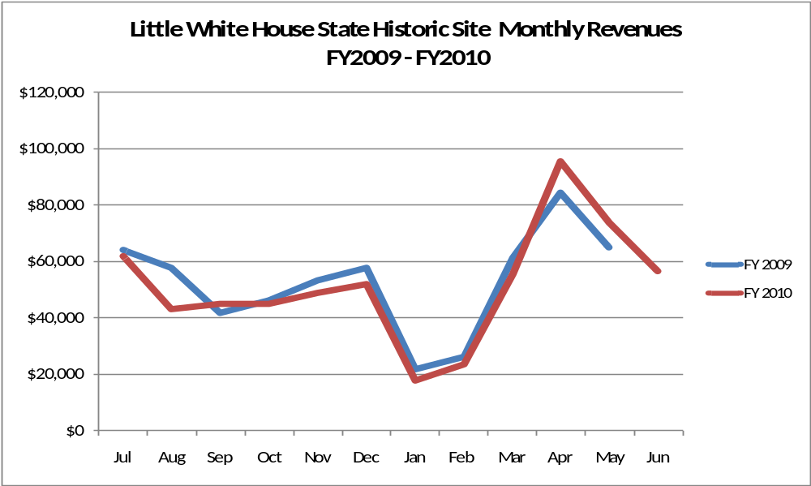

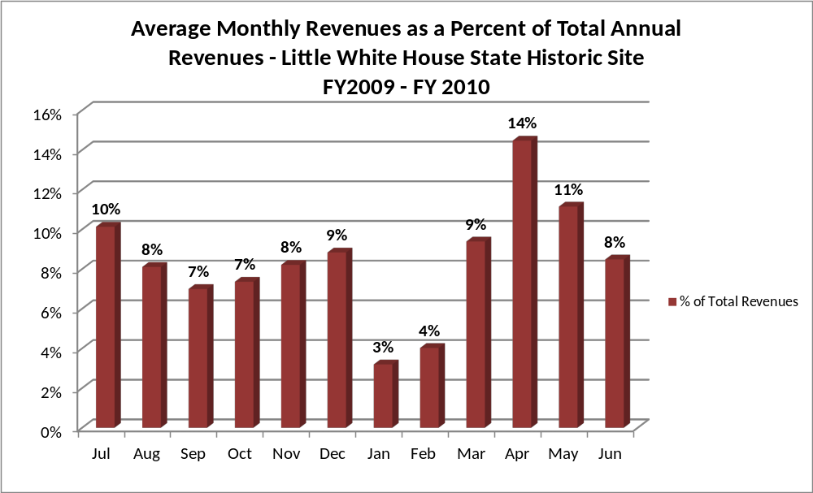

Cost Recovery Trends
Each site should summarize cost recovery trends for the last three years as indicated in the example below. Tables and graphs are available in the toolkit supplement or in the Business Plan Template.
Little White House State Historic Site consistently achieves 71-75% cost recovery of annual operational expenses through earned revenues. This is detailed and illustrated in the table and graph below.
Year | Operational  Expenses | Earned  Revenues | Percent Cost  Recovery
2008 | $926,321 | $667,489 | 72%
2009 | $835,794 | $628,809 | 75%
2010 | $867,413 | $618,705 | 71%
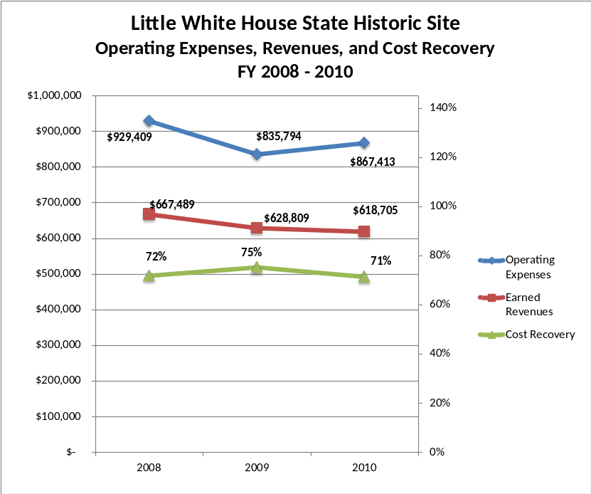

Review of Pricing
Each site should provide a summary of pricing for services and facilities for at least the last five years. This table is available in the toolkit supplement of this manual; the database of historical rates will be forwarded separately to site managers by Division staff.
Data on rate information for site admission fees is available as far back as 2002, but only the last five years are evaluated. There has been notable flexibility and growth in fees charged at Little White House State Historic Site since 2005, with the largest increase being in the admission fees for youth groups (100%), youth (67%), and seniors (40%). A table detailing the admission fees for Little White House State Historic Site is provided below.
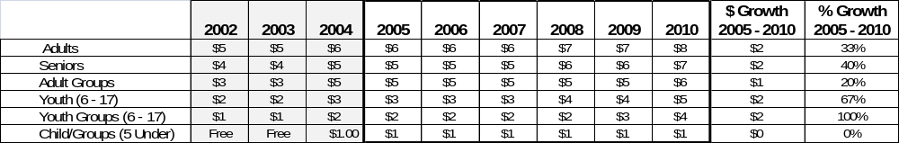

Developing a Business and Management Plan
As linked to the goals and objectives of the Division’s Direction 2015 sustainability initiative, the Business and Management Plan for each site is the culmination of multiple assessments and analyses, and reflects best practices and proven innovations in the state parks industry. While not all of the components listed below will be featured in each site business plan, the business planning process should include a review of the following:
- The goals and objectives for the D15 initiative based on the Division’s 2004 Strategic Plan
- An assessments of operations, site and facility conditions, and financial performance over the last three years
- An analysis of the site’s service market based on standard parameters (drive-time from the site) and prevailing point of origin based on ZIP code data from day / overnight visitors
- An analysis of similar service providers within the primary drive market of the site

Summary of Business Goals
As a component of the D15 initiative, PRHSD has developed a set of business goals for the entire system that can be applied at the site level. Each site must describe how these goals can be attained and implemented locally to have relevance to the site-specific business plans. The following examples from Little White House feature the system-wide business goals and illustrate how they are applied locally.
The following goals serve as the foundation for the key recommendations and strategies in the Little White House business plan.

Enhance Cost Recovery of Site Operations
The Little White House State Historic Site is operating at a 71-75% cost recovery of operational expenses through earned revenues. Historic sites generally have a more difficult time sustaining high cost recovery levels because of traditionally lower visitation and expensive resource management requirements. Little White House plans to improve cost recovery of site operations through controlling operational expenses specifically in labor costs, and by improving revenues through additional special events and amenities to draw more visitors to the site. It is critical that the site seek to increase its cost to no less than 85% through enhanced revenue generation and strategic expense reductions.

Enhance Revenue Generation Strategies
Increasing earned revenues will most likely result from the impacts of both increased visitation at the site and specific revenue enhancement strategies. Little White House will improve revenue generation through more flexible and dynamic admission fees, expanding retail sales to include on-line sales, increasing the number and type of special events held at the site and the fees charged for the events, and by overall fee increases for programs and facility usage.

Expand Special Events at the Site
Most, if not all, of the major programs and events at the site are directly linked to the unique history of the site. This is commendable and important, but should not be the sole criteria for delivering great programming at the Little White House State Historic Site. The expansion of facilities and amenities to include an events or program area near the museum is important in order to support the development of successful, large-scale events that can be held at the site to dramatically increase overall visitation and revenue generation. These events can include, but not be limited to, art and music festivals, wine festivals, local culinary festivals, weddings and receptions.

Improve the Diversity and Innovation of Recreational and Interpretive Programs
As with many historic sites, the Little White House features quality exhibits and displays that are predominantly appealing to adults. It will be crucial for the site to improve the appeal of all interpretative resources (e.g., displays, exhibits, and programs) to a wider range of age groups. For example, consideration should be given to developing exhibits that are tactile and experiential in order to best connect with younger audiences. Additionally, consideration should be given to providing more innovative exhibits including traveling displays on loan from other museums in order to encourage repeat visitation.

Improve the Effectiveness of Marketing and Sales
The effectiveness of marketing and promotional activities of the Little White House State Historic Site could be improved to produce greater visitation and revenues during peak, shoulder, and off seasons. This could be achieved in part through a shift in the existing marketing approach to one that is more targeted and focused on experiential and inspirational messaging geared to historic sites. Additionally, partnerships with nearby attractions and amenities in the region should improve the ability of the site to maintain an increased and steady flow of visitors and revenue throughout the year.

Establish Greater Consistency of Managing and Monitoring Customer Service & Satisfaction
Little White House plans to improve the consistency of managing and monitoring customer service and satisfaction by conducting on-site surveys annually to assess how well customer satisfaction levels are being met. LWH will strive to have 90% of visitors responding to ‘Comment Cards’ report that they were either ‘satisfied’ or ‘very satisfied’ (or some comparable metric to be developed). Programs or services that fall below that standard should be critically reviewed, enhanced, and results monitored; those with a history of poor performance will be evaluated and potentially considered for elimination.

Expand Partnership Opportunities
Given the breadth of partnership opportunities available to LWH, multiple priorities will drive partnership opportunities for the site. This will include expanding service partnerships in which alternative and related providers in the community support the provision of programs and services to visitors at Little White House State Historic Site; expanding vendor partners to reduce the costs of materials and supplies, and related services needed by the site; and seeking co-branding partners to off-set event and program costs, and to expand awareness of site programs and facilities in the site’s market area.

Classification of Programs and Services
Each site will have inventoried and classified all programs and services in the assessment phase of developing the business plan. Program and service classification is important as financial performance (cost recovery) goals are established for each category of services that are linked to the recommendations and strategies of a site’s business plan. These classifications should be sorted to correspond with cost recovery expectations defined for each category. In this section of its business plan, each site will assign specific cost recovery targets for each program or service that align with these expectations. The example below for Hard Labor Creek illustrates this process; the table to be used by each site is provided in the Business Plan Template.
Core Services
Program / Service | Target Cost Recovery
Protect the integrity of natural and cultural resources of the site through active management (i.e. CCC structures) | 0% cost recovery
Open and public access to the site and its resources | 50% cost recovery
Self-directed and site appropriate education, interpretation, and recreationa opportunities | 5 - 10% cost recovery
Public safety | 0% cost recovery
Site, grounds, facility, and infrastructure maintenance | 0% cost recovery

Important Services
Program / Service | Target Cost Recovery
Lake activities / beach area | 20 - 50% cost recovery
Picnicking / day use | 20% - 50% cost recovery
Nature trails | 0 - 20% cost recovery
Interpretive / recreation programs and events | 30% - 50% cost recovery

Visitor Supported
Program / Service | Target Cost Recovery
Equestrian activities | 80% - 100% cost recovery
RV camping | 100% - 120% cost recovery
Improved accommodations (cottages, yurts, etc.) | 100% - 150% cost recovery
Golf | 100% - 150% cost recovery
Visitor center / retail | 120% - 150% cost recovery
Tent camping | 80% - 100% cost recovery
Group shelters | 100% - 120% cost recovery
Group camping | 50% - 80% cost recovery

Partnership Development Plan
These recommendations are an overview of existing partnership opportunities available to the PRHSD, as well as a suggested approach to organizing partnership pursuits. This is not an exhaustive list of all potential partnerships that can be developed, but can be used as a reference for each site to identify priorities for partnership development.
The following five classifications of partners are recommended for each site:
- Operational Partners – Partners that help to maintain facilities and assets, promote amenities and site usage, support site needs, provide programs and events, and/or maintain the integrity of natural/cultural resources through labor, equipment, or materials.
- Vendor Partners – Service providers and/or contractors that can gain brand association and notoriety as a preferred vendor or supporter in exchange for reduced rates, services, or some other agreed upon benefit.
- Service Partners – Non-profit organizations and/or friends groups that support efforts to provide programs and events, advocacy and education, and/or collaboratively serve specific constituents in the community.
- Co-branding Partners – Private organizations that can gain brand association and notoriety as a supporter in exchange for sponsorship or co-branded programs, events, marketing and promotional campaigns, and/or advertising opportunities.
- Fund Development Partner – Private, non-profit organizations with the primary purpose to leverage private sector resources, grants, other public funding opportunities, and resources from individuals and groups within the community to support site goals and objectives for mutually agreed strategic initiatives.
Each site must complete the table below to identify specific partners and partnership targets within each of these classifications. The table below is populated with examples from Little White House State Historic Site; the table to be used by each site is provided in the Business Plan Template.

 | Public Partners | Not-for-profit Partners | Private / Enterprise Partners
Operational Partners | - Roosevelt Institute For Rehabilitation | - The Wilderness Camp  - Good Sheppard Therapeutic Camp | - AT&T Pioneers Southside Council of Atlanta
Vendor Partners |  |  | - Coca Cola  - Georgia Power  - Georgia EMC’s  - Georgia Poultry Federation
Service Partners | - City of Warm Springs | - Chamber of Commerce  - March of Dimes
Co-branding Partners | - FDR State Park  - Roosevelt Institute for Rehabilitation |  | - The Bullock House  - Callaway Gardens  - Best Western  - Hills and Dales  - Wild Animal Safari
Funding Resource Development Partner |  | - Friends of Georgia State Parks and Historic Sites  - Friends of Roosevelt’s Little White House  - Warm Springs Memorial Commission

Marketing and Sales Plan
For each site in the system, the goal of marketing and sales are:
- To increase visitation and usage of key revenue generating facilities
- To generate more revenue from overnight accommodations, group rental facilities, recreation services, programs, special events, private events, retail sales, etc.
- To produce more participation in large, signature events and programs
Monthly, quarterly, and annual goals for each of these areas should be identified, tracked and evaluated over time. All marketing and promotional efforts must be monitored through sales goals for each site – marketing without sales is just an awareness campaign that has little or no effect on the financial performance of the site.

Market Positioning and Messaging
A critical component of marketing efforts is to hone the ‘right’ messages to the right target markets in order to inspire and motivate purchasing behavior. The five step process for developing strong messages are outlined below:
- Identify the target market
In the case of PRHSD, there are multiple target markets. The matrix below identifies the different target markets served by a site, the benefits that should appeal to each, and the messaging that will help to communicate the benefits.
- Identify the needs of the target market segments
Each market segment to be targeted has unique needs. Appealing to those needs will help to make each site a local or regional service provider of choice. Messages should not only address these needs, but also imply easy solutions to any constraints the targeted customers may have pursuing state park and historic site experiences.
- Present the solution to the target market needs
Focus on selling benefits and experiences and not features and amenities. Communicating experiences is much more compelling that selling specific services and programs.
- Present the results you have delivered
One of the more powerful ways to motivate customers to visit or purchase is by demonstrating how people just like them have had wonderful, meaningful, and unique experiences at the site.
- Explain the points of difference
There are many recreational, cultural and educational alternatives for our target markets and customers. Explaining the unique aspects of the site experience that cannot be gained anywhere else is important.
Examples of sample messages for specific target markets are provided in the matrix below.
Target  Market | Benefit(s) | Message
Families | - High value, low cost experiences  - Wholesome family time  - Back to nature | “Tree forts, magic kingdoms, and wilderness exploring…let your kids walk a mile in the shoes of your childhood with a great outdoor experience at Georgia State Parks and Historic Sites. Family packages start at $XX.XX for a weekend full of activities and family fun.”
Businesses or  associations | - Conference services  - Lower cost than other venues  - Unparalleled ambiance | “Conferences and meetings at Georgia State Parks and Historic Sites feature ample meeting space, meals and lodging, event planning, and technology support included at a better value than traditional venues. Nature and outdoors are complimentary.”
Adventure  recreationalists | - High quality venues  - Multiple sports  - Support amenities | “Take a load off after cruising some of the nation’s finest mountain biking terrain, and shed the gear following a run on renowned whitewater. It doesn’t matter if you are a beginner or expert, Georgia State Parks and Historic Sites are the adventure destination of choice.”

Marketing and Sales Goals
One of the cornerstones of successful marketing and sales is the acceptance that strong, productive efforts are based on making more contacts than just the target goal. Generally, successful sales tactics will produce somewhere between a 1% and 5% conversion rate, which is the rate of converting an initial contact to a customer Hypothetically, if 5% is what Georgia State Parks sales and marketing efforts perform at and 1,000 additional customers is the goal, then 20,000 contacts or impressions must be made to yield 1,000 sales conversions. It is critical that sales and marketing staff have a good understanding of their performance and conversion rate, and take that into account when planning sales and marketing efforts.
Each site should establish marketing and sales goals that are realistic, yet ambitious to support the financial objectives outlined in the site business plan. An example for Hard Labor Creek is provided below. All tables are available in the toolkit supplement to this manual.
Sales goals for Hard Labor Creek State Park have been established based on the following desired outcomes:
- To produce more sales of overnight stays in cottages and the campground
- To produce more usage of reservable amenities (shelters, etc.)
- To produce more rounds of play at The Creek Golf Course
- To produce more participation in large, signature events and programs
- To produce improved performance of concessionaires on-site

In order to meet these criteria and outcomes, specific goals were identified in the areas of cottage occupancy, campground occupancy, golf course rounds, and program participation. These goals are detailed in the table below as an example from Hard Labor Creek State Park; the table to be used by each site is provided in the Business Plan Template.

Area of Focus | Current Performance | Goal by 2011 | Goal by 2012 | Goal by 2015
Cottage occupancy | 38% | 40% | 41% | 44%
Campground occupancy | 41% | 43% | 44% | 47%
Golf rounds | 15,426 | 17,000 | 12,000* | 24,000
Program participation | 1,800 | 1,900 | 2,000 | 2,300
* Decrease projected during clubhouse renovation

These goals can be achieved by using a balanced approach of multiple marketing strategies such as those recommended in the section that follows.

Marketing and Promotions Strategies

Publicity and Social Media
Publicity and social media are typically the least expensive and most effective forms of marketing for public park and recreation agencies. The challenge of great publicity that effectively produces results by motivating target markets is that it requires careful advance planning, constant monitoring, establishing meaningful relationships with media representatives and online customers, and strategic timing. It often takes much advance planning and many months to properly execute a publicity or social media campaign so that the timing of the campaign is aligned with the marketing season of specific programs, services, or opportunities that the agency is promoting. Each site, as well as the system as a whole, should approach marketing planning using the following guidelines and themes described below:
- Event publicity
Major events benefit by having short stories in local, regional, and statewide newspapers and online social media hooks planted that run three to four weeks in advance of the event and up to the date of the event itself. Stories and media need to be cultivated with contacts and online sales channels several weeks in advance of the time the stories need to run. Special interest interviews on morning, noon, and evening television news programs, radio interviews on popular rush-hour programs, and blogs on known affinity online sites should also be included.
- Program publicity
Special and unique programs should have feature stories in magazines, local and regional weekly newspapers, and statewide daily newspapers that are aimed at placements as front-page or sectional front-page stories. These stories are most effective if they run shortly before the season that the featured program begins. This will likely require several weeks of advanced planning with media contacts. Similar coverage on television and radio should also be considered. If pre-publicity cannot be generated, post-publicity can help promote future programs.
- Site Publicity
Site publicity focusing on a single site or sub-set of sites requires more intense planning efforts to attract multiple writers and editors from target publications. Each site could host several seasonal media familiarization tours (with 10 to 15 writers or editors) to familiarize them with the site and its benefits and amenities. Stories and features resulting from such tours typically take between two and six months to materialize so the tours should focus on experiences, benefits, and programs that would be available when the stories are expected to run.
In order to produce consistent and recurring publicity for state parks and historic sites and their programs, staff must understand and appreciate the benefits derived from publicity and actively plan programs, events, and experiences that are publicity worthy. A strategic approach to how programs are planned and developed, media contacts made, and publicity sought will help the division avoid “saturating the press” with ideas and requests that eventually may turn off the media you depend upon to create the publicity you seek.
Site managers must develop examples of publicity ideas based on the themes described above. These examples should be organized into the tables as shown below from Little White House and Hard Labor Creek; the tables to be used by each site are provided in the Business Plan Template.
Little White House State Historic Site
Event Publicity | Program Publicity | Site Publicity
Wine Festival | Artifact Day | FDR Remembered
Arts and Music Festival | Backyard Birding | WWII Commemorations
Swim the Warm Springs | Junior Ranger Camp | Cultural Crossroads Tour
Regional Culinary Festival | Georgia Outdoor Kids

Hard Labor Creek State Park
Event Publicity | Program Publicity | Site Publicity
Adventure Sport Triathlon | Leaf Watch | Family Lake Getaways
Golf Tournament Series | Georgia Outdoor Family | Remote and Rugged – Northern Georgia State Parks
Holiday Events | Hard Labor’s Pack and Paddle for the Cure | Crossroads of the Civil War – Georgia History Trail
Trail Rides | Georgia Outdoor Kids | Georgia Golf Trail

Packaging
The modern consumer is often motivated by the convenience of having “packaged” experiences that combine multiple aspects or dimensions of desired experiences. For example, packaging lodging/accommodations with certain programs can create a themed experience that will appeal to specific target market segments. Packaging does not always require price discounting, but can include some pricing incentives or value added features that help the “sell-ability” of the package; also packages should not discount prices disproportionately between sites, causing one to lose revenues while another gains revenues.
Another important element of packaging is that it doesn’t always have to involve only services or amenities at the site. Some of the most powerful packaging efforts are those that combine services or amenities at the site with those from complementary services offered by another provider nearby. For example, a package that provides a two-night stay at a local hotel, combined with a dinner for two at a popular restaurant in a nearby town, and a guided tour of the museum, actually engages the market positioning and promotional resources of other local businesses near the state historic site.
Site managers must develop sample packages for their site. These should be organized into tables as shown below in examples from Little White House and Hard Labor Creek. The tables to be used by each site are provided in the Business Plan Template.
Little White House State Historic Site
Suggested Package | Package Details
FDR Trail | Entrance into Little White House State Historic Site and FDR State Park
Tour and Gifts | Guided tour and discount in gift shop
Season of Fun Passbook | Voucher book of 10 day entries into the site

Hard Labor Creek State Park
Suggested Package | Package Details
Tee’s and Zzz’s | 2-night cottage stay and golf round for two
Sportsman’s Delight | 2 nights camping and fishing boat rental
Wonders of Wildlife | 2 nights camping at Hard Labor Creek State Park and entrance to Charlie Elliott Wildlife Center
Season of Fun Passbook | Voucher book of 10 nights of camping at Hard Labor Creek State Park

Group Sales
There is no science to group sales, just tedious attention to detail and follow-through. Successful group sales strategies are based on a ‘numbers game.’ As discussed previously, if the prevailing sales conversion rate is 5% and the park needs 1,000 more visitors from organized groups, then 20,000 potential visitors will need to be contacted with a sales message in order to produce the desired outcomes. The key to group sales is to organize a campaign around specific sales and marketing goals. The sequence of effective group sales is provided in the 10 steps listed below:
- Plan and develop the intended service or experience you plan to sell
- Identify the types of groups that the service or experience would appeal to and who are likely to purchase
- Identify specific target groups within those categories, including an estimation of how many individuals may be within each of those targeted groups. Ensure that the number participants in the targeted groups is high enough to account for the typical conversion rate and still reach the target sales goal
- Establish a protocol for making contacts and pursuing sales
- Establish a schedule and assigned responsibilities for making contacts
- Monitor sales success routinely during the campaign
- Reward sales efforts that are noticeably effective and above expectations
- Adjust sales techniques as needed throughout the campaign to improve the conversion rate
- Maintain consistent contact with converted sales leading up to (and even after) their experience or program to ensure that they were satisfied and motivated to return in the future
Site managers must identify specific target customers for group sales initiatives. Below are examples from Little White House State Historic Site; space to be used by each site is provided in the Business Plan Template.
- Families  - Youth service organizations  - Churches  - Activity or special interest clubs | - Businesses and professional groups  - Schools (public and private)  - Colleges and universities  - Associations | - Other public agencies  - Women’s groups  - Community organizations

Incentivizing New and Repeat Visitation
One way to build brand-loyalty is by providing incentives for new and repeat visitors. Each site should be running at least one incentive at all times during the year, and in some cases multiple incentives to encourage stronger purchasing behavior from the target markets. Incentives can include, but not be limited to:
- Early registration discounts
- Group / bulk pricing options
- Differential pricing based upon days of week, peak or off-peak seasons, etc.
- Post peak season follow-up with visitors
- Loyalty programs such as site ‘bucks’ or ‘miles’ earned based on dollars spent that can be redeemed for future visits or purchases at the site
- Co-branding partner benefits (e.g., members of affinity museums get discounts for certain services during specified times or redeem six Coca-Cola cans for a free souvenir from the gift shop).
Site managers must develop a list of strategies and/or incentives that can encourage new and repeat visitors. These can be taken from the examples above and/or customized to each site, and must be listed in the site’s business plan in the space provided in the Business Plan Template.

Marketing and Sales Metric Goals
Measuring the success of marketing and sales can include metrics obtained through customer surveys.
- Loyalty & Repeat Customers: The proportion of repeat customers is a measure of increased brand loyalty. Currently, the Division doesn’t appear to have easy but effective ways to measure repeat business. Metric Goal = % of repeat customers within a 12 month period
- Brand Confidence & Customers-Recruiting-Customers: Increased brand confidence is demonstrated whenever customers help to recruit other customers through exceptional reviews (especially in social media) or word-of-mouth referrals. Metric Goal = “Where/how did you hear about us” responses
Each site manager must develop a metric goal for these measures in the space provided in the Business Plan Template. This may involve developing methods for capturing this data efficiently.

Revenue Generation Plan
Building creative and stronger revenue generating functions into the system is the most productive strategy for improving the operational and financial sustainability of PRHSD. Operational sustainability is a blend of controlling costs and increasing revenues, and not just an exercise in expense reduction. Increasing revenues across the system requires:
- Understanding the characteristics, constraints, and opportunities of markets served by each site
- Classifying and prioritizing services, programs and functions
- Setting appropriate performance standards for each revenue generating service/function
- Monitoring performance regularly
- Being flexible and making adjustments to types and levels of services and pricing
Most importantly, staff at each site must accept and understand that “Important Services“ and “Visitor Supported Services” are expected to produce revenue that partially or wholly support the costs of providing that service, experience or amenity. The failure to produce targeted revenues must result in adjustments that can include, but not be limited to: 1) refinement of the service, 2) termination of the service, 3) reduction in staff, or 4) other operational changes to ultimately reduce the financial investment of the system.
The revenue generation section of each business plan must summarize the revenue goals and recommended strategies for the site. These recommendations must be taken into context with the overall expectations for improved performance of the site as a whole, as well as the entire state parks and historic sites system.

Revenue / Cost Recovery Goals
Each site must develop revenue / cost recovery goals that can be achieved through clearly identified and actionable strategies, and are aligned with the financial targets described and detailed in the Financial Targets Table provided in the Executive Summary. An example from Little White House is provided below. All tables are available in the toolkit supplement to this manual.
Little White House State Historic Site has set a financial goal of increasing annual revenues 3% annually between 2012 and 2015. The largest revenue growth opportunity is most likely in the shoulder season months of March, May, August, September, and October. In these months, revenues are not at their lowest or highest point of the year, and have the potential to grow. The table below details projected revenue growth leading up to 2015, based upon a nominal growth of revenues each year.
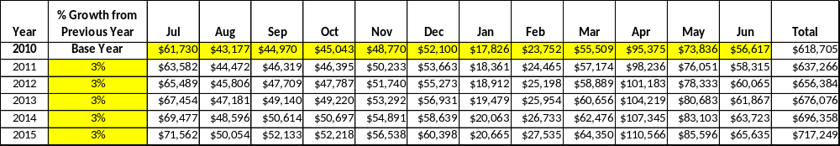

These projections would result in a total of 16% cumulative growth in total annual revenues between FY2010 and FY2015. If operational expenses can be managed with a cumulative reduction of 3% between FY 2010 and FY 2015, then the overall cost recovery of the site will be approximately 85% in FY 2015 at these projected revenue levels. This is significantly higher than the annual financial performance of the site in FY 2010, which was operated at 71% cost recovery in that year.

Revenue Generation Strategies
General strategies are provided below for pricing, programming and special events, and partnerships and concessions that can help each site improve their revenue generation efforts. Each site should review these strategies and adapt them so that they are appropriate for their unique circumstances. Region managers should review and approve all revenue generation strategies for individual sites.
Increasing earned revenues at state parks and historic sites will most likely result from increased visitation at the site that generates increased revenue from admission fees, usage of key revenue generating facilities (especially reservable facilities), retail sales, up-selling services, special events, and fee increases. Specific tactics for improving revenue at PRHSD sites are identified below.

Pricing
- Establish and routinely monitor progressive pricing and fees that are based on the cost of providing services. Pricing policies and practices are central to producing more revenue at each site.
- Develop a cost of service assessment for each amenity, program and service at the site to determine its level of tax funding or revenue contribution.
- Develop a pricing policy that distinguishes between core and non-core (important or visitor supported) services and is based on the perceived value and benefit to customers.
- Price services based on received benefits, level of exclusivity, prime time and non-prime time, season or off-season basis, site’s competitive market set, and guest length of stay.
- Train staff and volunteers on how pricing works and how to communicate prices to users.
- Create a tiered pricing structure that encourages early reservations, off-peak usage and diverse user groups, and supports the cost recovery goals of the site / system. Specific pricing methods should include:
  - Primetime/non-primetime (weekday vs. weekend or time of day/week)
  - Peak season/off season
  - Group discounts
  - Family / household discounts
  - Price by location (within a site or within the state)
  - Price by competition (within the site’s competitive market set)
  - Price by volume (reward quantity purchases)
  - Price to support loyalty (reward repeat purchases)
  - Price based on the level of benefits received (from customer’s perspective)
  - Price based on the level of exclusivity (perception of unique offerings)
  - Price by age segment (seniors, juniors, etc.
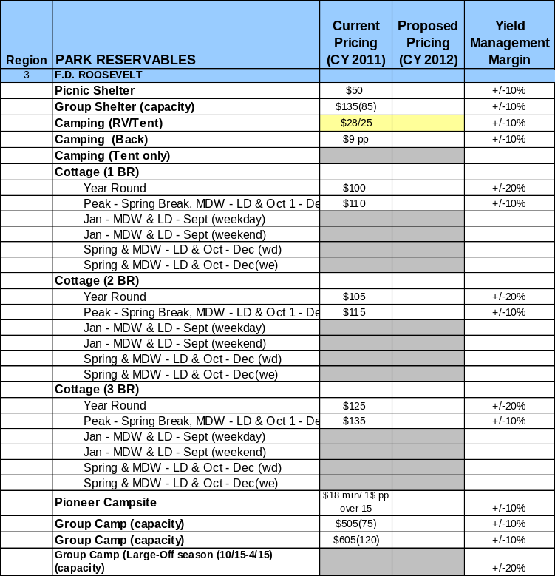
Each site must develop an updated pricing plan that is included in its business plan. The table provided to the right is a sample format from F.D. Roosevelt State Park that is available in the toolkit supplement to this manual. All plans must provide CY 2011 current pricing and CY 2012 proposed prices, as well as the maximum percent variability (+/-) of pricing authorized for site managers and staff to utilize for yield management. The database for this table will be forwarded separately to each site manager by Division staff.

Innovative Programming and Special Events
Innovative program offerings can dramatically improve the energy of sites and the quality of visitor experiences. Programs should be developed that enable each site to provide a balance of subsidized programs and services with those that generate 120% of their costs or more. The following program recommendations should be considered at each site:
- Establish criteria for evaluating whether programs are core programs and services, important, or visitor supported, based on linkage to the mission and objectives of the site.
- Develop and implement program standards that apply to core programs and services including health and wellness, outdoor recreation, and natural and cultural resource interpretation. Program standards can include:
  - Theme / purpose
  - Participation
  - Frequency
  - State educational curriculum requirements (if applicable)
  - Length
  - Revenue generation
  - Cost recovery

- Maintain a year-round calendar of programs a minimum of six months in advance of scheduled program/event dates in order to facilitate promotion of the programs. This calendar should include needed staff and volunteer resources and any required enhancements of facilities needed to support programs and special events.
- Develop and maintain a youth services program partnership plan with youth service organizations throughout the region. PRHSD should maintain consistent state-wide relationships with youth service organizations like Boy Scouts of America, Girl Scouts of America, and Camp Fire USA as host sites and services for events and merit advancement programs.
- Develop and maintain an active program plan for adults between the age of 55 and 85.
- Develop and maintain programs for people with disabilities and special needs.
- Increase programs targeting families that encourage and allow them to participate together.
- Develop a diverse blend of special events that engages the local community and draws tourists to each site for single and multi-day uses.
- Develop programs that represent a tiered level of service with varied and appropriate pricing.
- Reinvigorate the marketing and communications for programs.
Each site must develop a program plan in their business plan. The program plan must include the elements detailed in the headings in the table below, which is available in the Business Plan Template.
Program / Event | Theme / Purpose | Scheduled Date/Season | Frequency | Target Participation | Target User Fee | Target Cost Recovery
Owl Prowl Interpretive Hike | Nature and wildlife appreciation | Saturdays, 8-10 pm, April, Oct | Once a week, 8 weeks | 12+ | $8 | 85%+
Tax Day Golf Tournament | Recreation | April 15 | Annual | 150+ | $50 | 150%+
Mom and Me Weekend | Family recreation / Girl Scouts | May 15 October 15 | Semi-annual | 75+ | $30 | $100%+
Wine and Food Festival | Community Event | September 15 | Annual | 3,000+ | $10 | 200%+
Father and Son Hike and Bike | Family recreation / Boy Scouts | November 1 | Annual | 250+ | $20 | 100%+
Family Camping 101 | Family recreation | March, April, Sept., Nov. | Quarterly | 50+ | $10 | 50%+

Partnerships and Concessions
Partnerships and concessionaires should be utilized to expand program and service offerings, provide value added services or experiences beyond the capability or capacity of site staff or volunteer resources, increase revenue opportunities, and improve operational efficiencies throughout the system.
Each site must identify the partnerships and concessions planned to support operations. An example table is provided below, which is available in the Business Plan Template.
Service / Partnership | Term of Service | Financial Objective | Contract Manager
Food and coffee concessions | 1 year | 15% of gross receipts to park | Park manager
Event planning and promotion | 2 years | 15% of gross receipts | Regional manager
Landscaping | 2 years | Reduced personnel costs | Park manager
Waste collection | 1 year | No cost increase from previous year | Park manager
Packaging and promotions with local businesses | 1 year | Shared revenue | Regional manager

Expense Management Plan
Among the most common strategies for improving cost recovery is control and management of operational expenses. Often operational expenses of state park systems have evolved to a level that is unsustainable given current financial circumstances, and PRHSD is subject to this possibility as well. Where operational expenses generally can be reduced without suffering loss of revenue potential or asset quality are in the areas of modifying the level of service provided and staffing expectations of each site.
The following key strategies should be the foundation of the expense management approach for PRHSD:
- Assigning appropriate personnel to tasks
- Applying alternative management techniques to services and facilities
- Reducing levels of service while preserving the quality of visitor experiences

Personnel Assignments
Ensuring that the appropriate personnel are assigned to each task while managing individual sites and the entire PRHSD system can be a complex issue, especially during times when large staffing reductions have already occurred as a result of recent financial circumstances. For example, it is common to hear of site managers who are performing the duties for eliminated positions that are more appropriate to be performed by personnel at a lower pay scale. Resolving this issue requires a combination of coaching site managers on alternatives for producing outcomes at their sites, and accepting a lower level of service as an appropriate result of having less staff to perform duties. One of the greatest areas of financial waste in the public sector is a dedication to performing tasks (effort-based culture) or producing outcomes based on a traditional way of doing things, and not accepting that alternative methods can lead to the same outcome with less effort or expense (outcome-based culture).

Management Techniques
There are numerous alternatives to operating and managing state parks and historic sites in the traditional manner. These include, but are not limited to:
- Reduced operating seasons
- Reduced weekly operating schedules
- Contracted or concession-based operations
- Alternative personnel / staffing options
  - Part-time or seasonal employees
  - Contract or temporary employees
  - Volunteers

Adjusted Levels of Service
The third key strategy for managing operational expenses is through selective and strategic adjustment of service levels. In some ways this is linked to alternative management techniques when it includes reducing the hours, days, or seasons of site operations. In other ways, it is complementary to alternative management techniques in that it addresses “doing less with less” instead of trying to “do the same with less.” The following examples are opportunities for reduced levels of service that can be considered at each site:
- Reduced mowing and landscaping schedules / standards for sites
- Reduced cleaning or maintenance schedules / standards for facilities
- Reduced staffing requirements for sites
- Reduced facilitated (versus self-directed) programs and events at sites
Each site must develop an expense management plan that addresses each of these three key strategies, and details specific tactics unique to that site that will be employed to further manage or reduce operating expenses. It is critical for sites to manage or reduce expenses that do not negatively impact the revenue generation and cost recovery potential of the site, reduce customer satisfaction, or sacrifice the long-term integrity of assets and amenities. The examples below are taken from Little White House; the tables used are available in the Business Plan Template.
Personnel Assignments
The following actions will be taken to proactively manage labor costs via personnel assignments and classifications.
Action | Timeline | Outcome
Eliminate current Exhibit Guide vacancies | July 2012 | Annual labor cost reduction of $XXX,XXX
Convert full-time Exhibit Guides to part-time employees, volunteers or contract labor | January 2012 | Annual labor cost reduction of $XXX,XXX

Management Techniques
The following actions will be taken to proactively manage labor costs via management techniques.
Action | Timeline | Outcome
Concession coffee service | July 2012 | Annual revenue increase of $XXX,XXX
Contracted event promotion and coordination | July 2012 | Annual revenue increase of $XXX,XXX
Increased use of volunteers for site and grounds maintenance | July 2012 | Annual cost reduction of $XXX,XXX

Adjusted Levels of Service
The following actions will be taken to proactively manage labor costs via reduced levels of service.
Action | Timeline | Outcome
Adjusted mowing and landscaping schedules for portions of the site | July 2012 | Annual cost reduction of $XXX,XXX
Financial Pro Forma
Each site manager must develop five year financial pro forma to project operating expenses, earned revenues and total/cost recovery through FY 2015. The pro forma should be based on the strategies and desired outcomes identified in the site’s business plan, especially the revenue generation and expense management plans, and linked to corresponding performance goals.
The examples below are taken from the Little White House business plan. These tables are based on the Division’s Form-14 and revenue fund sources, and are available in the toolkit supplement to this manual. In these examples, the projections were created by reducing operating expenses by 0.7% annually, and increasing earned revenues and visitation by approximately 3.0% annually. Site managers must individually project the increases or decreases in expenses and revenues by account and fund source when developing their own pro forma.

Expense Pro Forma
Site managers must project and plan for operational line item expenses (by account) through FY 2015.
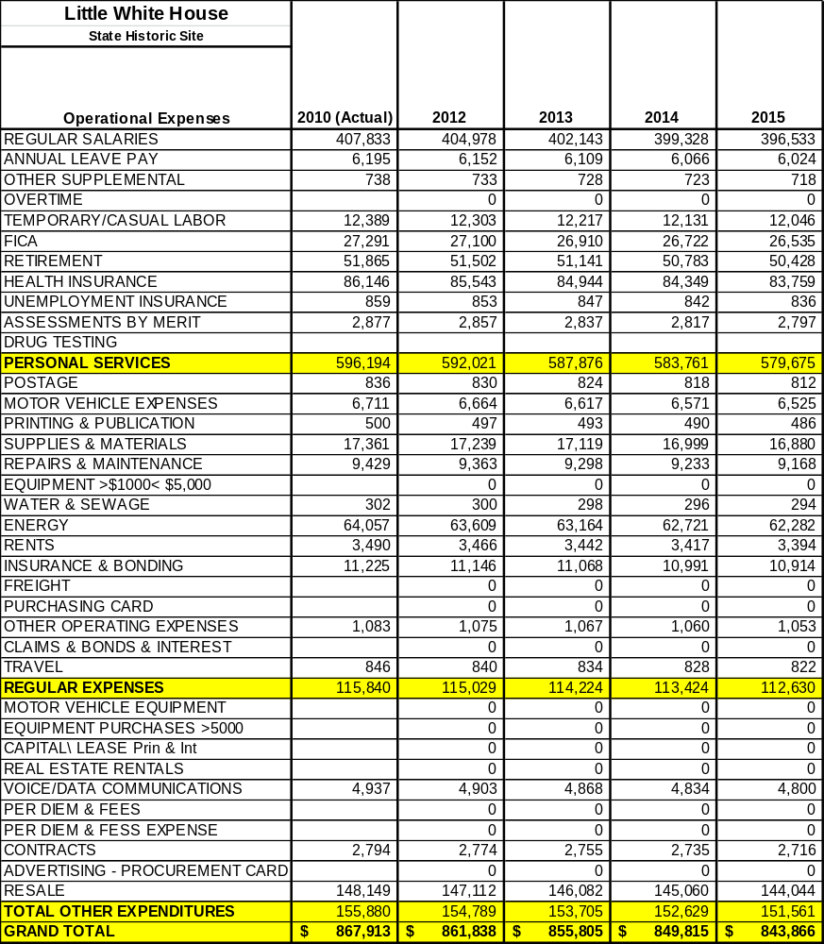

Revenue Pro Forma
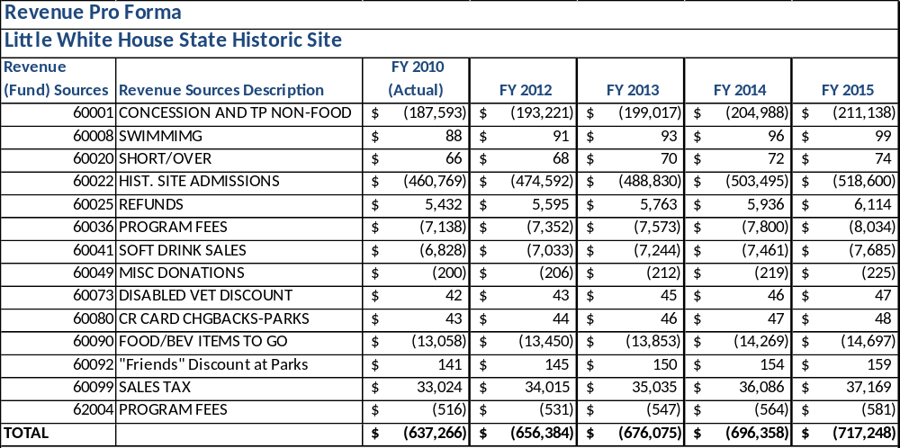
Site managers must project and plan for earned revenues (not including ParkPass) by fund source through FY 2015.

Total / Cost Recovery Pro Forma
Site managers must verify that accurate projections from the Expense Pro Forma and Revenue Pro Forma have transferred into the Cost Recovery Pro Forma, and add projections for visitation to the site through FY 2015.
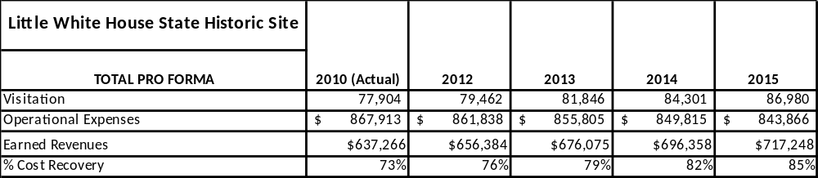

Glossary
Many of the following terms and phrases are utilized throughout this manual and related business planning templates. Definitions are provided below for some terms, and others are defined as they occur within the documents.
Sustainable, sustainability (fiscal or operational) – the operations of PRHSD is fiscally and/or operationally sustainable when the financial resources supporting operations are sufficient to deliver high quality state park or historic site experiences on a regular and consistent basis, maintain high quality facilities in working condition, and reasonably reinvest in the future operations of the sites via training, marketing and market development opportunities. Operations are not sustainable if the quality of site experiences, facilities and infrastructure, and marketing development activities are diminished due to insufficient financial resources.
Sustainability thresholds - “trigger points”, or thresholds, where operations of the site or the system have become unsustainable either by way of circumstances, budget cuts or management decisions.
Cost recovery (ratio) – the measure or ratio of operational expenses supported or “recovered” through earned revenues. Seventy-five percent (75%) cost recovery is when 75% of operational expenses are supported by earned revenues.
Best practices – successful innovations and operational practices of state park agencies, as well as the public park and recreation industry as a whole, that are recommended to be tailored and emulated by PRHSD.
Earned revenues – revenues earned from operational practices, programs, services and facility usage. These can include, but not be limited to, revenues from services delivered directly by sites, sponsorships, partnerships, and concessions.
Total costs of service – the sum total of direct and indirect costs associated with providing a service or group of services.
Cost of service analysis – an analysis that evaluates the total cost of service for providing specific programs and services, or groups of programs and services. A cost of service analysis involves a measurement or determination of the incremental costs of providing a program or service. For example, it is not helpful just to know how much it costs each year to mow or landscape at a site. A useful cost of service analysis defines the cost to mow per acre each year at a site. This is a measure that can be compared to similar measures from other sites or other state park systems to identify whether potential efficiencies, savings or cost avoidance opportunities exist.
Optimal cost of service – the results of a cost of service analysis produces a measure of total cost of service based on current levels of service (task, frequency, etc.). Total cost of service is a measure of status quo, which may or may not be considered sustainable. Optimal cost of service is the level at which operational expenses have become sustainable.
Performance goals – measurable goals for programs and services of PRHSD that are tracked and monitored. This can include, but not be limited to, financial goals such as revenues earned or a cost recovery percentage; participation goals such as total number of participants; or community service goals such as local impact for underserved residents, etc.
Volume-based business or operations – businesses or operations that depend upon volume of visitation or participation for solvency, versus exclusive pricing. Public park services are almost always volume-based business because of pricing limitations.
Core market – the base service market of a facility, program or service that represents the primary, traditional and most frequent customers.
Reserve fund / revolving account – a separate fund in which public park agencies can deposit earned revenues associated with specified programs and services that does not revert back to traditional public funding sources at the end of the year. This is also referred to as an enterprise fund and can be helpful for reinvesting in sites, programs and services. Reserve funds or revolving accounts often require policy authorization.
Non-labor expenses – materials and supplies, contract services, utilities, etc.
Operations and maintenance standards – level of service standards that are the framework for determining human and financial resources needed to sustainably operate and maintain a site. Examples include types of tasks, frequency of tasks, estimated time and materials to complete tasks, labor requirements per task, etc.
ROI – return on investment
Metrics – measures or measurements
Partners / partnerships – partners and partnerships in these business plans are not intended to imply the legal definition of partnership, but are more loosely used to describe individuals, groups, associations, private companies, other governmental entities, or non-profit organizations that can be or are currently utilized to leverage the operational resources of a site or multiple sites. Different types of partners and partnerships are described in more detail in this manual.
Tiered pricing – when programs and services of a site or multiple sites range in cost to the customer from free or very low cost, to services that are more exclusively priced.
Effort-based culture – an organizational culture that places a higher value on producing a greater level of effort to complete tasks or produce outcomes than on efficiency. Indications of an effort-based organizational culture are high labor costs in proportion to the total operating budget, and resistance to alternative forms of management that may be more efficient. Generally, measures of productivity (outcomes per labor hour) are considerably less in an effort-based culture than in an outcome-based culture.
Outcome-based culture – an organizational culture that places a higher value on identifying and then producing outcomes efficiently than on exhaustive or excessive levels of effort. Indications of an outcome-based culture are organizations that feature incentives for efficiency, and encourage streamlining versus being resistant to it. Generally, measures of productivity (outcomes per labor hour) are considerably higher in an outcome-based culture than in an effort-based culture.

Developing an Action Plan
In order to support attaining the business goals and the implementation of key recommendations identified in the business planning process, each site will develop a monthly action plan. This action plan will include the following elements:
- Schedule (Month)
- Strategies (see 5 groupings of strategies listed below)
- Tasks
- Cost / Funding Source
- Revenues / ROI
- Responsibilities
- Metrics
The following definitions and guidelines are provided to help site managers develop their action plans.
Schedule (Month)
The tasks of the action plan should be scheduled monthly for each fiscal year beginning with FY 2012. Development of a monthly action plan for FY 2013 should be listed among the last tasks in FY 2012. If there are repetitive or carryover tasks from month to month, it is suggested that the site manager cut and paste these tasks into the action plans for succeeding months.
Strategies
Short-term strategies are those that promise more immediate results, often with the smallest investment and largest return (return on investment or ROI) or they could just be strategies that can be accomplished quickly and easily.
Long-term strategies often take longer to accomplish with more advance planning and more resources (staff time, funding, equipment, outside contractors, etc.) required for implementation. Some important strategies will fall into this category and shouldn’t be avoided because they take longer and/or cost more: long-term strategies can have the most impact in the long run or the highest ROI.
Site managers must complete their action plans by expressing strategies as outcomes, whenever possible, and using the five strategic headings listed below:
- Site and facility infrastructure management
- Partnership development
- Marketing / sales
- Revenue generation
- Expense management
Tasks for Completion
Each short-term or long-term strategy should have the most crucial tasks listed that are necessary to accomplish the strategy; a short list or outline often suffices. Identifying the tasks helps determine the schedule and costs (see below) for the strategy and may even cause a manager to change it from short-term to long-term once it’s become clearer what’s involved in its implementation.
Costs & Funding Sources
The costs for a strategy or individual tasks will often be estimated at the beginning as an action plan is developed; however, a good estimate is a necessary first step to determine the ROI (see below) in order to identify the possible outcomes of a strategy. In addition to the estimate, it is very helpful to identify the funding source as this can determine the strategy’s feasibility or scheduling. For example, it be funded with state operating or capital outlay (CO) funds, site or division (off-site) operating revenues, ParkPass revenues, donations, Friends grants, etc. Costs may include capital outlay or operating expenses such as staff, supplies, equipment, utilities, maintenance and repairs.
Revenues & ROI/Cost Recovery
It can be complicated and difficult to determine whether a strategy has a positive (makes money) or negative (loses money) ROI/cost recovery, let alone calculate a specific dollar figure. However, it has become necessary to make this determination before we move forward with many of our strategies because it is unlikely that projects with a negative ROI will be implemented, unless they fulfill some core mission for the site or division. Using the estimated development and operating expenses (identified above) and an estimate of revenue generation, it should be determined what the percentage of ROI or cost recovery will be for the strategy during its first full year of implementation. Capital outlay expenses should be estimated but not included in the calculations for the ROI/cost recovery percentage. Theformula for ROI/cost recovery is revenue divided by expense; e.g., revenues of $110K divided by expenses of $90K would be an ROI of 122% (profit or positive ROI); revenues of $60K divided by expenses of $85K would be an ROI of 71% (loss or negative ROI).
Responsibilities
As part of outlining the tasks for completion of a strategy, the person responsible for completion should be listed. It is possible that one person might be responsible for all the tasks or an entire strategy, but this is unlikely as there are usually others involved that we must depend on to implement a task or strategy. The likelihood of completing the tasks or implementing the strategy successfully is much lower if the responsibilities for completion aren’t assigned and communicated.
Performance & Financial Measures/Metrics
It is important to determine what performance or financial metrics will be used to measure the success or accomplishment of a strategy so you know when it’s been fully implemented and whether it’s performed as projected. The metric will often consist of the costs and revenues (ROI) identified above, but could also include other performance measures that contribute to the ROI. Make this as painless as possible: beyond a calculation of ROI, try to use metrics that are easy to measure, collect and report and that demonstrate the success or accomplishment of the strategy.
ACTION PLAN
Site: |  | Site Manager: |  |  | Date:
Month:
Strategies | Tasks | Costs / Funding | Revenues / ROI | Responsibilities | Metrics

