ChC
Chattahoochee Bend State Park
Business & Management Plan

Prepared June 2011; Finalized February 2013
Direction 2015 – Sustainable Business Planning

Table of Contents

Executive Summary 3

Site and Operations Assessment 6
Site Inventory and Facility Assessment 7
Operational Assessment 9

Business and Management Plan 12
Business Goals 12
Classification of Programs and Services 13
Partnership Development Plan 14
Marketing and Sales Plan 15
Revenue Generation Plan 16
Expense Management Plan 19
Financial Pro Forma 20

Action Plan 22

Executive Summary
The Parks, Recreation and Historic Sites Division (PRHSD) of the Georgia Department of Natural Resources (DNR) is transitioning the management of Chattahoochee Bend State Park to operate more like a business, reflecting the Direction 2015 – Sustainable Business Planning initiative to improve the fiscal performance and management of the state parks and historic sites system. This business and management plan is designed to help the site recover more operating expenses through earned revenues, productive partnerships, and innovative programs.

Site Fact Sheet
Site Name | Chattahoochee Bend State Park
Site Manager | Tim Banks
Region Manager | Eric Bentley
Date of Business Plan completion | 2/15/13
Site size | 2,910 Acres
Total number of visitors (FY 2012) | 72,709
Total operating budget (FY 2012) | $259,313
Total earned revenues (FY 2012) | $125,529
Operational cost recovery (FY 2012) | 48.4%
Average operating cost per visitor (FY 2012) | $3.57
Average earned revenue per visitor (FY 2012) | $1.73
Average cost recovery (FY 2008 – 2010) | Not Available (park opened 7/1/11)
Target cost recovery (FY 2015) | 41.8%
Total full-time employees | 4
Total part-time employees | 2
Primary service markets | Newnan, Atlanta, Carrollton
Primary attractors/visitor appeal factors | Camping, day-use, river access
Leading opportunities for improved site performance | Create relationships with local organizations that will support the park. Continue to build volunteer support. Develop site history, interpretive materials & programs. Use visitation data from 1st year of operation to justify developing additional facilities such as cottages, disc golf, miniature golf, mountain bike and equestrian trails.

Site Summary and Key Attractions
The 2910-acre site of Chattahoochee Bend State Park is located in a rural setting, roughly 45 miles from major population centers in Georgia like Atlanta and 25 miles from Newnan. It is roughly 25 miles from Interstate 85. This is a brand new State Park with a great amount of local interest as we approach the July 1, 2011 opening. Excellent customer service/facility management and advertising will be crucial in the first year of operation to insure visitors know of the facility, and become repeat visitors.

Key Attractions
The amenities or features listed below are those that will be most popular for visitors.
- Camping
- River access
- Hiking
- Picnicking

Financial Targets
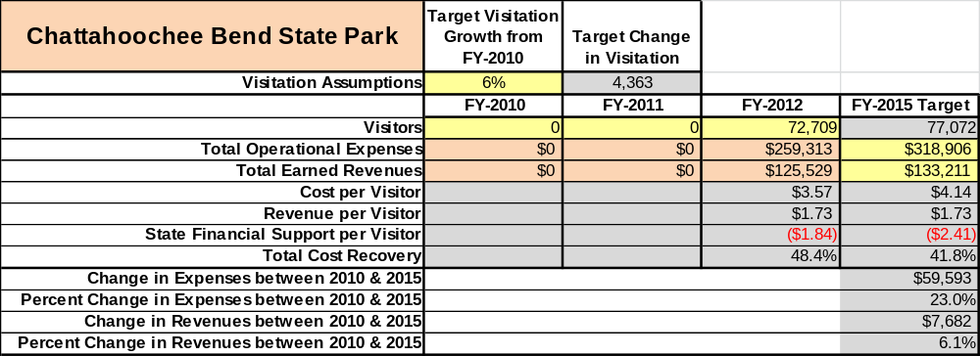
The table below details the projected total operating expenses and earned revenues for Chattahoochee Bend State Park over the next four years (2012 – 2015). This table also calculates total cost per visitor and revenues per visitor during these operating years, and details the target financial performance goals in the context of achieving at least 75% cost recovery. This table also calculates the necessary change from 2012 operating expenses and revenues.

Key Recommendations

Primary / Short Term Recommendations
- Manage site according to well-defined maintenance, programming and operational standards, monitored and enforced by region managers and senior management.
- Perform a thorough net cost-of-service analysis on major functions of site operations, including a detailed analysis of labor requirements by task. Thereafter, update costs to deliver services on a biennial schedule.
- Operate Chattahoochee Bend State Park using cost-based accounting, including the net cost recovery achieved annually.
- Conduct on-site surveys annually to assess how well customer satisfaction levels are being met. Park should strive to have 90% of visitors responding to ‘Comment Cards’ report that they were either ‘satisfied’ or ‘very satisfied’ (or some comparable metric to be developed). Programs or services that fall below that standard should be critically reviewed, enhanced, and results monitored; those with a history of poor performance should be considered for elimination.
- Seek local partners to help support operations, programs, and service delivery and for cross-marketing purposes.
- Partner with local Chambers of Commerce or other destination marketing organizations (DMOs) to promote local sites.
- Enhance and add facilities such as cottages and program offerings to provide a minimum of 10 unique experiences for each visitor while maintaining at least a 90% customer satisfaction rating.
- Pursue opportunities to employ concessionaires or private or public service providers on-site such as Georgia Trail Outfitters for canoe / kayak trips if they can be more cost-effective or provide desirable services, programs or amenities the Division cannot.
- Add more services, programs and amenities such as guided hikes, guided bird watching programs and plant identification programs that appeal to older adults.
- Construct facilities and amenities such as cottages, yurts, back country campsites and pioneer camping that are likely to have a cost recovery level at or above 100%.
- Add more youth and family focused services, programs and amenities such as guided canoe trips, mini golf, plant and animal programs, and junior ranger camp that appeal to younger audiences, families and educational groups.
- Develop a more detailed analysis of labor requirements of all major park functions to match the right position with the right job at the right pay.
- Develop funding to provide additional training to site staff for improved business management and marketing effectiveness.
- Track total economic impact of the site on the local communities and region and share with decision-makers, elected officials, local business operators and others to demonstrate the impact of each site.
- Seek volunteer support and labor to construct and maintain mountain bike trails, horse trails, miniature golf course, and disc golf course.

Secondary / Long Term Recommendations
- Engage local communities, user groups, and private organizations to improve connectivity between and within sites through trail development and maintenance projects.
- Install an improved retail point-of-sale and inventory tracking system.
- Begin the process of requesting the addition of 10 cottages including three hourly housekeepers, one hourly maintenance worker, an addition to the existing maintenance building for linen cleaning and storage, a washer/dryer for linen cleaning and a vehicle for housekeeping personnel.

Site and Operations Assessment
This site and operations assessment is a culmination of analyses and findings from a review of the condition of facilities, infrastructure, and operations at Chattahoochee Bend State Park. The findings and observations are not intended to be an exhaustive review of all issues present, but provide a basic understanding of the predominant issues that contribute to the site’s current operating conditions. The assessment includes the following:
- Site Inventory and Facility Assessment
- Operational Assessment
- Financial Assessment
Site Inventory and Facility Assessment

Methodology
Facility and asset conditions are rated using a differential scale of excellent, good, fair, or poor. Descriptions of conditions that are attributed to each of these findings are also provided.
Scale of Conditions
Rating | General Description
Excellent | Facilities/amenities are in ‘excellent’ condition when they show little or no maintenance or repair problems. Facilities do not feature any major design or operational issues or flaws that contribute to diminished use or increased maintenance or upkeep. Facilities are easy to clean and maintain in order to place them back into public use and the users perceive them to be in excellent shape.
Good | Facilities/amenities are in ‘good’ condition when they show only minor maintenance or repair problems. Most maintenance issues with these facilities typically appear to be the result of age and/or heavy use. Facilities may only feature minor design or operational issues that contribute to diminished use or increased maintenance or upkeep. Facilities are moderately easy to clean and maintain in order to place them back into service and the users perceive them to be adequate for their use, but probably not in excellent shape.
Fair | Facilities/amenities are in ‘fair’ condition when they show significant maintenance or repair problems. Facilities generally exhibit ongoing maintenance issues that appear to be the result of age, heavy use, or design or operational flaws. Some maintenance and repair needs may compound their fair condition by being deferred because of budget and/or resource limitations. Facilities require more effort to clean and maintain before placing them back into service and the users may perceive them as being less than adequate for their use and in a state of deterioration. The facility or structure may need of major repair or replacement.
Poor | Facilities/amenities are in ‘poor’ condition when they show significant, on-going maintenance or repair problems that ultimately may result in suspended use for repair/replacement. Maintenance and repair issues are possibly the result of poor maintenance and clearly the result of age, heavy use, or design or operational flaws. Problems with the facilities are often compounded over time due to consistently deferred maintenance and repair because of budget and/or resource limitations. Facilities may feature major design or operational issues that contribute to diminished use or increased maintenance or upkeep. Facilities require excessive effort to clean and maintain before placing them back into service and the users often perceive them as being inadequate for their use and in a state of serious deterioration. The facility or structure may need of major repair or replacement.

Inventory and Assessment
The table below is an inventory of facilities and amenities at Chattahoochee Bend State Park, and provides the assessed condition of each as reviewed in 6/11(month, year).
Site Asset / Amenity | Quantity | Condition
Visitor Center | 1 | New
Adirondack Buildings | 4 | New
Adirondack Restroom | 1 | New
Manager Residence  Residence 2 | 1 | New
Assistant Manager Residence | 1 | New
Well House 1 | 1 | New
Well House 2 | 1 | New
Comfort Station 1 | 1 | New
Camp Area 1 | 26 sites | New
Comfort Station 2 | 1 | New
Camp Area 2 | 23 sites | New
Day Use Restroom | 1 | New
West Platform Camp area | 8 sites | New
West Platform Restroom | 1 | New
North Platform Camp Area | 8 sites | New
North Platform Restroom | 1 | New
Picnic Shelter 1 | 1 | New
Picnic Shelter 2 | 1 | New
Maintenance Building | 1 | New

Prioritized Facility Needs
Based on the facility inventory and assessment, these prioritized needs have been identified. Each need has been aligned with a priority category of high, moderate, or low to support future decision making regarding project sequencing, investment of public resources, and meeting community expectations. The priority assignment for each need is not a measure of importance. Rather, these recommended priorities reflect a phased implementation approach over the next several years.
Facility Need | Priority Assignment
Build 10 cottages and infrastructure planned for Phase 2 development | High
Add disc golf course | Moderate to Low
Add mountain bike trails | Moderate
Add equestrian trails | Low
Add miniature golf course | Moderate to Low

Operational Assessment

The Operational Assessment includes:
- An inventory and classification of programs and services being provided at the site
- A review of staffing at the site
- A review of concessionaires and partners operating at the site
- Visitation and customer satisfaction

Inventory and Classification of Programs and Services
Programs and services are classified into one of three major categories:
1) Core or Essential Services
2) Important Services
3) Visitor Supported Services
Programs and services at the site are classified into these categories based in part on the mission and public mandates for both the site and the agency. For the programs and services in each of these categories, there are financial performance expectations that will define how services are funded and evaluated.

Category 1 – Core Services [Largely supported by tax funds]
Core programs, services and facilities are those the agency must provide and/or are essential in order to capably govern and meet statutory requirements. The failure of the agency to provide Category 1 services at adequate levels could result in significant negative consequences for the public and the resources under protection. The criteria for programs or services to be classified as core or essential are:
- The services are mandated by the agency’s law or charter or are contractually obligated by agreement to provide the services.
- The services are essential to protecting and supporting the public’s health and safety.
- The services protect and maintain valuable assets and infrastructure.
- The services would generally and reasonably be expected and supported by residents, businesses, customers and partners.
- The services are those that cannot or should not be provided by the private sector.
- The services provide a sound investment of public funds.
The following services offered at Chattahoochee Bend State Park have been identified as core services:
- Active management of site’s natural resources
- Open and public access to the site and its resources
- Site appropriate education, interpretation and educational opportunities
- Public safety
- Maintenance of grounds, facilities and infrastructure

Category 2 – Important Services [Supported by a balance of tax funds and earned revenues]
Important programs, services and facilities are those the agency should provide, and are important to governing and effectively serving residents, businesses, customers and partners. Providing Category 2 services expands or enhances the agency’s ability to provide and sustain its core services. The criteria for programs or services to be classified as important are:
- The services expand, enhance or support identified core services.
- The services are broadly supported and utilized by the community, and are considered an appropriate, important, and valuable public good. Public support may be conditional upon the manner by which the services are paid for or funded.
- The services generate income or revenue that offsets some or all of the operating cost and/or are deemed to provide economic, social or environmental outcomes or results.
The following programs and services offered at Chattahoochee Bend State Park have been identified as important services:
- Self-guided interpretive/educational opportunities
- Camping
- Hiking
- River access
- Day-use activities

Category 3 – Visitor Supported Services [Almost exclusively supported by earned revenue]
Visitor supported programs; services and facilities are those discretionary services that the agency may provide when additional funding or revenue exists to offset the cost of providing those services. Category 3 services provide added value above and beyond what is required or expected. The criteria for programs or services to be classified as visitor supported are:
- The services expand, enhance or support core services or important services and the quality of life of the visitors, community or stakeholders.
- The services are supported, valued and well utilized and provide an appropriate and valuable public benefit.
- The services generate income or funding from sponsorships, grants, user fees or other sources that offset some or all of their cost and/or provides a meaningful return on investment.

- The services can possibly be provided through outsourcing or use of concessionaires, providing opportunities for community enterprises that may not otherwise be provided by the agency.
The following programs and services offered at Chattahoochee Bend State Park have been identified as visitor supported services:
- Resale items / Visitor Center
- Ranger guided activities

Staffing Assessment
Labor costs at Chattahoochee Bend State Park represent the largest area of budgetary expense at an average of 74% of the total operating budget for the first year’s operation, which is higher than the target of total labor costs (including benefits) not exceeding 65% of the site’s total operating expenditures. The reason for this figure being higher than the target labor cost is that this is a new facility and labor needs are being estimated for the first year. The tables below and on the following page provide a basic review of the current staffing at the site.
Full Time Equivalent Employees
Position / Title | Quantity (FTE) | Vacancies | Annual Hours
Park Manager 2 | 1 | 0 | 2080
Asst. Park Manager 1 | 1 | 0 | 2080
Secretary | 1 | 0 | 2080
Park Ranger 1 | 1 | 0 | 2080
TOTAL | 4 | 0 | 8,320

Part Time Employees
Position / Title | Quantity (FTE) | Vacancies | Hours
PT Maintenance | 1 | 0 | 960
PT Clerk | 1 | 0 | 960
TOTAL | 2 | 0 | 1,920

Labor Support
Labor Support | Annual Hours
Volunteers | 2000
Community Service Workers | 0
Kiosk Worker | 260
Resource Management Crews | 80
TOTAL | 2,340

Total Labor Hours
Labor Type | Annual Hours
Full Time Equivalent Employees | 8,320
Part Time Employees | 1,920
Labor Support | 2,340
TOTAL Annual Labor Hours | 12,580

Business and Management Plan

Business Goals
The following goals serve as the foundation for the key recommendations and strategies in this business plan for Chattahoochee Bend State Park.

Enhance Cost Recovery of Site Operations
Chattahoochee Bend State Park will enhance cost recovery efforts by controlling and minimizing operational expenses. Utility bills will be monitored and staff will be trained to seek ways to minimize utility costs, such as turning off power and water heaters in facilities that are not in use. Labor costs will be monitored, especially part time hours, and work schedules will be set to ensure labor costs are kept to a minimum.

Enhance Revenue Generation Strategies
Strategies for generating revenue include flexible rates, special events, program fees and retail sales.

Expand Special Events at the Site
Chattahoochee Bend State Park will plan and promote special events, such as an Annual Fall Festival, canoe/kayaking event, trail walk/run race and geocaching events.

Improve the Diversity and Innovation of Recreational and Interpretive Programs
Recreational and interpretive programs will be planned with all user groups in mind. Coweta County will be funding a part-time Interpretive Naturalist for three years. The park will utilize this position to plan and implement programs for all user groups such as history, water ecology, plant identification, animal identification, and recreational activities like canoeing, hiking and biking.

Improve the Effectiveness of Marketing and Sales
Strategies for marketing and sales include:
- Working with the local Chamber and CVB to promote the site.
- Developing a relationship with local news and radio to get free advertising.

Establish Greater Consistency of Managing and Monitoring Customer Service & Satisfaction
Chattahoochee Bend State Park plans to use the information gathered from customer comment cards to achieve maximum customer satisfaction.

Expand Partnership Opportunities
Chattahoochee Bend State Park will continue to work closely with our Friends group to keep Friends volunteer support strong and seek additional partners that could offer financial or volunteer support.

Classification of Programs and Services
The tables below summarize the classifications of programs and services at Chattahoochee Bend State Park as either core, important, or visitor supported and projects a range of cost recovery percentages that might be achieved for each. These classifications establish financial performance goals for each category of services that are linked to the recommendations and strategies of this business plan.

Core Services
Program / Service | Target Cost Recovery
Active management of the site’s natural resources | 0%
Open and public access to the site and its resources | 10% - 20%
Site appropriate education, interpretation and educational opportunities | 100% +
Public safety | 0%
Maintenance of grounds, facilities and infrastructure | 0%

Important Services
Program / Service | Target Cost Recovery
Self-guided interpretative/educational opportunities | 10% - 15%
Camping | 100%-120%
Hiking | 10% - 20%
River access | 10% - 20%
Day-use activities | 10% - 30%

Visitor Supported
Program / Service | Target Cost Recovery
Resale items / Visitor Center | 120% - 180%
Ranger guided activities  Guided Activities | 100% - 130%

Partnership Development Plan
The table below summarizes existing partners and targeted partnerships by classification (operational, vendor, service, co-branding, funding partners) and by organizational type.
 | Public Partners | Not-for-profit Partners | Private / Enterprise Partners
Operational Partners |  | - Friends of Georgia State Parks
Vendor Partners |  |  | - Coca Cola  - Georgia Power
Service Partners | - Coweta County Public Works | - Chamber of Commerce  - Coweta County CVB
Co-branding Partners |  | - Chamber of Commerce  - Coweta County CVB
Funding Resource Development Partner |  | - Friends of Georgia State Parks  - Friends of Chattahoochee Bend State Park

Marketing and Sales Plan

Marketing and Sales Goals
Marketing and sales goals for Chattahoochee Bend are based on the following desired outcomes:
- To maximize visitation
- Increase and maximize revenue
- Increase visitor support
In order to meet these goals, examples of specific target outcomes were identified in the areas detailed in the table below.
Area of Focus | Current Performance | Goal by 2013 | Goal by 2014 | Goal by 2015
Special Events | 0 | 75-100 visitors/event | 150-200 visitors/event | 250-300 visitors/event
# of Special Events | 1 | 5 per year | 7 per year | 10 per year
# of Interpretive Programs | 0 | 10 per year | 15 per year | 20 per year
Visitation | 0 | 1000 people | 2500 people | 4000 people
Marketing and Promotion Strategies

Publicity and Social Media
Chattahoochee Bend State Park will approach marketing and publicity planning using the following guidelines and themes:
- Event publicity
Major events benefit by having short stories in local, regional, and statewide newspapers and online social media hooks planted that run three to four weeks in advance of the event up to the date of the event itself. Stories and media need to be cultivated with contacts and online sales channels several weeks in advance of the time the stories need to run. Special interest interviews on morning, noon, and evening television news programs, radio interviews on popular rush-hour programs, and blogs on known affinity online sites should also be included.
- Program publicity
Special and unique programs should have feature stories in magazines, weekly newspapers, and statewide daily newspapers that are aimed at placements as front-page or sectional front-page stories. These stories are most effective if they run shortly before the season that the featured program begins. This will likely require several weeks of advanced planning with media contacts. Similar coverage on television and radio should also be considered. If pre-publicity cannot be generated, post-publicity can help promote future programs.
- Site Publicity
Site publicity focusing on a single site or sub-set of sites requires more intense planning efforts to attract multiple writers and editors from target publications. Each site could host several seasonal media familiarization tours (with 10 to 15 writers or editors) to familiarize them with the site and its benefits and amenities. Stories and features resulting from such tours typically take between two and six months to materialize so the tours should focus on experiences, benefits, and programs that would be available when the stories are expected to run.
Examples and suggested opportunities for events, programs and related publicity efforts based on the themes described above at Chattahoochee Bend State Park are provided in the table below. Note: Event size will be limited to smaller events until access road at the north end of the park is completed. Once the north access road is complete, two large fields could be used for festivals, scout jamborees, arts/craft shows, car shows, hot air balloon shows and music events.
Event Publicity | Program Publicity | Site Publicity
Triathlon | Night hike | Local Indian history
Trail Run | Junior Ranger Camp
River Race | Plant identification
Orienteering event

Packaging
Examples and suggested packages for Chattahoochee Bend State Park are provided in the table below.
Package | Package Details
Camp & tour LWH | Camping at Chattahoochee Bend and admission to LWH

Group Sales
Types of groups within which specific target customers can be identified for Chattahoochee Bend State Park are listed below:
- Families  - School Groups | - Church Groups  - Business | - Scout Groups  - Social Groups

Incentivizing New and Repeat Visitation
Chattahoochee Bend State Park will utilize the following strategies and/or incentives to encourage new and repeat visitation starting in FY 2012:
- Rate Discounts
- Group Discounts
- Programming
- Annual Special Events
Marketing and Sales Metric Goals
The following marketing and sales metric goals and/or others will be monitored and progress reported at Chattahoochee Bend State Park:
- Loyalty and repeat customers = Outstanding Customer Service, clean and well maintained facilities.
- Brand confidence & customers-recruiting-customers = Enjoying their stay at Chattahoochee Bend State Park.
Revenue Generation Plan
Revenue / Cost Recovery Goals
Chattahoochee Bend State Park has set a financial goal of increasing annual revenues 6% annually between 2012 and 2015. The largest revenue growth opportunity is most likely Overnight Camping. The table below details projected revenue growth leading up to 2015, based upon a nominal growth of revenues each year.
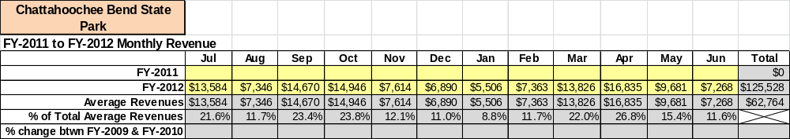

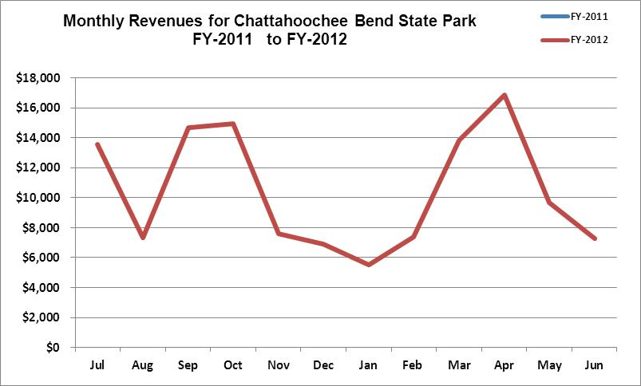

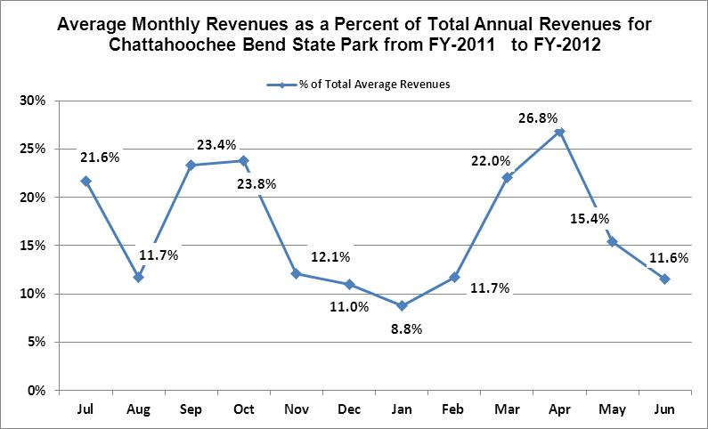

These projections would result in a total of 38% cumulative growth in total annual revenues between FY2012 and FY2015. If operational expenses can be managed with a cumulative reduction of 7% between FY 2012 and FY 2015, then the overall cost recovery of the site will be approximately 52% in FY 2015 at these projected revenue levels. This is higher than the estimated annual financial performance of the site in FY 2012, which we project, will be operated at 37% cost recovery in that year.
Revenue Generation Strategies
Pricing Plan
PARK RESERVABLES | Current Pricing (CY 2011) | Proposed Pricing  (CY 2012) | Positive Yield Management Margin (%) | Negative Yield Management Margin (%) | Positive  Yield  Management  Margin ($) | Negative  Yield  Management  Margin ($)
Picnic Shelter | $65 | $65 | 20% | -20% | $13 | $13
Camping (RV) | $28 | $28 | 30% | -30% | $8.40 | $8.40
Camping (Tent) | $25 | $25 | 30% | -30% | $7.50 | $7.50
Platform Camping | $20 | $20 | 30% | -30% | $6 | $6
Camping (Tent only) | $20 | $20 | 30% | -30% | $6 | $6
Adirondack Campsite | $35 | $35 | 30% | -30% | $10.50 | $10.50

Innovative Programming and Special Events Plan

Program / Event | Theme / Purpose | Scheduled Date/Season | Frequency | Target Participation | Target User Fee | Target Cost Recovery
River Race | Rec./fitness | June – Aug. | 2 x Yr. | 75 - 150 | $ 30 | 100% - 150%
Triathalon | Rec./fitness | Apr. – Sep | 2 x Yr. | 250 – 500 | $ 75 | 150% - 225%
Orienteering Event | Map skills | October | Annually | 150 -300 | $ 30 | 100% - 120%

Partnerships and Concessions Plan

Service / Partnership | Term of Service | Financial Objective | Contract Manager
Canoe/Kayak Outfitter | 5Yr | 15% Gross receipts | Park Manager

Expense Management Plan
Personnel Assignments
The following actions will be taken to proactively manage labor costs via personnel assignments and classifications.

Action | Timeline | Outcome
New Park – Will monitor 1st yr and adjust assignments to achieve max. efficiency | 1 yr | Unknown

Management Techniques
The following actions will be taken to proactively manage labor costs via management techniques.

Action | Timeline | Outcome
New Park – Will monitor labor costs and make adjustments needed to achieve cost goals. | 1 yr | Unknown

Adjusted Levels of Service
The following actions will be taken to proactively manage labor costs via reduced levels of service.

Action | Timeline | Outcome
New park – Will not cut any services initially, but closely monitor and adjust as needed.

Financial Pro Forma
The following five-year financial pro forma projects operating expenses, earned revenues and cost recovery through FY 2015. These pro forma are based on the strategies and desired outcomes identified in this business plan, especially the revenue generation and expense management plans, and are linked to corresponding performance goals.

Expense Pro Forma
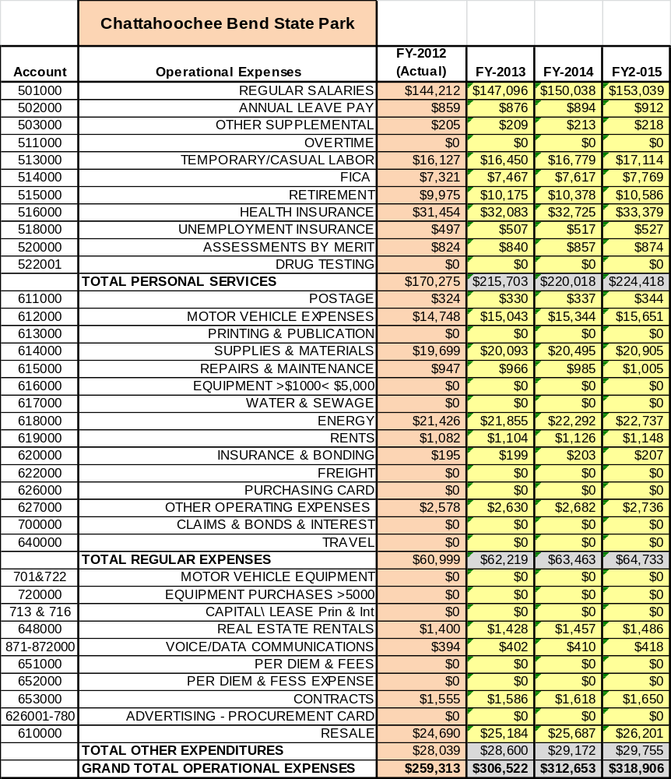

Revenue Pro Forma
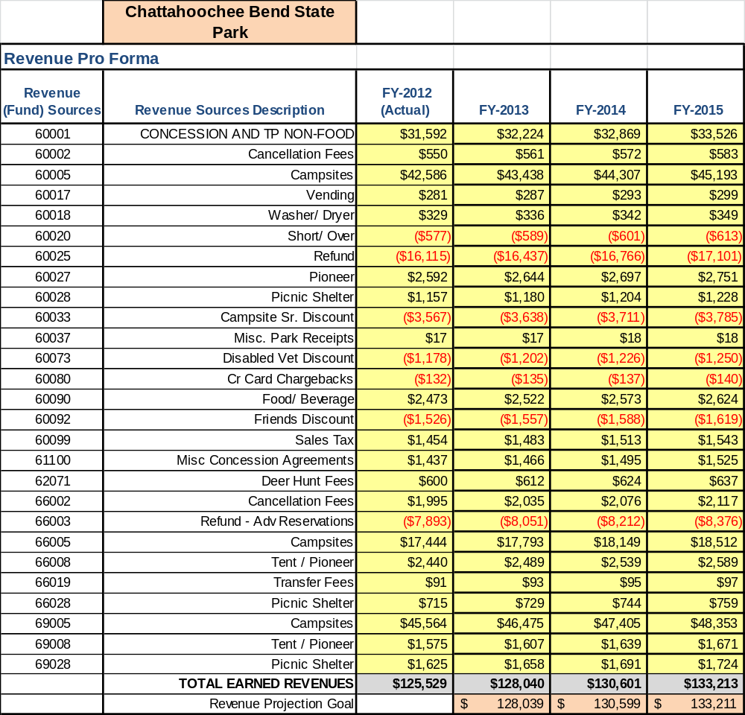

Total / Cost Recovery Pro Forma
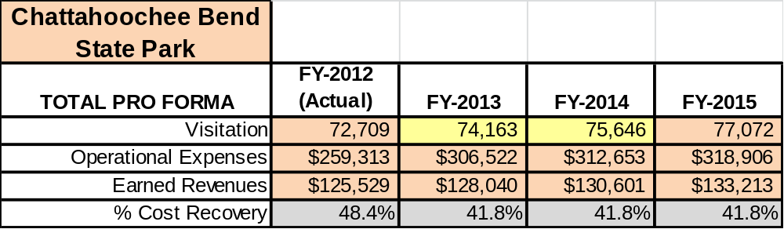

Action Plan
ACTION PLAN
Site: |  | Site Manager: |  |  | Date:
Month:
Strategy | Tasks | Costs / Funding | Revenues / ROI | Responsibilities | Metrics

ACTION PLAN
Site: |  | Site Manager: |  |  | Date:
Month:
Strategy | Tasks | Costs / Funding | Revenues / ROI | Responsibilities | Metrics

This is the average of the last three years – FY 2008, FY 2009, and FY 2010
Current employees, not including vacancies.
Current employees, not including vacancies.
Major population centers within a two-hour drive from the site

