Crooked River State Park
Business & Management Plan

Prepared June 2011; Finalized January 2013
Direction 2015 – Sustainable Business Planning

Table of Contents

Executive Summary 3

Site and Operations Assessment 6
Site Inventory and Facility Assessment 6
Operational Assessment 8
Financial Performance Assessment 13

Business and Management Plan 17
Business Goals 17
Classification of Programs and Services 18
Partnership Development Plan 19
Marketing and Sales Plan 20
Revenue Generation Plan 22
Expense Management Plan 24
Financial Pro Forma 25

Action Plan 28

Executive Summary
The Parks, Recreation and Historic Sites Division (PRHSD) of the Georgia Department of Natural Resources (DNR) is transitioning the management of Crooked River State Park to operate more like a business, reflecting the Direction 2015 – Sustainable Business Planning initiative to improve the fiscal performance and management of the state parks and historic sites system. This business and management plan is designed to help the site recover more operating expenses through earned revenues, productive partnerships, and innovative programs.

Site Fact Sheet
Site Name | Crooked River State Park
Site Manager | Joe Bradford
Region Manager | Tommy Turk
Date of Business Plan completion | June 13, 2011
Site size | 500 Acres
Total number of visitors (FY 2010) | 68,441
Total operating budget (FY 2010) | $437,534
Total earned revenues (FY 2010) | $455,812
Operational cost recovery (FY 2010) | 104%
Average operating cost per visitor (FY 2010) | $6.39
Average earned revenue per visitor (FY 2010) | $6.66
Average cost recovery (FY 2008 – 2010) | 103%
Target cost recovery (FY 2015) | 124%
Total full-time employees | 4
Total part-time employees | 5
Primary service markets | Jacksonville, Kingsland, Saint Mary’s, and Brunswick with fall and winter travelers from primarily northeastern states and Canada.
Primary attractors/visitor appeal factors | Clean, quiet, family oriented facility. Crooked River- boating and fishing. Birding/Ecotourism, Cumberland Island.
Leading opportunities for improved site performance | Additional overnight facilities: additional cottages, adventure based cottage packages, back country camping, new pioneer area, efficiency units or small group overnight facility to accommodate fishermen and visitors interested in outdoor adventure opportunities.

Site Summary and Key Attractions
Crooked River is comprised of 500 acres of mixed long-leaf pine, hardwood hammocks, bay forest/swamp and maritime forest. The park contains 62 campsites, 11 cottages, 5 picnic shelters, a group shelter, a nature center and a visitor center. There are 4.5 miles of nature trails, 4 playgrounds, a mini golf course and a boat ramp within its boundaries. The park is located 11 miles from I-95 which draws travelers to the park during their North/South migration. Although the park is located in a medium sized population center, a small percentage of visitors are from the local area. Families with young children from the Jacksonville, Florida area make up a large percentage of the visitors to the park. Testimonials from those visitors indicate that they choose Crooked River because the facilities are clean and attractive and it is a quiet and safe location for their family. Programs from the Nature Center focus on environmental education and are popular with guests and attract school groups from the local schools as well as schools from North Florida. Visitation to the park is dictated by weather trends with peak visitation occurring between October and May. Although the hot weather in southeast Georgia during the summer months causes a dramatic drop in occupancy for our campsites, the park’s facilities are heavily used and are showing wear. If improvements are not made, we could see a drop in occupancy for all facilities, resulting in the inability to meet revenue goals in the near future. The boat ramp at Crooked River is the busiest in the county. The addition of a live bait sales concession has increased the use of this facility further. Adding restroom facilities and a pavilion to host fishing tournaments could result in respectable returns of investment. The continued decline of the condition of our facilities and the current staffing shortages will make it difficult to meet future revenue goals.

Key Attractions
The amenities or features listed below are those that seem to be most popular for visitors.
- Clean, attractive facilities in a safe family oriented atmosphere.
- 11 cottages
- 62 campsites
- Boat ramp with access to open ocean and Cumberland Island
- Group and family gatherings in the group shelter
- Bird watching/ecotourism
- Close proximity to Jacksonville
- Close proximity to I-95
- Environmental education programs in Nature Center

Financial Targets
The table below details the total operating expenses and earned revenues for Crooked River State Park over the last three years (2008 – 2010). This table also calculates total cost per visitor and revenues per visitor during these operating years, and details the target financial performance goals in the context of achieving at least 124% cost recovery. This table also calculates the necessary change from 2010 operating expenses and revenues.

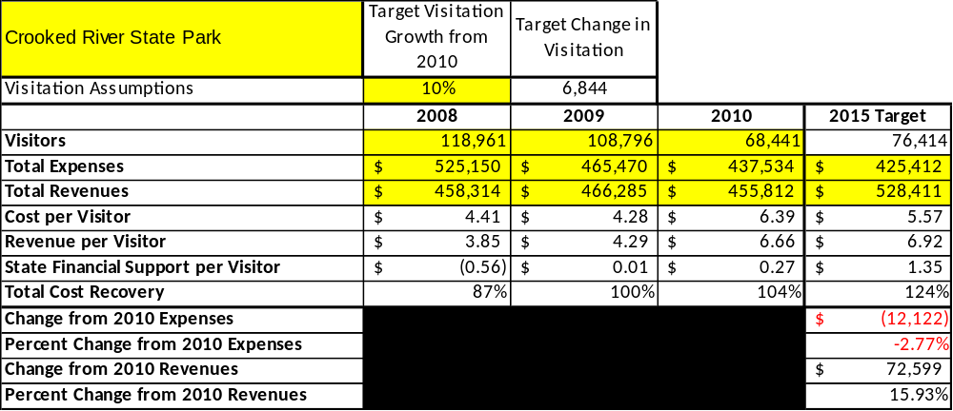

Key Recommendations

Primary / Short Term Recommendations
- Renovate exterior of cottages 6 thru 11, renovate or reconstruct Comfort Station 2 in the campground, renovate campsites to all 50 amp sites to include full hookup campsites in areas where they are feasible. Create a rate structure that can compete with local campgrounds for long term stays during the winter months to capitalize on the large number of travelers along the I-95 corridor.
- Establish relevant marketing strategies that target the types of people who come to Crooked River. Advertise in sporting and outdoor publications and focus on highlighting the activities available at the park.

Secondary / Long Term Recommendations
- Construct new facilities that will enhance the operation of Crooked River. Focus on the reasons visitors come to the park and provide additional opportunities for them to return on a regular basis. The boat ramp at Crooked River is the busiest ramp in Camden County. It would benefit by adding additional parking, restrooms and a full time live bait and tackle sales operation. There is also an opportunity to capitalize on visitors desiring low frills accommodations like camper cabins or efficiencies. There is a great location for facilities such as these on the north side of Charlie Smith Sr. Hwy. that would allow easy access to the boat ramp for fishermen and eco-tourists desiring to go to Cumberland Island.

Site and Operations Assessment
This site and operations assessment is a culmination of analyses and findings from a review of the condition of facilities, infrastructure, and operations at Crooked River State Park. The findings and observations are not intended to be an exhaustive review of all issues present, but provide a basic understanding of the predominant issues that contribute to the site’s current operating conditions. The assessment includes the following:
- Site Inventory and Facility Assessment
- Operational Assessment
- Financial Assessment
Site Inventory and Facility Assessment

Methodology
Facility and asset conditions are rated using a differential scale of excellent, good, fair, or poor. Descriptions of conditions that are attributed to each of these findings are also provided.
Scale of Conditions
Rating | General Description
Excellent | Facilities/amenities are in ‘excellent’ condition when they show little or no maintenance or repair problems. Facilities do not feature any major design or operational issues or flaws that contribute to diminished use or increased maintenance or upkeep. Facilities are easy to clean and maintain in order to place them back into public use and the users perceive them to be in excellent shape.
Good | Facilities/amenities are in ‘good’ condition when they show only minor maintenance or repair problems. Most maintenance issues with these facilities typically appear to be the result of age and/or heavy use. Facilities may only feature minor design or operational issues that contribute to diminished use or increased maintenance or upkeep. Facilities are moderately easy to clean and maintain in order to place them back into service and the users perceive them to be adequate for their use, but probably not in excellent shape.
Fair | Facilities/amenities are in ‘fair’ condition when they show significant maintenance or repair problems. Facilities generally exhibit ongoing maintenance issues that appear to be the result of age, heavy use, or design or operational flaws. Some maintenance and repair needs may compound their fair condition by being deferred because of budget and/or resource limitations. Facilities require more effort to clean and maintain before placing them back into service and the users may perceive them as being less than adequate for their use and in a state of deterioration. The facility or structure may need of major repair or replacement.
Poor | Facilities/amenities are in ‘poor’ condition when they show significant, on-going maintenance or repair problems that ultimately may result in suspended use for repair/replacement. Maintenance and repair issues are possibly the result of poor maintenance and clearly the result of age, heavy use, or design or operational flaws. Problems with the facilities are often compounded over time due to consistently-deferred maintenance and repair because of budget and/or resource limitations. Facilities may feature major design or operational issues that contribute to diminished use or increased maintenance or upkeep. Facilities require excessive effort to clean and maintain before placing them back into service and the users often perceive them as being inadequate for their use and in a state of serious deterioration. The facility or structure may need of major repair or replacement.

Inventory and Assessment
The table below is an inventory of facilities and amenities at Crooked River, and provides the assessed condition of each as reviewed in May 2011.
Site Asset / Amenity | Quantity | Condition
2BR Cottage 1,3,5 | 3 | Good
2BR Cottage 6 thru 11 | 6 | Fair
3BR Cottages | 2 | Good
Campsites 1 thru 41 | 41 | Poor
Campsites 42 thru 62 | 20 | Good
Comfort Station 1 | 1 | Good
Comfort Station 2 | 1 | Fair
Picnic shelters | 5 | Good
Group Shelter | 1 | Fair
Park Office | 1 | Good
Nature Center | 1 | Fair
Trails | 3 | Good
Courtesy Dock | 1 | Fair
Manager’s Residence | 1 | Good
Assistant’s Residence | 1 | Good
Ranger’s Residence | 1 | Good
Maintenance Facility | 1 | Good
Pioneer Camping Area | 1 | Poor
Re the pioneer camping area: although this facility is in poor condition, it rented 25 times last year, but it would rent much more and possibly at a higher rate if it were renovated.

Prioritized Facility Needs
Based on the facility inventory and assessment, these prioritized needs have been identified. Each need has been aligned with a priority category of high, moderate, or low to support future decision making regarding project sequencing, investment of public resources, and meeting community expectations. The priority assignment for each need is not a measure of importance. Rather, these recommended priorities reflect a phased implementation approach over the next several years.

Facility Need | Priority Assignment
Renovate Campsites 1 thru 41 | High
Renovate exterior of Cottages 6 thru 11 | High
Renovate Group Shelter | High
Renovate Comfort Station 2 | Moderate
Renovate Nature Center | Moderate
Renovate Courtesy Dock | High
Construct additional overnight facilities | Moderate
Renovate Pioneer Camping Area | Moderate

Operational Assessment
The Operational Assessment includes:
- An inventory and classification of programs and services being provided at the site
- A review of staffing at the site
- A review of concessionaires and partners operating at the site
- Visitation and customer satisfaction

Inventory and Classification of Programs and Services
Programs and services are classified into one of three major categories:
1) Core or Essential Services
2) Important Services
3) Visitor Supported Services
Programs and services at the site are classified into these categories based in part on the mission and public mandates for both the site and the agency. For the services in each of these categories, there are financial performance expectations that will define how services are funded and evaluated.

Category 1 – Core Services [Largely supported by tax funds]
Core programs, services and facilities are those the agency must provide and/or are essential in order to capably govern and meet statutory requirements. The failure of the agency to provide Category 1 services at adequate levels could result in significant negative consequences for the public and the resources under protection. The criteria for services to be classified as core or essential are:
- The services are mandated by the agency’s law or charter or are contractually obligated by agreement to provide the services.
- The services are essential to protecting and supporting the public’s health and safety.
- The services protect and maintain valuable assets and infrastructure.
- The services would generally and reasonably be expected and supported by residents, businesses, customers and partners.
- The services are those that cannot or should not be provided by the private sector.
- The services provide a sound investment of public funds.
The following services offered at Crooked River State Park have been identified as core services:
- Stewardship of natural resources, property and revenues
- Safety and security for guests, facilities and property
- Maintenance of public drinking water system
- Environmental education and public outreach programs

Category 2 – Important Services [Supported by a balance of tax funds and earned revenues]
Important programs, services and facilities are those the agency should provide, and are important to governing and effectively serving residents, businesses, customers and partners. Providing Category 2 services expands or enhances the agency’s ability to provide and sustain its core services. The criteria for programs or services to be classified as important are:
- The services expand, enhance or support identified core services.
- The services are broadly supported and utilized by the community, and are considered an appropriate, important, and valuable public good. Public support may be conditional upon the manner by which the services are paid for or funded.
- The services generate income or revenue that offsets some or all of the operating cost and/or are deemed to provide economic, social or environmental outcomes or results.
The following services offered at Crooked River State Park have been identified as important services:
- Outdoor recreational opportunities
- Nature trails
- Picnicking
- Wildlife observation
- Programs that are oriented toward entertainment (campfire programs, hay rides)

Category 3 – Visitor Supported Services [Almost exclusively supported by earned revenue]
Visitor supported programs, services and facilities are those discretionary services that the agency may provide when additional funding or revenue exists to offset the cost of providing those services. Category 3 services provide added value above and beyond what is required or expected. The criteria for programs or services to be classified as visitor supported are:
- The services expand, enhance or support core services or important services and the quality of life of the visitors, community or stakeholders.
- The services are supported and valued and provide an appropriate and valuable public benefit.
- The services generate income or funding from sponsorships, grants, user fees or other sources that offset some or all of their cost and/or provides a meaningful return on investment.

- The services can possibly be provided through outsourcing or use of concessionaires, providing opportunities for community enterprises that may not otherwise be provided by the agency.
The following services offered at Crooked River have been identified as visitor supported services:
- Camping
- Cottages
- Group shelter
- Equipment rentals (mini-golf, bicycles)
- Adventure outings (kayak trips, guided nature walks)
- Picnic shelter use
- Boat ramp and courtesy dock use
- Access to the facility

Staffing Assessment
Labor costs at Crooked River State Park represent the largest area of budgetary expense at an average of 68% of the total operating budget each year for the last three complete years, which is higher than the target of total labor costs (including benefits) not exceeding 65% of the site’s total operating expenditures. The tables below and on the following page provide a basic review of the current staffing at the site.
Full Time Equivalent Employees
Position / Title | Quantity (FTE) | Vacancies | Annual Hours
Parks Facility Management Spec (EL) | 1 | 0 | 2080
Parks Facility Management Spec (AL) | 1 | 0 | 2080
Parks Maintenance Technician | 1 | 0 | 2080
Building/Construction Trades Specialist | 0 | 1 | 0
Grounds/Maintenance Worker | 0 | 1 | 0
Naturalist/Curators/Preservation | 0 | 1 | 0
Clerk | 1 | 0 | 2080
Housekeeper | 0 | 2 | 0
TOTAL | 4 | 5 | 8,320
Part Time Employees
Position / Title | Quantity (FTE) | Vacancies | Annual Hours
Maintenance Worker | 1 | 0 | 1508
Parks Services Worker | 1 | 0 | 1508
Office Clerk | 1 | 1 | 1508
Housekeeper | 2 | 0 | 3016
Seasonal Naturalist | 1 | 0 | 1508
Manager in Training | 0 | 1 | 0
Recreation Intern | 0 | 1 | 0
TOTAL | 6 | 3 | 9,048
Labor Support
Labor Support | Annual Hours
Volunteers (based on 2010 hours) | 6116
Community Service Workers (based on 2010 hours) | 1040
Engineering and Construction Crews | 0
Resource Management Crews | 100
TOTAL | 7,256
Total Labor Hours
Labor Type | Annual Hours
Full Time Equivalent Employees | 8,320
Part Time Employees | 9,048
Labor Support | 7,256
TOTAL Annual Labor Hours | 24,624

Labor Budget Summary
 | Crooked River State Park
 |  | 2008 | 2009 | 2010 | % Change
 | Account Code and Sub-Class | Year End | Year End | Year End | from
 | Expenditure Descriptions | Expenses | Expenses | Expenses | 2008
 | REGULAR SALARIES | 197,864 | 206,854 | 180,811 | -9%
 | ANNUAL LEAVE PAY | 1 | 1,928 | 1 | 0%
 | OTHER SUPPLEMENTAL | 1,925 | 2,348 | 2,113 | 10%
 | TEMPORARY/CASUAL LABOR | 58,087 | 52,223 | 48,241 | -17%
 | FICA | 15,409 | 15,994 | 13,648 | -11%
 | RETIREMENT | 21,506 | 22,468 | 20,432 | -5%
 | HEALTH INSURANCE | 45,674 | 28,190 | 37,994 | -17%
 | UNEMPLOYMENT INSURANCE | 379 | 299 | 409 | 8%
 | ASSESSMENTS BY MERIT | 1,470 | 1,470 | 1,370 | -7%
 | PERSONAL SERVICES | 342,315 | 331,775 | 305,019 | -11%

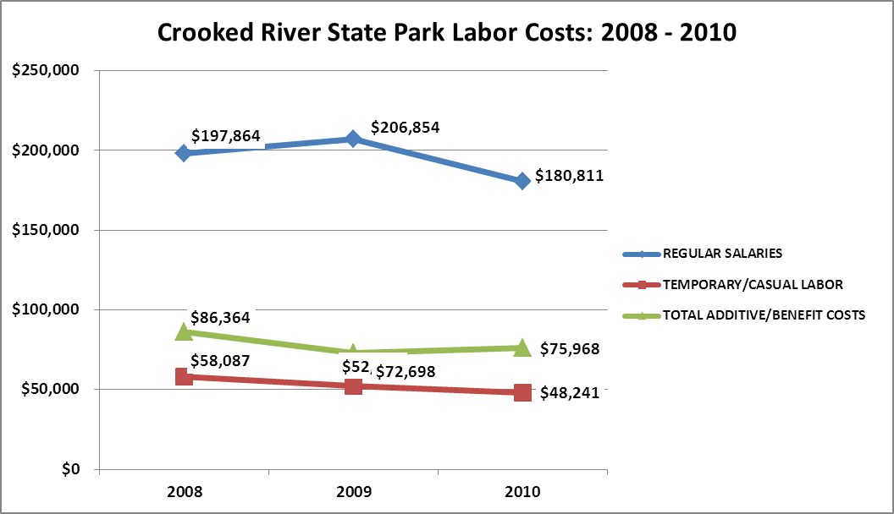

Visitation and Occupancy
Overall annual visitation to the site has trended downward from 2008 to 2010, decreasing by 42% or over 50,520 visitors. This is largely attributed to the price of fuel, a weak economy and the change in formulas related to visitation.

Year | Total Visitation
2008 | 118,961
2009 | 108,796
2010 | 68,441

Occupancy for the overnight accommodations at Crooked River State Park the last three years is detailed in the table below. Overall occupancy for cottages has trended upward from 2008 to 2010, increasing by approximately 24%, while campsite occupancy has trended downward by approximately 6%. It is difficult to determine the cause of the occupancy differential shown with these trends.

Year | Cottage Occupancy | Campsite Occupancy
2008 | 52.18% | 43.31%
2009 | 52.14% | 40.38%
2010 | 76.28% | 37.71%

Customer Service and Satisfaction

Site | Year | Customer Satisfaction Level
Crooked River State Park | 2009 | 79%
Crooked River State Park | 2010 | 77%

Financial Performance Assessment

Operational Expenses
A summary of total operating expenses at Crooked River State Park from 2008 to 2010, as well as their percent change from 2008 are provided in the table below.

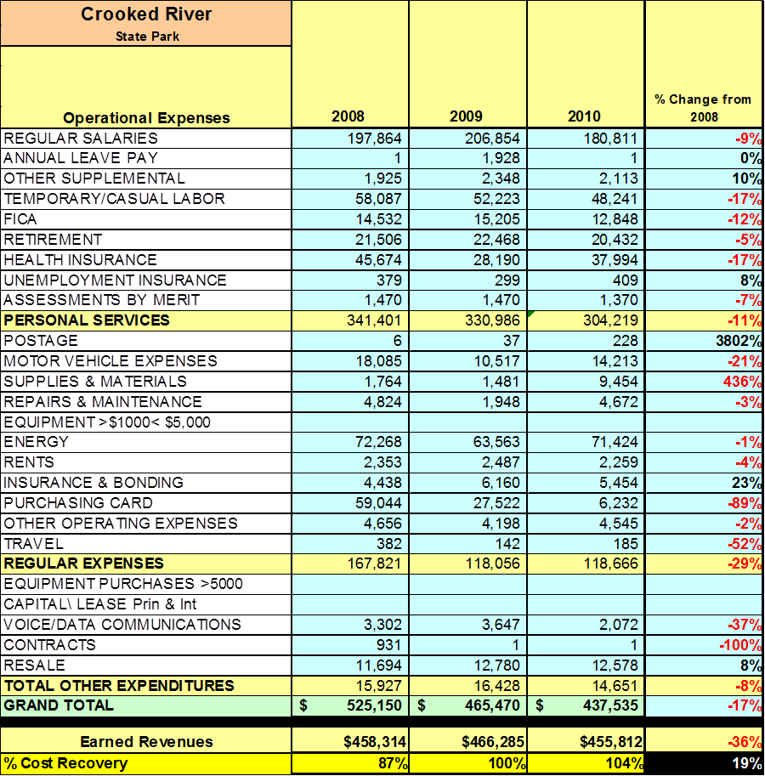

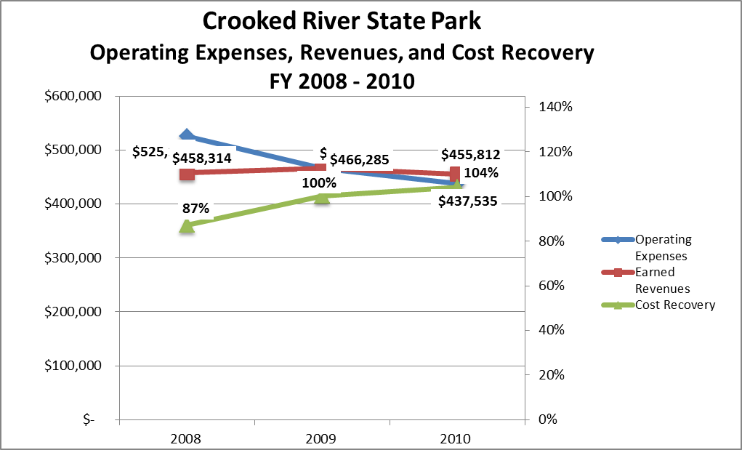

Earned Revenues
Earned revenues at Crooked River State Park have remained relatively stable since 2008, which is largely attributed to the corresponding increase in cottage occupancy and decrease in campsite occupancy and a decrease in overall visitation.
Monthly earned revenues for the last two years (see table below) indicate that the total annual revenue decreased 2% from 2009 to 2010, with the largest increases in monthly revenues in May (5%), June (5%), April (1%), and July (1%), and the largest decreases in the months of January (-16%), September
(-8%), October (-6%), August (-6%), November (-2%), and December (-2%).

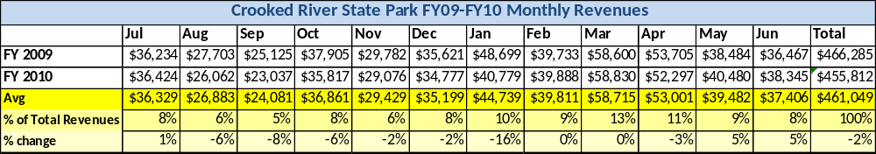
The graphs below illustrate the monthly revenue trends each year and the average percent of total annual revenue earned each month.

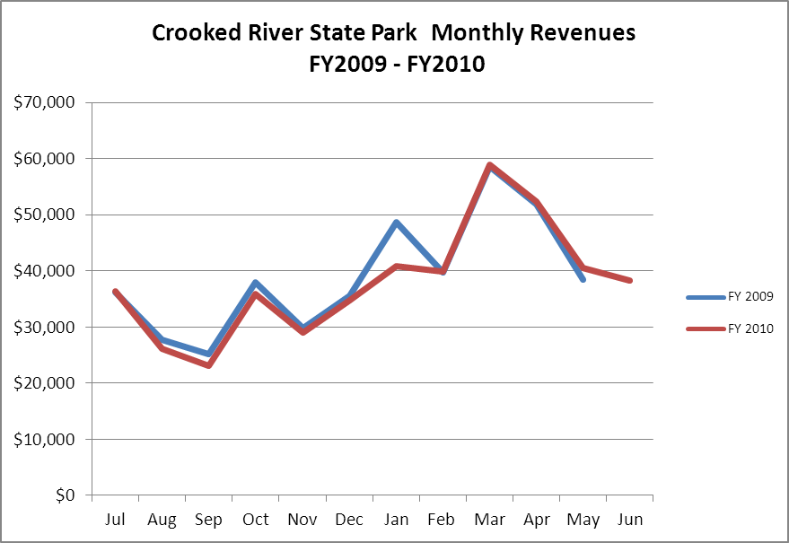

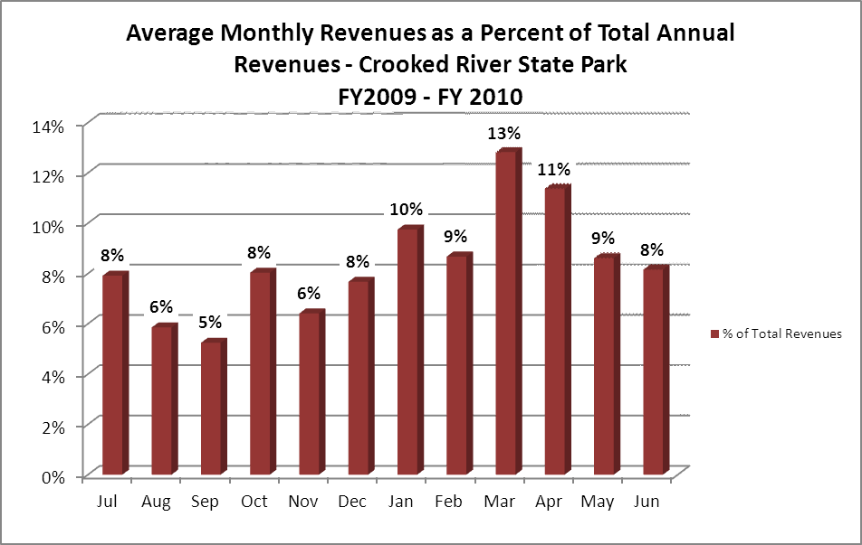
Cost Recovery Trends
Crooked River State Park has achieved an average cost recovery of 97% of annual operational expenses through earned revenues from FY 2008 to FY 2010. This is detailed and illustrated in the table and graph below.
Year | Operational  Expenses | Earned  Revenues | Percent Cost  Recovery
2008 | $525,150 | $458,314 | 87%
2009 | $465,470 | $466,285 | 100%
2010 | $437,535 | $455,812 | 104%

Review of Pricing
Data on rate information is available as far back as 2002, but only the last five years are evaluated. There has been notable growth in fees charged at Crooked River since 2005, with the largest increase being cottage rates which have increased by approximately 70%. A table detailing the rates for Crooked River is provided below.

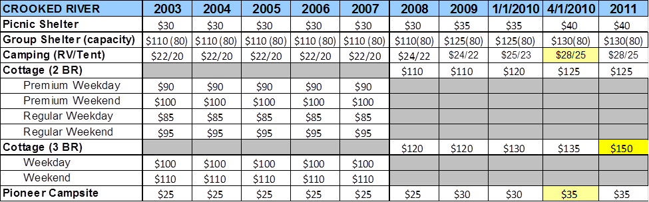
Business and Management Plan

Business Goals
The following goals serve as the foundation for the key recommendations and strategies in this business plan for Crooked River State Park.

Enhance Cost Recovery of Site Operations
Continue to closely monitor operating expenditures and labor costs to improve cost recoveries. Continue to research and implement cost saving measures related to energy efficiency and maintenance alternatives while conservatively spending operating funds to effectively maintain and manage all park facilities.

Enhance Revenue Generation Strategies
Implement packages and incentive programs to increase occupancy and repeat visitation. Develop and implement a rate adjustment tool that will enable park managers to immediately adjust rates when a downturn in occupancy is identified.

Expand Special Events at the Site
Great efforts have been made to establish successful special events at Crooked River. Being in a county that annually hosts 6 established festivals and 6 to 8 additional festivals in Brunswick and Jacksonville that require no fees to enter has proven to be detrimental to the success of our events. The annual Crooked River Spooktacular that is focused on Haunted Trail Rides and Nature Center has proven to be our one successful venture. Plans to add additional vendors and daytime activities are in place for the coming year. Our summer Junior Ranger camps are very successful and could be enhanced by adding additional dates throughout the year. To do this, additional staff members or volunteers would need to be committed to the venture.

Improve the Diversity and Innovation of Recreational and Interpretive Programs
To take advantage of the economic impact of eco-tourism, we will develop coastal experience packages that will focus on visitors that desire to get more from their stay than just clean accommodations. We plan to start offering a combination of a campsite/cottage stay with a guided kayak trip or birding adventure. This approach will attract visitors that are looking for that nature based experience that will satisfy their desire for a brush with nature and clean comfortable facilities.

Improve the Effectiveness of Marketing and Sales
Develop marketing strategies that focus on the reason visitors come to Crooked River. We are located on some of the most beautiful sections of waterway on the east coast and have immediate access to Cumberland Island. Our facility is located on the Coastal Birding Trail and is host to a vast array of migratory and local species. Our coastal waterways are some of the least utilized in the state. Their natural pristine beauty and abundance of fish stocks could be marketed to nature enthusiasts of all types.

Establish Greater Consistency of Managing and Monitoring Customer Service & Satisfaction
Develop an online customer response tool that compiles statistical data and includes areas for customer suggestions.

Expand Partnership Opportunities
We have recently partnered with Gillman Paper Co. which will allow us to escort guests on their properties to view the largest known wood stork nesting sites. Other partnerships are being explored.

Classification of Programs and Services
The tables below summarize the classifications of programs and services at Crooked River as either core, important, or visitor supported and projects a range of cost recovery percentages that might be achieved for each. These classifications establish financial performance goals for each category of services that are linked to the recommendations and strategies of this business plan.

Core Programs / Services | Target Cost Recovery
Stewardship of natural resources, property and revenues | 0%
Safety and security for guests, facilities and property | 0%
Maintenance of public drinking water system | 0%
Environmental education and public outreach programs | 10%

Important Programs / Services | Target Cost Recovery
Outdoor recreational opportunities | 10%
Nature trails | 10%
Picnicking | 10%
Wildlife observation | 10%
Entertainment based programming (campfire programs) | 10%

Visitor Supported Programs / Services | Target Cost Recovery
Camping | 150%
Cottages | 120%
Group shelter | 200%
Equipment rentals (mini-golf, bicycles) | 150%
Adventure outings ( kayak trips, guided nature walks and birding trips) | 100%
Picnic shelters | 50-70 %
Boat ramp and courtesy dock use | 100%
Access to the facility (A use fee needs to be implemented in addition to the parking fee. One example would be the new Georgia Outdoor Recreation Pass. WRD recognized that while every visitor utilizing WMAs had an impact on the facility, but only hunters and fishermen were paying the tab. Now every user incurs a fee to utilize the property. Many systems already have a use fee in place. Our Parkpass fee does not cover users who walk or ride their bikes onto our facilities but they share in the associated operational costs.)  ) | 100%
Retail Sales | 150%

Partnership Development Plan
The table below summarizes existing partners and targeted partnerships by classification (operational, vendor, service, co-branding, funding partners) and by organizational type.
 | Public Partners | Not-for-profit Partners | Private / Enterprise Partners
Operational Partners | - Camden Co. Sheriff’s Office  - Camden Co. Skills USA | - Coastal Audubon  - Coastal Wildscapes  - St. Mary’s Earthkeepers  - Keep GA Beautiful  - Boy/Girl Scouts  - Kiwanis International  - Coastal GA Education Group | - Wild Birds Unlimited  - Tail Chaser Charters
Vendor Partners |  |  | - Arts Camden Inc.  - GA Power  - Coke
Service Partners |  | - Camden Chamber Of Commerce  - GA Welcome Centers (Kingsland and Saint Mary’s)
Co-branding Partners | - Hofwyl Broadfield Plantation  - Cumberland National Seashore  - U.S. Fish & Wildlife Suwannee Canal Recreation Area
Funding Resource Development Partner |  | - Friends of the Park

Marketing and Sales Plan

Marketing and Sales Goals
Marketing and sales goals for Crooked River State Park are based on the following desired outcomes:
- Increase campground and cottage occupancy by 10%
- Increase shelter occupancy by 5%
- Increase program outreach by 16%
In order to meet these goals, examples of specific target outcomes were identified in the areas detailed in the table below.
Area  of Focus | Current  Performance | Goal  by 2011 | Goal  by 2012 | Goal  by 2015
Programs | 4732 | 4900 | 5300 | 5500
Campground | 37.71% | 40% | 43% | 47%
Cottages | 76.28% | 78% | 80% | 85%
Shelters | 1% | 1% | 3% | 5%

Marketing and Promotion Strategies

Publicity and Social Media
Crooked River will approach marketing and publicity planning using the following guidelines and themes:
- Event publicity
Major events benefit by having short stories in local, regional, and statewide newspapers and online social media hooks planted that run three to four weeks in advance of the event up to the date of the event itself. Stories and media need to be cultivated with contacts and online sales channels several weeks in advance of the time the stories need to run. Special interest interviews on morning, noon, and evening television news programs, radio interviews on popular rush-hour programs, and blogs on known affinity online sites should also be included.
- Program publicity
Special and unique programs should have feature stories in magazines, weekly newspapers, and statewide daily newspapers that are aimed at placements as front-page or sectional front-page stories. These stories are most effective if they run shortly before the season that the featured program begins. This will likely require several weeks of advanced planning with media contacts. Similar coverage on television and radio should also be considered. If pre-publicity cannot be generated, post-publicity can help promote future programs.
- Site Publicity
Site publicity focusing on a single site or sub-set of sites requires more intense planning efforts to attract multiple writers and editors from target publications. Each site could host several seasonal media familiarization tours (with 10 to 15 writers or editors) to familiarize them with the site and its benefits and amenities. Stories and features resulting from such tours typically take between two and six months to materialize so the tours should focus on experiences, benefits, and programs that would be available when the stories are expected to run.
Examples and suggested opportunities for events, programs and related publicity efforts based on the themes described above at Crooked River State Park are provided in the table below.
Event Publicity | Program Publicity | Site Publicity
Fall Haunted Park Event | Junior Rangers | PSA’s, Website, Facebook, Fliers at local businesses and libraries
Wedding Packages | Raptor Programs | “
 | Monthly Special Programs | “

Packaging
Examples and suggested packages for Crooked River are provided in the table below.
Package | Package Details
Piddle and Paddle Adventure Special | Reserve two nights in a cottage or three nights at a campsite and get a guided kayak trip. Package available Monday through Thursday during the months of July, August and September.
Birds of a Feather Special | Reserve two nights in a cottage or a campsite and receive a guided birding adventure. Package available Monday through Thursday during the months of July, August, September, January and February.
Premier Outdoor Adventure Package | Reserve a cottage or campsite for two nights in conjunction with a half or whole day guided fishing charter and receive a 25% discount for the entire experience. (Discount to be evaluated )
Day Use Wedding Bliss Package | Reserve a picnic shelter, seating for 100, altar for ceremony, and park passes for 25 cars.
Stay Use Premier Wedding Package | Reserve 3 or more cottages and group/picnic shelter, seating for 100, altar for ceremony, and park passes for 25 cars.
RV Club /Scouts Pkg deal | June-Sept or Jan-Feb reserve 15 or more camp sites at a discounted rate of $20 per site plus free use of Group Shelter Sun-Thurs.

Group Sales
Types of groups within which specific target customers can be identified for Crooked River are listed below:
- Camping Clubs  - Military Support Groups | - YMCA Family groups  - Church Groups | - Senior RV Travelers  - Scout Groups

Incentivizing New and Repeat Visitation
Crooked River will utilize the following strategies and/or incentives to encourage new and repeat visitation starting in FY 2012:
- Bring a friend or neighbor new to Crooked River and receive 2 nights of camping to be used anytime during the year. (Friend or neighbor must rent their own site)
- Camp six nights July thru September and receive 2 nights of camping to be used anytime during the year.
Marketing and Sales Metric Goals
The following marketing and sales metric goals and/or others will be monitored and progress reported:
- Loyalty and repeat customers = 60% Repeat customers
- Brand confidence & customers-recruiting-customers = 20% of new customers resulting in referrals from repeat customers.
Revenue Generation Plan
Revenue / Cost Recovery Goals
Crooked River has set a financial goal of increasing annual revenues 3% annually between 2012 and 2015. The largest revenue growth opportunity is most likely Campsite and Cottage rentals in conjunction with packages and incentives. The table below details projected revenue growth leading up to 2015, based upon a nominal growth of revenues each year. To accomplish the goals set forth in this plan it is necessary to increase expenditures to facilitate the adequate maintenance and improvement levels that Crooked River desperately needs. Continuing to ignore these items will result in a rapid decline in earned revenues.

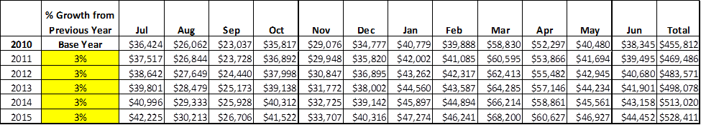
These projections would result in a total of 15% cumulative growth in total annual revenues between FY2010 and FY2015. If operational expenses can be managed with a cumulative increase of 10% between FY 2010 and FY 2015, then the overall cost recovery of the site will be approximately 124% in FY 2015 at these projected revenue levels. This is higher than the annual financial performance of the site in FY 2010, which was operated at 104% cost recovery in that year.
Revenue Generation Strategies

Pricing Plan
PARK RESERVABLES  Crooked River  State Park | Current Pricing (FY 2011) | Proposed Pricing  (FY 2012) | Positive Yield Mngmt Margin (%) | Negative Yield Mngmt Margin (%) | Positive  Yield  Mngmt  Margin ($) | Negative  Yield  Mngmt  Margin  ($)
Picnic Shelter | $35 | $40 | 15% |  | 6 | -6
Group Shelter (80 capacity) | 135 | 140 | 0 | 0 | 0 | 0
Camping (RV/Tent) | $28/25 | 28/25 | 0 | 0 | 0 | 5.60/5.00
Cottage (3 BR) | $150 | $150 | 0 | 25% | 0 | 37.5
Cottage (2 BR) | $125 | $125 | 0 | 25% | 0 | 31.25
Pioneer Campsite | $30 | $30 | 0 | 0 | 0 | 0

Innovative Programming and Special Events Plan
Program / Event | Theme / Purpose | Scheduled Date/Season | Frequency | Target Participation | Target User Fee | Target Cost Recovery
Fall Festival | Haunted Spooktacular | 3rd wknd October | Annual | 600-800 | $5 PP + $2 hayride | 100%
Holiday Festival | Winter/Holiday Caroling/Hayride | December | Annual | 50 | $5 PP + $1 Hayride | 100%
Pine Needle Program | Basketweaving | November | Annual | 20 | $5 PP + $25 fee | 100%
Kayak Trips | Marsh Exp. | July-Nov | Monthly | 6/trip | $5 PP + $45/tandem | 100%
Spring Festival | Spring Egg Hunt | Mar/April | Annual | 100-200 | $5 PP + $5 fee per family | 125%
Raptor Prog. | Raptors | July | Annual | 200 | $5 PP +$3/person | 100%
Sunset Dolphin Cruise | Dolphin and Marsh Ecology | April-Nov | Monthly | 6 | $5 PP  +$30 fee | 150%
Local Birding Excursions | Camden County Bird Hot spots | April- Nov | Monthly | 20 | $5 PP  +$10 fee | 150%
Cake Decoration and crafts | Crafts | June | Monthly | 12 | $5 PP  +$25 fee | 125%

Partnerships and Concessions Plan
Service / Partnership | Term of Service | Financial Objective | Contract Manager
Friends | Annual | Process donations & project money | Park Manager
Winged Ambassadors | Annual | Bring in more revenue through programming | Park Manager
Live Bait Sales Concession | 5 years | Increase revenue at no cost | Park Manager
Fishing charters, kayak outfitters, dolphin cruises | Annual | Partner with outfitters/guides to offer adventure based cottage packages | Park Manager

Expense Management Plan
Personnel Assignments
The following actions will be taken to proactively manage labor costs via personnel assignments and classifications.
Action | Timeline | Outcome
Change Park Ranger from Non-Exempt to Exempt | July 1, 2011 | As an integral part of the management team, this will allow the Park Ranger to work as needed.
Fill Naturalist position in order to have a staff position to develop and organize revenue generating programs. | July 1 2011 | This will increase revenue and visitation through promoting reservations and marketing of “experience” based packages especially during off peak months while providing enhanced opportunities for recreation, education, and exploration for all visitors.

Management Techniques
The following actions will be taken to proactively manage labor costs via management techniques.
Action | Timeline | Outcome
Reduce hourly labor when visitation is low | July 1, 2011 | Reduction in overall personnel services expenditures
Aggressively recruit volunteers with specific skills | Immediately and on-going | Reduction in overall personnel services expenditures and production of quality work at no cost.

Adjusted Levels of Service
The following actions will be taken to proactively manage labor costs via reduced levels of service.
Action | Timeline | Outcome
Reduction in amount of grounds to be maintained. | July 1, 2011 | Reduction of labor and cost of supplies.

Financial Pro Forma
The following five-year financial pro forma projects operating expenses, earned revenues and cost recovery through FY 2015. These pro forma are based on the strategies and desired outcomes identified in this business plan, especially the revenue generation and expense management plans, and are linked to corresponding performance goals.

Expense Pro Forma

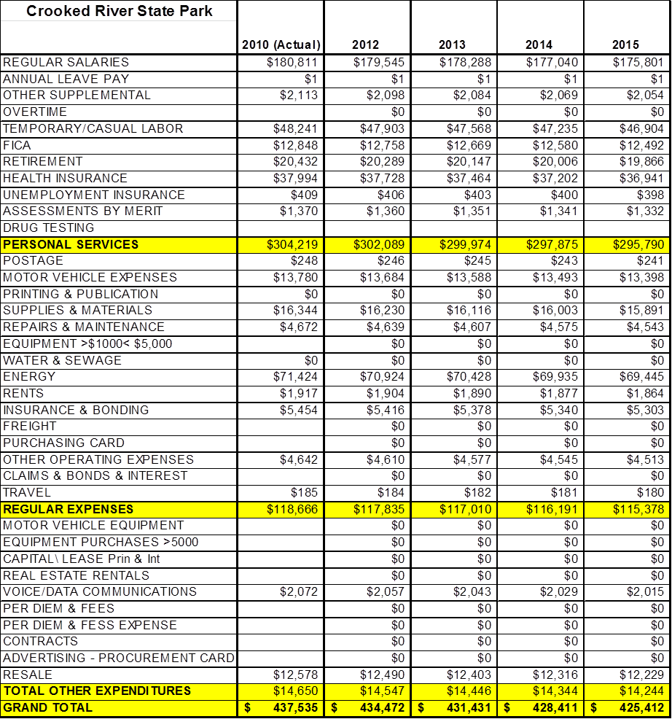

Revenue Pro Forma

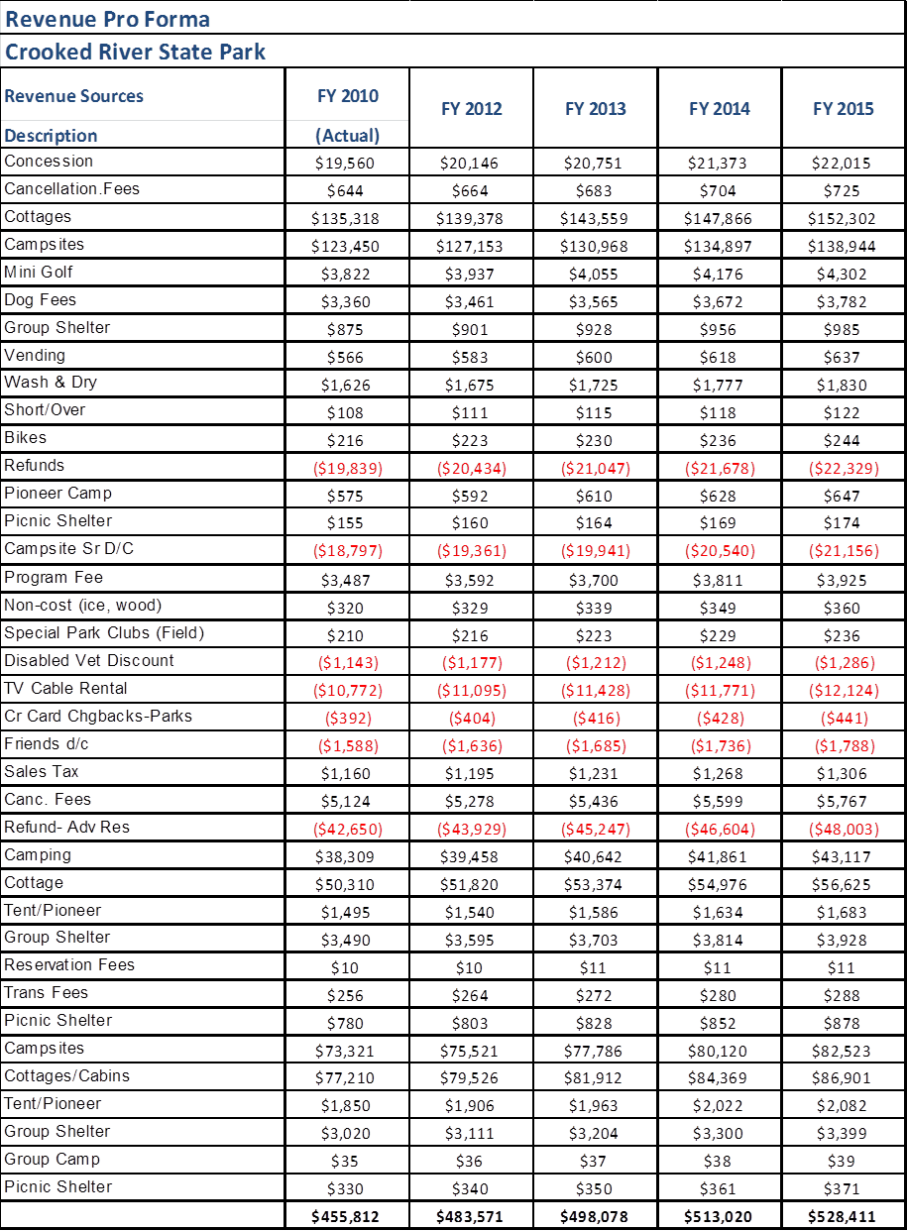

Total / Cost Recovery Pro Forma

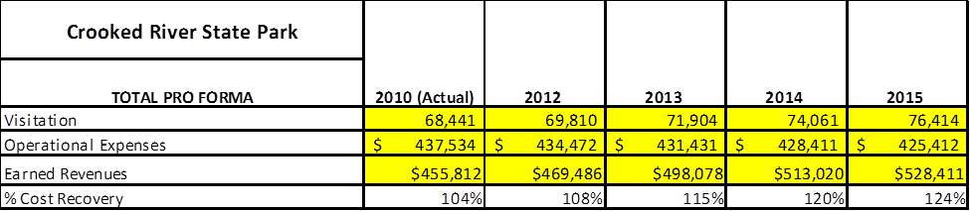

Action Plan
ACTION PLAN
Site: |  | Site Manager: |  |  | Date:
Month:
Strategy | Tasks | Costs / Funding | Revenues / ROI | Responsibilities | Metrics

ACTION PLAN
Site: |  | Site Manager: |  |  | Date:
Month:
Strategy | Tasks | Costs / Funding | Revenues / ROI | Responsibilities | Metrics

This is the average of the last three years – FY 2008, FY 2009, and FY 2010
Current employees, not including vacancies.
Current employees, not including vacancies.
Major population centers within a two-hour drive from the site

