Dahlonega Gold Museum
Business & Management Plan

Prepared June 2011; Finalized February 2013
Direction 2015 – Sustainable Business Planning

Table of Contents

Executive Summary 3

Site and Operations Assessment 6
Site Inventory and Facility Assessment 6
Operational Assessment 8
Financial Performance Assessment 12

Business and Management Plan 15
Business Goals 15
Classification of Programs and Services 16
Partnership Development Plan 18
Marketing and Sales Plan 19
Revenue Generation Plan 21
Expense Management Plan 23
Financial Pro Forma 24

Action Plan 26

Executive Summary
The Parks, Recreation and Historic Sites Division (PRHSD) of the Georgia Department of Natural Resources (DNR) is transitioning the management of The Dahlonega Gold Museum to operate more like a business, reflecting the Direction 2015 – Sustainable Business Planning initiative to improve the fiscal performance and management of the state parks and historic sites system. This business and management plan is designed to help the site recover more operating expenses through earned revenues, productive partnerships, and innovative programs.

Site Fact Sheet
Site Name | Dahlonega Gold Museum
On-Site Supervisor | Julia Autry, Interpretive Ranger (Satellite of Vogel)
Region Manager | Joe Yeager
Date of Business Plan completion | 5/18/2011
Site size | 1 Acre
Total number of visitors (FY 2010) | 43,095
Total operating budget (FY 2010) | $ 152,883
Total earned revenues (FY 2010) | $ 154,215
Operational cost recovery (FY 2010) | 101%
Average operating cost per visitor (FY 2010) | $ 3.55
Average earned revenue per visitor (FY 2010) | $ 3.58
Average cost recovery (FY 2008 – 2010) | 86%
Target cost recovery (FY 2015) | 100%
Total full-time employees | 3
Total part-time employees | 3 (Two positions paid for by partnership agreement)
Primary service markets | Atlanta, Gainesville, Northeast GA Mountains
Primary attractors/visitor appeal factors | History of gold mining in Georgia.
Leading opportunities for improved site performance | Expand and update exhibits to provide for better visitor experience. Increase small special events programming to increase revenue.

Site Summary and Key Attractions

The Dahlonega Gold Museum State Historic Site is housed in the historic Dahlonega courthouse building in the middle of downtown Dahlonega, GA. The first major gold rush in the United States happened in this small mountain town in 1829. Built in 1836, the Lumpkin County Courthouse building is one of the oldest surviving courthouses in Georgia and is on the National Register of Historic Places. Today, the museum has exhibits on the 1828 gold rush, the U.S. Mint in Dahlonega, and various gold mining techniques. A tour includes a 17-minute film, “America’s First Gold Rush”. The most talked about exhibit is the collection of Dahlonega gold coins and nuggets. The site has a complete set of Dahlonega minted coins, which are some of the rarest collectable coins in the United States.

Key Attractions
The amenities or features listed below are those that seem to be most popular for visitors.
- Site Film
- Gold Safe (Gold Nuggets & Coins)
- Water Cannon
- Gold in the Bricks
- Gold Maps

Financial Targets
The table below details the total operating expenses and earned revenues for Dahlonega Gold Museum over the last three years (2008 – 2010). This table also calculates total cost per visitor and revenues per visitor during these operating years, and details the target financial performance goals in the context of achieving at least 100% cost recovery. This table also calculates the necessary change from 2010 operating expenses and revenues.
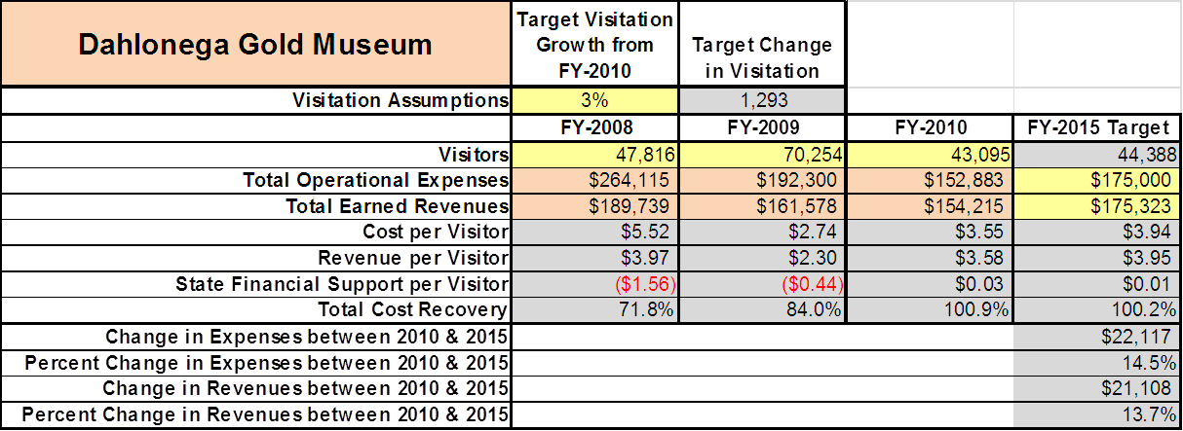

Key Recommendations

Primary / Short Term Recommendations
- Update our severely outdated exhibits to increase visitor’s positive experience and create positive promotional materials on the “new and improved museum” in various media outlets.
  - Add displays and exhibits that relate and are more interactive with younger audiences.
- Plan and implement special events in December, January and February to increase visitation in our least visited months.
  - DGM open house program to recruit new volunteers.
  - Gold Museum After Dark programs to increase revenue opportunities after normal business hours.
- Continue good relations with the Friends of the Dahlonega Gold Museum and utilize more funding support to minimize operational costs whenever possible.
  - Friends of DGM funds would be directed towards funding two part time positions as well as various supplies and materials needed for routine maintenance.
- Continue to develop a good relationship with the Dahlonega Downtown Development Authority to find ways to mutually promote visitation in the town square, and thus into the museum.
  - Advertise city events through the DGM website and other media outlets in exchange for the same service for the DGM on the city’s website.
- Continue our positive relationship with the Dahlonega Chamber of Commerce to promote Gold Museum events with their media & media contacts.
- Track total economic impact of the site on the local communities and region and share with decision-makers, elected officials, local business operators and others to demonstrate the impact of DGM.
- Add more youth-focused services, programs and amenities at the site that appeal to younger audiences, families and educational groups.
  - Tailor school programs to meet school curriculum standards.
  - Tailor tours to meet badge requirements for scout groups.
- Add more services, programs and amenities that appeal to older adults.

Secondary / Long Term Recommendations
- Continue to improve and enrich the visual impact of the retail sales area to promote better concession sales numbers.
- Engage the local community, user groups, and private organizations to improve connectivity between DGM and other local state parks (Amicalola Falls, Unicoi & Vogel).
- Engage the local community, user groups, and private organizations to improve connectivity between DGM and local attractions including gold mines, Chestatee Wildlife Center, local wineries, etc.

Site and Operations Assessment
This site and operations assessment is a culmination of analyses and findings from a review of the condition of facilities, infrastructure, and operations at Dahlonega Gold Museum. The findings and observations are not intended to be an exhaustive review of all issues present, but provide a basic understanding of the predominant issues that contribute to the site’s current operating conditions. The assessment includes the following:
- Site Inventory and Facility Assessment
- Operational Assessment
- Financial Assessment
Site Inventory and Facility Assessment

Methodology
Facility and asset conditions are rated using a differential scale of excellent, good, fair, or poor. Descriptions of conditions that are attributed to each of these findings are also provided.
Scale of Conditions
Rating | General Description
Excellent | Facilities/amenities are in ‘excellent’ condition when they show little or no maintenance or repair problems. Facilities do not feature any major design or operational issues or flaws that contribute to diminished use or increased maintenance or upkeep. Facilities are easy to clean and maintain in order to place them back into public use and the users perceive them to be in excellent shape.
Good | Facilities/amenities are in ‘good’ condition when they show only minor maintenance or repair problems. Most maintenance issues with these facilities typically appear to be the result of age and/or heavy use. Facilities may only feature minor design or operational issues that contribute to diminished use or increased maintenance or upkeep. Facilities are moderately easy to clean and maintain in order to place them back into service and the users perceive them to be adequate for their use, but probably not in excellent shape.
Fair | Facilities/amenities are in ‘fair’ condition when they show significant maintenance or repair problems. Facilities generally exhibit ongoing maintenance issues that appear to be the result of age, heavy use, or design or operational flaws. Some maintenance and repair needs may compound their fair condition by being deferred because of budget and/or resource limitations. Facilities require more effort to clean and maintain before placing them back into service and the users may perceive them as being less than adequate for their use and in a state of deterioration. The facility or structure may need of major repair or replacement.
Poor | Facilities/amenities are in ‘poor’ condition when they show significant, on-going maintenance or repair problems that ultimately may result in suspended use for repair/replacement. Maintenance and repair issues are possibly the result of poor maintenance and clearly the result of age, heavy use, or design or operational flaws. Problems with the facilities are often compounded over time due to consistently-deferred maintenance and repair because of budget and/or resource limitations. Facilities may feature major design or operational issues that contribute to diminished use or increased maintenance or upkeep. Facilities require excessive effort to clean and maintain before placing them back into service and the users often perceive them as being inadequate for their use and in a state of serious deterioration. The facility or structure may need of major repair or replacement.

Inventory and Assessment
The table below is an inventory of facilities and amenities at Dahlonega Gold Museum, and provides the assessed condition of each as reviewed in May 2011.

Site Asset / Amenity | Quantity | Condition
Lawn (1 Acre) | 1 | Fair (being improved)
Dahlonega Courthouse Building | 1 | Fair
Gift Shop | 1 | Good
Offices | 2 | Good
Attic (Storage) | 1 | Poor
Exhibit Rooms | 6 | Fair
Theater | 1 | Good

Prioritized Facility Needs
Based on the facility inventory and assessment, these prioritized needs have been identified. Each need has been aligned with a priority category of high, moderate, or low to support future decision making regarding project sequencing, investment of public resources, and meeting community expectations. The priority assignment for each need is not a measure of importance. Rather, these recommended priorities reflect a phased implementation approach over the next several years.

Facility Need | Priority Assignment
Add additional decking, insulation, hand rails and lighting to the attic to increase storage | High
Update severely outdated exhibits | High
Landscape & beautify museum grounds (ongoing) | Moderate
Update heat and air system (being improved currently) | Low
Improve retail merchandise area/gift-shop displays | Moderate

Operational Assessment
The Operational Assessment includes:
- An inventory and classification of programs and services being provided at the site
- A review of staffing at the site
- A review of concessionaires and partners operating at the site
- Visitation and customer satisfaction

Inventory and Classification of Programs and Services
Programs and services are classified into one of three major categories:
1) Core or Essential Services
2) Important Services
3) Visitor Supported Services
Programs and services at the site are classified into these categories based in part on the mission and public mandates for both the site and the agency. For the services in each of these categories, there are financial performance expectations that will define how services are funded and evaluated.

Category 1 – Core Services [Largely supported by tax funds]
Core programs, services and facilities are those the agency must provide and/or are essential in order to capably govern and meet statutory requirements. The failure of the agency to provide Category 1 services at adequate levels could result in significant negative consequences for the public and the resources under protection. The criteria for services to be classified as core or essential are:
- The services are mandated by the agency’s law or charter or are contractually obligated by agreement to provide the services.
- The services are essential to protecting and supporting the public’s health and safety.
- The services protect and maintain valuable assets and infrastructure.
- The services would generally and reasonably be expected and supported by residents, businesses, customers and partners.
- The services are those that cannot or should not be provided by the private sector.
- The services provide a sound investment of public funds.
The following services offered at Dahlonega Gold Museum have been identified as core services:
- Continue to manage and maintain the various historical artifacts on the site, including the Dahlonega Courthouse building, which is over 175 years old
- Provide site access to the public
- Provide the public with accurate, educational and entertaining interpretation to enhance their visit and further their appreciation for Georgia’s unique history
- Public safety
- Maintain grounds
- Security of gold held on the premises

Category 2 – Important Services [Supported by a balance of tax funds and earned revenues]
Important programs, services and facilities are those the agency should provide, and are important to governing and effectively serving residents, businesses, customers and partners. Providing Category 2 services expands or enhances the agency’s ability to provide and sustain its core services. The criteria for programs or services to be classified as important are:
- The services expand, enhance or support identified core services.
- The services are broadly supported and utilized by the community, and are considered an appropriate, important, and valuable public good. Public support may be conditional upon the manner by which the services are paid for or funded.
- The services generate income or revenue that offsets some or all of the operating cost and/or are deemed to provide economic, social or environmental outcomes or results.
The following services offered at Dahlonega Gold Museum have been identified as important services:
- Written brochures and interpretive materials
- Public access to historical materials
- Interpretive programming outdoors on museum grounds

Category 3 – Visitor Supported Services [Almost exclusively supported by earned revenue]
Visitor supported programs, services and facilities are those discretionary services that the agency may provide when additional funding or revenue exists to offset the cost of providing those services. Category 3 services provide added value above and beyond what is required or expected. The criteria for programs or services to be classified as visitor supported are:
- The services expand, enhance or support core services or important services and the quality of life of the visitors, community or stakeholders.
- The services are supported, valued and well utilized and provide an appropriate and valuable public benefit.
- The services generate income or funding from sponsorships, grants, user fees or other sources that offset some or all of their cost and/or provides a meaningful return on investment.

- The services can possibly be provided through outsourcing or use of concessionaires, providing opportunities for community enterprises that may not otherwise be provided by the agency.

The following services offered at Dahlonega Gold Museum have been identified as visitor supported services:
- Gift shop
- Guided group tours
- Special events / programs related to the site
- Special events / lectures not related to the site (i.e. Historical Societies )

Staffing Assessment
Labor costs at Dahlonega Gold Museum represent the largest area of budgetary expense at an average of 63% of the total operating budget each year for the last three complete years, which is lower than the target of total labor costs (including benefits) not exceeding 65% of the site’s total operating expenditures. The cost of part-time labor is currently offset through a partnership agreement with the Friends of the Gold Museum, which pays for the cost of two part-time personnel positions. The tables below and on the following page provide a basic review of the current staffing at the site.

Full Time Equivalent Employees
Position / Title | Quantity (FTE) | Vacancies | Annual Hours
Interpretive Ranger | 1 |  | 2080
Exhibit Guide | 2 |  | 4160
TOTAL | 3 |  | 6,240

Part Time Employees
Position / Title | Quantity (FTE) | Vacancies | Hours
Tour Guide | 3* |  | 3120
TOTAL | 3 |  | 3,120
*Two of the three positions are paid for via partnership agreement.

Labor Support
Labor Support | Annual Hours
Volunteers | 2000
Community Service Workers | 0
Engineering and Construction Crews | 0
Resource Management Crews | 0
TOTAL | 2,000

Total Labor Hours
Labor Type | Annual Hours
Full Time Equivalent Employees | 6,240
Part Time Employees | 3,120
Labor Support | 2,000
TOTAL Annual Labor Hours | 11,360

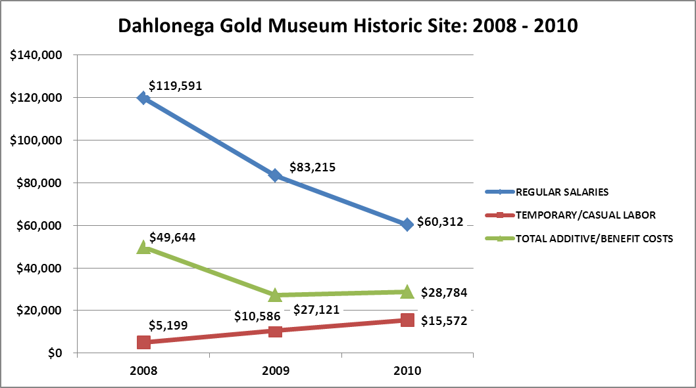
Labor Budget Summary
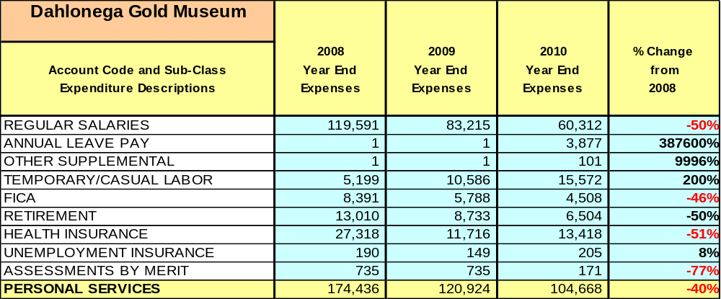

Visitation and Occupancy
Overall annual visitation to the site has trended downward from 2008 to 2010, decreasing by 11% or over 4,721 visitors. This is largely attributed to rising fuel costs and the economic downturn’s impact on school field trips, day trip visitors and vacationers.
Year | Total Visitation
2008 | 47816
2009 | 70254
2010 | 43095
Financial Performance Assessment

Operational Expenses
A summary of total operating expenses at Dahlonega Gold Museum from 2008 to 2010, as well as their percent change from 2008 are provided in the table below.

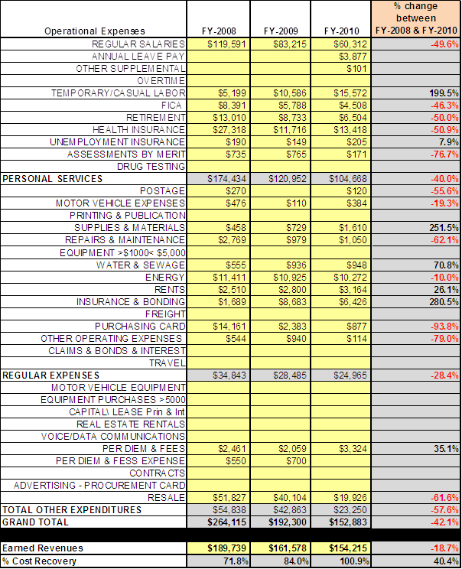

Earned Revenues
Earned revenues at Dahlonega Gold Museum have decreased since 2008, which is largely attributed to the corresponding decrease in overall visitation.
Monthly earned revenues for the last two years (see table on the following page) indicate that the total annual revenue decreased 4.6% from 2009 to 2010, with the largest increase in monthly revenues in September (50%) and the largest decreases in the months of August (-22%) and February (-20%).

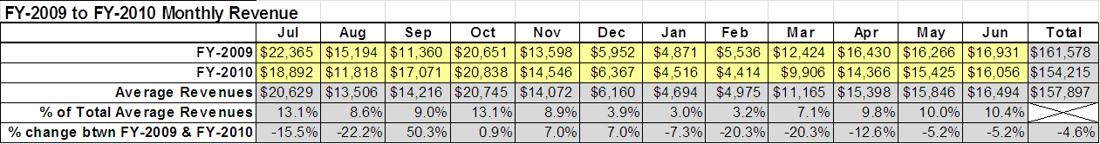
The graphs below illustrate the monthly revenue trends each year and the average percent of total annual revenue earned each month.

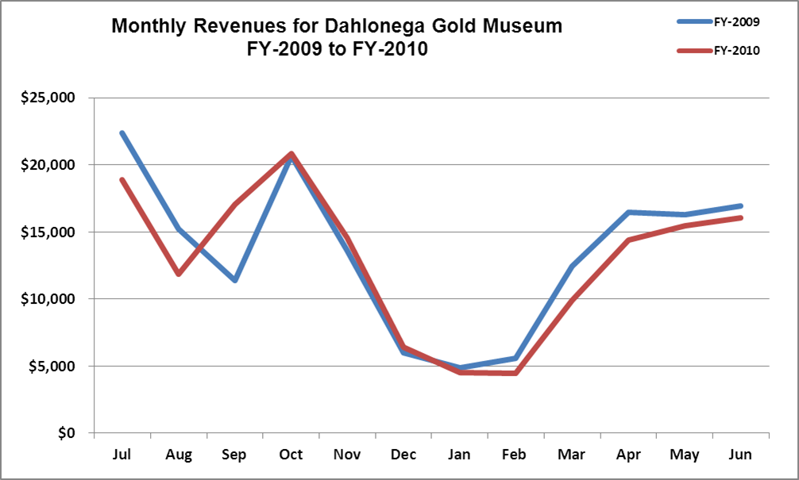

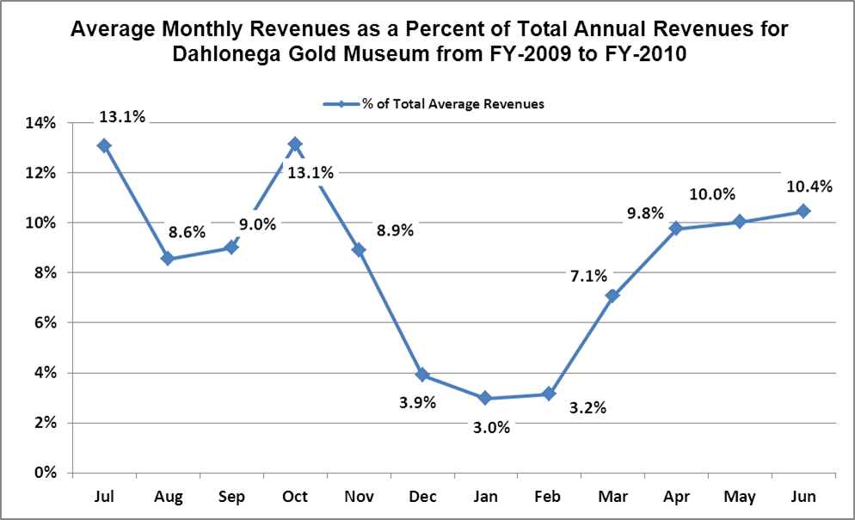
Cost Recovery Trends
Dahlonega Gold Museum has achieved an average cost recovery of 86% of annual operational expenses through earned revenues from FY 2008 to FY 2010. This is detailed and illustrated in the table and graph below.
Year | Operational  Expenses | Earned  Revenues | Percent Cost  Recovery
2008 | $ 264,115 | $ 189,739 | 72%
2009 | $ 192,300 | $ 161,578 | 84%
2010 | $ 152,883 | $ 154,215 | 101%

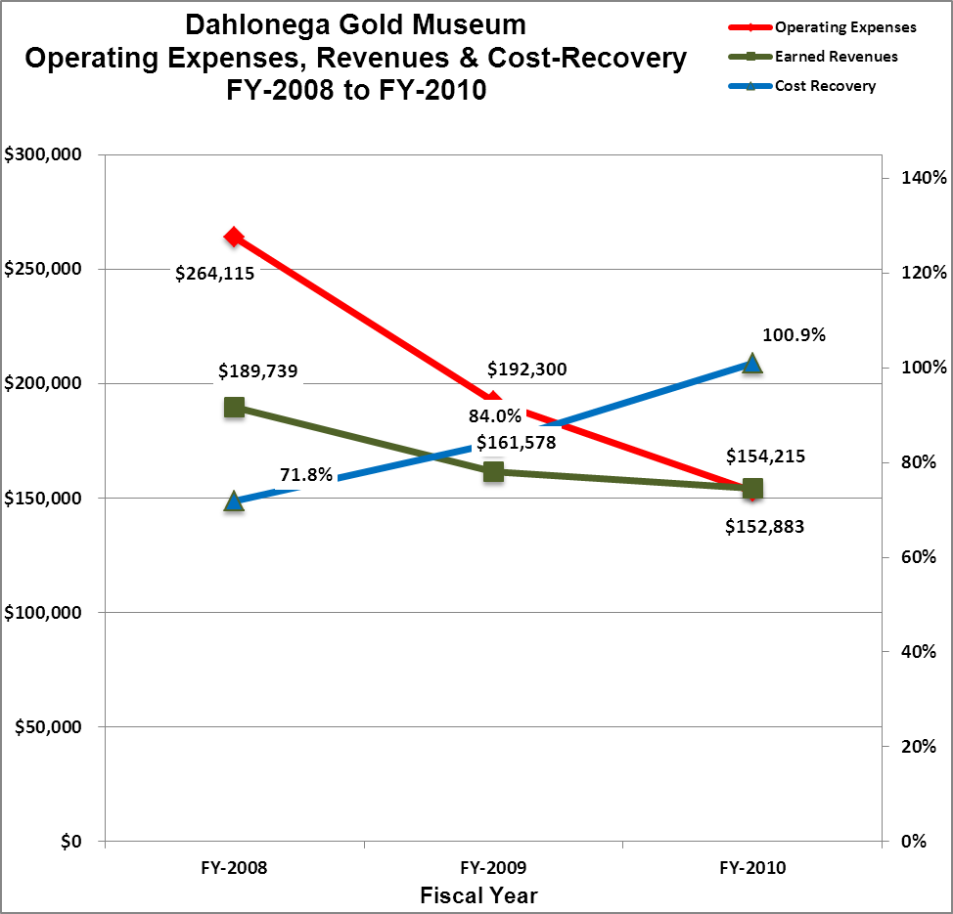

Review of Pricing
Data on rate information is available as far back as 2002, but only the last five years are evaluated. There has been a nominal increase in fees charged at the Dahlonega Gold Museum since 2005. A table detailing the rates change is provided below.
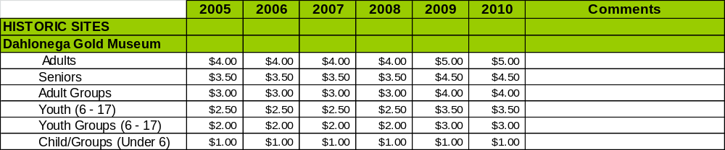
Business and Management Plan

Business Goals
The following goals serve as the foundation for the key recommendations and strategies in this business plan for Dahlonega Gold Museum.

Enhance Cost Recovery of Site Operations

The Dahlonega Gold Museum State Historic Site is operating at an average of 88% cost recovery of operational expenses through earned revenues over the last three fiscal years. While historic sites generally have a more difficult time generating revenues to offset expenses, and with staff already reduced to a minimum, the Gold Museum can likely improve revenues through additional special events and other measures to draw more visitors to the site and generate higher revenues. As there is extremely limited program space at the museum, special efforts to increase the amount of smaller programs throughout the year could effectively facilitate an increase in visitation. If the existing exhibits are improved and modernized then the Gold Museum could definitely justify a significant increase in admissions which would aid in cost recovery as well. However, with the current plain and dated exhibit displays, and virtually no exhibits geared toward youth, only modest increases in admissions are recommended.

Enhance Revenue Generation Strategies

Increasing earned revenues will most likely result from the impacts of both increased visitation at the site and specific revenue enhancement strategies. The Gold Museum will improve revenue generation through increasing the number and type of special events held at the site and the fees charged for the events, and by enhancing the resale space for more dynamic impact to improve resale sales.

Expand Special Events at the Site

All of the major programs and events at the site are directly linked to the unique history of the site. Because the Gold Museum is housed inside an authentic 175 year old courthouse, it is distinctively inhibited by a lack of programming space which makes large-scale events virtually impossible. However, the expansion of smaller indoor programs, especially during off season weeks, could significantly impact visitation.

Improve the Diversity and Innovation of Recreational and Interpretive Programs

The exhibits and displays at the Gold museum are rather stagnant and outdated and as with many historic sites, the Gold Museum features exhibits and displays that are predominantly adult centered. It will be crucial for the site to improve the appeal of all interpretative resources (e.g., displays, exhibits, and programs) to a wider range of age groups. For example, consideration should be given to developing exhibits that are tactile and experiential in order to best connect with younger audiences. Additionally, consideration should be given to providing more innovative exhibits including traveling displays on loan from other museums in order to encourage repeat visitation.

Improve the Effectiveness of Marketing and Sales

The effectiveness of marketing and promotional activities of the Gold Museum could be improved to produce greater visitation and revenues during peak, shoulder, and off seasons. This could be achieved in part through a shift in the existing marketing approach to one that is more targeted and focused on experiential and encouraging messaging geared to historic sites. Additionally, partnerships with nearby attractions and amenities in the region should improve the ability of the site to maintain an increased and steady flow of visitors and revenue throughout the year. A significant opportunity to increase visitation to the Gold Museum exist with GA State Route 400 traffic. Added signage along 400 (including billboards) emphasizing the museum and our gold displays would prove beneficial in increasing traffic.

Establish Greater Consistency of Managing and Monitoring Customer Service & Satisfaction

The Gold Museum will strive to have 90% of visitors responding to ‘Comment Cards’ report that they were either ‘satisfied’ or ‘very satisfied’. Better processes for evaluation of special programs by staff, volunteers and visitors should be established to improve programs being offered. All events/programs offered should be closely evaluated and value(s) determined to decide whether event is held or discontinued.

Expand Partnership Opportunities

Although the Gold Museum State Historic Site has a history of network marketing with the City of Dahlonega, local merchants within the historic Dahlonega town square, and with the two local gold mine attractions, opportunities for greater marketing and partnering for special events and programs still exist. Greater corporate and local municipal co-sponsorship or partial support from the northeast Georgia mountain region for both special events and regular operations should be solicited and increased.

Classification of Programs and Services
The tables below summarize the classifications of programs and services at Dahlonega Gold Museum as either core, important, or visitor supported and projects a range of cost recovery percentages that might be achieved for each. These classifications establish financial performance goals for each category of services that are linked to the recommendations and strategies of this business plan.

Core Services
Program / Service | Target Cost Recovery
Continue to manage and maintain the various historical artifacts on the site including the Dahlonega Courthouse building, which is over 175 years old | 0%
Provide site access to the public | 0%
Provide the public with accurate, educational and entertaining interpretation to enhance their visit and further their appreciation for Georgia’s unique history | 20% to 50%
Public safety | 0%
Maintain grounds | 0%
Security of gold held on the premises | 0%

Important Services
Program / Service | Target Cost Recovery
Written brochures and interpretive materials | 20 to 80%
Public access to historical materials | 50% to 80%
Interpretive programing outdoors on museum grounds | 40% to 80%

Visitor Supported
Program / Service | Target Cost Recovery
Gift Shop | 150% to 200+%
Guided group tours | 100% to 150%
Special events / programs related to the site | 100% to 150%
Special events/ programs not related to the site | 100% to 150%
Partnership Development Plan
The table below summarizes existing partners and targeted partnerships by classification (operational, vendor, service, co-branding, funding partners) and by organizational type.
 | Public Partners | Not-for-profit Partners | Private / Enterprise Partners
Operational Partners | - City of Dahlonega  - Dahlonega Downtown Development Authority  - Lumpkin County | - Friends of the Dahlonega Gold Museum
Vendor Partners
Service Partners | - City of Dahlonega  - Dahlonega Downtown Development Authority | - Chamber of Commerce
Co-branding Partners | - Vogel State Park  - Amicalola Falls State Park  - North GA College & State University |  | - Local Wineries  - Consolidated Mine  - Crisson Mine  - Chestatee Wildlife Center
Funding Resource Development Partner |  | - Friends of Georgia State Parks and Historic Sites  - Friends of the Dahlonega Gold Museum

Marketing and Sales Plan

Marketing and Sales Goals
Marketing and sales goals for Dahlonega Gold Museum are based on the following desired outcomes:
- To produce more interpretive programs that draw visitors to the site
- To produce more signature events with larger participation
- To produce increased overall visitation and revenues
In order to meet these goals, examples of specific target outcomes were identified in the areas detailed in the table below.

Area  of Focus | Current  Performance | Goal  by 2011 | Goal  by 2012 | Goal  by 2015
Special Events | Unknown | 1,000 vis. / yr | 2,000 vis./yr | 3,000 vis./yr
Overall Visitation | 43,095 | 44,095 | 46,095 | 49,095

Marketing and Promotion Strategies

Publicity and Social Media
Dahlonega Gold Museum will approach marketing and publicity planning using the following guidelines and themes:
- Event publicity
Major events benefit by having short stories in local, regional, and statewide newspapers and online social media hooks planted that run three to four weeks in advance of the event up to the date of the event itself. Stories and media need to be cultivated with contacts and online sales channels several weeks in advance of the time the stories need to run. Special interest interviews on morning, noon, and evening television news programs, radio interviews on popular rush-hour programs, and blogs on known affinity online sites should also be included.
- Program publicity
Special and unique programs should have feature stories in magazines, local and regional weekly newspapers, and statewide daily newspapers that are aimed at placements as front-page or sectional front-page stories. These stories are most effective if they run shortly before the season that the featured program begins. This will likely require several weeks of advanced planning with media contacts. Similar coverage on television and radio should also be considered. If pre-publicity cannot be generated, post-publicity can help promote future programs.
- Site Publicity
Site publicity focusing on a single site or sub-set of sites requires more intense planning efforts to attract multiple writers and editors from target publications. Each site could host several seasonal media familiarization tours (with 10 to 15 writers or editors) to familiarize them with the site and its benefits and amenities. Stories and features resulting from such tours typically take between two and six months to materialize so the tours should focus on experiences, benefits, and programs that would be available when the stories are expected to run.
Examples and suggested opportunities for events, programs and related publicity efforts based on the themes described above at Dahlonega Gold Museum are provided in the table below.

Event Publicity | Program Publicity | Site Publicity
Gold Rush Festival | Artifact Day | Lectures
Bear on the Square | Coin Identification | Genealogy Class
Mountain Flower Fest | Appalachian Jam
Six Gap Bike Race

Packaging
Examples and suggested packages for Dahlonega Gold Museum are provided in the table below.

Package | Package Details
Gold Fever Package | Group rate admissions for Gold Museum and local gold mines
GA Mountain Package | Special rates encouraging exploration of Dahlonega Gold Museum Historic Site along with Amicalola Falls, Unicoi, and Vogel State Parks
Local College Rates | For NGCSU, Bernau, and Lanier Tech
Senior Tour Rate | Group rate admissions for senior groups (i.e. Road Scholar (Elderhostel), Church Groups, Senior Centers, etc.)

Group Sales
Types of groups within which specific target customers can be identified for Dahlonega Gold Museum are listed below:
- Families  - Youth service organizations  - Churches  - Activity or special interest clubs | - Senior Citizens  - Schools (public and private)  - Colleges and universities  - Associations | - Other public agencies  - Community organizations  - Scouts  - GA Dept of Education

Incentivizing New and Repeat Visitation
Dahlonega Gold Museum will utilize the following strategies and/or incentives to encourage new and repeat visitation starting in FY 2012:
- Group / bulk pricing options
- Differential pricing based upon days of week, peak or off-peak seasons, etc.
- Increased marketing/advertising along GA 400 between Atlanta and Dahlonega
Marketing and Sales Metric Goals
The following marketing and sales metric goals and/or others will be monitored and progress reported at Dahlonega Gold Museum:
- Loyalty and repeat customers = 35% local families returning with out of town guests primarily. New Historic Site family pass should be marketed for these return visitors.
- Brand confidence & customers-recruiting-customers = 15% zip codes from visitor’s register will aid in targeting specific areas to implement marketing strategies.
Revenue Generation Plan
Revenue / Cost Recovery Goals
Dahlonega Gold Museum has set a financial goal of increasing annual revenues 13% total between 2010 and 2015. The largest revenue growth opportunity is most likely during school group season in April, May, September, October, and November. The table below details projected revenue growth leading up to 2015, based upon a nominal growth of revenues each year.

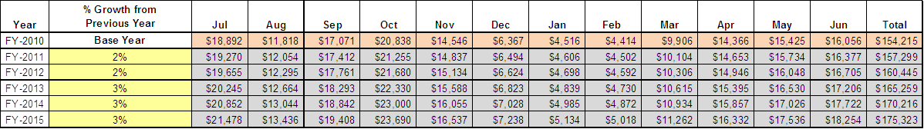
These projections would result in a total of 14% cumulative growth in total annual revenues between FY2010 and FY2015. If operational expenses can be managed with a cumulative increase of 14% between FY 2010 and FY 2015, then the overall cost recovery of the site will be approximately 100% in FY 2015 at these projected revenue levels. This is the same as the annual financial performance of the site in FY 2010, which was operated at 100% cost recovery in that year.
Revenue Generation Strategies

Pricing Plan

Dahlonega Gold Museum  Pricing Chart |  | Current Pricing | Proposed Pricing  2012* | Yield Management  Margin
 | Adults | $5.00 | $6.00
 | Seniors | $4.50 | $5.50
 | Adult Groups | $4.00 | $5.00
 | Youth (6-17) | $3.50 | $3.50
 | Youth Groups (6-17) | $3.00 | $3.00
 | Child/Groups (under 6) | $1.00 | $1.00
*Without significant improvements to current displays & exhibits only modest increases in admission pricing should be considered. However, if enhancements and updating of display areas are made, then substantial admission price increases would be justified in all categories in the future.

Innovative Programming and Special Events Plan

Program / Event | Theme / Purpose | Scheduled Date/Season | Frequency | Target Participation | Target User Fee | Target Cost Recovery
Appalachian Jam | Community goodwill / Promotional | Saturday afternoons, April – October | Annually | 100+ | Admission Fee | 100% profit
Artifact ID Day | Historical/ Promotional /Educational | Winter | Annually | 50+ | Admission Fee | 100% Profit
Coin ID Day | Historical/ Promotional /Educational | Winter | Annually | 50+ | Admission Fee | 100% Profit
Genealogy Class | Historical/ Promotional /Educational | Winter | Annually | 25+ | Increased Fees | 200% Profit
Lectures | Historical/ Promotional /Educational | Any Saturday throughout the year | Annually | 25+ | Admission Fee | 100% Profit
Gold Museum Travel Trunk | Historical/ Promotional /Educational | As schools book | Annually | 25 – 100+ | Per Student Fee | 100%-150%

Partnerships and Concessions Plan

Service / Partnership | Term of Service | Financial Objective | Contract Manager
Friends of the Gold Museum, Dahlonega Downtown Development Authority, City of Dahlonega & Lumpkin County | Year to Year | To provide the operational costs of the museum two days a week and the cost of two part-time tour guides. | Joe Yeager, Region One Manager

Expense Management Plan
Personnel Assignments
The following actions were taken since June of 2009 to proactively manage labor costs via personnel assignments and classifications.

Action | Timeline | Outcome
Reduced full-time positions by 50% | June 2009 | Annual labor cost reduction of 50% since 2008
Reduced part-time positions by 50% | June 2009 | Part Time labor cost reduction of 50%
Entered into partnership agreement with the Friends of the Gold Museum, the Dahlonega Downtown Development Authority, the City of Dahlonega & Lumpkin County | September 2009 | Provided the capital for two part-time labor salaries.

Management Techniques
The following actions have & will be taken to proactively manage labor costs via management techniques.

Action | Timeline | Outcome
Increased the use of volunteers to assist in periods of high volume visitation | June 2009 | Helped to lessen the impact labor cutbacks
Increase the use of volunteers for site and grounds maintenance | July 2012

Adjusted Levels of Service
The following actions will be taken to proactively manage labor costs via reduced levels of service.

Action | Timeline | Outcome
Elimination of “A Day in a Miners Life” program | July 2011 | Save $300+ on cost of exhibitors & re-enactors for an exterior program which only provided income if the visitors came indoors.

Financial Pro Forma
The following five-year financial pro forma projects operating expenses, earned revenues and cost recovery through FY 2015. These pro forma are based on the strategies and desired outcomes identified in this business plan, especially the revenue generation and expense management plans, and are linked to corresponding performance goals.

Expense Pro Forma

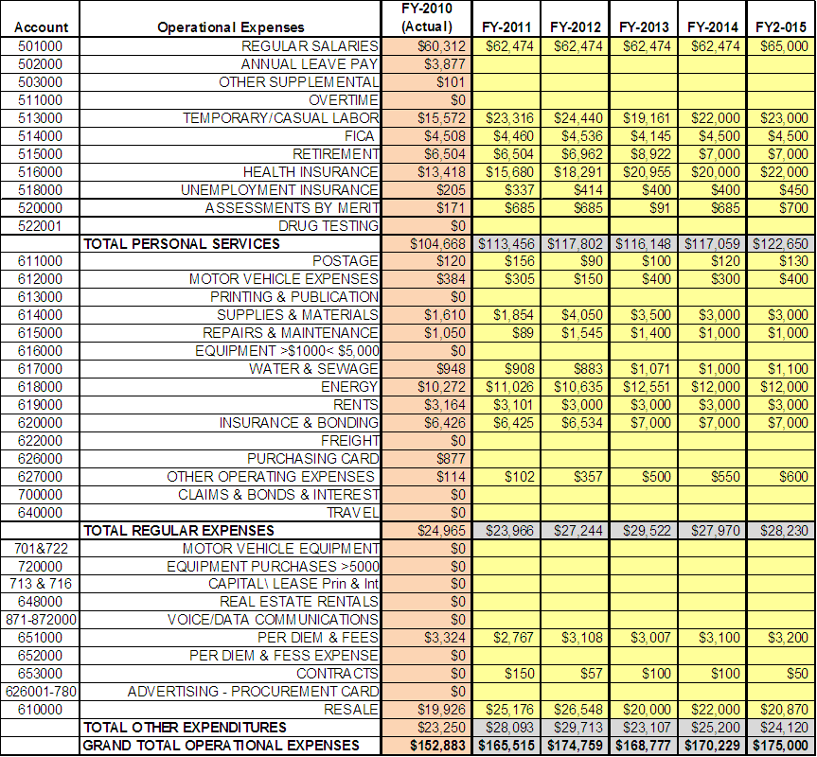

Revenue Pro Forma

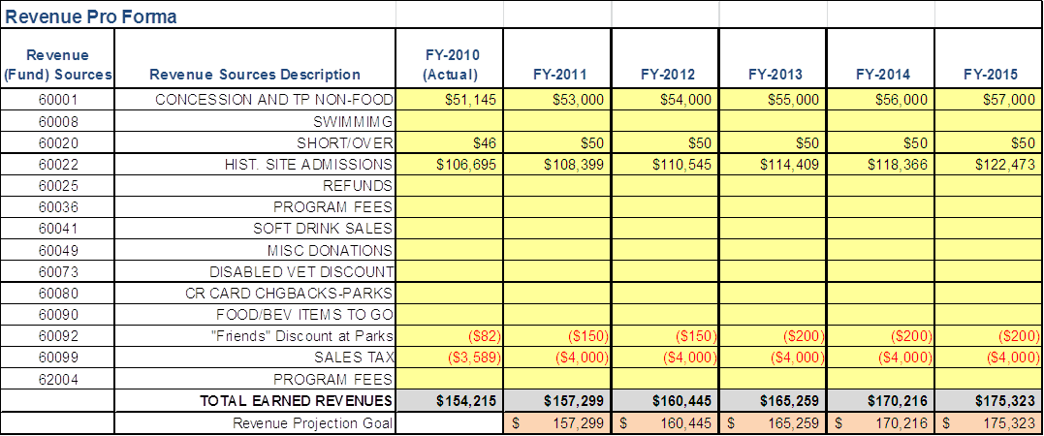

Total / Cost Recovery Pro Forma

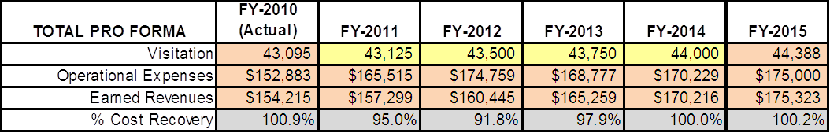

ACTION PLAN
Site: |  | Site Manager: |  |  | Date:
Month:
Strategy | Tasks | Costs / Funding | Revenues / ROI | Responsibilities | Metrics

Action Plan

This is the average of the last three years – FY 2008, FY 2009, and FY 2010
Current employees, not including vacancies.
Current employees, not including vacancies.
Major population centers within a two-hour drive from the site

