Elijah Clark State Park
Business & Management Plan

Prepared June 2011; Finalized December 2012
Direction 2015 – Sustainable Business Planning

Table of Contents

Executive Summary 3

Site and Operations Assessment 6
Site Inventory and Facility Assessment 6
Operational Assessment 8
Financial Performance Assessment 13

Business and Management Plan 16
Business Goals 16
Classification of Programs and Services 18
Partnership Development Plan 19
Marketing and Sales Plan 20
Revenue Generation Plan 22
Expense Management Plan 23
Financial Pro Forma 24

Action Plan 27

Executive Summary
The Parks, Recreation and Historic Sites Division (PRHSD) of the Georgia Department of Natural Resources (DNR) is transitioning the management of Elijah Clark State Park to operate more like a business, reflecting the Direction 2015 – Sustainable Business Planning initiative to improve the fiscal performance and management of the state parks and historic sites system. This business and management plan is designed to help the site recover more operating expenses through earned revenues, productive partnerships, and innovative programs.

Site Fact Sheet
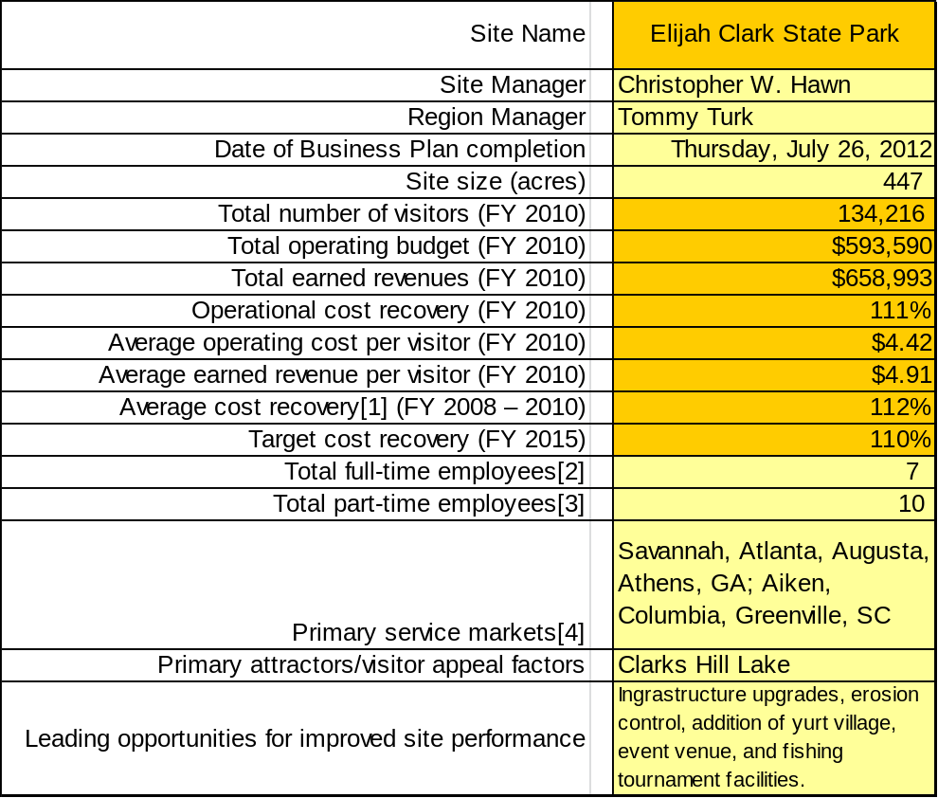

Site Summary and Key Attractions
Elijah Clark State Park (ECSP) is comprised of 447 acres located on the banks of 71,000-acre Clark’s Hill Lake. The largest state campground with 175 campsites is a destination for many campers from Augusta and Savannah, GA and several areas in South Carolina. The replica of Elijah Clark’s home and his cemetery are attractions for historians.

Key Attractions
The amenities or features listed below are those that seem to be most popular for visitors.
- Clark’s Hill Lake
- Cottages
- Camping
- Customer Service
- Historic Site

Financial Targets
The table below details the total operating expenses and earned revenues for Elijah Clark State Park over the last three years (2008 – 2010). This table also calculates total cost per visitor and revenues per visitor during these operating years, and details the target financial performance goals in the context of achieving at least 110% cost recovery. This table also calculates the necessary change from 2010 operating expenses and revenues.

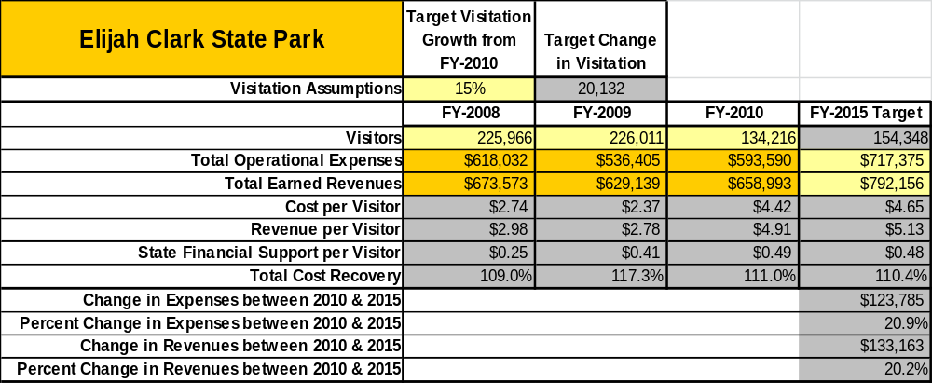

Key Recommendations

Primary / Short Term Recommendations
- Increase the number of special events held during spring and fall months. This will fill campsites and cottages during an otherwise slow season.
- Increase fee-based programs. This will generate a new source of revenue. As well, it will enhance the experience of guests, which should increase retention, repeat visits and referrals.
- Increase marketing: utilize PRHSD resources and local Chamber of Commerce; initiate plan to connect with Central Savannah River Area organization to use ECSP as a conference center.
- Utilize Friends of Elijah chapter to develop a stronger volunteer base. Engage Friends members in the business plan as a partner to help the site meet or exceed its sustainability goals.
- Develop a system of analysis to determine efficiency/productivity of park employees.

Secondary / Long Term Recommendations
- Develop General Development Plan.
- Plan, fund and develop a Yurt Village.
- Plan, fund and develop a large event venue for use in a wide variety of programs.
- Install water/electric in the Walk-In tent camping area to free up regular campsites for RV use.
- Develop the park’s relationship with the local county citizens and government to build a sense of “ownership” within the county.

Site and Operations Assessment
This site and operations assessment is a culmination of analyses and findings from a review of the condition of facilities, infrastructure, and operations at Elijah Clark State Park. The findings and observations are not intended to be an exhaustive review of all issues present, but provide a basic understanding of the predominant issues that contribute to the site’s current operating conditions. The assessment includes the following:
- Site Inventory and Facility Assessment
- Operational Assessment
- Financial Assessment
Site Inventory and Facility Assessment

Methodology
Facility and asset conditions are rated using a differential scale of excellent, good, fair, or poor. Descriptions of conditions that are attributed to each of these findings are also provided.
Scale of Conditions
Rating | General Description
Excellent | Facilities/amenities are in ‘excellent’ condition when they show little or no maintenance or repair problems. Facilities do not feature any major design or operational issues or flaws that contribute to diminished use or increased maintenance or upkeep. Facilities are easy to clean and maintain in order to place them back into public use and the users perceive them to be in excellent shape.
Good | Facilities/amenities are in ‘good’ condition when they show only minor maintenance or repair problems. Most maintenance issues with these facilities typically appear to be the result of age and/or heavy use. Facilities may only feature minor design or operational issues that contribute to diminished use or increased maintenance or upkeep. Facilities are moderately easy to clean and maintain in order to place them back into service and the users perceive them to be adequate for their use, but probably not in excellent shape.
Fair | Facilities/amenities are in ‘fair’ condition when they show significant maintenance or repair problems. Facilities generally exhibit ongoing maintenance issues that appear to be the result of age, heavy use, or design or operational flaws. Some maintenance and repair needs may compound their fair condition by being deferred because of budget and/or resource limitations. Facilities require more effort to clean and maintain before placing them back into service and the users may perceive them as being less than adequate for their use and in a state of deterioration. The facility or structure may need of major repair or replacement.
Poor | Facilities/amenities are in ‘poor’ condition when they show significant, on-going maintenance or repair problems that ultimately may result in suspended use for repair/replacement. Maintenance and repair issues are possibly the result of poor maintenance and clearly the result of age, heavy use, or design or operational flaws. Problems with the facilities are often compounded over time due to consistently-deferred maintenance and repair because of budget and/or resource limitations. Facilities may feature major design or operational issues that contribute to diminished use or increased maintenance or upkeep. Facilities require excessive effort to clean and maintain before placing them back into service and the users often perceive them as being inadequate for their use and in a state of serious deterioration. The facility or structure may need of major repair or replacement.

Inventory and Assessment
The table below is an inventory of facilities and amenities at Elijah Clark State Park, and provides the assessed condition of each as reviewed in June 2011.
Site Asset / Amenity | Quantity | Condition
Cottages | 20 | Fair
RV Campsites | 165 | Fair
Walk-in Tent Sites | 10 | Good
Museum | 1 | Good
Cemetery | 1 | Good
Mini-golf Course | 1 | Good
Office/Retail Store | 1 | Excellent
Staff Residences | 2 | Good
MIT Residence | 1 | Excellent
Group Shelter I | 1 | Good
Group Shelter II | 1 | Fair
Picnic Shelters | 7 | Good
Assembly Shelter | 1 | Good
Maintenance Complex | 1 | Good
Well house | 5 | Fair
Comfort Station 7, 8 | 2 | Excellent
Comfort Station 1, 3, 4, 5, 10 | 4 | Good
Comfort Station 2, 6, 9 | 4 | Poor
Sewage Treatment Plant | 1 | Excellent

Prioritized Facility Needs
Based on the facility inventory and assessment, these prioritized needs have been identified. Each need has been aligned with a priority category of high, moderate, or low to support future decision making regarding project sequencing, investment of public resources, and meeting community expectations. The priority assignment for each need is not a measure of importance. Rather, these recommended priorities reflect a phased implementation approach over the next several years.

Facility Need | Priority Assignment
Group Shelter II (Beach House) Renovation | High
Comfort Station Replacement 6, 9 | High
Comfort Station Removal 2 | High
Campground Electrical Upgrade (100 amp) | High
Cottage Renovation | High
Yurt Village | High
Large Event Venue | Moderate
Fishing Tournament Ramp/Parking/Weigh Station | Moderate
Parking area for Group Shelter I | Moderate
Build 10 additional Walk-In tent sites. | Low
Install water/electric to Walk-In tent Sites | Low

Operational Assessment
The Operational Assessment includes:
- An inventory and classification of programs and services being provided at the site
- A review of staffing at the site
- A review of concessionaires and partners operating at the site
- Visitation and customer satisfaction

Inventory and Classification of Programs and Services
Programs and services are classified into one of three major categories:
1) Core or Essential Services
2) Important Services
3) Visitor Supported Services
Programs and services at the site are classified into these categories based in part on the mission and public mandates for both the site and the agency. For the programs and services in each of these categories, there are financial performance expectations that will define how services are funded and evaluated.

Category 1 – Core Services [Largely supported by tax funds]
Core programs, services and facilities are those the agency must provide and/or are essential in order to capably govern and meet statutory requirements. The failure of the agency to provide Category 1 services at adequate levels could result in significant negative consequences for the public and the resources under protection. Criteria for programs or services to be classified as core or essential are:
- The services are mandated by the agency’s law or charter or are contractually obligated by agreement to provide the services.
- The services are essential to protecting and supporting the public’s health and safety.
- The services protect and maintain valuable assets and infrastructure.
- The services would generally and reasonably be expected and supported by residents, businesses, customers and partners.
- The services are those that cannot or should not be provided by the private sector.
- The services provide a sound investment of public funds.
The following programs and services offered at ECSP have been identified as core services:
- Law Enforcement to provide public safety.
- Management of the natural and cultural resources of the site.
- Maintenance of grounds, facilities and infrastructure.
- Housekeeping of cottages, group shelters and comfort stations.
- Provide the highest quality customer service.
- Provide site appropriate education and interpretation opportunities.
- Special events (educational priority)
- Living history demonstrations.

Category 2 – Important Services [Supported by a balance of tax funds and earned revenues]
Important programs, services and facilities are those the agency should provide, and are important to governing and effectively serving residents, businesses, customers and partners. Providing Category 2 services expands or enhances the agency’s ability to provide and sustain its core services. The criteria for programs or services to be classified as important are:
- The services expand, enhance or support identified core services.
- The services are broadly supported and utilized by the community, and are considered an appropriate, important, and valuable public good. Public support may be conditional upon the manner by which the services are paid for or funded.
- The services generate income or revenue that offsets some or all of the operating cost and/or are deemed to provide economic, social or environmental outcomes or results.
The following programs and services offered at ECSP have been identified as important services:
- Boat Rentals

Category 3 – Visitor Supported Services [Almost exclusively supported by earned revenue]
Visitor supported programs, services and facilities are those discretionary services that the agency may provide when additional funding or revenue exists to offset the cost of providing those services. Category 3 services provide added value above and beyond what is required or expected. The criteria for programs or services to be classified as visitor supported are:
- The services expand, enhance or support core services or important services and the quality of life of the visitors, community or stakeholders.
- The services are supported, valued and well utilized and provide an appropriate and valuable public benefit.
- The services generate income or funding from sponsorships, grants, user fees or other sources that offset some or all of their cost and/or provides a meaningful return on investment.

- The services can possibly be provided through outsourcing or use of concessionaires, providing opportunities for community enterprises that may not otherwise be provided by the agency.
The following programs and services offered at ECSP have been identified as visitor supported services:

- Retail Sales
- Special Events (Cottage/Campsite Rental priority)
- Cottage Rentals
- Campsite Rentals
- Fee-Based Programs

Staffing Assessment
Labor costs at Elijah Clark State Park represent the largest area of budgetary expense at an average of 63% of the total operating budget each year for the last three complete years, which is lower than the target of total labor costs (including benefits) not exceeding 65% of the site’s total operating expenditures. The tables below and on the following page provide a basic review of the current staffing at the site.
Full Time Equivalent Employees
Position / Title | Quantity (FTE) | Vacancies | Annual Hours
Manager | 1 | 0 | 2,600
Assistant Manager | 0 | 1 | 2,080
Facility Safety Officer | 1 | 0 | 2,080
Parks Maintenance Tech | 1 | 0 | 2,080
Secretary | 1 | 0 | 2,080
Construction Trades Specialist (AL) | 1 | 0 | 2,080
Grounds/Maint Worker (WL) | 1 | 0 | 2,080
TOTAL | 6 | 3 | 15080

Part Time Employees
Position / Title | Quantity (FTE) | Vacancies | Hours
Park Service Worker (Museum) | 1 | 0 | 550
Maintenance Worker | 4 | 0 | 4,016
Office Clerk | 2 | 0 | 2,308
Housekeeper | 4 | 0 | 3,558
TOTAL | 11 | 0 | 10,432

Labor Support
Labor Support | Annual Hours
Volunteers (Campground Hosts / Volunteers) | 7,500 / 600
Kiosk Clerk | 800
Intern | 500
Community Service Workers | 100
Resource Management Crews | 0
TOTAL | 9,500

Total Labor Hours
Labor Type | Annual Hours
Full Time Equivalent Employees | 15080
Part Time Employees | 10,432
Labor Support | 9,500
TOTAL Annual Labor Hours | 35012

Labor Budget Summary
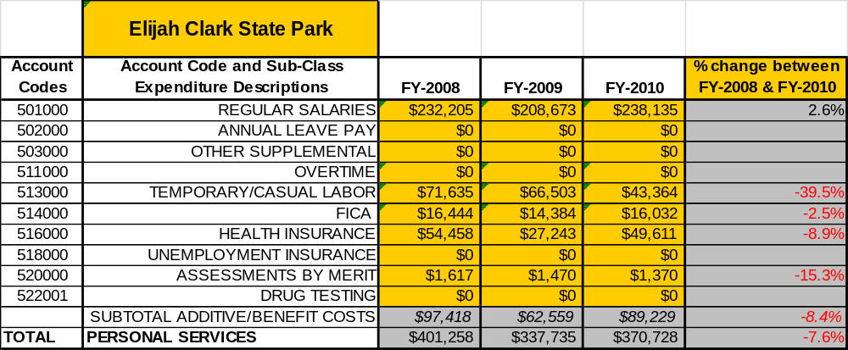

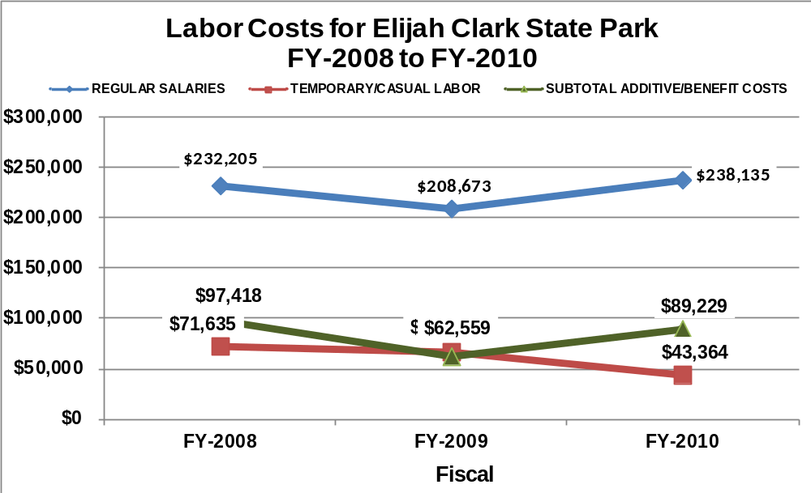

Visitation and Occupancy
Overall annual visitation to the site has trended downward from 2008 to 2010, decreasing by 41% or over 91,750 visitors. This is largely attributed to incorrect calculations and continuing low lake levels.
Year | Total Visitation
2008 | 225,966
2009 | 226,011
2010 | 134,216

Occupancy for the overnight accommodations at Elijah Clark State Park the last three years is detailed in the table below. Overall occupancy has trended downward from 2008 to 2010, decreasing by 5%. This is largely attributed to low lake levels in 2009 and the poor economy.
Year | Visitors | Camping Occupancy | Cottage  Occupancy
2008 | 225,966 | 22% | 51%
2009 | 226,011 | 20% | 46%
2010 | 134,216 | 20% | 43%

Customer Service and Satisfaction

Site | Year | Customer Satisfaction Level
Elijah Clark State Park | 2009 | 67%
Elijah Clark State Park | 2010 | 78%
Financial Performance Assessment

Operational Expenses
A summary of total operating expenses at Elijah Clark State Park from 2008 to 2010, as well as their percent change from 2008 is provided in the table below.
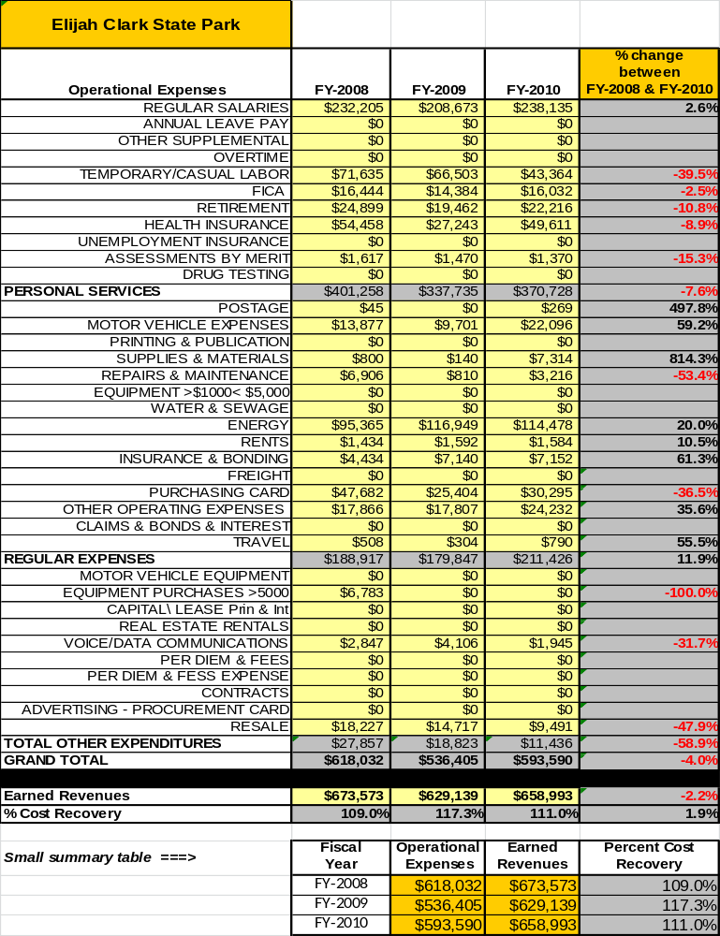

Earned Revenues
Earned revenues at Elijah Clark State Park have decreased slightly since 2008, which is largely attributed to the corresponding decrease in overall visitation and overnight occupancy.
Monthly earned revenues for the last two years (see table on the following page) indicate that the total annual revenue increased 6% from 2009 to 2010, with the largest increases in monthly revenues in July (30%), November (27%), and December (27%), and the largest decreases in the month of April (17%).
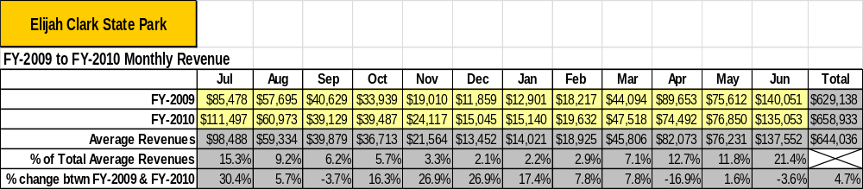

The graphs below illustrate the monthly revenue trends each year and the average percent of total annual revenue earned each month.
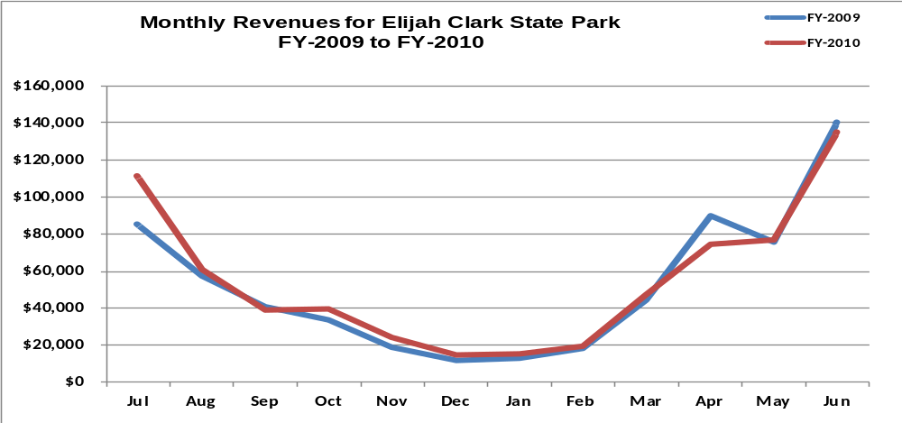

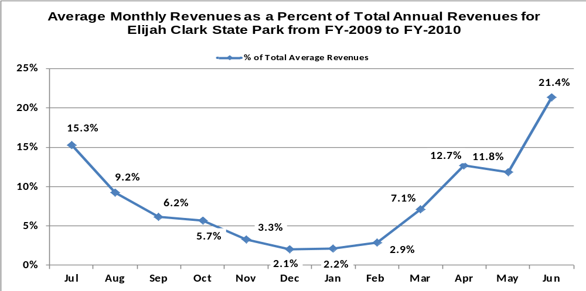

Cost Recovery Trends
Elijah Clark State Park has achieved an average cost recovery of 112% of annual operational expenses through earned revenues from FY 2008 to FY 2010. This is detailed and illustrated in the table and graph below.
Year | Operational  Expenses | Earned  Revenues | Percent Cost  Recovery
2008 | $ 618,032 | $ 673,573 | 109%
2009 | $ 536,405 | $ 629,139 | 117%
2010 | $ 593,590 | $ 658,933 | 111%
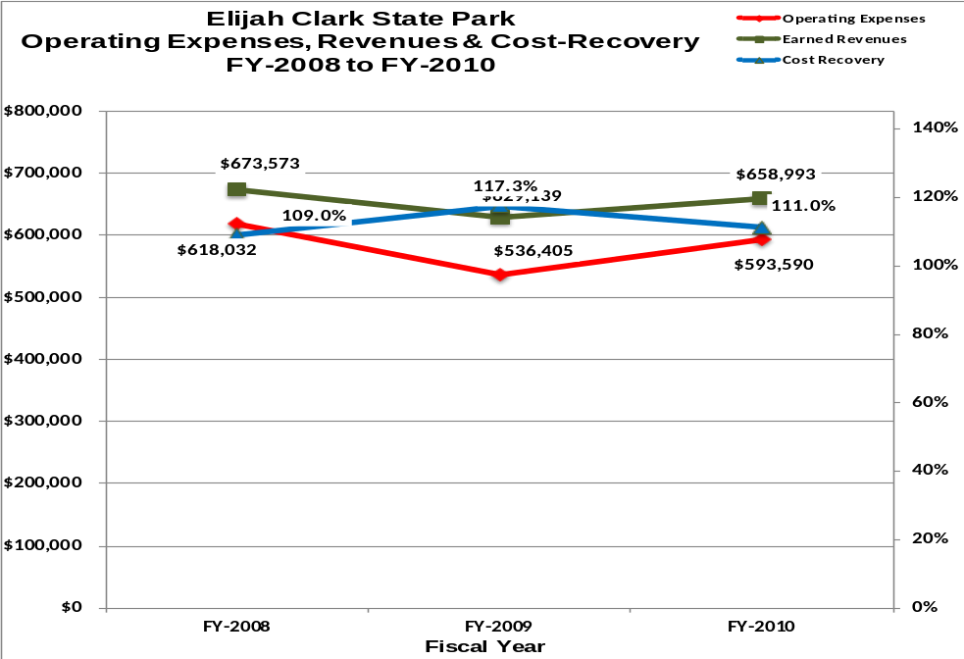

Review of Pricing
Data on rate information is available as far back as 2002, but only the last five years are evaluated. There has been notable growth in fees charged at Elijah Clark State Park since 2005, with the largest increase being cottages (44%). A table detailing the rates for Elijah Clark State Park is provided below.
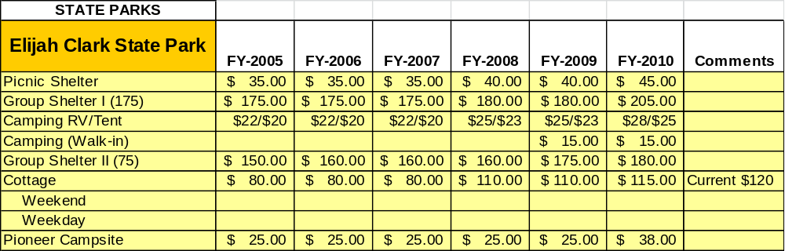
Business and Management Plan

Business Goals
The following goals serve as the foundation for the key recommendations and strategies in this business plan for Elijah Clark State Park.

Enhance Cost Recovery of Site Operations
Elijah Clark State Park is operating at an average of 112% cost recovery. ECSP has historically been a high revenue producer. However, much needs to be assessed concerning staff efficiency and the potential of new revenue sources. The potential of ECSP’s sustainability may be much higher than current operations indicate.

Enhance Revenue Generation Strategies
ECSP must develop new sources of revenue. There are three sources that have the potential to yield a large amount of unrealized income:
- Yurt Village – Yurt villages at state parks around the state provide a more affordable option than cottages, and a more comfortable option for those that do not enjoy tent camping.
- Event Venue – A large event venue including permanent structure, stage, parking, and utilities could gain popularity among promoters for a variety of events, musical concerts, sporting events, rallies (VW, jeep, classic car) and craft fairs. Elijah Clark’s current Bone Yard is an ideal location for the Venue.
- Fee-Based Programs – Providing fee-based programs for visitors is a new concept for ECSP. Programs such as canoeing, archery, hayrides, and tree climbing could yield a substantial increase in revenue while enhancing the experience of guests that will increase retention.

Expand Special Events at the Site
ECSP is well known as a site for the Lewis Family Bluegrass Festival. In turn, ECSP has been hosting its own Bluegrass Festival for over a decade. These events have proven to fill campsites and cottages during an otherwise slow season. With the development of a large event venue the park could see several large events being held at ECSP.

Improve the Diversity and Innovation of Recreational and Interpretive Programs
Pioneer/Revolutionary War history has been intricate to ECSP programming. Museum tours and living history demonstrations occur during peak-season weekends. It is important that historical interpretation can continue during slower seasons and unstaffed hours of operation. The addition of displays and electronic recordings would enable the story and lifestyle of Elijah Clark and early settlers be told in the absence of staff availability.
Environmental programming is absent from ECSP. The development of environmental education will entice schools, scouts, and other groups to enjoy and visit the park.
Recreational programming can provide experiences that both create memories and enhance the experience of the visitor but can also create a new source of revenue.

Improve the Effectiveness of Marketing and Sales
Elijah Clark State Park can improve marketing efforts in several ways: utilize the current PRHSD website more effectively, utilize local activity calendars more effectively, and develop a marketing Plan of Action. This Plan of Action would be charged with identifying organizations and businesses that could utilize
park facilities and services to the benefit of the organization. For example, churches may be searching for a men’s retreat site or a business may use the park for an annual planning meeting.

Establish Greater Consistency of Managing and Monitoring Customer Service & Satisfaction
Elijah Clark State Park plans to improve the consistency of managing and monitoring customer service and satisfaction by conducting on-site surveys annually to assess how well customer satisfaction levels are being met. ECSP will strive to have 90% of visitors responding to Comment Cards report that they were either satisfied of very satisfied. Programs or services that fall below that standard should be critically reviewed, enhanced, and results monitored; those with a history of poor performance will be evaluated and potentially considered for elimination.

Expand Partnership Opportunities
Elijah Clark State Park has limited partnerships at this time. Much potential lies within the local community to develop partnerships. Such partnerships may enable ECSP to develop a stronger volunteer base to expand programs, maintenance services, and grow community connections. Engage Friends members in the business plan as a partner to help the site meet or exceed its sustainability goals.

Classification of Programs and Services
The tables below summarize the classifications of programs and services at Elijah Clark State Park as either core, important, or visitor supported and projects a range of cost recovery percentages that might be achieved for each. These classifications establish financial performance goals for each category of services that are linked to the recommendations and strategies of this business plan.
Core Programs / Services | Target Cost Recovery
Law Enforcement/Public Safety | 0%
Management of the natural and cultural resources of the site | 0%
Maintenance of grounds, facilities and infrastructure | 0%
Housekeeping of cottages, group shelters and comfort stations | 0%
Provide the highest quality customer service | 0%
Provide site appropriate education and interpretation opportunities. | 0%
Special Events (Educational Priority) | 0%
Living History Demonstrations | 0%

Important Programs / Services | Target Cost Recovery
Boat Rentals | 100%

Visitor Supported Programs / Services | Target Cost Recovery
Retail Sale | 150%
Special Events (Cottage/Campsite Rental priority) | 150% - 200%
Cottage Rentals | 100%
Campsite Rentals | 100%
Fee-Based Programs | 100%

Partnership Development Plan
The table below summarizes existing partners and targeted partnerships by classification (operational, vendor, service, co-branding, funding partners) and by organizational type.
 | Public Partners | Not-for-profit Partners | Private / Enterprise Partners
Operational Partners | - Army Corps of Engineers  - Lincoln County Sheriff’s Office
Vendor Partners |  |  | - Club Car  - John Deere
Service Partners | - One Stop | - Chamber of Commerce
Co-branding Partners |  | - Little River Blue Way | - Graves Mountain
Funding Resource Development Partner | - Development Authority | - Friends of Georgia State Parks  - Friends of Elijah

Marketing and Sales Plan

Marketing and Sales Goals
Marketing and sales goals for Elijah Clark State Park are based on the following desired outcomes:
- To create an average of 50 marketing “hits” annually. A marketing “hit” is defined as a face-to-face contact with the purposes of expressing the park’s benefits to an established organization.
- To develop one new large attendance event annually. A large attendance event will result in the attendance of a minimum of 300 people (I.e. bluegrass festival, arts fair, etc).
- To develop three new programs annually. A program may be a fee-based or zero-based program that may be of an interpretive or recreational focus.
In order to meet these goals, examples of specific target outcomes were identified in the areas detailed in the table below.

Area  of Focus | Current  Performance | Goal  by 2011 | Goal  by 2012 | Goal  by 2015
Marketing Hits | 0 | 50 | 50 | 50
Large Event | 1 | 1 | 2 | 5
Programs | 1 | 4 | 7 | 19

Marketing and Promotion Strategies

Publicity and Social Media
Elijah Clark State Park will approach marketing and publicity planning using the following guidelines and themes:
- Event publicity
Major events benefit by having short stories in local, regional, and statewide newspapers and online social media hooks planted that run three to four weeks in advance of the event up to the date of the event itself. Stories and media need to be cultivated with contacts and online sales channels several weeks in advance of the time the stories need to run. Special interest interviews on morning, noon, and evening television news programs, radio interviews on popular rush-hour programs, and blogs on known affinity online sites should also be included.
- Program publicity
Special and unique programs should have feature stories in magazines, local and regional weekly newspapers, and statewide daily newspapers that are aimed at placements as front-page or sectional front-page stories. These stories are most effective if they run shortly before the season that the featured program begins. This will likely require several weeks of advanced planning with media contacts. Similar coverage on television and radio should also be considered. If pre-publicity cannot be generated, post-publicity can help promote future programs.

- Site Publicity
Site publicity focusing on a single site or sub-set of sites requires more intense planning efforts to attract multiple writers and editors from target publications. Each site could host several seasonal media familiarization tours (with 10 to 15 writers or editors) to familiarize them with the site and its benefits and amenities. Stories and features resulting from such tours typically take between two and six months to materialize so the tours should focus on experiences, benefits, and programs that would be available when the stories are expected to run.
Examples and suggested opportunities for events, programs and related publicity efforts based on the themes described above at Elijah Clark State Park are provided in the table below.

Event Publicity | Program Publicity | Site Publicity
VW Rally | 5-K Run | Battle at Kettle Creek
CMA Rally | Camping Basics | Pioneer Christmas
Ole Timer’s Festival | Dutch-Oven Cooking | Polar Bear Swim
Pop-Up-Alooza | Canoe Classes

Packaging
Examples and suggested packages for Elijah Clark State Park are provided in the table below.

Package | Package Details
Elijah Clark Retreat | Rent 5 Cottages/2 nights M – Th gets Group Shelter for free. Oct - Mar
Camping Club Special | Rent 20 Camp Sites/3 nights 25% off Oct - Mar

Group Sales
Types of groups within which specific target customers can be identified for Elijah Clark State Park are listed below:
- Churches | - Business/Corporations | - Schools (public, private)
- Home-school groups | - Community Organizations | - Special Interest Clubs

Incentivizing New and Repeat Visitation
Elijah Clark State Park will utilize the following strategies and/or incentives to encourage new and repeat visitation starting in FY 2012:
- Utilize a more direct, aggressive marketing approach.
- Personal follow-up phone call after family reunion, church retreat, corporate business meeting, etc.
Marketing and Sales Metric Goals
The following marketing and sales metric goals and/or others will be monitored and progress reported at Elijah Clark State Park:
- Loyalty and repeat customers = Annual retention rate will achieve 65%.
- Brand confidence & customers-recruiting-customers = Customer referrals equal a minimum of 25% of “Where did you hear about us?” responses from visitors polled.

Revenue Generation Plan
Revenue / Cost Recovery Goals
ECSP has set a financial goal of increasing annual revenues 4% annually between 2012 and 2015. The largest revenue growth opportunity is most likely fee based increases. The table below details projected revenue growth leading up to 2015, based upon a nominal growth of revenues each year.
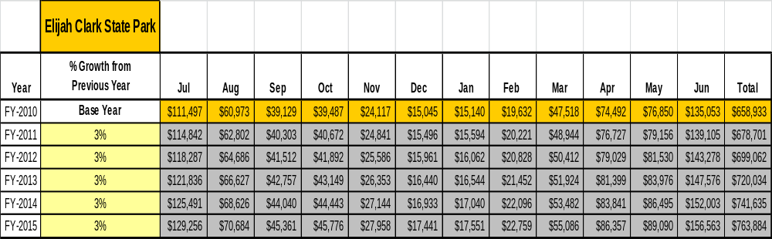

These projections would result in a total of 20% cumulative growth in total annual revenues between FY2010 and FY2015. If operational expenses can be managed with a cumulative increase of 14% between FY 2010 and FY 2015, then the overall cost recovery of the site will be approximately 110% in FY 2015 at these projected revenue levels.

Revenue Generation Strategies

Pricing Plan
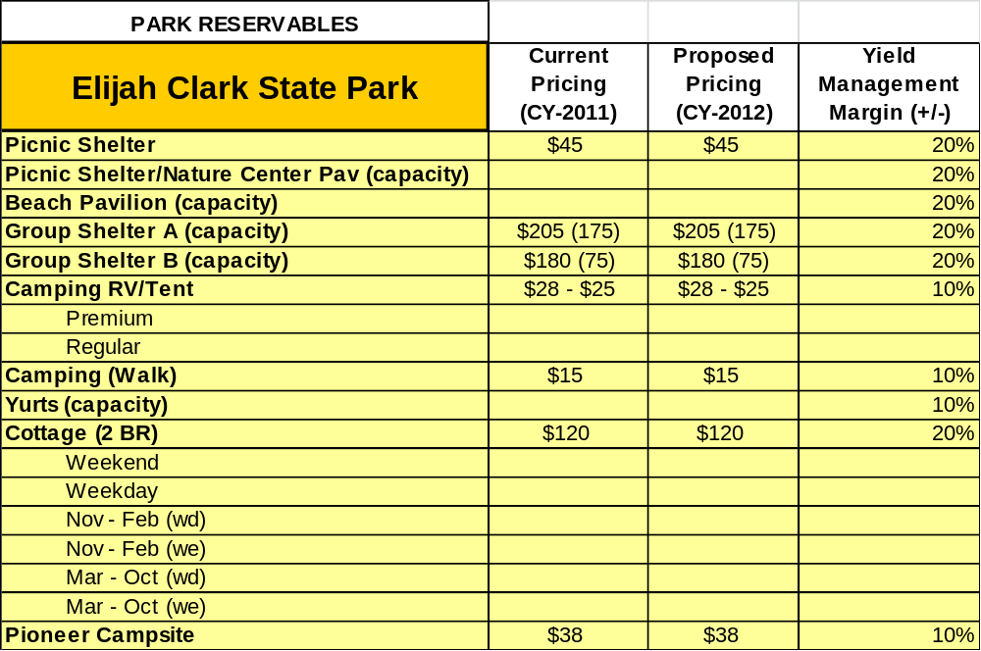

Innovative Programming and Special Events Plan
Program / Event | Theme / Purpose | Scheduled Date/Season | Frequency | Target Participation | Target User Fee | Target Cost Recovery
Cool Critters | Snake Ed | By Request | By Request | 16 classes | $25/class | 100%
VW Rally | Fill Camp | March | Annually | 50 campsites | $28/campsite | 150%
5-K Run | Exposure | October | Annually | 50 runners | $20/runner | 100%

Partnerships and Concessions Plan
Service / Partnership | Term of Service | Financial Objective | Contract Manager
Lincoln County | TBA | Earth work at Bone Yard for Venue | Chris Hawn
Club Car | August 2012 | Acquire camp host golf carts. | Chris Hawn
Blue Grass Festival | Sept 2013 | Expand vendors at Blue Grass | Friends President

Expense Management Plan
Personnel Assignments
The following actions will be taken to proactively manage labor costs via personnel assignments and classifications.
Action | Timeline | Outcome
Part-Time Staff Redistribution | June 2012 | Use PT Staff in accordance with the seasonal needs of the park.

Management Techniques
The following actions will be taken to proactively manage labor costs via management techniques.
Action | Timeline | Outcome
Cross train Staff | October 2011 | Staff will be enabled to work in more than one department (i.e. Clerks can cover Housekeeping).

Adjusted Levels of Service
The following actions will be taken to proactively manage labor costs via reduced levels of service.
Action | Timeline | Outcome

Financial Pro Forma
The following five-year financial pro forma projects operating expenses, earned revenues and cost recovery through FY 2015. These pro forma are based on the strategies and desired outcomes identified in this business plan, especially the revenue generation and expense management plans, and are linked to corresponding performance goals.

Expense Pro Forma
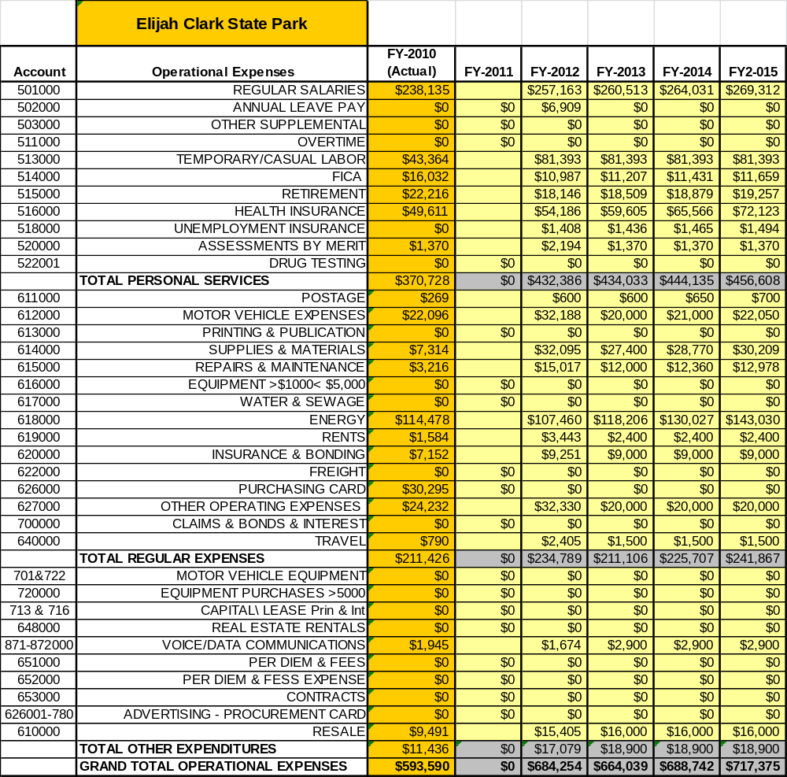

Revenue Pro Forma
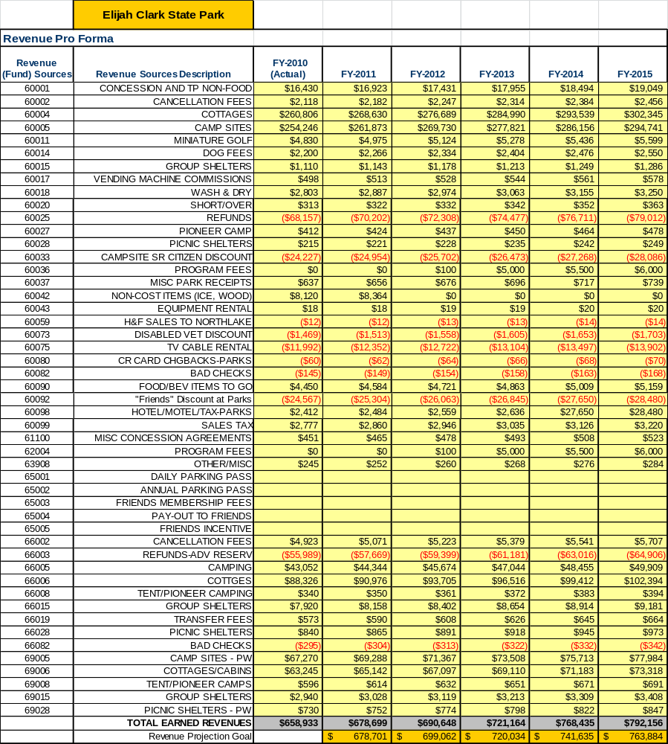

Total / Cost Recovery Pro Forma
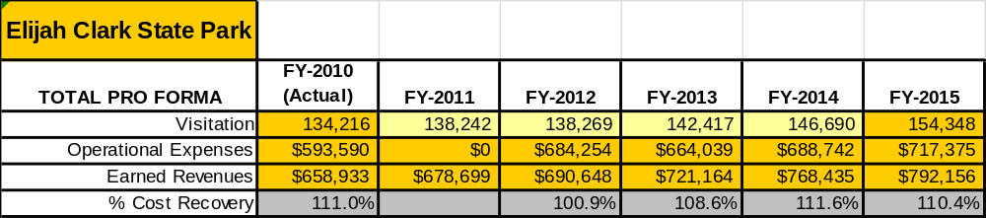

Action Plan
ACTION PLAN
Site: |  | Site Manager: |  |  | Date:
Month:
Strategy | Tasks | Costs / Funding | Revenues / ROI | Responsibilities | Metrics

ACTION PLAN
Site: |  | Site Manager: |  |  | Date:
Month:
Strategy | Tasks | Costs / Funding | Revenues / ROI | Responsibilities | Metrics

