Etowah Indian Mounds State Historic Site

Business & Management Plan

Prepared June 2011; Finalized February 2013

Direction 2015 – Sustainable Business Planning

Table of Contents

Executive Summary 3

Site and Operations Assessment 7
Site Inventory and Facility Assessment 7
Operational Assessment 9
Financial Performance Assessment 14

Business and Management Plan 17
Business Goals 18
Classification of Programs and Services 20
Partnership Development Plan 21
Marketing and Sales Plan 22
Revenue Generation Plan 24
Expense Management Plan 25
Financial Pro Forma 26

Action Plan 28

Executive Summary
The Parks, Recreation and Historic Sites Division (PRHSD) of the Georgia Department of Natural Resources (DNR) is transitioning the management of Etowah Indian Mounds Historic Site to operate more like a business, reflecting the Direction 2015 – Sustainable Business Planning initiative to improve the fiscal performance and management of the state parks and historic sites system. This business and management plan is designed to help the site recover more operating expenses through earned revenues, productive partnerships, and innovative programs.

Site Fact Sheet
Site Name | Etowah Indian Mounds State Historic Site
Site Manager | Daniel Hill
Region Manager | Joe Yeager (Region #1)
Date of Business Plan completion | 1/14/2012
Site size | 54 acres
Total number of visitors (FY 2010) | 22,753
Total operating budget (FY 2010) | $141,636
Total earned revenues (FY 2010) | $101,864
Operational cost recovery (FY 2010) | $ (59,727) 58%
Average operating cost per visitor (FY 2010) | $ 6.22
Average earned revenue per visitor (FY 2010) | $ 4.48
Average cost recovery (FY 2008 – 2010) | 38%
Target cost recovery (FY 2015) | 102%
Total full-time employees | 1
Total part-time employees | 1
Primary service markets | Atlanta, Woodstock , Marietta, Roswell, Acworth, Cartersville, Rome, Calhoun, Dalton, Kennesaw
Primary attractors/visitor appeal factors | Located in Cartersville, close to I-75, historical Native American site.
Leading opportunities for improved site performance | Increased community involvement utilizing Friends group outreach, improved retail offerings

Site Summary and Key Attractions
The 54 acre historic site of Etowah Indian Mounds is located in a metro/rural setting, centered between several large population centers and approximately 40 miles north of downtown Atlanta, and just 5 miles west of I-75. This 54-acre site was home to several thousand Native Americans from 1000 A.D. to 1550 A.D. It protects and interprets six earthen mounds, a plaza, and village site; borrow pits, and defensive ditch. Etowah Mounds is the most intact Mississippian Culture site in the Southeast. A museum displays artifacts and shares how natives of this political and religious center decorated themselves with hell beads, paint, complicated hairdos, feathers and copper ear ornaments. Hand-carved stone effigies weighing 125 pounds still bear some original pigments. Objects made of wood seashells and stone are also displayed. A nature trail meanders along the Etowah River and highlights a v-shaped fish trap the natives built in the river. The proximity of population centers, interstate, recreational and cultural offerings, should benefit ability to achieve the identified cost recovery target.

Key Attractions
The amenities or features listed below are those that seem to be most popular for visitors.
- Six earthen mounds
- Museum
- Nature trail
- Programs and special events
- Nearby world-class museums in Cartersville

Financial Targets
The table below details the total operating expenses and earned revenues for Etowah Indian Mounds over the last three years (2008 – 2010). This table also calculates total cost per visitor and revenues per visitor during these operating years, and details the target financial performance goals in the context of achieving at least 102% cost recovery. This table also calculates the necessary change from 2010 operating expenses and revenues.
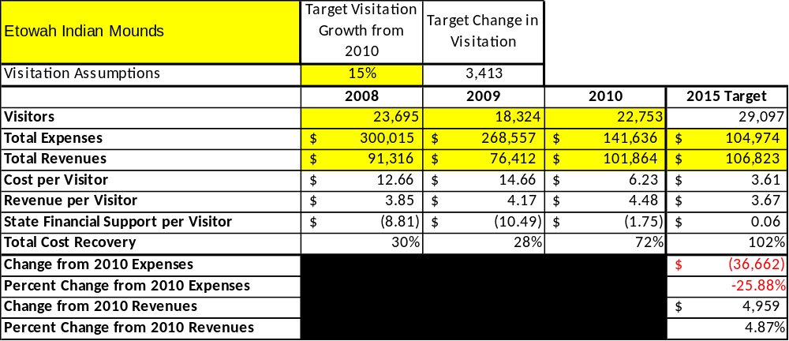

FY 2009 visitation was a deviation from normal; based on revenue data, visitation is estimated to have been 20,477

Key Recommendations

Primary / Short Term Recommendations
- Operate the site using cost-based accounting, including the net cost recovery achieved annually.
- Conduct in-park surveys annually to assess how well customer satisfaction levels are being met. EIM should strive to have 90% of visitors responding to ‘Comment Cards’ report that they were either ‘satisfied’ or ‘very satisfied’ (or some comparable metric to be developed). Programs or services that fall below that standard should be critically reviewed, enhanced, and results monitored; those with a history of poor performance should be considered for elimination.
- Evaluate and pursue opportunities to employ concessionaires or private or public service providers on-site if they can be more cost-effective. For example, outsource landscaping and maintenance.
- Collect a statistically-valid sample of ZIP code data from visitors in a non-intrusive way to gauge their origins and demographics (e.g., age, ethnicity, income, etc.) and use the results to improve programming and marketing efforts to appeal to a broader audience.
- Utilize a minimum of six special events annually to help draw more visitors to the site.
- Seek local partners to help support operations, programs, and service delivery and for cross-marketing purposes.
- Sustain sufficient non-labor operational funding or reduce staff so that required staff operational costs (with benefits) do not exceed 60% of the total operational budget.
- Enhance facilities and program offerings to provide a minimum of 10 unique experiences for each visitor while maintaining at least a 90% customer satisfaction rating.
- Manage Etowah Indian Mounds according to well-defined maintenance, program and operational standards monitored and enforced by region managers and senior management.
- Partner with local Chambers of Commerce, CVB, or other destination marketing organizations (DMOs) to promote EIM.
- Work with the Etowah Indian Mounds Chapter of the Friends of Georgia Historic Sites and Historic Sites to help raise funds or provide volunteers for improvements and program support.
- Perform a thorough net cost-of-service analysis on major functions of site operations, including the detailed analysis of labor requirements (by task) that has already been produced by site staff. Thereafter, update costs to deliver services on a biennial schedule.
- Review and update rates at the site on an annual basis to recover the total net cost of service for important and visitor-supported services.
- Track total economic impact of the site on the local communities and region and share with decision-makers, elected officials, local business operators, and others to demonstrate the impact of EIM.
- Develop a more detailed analysis of labor requirements of all major site functions to match the right position with the right job at the right pay.
- Develop funding to provide additional training to site staff for improved business management and marketing effectiveness.
- Regain a presence with the local school community for program / educational offerings at Allatoona Pass, Red Top, Etowah Mounds and Pickett’s Mill.
- Develop immediate partner/amenity packages with local attractions.

Secondary / Long Term Recommendations
- Engage the local community, user groups, and private organizations to improve connectivity.
- Install an improved retail point-of-sale and inventory tracking system.
- Continue evaluating use of personnel to cover Etowah Indian Mounds, Pickett’s Mill and Red Top Mountain operations.

Site and Operations Assessment
This site and operations assessment is a culmination of analyses and findings from a review of the condition of facilities, infrastructure, and operations at Etowah Indian Mounds Historic Site. The findings and observations are not intended to be an exhaustive review of all issues present, but provide a basic understanding of the predominant issues that contribute to the site’s current operating conditions. The assessment includes the following:
- Site Inventory and Facility Assessment
- Operational Assessment
- Financial Assessment
Site Inventory and Facility Assessment

Methodology
Facility and asset conditions are rated using a differential scale of excellent, good, fair, or poor. Descriptions of conditions that are attributed to each of these findings are also provided.
Scale of Conditions
Rating | General Description
Excellent | Facilities/amenities are in ‘excellent’ condition when they show little or no maintenance or repair problems. Facilities do not feature any major design or operational issues or flaws that contribute to diminished use or increased maintenance or upkeep. Facilities are easy to clean and maintain in order to place them back into public use and the users perceive them to be in excellent shape.
Good | Facilities/amenities are in ‘good’ condition when they show only minor maintenance or repair problems. Most maintenance issues with these facilities typically appear to be the result of age and/or heavy use. Facilities may only feature minor design or operational issues that contribute to diminished use or increased maintenance or upkeep. Facilities are moderately easy to clean and maintain in order to place them back into service and the users perceive them to be adequate for their use, but probably not in excellent shape.
Fair | Facilities/amenities are in ‘fair’ condition when they show significant maintenance or repair problems. Facilities generally exhibit ongoing maintenance issues that appear to be the result of age, heavy use, or design or operational flaws. Some maintenance and repair needs may compound their fair condition by being deferred because of budget and/or resource limitations. Facilities require more effort to clean and maintain before placing them back into service and the users may perceive them as being less than adequate for their use and in a state of deterioration. The facility or structure may need of major repair or replacement.
Poor | Facilities/amenities are in ‘poor’ condition when they show significant, on-going maintenance or repair problems that ultimately may result in suspended use for repair/replacement. Maintenance and repair issues are possibly the result of poor maintenance and clearly the result of age, heavy use, or design or operational flaws. Problems with the facilities are often compounded over time due to consistently-deferred maintenance and repair because of budget and/or resource limitations. Facilities may feature major design or operational issues that contribute to diminished use or increased maintenance or upkeep. Facilities require excessive effort to clean and maintain before placing them back into service and the users often perceive them as being inadequate for their use and in a state of serious deterioration. The facility or structure may need of major repair or replacement.

Inventory and Assessment
The table below is an inventory of facilities and amenities at Etowah Indian Mounds Historic Site, and provides the assessed condition of each as reviewed in January, 2012.

Site Asset / Amenity | Quantity | Condition
Total Acreage | 54 | Good
Museum | 1 | Fair
Hiking Trails | 8 | Good
Maintenance Facility | 1 | Good

Prioritized Facility Needs
Based on the facility inventory and assessment, these prioritized needs have been identified. Each need has been aligned with a priority category of high, moderate, or low to support future decision making regarding project sequencing, investment of public resources, and meeting community expectations. The priority assignment for each need is not a measure of importance. Rather, these recommended priorities reflect a phased implementation approach over the next several years.

Facility Need | Priority Assignment
Refurbish museum and artifact storage | High

Operational Assessment
The Operational Assessment includes:
- An inventory and classification of programs and services being provided at the site
- A review of staffing at the site
- A review of concessionaires and partners operating at the site
- Visitation and customer satisfaction

Inventory and Classification of Programs and Services
Programs and services are classified into one of three major categories:
1) Core or Essential Services
2) Important Services
3) Visitor Supported Services
Programs and services at the site are classified into these categories based in part on the mission and public mandates for both the site and the agency. For the programs and services in each of these categories, there are financial performance expectations that will define how services are funded and evaluated.

Category 1 – Core Services [Largely supported by tax funds]
Core programs, services and facilities are those the agency must provide and/or are essential in order to capably govern and meet statutory requirements. The failure of the agency to provide Category 1 services at adequate levels could result in significant negative consequences for the public and the resources under protection. The criteria for programs or services to be classified as core or essential are:
- The services are mandated by the agency’s law or charter or are contractually obligated by agreement to provide the services.
- The services are essential to protecting and supporting the public’s health and safety.
- The services protect and maintain valuable assets and infrastructure.
- The services would generally and reasonably be expected and supported by residents, businesses, customers and partners.
- The services are those that cannot or should not be provided by the private sector.
- The services provide a sound investment of public funds.
The following programs and services offered at Etowah Indian Mounds Historic Site have been identified as core services:
- Safe environment for public to utilize the site
- Protection of cultural and natural resources

Category 2 – Important Services [Supported by a balance of tax funds and earned revenues]
Important programs, services and facilities are those the agency should provide, and are important to governing and effectively serving residents, businesses, customers and partners. Providing Category 2 services expands or enhances the agency’s ability to provide and sustain its core services. The criteria for programs or services to be classified as important are:
- The services expand, enhance or support identified core services.
- The services are broadly supported and utilized by the community, and are considered an appropriate, important, and valuable public good. Public support may be conditional upon the manner by which the services are paid for or funded.
- The services generate income or revenue that offsets some or all of the operating cost and/or are deemed to provide economic, social or environmental outcomes or results.
The following programs and services offered at Etowah Indian Mounds Historic Site have been identified as important services:
- Hiking trails
- Self-guided interpretive and educational programs
- Artifact management
- Historic research support
- Maintenance
- Passive interpretation (bulletin boards, interpretive panels, maps, etc.)

Category 3 – Visitor Supported Services [Almost exclusively supported by earned revenue]
Visitor supported programs, services and facilities are those discretionary services that the agency may provide when additional funding or revenue exists to offset the cost of providing those services. Category 3 services provide added value above and beyond what is required or expected. The criteria for programs or services to be classified as visitor supported are:
- The services expand, enhance or support core services or important services and the quality of life of the visitors, community or stakeholders.
- The services are supported, valued and well utilized and provide an appropriate and valuable public benefit.
- The services generate income or funding from sponsorships, grants, user fees or other sources that offset some or all of their cost and/or provides a meaningful return on investment.

- The services can possibly be provided through outsourcing or use of concessionaires, providing opportunities for community enterprises that may not otherwise be provided by the agency.

The following programs and services offered at Etowah Indian Mounds Historic Site have been identified as visitor supported services:
- Special events & staffed interpretive programming

Staffing Assessment
Labor costs at Etowah Indian Mounds Historic Site represent the largest area of budgetary expense at an average of 77% of the total operating budget each year for the last three complete years, which is higher than the target of total labor costs (including benefits) not exceeding 65% of the site’s total operating expenditures. The tables below and on the following page provide a basic review of the current staffing at the site.
Full Time Equivalent Employees
Position / Title | Quantity (FTE) | Vacancies | Annual Hours
Interpretive Ranger | 1 | 0 | 2080
Senior Ranger | 0 | 1 | 0
TOTAL | 1 | 1 | 2,080

Part Time Employees
Position / Title | Quantity (FTE) | Vacancies | Hours
Part Time Naturalist | 1 | 0 | 1508
Part Time Clerk | 0 | 1 | 1508
TOTAL | 1 | 1 | 3,016

Labor Support
Labor Support | Annual Hours
Volunteers | 85
Community Service Workers | 1500
Engineering and Construction Crews | 0
Resource Management Crews | 20
Prison Crew Detail | 832
TOTAL | 2,437

Total Labor Hours
Labor Type | Annual Hours
Full Time Equivalent Employees | 2,080
Part Time Employees | 3,016
Labor Support | 2,437
TOTAL Annual Labor Hours | 7,533

Labor Budget Summary

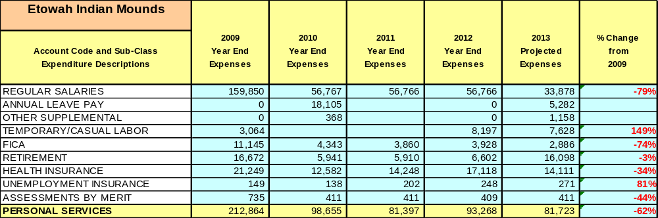

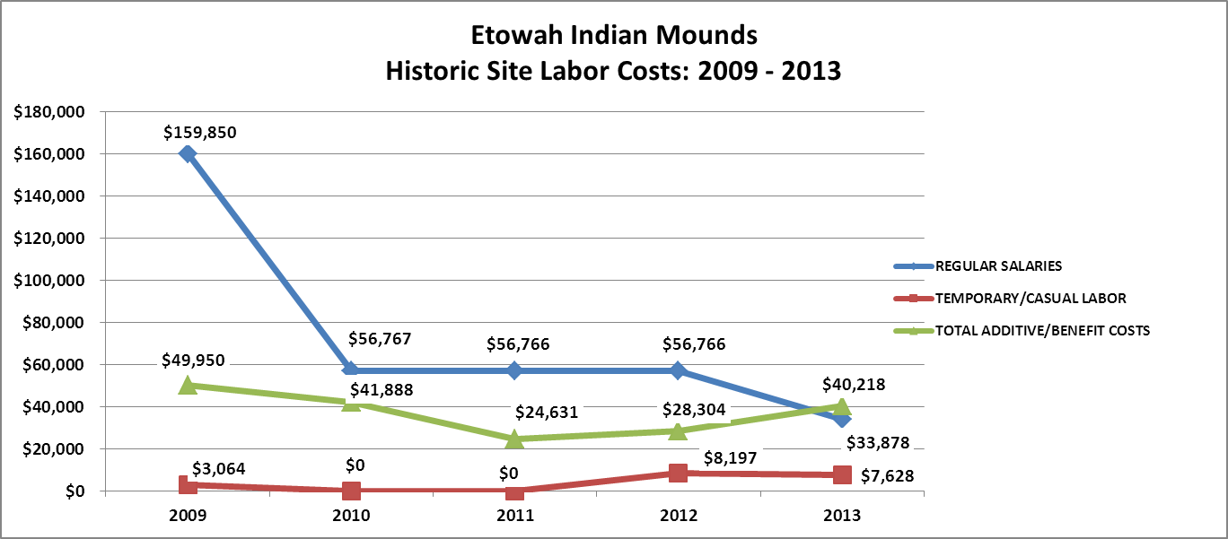

Visitation and Occupancy
Overall annual visitation to the site has trended upward from 2008 to 2012, increasing by 16% or over 3,724. A decrease was seen in 2009 and 2011 respectively, however additional programs, and an active Friends Group has significantly increased site visitation. .

Year | Total Visitation
2008 | 23,695
2009 | 18,327
2010 | 22,753
2011 | 15,337
2012 | 27,419

Customer Service and Satisfaction

Site: Etowah Indian Mounds | Year | Customer Satisfaction Level
 | 2009 | 80% (4 of 5)
 | 2010 | 67% (4 of 6)
Financial Performance Assessment

Operational Expenses
A summary of total operating expenses at Etowah Indian Mounds Historic Site from 2008 to 2012, as well as their percent change from 2008 are provided in the table below.

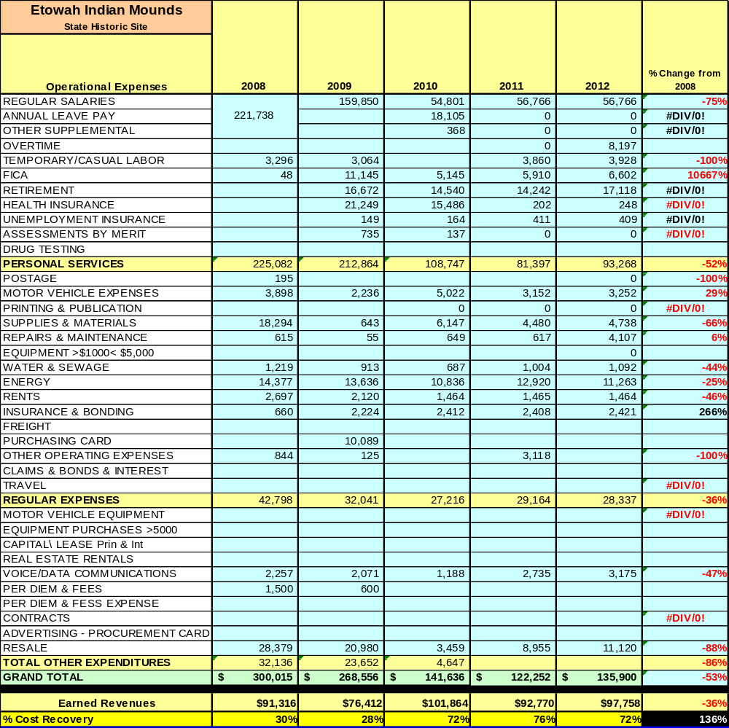

Earned Revenues
Earned revenues at Etowah Indian Mounds have decreased since 2008, which is largely attributed to speculation and closure of the lodge facility, decrease in overall visitation in addition, and poor economy.
Monthly earned revenues for the last two years (see table on the following page) indicate that the total annual revenue decreased 12% from 2009 to 2010, with the largest increases in monthly revenues in December (32%) and January (79%), and the largest decreases in the months of September (-35%) and April (-14%).
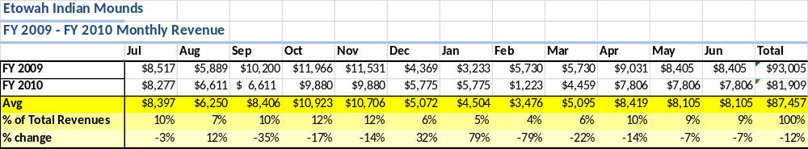

The graphs below illustrate the monthly revenue trends each year and the average percent of total annual revenue earned each month.
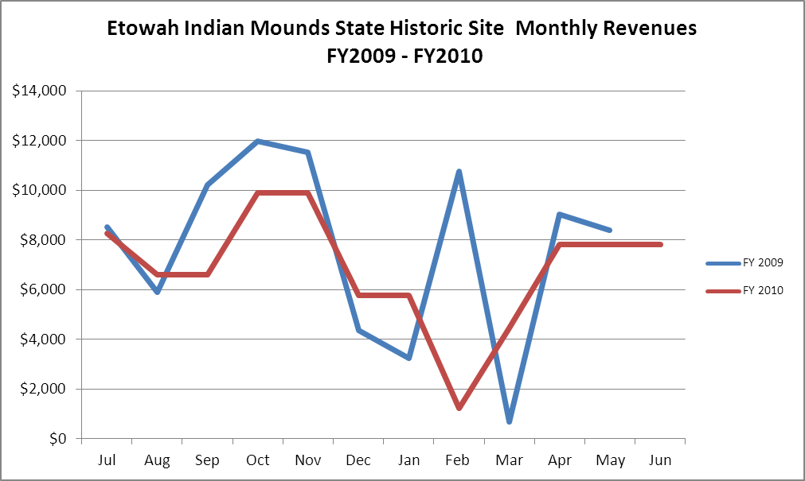

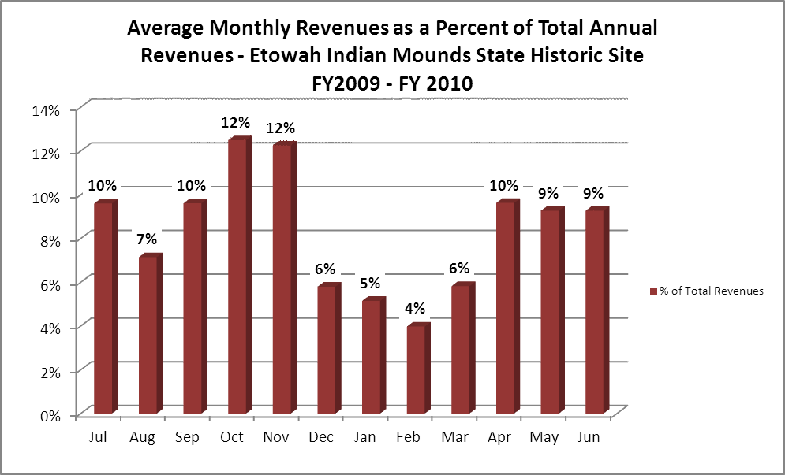

Cost Recovery Trends
Etowah Indian Mounds has achieved an average cost recovery of 55.6% of annual operational expenses through earned revenues from FY 2008 to FY 2012. However the average cost recovery from 2010-2012 has been 73.3%. This is detailed and illustrated in the table and graph below.
Year | Operational  Expenses | Earned  Revenues | Percent Cost  Recovery
2008 | $300,015 | $91,316 | 30%
2009 | $268,556 | $76,412 | 28%
2010 | $141,636 | $101,864 | 72%
2011 | $122,252 | $101,864 | 76%
2012 | $135,900 | $97,758 | 72%

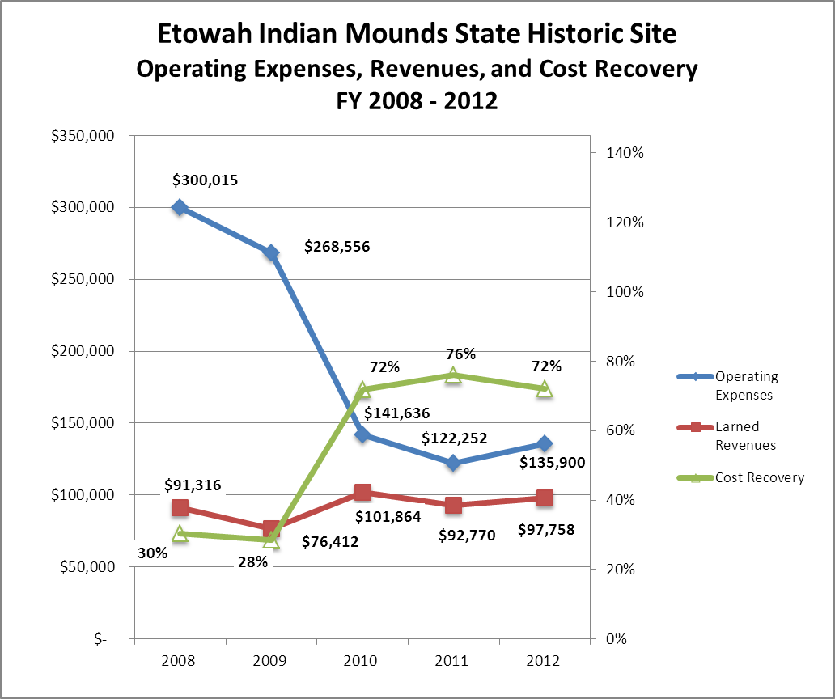

Review of Pricing
Data on rate information is available as far back as 2002, but only the last five years are evaluated. There has been little growth in fees charged at Etowah Indian Mounds since 2008, with the largest increase being an across the board increase if $1.00, except for the Child/Groups Under 6 rate. A table detailing the rates for Etowah Indian Mounds is provided below.
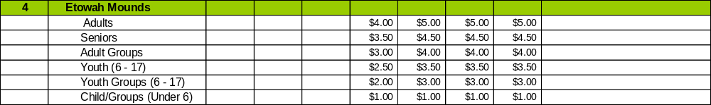

Business and Management Plan
Business Goals
The following goals serve as the foundation for the key recommendations and strategies in this business plan for Etowah Indian Mounds Historic Site.
Enhance Cost Recovery of Site Operations
A key outcome of this business planning process and the D15 sustainability initiative is to better define the parameters of sustainable operations for Georgia State Parks and Historic Sites. This plan identifies the criteria for sustainable operations at Hard Labor Creek State Park, as well as establishes a minimum standard under which operations at the park should be drastically altered, suspended, or discontinued.
Enhance Revenue Generation Strategies
Improving earned revenues will most likely result from the impacts of both increased traffic and visitation in the historic site, and increased proportional revenues from services based on pricing and fee adjustments. Proactive and progressive pricing and fees that are appropriately aligned with costs of service should be established and routinely monitored. Pricing and fee policies and practices are central to producing more resources at the park. The following recommendations should be considered and monitored over the next five years:
- Develop a cost of service assessment for each attraction, amenity and program in the site to determine its level of tax funding and or revenue contribution.
- Develop a pricing policy based on core and non-core services and based on its public, merit and private value and benefit received.
- Price services based on benefit received level of exclusivity, prime-time and non-prime time basis, season or off-season time, market place and length of stay.
- Train staff on how pricing works and how to communicate prices to users.
- Engage Friends members as a partner to help the site meet or exceed its sustainability goals
- Create a tiered pricing structure that encourages early reservations, off-peak usage, diverse user groups, and supports the cost recovery goals of the site.
Expand Special Events at the Site
- Establish criteria for evaluating whether programs are core programs and services, value-added, or peripheral to the mission and objectives of the site.
- Develop and implement program standards as it applies to core programs and services including health and wellness, outdoor recreation, and natural and cultural resource stewardship.
- Create functional and productive year-round programs, including enhancement of facilities and services targeting special events.
- Develop a youth services program partnership plan with youth service organizations throughout the region.
- Develop appropriate programs for people with disabilities.
- Increase programs targeting family recreation to increase families participating together.
- Develop a diverse blend of special events that engage the local community and draw tourists to the Historic Site.
- Develop programs that represent a tiered level of service with varied and appropriate pricing.
- Reinvigorate the marketing and communications promoting programs at Etowah Indian Mounds Historic Site.
Improve the Diversity and Innovation of Recreational and Interpretive Programs
The needs of historic site guests are evolving as more diverse interests grow in the market. Etowah Indian Mounds can improve its ability to meet the needs of the modern user by diversifying the age appeal of the site, hosting special events and/or competitions in themes and activities that are becoming increasingly popular, and by engaging alternative providers in supporting the amenities and programs at the historic site.
Improve the Effectiveness of Marketing and Sales
The effectiveness of marketing and promotional activities of Etowah Indian Mounds can be improved in order to produce greater outcomes from peak, shoulder and off seasons. Much of this can be achieved through a shift in the basic platform of marketing to a more targeted approach and inspirational mantra. Additionally, the use of pre-season incentives to promote off season usage and advanced registration for peak and shoulder seasons will improve the ability of the park to maintain an increased and balanced flow of usage throughout the year. Most importantly, all marketing and promotional efforts must be monitored through sales goals the site – marketing without sales is just an awareness campaign that has little or no effect on the financial performance of the park.
Establish Greater Consistency of Managing and Monitoring Customer Service & Satisfaction
Creating a more efficient and consistent process for soliciting visitor and user feedback will improve the ability of the site to be a more proactive facility and service provider in the region.
Expand Partnership Opportunities
Many times partnerships are inequitable to the public agency and do not produce reasonable shared benefits between parties. The recommended policies will promote fairness and equity within the existing and future partnerships while helping staff to manage against what may have caused conflicts internally and externally. Certain partnership principles must be adopted by the site for existing and future partnerships to work effectively.

Classification of Programs and Services
The tables below summarize the classifications of programs and services at Etowah Indian Mounds as either core, important, or visitor supported and projects a range of cost recovery percentages that might be achieved for each. These classifications establish financial performance goals for each category of services that are linked to the recommendations and strategies of this business plan.

Core Services
Program / Service | Target Cost Recovery
Public Safety | 0%
Protection of cultural and natural resources | 0%

Important Services
Program / Service | Target Cost Recovery
Hiking trails | 50%
Self-guided interpretation and education programs | 20%
Artifact management | 20%
Historic research support | 50%
Maintenance (grass cutting, buildings, bathrooms, etc.) | 50%
Passive Interpretation | 25%

Visitor Supported
Program / Service | Target Cost Recovery
Special events & staffed interpretive programming | 80%

Partnership Development Plan
The table below summarizes existing partners and targeted partnerships by classification (operational, vendor, service, co-branding, funding partners) and by organizational type.
 | Public Partners | Not-for-profit Partners | Private / Enterprise Partners
Operational Partners | - Bartow SO, EMS | - Friends of EIM  - Etowah Valley Historical Society
Vendor Partners
Service Partners
Co-branding Partners |  | - Cartersville/Bartow CVB
Funding Resource Development Partner |  | - Friends of EIM

Marketing and Sales Plan

Marketing and Sales Goals
Marketing and sales goals for Etowah Indian Mounds are based on the following desired outcomes:
- Increased group visitation
- Increased public programs
In order to meet these goals, examples of specific target outcomes were identified in the areas detailed in the table below.
Area  of Focus | Current  Performance | Goal  by 2011 | Goal  by 2012 | Goal  by 2015
Social Media | None | Facebook | Facebook Twitter | All social media
Friends Group | Just formed | Form core group and hold two events | Expand active membership, hold four events/yr. | Actively engage in social media roles, and assist site to maintain sustainability.
Off-Site Outreach | 6 programs/yr. | 12 programs/yr. | 14 programs/yr. | 16 programs /yr.

Marketing and Promotion Strategies

Publicity and Social Media
Etowah Indian Mounds will approach marketing and publicity planning using the following guidelines and themes:
- Event publicity
Major events benefit by having short stories in local, regional, and statewide newspapers and online social media hooks planted that run three to four weeks in advance of the event up to the date of the event itself. Stories and media need to be cultivated with contacts and online sales channels several weeks in advance of the time the stories need to run. Special interest interviews on morning, noon, and evening television news programs, radio interviews on popular rush-hour programs, and blogs on known affinity online sites should also be included.
- Program publicity
Special and unique programs should have feature stories in magazines, local and regional weekly newspapers, and statewide daily newspapers that are aimed at placements as front-page or sectional front-page stories. These stories are most effective if they run shortly before the season that the featured program begins. This will likely require several weeks of advanced planning with media contacts. Similar coverage on television and radio should also be considered. If pre-publicity cannot be generated, post-publicity can help promote future programs.
- Site Publicity
Site publicity focusing on a single site or sub-set of sites requires more intense planning efforts to attract multiple writers and editors from target publications. The site could host several seasonal media familiarization tours (with 10 to 15 writers or editors) to familiarize them with the site and its benefits and amenities. Stories and features resulting from such tours typically take between two and six months to materialize so the tours should focus on experiences, benefits, and programs that would be available when the stories are expected to run.
Examples and suggested opportunities for events, programs and related publicity efforts based on the themes described above at Etowah Indian Mounds Historic Site are provided in the table below.
Event Publicity | Program Publicity | Site Publicity
Friends Events | Torchlight Tours | Barbecoa and Silent Auction

Packaging
Examples and suggested packages for Etowah Indian Mounds are provided in the table below.
Package | Package Details
Historic Bartow Tour | Collaborate with Booth Museum, EVHA (Etowah Valley Historical Society) Bartow History Museum, Tellus Science Museum, Red Top Mountain and Etowah to form a Bartow history package tour.

Group Sales
Types of groups within which specific target customers can be identified for Etowah Indian Mounds are listed below:
- Young organized tour groups | - Older organized tour groups | - Individual Adults  - Individual Child/Youth

Incentivizing New and Repeat Visitation
Etowah Indian Mounds will utilize the following strategies and/or incentives to encourage new and repeat visitation starting in FY 2012:
- Creative special events
- Community partnerships and outreach
- Engage Friends Chapter as a partner to help the site meet or exceed its sustainability goals
- Friends Chapter outreach

Marketing and Sales Metric Goals
The following marketing and sales metric goals and/or others will be monitored and progress reported at Etowah Indian Mounds:
- Loyalty and repeat customers = Schools, Historical Societies
- Brand confidence & customers-recruiting-customers = local businesses / CVB

Revenue Generation Plan
Revenue / Cost Recovery Goals
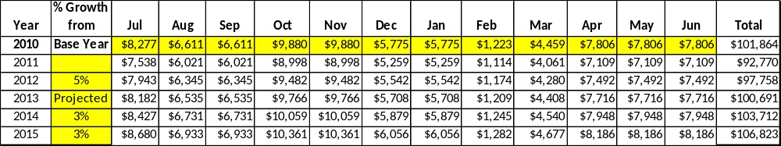
Etowah Indian Mounds has set a financial goal of increasing annual revenues 3% annually between 2013 and 2015. The largest revenue growth opportunity is most likely retail improvements and pricing. This was first implemented in 2012, showing an increase of 5%. The table below details projected revenue growth leading up to 2015, based upon a nominal growth of revenues each year.

These projections would result in a total of 16% cumulative growth in total annual revenues between FY2011 and FY2015. If operational expenses can be managed with a cumulative reduction of 3% between FY 2010 and FY 2015, then the overall cost recovery of the site will be approximately 102% in FY 2015 at these projected revenue levels. This is higher than the annual financial performance of the site in FY 2010, which was operated at 58% cost recovery in that year.
Revenue Generation Strategies

Pricing Plan
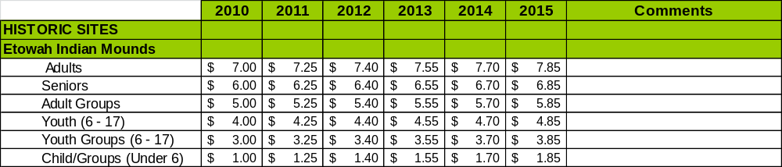

Innovative Programming and Special Events Plan
Program / Event | Theme / Purpose | Scheduled Date/Season | Frequency | Target Participation | Target User Fee | Target Cost Recovery
Hayrides | Visitation | Fall/Spring | Twice/year | 7-12 yo | $5.50 | 170%
Torchlight Tours | Visitation | Late Summer | Once/year | Adults | $7.00 | 150%

Partnerships and Concessions Plan
Service / Partnership | Term of Service | Financial Objective | Contract Manager
Friends of Etowah Indian Mounds | Ongoing | Engage Friends members as a partner to help the site meet or exceed its sustainability goals | Friends President

Expense Management Plan
Personnel Assignments
The following actions will be taken to proactively manage labor costs via personnel assignments and classifications.

Action | Timeline | Outcome
Utilize staff at RTM & PM to cross support Etowah | Immediate | Better support for events at EM/PM and RTM.
Fill Maint. Engineer position | Spring 2012 | Better cross-site support for maintenance at all three sites
Utilize Resource Manager 2 to oversee EM and PM operations, RTM programming | Immediate | Increased efficiency and cross support of programs and ops.

Management Techniques
The following actions will be taken to proactively manage labor costs via management techniques.

Action | Timeline | Outcome
Utilize retired park managers with LE to support special events, heavy use weekends, etc. | Immediate | Eliminate need to fill additional salaried LE position to support site.

Adjusted Levels of Service
The following actions will be taken to proactively manage labor costs via reduced levels of service.

Action | Timeline | Outcome
Museum Hours of Operation | 2011 | Better balance service to customers at this key location, close operation at times when traffic is slow.

Financial Pro Forma
The following five-year financial pro forma projects operating expenses, earned revenues and cost recovery through FY 2015. These pro forma are based on the strategies and desired outcomes identified in this business plan, especially the revenue generation and expense management plans, and are linked to corresponding performance goals.

Expense Pro Forma
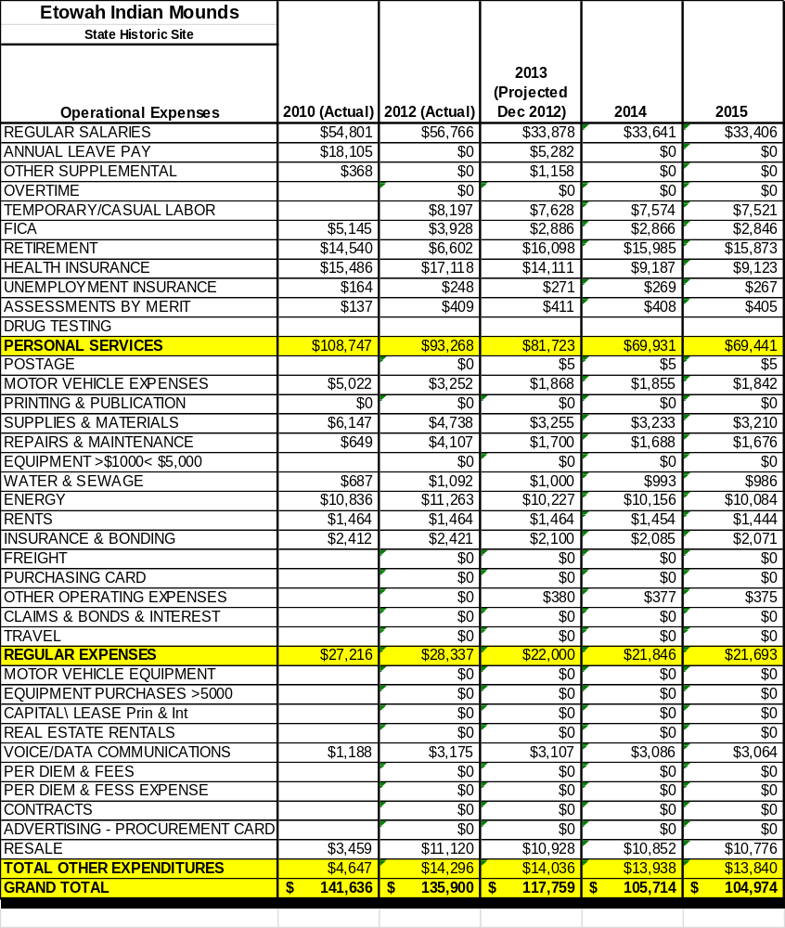

Revenue Pro Forma
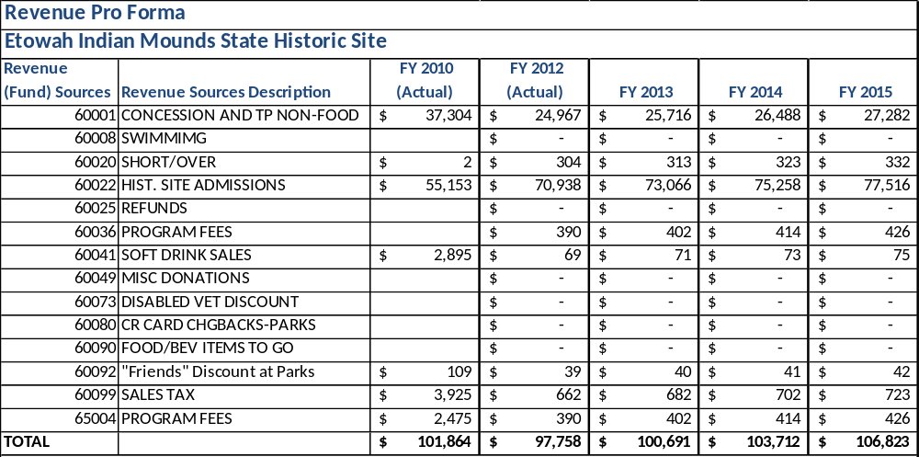

Total / Cost Recovery Pro Forma
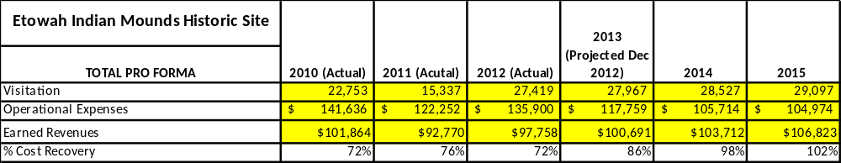

Action Plan
ACTION PLAN
Site: Etowah Indian Mounds |  | Site Manager: Daniel Hill |  |  | Date:
Month:
Strategy | Tasks | Costs / Funding | Revenues / ROI | Responsibilities | Metrics

ACTION PLAN
Site: Etowah Indian Mounds |  | Site Manager: Daniel Hill |  |  | Date:
Month:
Strategy | Tasks | Costs / Funding | Revenues / ROI | Responsibilities | Metrics

This is the average of the last three years – FY 2008, FY 2009, and FY 2010
Current employees, not including vacancies.
Current employees, not including vacancies.
Major population centers within a two-hour drive from the site

